
ST. PHILOMENA’S COLLEGE (Autonomous), MYSORE – 570 015
Affiliated to University of Mysore
College of Excellence – UGC, Re-accredited by NAAC
PG DEPARTMENT OF ECONOMICS
REPORT
The PG Department of Economics students and faculties participated in Talk and career guidance program organized by DoS in Economics and Co-operation, Manasaganagotri, Mysore.

Objectives
- Inspire Students: To motivate students by sharing real-life success stories of achieving significant milestones.
- Provide Guidance: To offer practical advice and strategies for preparing for competitive exams like UPSC and CSE.
- Highlight Career Opportunities: To inform students about various career opportunities available beyond traditional academic paths.
- Encourage Academic Excellence: To emphasize the importance of academic diligence and continuous learning.
- the industry's impact on society and the economy.
Dr. Rashmi, M.A., PhD, who shared her journey from being a Master's student in Economics to becoming a part of the Indian Revenue Service, and Mr. Sooraj KL, B.E., who provided valuable insights on equipping students for UPSC, CSE, and exploring opportunities beyond these examinations. The session was organized with the aim of inspiring and guiding students in their academic and career pursuits.
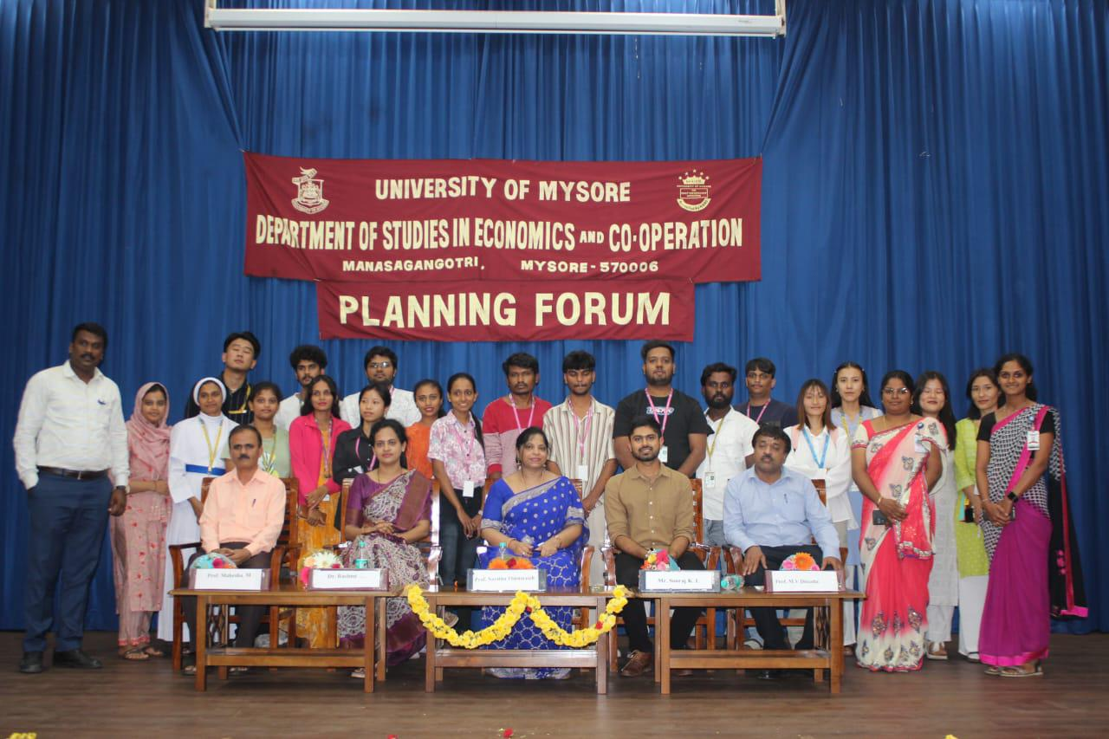
Dr. Rashmi began her talk by recounting her academic journey, detailing her experiences and challenges as a Master's student in Economics. She elaborated on her preparation strategy for the UPSC exam, sharing valuable tips and resources that helped her succeed. Dr. Rashmi discussed the obstacles she faced and how she overcame them through perseverance and dedication. She provided insights into her role and responsibilities as a member of the Indian Revenue Service, highlighting the impact and importance of her work. Dr. Rashmi concluded with motivational advice for students aspiring to pursue similar paths, emphasizing the importance of hard work, focus, and resilience.
Mr. Sooraj KL began by explaining the structure and requirements of the UPSC and CSE exams, demystifying the process for students. He shared effective preparation techniques, including time management, resource selection, and maintaining a disciplined study routine. Mr. Sooraj also highlighted alternative career opportunities available to students, encouraging them to explore diverse fields and industries. Emphasizing the importance of continuous skill development, he encouraged students to acquire skills that are valuable in various career paths. The talk ended with an interactive Q&A session where students had the opportunity to ask questions and seek personalized advice.

Outcomes
- Increased Motivation: Students felt inspired by the success stories of Dr. Rashmi and Mr. Sooraj, which boosted their motivation to excel in their academic and career pursuits.
- Enhanced Understanding: The session provided students with a clearer understanding of the UPSC and CSE exams, including preparation strategies and expectations.
- Career Awareness: Students gained awareness of various career opportunities beyond traditional academic paths, broadening their horizons and encouraging them to explore diverse options.
- Practical Insights: The practical advice and tips shared by the speakers equipped students with actionable steps they can take towards achieving their career goals.
- Interactive Engagement: The interactive nature of the session allowed students to engage with the speakers, seek guidance, and clarify their doubts.

Conclusion
The special talk by Dr. Rashmi and Mr. Sooraj KL was a resounding success, fulfilling its objectives of inspiring, guiding, and informing students at St. Philomena's College. The insights and experiences shared by the speakers have left a lasting impact on the students, motivating them to pursue their goals with renewed vigor and confidence. We look forward to organizing more such events that contribute to the holistic development of our students.



