
ST. PHILOMENA’S COLLEGE (Autonomous), MYSORE – 570 015

P G DEPARTMENTS OF ECONOMICS
REPORT
TOPIC: FREE ONLINE COACHING FOR PGCET 2022–23
Date: 17to 21/10/2022 Time: 3pm to 5pm

PREAMBLE: The PG Department of Economics has conducted a free online coaching class for the aspirants writing the PG-CET entrance exam for MA Economics admission for the academic year 2022-23.
OBJECTIVES
- To increase admission to our college's MA economics programme.
- To enhance the subject's interest among the students.
- To increase the students' knowledge to face the PG-CET

The PG department of economics organized free online coaching classes for 5 days, each session lasting 2 hours, with the goal of increasing student admission to our college's PG economics program and enhancing and increasing the subject's interest as well as knowledge. The first day's session was taken by Dr. Sarah Razack, Assistant Professor, Government First Grade College, Athani. She discussed the topic of "Quantitative Techniques for Economics." The second day's session was taken by Dr. Divya B.S. Assistant Professor, Maharani’s College for Women, Mysore. She shared information on the topic of "Indian Economy," and more than 30 students and PG CET students actively participated in the session. On the third day, sessions were taken by Dr. Chethan B., Assistant Professor, Government First Grade College, Saligrama. He spoke on the topic of "Development of Economics," and the session was good and the students enjoyed it. Dr. Kempe Gowda, G.N., Assistant Professor, Government First Grade College Talakadu, led the session on the fourth day. The resource person discussed "International Economics." He shared information on basic ideas and essential questions, as well as previously asked questions he had solved. On the last day, the fifth-day session was carried out by Dr. Satyanarayana, Assistant Professor, Government First Grade College, Konanur. He had discussed "Fundamentals of Economics," which included both the basics of micro and macroeconomics. The session was very informative, and students could gain more information on the basics of economics, and he had discussed previously asked questions as well.
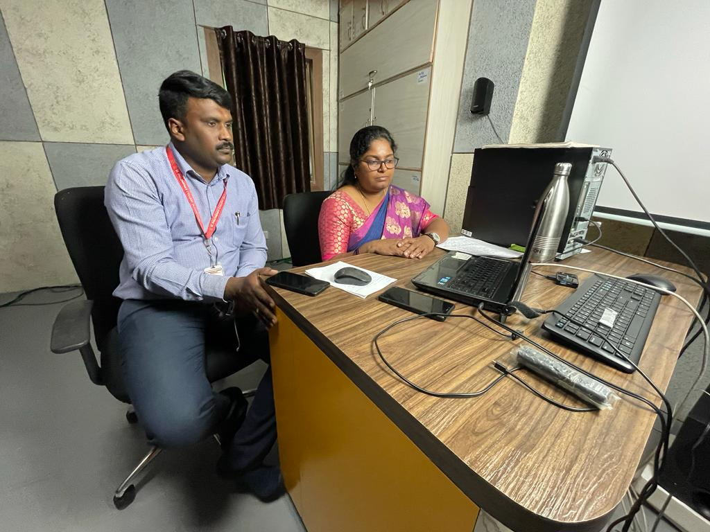
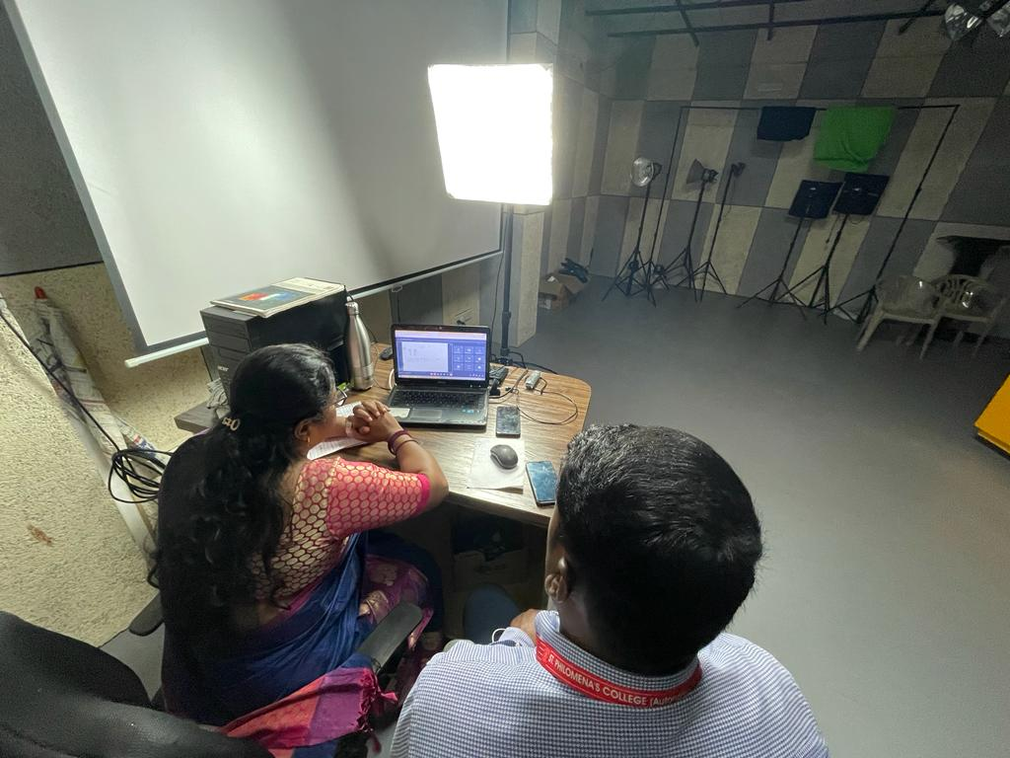
Overall Feedback from the Participants


