Introduction to Computers
Def:A computer can be defined as an electronic device capable of processing the data and producing the information.
Characteristics of the computer system

The characteristics of the computer system are as follows −
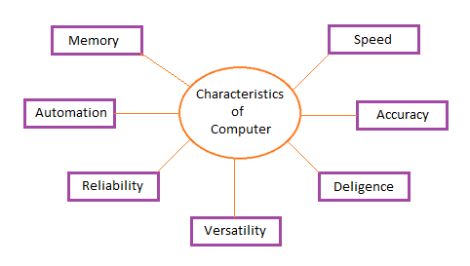

Speed
A computer works with much higher speed and accuracy compared to humans while performing mathematical calculations. Computers can process millions (1,000,000) of instructions per second. The time taken by computers for their operations is microseconds and nanoseconds.

Accuracy
Computers perform calculations with 100% accuracy. Errors may occur due to data inconsistency or inaccuracy.

Diligence
A computer can perform millions of tasks or calculations with the same consistency and accuracy. It doesn’t feel any fatigue or lack of concentration. Its memory also makes it superior to that of human beings.

Versatility
Versatility refers to the capability of a computer to perform different kinds of works with same accuracy and efficiency.

Reliability
A computer is reliable as it gives consistent result for similar set of data i.e., if we give same set of input any number of times, we will get the same result.
Automation
Computer performs all the tasks automatically i.e. it performs tasks without manual intervention.

Memory
A computer has built-in memory called primary memory where it stores data. Secondary storage are removable devices such as CDs, pen drives, etc., which are also used to store data.

The computer system essentially comprises three important parts –
1. input device,
2. central processing unit (CPU) and
3. output device.
The CPU itself is made of three components namely,
1. arithmetic logic unit (ALU),
2. memory unit, and
3. control unit.
Components of a computer system:
On broad basis, a computer performs the following tasks:
Input: Sending the data and command to the computer is known as input.
Processing: Work done by the computer with the help of processing hardware and software to produce results is known as processing.
Output: The result displayed by the computer is known as output. Storage: A place to save result inside or outside the computer is known as storage.

