
MYSORE DIOCESAN EDUCATIONAL SOCIETY
ST. PHILOMENA’S COLLEGE (Autonomous), MYSORE – 570 015
Affiliated with the University of Mysore
UGC. Re-accredited by NAAC

P G DEPARTMENTS OF ECONOMICS & COMMERCE
REPORT
Special Lecture
TOPIC: DATA ANALYTIC TECHNIQUES AND USAGE

Date: 09.02.2022 Time: 10.30 am Venue: PG Conference Hall
Resource Person
Dr. Sarah Razack, Assistant Professor, Post Graduate Department of Studies in Economics, Maharani’s Arts College for Women, Mysore
The PG Department of Economics in collaboration with the PG Department of Commerce, St. Philomena’s College (Autonomous), Mysore has organized a Special Lecture on 9th February 2022 as part of the Curriculum on the different aspects for the benefit of the students.

OBJECTIVES
- To understand the nature of different types of data sets.
- To select the appropriate test for the data.
- To present the data systematically.
- To estimate the data using excel.
- To create the appropriate chart and graph for the data.

Dr. Sarah Razack educated the students on Data Analytic Techniques and Usage. She focused on the need and importance of data usage in research in today’s world. She covered the research process, when we need to go for data collection and how to determine the sample size. Madam stressed the different types of data based on the Scale of measurement, Continuity of data, Time and Characteristics so on. She even focused on the need for primary data and its types of collection and the need for secondary data. She also covered the type of analysis required to estimate the data. The parametric and non-parametric approaches for the data estimation and when do we apply these tests. The session was were interactive and faculty and students actively participated and seek answers to their questions.
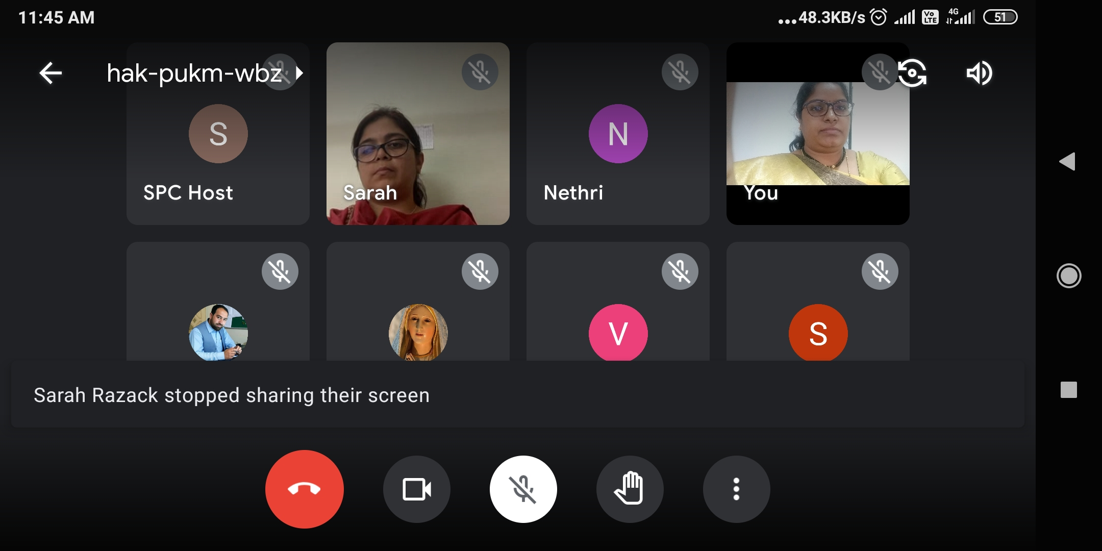 | 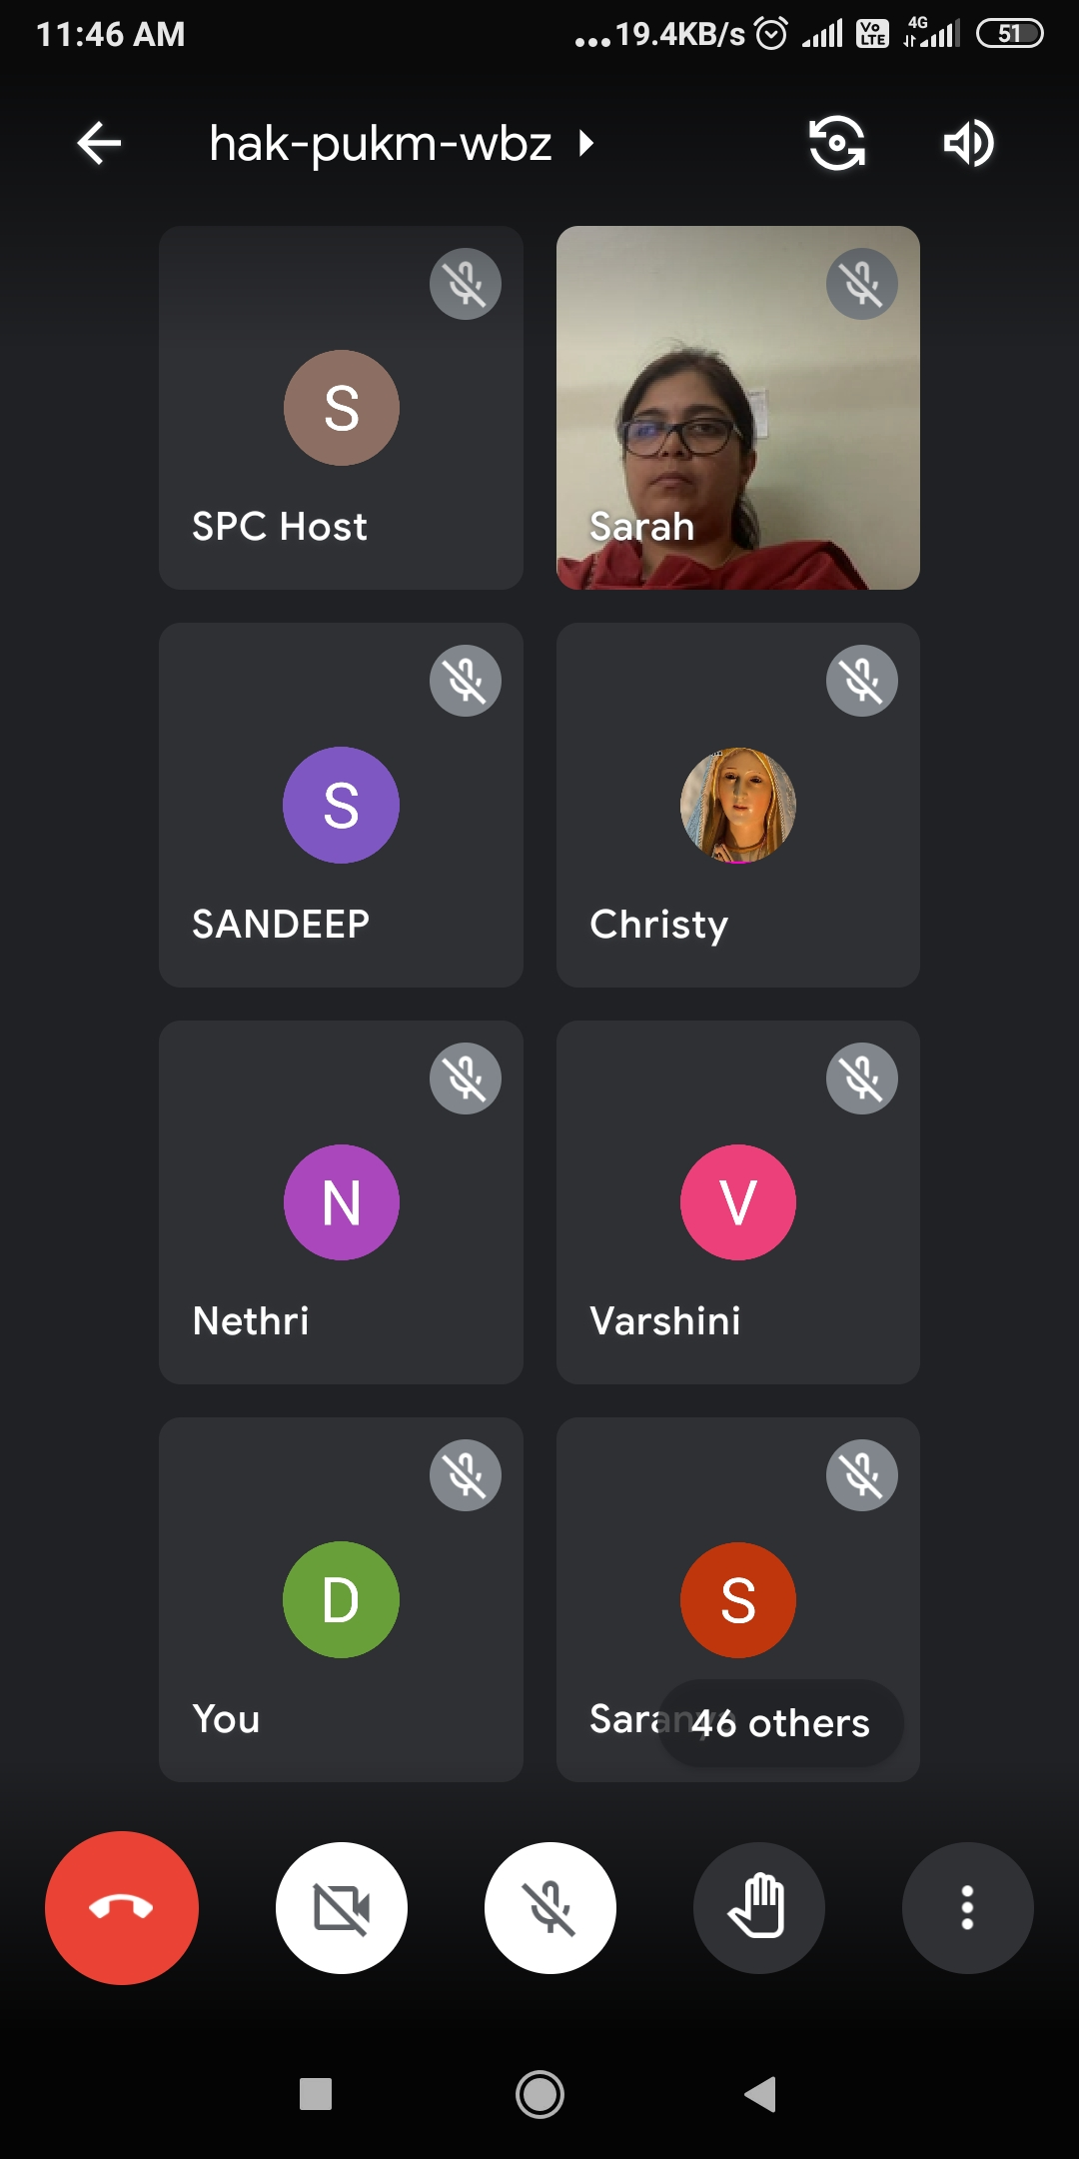

Students Performance Analysis- Topic- Data Analytic Techniques and Usage.
Students Score Before Session | Students Score After Session
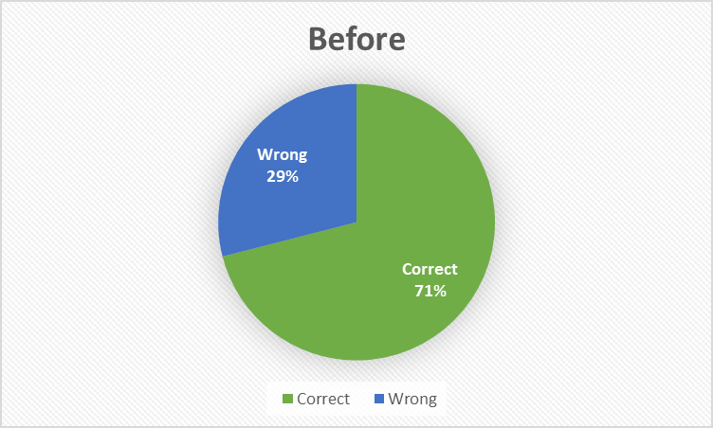 | 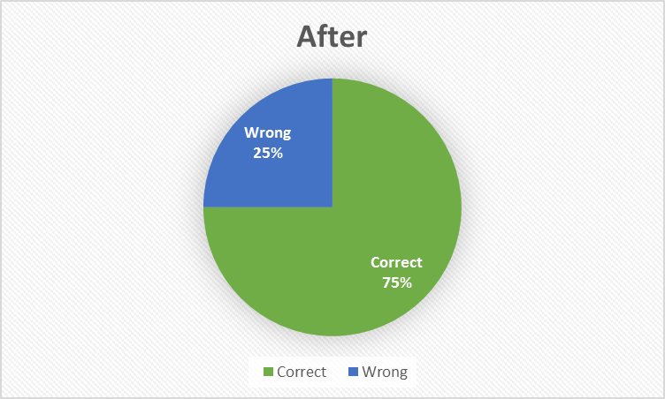

Overall Feedback from the Participants of the Special Lecture:



