
MYSORE DIOCESAN EDUCATIONAL SOCIETY
ST. PHILOMENA’S COLLEGE (Autonomous), MYSORE – 570 015
Affiliated with the University of Mysore
UGC. Re-accredited by NAAC

P G DEPARTMENTS OF ECONOMICS & COMMERCE
REPORT
Special Lecture
TOPIC: UNION BUDGET-2022-2023
Date: 10.02.2022 Time: 10.30 am Venue: PG Conference Hall
Resource Person
Dr.Divya B.S, Assistant Professor, PG Department of Economics, Government Autonomous College, Mandya
The PG Department of Economics in collaboration with the PG Department of Commerce, St. Philomena’s College (Autonomous), Mysore has organized a Special Lecture on 10th February 2022 as part of the Curriculum on the different aspects for the benefit of the students.

OBJECTIVES
- To understand the concept of budget and its need.
- To know the various functional areas of budgeting.
- To get an idea about budget proceedings of the country.
- To highlight and analyze the current Union Budget Financial Year 2022-2023,

Dr. Divya. B.S educated the students on the concept of budget and its types. She covered different aspects of the budget such as instruments of budgeting, deficit financing and its types, source of revenue receipts, and expenditure. She also stressed the capital receipts and their expenditure. She covered the highlights of the union budget 2022-23. Also thought the students the different perceptive of the different income categories of people regarding the budget. She covered the significance and process of budget preparation and presentation. The session was were interactive and faculty and students actively participated and seek answers to their questions.
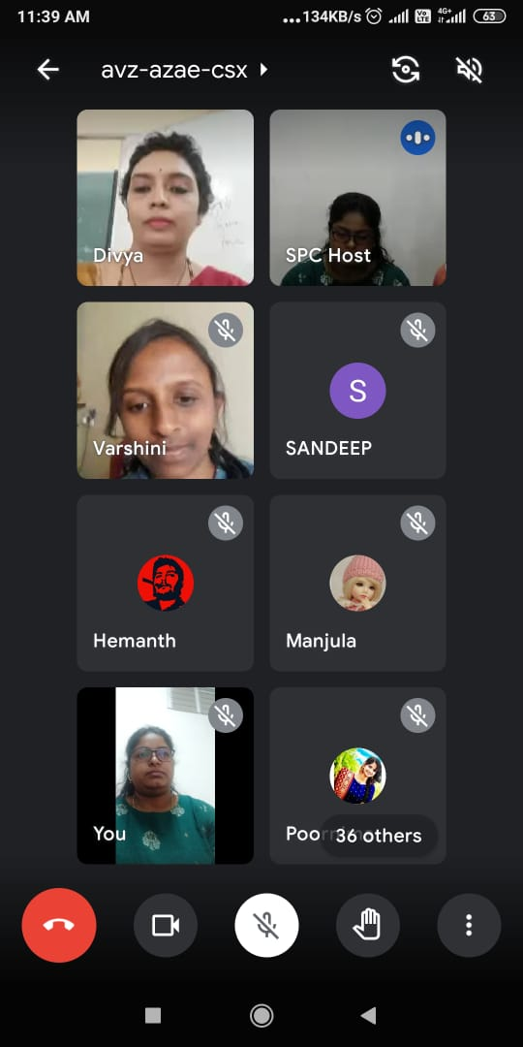 | 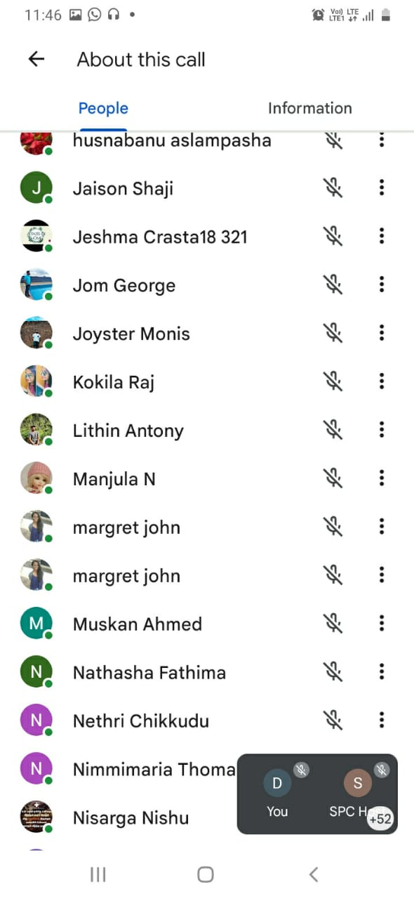

Students Performance Analysis- Topic- Data Analytic Techniques and Usage.
Students Score Before Session | Students Score After Session
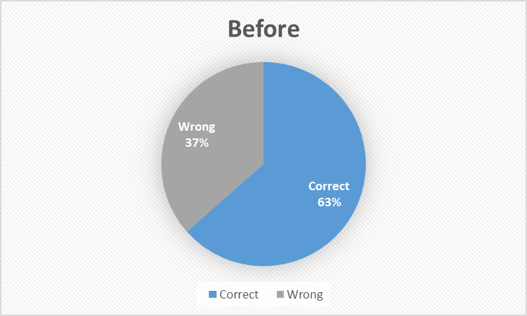 | 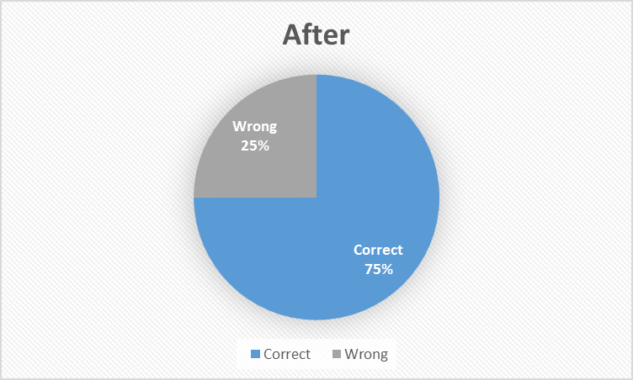

Overall Feedback from the Participants of the Special Lecture:



