
MYSORE DIOCESAN EDUCATIONAL SOCIETY
ST. PHILOMENA’S COLLEGE (Autonomous), MYSORE – 570 015
Affiliated with the University of Mysore
UGC. Re-accredited by NAAC

P G DEPARTMENTS OF ECONOMICS & COMMERCE
REPORT
Special Lecture
TOPIC: INTERNATIONAL TRADE AND FINANCE
Date: 11.02.2022 Time: 10.30 am Venue: PG Conference Hall
Resource Person
Dr.Kempe Gowda G.N, Assistant.Professor in Economics, Government First Grade College, Thalakadu.
The PG Department of Economics in collaboration with P G Department of Commerce, St. Philomena’s College (Autonomous), Mysore has organized a Special Lecture on 11th February 2022 as part of the Curriculum on the different aspects for the benefit of the students.

OBJECTIVES
- To know the need of the subject in the current scenario.
- To understand the basic concepts of international trade and business.
- To identify various terms to do international trade.
- To get in-depth knowledge about the EXIM policies.

Dr. Kempegowda educated the students on the Concepts and terms of International trade. He stressed various theories on trade, Terms of trade, and their types, need, and significance of trade. He also stressed Economic integration and its types, and the role of economic integration in global trade. He covered the aspects of the balance of payments and its types, cause, and consequences of BoP. He also highlighted the international trade organizations and their role in trade activity. He also focused on the international financial institution and their role in trade activity. The session was were interactive and faculty and students actively participated and seek answers to their questions.
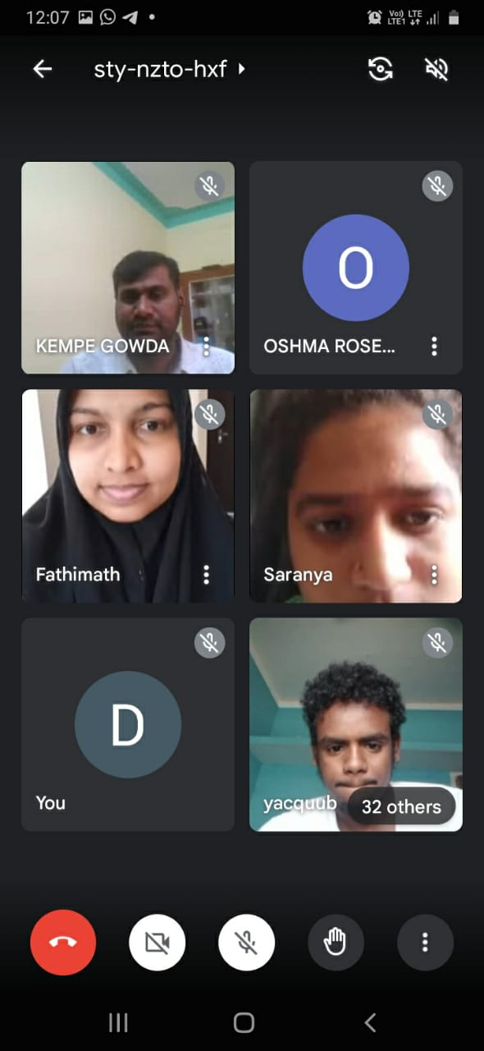 | 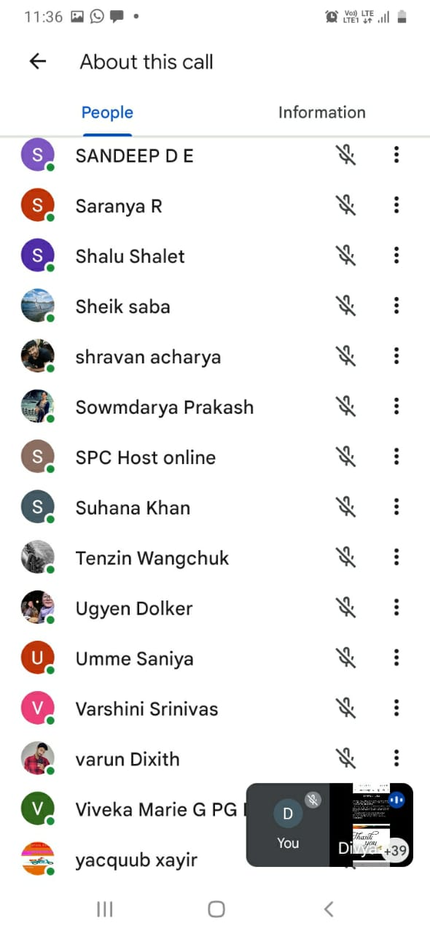

Students Performance Analysis- Topic- Data Analytic Techniques and Usage.
Students Score Before Session | Students Score After Session

Overall Feedback from the Participants of the Special Lecture :



