
MYSORE DIOCESAN EDUCATIONAL SOCIETY
ST. PHILOMENA’S COLLEGE (Autonomous), MYSORE – 570 015
Affiliated with the University of Mysore
UGC. Re-accredited by NAAC

P G DEPARTMENTS OF ECONOMICS & COMMERCE
REPORT
Special Lecture
TOPIC: GENDER SEGMENTATION OF EMPLOYMENT
Date: 12.02.2022 Time: 10.30 am Venue: PG Conference Hall
Resource Person
Dr.Roopa Patvardan, Assistant Professor, Department of Economics, CHRIST (Deemed to be University) Bangalore
The PG Department of Economics in collaboration with the PG Department of Commerce, St. Philomena’s College (Autonomous), Mysore has organized a Special Lecture on 12th February 2022 as part of the Curriculum on the different aspects for the benefit of the students.

OBJECTIVES
- To understand the concept of Gender Segmentation.
- To get knowledge about the indicators to understand gender segmentation.
- To know the need for gender study.
- To understand the different concepts of gender segmentation and employment.

Dr. Roopa Patvardan educated the students on the gender segmentation of employability. She focused on Concepts of Gender and gender segmentation. She also focused on gender discrimination, gender bias, and the need for gender study. Access to skill development opportunities is unequal across caste, gender, and different socio-geographical locations. No doubt, various policies and five-year plans in India emphasized upon expansion of skill development opportunities. However, the design and implementation of these programs do not match completely the needs of these groups and even the training provided to these clientele groups does not help them to avail relevant opportunities in the job market. She also stressed on the lack of gender focus in these schemes and programs has resulted in lower participation of women in the labor market and has impacted the wide gender gap in various social and economic indicators. The stereotyped mindset about education and employability of women and the further unwillingness of the parents to invest in women’s education has led to gender disparity in education and employment. It is often assumed that education; particularly in the area of skill development is a means of achieving gender equality or improving women’s well-being. The session was were interactive and faculty and students actively participated and seek answers to their questions.
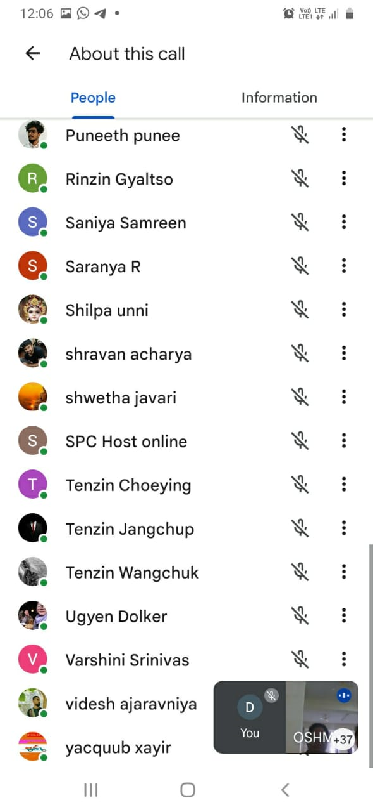 | 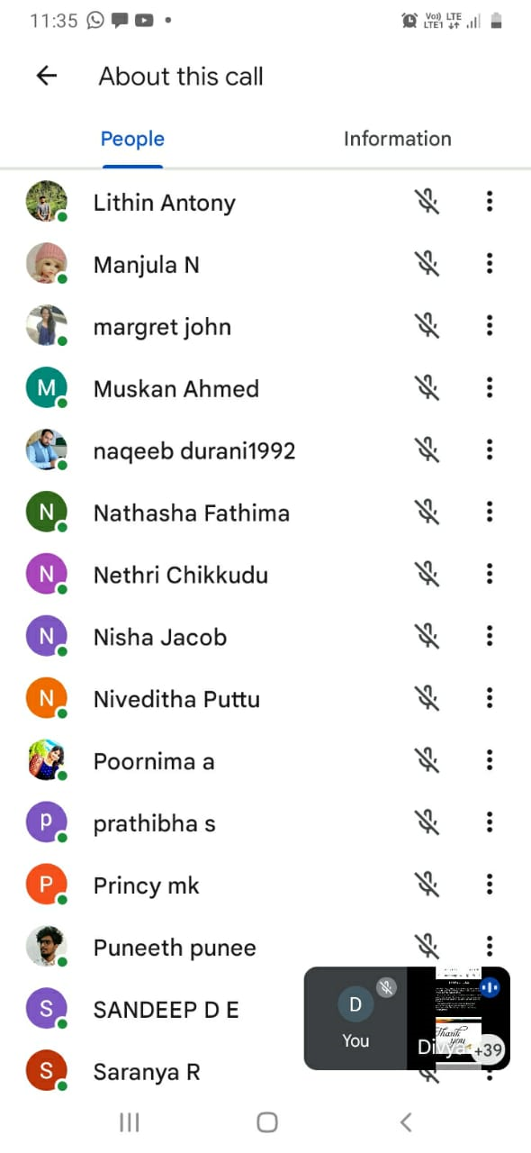

Students Performance Analysis- Topic- Data Analytic Techniques and Usage.
Students Score Before Session | Students Score After Session

Overall Feedback from the Participants of the Special Lecture:

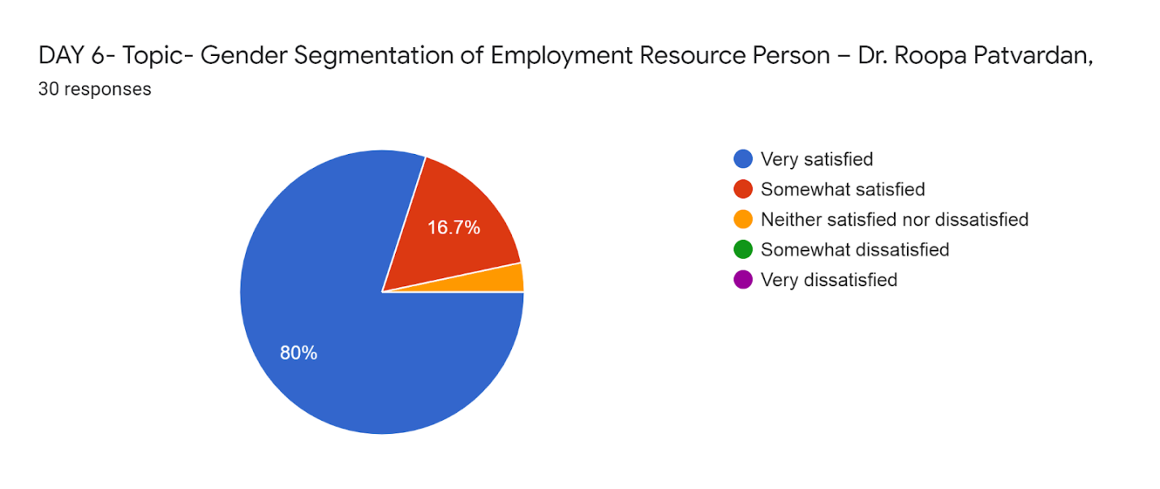

Over All Feedback from the Participants Topic Selection to the Lecture:
The overall feedback of the students regarding the topic students said the chosen for the lecture series is very much help full for their studies



