
ST. PHILOMENA’S COLLEGE (Autonomous), MYSORE – 570 015

P G DEPARTMENTS OF ECONOMICS & COMMERCE
REPORT
Special Lecture
TOPIC: INTRODUCTION TO ‘BASIC ECONOMETRICS’
Date: 07.02.2022 Time: 10.30 am Venue: PG Conference Hall
Resource Person
Prof. C.K. Renukarya, Director, Pooja Bhagavath Mahajana P G Centre, KRS Road, Mysore

PREAMBLE: The PG Department of Economics in collaboration with the PG Department of Commerce, has organized a Special Lecture on 7th February 2022 as part of the Curriculum on the different aspects for the benefit of the students.

OBJECTIVES
- To give in-depth knowledge in Economics and Commerce such as Introduction to Econometrics and its modeling.
- Identifying variables to the model.
- Understand the significance of error term in the model
- Model estimation and interpretation

Prof. C.K. Renukarya focused on the concept of Basic Econometrics and the need for econometrics in the field of Economics and Commerce. He taught the students to determine the econometric models to verify the existing theory or new theory. Identifying the variables for the model based on the study area. He also covered steps in Econometric Analysis. He highlighted the different types of data sets and their estimation. He stressed the significance of error inclusion in the econometric model. He also covered the econometrics application to analyze the various theories in economics as well as commerce. He concentrated on the significance of econometrics in the field of research. The students actively participated in this session and sought the answers to their questions.

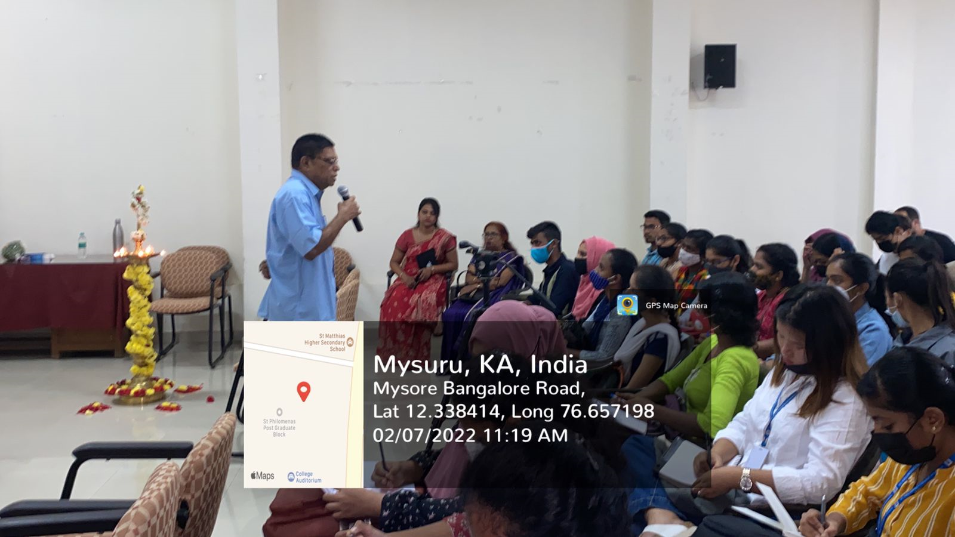 | 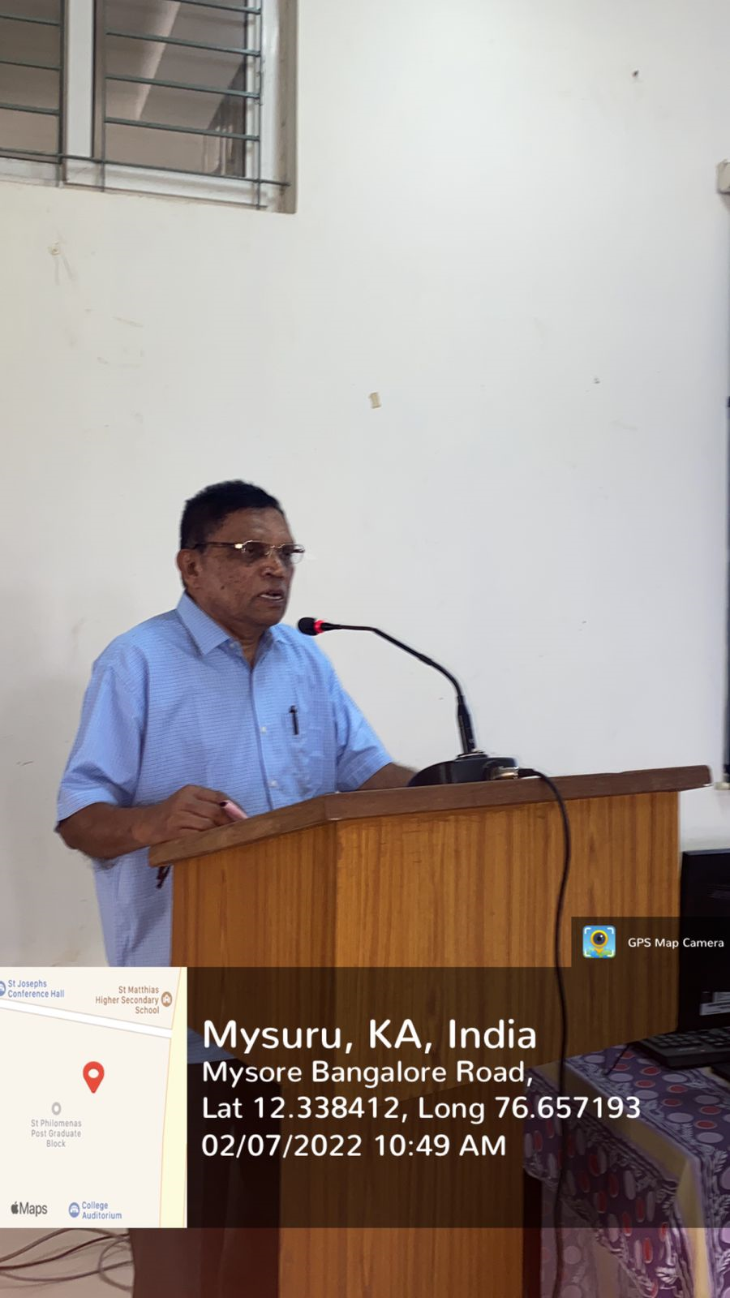

Students Performance Analysis- Topic- Introduction to Econometrics

Students Score Before Session | Students Score After Session

Overall Feedback from the Participants of the Special Lecture:



