Enzyme-Linked Immunosorbent Assay (ELISA):
- Enzyme-linked immunosorbent assay, commonly known as ELISA (or EIA), is similar in principle to RIA but depends on an enzyme rather than a radioactive label.
- An enzyme conjugated with an antibody reacts with a colourless substrate to generate a coloured reaction product. Such a substrate is called a chromogenic substrate.
- A number of enzymes have been employed for ELISA, including alkaline phosphatase, * horseradish peroxidase, and β-galactosidase.
- These assays approach the sensitivity of RIAs and have the advantage of being safer and less costly.
- Because the ELISA can be performed to evaluate either the presence of antigen or the presence of antibody in a sample, it is a useful tool both for determining serum antibody concentrations (such as with the HIV test or West Nile Virus) and also for detecting the presence of antigen.
- It has also found applications in the food industry in detecting potential food allergens such as milk, peanuts, walnuts, almonds, and eggs.

General Method and Instrumentation of ELISA: The steps of the general, “indirect,” ELISA for determining serum antibody includes:
1. A sample of known antigen is applied to a surface, often the well of a microtiter plate. The antigen is fixed to the surface to render it immobile. Simple adsorption of the protein to the plastic surface is usually sufficient. These samples of known antigen concentrations will constitute a standard curve used to calculate antigen concentrations of unknown samples. Note that the antigen itself may be an antibody.
2. The plate wells or other surfaces are then coated with serum samples of unknown antigen concentration, diluted into the same buffer used for the antigen standards. Since antigen immobilization in this step is due to non-specific adsorption, it is important for the total protein concentration to be similar to that of the antigen standards.
3. A concentrated solution of non-interacting protein, such as Bovine Serum Albumin (BSA) or casein, is added to all plate wells. This step is known as blocking, because the serum proteins block non-specific adsorption of other proteins to the plate.
4. The plate is washed, and a detection antibody specific to the antigen of interest is applied to all plate wells. This antibody will only bind to immobilized antigen on the well surface, not to other serum proteins or the blocking proteins.
5. The plate is washed to remove any unbound detection antibody. After this wash, only the antibody-antigen complexes remain attached to the well.
6. Secondary antibodies, which will bind to any remaining detection antibodies, are added to the wells. These secondary antibodies are conjugated to the substrate-specific enzyme. This step may be skipped if the detection antibody is conjugated to an enzyme.
7. Wash the plate, so that excess unbound enzyme-antibody conjugates are removed.
8. Apply a substrate which is converted by the enzyme to elicit a chromogenic or fluorogenic or electrochemical signal.
9. View/quantify the result using a spectrophotometer, spectrofluorometer, or other optical/electrochemical device.
The enzyme acts as an amplifier; even if only a few enzyme-linked antibodies remain bound, the enzyme molecules will produce many signal molecules. A major disadvantage of the indirect ELISA is that the method of antigen immobilization is non-specific; any proteins in the sample will stick to the microtiter plate well, so small concentrations of analyte in serum must compete with other serum proteins when binding to the well surface. The sandwich ELISA provides a solution to this problem.
ELISA may be run in a qualitative or quantitative format. Qualitative results provide a simple positive or negative result for a sample. The cut-off between positive and negative is determined by the analyst and may be statistical. Two or three times the standard deviation is often used to distinguish positive and negative samples. In quantitative ELISA, the optical density or fluorescent units of the sample is interpolated into a standard curve, which is typically a serial dilution of the target.
Types of ELISA: Number of variations of ELISA have been developed, allowing qualitative detection or quantitative measurement of either antigen or antibody. Each type of ELISA can be used qualitatively to detect the presence of antibody or antigen. Alternatively, a standard curve based on known concentrations of antibody or antigen is prepared, from which the unknown concentration of a sample can be determined.
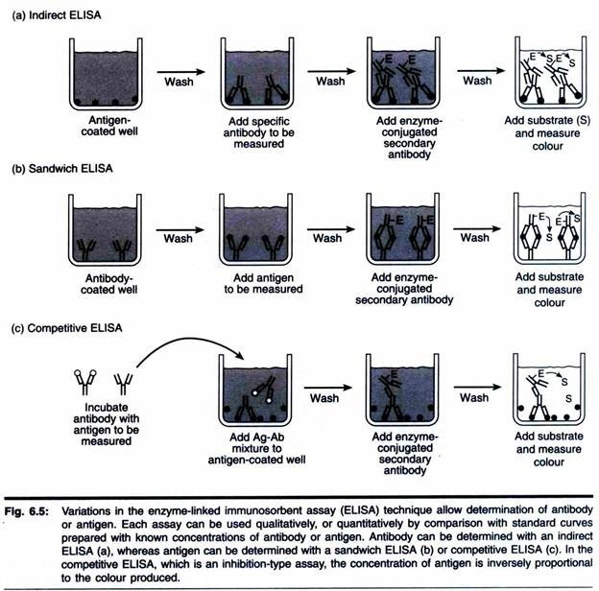
Indirect ELISA:
- Antibody can be detected or quantitatively determined with an indirect ELISA.
- Serum or some other sample containing primary antibody (Ab₁) is added to an antigen-coated microtiter well and allowed to react with the antigen attached to the well.
- After any free Ab₁ is washed away, the presence of antibody bound to the antigen is detected by adding an enzyme-conjugated secondary anti-isotype antibody (Ab₂), which binds to the primary antibody.
- Any free Ab₂ then is washed away, and a substrate for the enzyme is added.
- The amount of coloured reaction product that forms is measured by specialized spectrophotometric plate readers, which can measure the absorbance of all of the wells of a 96-well plate in seconds.
- Indirect ELISA is the method of choice to detect the presence of serum antibodies against human immunodeficiency virus (HIV), the causative agent of AIDS.
- In this assay, recombinant envelope and core proteins of HIV are adsorbed as solid-phase antigens to microtiter wells.
- Individuals infected with HIV will produce serum antibodies to epitopes on these viral proteins. Generally, serum antibodies to HIV can be detected by indirect ELISA within 6 weeks of infection.
Sandwich ELISA:
- Antigen can be detected or measured by a sandwich ELISA. In this technique, the antibody (rather than the antigen) is immobilized on a microtiter well.
- A sample containing antigen is added and allowed to react with the immobilized antibody.
- After the well is washed, a second enzyme-linked antibody specific for a different epitope on the substrate is added, and the coloured reaction product is measured.
Competitive ELISA:
- Another variation for measuring amounts of antigen is competitive ELISA.
- In this technique, antibody is first incubated in solution with a sample containing antigen. The antigen-antibody mixture is then added to an antigen-coated microtiter well.
- The more antigens present in the sample, the less free antibody will be available to bind to the antigen-coated well.
- Addition of an enzyme-conjugated secondary antibody (Ab₂) specific for the isotype of the primary antibody can be used to determine the amount of primary antibody bound to the well as in an indirect ELISA.
- In the competitive assay, however, the higher the concentration of antigen in the original sample, the lower the absorbance.
*************

