ENZYMES IN DIAGNOSIS
Introduction: changes in concentration various biomolecules is indication of abnormal metabolic activities, infectious and noninfectious diseases and inflammatory conditions steroid hormones and some proteins released from the damaged tissues. Diagnostic tests are also developed for detection of serum lipoproteins, viruses and other microorganisms.
Enzymes used for diagnosis:
Enzymes used in diagnosis may be of plant, animal or microbial origin. Stability, good self life are additional characteristics which are looked for while developing enzymes as diagnostic tools.
Enzymes used for diagnostic purpose may not be as pure as those protein preparations which are used for parenteral administration, but there should be no interfering substances which may come in the way of detection or quantization of specific metabolites.
Enzymes used in the detection and quantization of specific metabolites normally use specific metabolite in question as a substrate. After the reaction is over, either co- reactants or co factors or products are monitored for their concentration to diagnose the metabolite.
Two most commonly used enzyme types in diagnostic systems are – dehydrogenases and oxidases.
Substrate + NAD ^{Dehydrogenase} product +NADH + H⁺
Formation or disappearance of NADH may be readily monitored spectrophotometrically (NADH absorbs light at 640 nm where as NAD does not.) progression of the reaction may also be followed by fluorescence or luminescence.
Oxidasese yield hydrogen peroxide as reaction product. Second enzyme is generally required in detection of product.
Assay of blood glucose: the conce4ntration of glucose present in blood is an important diagnostic marker for several disease states, especially diabetes mellitus. Blood glucose assay determination is one of the most common assays carried out in clinical laboratories. Although different methods have been available for blood glucose determination, enzymatic assay is most sensitive, reliable, and accurate and is routinely used. Reactions involved are as follows-
Assay system I:
Glucose + O₂+H₂O ^{Glucose Oxidase} Gluconic acid + H₂O₂

2H₂O₂ +4 aminophenazone +phenol ^{Peroxidase} Quinonimine +4H₂O
Quinoneimine is a red violet dye whose concentration can be determined by measuring its absorbance at 500nm.
Assay system II:
Glucose + ATP ^{Hexokinase} Glucose-6-phosphate + ADP

Glucose-6-phosphate + NAD⁺ ^{G-6-P Dehydrogenase} Gluconate-6-phosphate + NADH +H⁺
The concentration of glucose present in the sample is directly propotional to the quantity of NADH formed, which may be measured by absorbance at 340nm.
Assay of blood cholesterol and triglycerides:
An association between atherosclerosis and elevated plasma cholesterol has been established. Also elevated levels of serum triglycerides have been linked to atherosclerosis and coronary artery disease. Various enzymatic methods have been developed for assay of cholesterol and triglycerides in blood.
Reactions involved:
Cholesterol ester +H₂O ^{Cholesterol esterase} cholesterol + fatty acids

Cholesterol + O₂ ^{Cholesterol oxidase} 4-cholestenone +H₂O₂

2H₂O₂ + phenol + 4-aminoantipyrine ^{Peroxidase} Quinoneimine +4 H₂O
Quinoneimine is a red violet dye whose concentration can be determined by measuring its absorbance at 500nm.
Reactions involved:
Triglycerides +H₂O ^{Lipases} Glycerol + fatty acids

Glycerol + ATP ^{Glycerol kinase} Glycerol -3- phosphate + ADP

Glycerol -3- phosphate + O₂ ^{Glycerol-3-P Oxidase} Dihydrooxiacetone phosphate +H₂O₂
H₂O₂ + 4-aminoantipyrine + chlorophenol ^{Peroxidase} Quinoneimine +HCL + 2H₂O
Assay of blood Urea and Uric acid: elevated levels of urea and uric acid in blood are indicative of a variety of metabolic disorders including diseases of kidney.
Reactions involved –
- Urea + H₂O ^{Urease} Ammonia +CO₂
Ammonia formed may be measured by variety of methods. One such method involves reaction of ammonium ions with phenol and hypochlorite in the presence of nitopruside, forming a blue colored complex which absorbs light strongly at 640 nm.
- Urea + H₂O ^{Urease} 2NH₄⁺+CO₂

2α Ketogluterate + 2NADH + NH₄^{+ Glutamate Dehydrogenase} 2Glutamate +2NAD⁺ + 2H₂O
NAD⁺ formed is monitored.
Uric acid assay:
Reaction involved:
Uric acid + O ₂ +2H₂O ^{Uricase} Allantoin + CO₂ +H₂O₂
2H₂O₂ + 4 Aminophenazonee + 3, 5 – dichloro -2 hydroxybenzene sufonic acid ^{Peroxidase} Quinoneimine+ 4 H₂O₂
Quinoneimine is a red – violet dye whose concentration can be determined by measuring its absorbance at 500 nm.
CREATININE ANALYSIS: Worldwide number of tests performed for creatinine analysis is estimated to be 1 billion. Currently chemical test called the Jaffe is used on large scale this method is based on reaction of creatinine with alkaline picrate or its modification. This reaction is not enough specific and non creatinine substances in blood may also give it positive. However, now after a long research work by Boehringer Mannheim Company and later work by others enzymatic methods are slowly being accepted. There is still scope for cost reduction, accuracy and specificity improvement.
Neonatal screening: tests for genetic disorders are performed on new born babies . These include tests for galactose (galactosemia), and phenylalanine (phenylketonuria). Semi quantitative tests are performed for phenylalanine, which are slow. Also flourimetric assays are not favored.
An enzymatic method developed for phenylalanine analysis(enzyme kits).in this NAD requiring enzyme, NADH produced is reacted with iodonitrotoluene(INT)to produce a colored (red) product , the concentration of which is directly proportional to the amount of phenylalanine originally present in the sample .
GASTRIC DISORDER DIAGNOSIS: Gastric disorders which are caused due to malabsorption can cause vomiting, diarrhea and or weight loss as initial symptoms. The mannitol and cellobiose concentration in urine has to be determined for diagnosis of the problem. Three enzymes mannitol dehydrogenase ,cellobiase and lactase-beta-galactosidase are now commercially available for diagnostic test at reasonable price.
IMMOBILIZED ENZYMES AS DIAGNOSTIC TOOLS;
- Enzymes may be used for the purpose of diagnosis in the immobilized form.
- Reagent strips and enzyme electrodes are the two systems available in this category.
- Reagent strips are convenient and are used by clinical laboratories and even patients.
- Very often these are designed so that product of enzyme reaction is a chromogen and is easily detectable by visual examination.
- Intensity of colour produced when reagent strip is immersed in sample is directly proportional to concentration of metabolite in sample.
- Reagent strips used to detect glucose usually contains immobilized glucose oxidase and peroxidase.
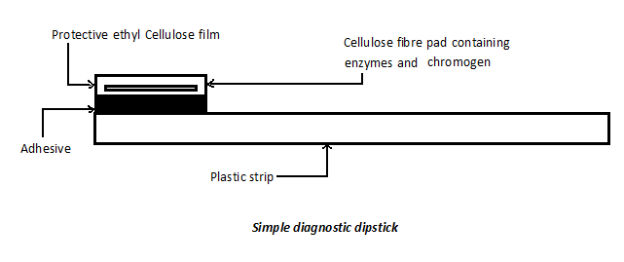
- Enzymes may be immobilized and used in the form of enzymes electrode.
- Here enzymes are immobilized by trapping them between two membrane layers , the inner permitting the products of enzyme reaction to reach up to electrode and outer preventing unwanted proteins and other metabolites from reaching up to enzymes but allowing free passage of metabolite to be quantitated.
- When enzyme electrode is immersed in test sample, substrate(substances to be detected) diffuses up to enzymes catalytic reaction occurs.
- Product of reaction reach up to the electrod, generate a signal which is proportional to the concentration of substate in sampl.
- The exact value of the concentration can be determined by reference to the standard curve.

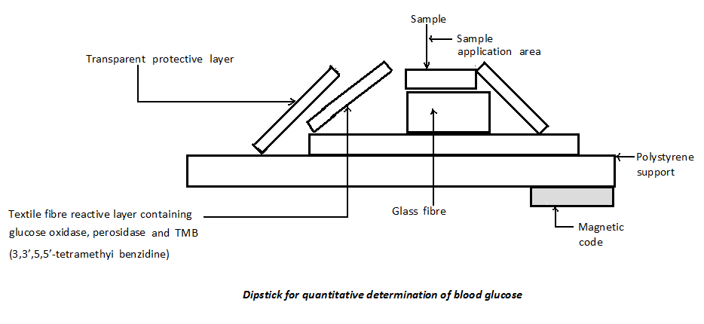

- Electrode used for the construction of enzyme electrodes specifically detects gases such as oxygen, carbondioxide and Ammonia and various ionic species.
- The electrodes chosen upon the type of product which is going to be produced by a particular enzyme used.

DIAGONOSTIC PROTEINS:
- Proteins which have diagnostic value can be produced by recombinant DNA technology.
- Such recombinant proteins are useful for diagnosis of many viral diseases.
- The entire field of serological diagnosis is moving towards the use of recombinant-derived proteins as detecting antigens.
- Here recombinant derived antigens are free of other disease-related antigens and hence will exhibit an absolute specificity and sensitivity which a purified preparation of can offer.
- Development in expression systems and capacity to bring about post-translational modifications such as glycosylation similar to that found in natural proteins will optimize the specificity of detection even further.
- Such recombinant proteins are meant for diagnosis.
- Use of such recombinant diagnostic proteins should be advantageous to clinical evaluation of vaccines and for planning and evaluation of therapies for infectious diseases.
AIDS
- Antibodies to HIV infections are detected by enzyme linked immunosorbent assay (ELISA) and immunoblot.
- Antibodies to two envelop (env) glycoproteins gp120 and gp 41. The three gag or core proteins p24, p17 and p15, the polymerase gene products and the tat, sor art gene products can be detected.
- Env and gag are paid most attention in this respect.
- Clinical progression of the disease is associated with the loss of antibodies to p24 while antibodies to env determinants do not change the titre during such progression.
- This can be useful to direct the therapy and to monitor the success of Therapy.
- The recombinant derived proteins as aids Diagnosis reagents will have several advantages over infected cells , these are;
- ElLSA is much more rapid and automobile assay and recombinant proteins can be used in tem while immunoblot requires a mixture of natural proteins only as a specific substrate.
- Use of recombinant derived proteins ensures specific, since only a single HIV-derived protein will be present in any preparation.
- Use of recombinant-derived proteins avoids risk to scientists who otherwise have to grow and handle HIV-infected as a source of proteins.
- A scientist in Bangalore has developed an indigenous kit to detect the AIDS-causing virus.
- The kit is based on the synthetic polypeptide antigens which specifically recognize antibodies to two strains of the virus HIV-1 and HIV-2.
- It has high sensitivity anf specificity and has been approved for production by the drug controlled of India.
- The kit was developed by collaboration between Indian Institute of Science (IISc) and National Institute of Mental Health and Neurosciences.
- The kit will be marketed by Cadilla Healthcare (Ahmedabad).
- The cost of this ELISA kit is around Rs 40 only and is far cheaper than imported ones which are in use.

