EPISTASIS
Due to the phenomenon of dominance a recessive allele remains obscure in the hybrid. But when two different genes which are not alleles, both affect the same character in such a way that the expression of one masks, inhibits or suppresses the expression of the other gene, it is called epistasis. The gene that suppresses is said to be epistatic, and the gene which remains obscure is hypostatic.

Types of Epistasis:
- Dominant recessive Epistasis(13:3):
- Sometimes the dominant alleles of one gene locus (A) in homozygous and heterogygous (AA, Aa) condition and homozygous recessive alleles bb of another gene locus (B) produce the same phenotype.
- The F₂ ratio will become 13: 3.
- The genotype AABB, AaBB, AAbb, Aabb and aabb produce one type of phenotype and genotype aaBb, aaBB will produce another type of phenotype.

In poultry white birds belong to two different varieties namely white leghorns or white Wyandotte’s. Experiments reveal that the gene for white plumage of white leghorns is dominant over the gene for coloured plumage of coloured varieties. But the gene for white plumage of white Wyandotte’s is recessive to the gene for coloured plumage of coloured varieties.
Therefore the gene which produces white plumage in white leghorns is different from the gene for white plumage in white Wyandotte’s. A cross between a white leghorn and a white Wyandotte gives an F₁ of white birds with small dark flecks. When such birds are inbred, the F₂ progeny segregates in the ratio of 13 white to 3 coloured birds.
The experiment is explained below by postulating two genes C and I for the white leghorns:
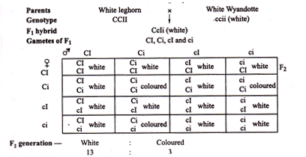
A checkerboard for the 16 phenotypes and genotypes of the F₂ birds indicates that only three out of sixteen genotypes, that isiiCC, iiCc, iiCc produce coloured birds. The white leghorns obviously contain a gene I, which in the dominant state inhibits or suppresses the expression of the dominant colour gene C, resulting in white plumage.
The recessive alleles of the inhibitor gene (ii) produce coloured birds due to expression of gene C. In other words gene I isepistatic to gene C. This is a case of dominant epistasis because even one dominant allele of gene I is able to express itself.

ii. Recessive Epistasis(9:3:4):
- Recessive alleles at one locus (aa) mask the phenotypic expression of other gene locus (BB, Bb or bb) such epistasis is called recessive epistasis.
- The alleles of ‘B’ locus express themselves only when epistatic locus ‘A’ has dominant allele like AA or Aa. The phenotypic ratio is 9: 3: 4.

Epistasis due to recessive genes is called recessive epistasis. In mice albinism (white coat) is produced by a recessive gene aa. There is a different gene B which in the dominant state (BB and Bb) produces grey coat colour called agouti, and when recessive (bb) leads to black coat colour.
The recessive gene for albinism (aa) is found to be epistatic to the gene for agouti (BB and Bb), and also to its recessive, homozygous allele (bb) for black. The presence of the dominant allele (AA) of the epistatic gene allows expression of gene B so that agouti (BB and Bb) and black (bb) coat colours can be produced (Fig.).
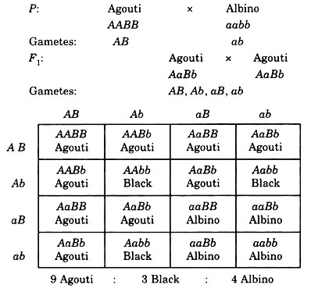
The 9: 3: 4 ratio obtained is a modification of the classical 9: 3: 3 : 1 in which the last two classes (3: 1) are phenotypically identical and are therefore added up together. In human beings also the recessive gene for albinism shows epistasis in a similar manner. Epistatic effect is usually only in one direction, from one particular gene pair to another.
Dominant epistasis: When dominant allele ‘A’ masks the expression of ‘B’ ‘A’ is epistatic gene of ‘B’. A can express itself only in the presence of ‘B’ or b allele. Therefore it is called dominant epistasis. B expresses only when ‘aa’ is present. , in 9: 3: 3: 1 ratio both 9 and 3 are expressing the ‘A’ gene the ratio is now 12: 3: 1.
Example:Complete dominance at both gene pairs, but one gene, when dominant, epistatic to the other.
Fruit colour in summer squash:
- Gene pair A: White dominant to colour 12/16 white
- Gene pair ‘B’ – Yellow dominant to green 3/16 yellow
- Green – 1/16 both recessive aabb
- Dominant white hides the effect of yellow or green.
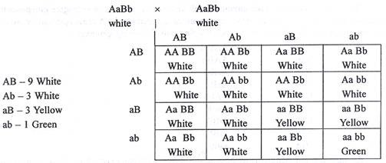
Naziya Habeeb M
Department of Biotechnology

*********************

