Immunization
Immunization, process by which resistance to disease is acquired or induced in plants and animals. Immunization may occur naturally, as when a person is exposed unintentionally to a pathogen (any infectious agent), or it may be brought about artificially through a vaccine. In either case, immunization provides resistance, or immunity, to a particular pathogen by means of antibody proteins that are targeted to eliminate that pathogen from the body. These antibodies do not react to the entire pathogen but only to a specific part of it, which is called an antigen. An individual can acquire immunity for a specific pathogen passively or actively. In passive immunization a person receives antibodies or lymphocytes that have been produced by another individual’s immune system; in active immunization the individual’s own immune system is stimulated to produce antibodies and lymphocytes.
Passive immunization: imparts immediate, but not long-lasting, protection against a pathogen and may arise naturally, such as when a fetus receives antibodies from the mother across the placenta or when a breast-feeding infant ingests antibodies in the mother’s milk. Passive immunization against a particular pathogen, such as the hepatitis B virus (HBV), also can be conferred artificially. A person lacking immunity to HBV can receive a preparation called immune serum globulin that contains antibodies formed against the virus. These antibodies are obtained from serum taken from animal or human donors who previously were infected by or immunized against the virus.
Active immunization : stimulates the immune system to produce antibodies against a particular infectious agent. Active immunity can arise naturally, as when someone is exposed to a pathogen. For example, an individual who recovers from a first case of the measles is immune to further infection by the measles-causing virus, because the virus stimulates the immune system to produce antibodies that specifically recognize and neutralize the pathogen the next time it is encountered. Active immunization also can be artificially induced through vaccination. Vaccines are preparations containing antigens that stimulate an immune response without causing illness. The purpose of vaccination is to ensure that a large enough number of antibodies and lymphocytes capable of reacting against a specific pathogen or toxin are available before exposure to it occurs. Active immunization is often long-lasting and may be reactivated quickly by a recurrence of the infection or by revaccination.

***********

Immune Responses:
The immune response involves primary immune response and secondary immune response.
(a) The primary immune response:
After an initial contact with an antigen, no antibodies are present for a period of several days. Then, a slow rise in the antibody titer o (arbitrary units) occurs, first IgM and then IgG followed by a gradual decline in antibody titer. This is called the primary immune response.
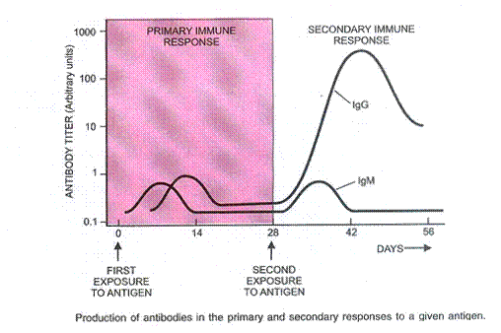
(b) The secondary immune response:
Memory cells may remain in the body for decades. Every new encounter with the same antigen results in a rapid proliferation of memory cells. This is also called “booster response”. The antibody titer after subsequent encounters is far greater than during a primary response and consists mainly of IgG antibodies. This accelerated, more intense response is called the secondary immune response. Antibodies produced during a secondary response have an even higher affinity for the antigen.
A person who had been suffering from diseases like measles, small pox or chicken pox becomes immune to subsequent attacks of these diseases. It includes spleen, lymph nodes, tonsils, Peyer’s patches of small intestine and appendix.The increased power and duration of the secondary immune response explain why immunization (method of providing immunity artificially, it is called vaccination) is usually accomplished by injecting antigen in multiple doses.
*************

