The Department of Zoology, as part of the extension activities, donated books and other study materials to the Government Higher Primary School, Hebbalu Extension, K.R. Nagar Taluk, Mysuru on 18/12/2020. The objective of the activity was to help underprivileged rural children in their studies and to foster their reading habit.
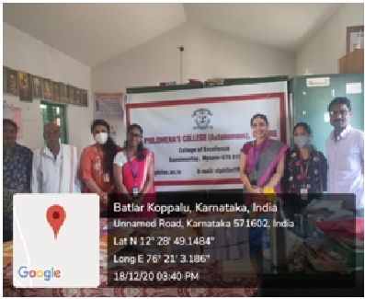

Considering the COVID-19 pandemic situation, the participants were restricted to two faculty of Zoology department and two student volunteers.70 notebooks, 70 sets of pencils, erasers, scales and pencil-sharpenerswere distributed to the students of the school. 25 supplementary reading materials, mostly books on great personalities like Mahatma Gandhi, Pandit Jawaharlal Nehru, Swami Vivekananda, Dr. A. P. J. Abdul Kalam, Bhagat Singh, Mother Teresaetc.,moral stories like Panchatantra stories, books on basic concepts of Science, Social Studies, English and Kannada grammar, Mathematics etc. and Kannada- English dictionary were donated to the school library to enrich their collection of books. The books were selected according to the requirements of students studying in classes I to VIIas specified by the school authorities.
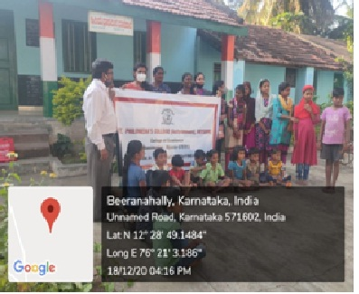
Mrs. Sangeetha M. D, Assistant Professor, Department of Zoology addressed the officials and the students. She briefed the commitment of the college towards social welfare and on the importance of reading habit in the young generation. The school officials, Mr. Devaraju, Mr. Rajayya and Mr Mohan Kumar coordinated the event. This was made possible through the “DONATE A BOOK CAMPAIGN” launched by the department which was supported by the staff and the students of the college.


