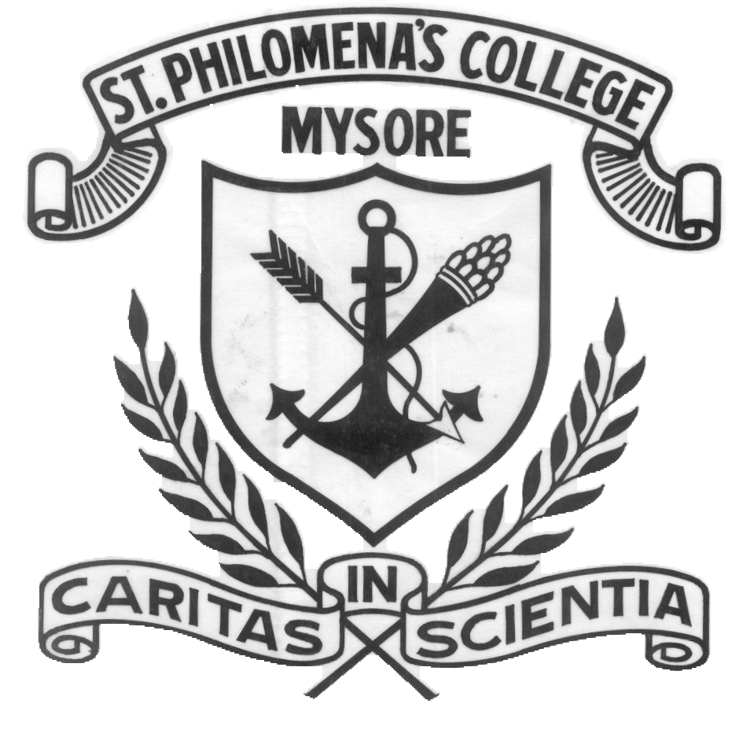

MYSORE DIOCESAN EDUCATIONAL SOCIETY
ST. PHILOMENA’S COLLEGE (AUTONOMOUS), MYSORE

Affiliated to University of Mysore
Report
Title: Guest Lecture on “Research Grant Writing and Funding Opportunities”
Preamble- The PG Department of Biochemistry,St.Philomena’s College(Autonomous), Mysore had organized a guest lecture by , Dr. Prashanth Vishwanath, Dean (Research) JSS Academy of Higher Education & Research Professor, Department of Biochemistry JSS Medical College, JSSAHER, Mysore.
Venue: PG conference Hall on 16th May, 2024 between 10.00 am to 12.00 pm.
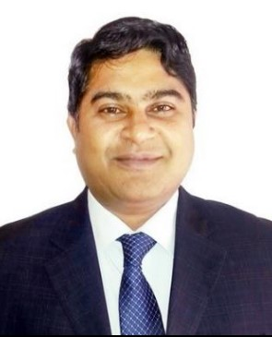
About the resource person : Dr. Prashanth Vishwanath, Dean (Research) JSS Academy of Higher Education & Research Professor, Department of Biochemistry JSS Medical College, JSSAHER, Mysore.

OBJECTIVES OF THE INVITED LECTURE:
- Equip students with the necessary skills and knowledge to write compelling and successful grant proposals.
- To Provide students with a comprehensive understanding of the various funding opportunities available to them.

Introduction:
Grant writing and securing funding are crucial skills for students pursuing research and academic projects. This lecture will demystify the grant writing process, offering practical tips to craft compelling proposals. Additionally, it will highlight various funding opportunities, helping you identify sources that align with your research interests. By mastering these skills, you can enhance your academic journey and achieve your research goals.
Program began with the Welcome note addressing the Guest, Coordinator, HOD of the department and the audience, followed by introduction of the speaker.
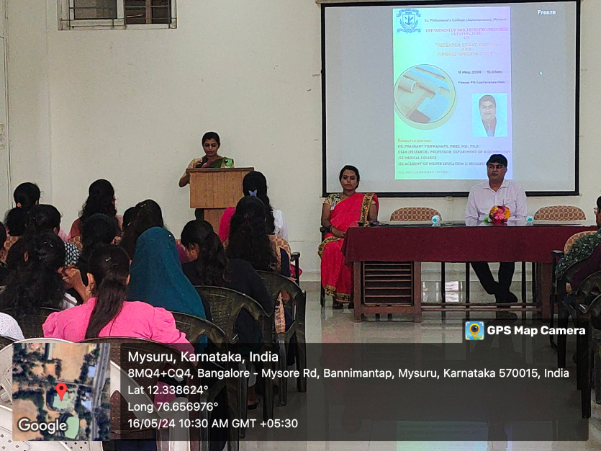
Later Dr. Vishwanath began the seminar by emphasizing the importance of research grants in advancing academic and scientific pursuits. He discussed the various types of grants available, including:
Government Grants: Offered by federal and state agencies, these grants often focus on broad societal issues and innovation.
Private Foundation Grants: Provided by philanthropic organizations, these grants typically support specific research areas aligned with the foundation's mission.
Corporate Grants: These are offered by private companies, often with a focus on applied research that can benefit the company's interests.
He highlighted the significance of understanding the grantor’s objectives and aligning research proposals accordingly.
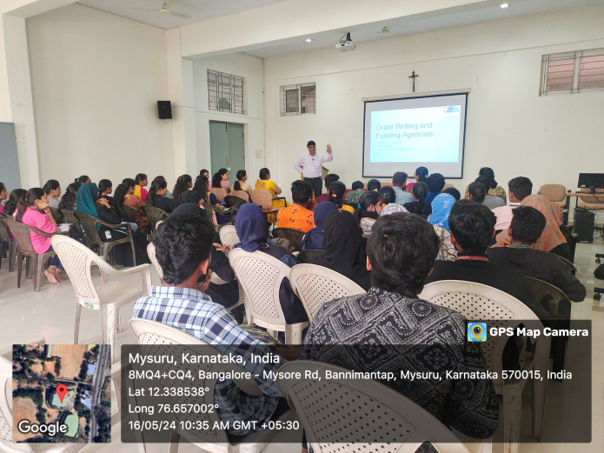
Dr. Vishwanath delved into the core of Effective Grant Writing Techniques
. He outlined the following critical components of a successful grant proposal:
- Steps to follow on grant writing
- Characteristics of Successful Grants
- Critical stages
- Generate and Idea
- Find a Matching Funding Opportunity
- Background research
- Write technical portion
- Check administrative parts
- Submit and forget
- Top tips & tricks
- Key questions : Funders ask Reviewers
- Understand your Funder
- Understand your reviewer
- Common Grant Proposal Mistakes
- Current Opportunities

Funding initiatives aligned with emerging research areas and pressing societal challenges. Stay informed through grant databases and funding agency announcements to capitalize on these openings.
Dr. Vishwanath also shared common pitfalls to avoid, such as ambiguous language, lack of focus, and poor organization.
The seminar focused on identifying and pursuing funding opportunities. Dr. Vishwanath provided a comprehensive overview of various funding sources, including:
National Institutes of Health (NIH)
National Science Foundation (NSF)
European Research Council (ERC)
Private foundations like the Bill & Melinda Gates Foundation
Industry partnerships and collaborations
He offered practical tips on how to search for and evaluate potential funding opportunities, emphasizing the importance of networking and building relationships with funding agencies and collaborators. Dr. Vishwanath encouraged attendees to utilize online databases and resources such as:
Grants.gov
Foundation Directory Online
Research Professional
Additionally, he highlighted the role of institutional support, such as university grant offices and research administrators, in assisting researchers throughout the grant application process.
Program was concluded with a brief vote of thanks to the audience and the Guest presenting him with a memento on behalf of the college.
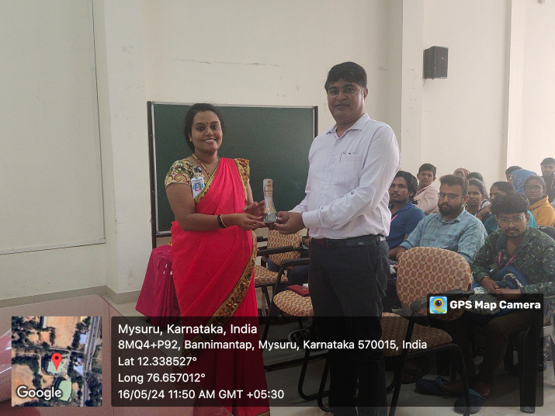
Outcome of the program : Dr. Prashanth Vishwanath’s seminar on research grant writing and funding opportunities was highly informative and beneficial for all students. His expertise and practical guidance provided attendees with a solid foundation to enhance their grant writing skills and increase their chances of securing funding for their research projects. The seminar not only educated but also inspired researchers to pursue their funding goals with renewed vigor and strategic approach.
Overall, the event was a resounding success, leaving participants equipped with the tools and knowledge to navigate the competitive landscape of research funding. This lecture was attended by 70 students of UG & PG Biochemistry.

Feedback analysis

