
ST. PHILOMENA’S COLLEGE (Autonomous), MYSORE – 570 015
Affiliated to University of Mysore
College of Excellence – UGC, Re-accredited by NAAC
PG DEPARTMENT OF ECONOMICS
REPORT
Special Lecture
TOPIC: “CAREER OPPORTUNITIES FOR ECONOMICS STUDENTS”

Date: 23.01.2024 Time: 11.00 am Venue: PG Conference Hall
Resource Person
Dr. Kempe Gowda G N Assistant Professor and Head, Department of Economics, Government First Grade College, Talakadu
The PG Department of Economics had conducted a special lecture for MA Economics students, on the part of their subject interest. Special lecture was delivered by Dr. Kempe Gowda G N Assistant Professor and Head, Department of Studies in Economics, Government First Grade College Talakad, on 23/01/2024 on the topics of “Career Opportunities for Economics Students” respectively.

OBJECTIVES OF THE INVITED LECTURE
- To get an idea about subject scope in the job market.
- To enhance the knowledge on competitive exams.
- To educate students to face competitive world.
- Clarifying Career Opportunities Post-Programme Completion.

Understanding Subject Scope in the Job Market: The lecture aimed to give students a comprehensive idea of the scope of economics in the job market, highlighting the diverse fields where economics knowledge is applicable. Enhancing Knowledge on Competitive Exams: Another objective was to enhance students' knowledge about various competitive exams relevant to economics graduates, such as civil services examinations, banking, and other government jobs, educating Students to face the competitive world, the lecture aimed to prepare students to face the competitive world by providing them with information on how to develop their skills and knowledge to stand out in the job market. Clarifying Career Opportunities Post-Programme Completion: Lastly, the lecture aimed to provide a clear understanding of the career opportunities available to students after completing their MA in Economics.
Highlights
Dr. Kempe Gowda G N began the lecture by discussing the relevance of economics in today's world and its impact on various sectors such as finance, policy-making, and international relations. He emphasized the importance of analytical skills, critical thinking, and problem-solving abilities that are developed through the study of economics.
He then proceeded to discuss the various career paths available to economics graduates, including roles in government, banking, research institutions, NGOs, and international organizations. He also highlighted the increasing demand for economists in the private sector, especially in consulting firms, financial institutions, and data analysis companies. 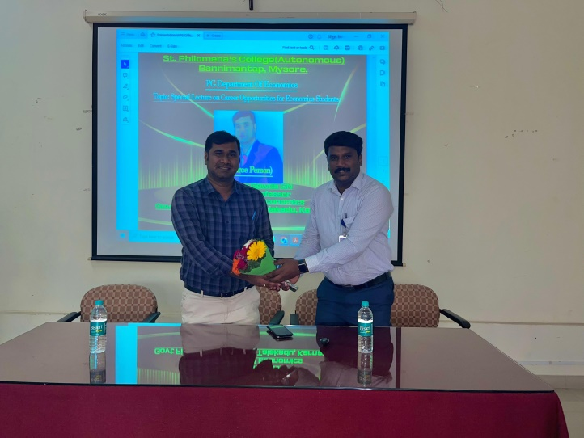
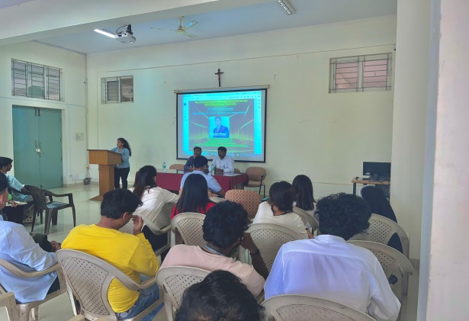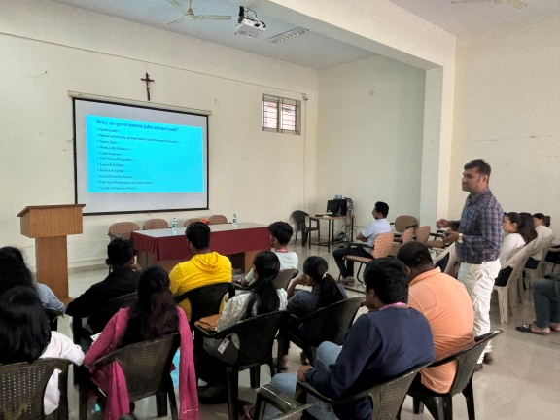

OUTCOME OF THE INVITED LECTURE
The special lecture on career opportunities for economics students was highly informative and beneficial for MA Economics students. It provided them with a clear understanding of the various career paths available to them and equipped them with the knowledge and skills needed to succeed in their chosen field. The lecture was well-received by the students, who expressed gratitude for the valuable insights provided by Dr. Kempe Gowda G N.

