
ST. PHILOMENA’S COLLEGE (Autonomous), MYSORE – 570 015
Affiliated to University of Mysore
College of Excellence – UGC, Re-accredited by NAAC
PG DEPARTMENT OF ECONOMICS
REPORT
The PG Department of Economics had conducted a special lecture for IV Semester MA Economics students, on the part of their term project. special lecture was delivered by Dr. Madhu G R Faculty in Economics, Department of Studies in Economics and Cooperation, Manasagangothri Mysuru on 15/06/2022 on the topics of “Use of SPSS Software for Research” and “Data Interpretation Techniques in Research” respectively.

OBJECTIVES OF THE INVITED LECTURE
- To get hands on experience on use of SPSS software for research.
- To restorative the basic research knowledge to the students.
- To educate them to interpret the data in research.
- To make clear the data interpretation techniques in research.

Session-01

The first session was started on 15-06-2022 at 11.30 am, on the topic of “Use of SPSS Software for Research”. The session was attended by the students of IV semester MA Economics and session was informative and interactive. The resource person had an interacted with students very interestingly and he was shared his knowledge on the usage of SPSS software in research. He had also shared the software with students and it was useful for students to get hand –on experience of use of software in research. Once students understood the entering the data in to software then he thought how to analyse the data and how to run the test for respective data in research. He gave Practical/hands on experience to all the participants, demonstrated these tests/techniques to be conducted by using SPSS and MS Excel. This was a very interactive session. He cleared all doubts of participant very efficiently. Totally the first session was very useful and students were enjoyed the session with hands-on experience. And the first session was concluded by 12:30 PM.
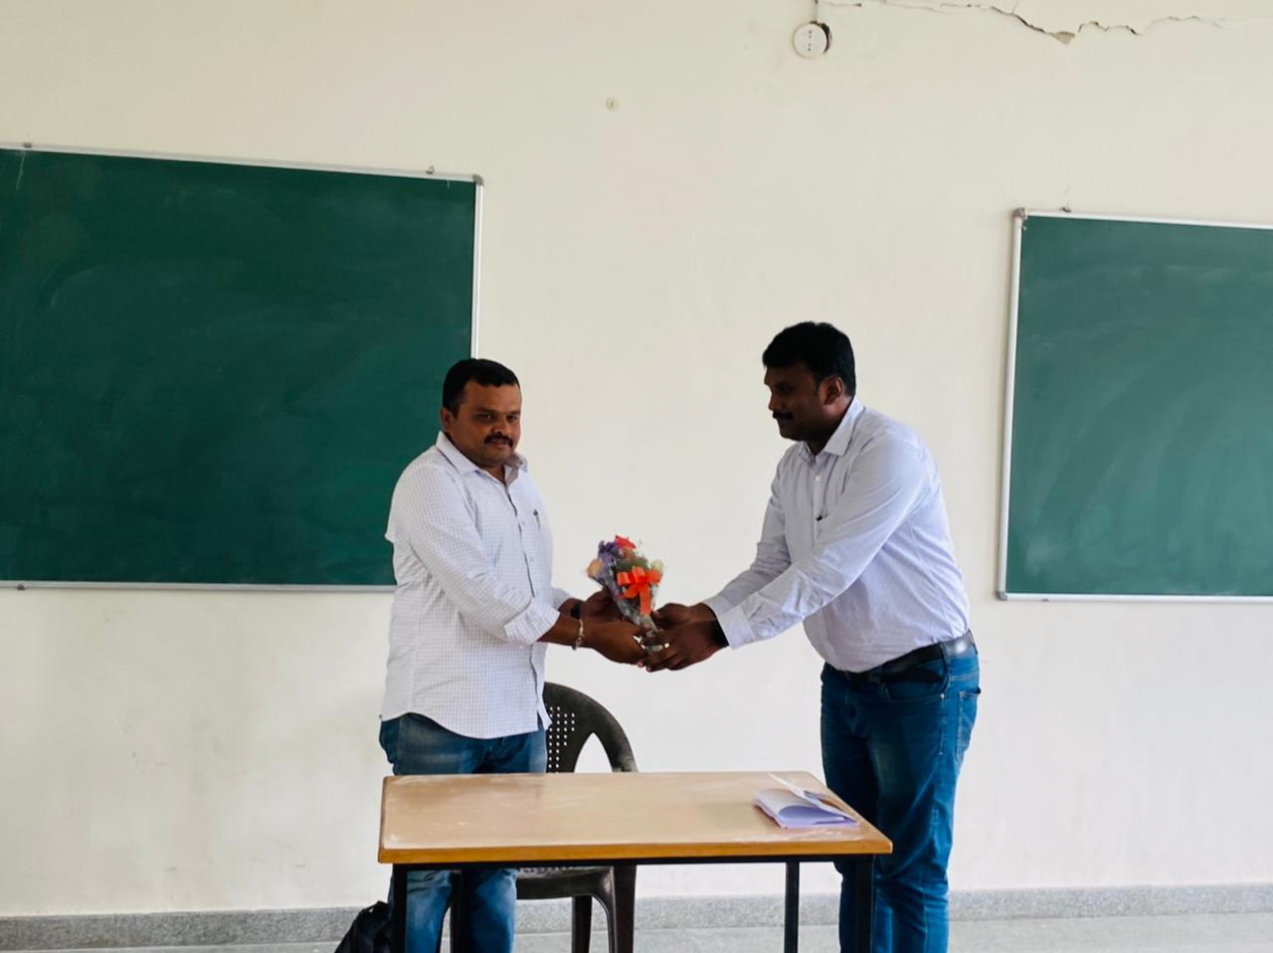
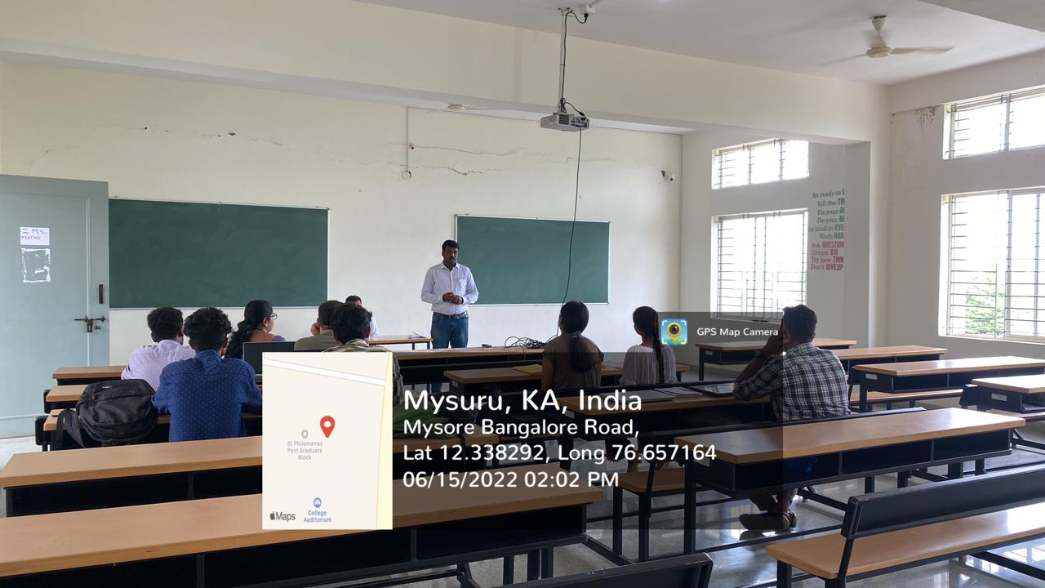
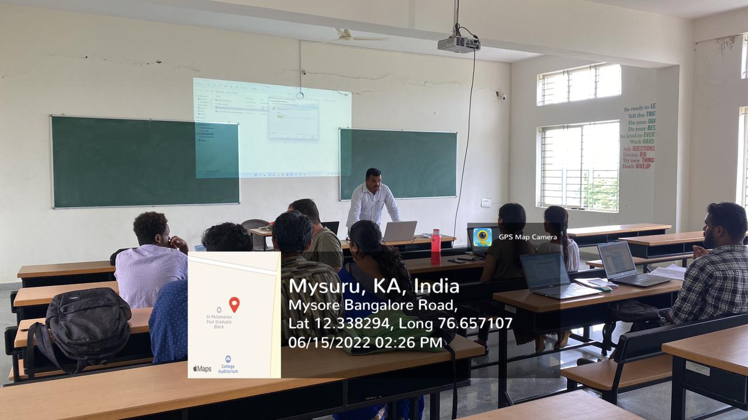

Session-02
The second session was started on at 1.30 pm, on the topic of “Data Interpretation Techniques in Research”. The session was attended by the students of IV semester MA Economics and session was informative and interactive. The resource person had an interacted with students very interestingly and he was shared his knowledge on data interpretation techniques in research. He discussed on Basic Concept of Research, Variables, Various Types of Research Methods, Formulation of Hypotheses, Data Collection etc. He stressed upon the characteristic features of quantitative approach that involves collecting and converting data into numerical form. He has explained the significance and importance of Data base, data structure, data Mining and Data interpretation techniques in research. He covered all the basics concepts such as Parametric Test, Non-Parametric tests in detail. During his talk he also deliberated on different issues with statistical tests/techniques etc. Overall, the second session was very fruitful and all participants were highly satisfied. And the session was concluded by 2:30 PM.

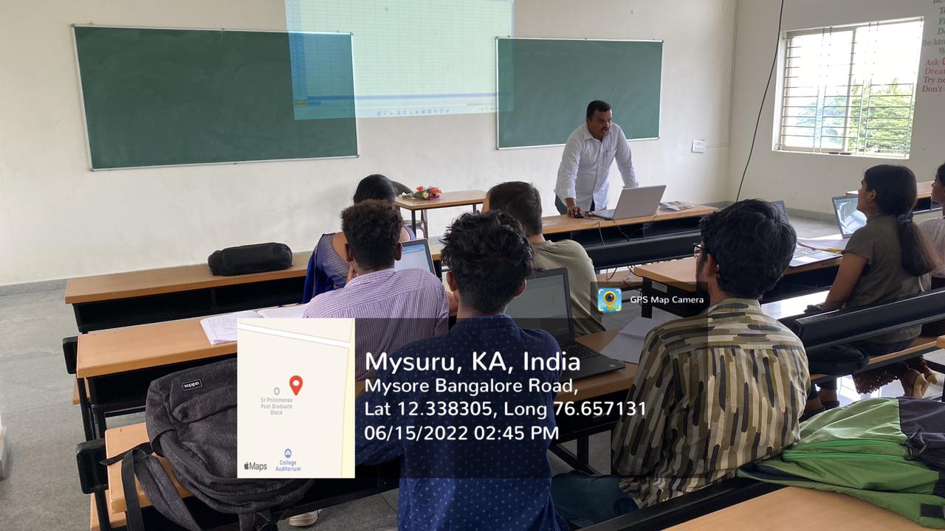

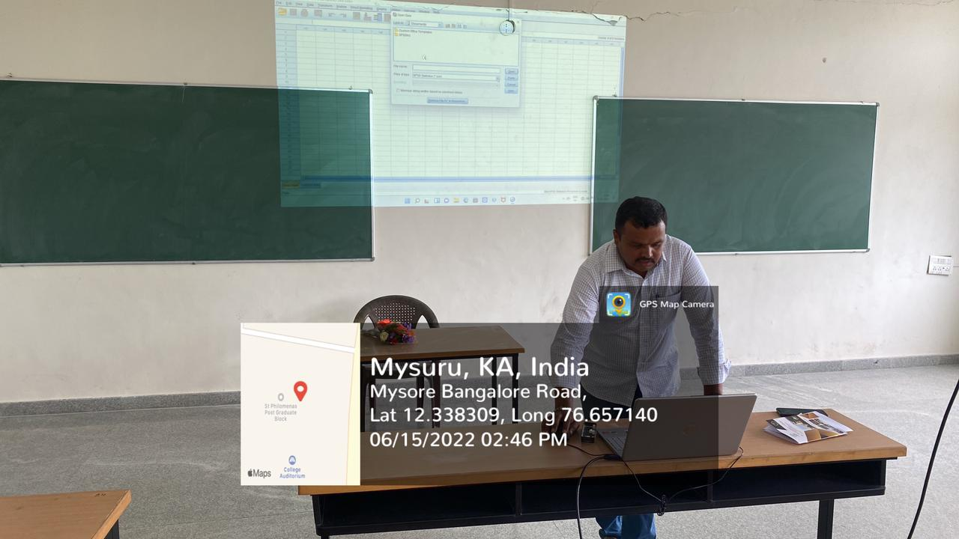

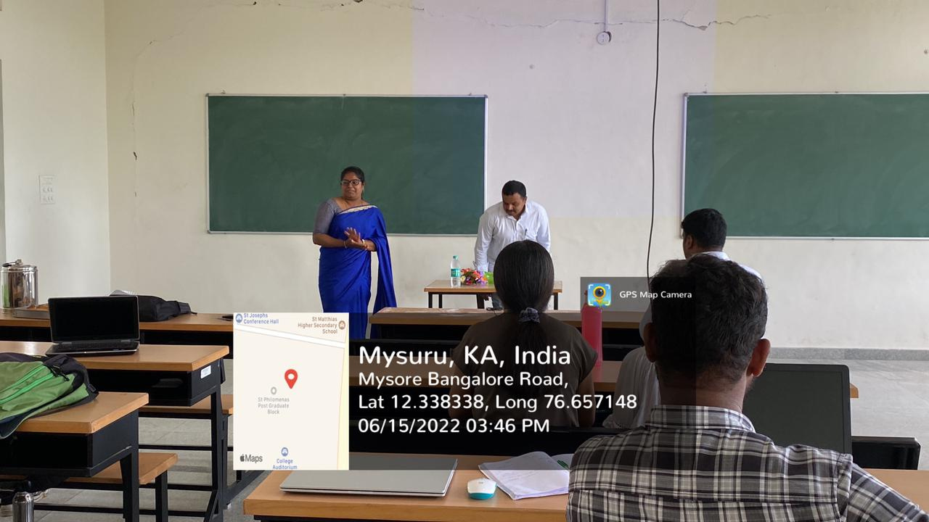
OUTCOME OF THE INVITED LECTURE
The special lecture sessions were knowledgeable and useful for the students to make clear and easy understand the research techniques as well as software usage in research. Students gain the knowledge on quantitative techniques for economics and usage of statistical tools in research. Students develop their ability to interpret the data in research and understand the techniques and usage of SPSS software in research.

