
St. Philomena’s College (Autonomous) Binnimantap, Mysore
Inauguration of the Equal Opportunity Cell
&
An awareness programme on
Equality and Discrimination
Date: 12th November 2024, Time: 10:30 AM
Venue: Auditorium
Report on Inauguration of the Equal Opportunities Cell
Event | : | Inauguration of the Equal Opportunity Cell
Resource Person | : | S. Nazeema Begum, Deputy Director of Prosecution at the Karnataka Police Academy, Mysore
Date: | : | 12/11/2024 | Timing | 10.30am to 12.00pm
Participants | : | PG students of St.Philomena’s College
Organized by | : | Equal Opportunity Cell, IQAC and IIC

On November 12, 2024, St. Philomena College, Mysore, held an inauguration ceremony of "Equal Opportunities Cell" at 10:30 a.m. The program commenced with the “Philos anthem," creating a serene atmosphere for the event. Dr. Deepa M., Assistant Professor BBA Department, extended a warm welcome to all gatherings.
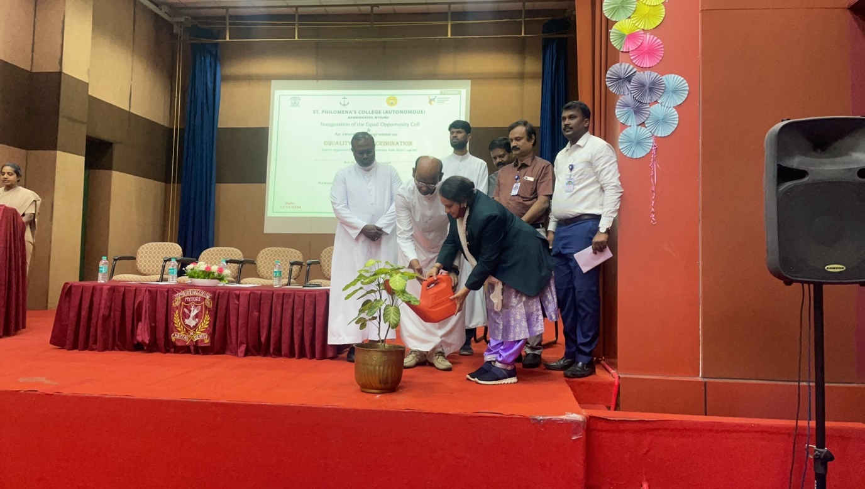
The inauguration ritual was symbolized by the dignitaries watering a plant on stage, underscoring a commitment to growth, inclusivity, and respect for diversity.
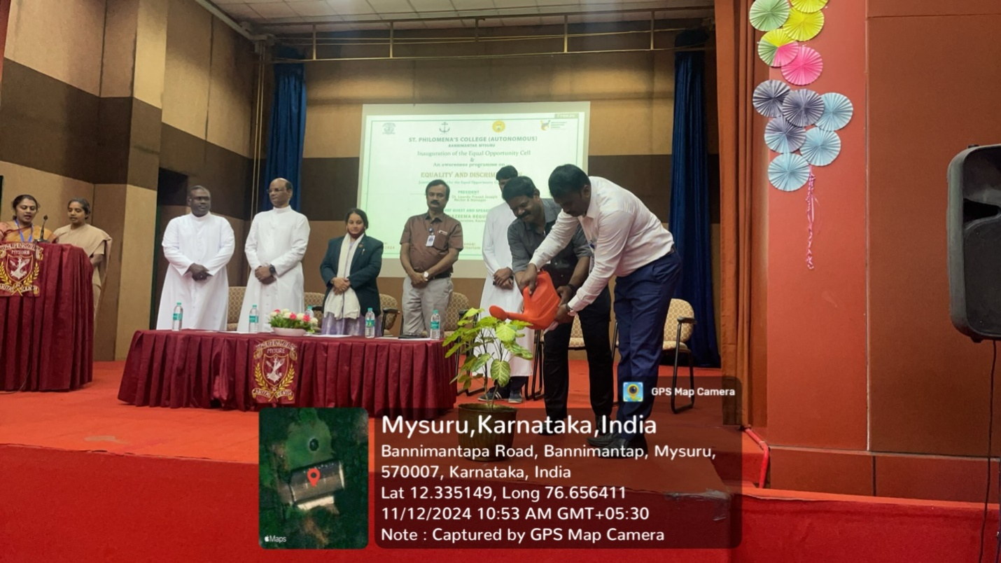 Professor Anand, Head of the Department of Political Science, led the audience in the Preamble to the Constitution of India, emphasizing the country's foundational principles of justice, equality, and fraternity.
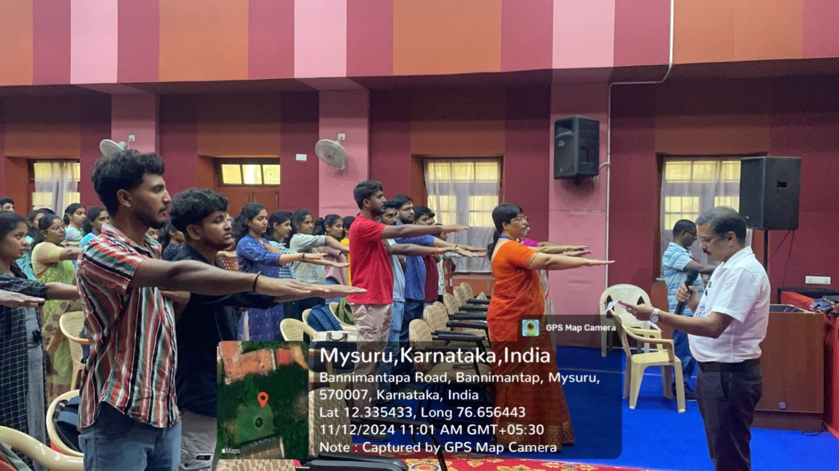
The chief guest was introduced by Dr.Shyla B Associate Professor, PG Department of Chemistry.
The event’s chief guest, S. Nazeema Begum, Deputy Director of Prosecution at the Karnataka Police Academy, Mysore, highlighted the importance of equality and equal opportunities as enshrined in the Indian Constitution. She described how the newly formed Equal Opportunities Cell is designed to foster an inclusive environment for all students, free from discrimination based on gender, caste, or religion. She also touched upon the Indian Civil Protection Code, educating attendees about the legal framework for equality in the country.
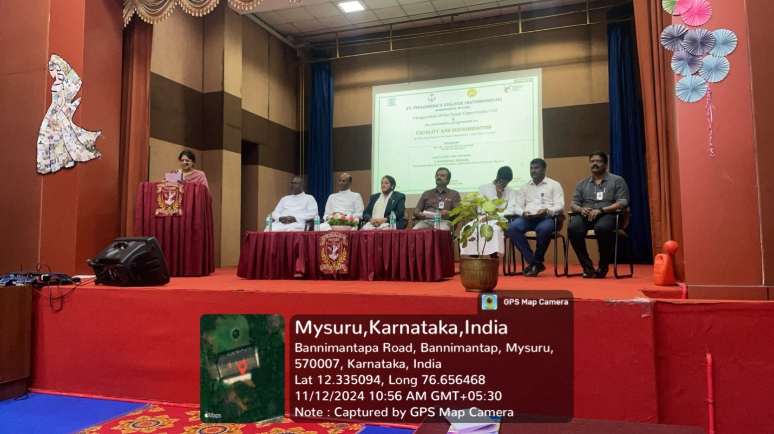

In her extended address, Ms. Begum discussed recent updates in investigative practices and legal rights. She explained how technological advancements have impacted evidence gathering and investigations in the digital age, referencing changes enacted from July 1, 2023, which make online offenses more traceable and enhance protections under the Digital and Electronic Legal Services System (DLSS). She also addressed the Zero FIR process, where complaints can be registered and followed up regardless of the police station’s jurisdiction. This, she noted, empowers individuals to actively monitor the progress of their cases and promotes accountability within the system.

Ms. Begum’s speech also explored the evolving role of scientific officers, particularly SOCO officers, who now play a significant role in forensic investigations, and encouraged science students to consider careers in this critical field.

Rev. Father Lourdu Prasad Joseph, the presiding dignitary of St. Philomena College, offered his support for the Equal Opportunities Cell, expressing hopes for its positive impact on the college community. He was joined by various college officials, including Rev. Pa. Gnanapragash, Assistant Rector David Sagai Raj, Principal Dr. J.D. Saldanha, IQAC Coordinator Professor Thomas Gunaseelan, and Equal Opportunities Cell Coordinator Dr. Nandeesha H K.

Postgraduate student Nisarga Lakshmi narrated the event’s proceedings, adding a student perspective to the gathering, while Dr. Nandeesh, Head of the Department of Economics, extended a vote of thanks to the participants and dignitaries.

The Equal Opportunities Cell at St. Philomena College is expected to drive initiatives that promote inclusivity, respect, and fair treatment, contributing to a campus culture that values and upholds equal opportunities for all.

Convener | : | Mr. Thomas Gunaseelan, IQAC Coordinator
Coordinators | : | Dr.Nandeesha H K, Assistant Professor, PG Department of Economics.
Member | : | EOC, IQAC,IIC

