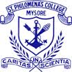

ST. PHILOMENA’S COLLEGE (AUTONOMOUS), MYSORE
Affiliated with the University of Mysore

REPORT

EDUCATIONAL TOUR BY COMMERCE AND ECONOMICS STUDENTS TO SUPREME SOLAR PROJECT PRIVATE LIMITED, BANGALORE

The PG Department of Economics St. Philomena's College, Mysuru, organized a one-day educational excursion to Supreme Solar Project Private Limited in Bangalore on August 28, 2023.
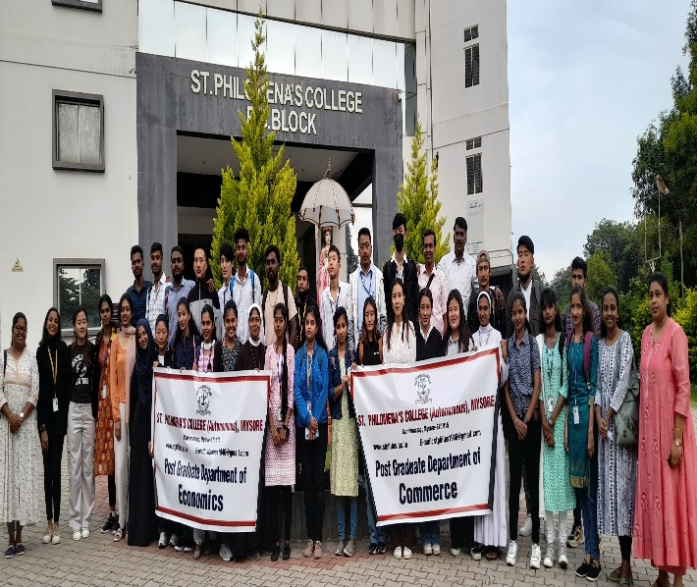
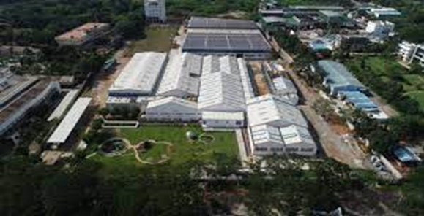
The objective of the educational tour to Supreme Solar Project Private Limited in Bangalore was to provide students and staff members with insightful and hands-on experience in the operations of a leading solar water heater manufacturing company. The tour aimed to enhance participants' understanding of renewable energy technologies, manufacturing processes, and corporate sustainability practices. Additionally, it sought to expose students to real-world industrial environments and foster a connection between classroom learning and practical industry applications.
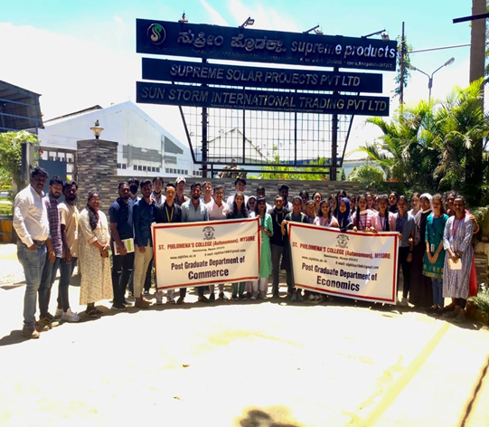
The tour was meticulously planned and coordinated by a private tour operating agency. A total of 38 students from the Commerce and Economics departments were accompanied by four faculty members.The industrial visit commenced with a warm welcome from Mr. Virat of E-Stores Global, Bangalore who provided the students with a brief introduction to the company's background and mission. Later, the group was guided by Mr. Vinod, the HR manager of Supreme Solar Project Pvt Ltd.

INTRODUCTION TO SUPREME SOLAR PROJECT PVT LTD, BANGALORE
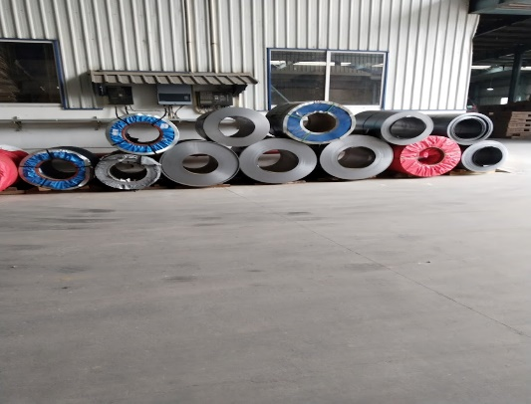
Supreme Solar Project Pvt Ltd has been a leading manufacturer of solar water heaters for 16 years. Over the years, it has evolved from having a modest customer base to becoming a trusted brand in the home appliances market, not only in India but also in countries like Nepal, Africa, Sri Lanka, and Bangladesh. They trade under the brand name "Supreme Products" and specialize in solar water heaters and kitchen appliances, including chimneys, water purifiers, and electric geysers.
Supreme Solar Projects Pvt Ltd boasts ISO 9001 and ISO 14001 certifications and operates in 24 states with 70 franchises, 4500 trusted distributors, and dedicated service centers to provide prompt service to their customers. Their corporate office is located in Bangalore Yelahanka New Town, while the production unit is situated in Doddaballapur. They also have branches in Delhi, Nagpur, Pune, and Hyderabad.
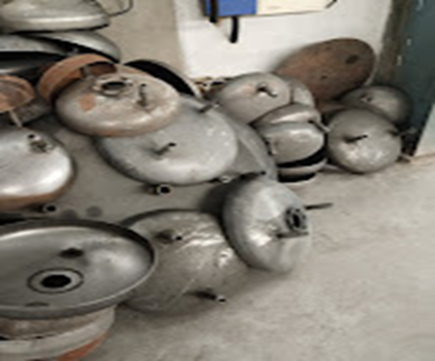
The Cutting Section of the Industry:
The industry comprises two types of solar water heaters: cube and panel.
- In the cube solar water heater manufacturing section:
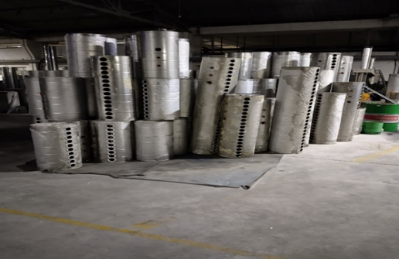
The process of creating the solar tank involves a series of meaningful steps to ensure its quality and functionality. Imported sheets serve as the foundation for the tank's construction, and they are utilized to form its various layers. The cutting phase employs two distinct methods: traditional machine cutting for the outer layer and precise laser cutting for the inner layer, guaranteeing precision and durability. Additionally, specialized machinery is used to roll the sheets after cutting, shaping them into the desired form.
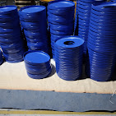
To enhance the tank's utility, punching is carried out, adding 10 to 15 strategically placed holes that facilitate the connection of tubes at the tank's base. The main tank is positioned snugly between the inner and outer layers, and bowl-shaped side parts are securely attached. The choice of tank material, whether ceramic or glass, is determined by the type of water it will contain, and the tank's capacity ranges from 100 to 1,000 liters, catering to diverse customer needs. Furthermore, the outer layer can be finished with either a PPJ or a Mirror surface, adding a touch of customization.
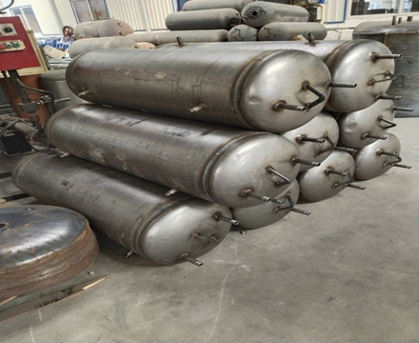
The assembly process proceeds with the welding of tubes onto the side parts, followed by a meticulous pressure leakage test to ensure the tank's integrity. Coating and purification processes are then applied, culminating in the application of a distinctive blue coating. Blue caps are fitted onto the tanks, and other essential components are also painted in a matching blue hue, lending the final product a cohesive and appealing appearance.
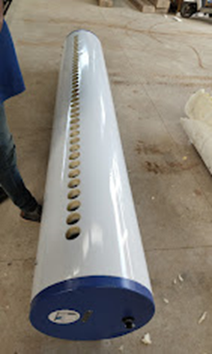
The remaining components are thoughtfully packaged separately, with some elements, such as the solar tubes, sourced from specialized industries to meet the highest standards. The final step involves the careful assembly and installation of all components at the delivery location, resulting in the delivery of a fully functional and high-quality solar tank to our valued customers. This meticulous process reflects our commitment to delivering reliable and efficient solar solutions.

- The other type of solar water heater is the panel type, which lacks tubes and instead uses a C.R.C.A sheet with a prime guard black coating. The outer tank is powder-coated and made of stainless steel, while the black panel absorbs sunlight for heating.

OUTCOME OF THE EDUCATIONAL TOUR
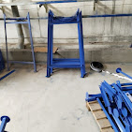
- Insight into Corporate Sustainability Practices: Supreme Solar Project Pvt Ltd.’s commitment to sustainability, as indicated by their ISO 14001 certification, likely left a lasting impression on the participants. Learning about the company's sustainable practices can inspire students to consider the environmental impact of businesses and incorporate sustainability into their future careers.
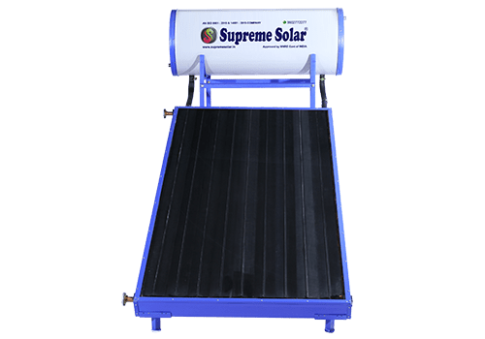
- Connecting Classroom Learning to Industry Applications: The excursion helped bridge the gap between classroom learning and practical industry applications. Students and staff had the opportunity to see how the theoretical knowledge they acquire in their coursework is put into practice in a real-world industrial setting. This hands-on experience can motivate students to apply their education effectively in their future professions.
- Networking and Industry Insights: Interactions with industry professionals provided valuable networking opportunities for both students and faculty members. Additionally, gaining insights into the company's growth, market reach, and product specialization can be valuable for students planning to enter the business or marketing sectors.

In summary, the educational excursion to Supreme Solar Project Private Limited in Bangalore had a meaningful impact on the participants by broadening their knowledge, exposing them to industry practices, and fostering connections between academia and the corporate world. It provided a valuable educational experience that could influence their future career choices and decisions related to renewable energy and sustainability. The following faculty and students were a part of the educational tour

Sl. No | Name | Designation
 | Dr. NANDEESHA .H.K | Faculty
 | Dr. ASHWINI .K.J | Faculty
 | CHRISTY S P | Student
 | DAWA TSERING | Student
 | DIVYA S | Student
 | FATHIMA M H | Student
 | FATHIMA REHNA PP | Student
 | JESHMA CRASTA | Student
 | NISHA JACOB | Student
 | NIVEDITHA K | Student
 | POORNIMA A | Student
 | RAHEL R PRASAD | Student
 | RINZIN GYALTSO | Student
 | SANDEEP D E | Student
 | SHALET S | Student
 | SHARATH M S | Student
 | SHILPA U S | Student
 | SUHANA ANJUM | Student
 | TENZIN CHOEYING | Student
 | TENZIN JANGCHUP | Student
 | TENZIN WANGCHUK | Student
 | UGYEN DOLKAR | Student
 | ANGEL SHINNY | Student
 | DAYANANDA J N | Student
 | GANGADHARA BK | Student
 | KARMA TENZIN | Student
 | TENZIN SANGYAL | Student
 | VISHWAS P | Student
 | BASANT SEHLOT | Student
 | SANGEETHA D S | Student

