
ST. PHILOMENA’S COLLEGE (Autonomous), MYSORE – 570 015
Affiliated to University of Mysore
College of Excellence – UGC, Re-accredited by NAAC
PG DEPARTMENT OF ECONOMICS
REPORT
Subject: Visit to Vidhana Soudha, Bangalore to witness the Karnataka State Budget Presentation for the FY 2024-25 as a part of experiential Learning.
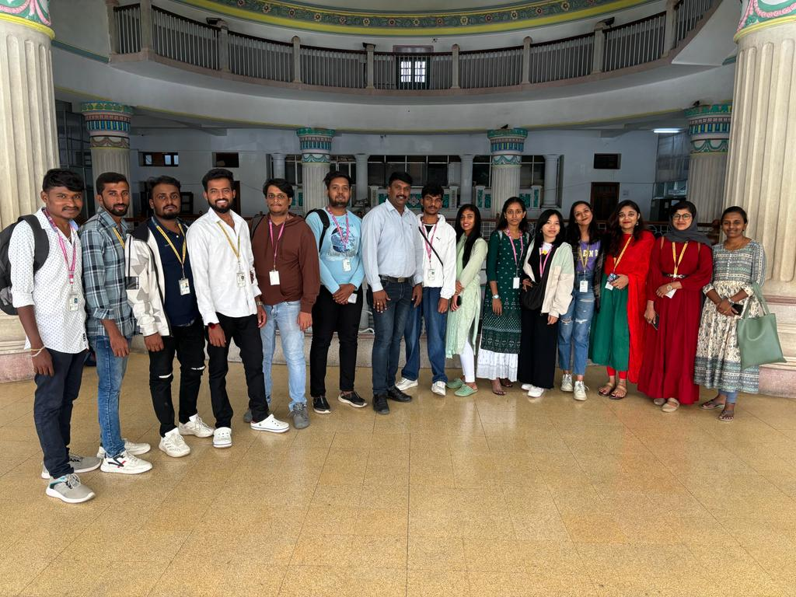
The students of M.A Economics of St. Philomena's College, Mysuru, visited the Vidhana Soudha in Bangalore, the headquarters of the Karnataka State Legislature, on February 16th, 2024, to witness Assembly Session on the presentation of the State Budget by the Honourable Chief Minister Sri. Siddaramaiah.
The primary aim was to acquire a comprehensive understanding of the state budget's development process, encompassing formulation, fund allocation, and the involvement of various stakeholders in decision-making
The students had an opportunity to be with representatives from diverse sectors, including government officials, economists, scholars, journalists, and members of civil society organizations
The faculty and students in front of the Vidhana Soudha

Key Insights on the State Budget Presentation:
- Budget Formulation Presentation: The session commenced with an elaborate presentation on the budget formulation process, emphasizing critical elements such as revenue forecasts, expenditure priorities, and fiscal policy objectives.
- Role of the Legislative Assembly: The discussions were centred on the Legislative Assembly's role in scrutinizing budget proposals, debating on resource distribution, and ensuring transparency and accountability in financial matters.
- Sector-wise Allocation: Representatives from different sectors offered their perspectives on budget allocations, stressing the importance of adequate funding for areas like healthcare, education, infrastructure, and rural development.
- Public Participation: The session highlighted the significance of public engagement in the budgeting process, with discussions on mechanisms for gathering feedback from citizens and integrating their priorities into the budget.
- Challenges and Opportunities: The speakers outlined the challenges in budget formulation, including revenue constraints, expenditure pressures, and the need for efficient resource management. They also discussed the opportunities for boosting revenue generation and optimizing expenditure.
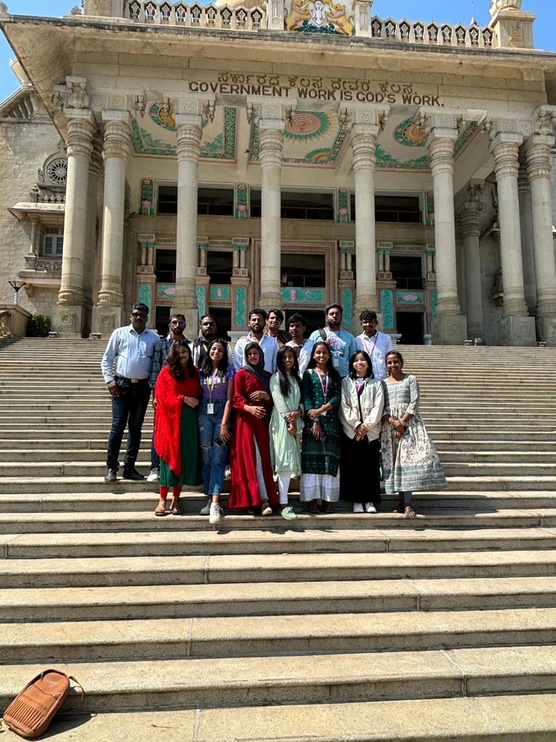
OUTCOME OF THE VISIT
- Understanding the budgeting process and its significance in governance.
- Recognition of the diverse roles played by stakeholders in shaping budgetary decisions.
- Insights on sector-specific budgetary priorities and obstacles.
The faculty and students on the steps of Vidhana Soudha

- Importance of public involvement and transparency in budget formulation.

In summary, the visit to Vidhana Soudha offered valuable insights into the state budgeting process and facilitated a deeper understanding of resource allocation challenges and opportunities. It emphasized the necessity for collaborative efforts among the government, civil society, and the public to achieve effective and equitable budget outcomes. The following students and faculty members of M.A Economics witnessed the Karnataka State Budget Presentations for the FY 2024-25.
Sl. No | Name | Designation
 | Dr. NANDEESHA. K | Faculty
 | Ms. VARSHINI. S | Faculty
 | GOWRI M | Student
 | JURRY CHAKMA | Student
 | KEERTHIRAJ N | Student
 | MADHUSUDHAN G | Student
 | PRAJWAL C G | Student
 | S N DAYANAND BHARANI | Student
 | SOWNDARYA S C | Student

