
REPORT ON OVERVIEW OF THE PROGRAMME ON WALK TO HERITAGE SITES
OF MYSURU
Event | : | Walk to the Heritage Sites of the Mysuru City
Resource Person | : | Prof. N. S. Rangaraju. Former Professor and Archaeologist (Tulu)
Date: | : | 03/02/2024 | Timing | 10.00am to 2.00pm
Participants | : | PG students of Economics, PG Journalism & B.Voc Media &Entertainment
Organized by | : | PG Dept. of Economics in association with Journalism & Mass Communication B.Voc Media & Entertainment.

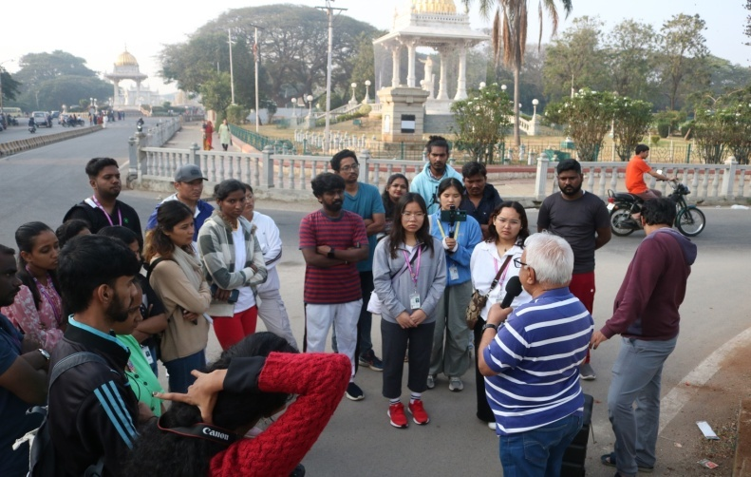
Objective: To provide a comprehensive understanding of the rich cultural and historical heritage of Mysore. Through guided exploration of significant sites and monuments, students will gain insights into the city's architectural marvels, cultural traditions, and historical narratives, enabling them to enrich their journalistic and communication skills with a deeper appreciation of local heritage.
On 03/02/2024, PG Department of Economics and Journalism & Mass Communication and students embarked on a captivating heritage walk in Mysore city led by esteemed persona Prof. Rangaraju of Archeology department, Mysore as part of their curriculum organized by the PG Department of Journalism and Mass Communication along with Economics. This Heritage walk aims to provide students with a comprehensive understanding of the History and significance of heritage sites which will enhance the students’ storytelling abilities, adding depth and meaning to their work.
Summary: The heritage walk commenced at the Town Hall, Mysore, and proceeded through landmarks such as the Big Clock Tower and statues of the Maharajas in the Wodeyar dynasty. Dr. Venugopal Gowda M K, HoD of the Department of Studies and Research in Journalism and Mass Communication welcomed Prof. N. S. Rangaraju, former Professor and Archaeologist and other staff members of department of Archaeology.
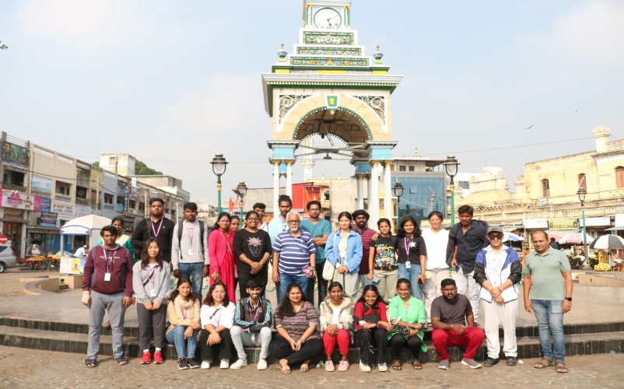
Prof. N. S. Rangaraju shared his insights into the history of Mysore town, starting from the Town Hall and delving into the significance of the Maharaja's statue, while elucidating the history and grandeur of their monarchy. He elaborated on the architectural wonders and regal history of the esteemed Wodeyar dynasty and Mysore Palace, exploring its illustrious past. Moving through the lively KR Market, he described its bustling ambiance and rich cultural heritage, enhancing students' understanding of their roots. Prof. Rangaraju underscored the importance of preserving this cultural legacy, imparting invaluable knowledge, and nurturing a deeper reverence for Mysore's heritage.
Guided Exploration of Significant Sites and Monuments: Prof. Rangaraju, being an esteemed persona in the Archeology department, provided expert guidance to the students, leading them to explore significant sites and monuments in Mysore city. This hands-on experience allowed students to directly observe and interact with architectural marvels, such as the Mysore Palace, and other historical landmarks.
Insights into Architectural Marvels: Through Prof. Rangaraju's expertise, students gained insights into the architectural styles, construction techniques, and historical significance of the visited sites. They learned about the evolution of architectural styles in Mysore and how they reflect the cultural and historical contexts of different periods.
Understanding Cultural Traditions: Alongside exploring monuments, students were exposed to the rich cultural traditions of Mysore. Prof. Rangaraju likely shared anecdotes and stories related to the cultural practices, festivals, and rituals associated with the visited sites, giving students a deeper understanding of the local culture.
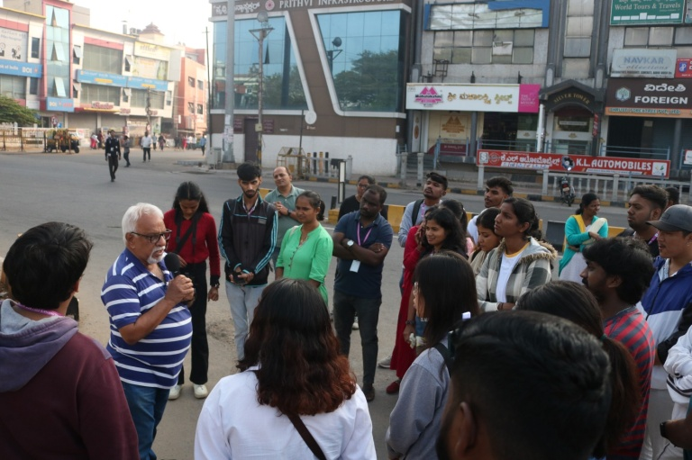
Exploration of Historical Narratives: Through discussions led by Prof. Rangaraju, students delved into the historical narratives behind each heritage site. They learned about the rulers, dynasties, and historical events that shaped Mysore's history, gaining a nuanced understanding of the city's past. 34 students took part in the Programme accompanied by 3 faculty members
Outcome of the Programme: Enrichment of Journalistic and Communication Skills: By experiencing and learning about Mysore's heritage firsthand, students were able to enrich their storytelling abilities. They gained valuable insights and knowledge that they can incorporate into their journalistic work, adding depth and meaning to their storytelling. This firsthand experience also provided them with unique perspectives and anecdotes that they can use to engage and inform their audience effectively.
Convener | : | Dr. Venugopal Gowda M. HoD, DoS in Journalism and Mass Communication.
Coordinators | : | Mr. Sanju T S, Assistant Professor of Journalism and Mass Communication.
Member | : | Dr. Ashwini K J Assistant Professor of Economics,

******

