SESSION -01
System modeling:
System modeling is the process of developing abstract models of a system, with each model presenting a different view or perspective of that system.
Models can explain the system from different perspectives:
- An external perspective, where you model the context or environment of the system.
- An interaction perspective, where you model the interactions between a system and its environment, or between the components of a system.
- A structural perspective, where you model the organization of a system or the structure of the data that is processed by the system.
- A behavioral perspective, where you model the dynamic behavior of the system and how it responds to events.
System engineering:
- Systems engineering encompasses all of the activities involved in procuring, specifying,
- designing, implementing, validating, deploying, operating, and maintaining
- sociotechnical systems. Systems engineers are not just concerned with software but
- also with hardware and the system’s interactions with users and its environment.
3 stages of system engineering are:
- 1. Procurement or acquisition:
During this stage, the purpose of a system is
decided; high-level system requirements are established; decisions are made on
how functionality will be distributed across hardware,
software, and people; and
the components that will make up the system are purchased.
2. Development
During this stage, the system is developed. Development
processes include all of the activities involved in system development such as
requirements definition, system design, hardware and software engineering,
system integration, and testing. Operational processes are defined and the training
courses for system users are designed.
3. Operation
At this stage, the system is deployed, users are trained, and the system
is brought into use. The planned operational processes usually then have to change to reflect the real working environment where the system is used.
Over time, the system evolves as new requirements are identified. Eventually, the system
declines in value and it is decommissioned (Decommissioning is a process by which a business application (or system) is removed from use in an organization.) and replaced.
These stages are not independent.
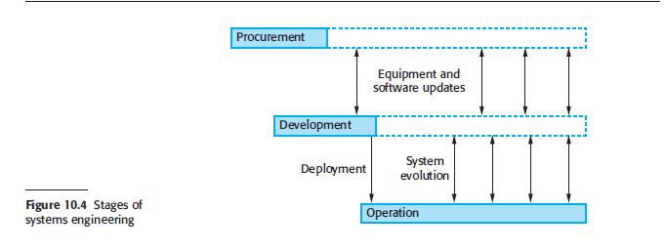

System procurement:
- The initial phase of systems engineering is system procurement (sometimes called
system acquisition). At this stage, decisions are made on the scope of a system that
is to be purchased, system budgets and timescales, and the high-level system requirements.
Using this information, further decisions are then made on whether to procure
a system, the type of system required, and the supplier or suppliers of the system.
- The drivers for these decisions are:
1. The state of other organizational systems If the organization has a mixture of
systems that cannot easily communicate or that are expensive to maintain, then
procuring a replacement system may lead to significant business benefits.
2. The need to comply with external regulations
3. External competition If a business needs to compete more effectively or maintain
a competitive position, investment in new systems that improve the efficiency of
business processes may be advisable
4. Business reorganization Businesses and other organizations frequently restructure
with the intention of improving efficiency and/or customer service.
Reorganizations lead to changes in business processes that require new systems
support.

