Session-02
Software process models

Water fall model:
Water fall model:
It has 2 types
->iterative Water fall model and
->classical Water fall model
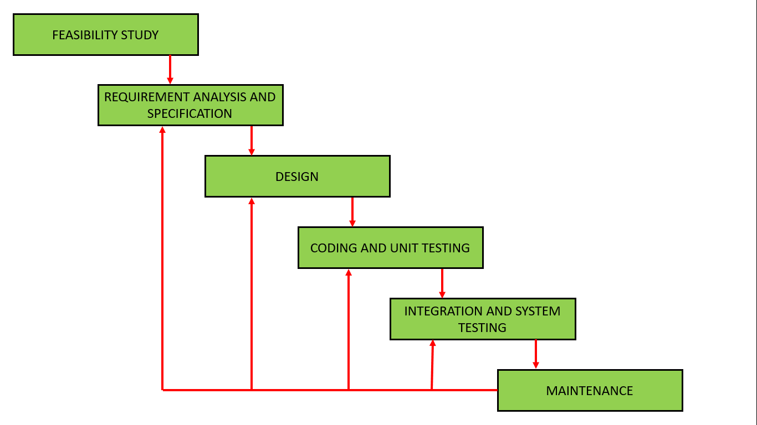
Phase Containment of Errors:
- The principle of detecting errors as close to their points of commitment as possible is known as Phase containment of errors.
Classical Waterfall Model:
- Classical waterfall model is the basic software development life cycle model. It is very simple but idealistic. Earlier this model was very popular but nowadays it is not used. But it is very important because all the other software development life cycle models are based on the classical waterfall model.,
- Design: The aim of the design phase is to transform the requirements specified in the SRS document into a structure that is suitable for implementation in some programming language.
- Coding and Unit testing: In coding phase software design is translated into source code using any suitable programming language. Thus each designed module is coded. The aim of the unit testing phase is to check whether each module is working properly or not.
- Integration and System testing: Integration of different modules are undertaken soon after they have been coded and unit tested. Integration of various modules is carried out incrementally over a number of steps. During each integration step, previously planned modules are added to the partially integrated system and the resultant system is tested. Finally, after all the modules have been successfully integrated and tested, the full working system is obtained and system testing is carried out on this.
Spiral Model:
Spiral model is one of the most important Software Development Life Cycle models, which provides support for Risk Handling. In its diagrammatic representation, it looks like a spiral with many loops. The exact number of loops of the spiral is unknown and can vary from project to project. Each loop of the spiral is called a Phase of the software development process.
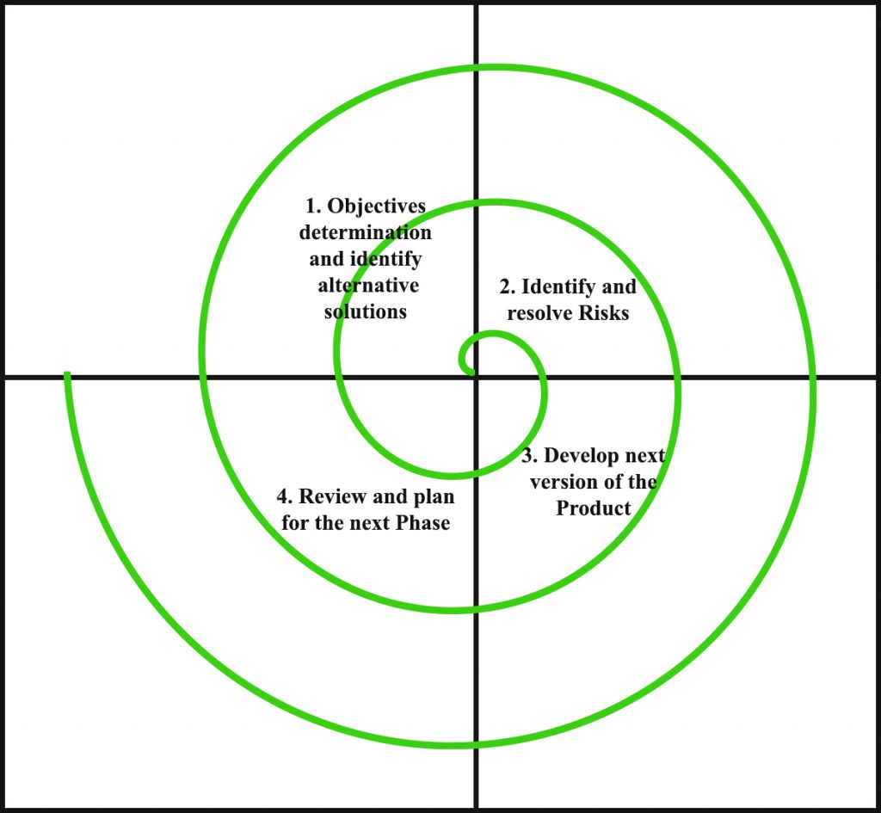
four quadrants are discussed below-
- Objectives determination and identify alternative solutions: Requirements are gathered from the customers and the objectives are identified, elaborated and analyzed at the start of every phase. Then alternative solutions possible for the phase are proposed in this quadrant.
- Identify and resolve Risks: During the second quadrant all the possible solutions are evaluated to select the best possible solution. Then the risks associated with that solution is identified and the risks are resolved using the best possible strategy. At the end of this quadrant, Prototype is built for the best possible solution.
- Develop next version of the Product: During the third quadrant, the identified features are developed and verified through testing. At the end of the third quadrant, the next version of the software is available.
- Review and plan for the next Phase: In the fourth quadrant, the Customers evaluate the so far developed version of the software. In the end, planning for the next phase is started.

