
ST. PHILOMENA’S COLLEGE (Autonomous), MYSORE – 570 015
PG Department of Economics
******
MINUTES OF THE STAFF COUNCIL MEETING
Date: 12 ^{th} February 2023. Venue: Department. Time: 11.30am.
THE FOLLOWING MEMBERS WERE PRESENT
Sl. No | Name of the Staff Member | Designation | Signature
 | Dr. Nandeesha H K  Assistant Professor | Chairperson
 | Dr. Ashwini K J  Assistant Professor | Member SPC

Agenda:
- To decide to attend live budget session at Vidhana Soudha Bangalore
- To finalise the amount to be collected from the students.
- Any other Matter

The Chairperson of the council welcomed the members and commenced the meeting.

- Agenda-1: To decide to attend live budget session at Vidhana Soudha Bangalore
Briefing the members, the Chairperson informed the council that an educational trip for M.A Economics students should be conducted. Since the course focuses public economics and monetary economics the combined educational visit to live budget sessionwill fill the gap between class room teaching and hands on experience on what they learn in the class. After deliberation the members gave their consent to visit the Vidhana Soudha.
Decision: Decidedto organise an Educational visit to M.A Economics students.

Agenda-2. To finalise the amount to be collected from the students
The Chairperson informed the members in the presence of the PG Director in his chamber and finalised the amount to be paid by each student towards the Vidhana Soudha visit. The amount fixed was Rs 300/- per student including the travelling and food for the entire duration of the visit. Both the side (Mysuru to Bangalore and Bangalore to Mysuru) travelling has been decided to travel by train.

Decision: Decided that to collect Rs 300/ - per student and travelling by train.

Any Other Matter
The Chairperson requested minimum two faculty members to accompany the educational visit. As there are both boys and girls joining the visit. There must be one male faculty and one female faculty in the tour program.
The Members suggested the names for accompanying the students for the visit as follows:
Sl. No | Name of the Faculty Members
 | Dr. Nandeesha.H K
 | Dr.Ashwini K J

Decision- Approved
Resolutions
- To organize the Educational visit to M A Economics students.
- To visit Vidhana Soudha in Bangalore, for live budget session.
- To collect Rs 300/ - amount per students during the visit.

The Chairperson thanked the members for their cooperation and suggestions and declared the meeting closed

Dr. Nandeesha H K
Chairperson

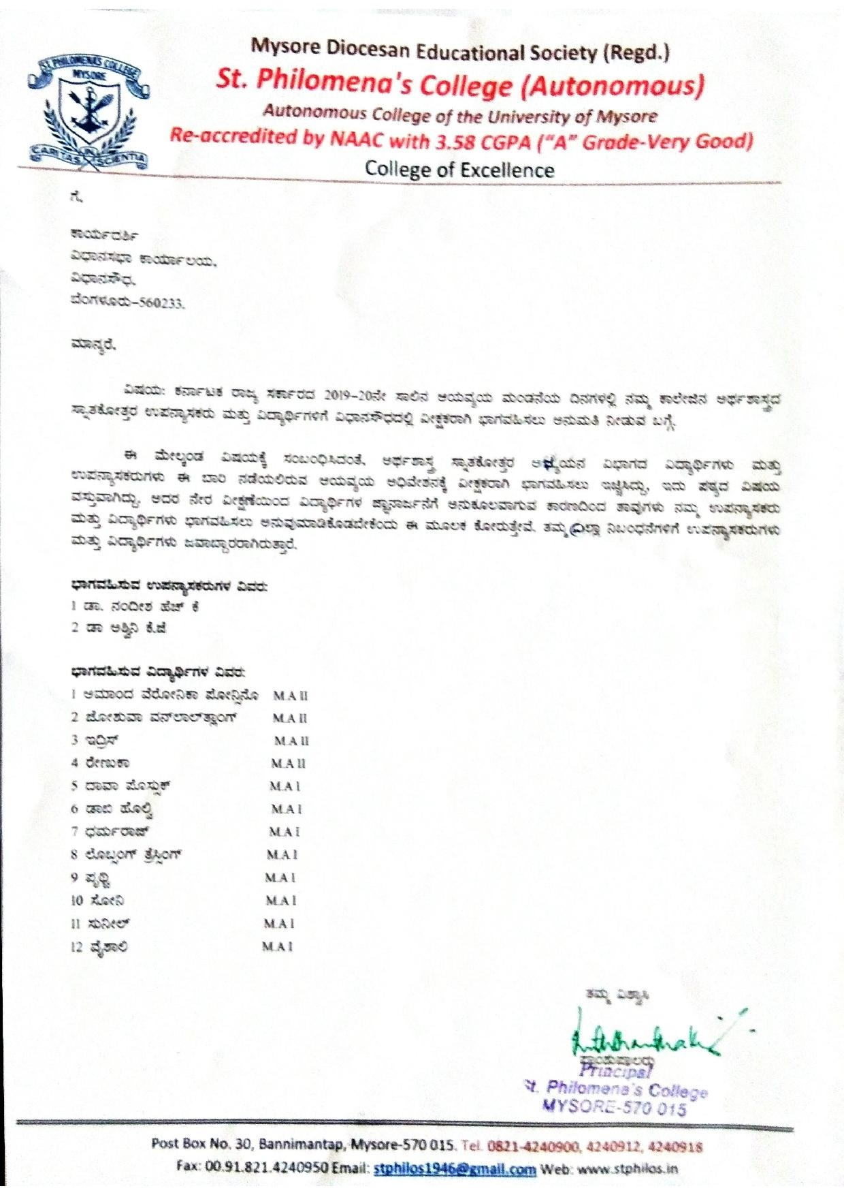

Photo Gallery:
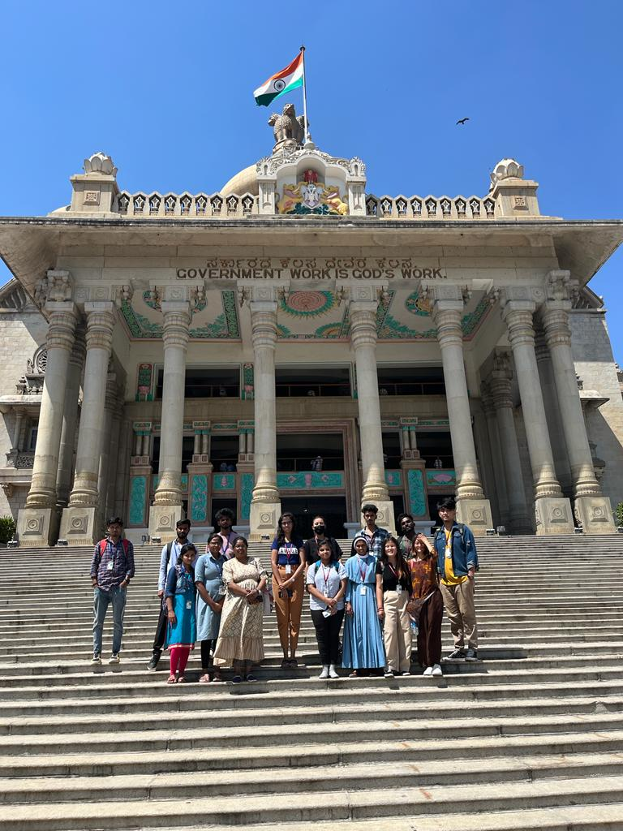

Report on Budget Session Attended
We the faulty members and students of M.A. Economics went to budget session on 17-2-2023 at legislative assembly, VidhanSoudha, Banglore.We entered the hall by 11.15 am and witnessed the budget session.
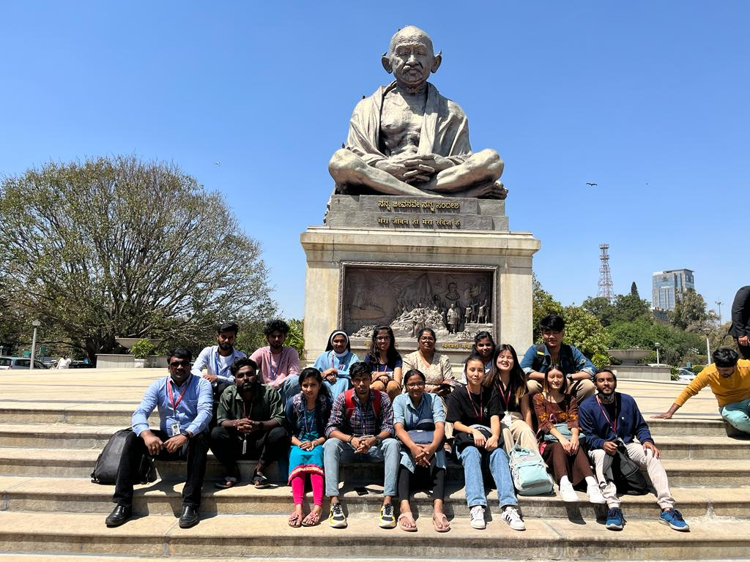

Budget Presented by Honrable Chief Minister Sri Basavaraj Bommai on 17th February 2023.Both ruling and opposition party members were present. Budget estimate (Consolidated Fund) - Rs.3,09,182 crore. Total receipts - Rs.3,03,910 crore; Revenue receipts• Rs.2,25,910 crore; Public debt - Rs.77,750 crore and Capital receipts - Rs.78,000 crore including public debt of Rs.77,750 crore. Total expenditure - Rs.3,03,910 crore ; Revenue expenditure• - Rs.2,25,507 crore: Capital expenditure - Rs.61,234 crore and Loan repayment - Rs.22,441crore
Allocation provided to different Sectors 1. Agriculture and Allied Activities-Rs.39,031crore. 2. Welfare and Inclusive Growth-Rs.80,318 crore. 3. Stimulating Economic Growth-Rs.61,488 crore. 4. Comprehensive Development of Bengaluru-Rs.9,698 crore. 5. Conservation of Culture, Heritage and Natural Resources-Rs.3,458 crore. 6. Administrative Reforms and Public Service Delivery-Rs.68,585 crore. Allocation in Gender Budget for Women Empowerment and• Welfare Rs.46,278 crore. Allocation in Child Budget for Children Welfare Rs.47,256• crore. Allocation under SCSP and TSP Rs.30,215 crore; Under SCSP Rs.21,343 crore and under TSP is Rs.8,872 crore.
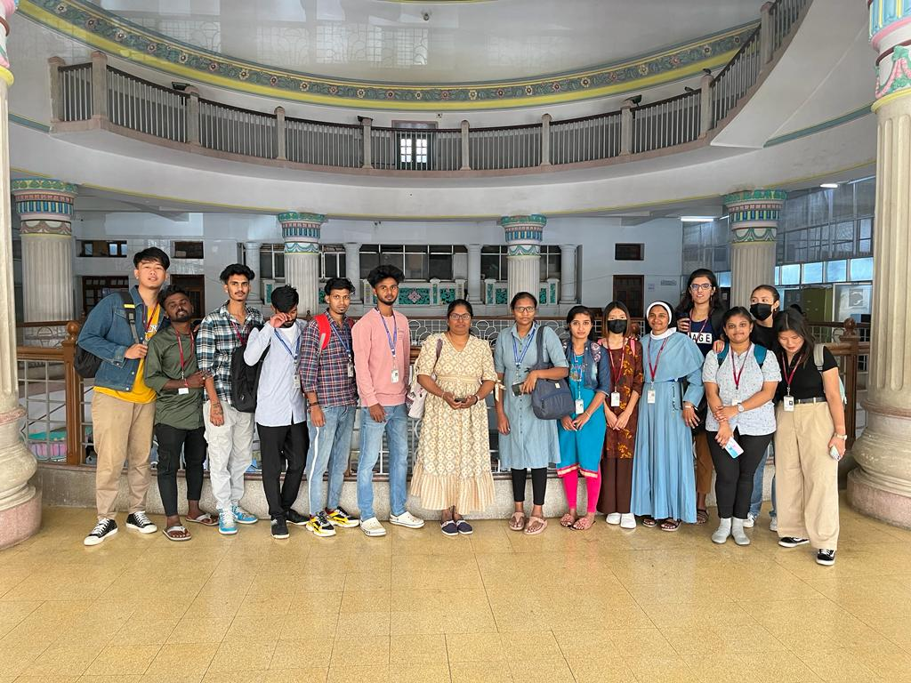

Our students have got to know about proceedings of budget that took place in the assembly.

Director
HOD

STUDENTS ATTENDENCE
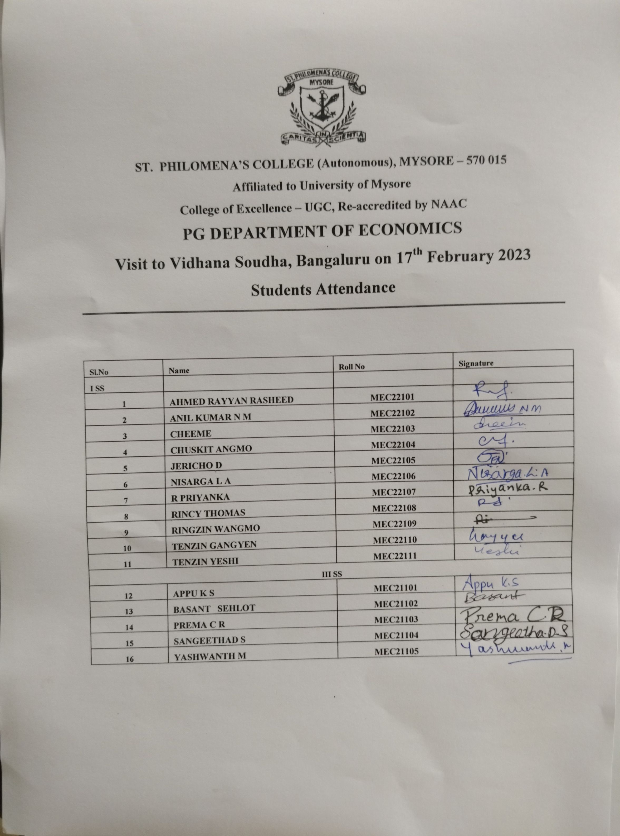

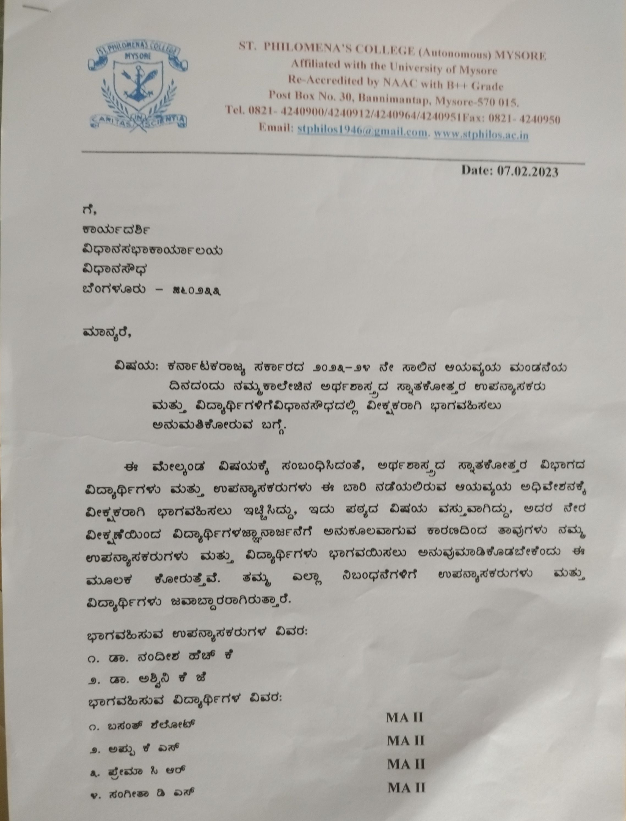

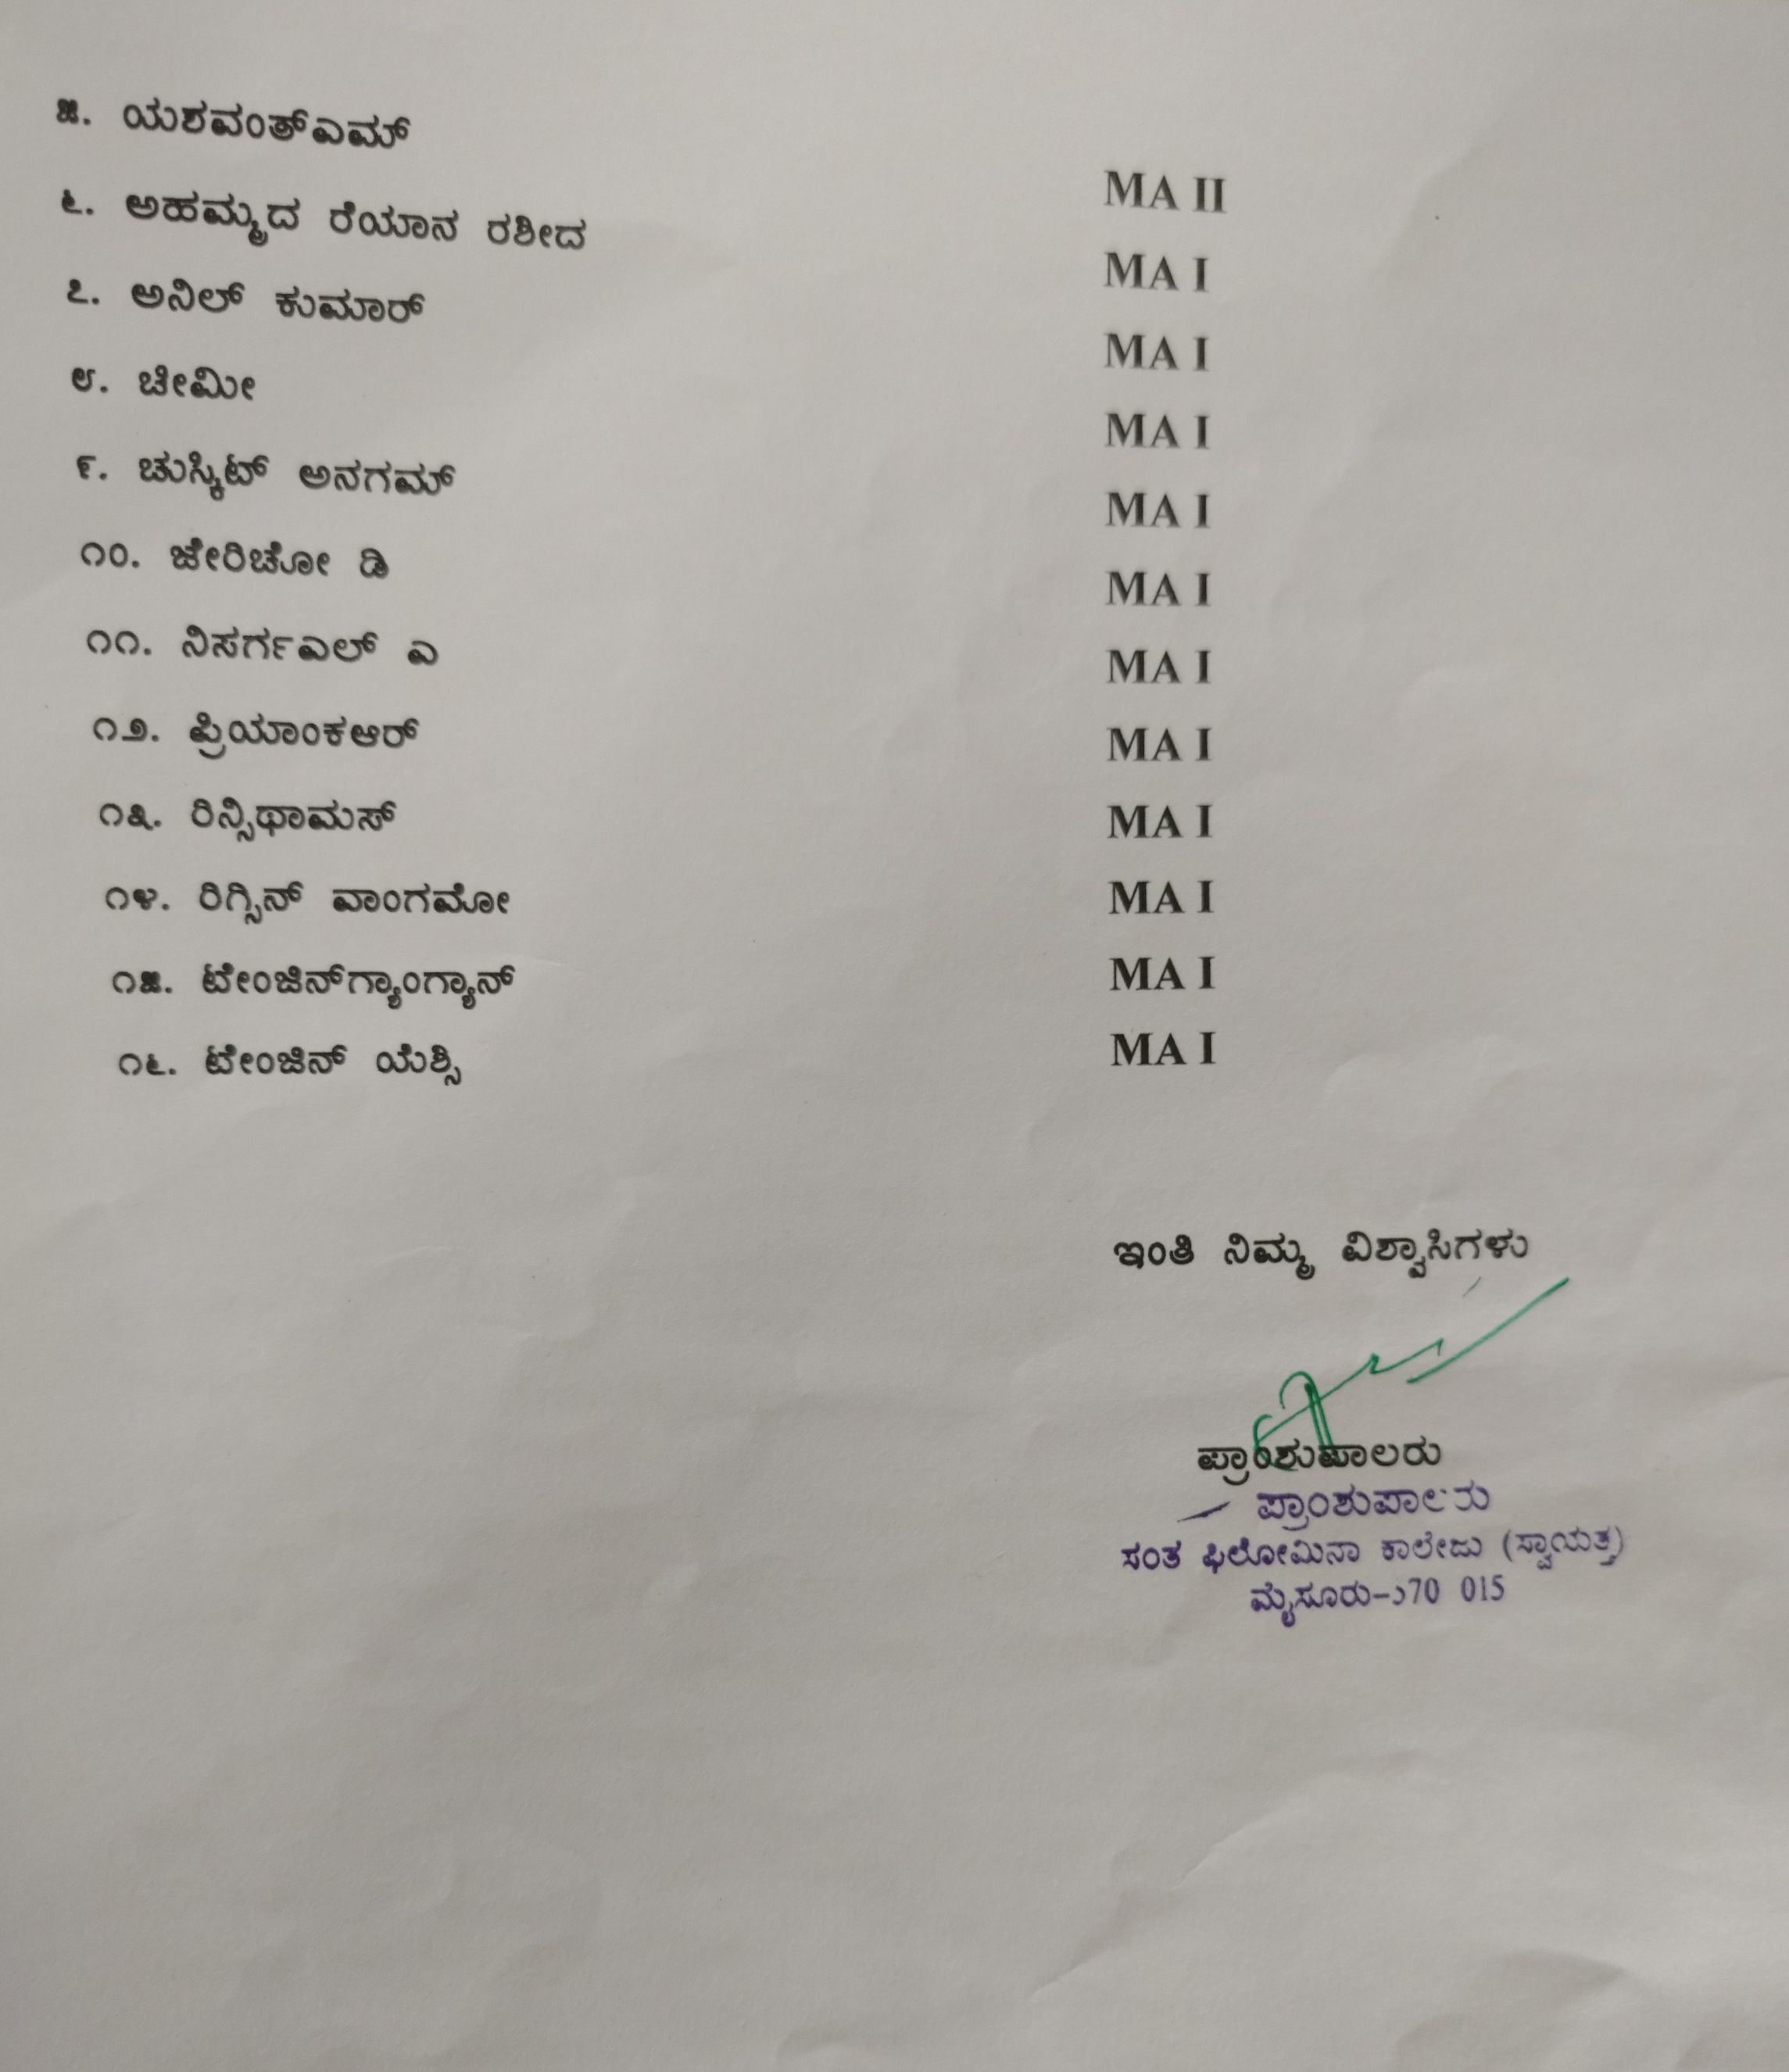

ST.PHILOMENA’ S COLLEGE (AUTONOMOUS), MYSURU – 570015
Visit to VidhanaSoudha, Bangalore, to witness live Karnataka State Budget session 2023-24
On 17th February 2023
Feedback Analysis
 |  | 1=Not Satisfactory | 2=Satisfactory | 3= Good | 4=Very Good
1 | Selection of Place | 0 | 0 | 5 | 7
2 | About live budget session | 0 | 0 | 4 | 8
3 | Overall organization of the Visit | 0 | 1 | 6 | 5
4 | Overall performance of the Visit | 0 | 0 | 4 | 8
 | a. Quality of Programme | 0 | 0 | 5 | 7
 | b. Practical and Skill aspects | 0 | 0 | 5 | 7
 | c. Usefulness | 0 | 0 | 6 | 6
 | d. Maintenance of Time Schedule | 0 | 0 | 11 | 1

ST. PHILOMENA’S COLLEGE (Autonomous), MYSORE – 570 015
PG Department of Economics
******
MINUTES OF THE STAFF COUNCIL MEETING
Date: 20th February 2023. Venue: PG Department. Time: 1.30 Pm.
THE FOLLOWING MEMBERS WERE PRESENT
Sl. No | Name of the Staff Member | Designation | Signature
 | Dr. Nandeesha H K  Assistant Professor | Chairperson
 | Dr. Ashwini K J  Assistant Professor | Member SPC

Agenda:
- Placing the minutes of the previous meeting for approval.
- Presentation of the education visit report
- The outcomes of the live budget session visit.

The Chairperson of the council welcomed the, Members and commenced the meeting.
Agenda-1: Placing the minutes of the previous meeting for approval.
The chairperson placed the minutes of the previous meeting and sought the members’ approval. After deliberation on behalf of the members present Dr. Nandeesha proposed the approval and Dr.Ashwini K J supported it.
Decision :Approved

- Agenda-2: Presentation of the education visit report
The chairperson placed the visit report which was circulated to the members two days before the meetingand sought the members’ approval.
Decision :Approved

Agenda-3: The outcomes of the Live budget session visit.
The Chairperson who had accompanied the students during the visit briefed the members at Vidhana Saudha Bangalore. The students witnessed a live budget session which presented by Chief Minister of Karnatakaat Legislative Assembly hall. This live budget session helped the students of Economicsto understand the budget allocation with live experience. In total the educational visit gave the students and faculties a refreshing, enlightening, learning experience through visit the Vidhana Saudha. It was a wonderful experience which was helped to gain immense knowledge to the students.

Resolution
- Resolved to approve the visit report placed in the staff council.
- Resolved to approve the outcome of the tour.
- Resolved to implement to include in the future educational tours to visit to nationalised banks, reputed financial institutions.

Dr. Nandeesha H K
Chairperson
****************************************

