Unit -1
What is communication and explain?
Communication is the act of giving, receiving, and sharing information -- in other words, talking or writing, and listening or reading. Good communicators listen carefully, speak or write clearly, and respect different opinions.
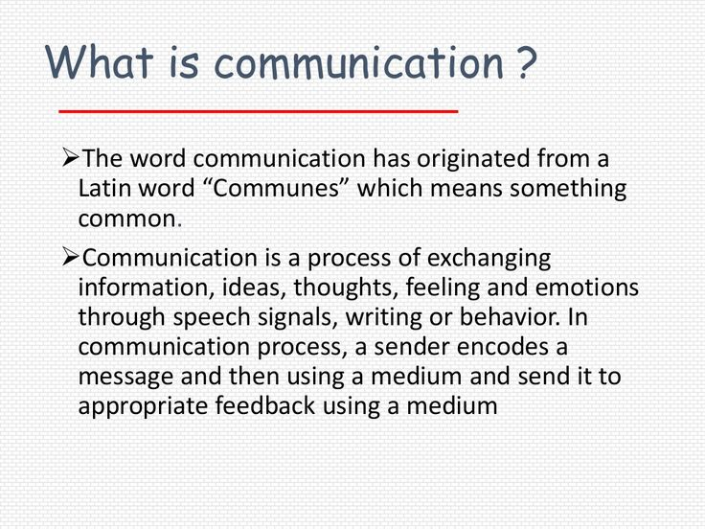

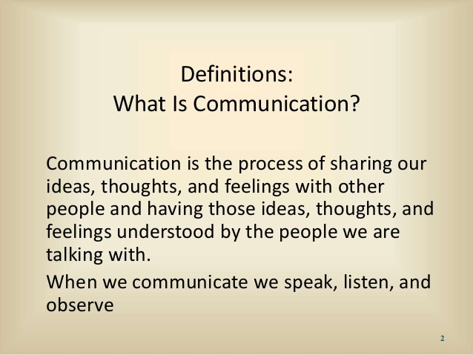
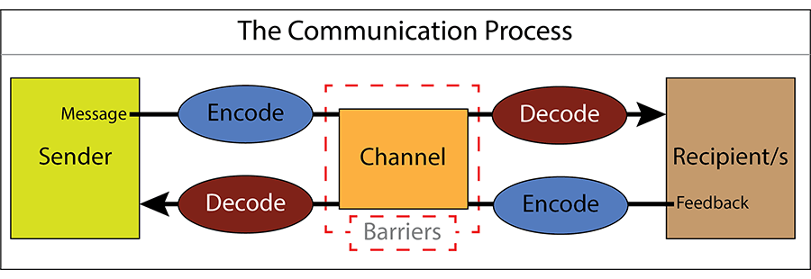
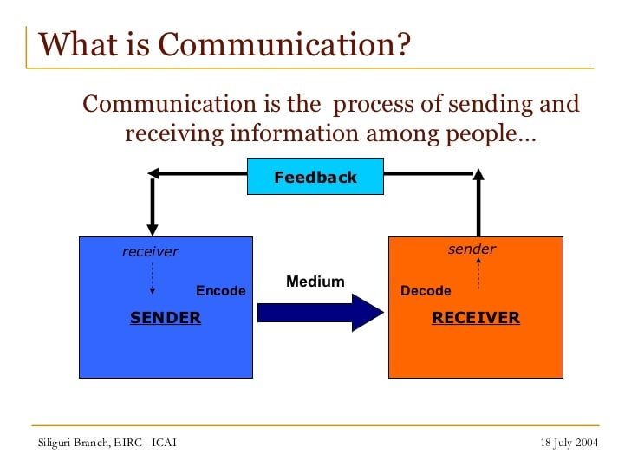
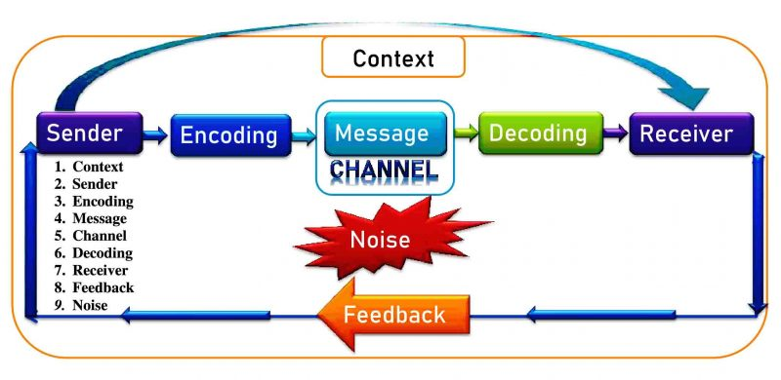
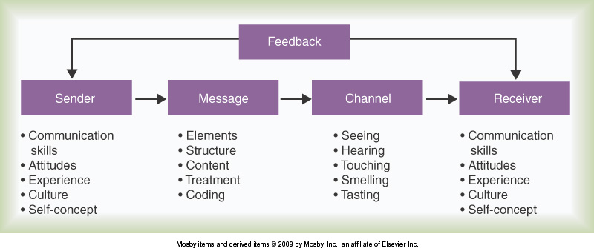

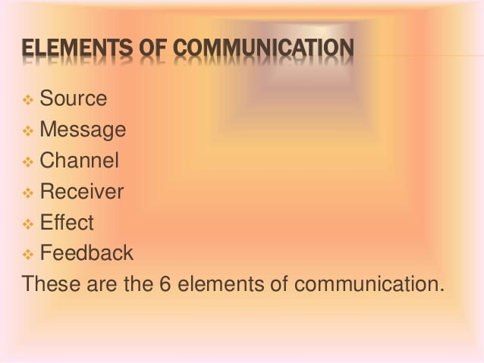
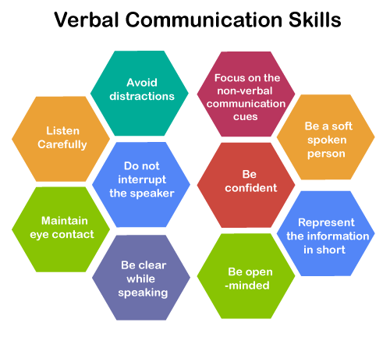
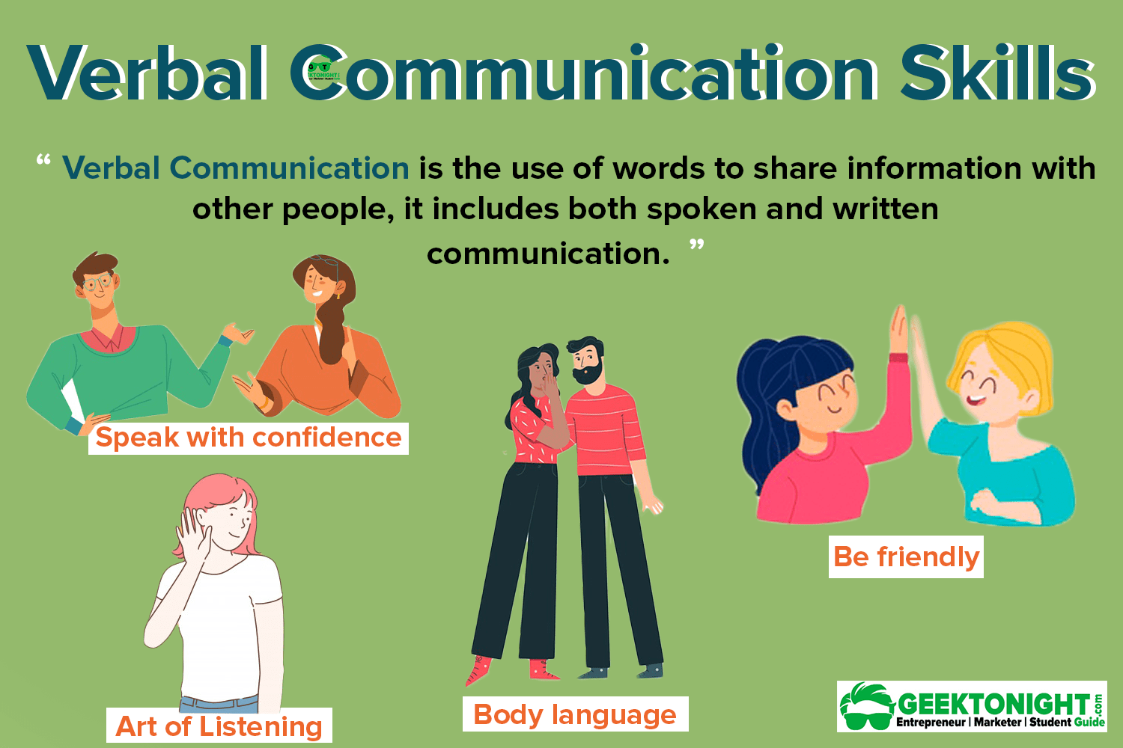
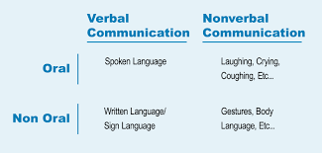

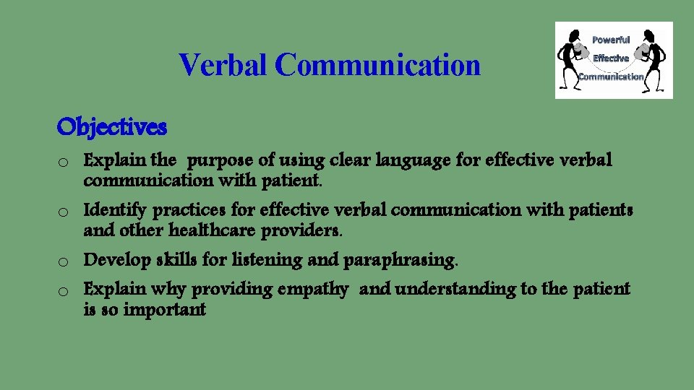
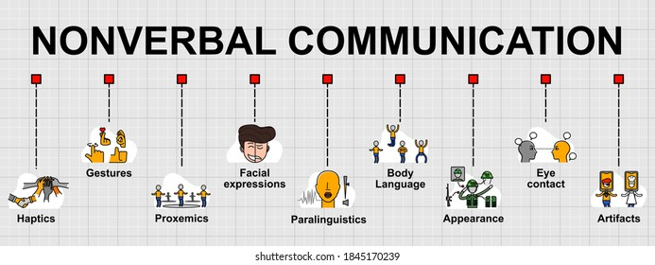

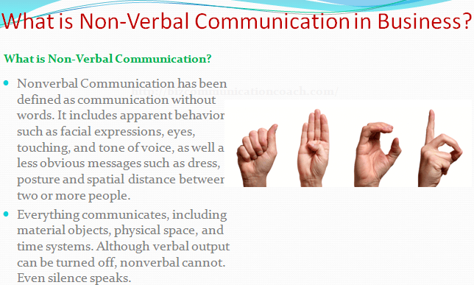

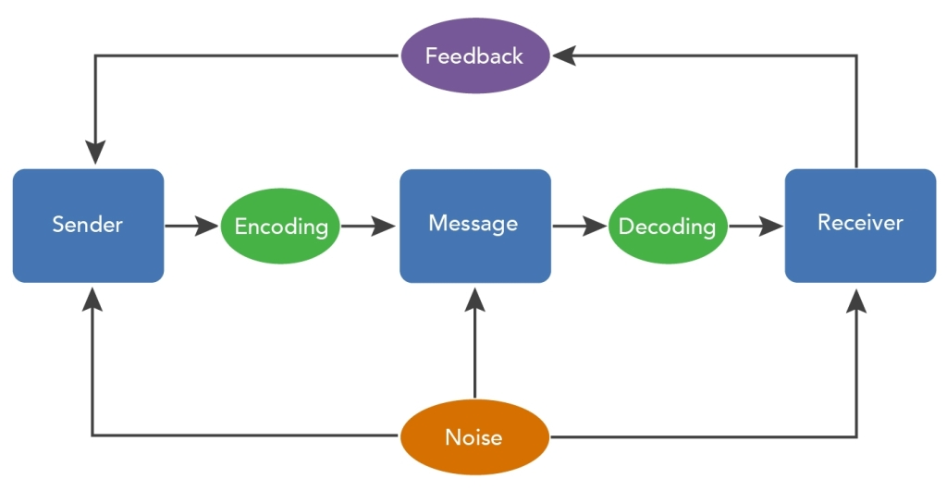
UNIT-2
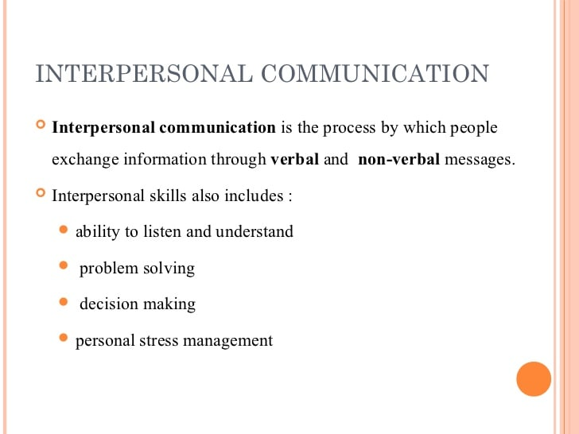
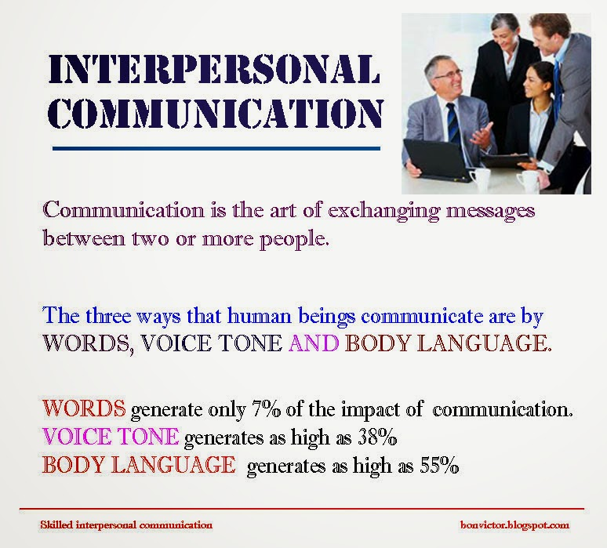
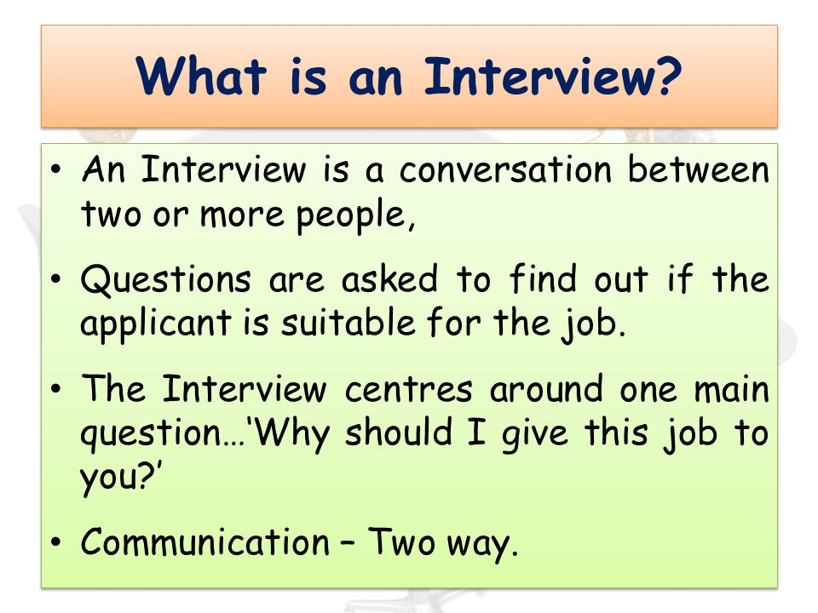
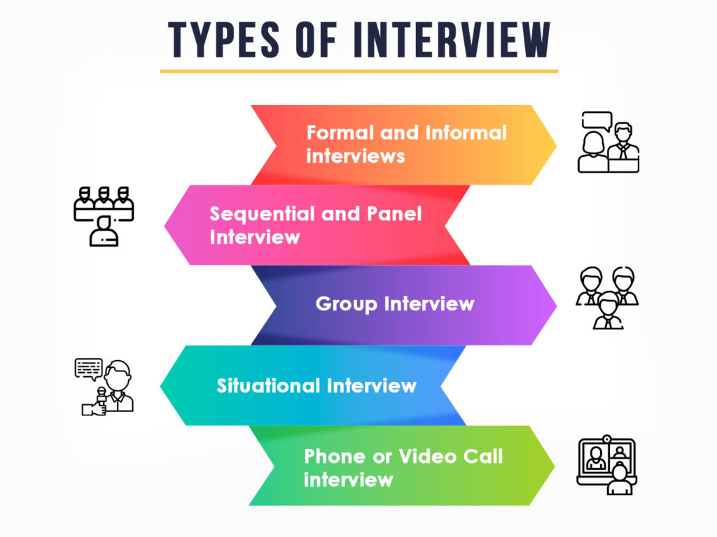
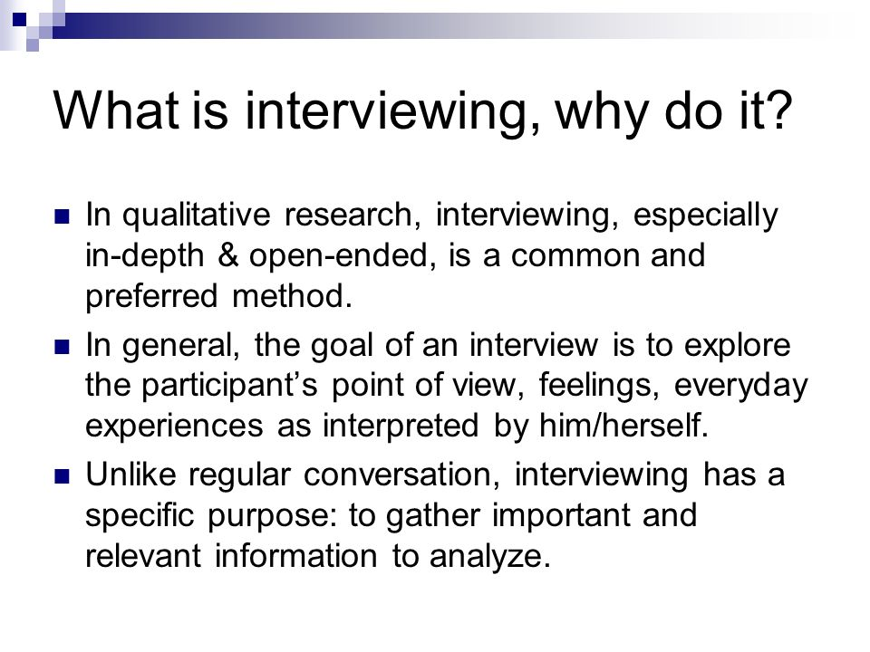
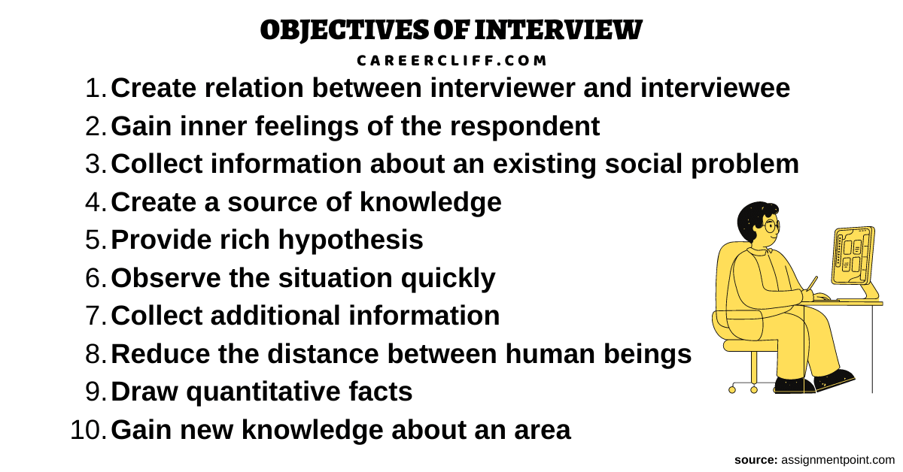
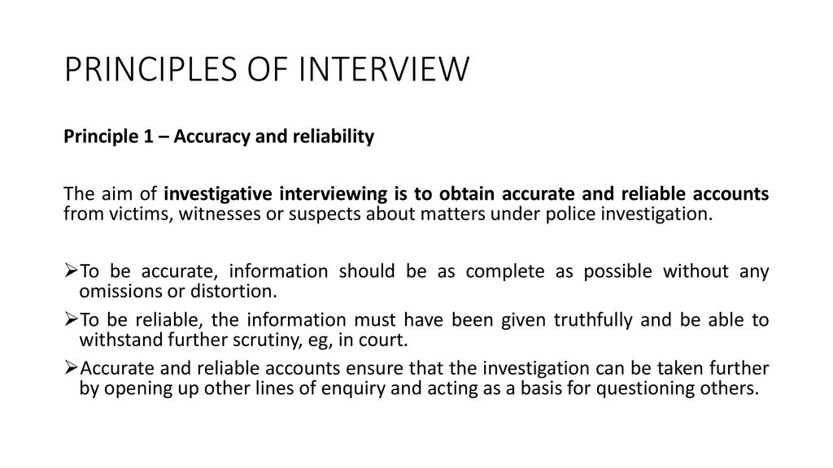

4 principles of interviews
- Prepare carefully, familiarizing yourself with as much background as possible.
- Establish a relationship with the source conducive to obtaining information.
- Ask questions relevant to the source that induce the source to talk.
- Listen and watch attentively.

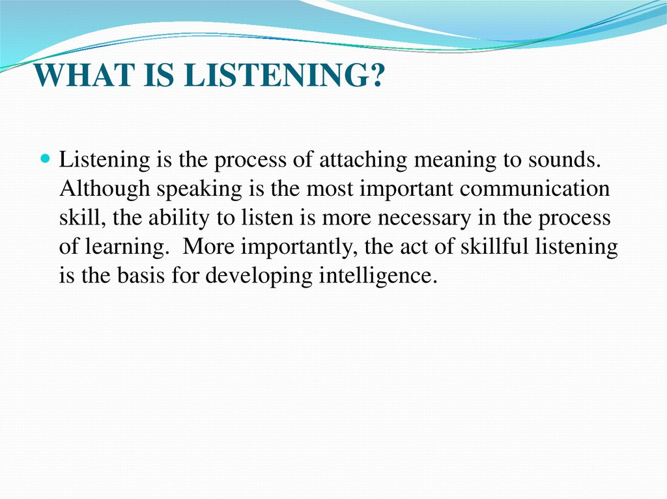
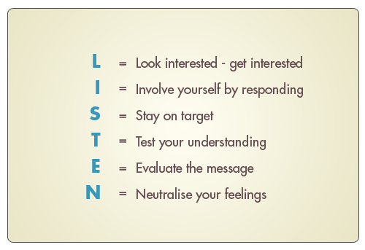
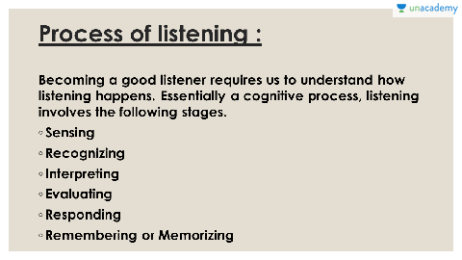

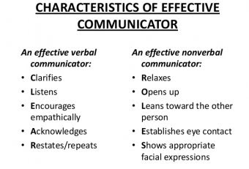

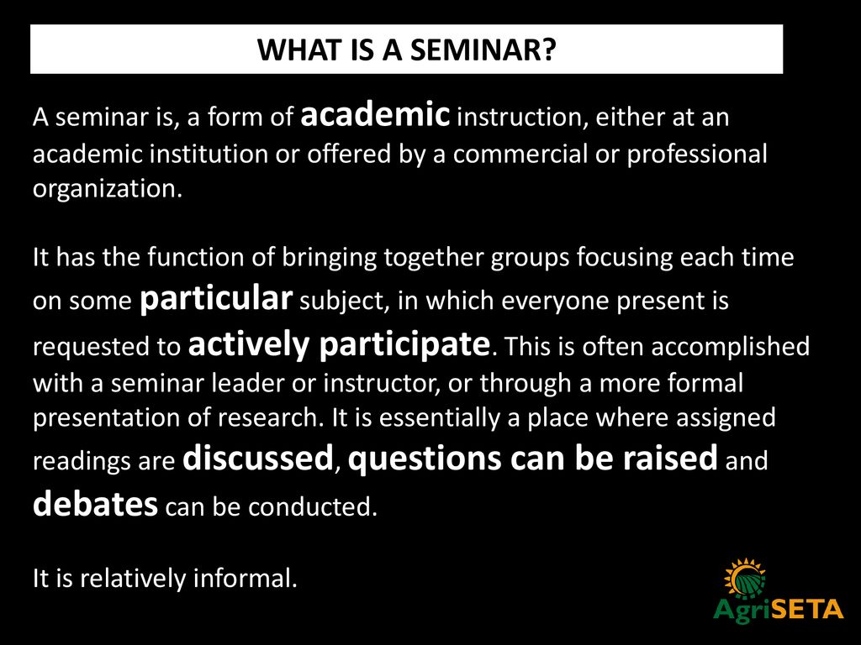

conference objectives
The conference is also a space for creating collaborative links between academics and professional practitioners and their workplaces, aiming at long-term sharing of knowledge and discussions of highly current issues. ...

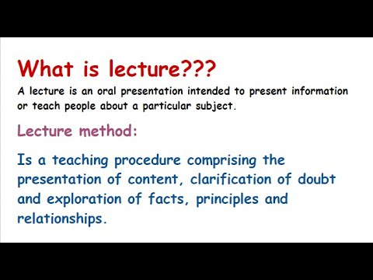

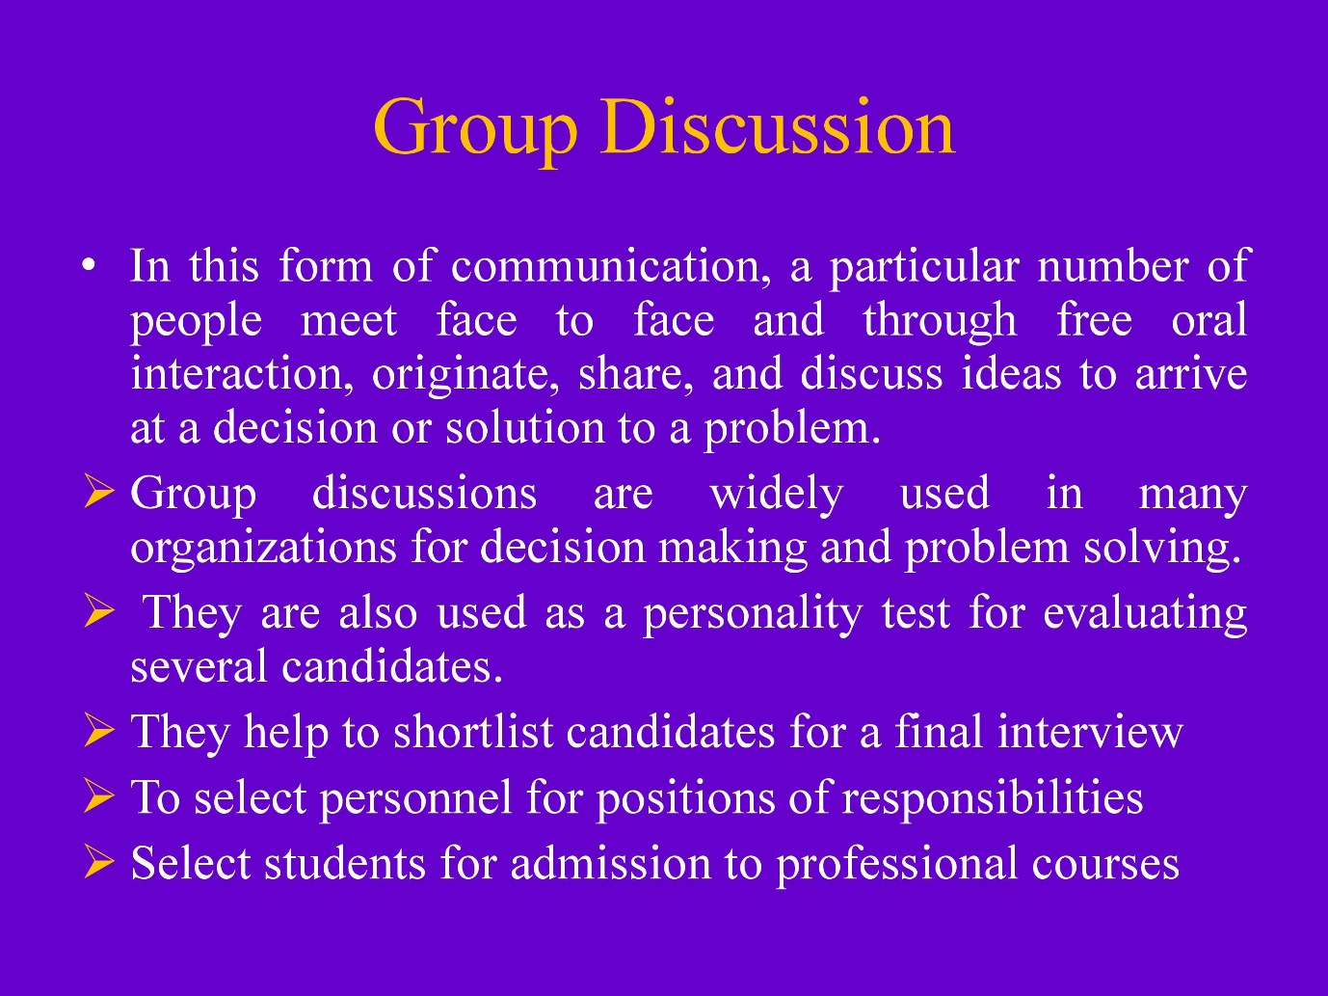

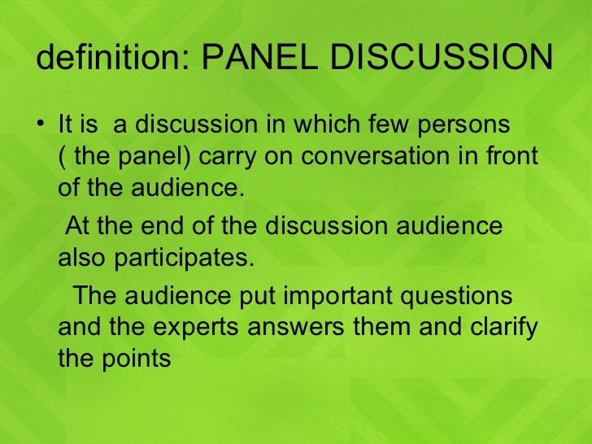
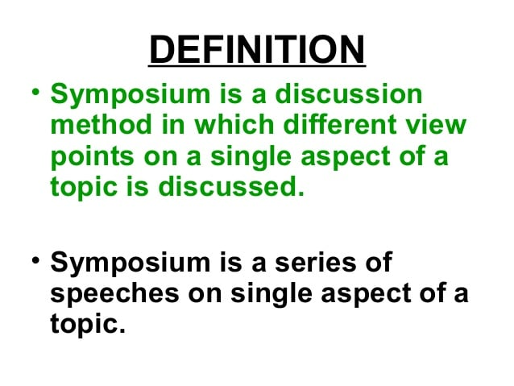

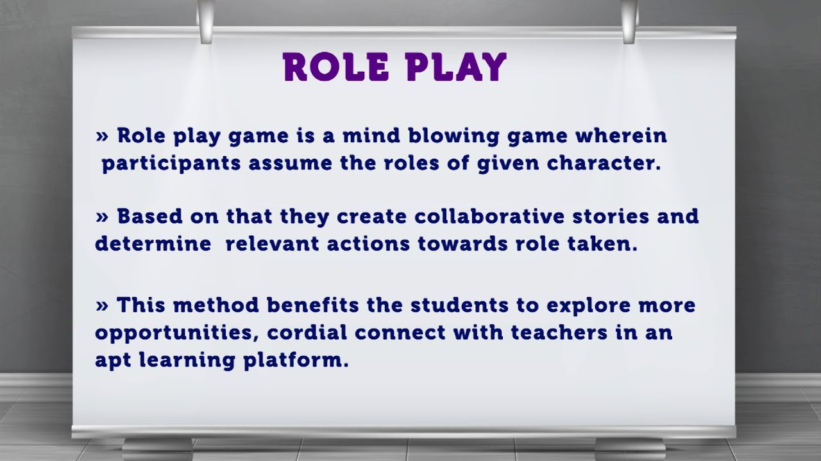

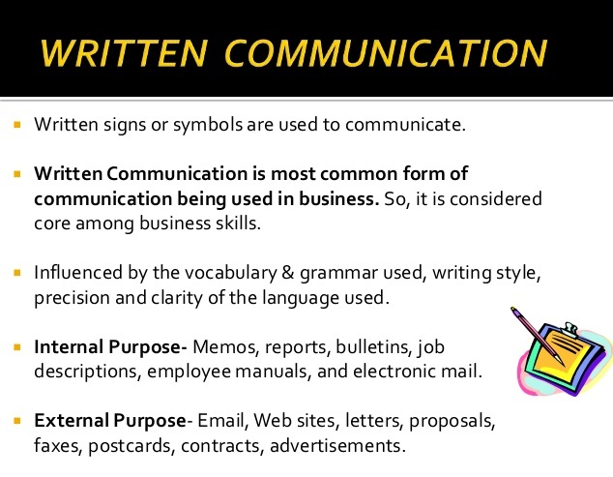
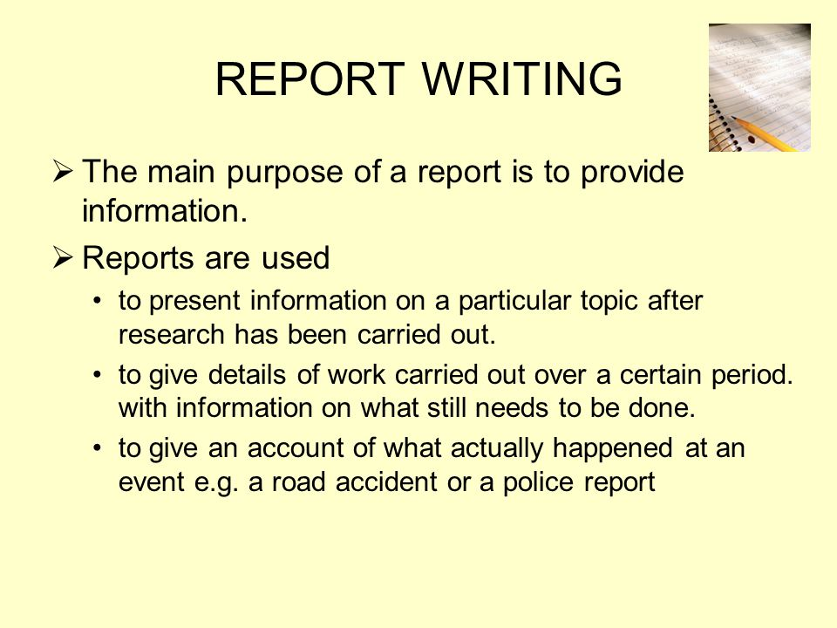
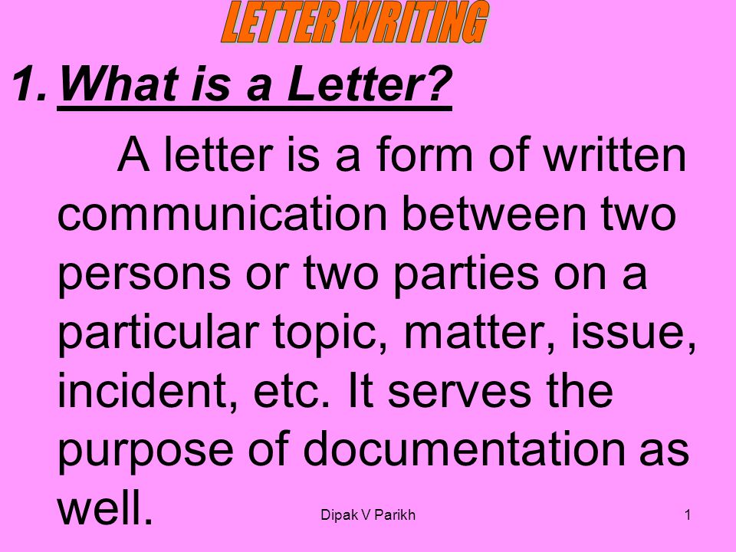

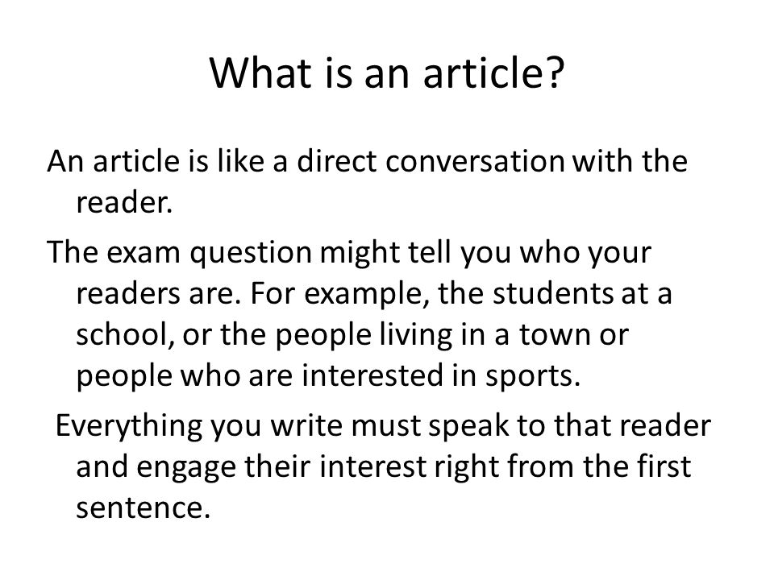

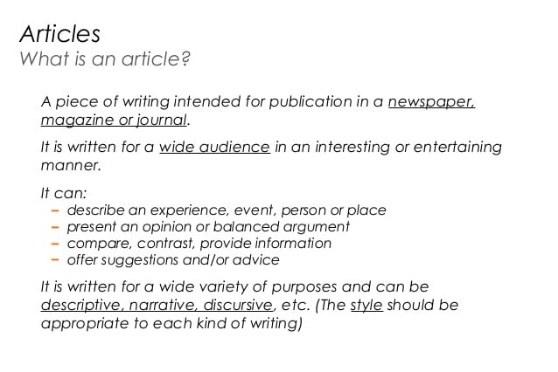
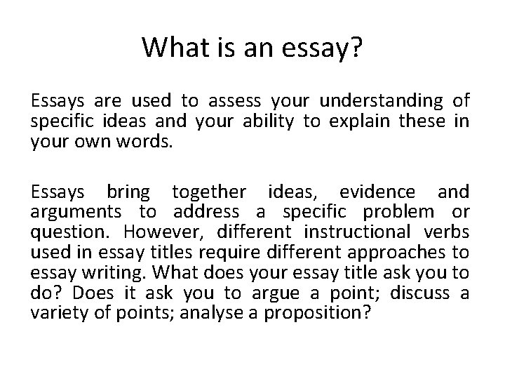
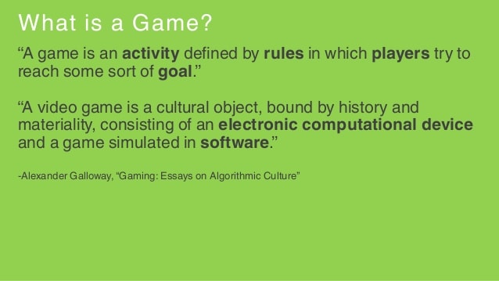
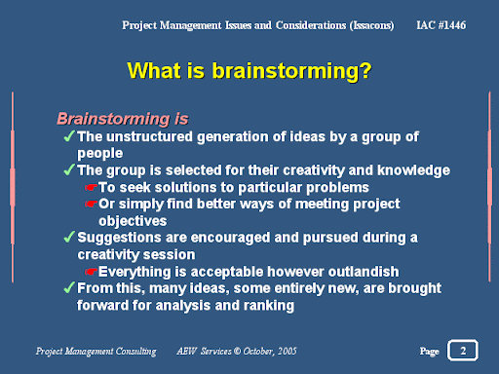
Street theatre is a form of theatrical performance and presentation in outdoor public spaces without a specific paying audience. ... Nowadays, street play is used to convey a message to the crowd watching it. Street play is considered to be the rawest form of acting, because one does not have a microphone or loud speakers.
What does one act play and street play mean?
A one-act play is a play that has only one act, as distinct from plays that occur over several acts. One-act plays may consist of one or more scenes.
What does field work mean?
uncountable noun. Fieldwork is the gathering of information about something in a real, natural environment, rather than in a place of study such as a laboratory or classroom.
Unit-3
Visual aids are items of a visual manner, such as graphs, photographs, video clips etc used in addition to spoken information. ... Reduce the amount of spoken words, for example, you may show a graph of your results rather than reading them out. Clarify and show examples
visual aids
: an instructional device (such as a chart, map, or model) that appeals chiefly to vision especially : an educational motion picture or filmstrip.

It is used for making an announcement or appeal, issuing a notice, advertising a product, or bringing about awareness on any issue of public interest. The art of making a poster is called "Poster Making".09-May-2021
What is poster making in simple words?
A poster is a large-sized sheet of paper that is used for the promotion of an event, product, or idea. Generally, it contains both graphical and textual content. A poster aims to grab the attention of the mass public. A poster is designed in a way that is informative and attractive at the same time.

A bulletin board (pinboard, pin board, noticeboard, or notice board in British English) is a surface intended for the posting of public messages, for example, to advertise items wanted or for sale, announce events, or provide information.
What do you mean by flipchart?
: a chart that consists of a series of large pieces of paper which are attached at the top and which are used to present information to an audience by turning over one piece of paper at a time.

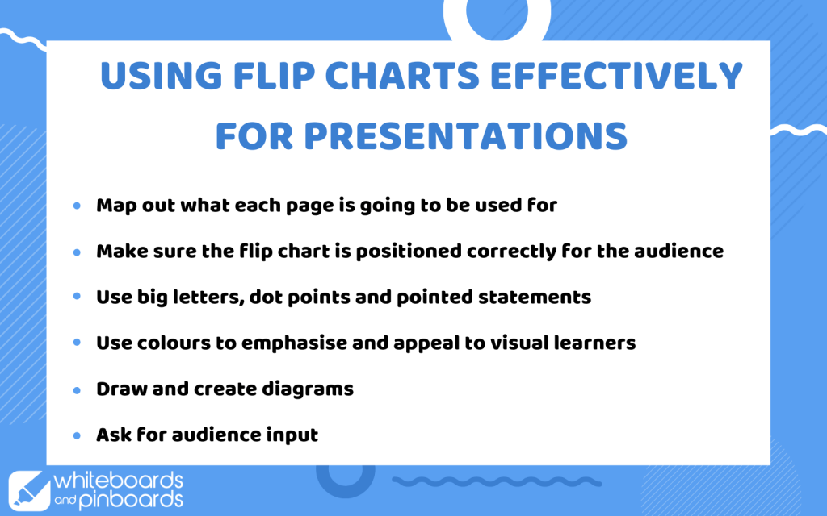

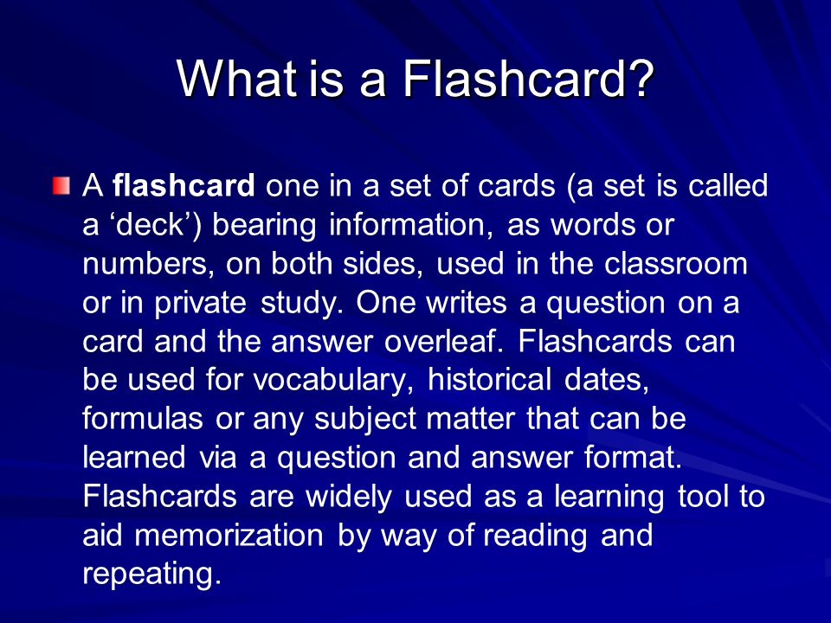
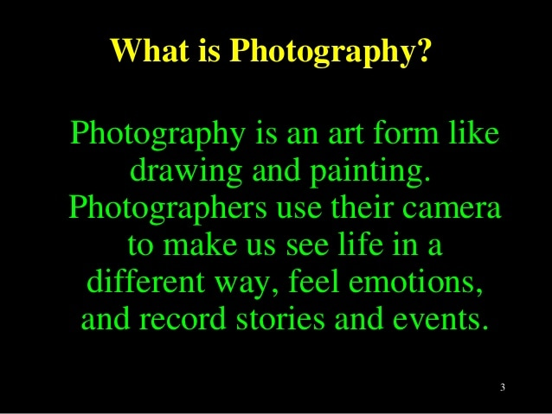
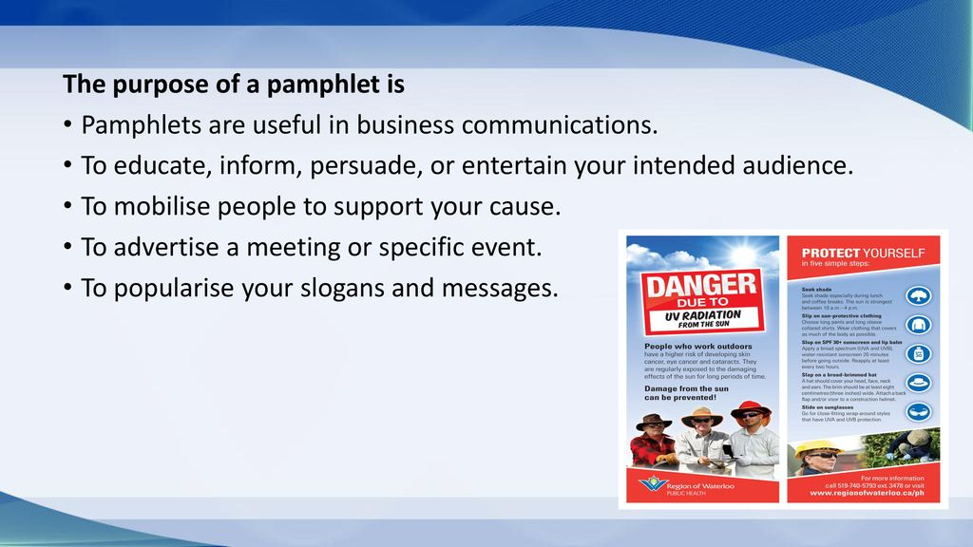

slide show
a presentation of photographic slides, or images on a transparent base, placed in a projector and viewed sequentially on a screen. a presentation of digital images, sometimes with text, viewed in progression on a screen.
What do you mean by mass communication?
Answer: Mass communication (or communications) can be defined as the process of creating, sending, receiving, and analyzing messages to large audiences via verbal and written media. ... These mediums are wide-ranging, and include print, digital media and the Internet, social media, radio, and television.
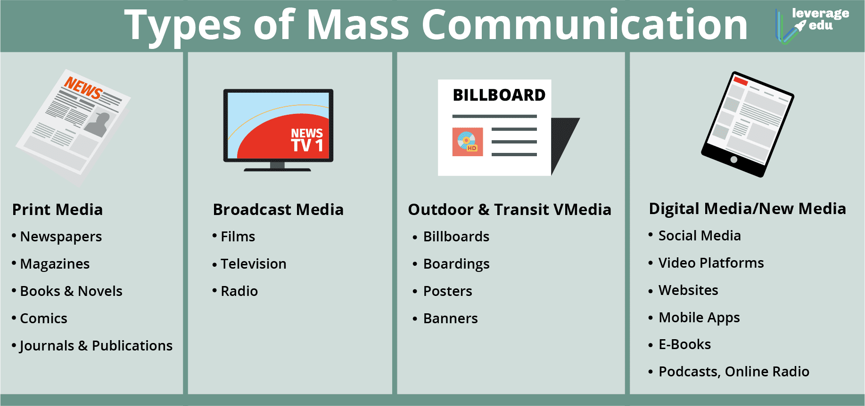
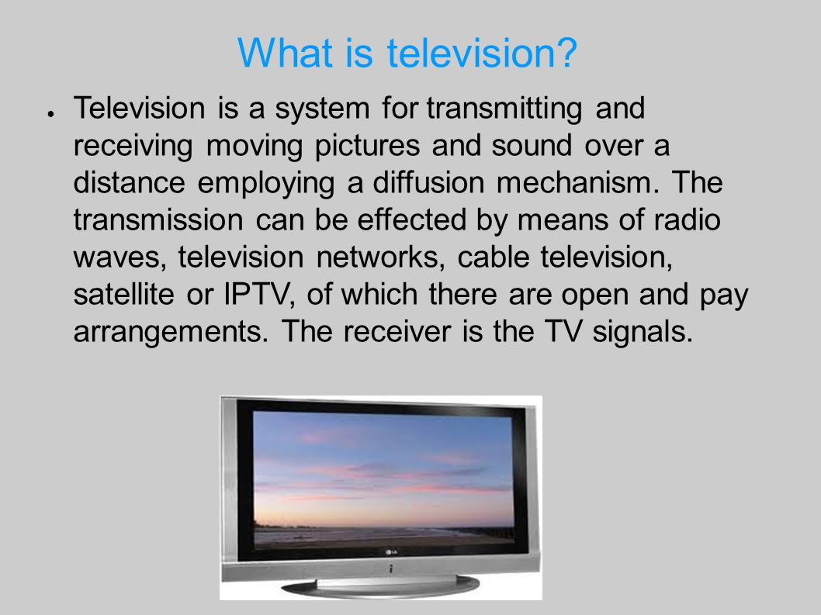

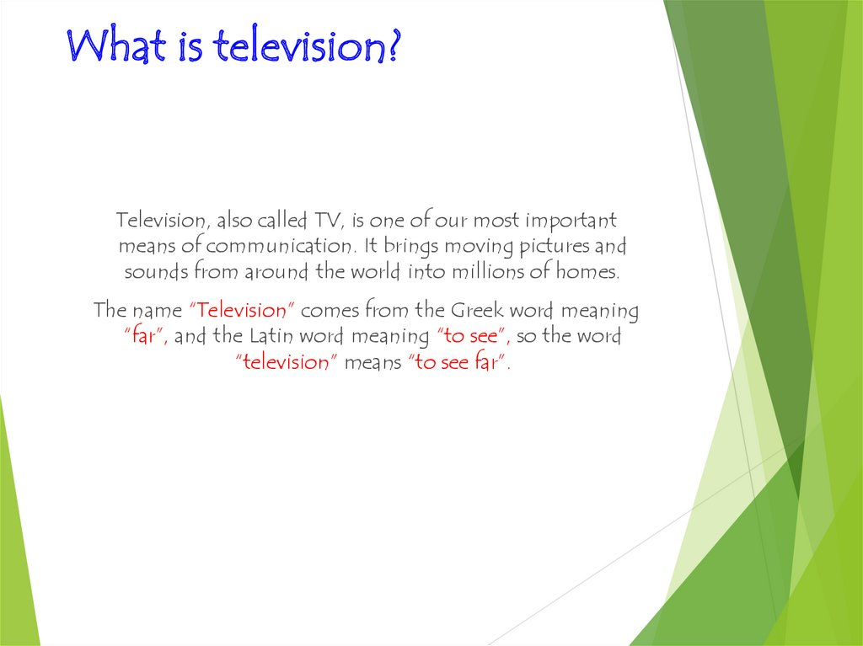
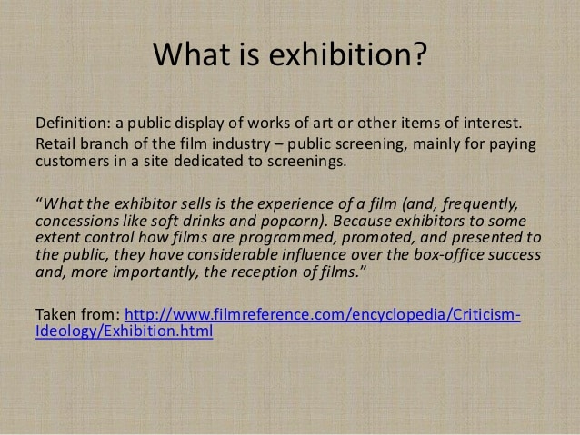
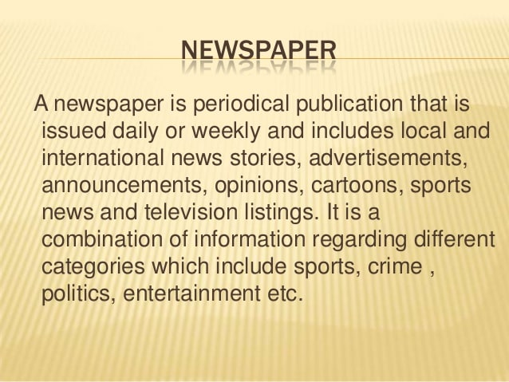

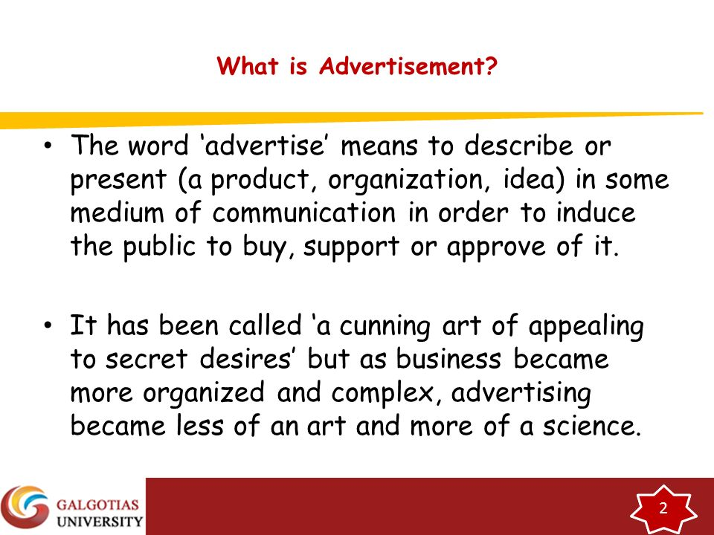
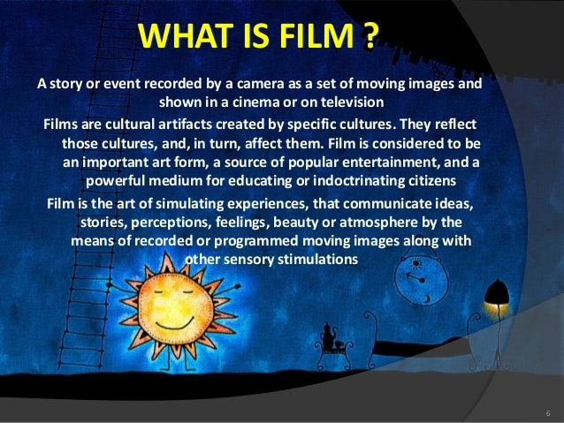
A video compact disc (VCD) is a digital video format used for storing video on standard compact discs. Video compact discs can be played on dedicated video compact disc players, personal computers and other players such as DVD players.
DVD
DVD, in full digital video disc or digital versatile disc, type of optical disc used for data storage and as a platform for multimedia.
What is radio and its uses?
radio: Uses of Radio Waves
The prime purpose of radio is to convey information from one place to another through the intervening media (i.e., air, space, nonconducting materials) without wires. Besides being used for transmitting sound and television signals, radio is used for the transmission of data in coded form

Communication planning represents the dedication of an organization to transparent and ongoing relationships with stakeholders. It defines the ways and means of communication, targeted audiences, and attitudes or behaviours outreach should impact.
communication planning process
The communications planning process concerns defining the types of information you will deliver, who will receive it, the format for communicating it, and the timing of its release and distribution.
- Communication analysis uses a variety of techniques, which not only focus on words spoken, but may also consider other features such as intonation, pitch, tempo, and nonverbal cues such as posture and gesturing. Learn more in: Measuring Shared Mental Models in Unmanned Aircraft Systems.
How do you analyze communication?
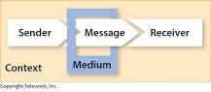

To analyze a communication situation, simply lead students through a discussion about the five parts:
- Who is the sender?
- What is the message?
- What is the medium?
- Who is the receiver? What is context ?
6 methods of communication?
Image result for various methods of communication
As you can see, there are at least 6 distinct types of communication: non-verbal, verbal-oral-face-to-face, verbal-oral-distance, verbal-written, formal and informal types of communication.
Facebook is a website which allows users, who sign-up for free profiles, to connect with friends, work colleagues or people they don't know, online. It allows users to share pictures, music, videos, and articles, as well as their own thoughts and opinions with however many people they like.
Twitter is a service for friends, family, and coworkers to communicate and stay connected through the exchange of quick, frequent messages. People post Tweets, which may contain photos, videos, links, and text. These messages are posted to your profile, sent to your followers, and are searchable on Twitter search.
For many young people, YouTube is used to watch music videos, comedy shows, how to guides, recipes, hacks and more. Teens also use the video-sharing service to follow their favourite vloggers (video blogger), subscribe to other YouTubers and celebrities they are interested in.
WhatsApp uses the internet to send messages, images, audio or video. The service is very similar to text messaging services, however, because WhatsApp uses the internet to send messages, the cost of using WhatsApp is significantly less than texting.
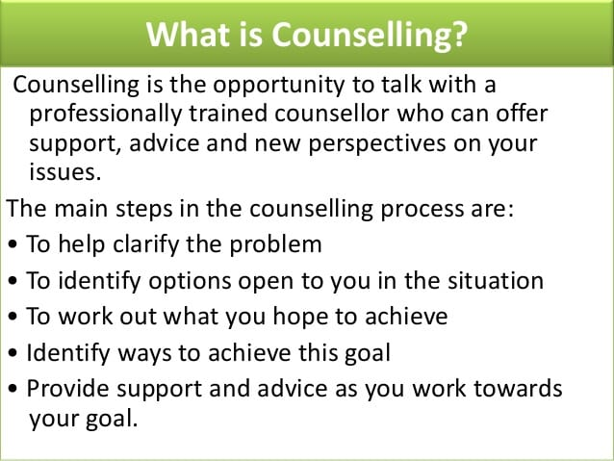
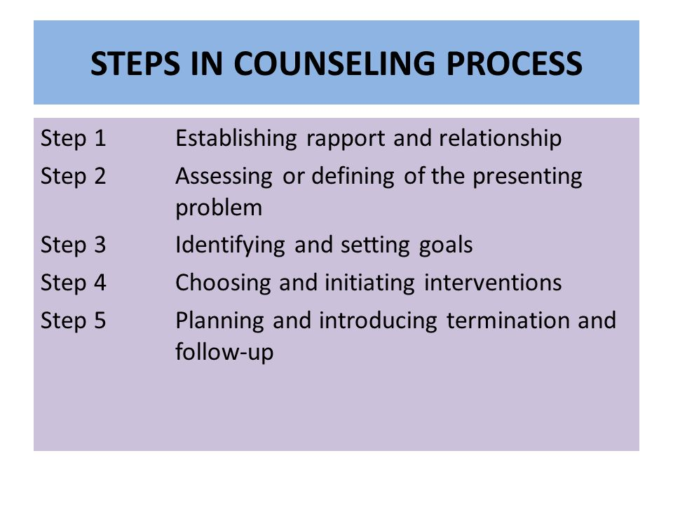
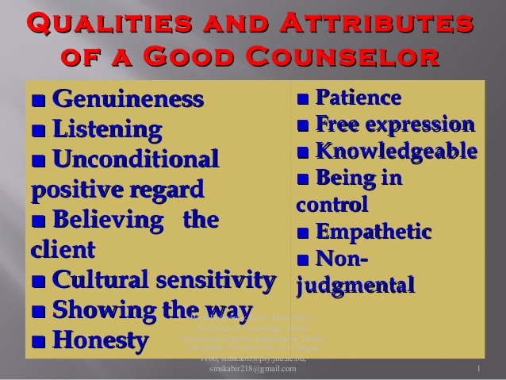

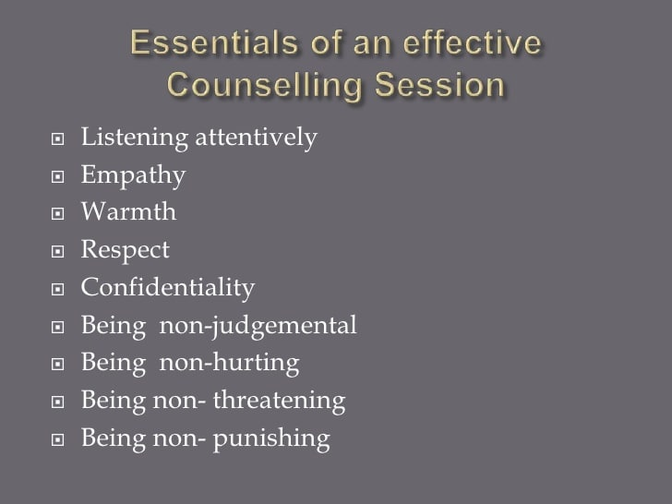

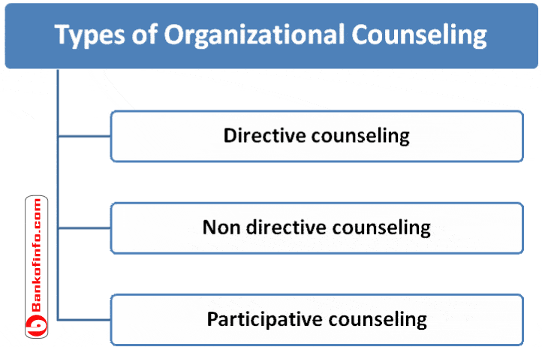
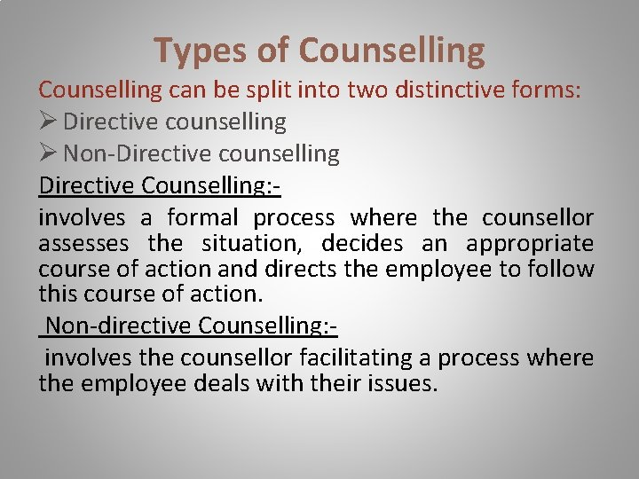
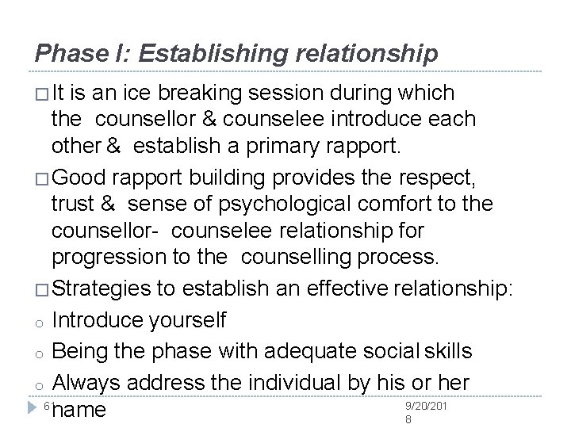
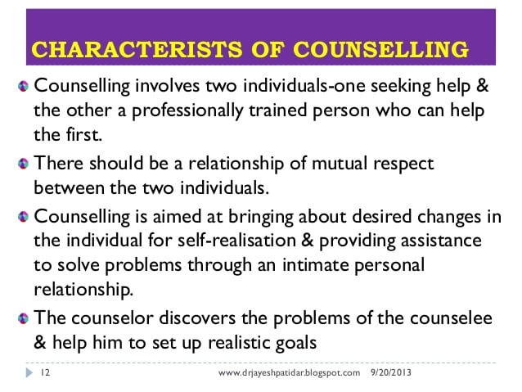
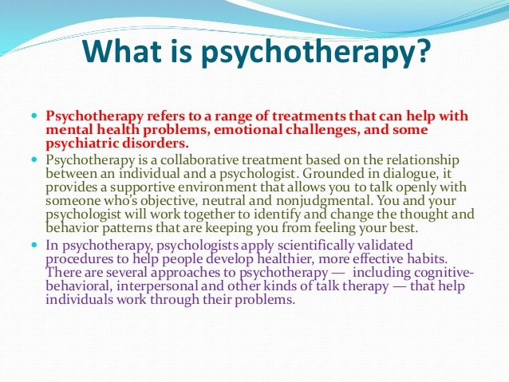
Unit-4
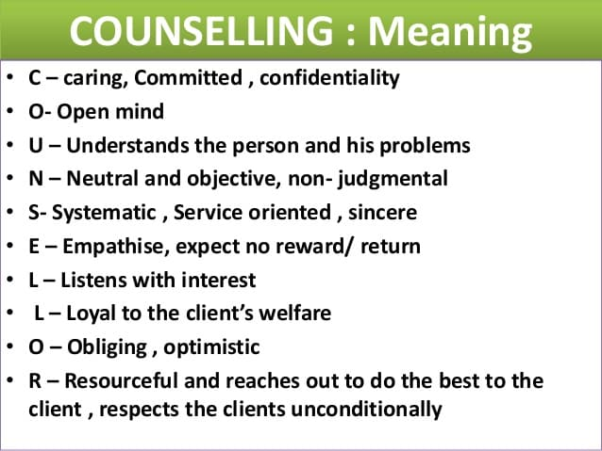
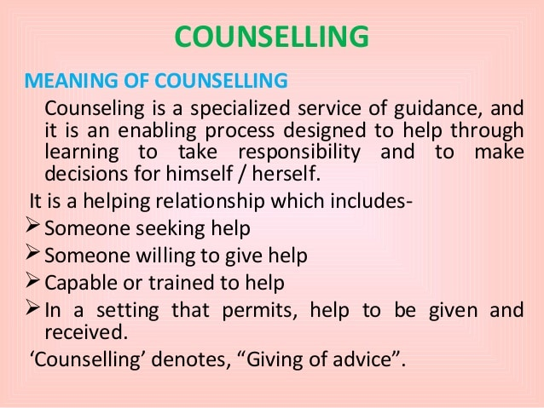
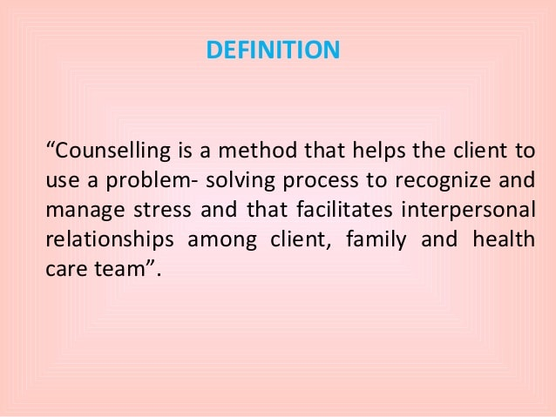
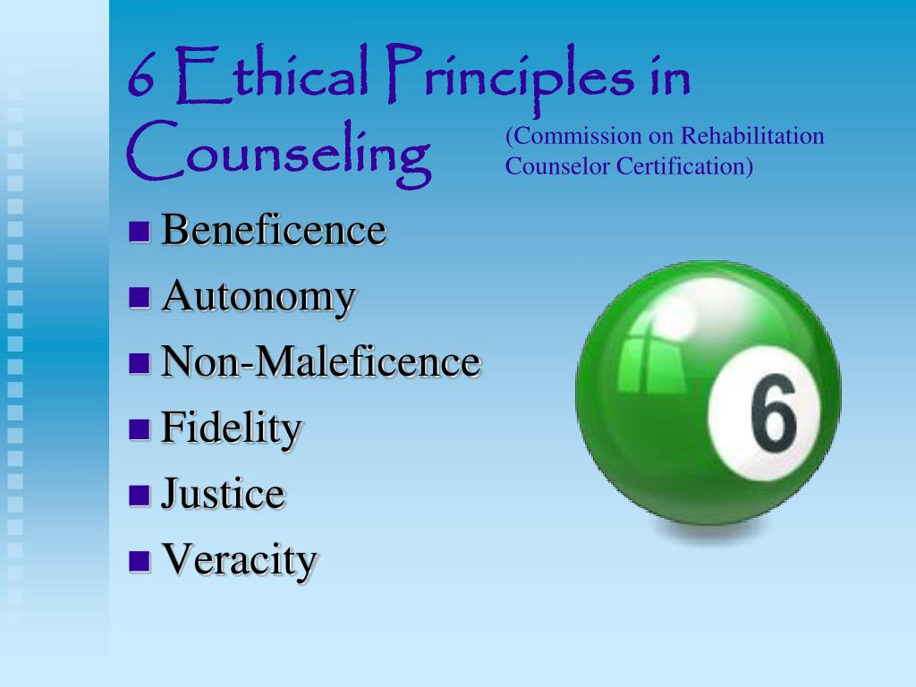
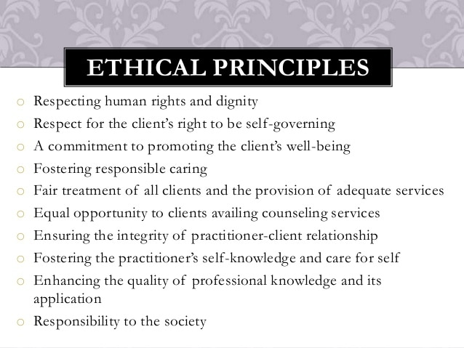
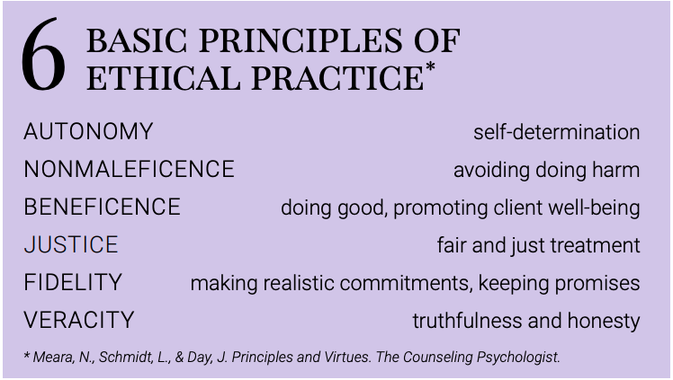

Unit-5
“Scope of practice is the area of the profession in which a counsellor has the knowledge, skills and experience to practise competently, safely and lawfully, in a way that meets standards and does not pose any danger to the public or to themselves.
scope of practice mean in counseling
Scopes of practice (SOPs) define which services a state or territory allows a licensed or certified professional to perform. These essential constructs can vary by state, potentially leading to service coverage gaps on a national scale.
Counseling is a collaborative effort between the counselor and client. Professional counselors help clients identify goals and potential solutions to problems which cause emotional turmoil; seek to improve communication and coping skills; strengthen self-esteem; and promote behavior change and optimal mental health.
Counselling practices
Counselling is a relational process based upon the ethical use of specific professional competencies to facilitate human change. Counselling addresses wellness, relationships, personal growth, career develop, mental health, and Page 4 4 psychological illness or distress.
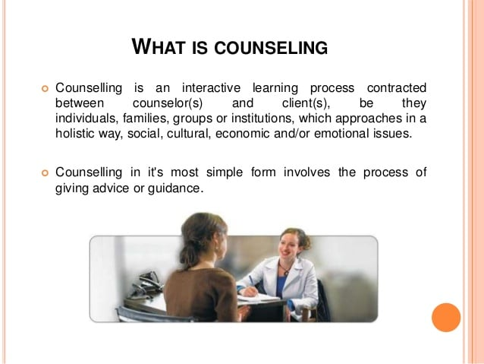

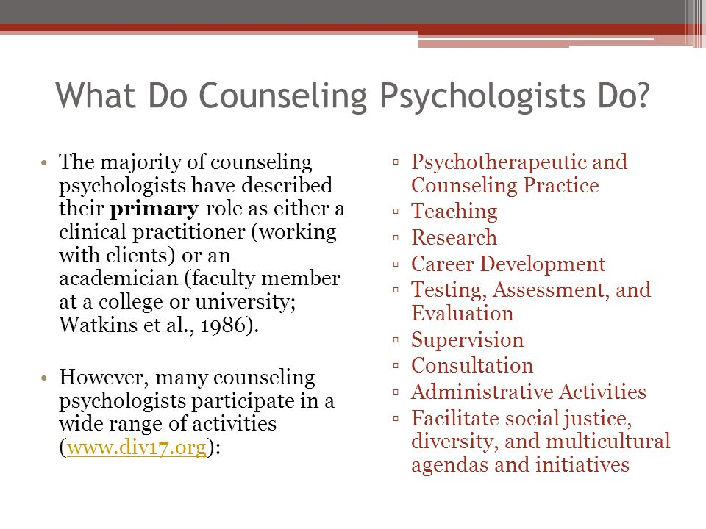

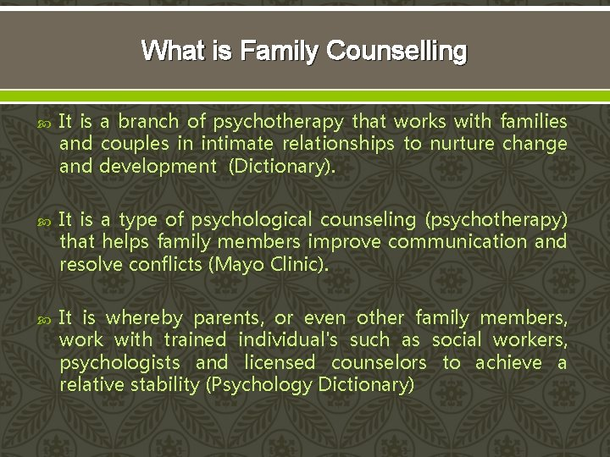

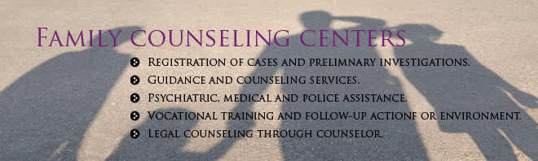
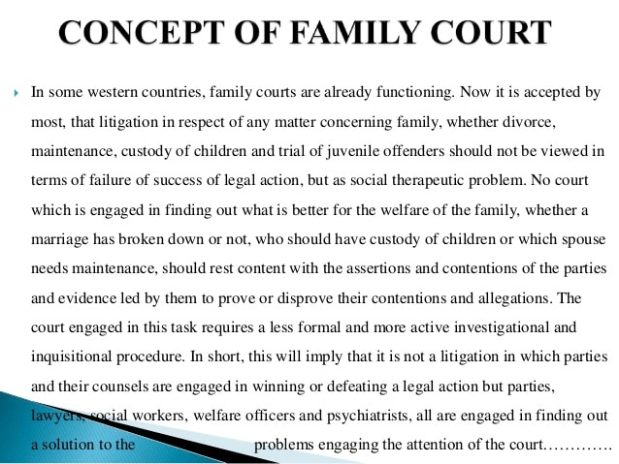
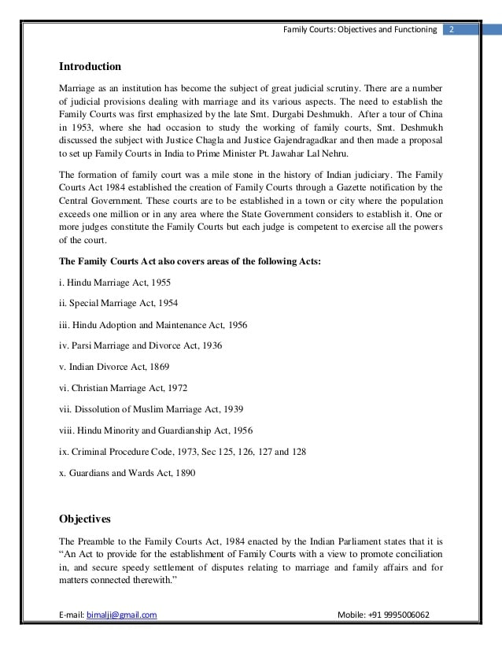
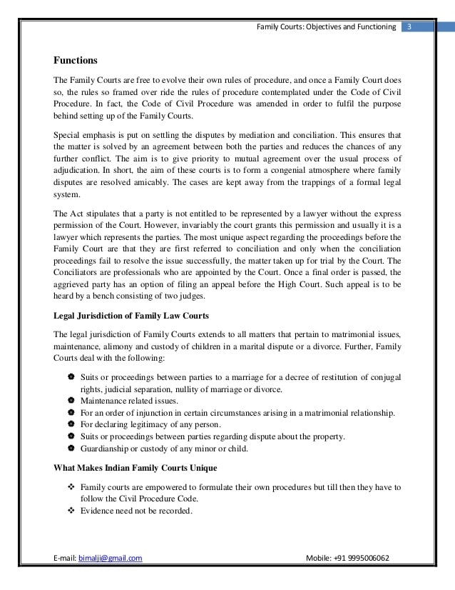
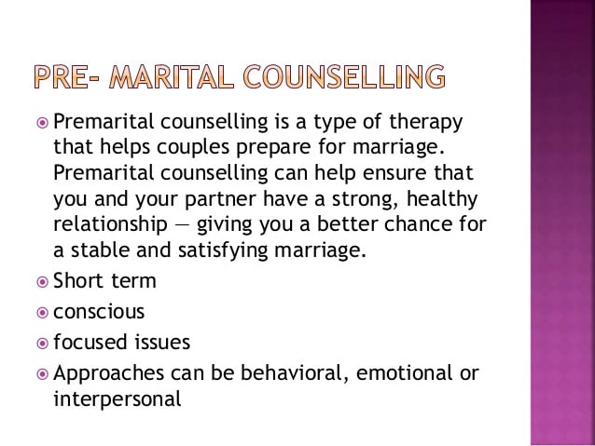

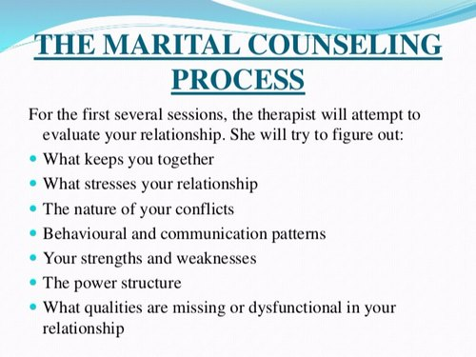
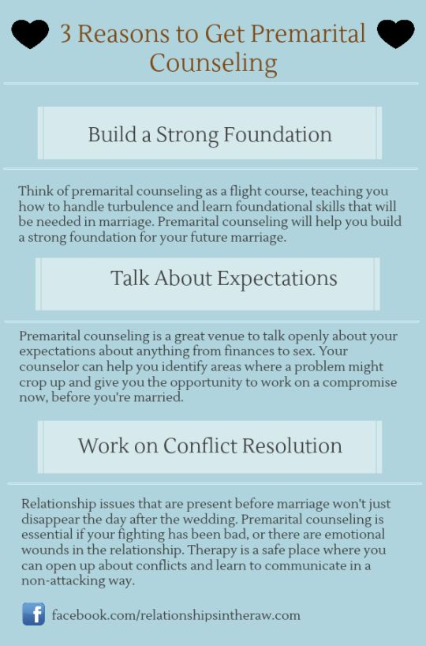
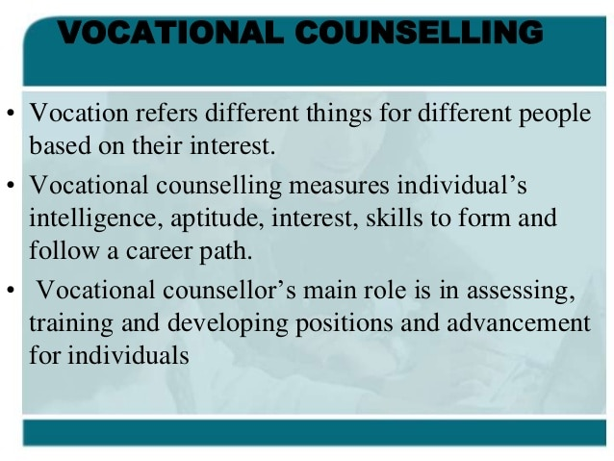

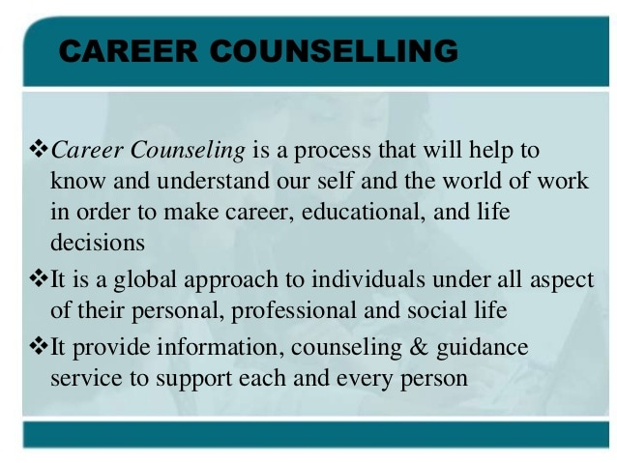
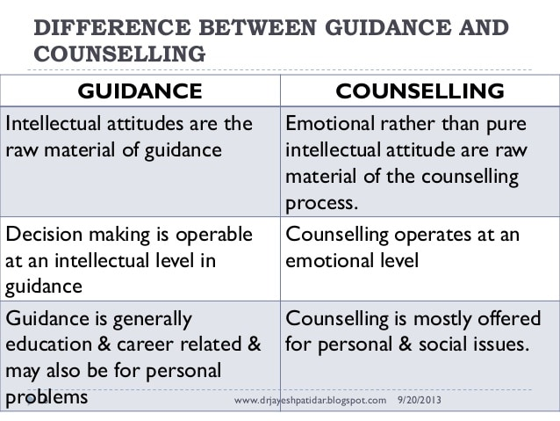
vocational career Counselling
DEFINITION: Vocational and career counseling consists of those activ- ities performed or coordinated by individuals who have the professional credentials to work with and counsel other individuals or groups of in- dividuals about occupations, careers, life-career, career decision making, career planning, career pathing ...
types of career counseling
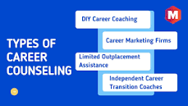

Types of Career Counseling
- DIY Career Coaching ( Self-Directed Job Search) Most people are on a self-directed job hunt and they do not have the option of seeking help from a career coach. ...
- Career Marketing Firms. ...
- Limited Outplacement Assistance. ...
- Independent Career Transition Coaches.
Karnataka
- National Institute of Mental Health and Neurosciences, Bangalore.
- Dharwad Institute of Mental Health and Neurosciences, Dharwad.
Article - Top 20 psychiatric hospitals in India
- Dr. ...
- Sukoon Healthcare, Gurugram. ...
- Father Muller Medical College And Mental Health Centre, Mangalore. ...
- Athma Hospitals, Tiruchirappalli. ...
- Schizophrenia Research Foundation (SCARF), Chennai. ...
- Tulasi Healthcare, New Delhi. ...
- State Mental Health Institute, Selakui.
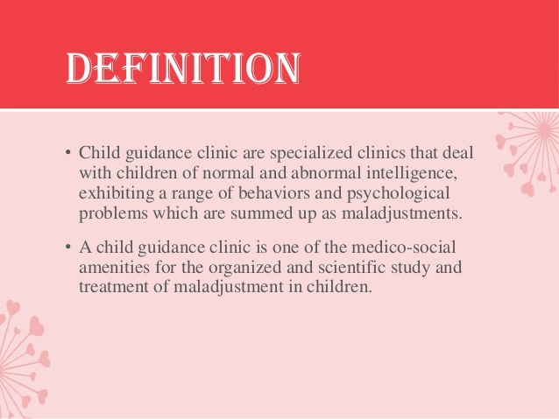
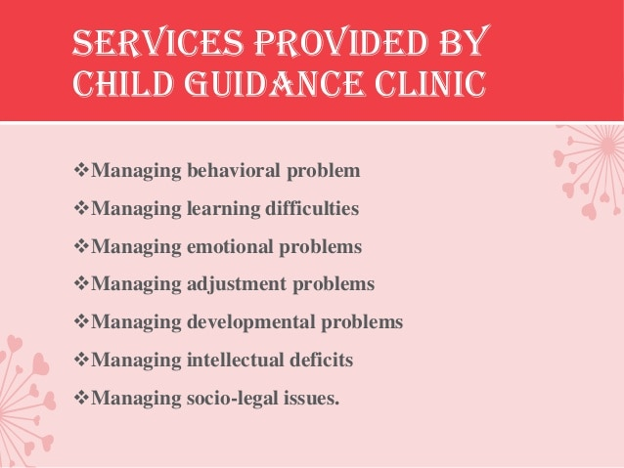
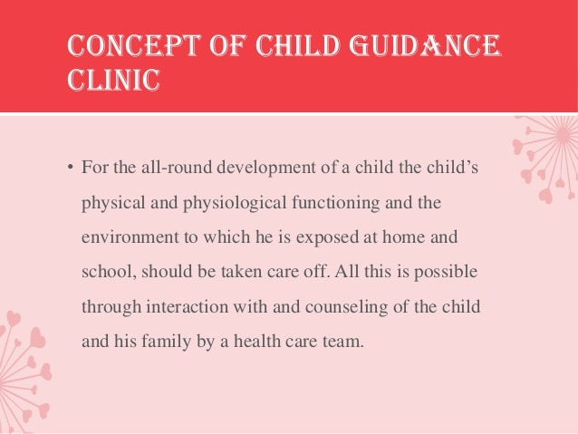
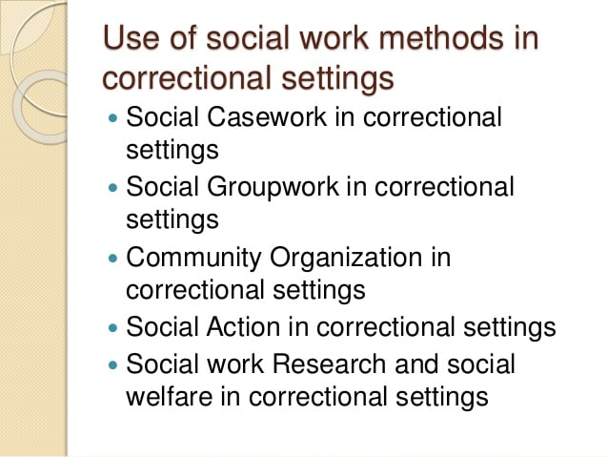
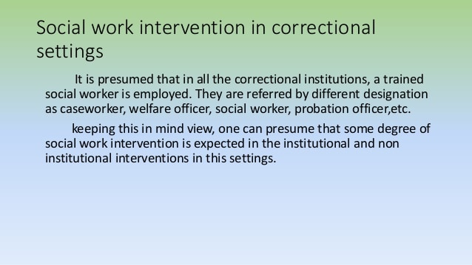

correctional setting in social work
In correctional setting, social workers may work in jails, prisons, community-based organizations and primary health care agencies that serve ex-offenders, and in the courts. ... Practitioners on the macro level usually focus on helping groups, communities and society as a whole.
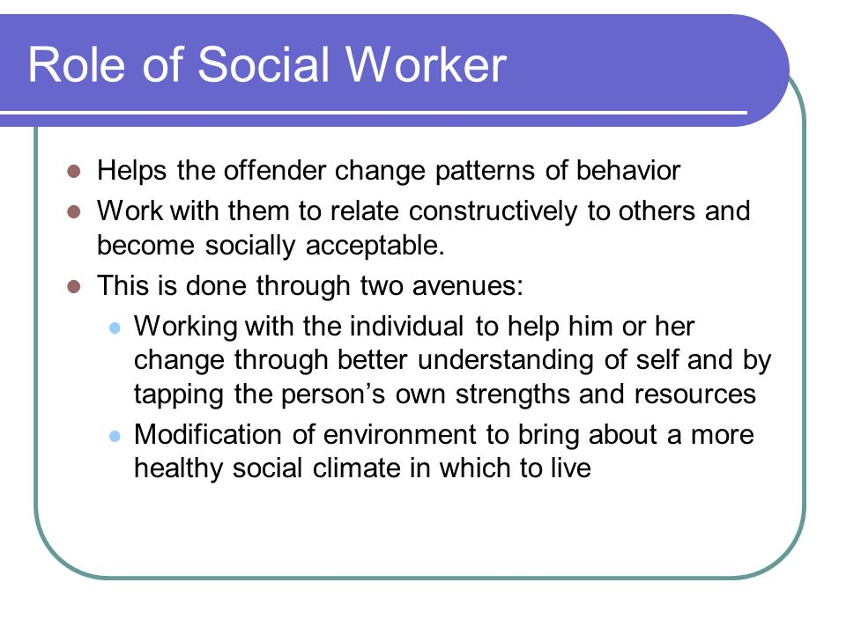
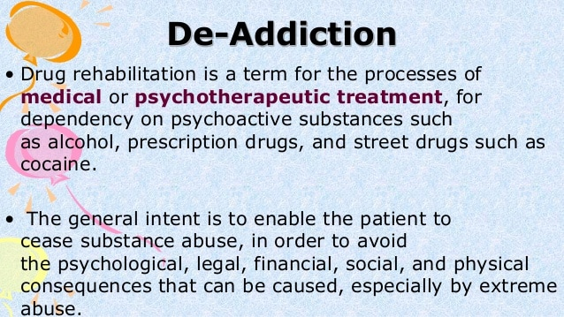
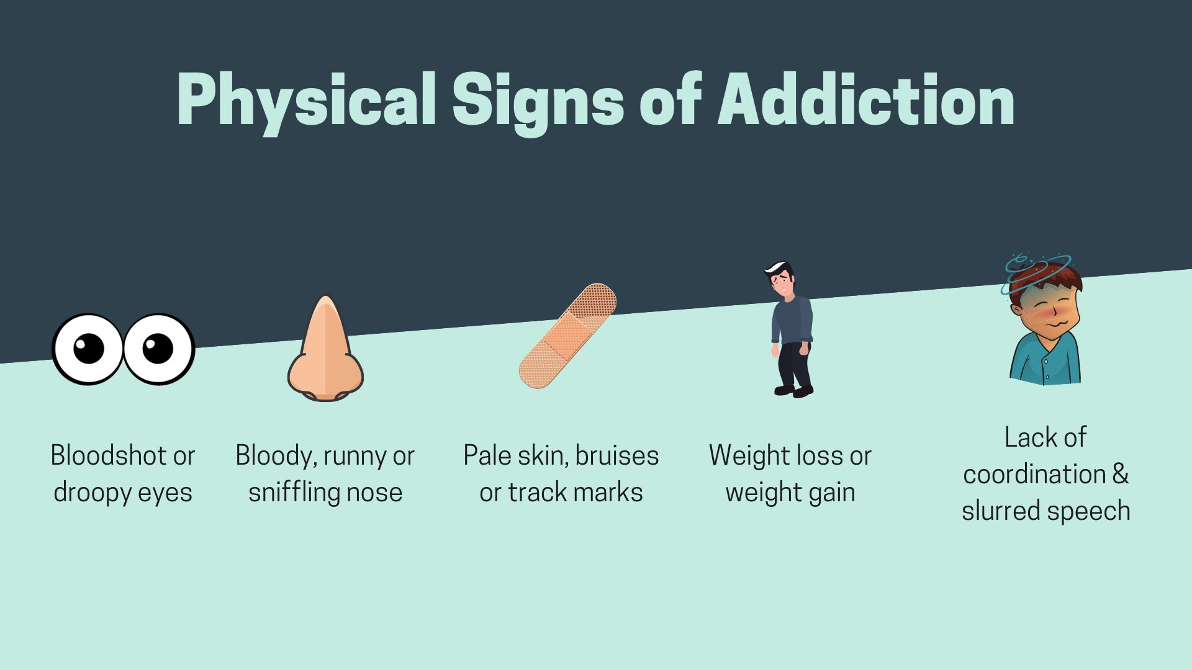
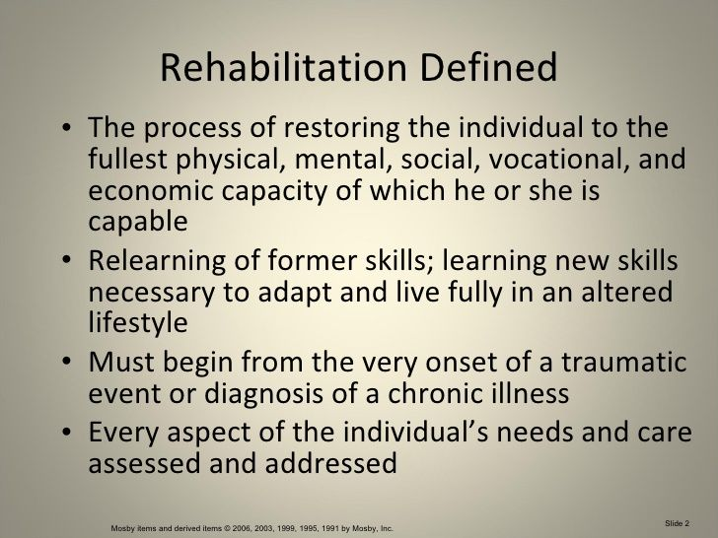
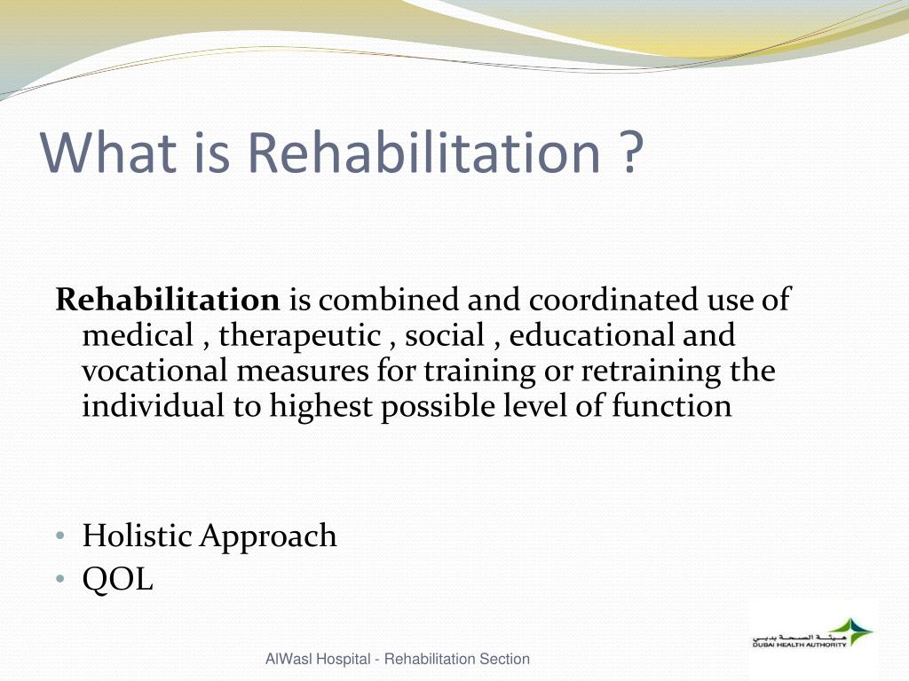
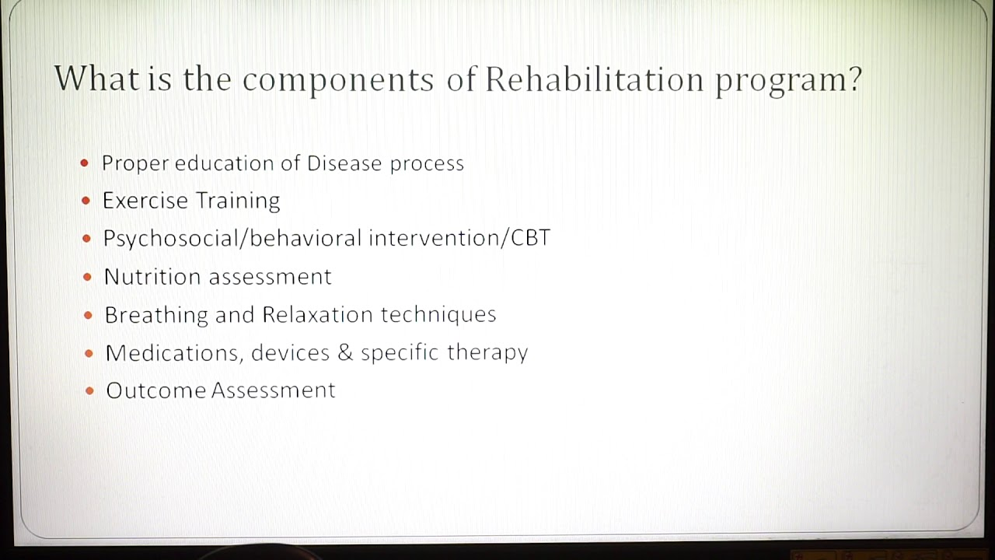
types of rehabilitation


The three main types of rehabilitation therapy are occupational, physical and speech. Each form of rehabilitation serves a unique purpose in helping a person reach full recovery, but all share the ultimate goal of helping the patient return to a healthy and active lifestyle.
What are the four stages of rehabilitation?


The 4 Stages of Complete Rehabilitation
- Rest and Protect the Injury.
- Recover Your Motion.
- Recover Your Strength.
- Recover Your Function.
- The Right Treatment for You.
What are the 7 principles of rehabilitation?
The following principles guide rehabilitation;
- Promote Adaptation.
- Emphasise Abilities.
- Treat the Whole Person.
- Time.
- Educate.
- People Centred Care.
educational institution means
- Educational institution means a public or private preschool, elementary, or secondary school, college or university, or institution; the governing board of a school district; or any combination of school districts or counties recognized as the administrative agency for public elementary or secondary schools.
It is the social institution through which society provides its members with knowledge, including basic facts, job skills, and cultural norms and values. Educational institution is responsible for the systematic transmission of knowledge, skills and cultural values within a formally organized structure.
the purpose of institution
An institution is a social structure in which people cooperate and which influences the behavior of people and the way they live. An institution has a purpose. Institutions are permanent, which means that they do not end when one person is gone. An institution has rules and can enforce rules of human behavior.

The role of the educational institutions to the values development of the students
Since education is a powerful instrument of social change and human progress, it is also a powerful tool to cultivate values in an individual. Therefore all the educational institutes have greater responsibility to impart learning and cultivation of values through education.

By
DEEPHTY MJ MSW,B.ed
HOD OF BSW

