
ST. PHILOMENA’S COLLEGE (Autonomous), MYSORE – 570 015
Affiliated to University of Mysore
College of Excellence – UGC, Re-accredited by NAAC
PG DEPARTMENT OF ECONOMICS
REPORT
The PG Department of Economics organised Industrial Visit to Coonoor - Ooty on 25th and 26th June 2024 in association with the PG Department of Commerce.

OBJECTIVES OF THE INVITED LECTURE
- The visit will provide students with practical insights into industrial processes relevant to their studies, bridging the gap between theory and practice.
- It also aims to expose students to various career opportunities within the industry, facilitating networking with professionals for mentorship and potential employment.
- These visits inspire and motivate students by showcasing real-world applications of their academic knowledge and demonstrating the industry's impact on society and the economy.
Day-1: Visit of HighField Tea Estate and Factory at Coonoor, Tamil Nadu
Introduction: On 25th June 2024 we started out journey towards the Coonoor via Ooty with five faculties and forty students form the St.Philomena’s College, Mysore. Visited the High field Tea Estate and Tea Factory located in Coonoor, Tamil Nadu. The objective of the visit was to gain practical insights into tea cultivation, processing, and the operations of a tea factory.High field Tea Estate is nestled in the picturesque Nilgiri Hills, renowned for its ideal climate and fertile soil for tea cultivation. Upon arrival, we were greeted by lush green tea plantations spread across rolling hills, creating a serene and scenic atmosphere.During the tour, we were guided through the tea plantations where we learned about various tea cultivars grown at High field Estate. The estate manager explained the techniques involved in tea cultivation, including planting, pruning, and pest management strategies. We also witnessed first and the meticulous care taken to maintain the quality and yield of tea leaves.
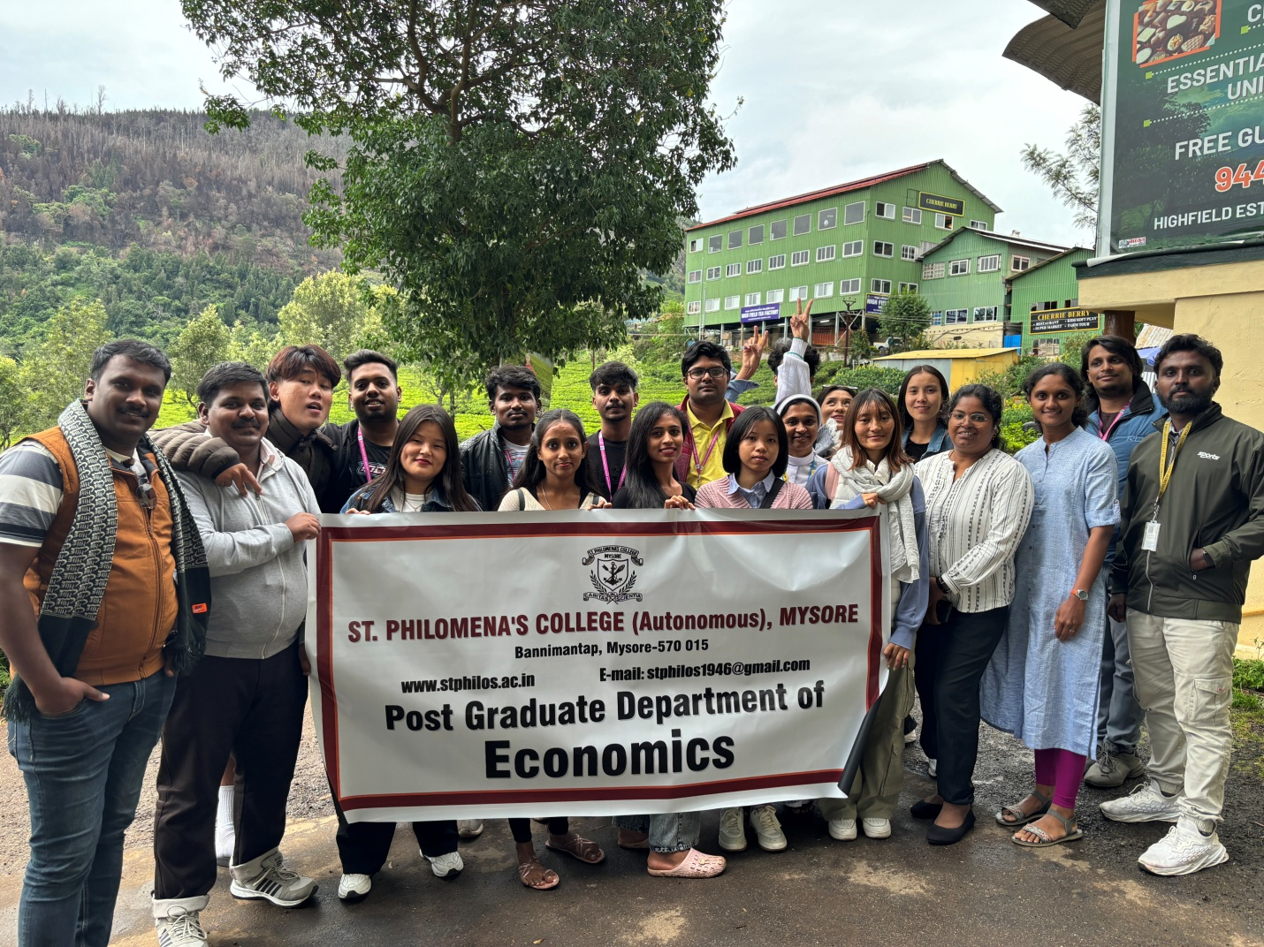
Next, we visited the tea factory where we observed the intricate process of tea processing. The factory manager demonstrated each stage, from withering and rolling to fermentation and drying. We gained insights into the machinery and equipment used for processing tea leaves, ensuring hygiene and quality standards are met.The visit provided invaluable educational insights into the tea industry, linking theoretical knowledge with practical application. We learned about the importance of climate, altitude, and soil conditions in tea cultivation, as well as the economic significance of tea production in the region.
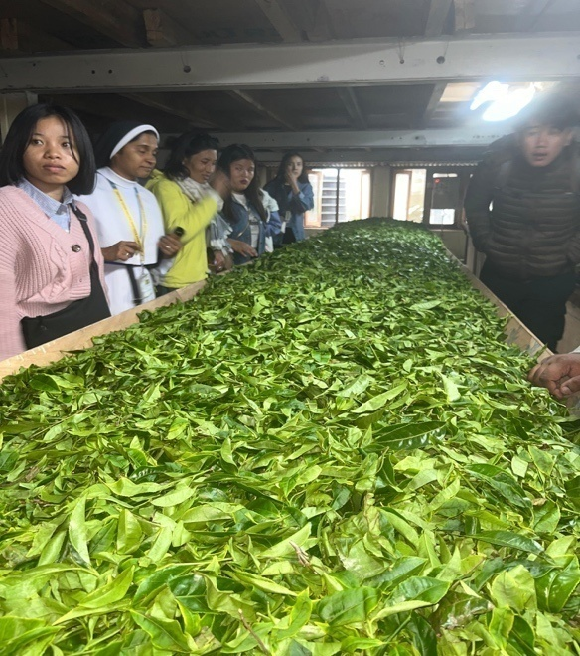
Overall, the visit to High field Tea Estate and Tea Factory was highly informative and enriching. It deepened our understanding of the tea industry's complexities and highlighted its impact on the local economy. We are grateful for the hospitality extended by the staff of High field Estate and look forward to applying our learnings in our academic pursuits.
Visit to Chocolate and essential oil factory.
During an industrial visit to a chocolate factory and an essential oil factory in Coonoor, Tamil Nadu, students experienced firsthand the meticulous processes involved in creating these products. At the chocolate factory, they observed the transformation of cocoa beans into various types of chocolates, witnessing stages from roasting to tempering and molding. The tour highlighted the artisanal methods used to ensure high quality and rich flavors. Visitors also enjoyed sampling different chocolate varieties and understanding the significance of locally sourced ingredients.
At the essential oil factory, students learned about the cultivation of aromatic plants and the extraction process of essential oils through steam distillation. The factory showcased a range of oils, including eucalyptus and lavender, emphasizing their therapeutic benefits and applications in aromatherapy and natural remedies. The visit provided insights into sustainable farming practices and the importance of purity in essential oil production.
Overall, the industrial visit offered a comprehensive understanding of the chocolate and essential oil industries in Coonoor, demonstrating the blend of traditional craftsmanship and modern techniques that contribute to their success.
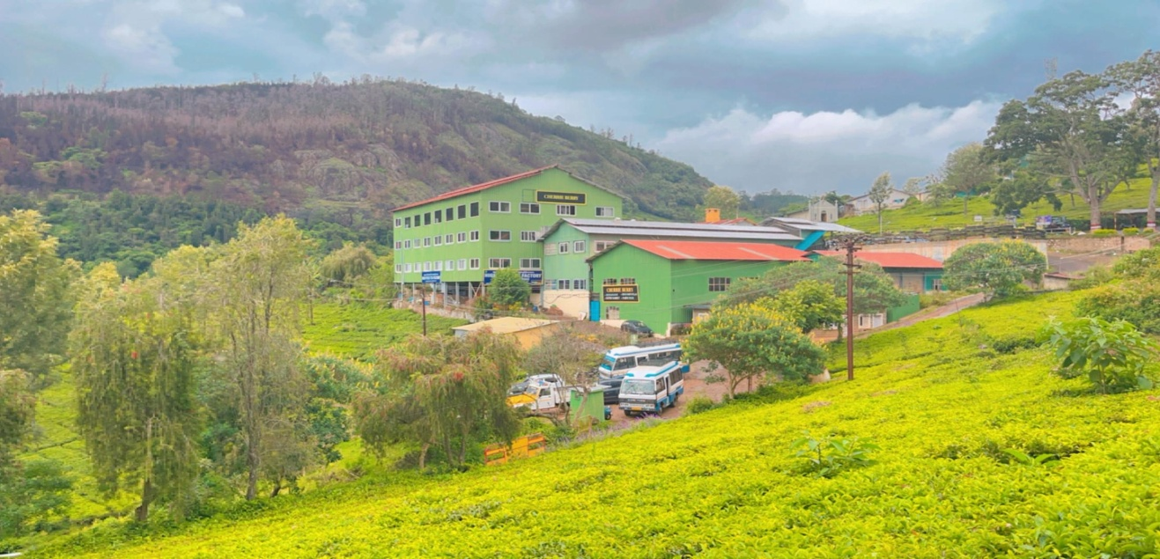
Day -2
On the day-2 of the toy train journey from Coonoor to Ooty, students gathered at the Coonoor railway station at 7:45 AM, excited to embark on this scenic adventure. The train, part of the Nilgiri Mountain Railway, is renowned for its picturesque route through the Nilgiri Hills, a UNESCO World Heritage site. As the train chugged along, the students were treated to breathtaking views of lush tea gardens, dense forests, and mist-covered mountains.
The journey, characterized by its charming and vintage carriages, provided a unique experience of traveling through winding tracks and over quaint bridges. The train made several brief stops at small, idyllic stations, allowing passengers to stretch their legs and enjoy the cool, crisp morning air. One of the highlights was the passage through several tunnels, adding a sense of adventure to the ride.
Throughout the trip, the students marveled at the engineering marvel of the railway, which included steep gradients and sharp curves. They also learned about the historical significance of the Nilgiri Mountain Railway, which has been operating since the early 20th century. The rhythmic sound of the train and the panoramic views made for a memorable and serene experience.
Arriving in Ooty, the students felt a mix of exhilaration and tranquility, having witnessed the natural beauty and heritage of the region in such an intimate and enchanting manner. The toy train journey from Coonoor to Ooty left a lasting impression, blending education with the joy of travel.
Karnataka Siri Horticulture Garden in Ooty:
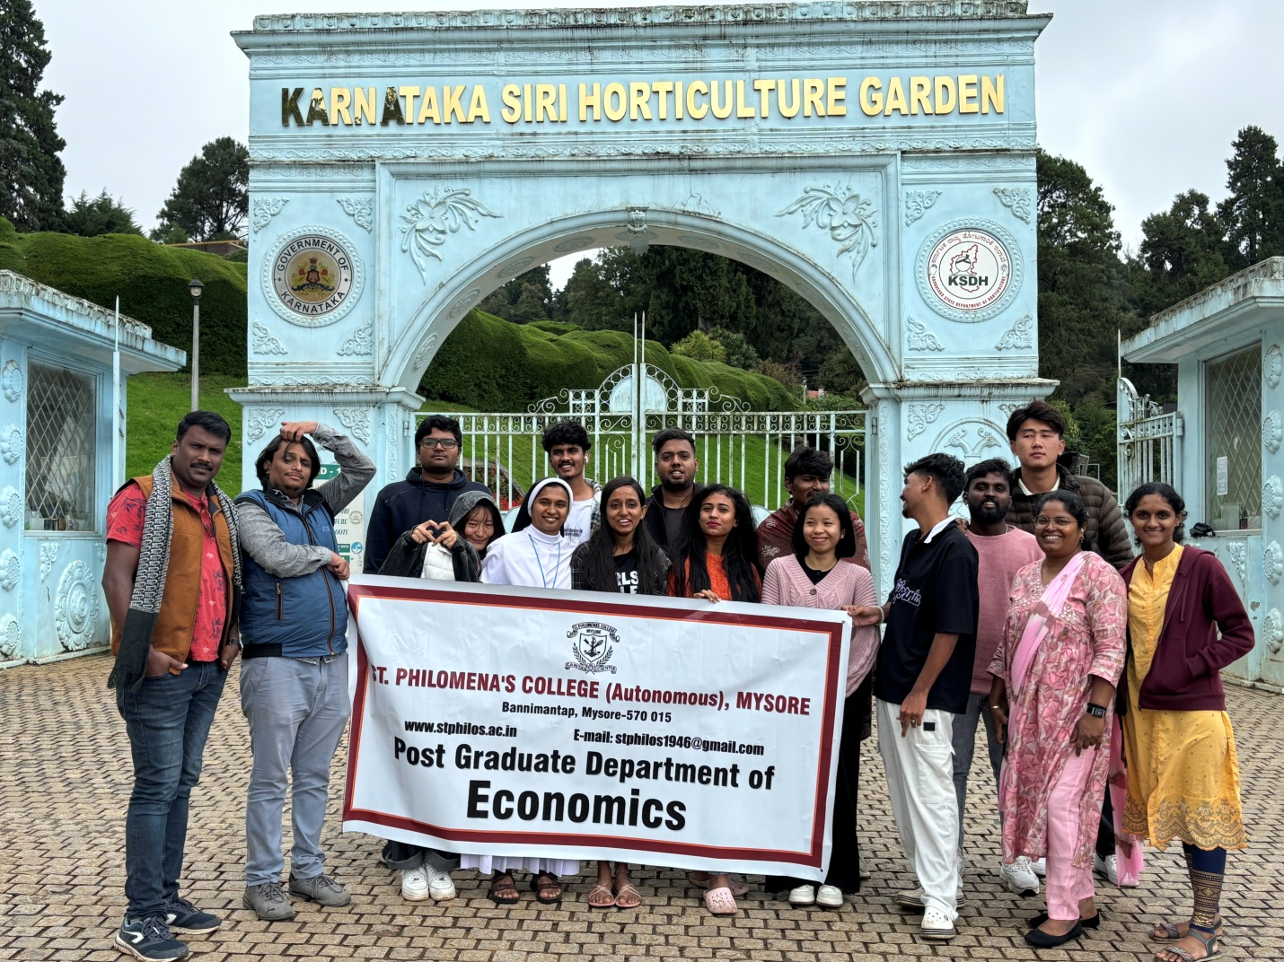
visit, students explored the Karnataka Siri Horticulture Garden in Ooty, a sprawling botanical garden renowned for its diverse plant species and beautifully landscaped gardens. They were greeted by an array of colorful flowers and meticulously maintained lawns, offering a serene and picturesque environment. The guided tour provided insights into the various sections of the garden, including the fern house, rose garden, and medicinal plant area.
Students learned about the different horticultural practices used to cultivate and maintain the plants, as well as the significance of each plant species. The highlight of the visit was the topiary garden, featuring creatively shaped shrubs and plants that added a whimsical touch to the experience. They also visited the bonsai garden, which showcased the art of growing miniature trees.
The garden's emphasis on biodiversity and conservation efforts was evident throughout the tour, educating visitors on the importance of preserving plant species. The visit concluded with a leisurely walk through the garden's scenic pathways, allowing students to appreciate the beauty of nature and the efforts involved in maintaining such a vast horticultural space. Overall, the day at the Karnataka Siri Horticulture Garden provided a blend of education and relaxation, leaving the students inspired and enriched.
Outcome of the Industrial Visit:
The industrial visit experience enhanced the students' appreciation for the meticulous efforts involved in producing tea, chocolate, and essential oils. It provided a practical understanding of the manufacturing processes, quality control, and market dynamics. The visit also highlighted the importance of local resources and sustainable practices in these industries, inspiring students with potential career interests in these fields.

