Reproductive biology- Microsporangium
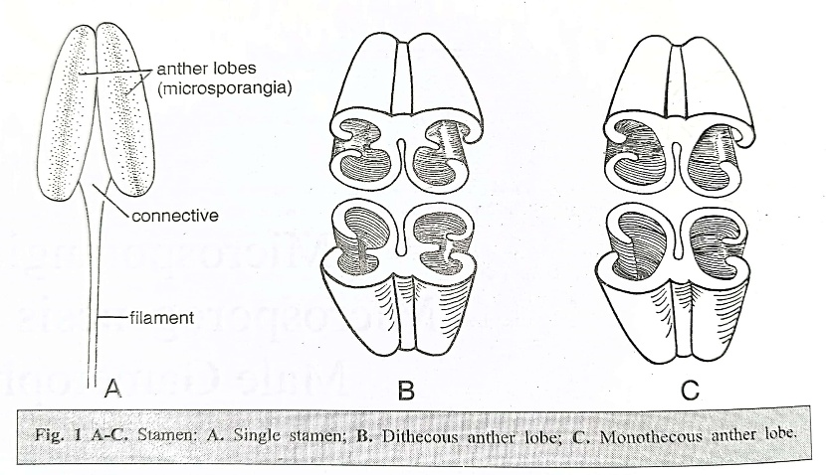
Stamen is the male reproductive organ of the flower. Typically it consists of two more or less distinct parts a lower sterile part, the filament and an upper fertile part, the anther. The sterile median part of the anther is known as connective. The anther shows great variety in form, but typically it is two-lobed and the lobes are called anther lobes. Each anther lobe has a pair of pollen sacs or microsporangia.

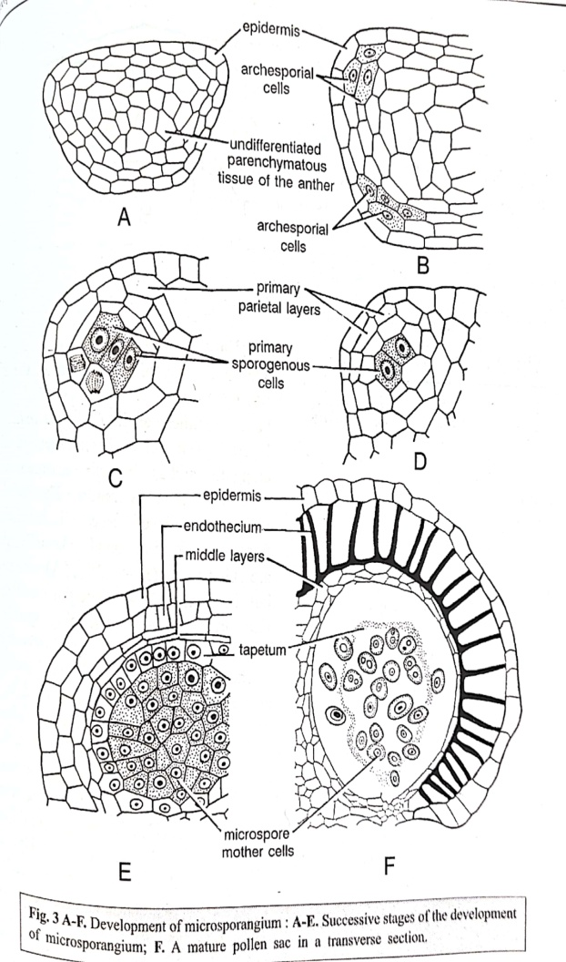
A typical anther comprises four microsporangia. Such an anther is said to be tetrasporangiate and is seen in 83.6% of the dicotyledons. Sometimes, the anthers may be bisporangiate as in Spilanthers acmella of Asteraceae. Very rarely as in Bixaceae, an anther may have eight sporangia.

Development of the microsporangium: A very young anther in a cross section shows a homogenous mass of cells bound by an epidermis. During further growth the anther assumes a four lobed shape. In each lobe a few of the hypodermal cells (sometimes one) become differentiated from the others by their prominent nucleus and dense cytoplasm. These are the archesporial cells. In majority of the members, the archesporium consists of several vertical rows of cells which appear as a plate of cells in a transverse section.
The archesporial cells divide periclinally cutting off primary parietal cells towards the epidermis and primary sporogenous cells towards the interior. The primary parietal layer divides to form two secondary parietal layers. Of these, the inner one distinguishes itself into tapetum while the outer divides again periclinally to form two layers of cells. Of these, the outer one forms the Endothecium while the inner one forms the middle layer. The sporogenous cells develop into microspore mother cells.
Structure of matured anther
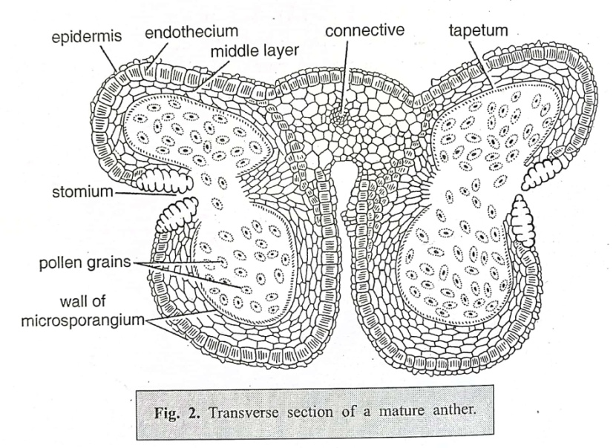
Transverse section of a mature anther at the time of dehiscence
Anther wall: A transverse section of a fully developed anther shows a group of microspore mother cells surrounded by a tapetum, a middle layer, an endothecium and an epidermis.
Epidermis: It is the outermost wall layer of the anther. During anther development, it undergoes anticlinal divisions to keep pace with the enlargement of the inner tissues. The epidermal cells become greatly stretched and flattened. In a mature anther, only the remnants of the epidermis are seen.
Endothecium: The layers of cells lying immediately below the epidermis constitute the endothecium. Endothecium attains its maximum development at the time of the anther dehiscence. Cells of this layer develop fibrous bands of callose which arise from the inner tangential walls (rarely from the radial walls) and run toward and upward ending near the outer wall of each cell. The outer tangential walls however remain thin. These thickenings are apparently associated with the dehiscence mechanism of the anther.
Middle layers: Cells of the middle layer lack the capacity to divide anticlinally and hence the tissue cannot adjust itself to the multiplying and expanding sporogenous cells within the sporangium. As a result, it gets crushed and cannot be seen in the mature anther.
Tapetum: Tapetum, the innermost wall layer of the anther, usually occurs as a single layer around the Sporogenous tissue. Sometimes as in Coccinia, Nicotiana and Costus the tapetal cells divide periclinally giving rise to supernumerary layers. Physiologically, tapetum has an important role as food material to the sporogenous tissue passes through it.
The cells of the tapetum are relatively large and centripetally extended. They have dense cytoplasm and prominent nuclei. Sometimes the cytoplasm of tapetal cells is pigmented; for instance, red-brown pigments are present in apple and violet pigments in Anemone.
Tapetum is present in the form of a homogeneous layer which completely surrounds the sporogenous tissue. In some taxa, however, a dimorphic tapetum is present. For example, in Alectra thomsonii and Nigella damascena the tapetum on the protuberant side of the anther, formed from the derivatives of primary parietal cells, is called P-tapetum; and on the connective side, where it differentiates from the cells of the Connective and or septum between the two pollen sacs, is referred to as C-tapetum. The cells of C-tapetum are relatively large than those of P-tapetum
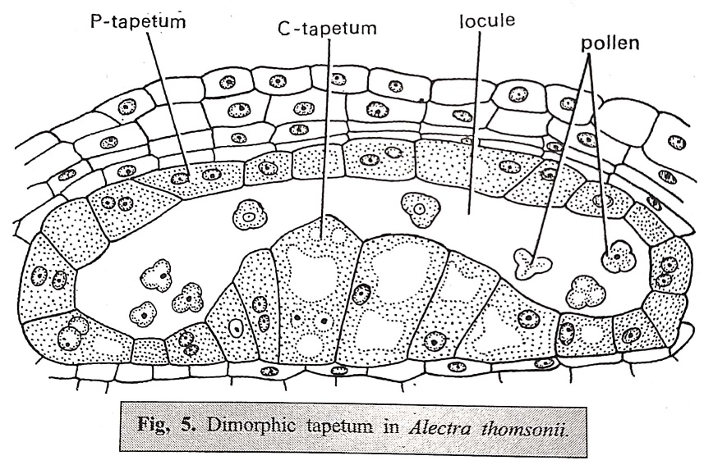
As the sporogenous cells undergo meiosis, the nuclei of tapetal cells also divide and as such the cells of mature tapetum are usually multinucleate.
- Nuclear divisions in the tapetal cells. The nucleus of the tapetal cell may divide by the following methods:
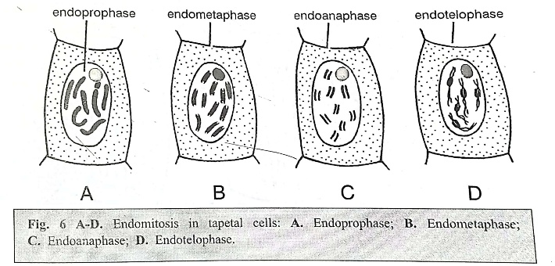
  - By endomitosis. In such divisions, the nucleolus and nuclear membrane remain intact and chromosomes split longitudinally. As no spindle is organised, separation of chromosomes does not take place. Thus the chromosomes double inside the nuclear membrane and with the result polyploid nuclei are formed.
Examples: Spinacia oleracea, Cucurbita pepo.
  - By normal mitosis. In this type the nucleus of the tapetal cell undergoes normal mitosis but the nuclear division is not accompanied by cytokinesis. Thus depending upon the number of nuclear divisions, a tapetal cell may have 2, 4, 8 or more nuclei. This is the most common method of nuclear divisions in tapetal cells.
Example – Zea mays.
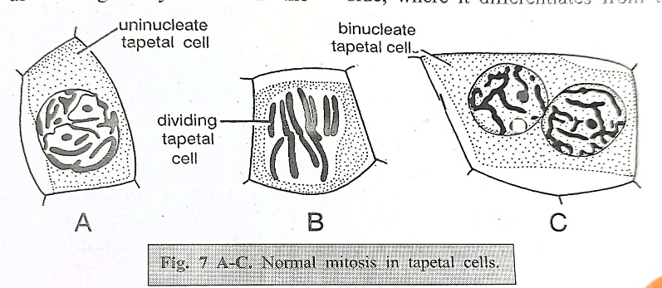

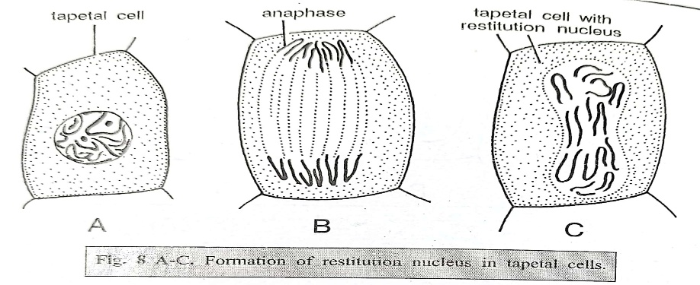
(C) Formation of restitution nuclei s Lilium canadense and few other species, the nuclear division is almost normal till anaphase Subsequently, chromosomes fail to separate and as such a dumbell-shaped tetraploid nucleus is formed ,This nucleus is known as Restitution nucleus.

2. Types of tapetum. The following two types of tapetum have been recognised in angiosperms
- Amoeboid or plasmodial tapetum. In this type the radial and inner walls of the tapetal cells break down early due to the action of hydrolytic enzymes. The protoplasm of these cells enters into the anther locule and fuses to form a common mass called tapetal periplasmodium this mass surrounds the pollen grains till they are mature and provides them proper nutrition, when pollen grains mature, the periplasmodium also contributes to their exine by providing sporopollenin precursors. Electron microscopic studies have shown that periplasmodium is a highly organised functional structure.
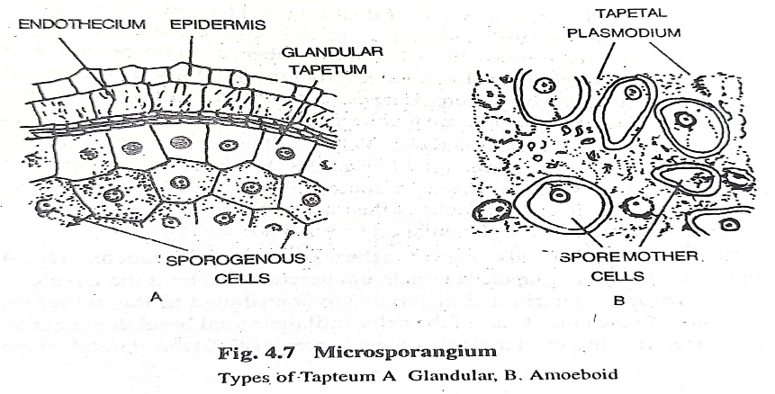
- Secretory or glandular tapetum. The cells of the secretory tapetum remain attached to the Middle layer till the development of pollen grains. At the pre-meiotic stage of the pollen mother cells, tapetal cells are very thin and possess almost all cell organelles like mitochondria, plastids, dictyosomes, etc. Some spherical structures, called pro-übisch bodies, are also present in this cell. Just before the pollen mother cells undergo meiosis, the walls of the tapetal cells become thick and there is considerable increase in the number of ribosomes and pro-übisch bodies. With the completion of pollen development pro-übisch bodies pass into the anther locule from the tapetal cells and these are now called übisch bodies. They perhaps help in the formation of exine of pollen grains. The secretory tapetum is found in most of the angiosperms.

Role of tapetum in pollen development:
The tapetum appears to play a very important role in the development of the pollen which includes microsporogenesis and maturation of microspores into pollen grains. It has been seen that in anthers where the tapetum degenerates early or it persists in a perfect intact condition even during pollen development has been known to result in either non formation of pollen grains or pollen sterility. The following functions are attributed to the tapetum.
- During microsporogenesis the nutrients are channelled into the developing microspores via tapetum as it is the only pathway for the meiocytes to obtain nutrition. At this stage however the tapetum itself does not provide nutrition to the meiocytes.
- Tapetum plays a very important role in the formation of the pollen wall. The sporopollenin contributed by tapetum through Ubisch bodies is very essential for the formation of pollen wall. When the microspores are still within the tetrads the wall formation begins. At this stage some special rounded bodies of lipid nature appear in the cytoplasm of the tapetal cells. These bodies called pro Ubisch bodies migrate to the cell surface (of the tapetum) where they get coated with a class of material called sporopollenin. This sporopollenin is highly resist -ant to physical and biological decomposition. The pro-Ubisch bodies after get ting the coating of sporopollenin are released into the anther cavity and are now called Ubisch bodies. These Ubisch bodies are involved in the external thicken ing of exine.
- Studies of Dickenson 1973 have clearly shown that an oily material pol len kit is synthesised in some special plastids in the tapetal cells and released outside and gives a coating to the pollen grain. Pollen kit coated pollen grains are specially seen in entomophilous species. The pollen kit chiefly comprises of carotenes and flavonoids.
- The proteins present in the pollen wall are a combination of the ones derived from the gametophyte as well as from the tapetal cells. Studies have shown that tapetal proteins are present in the spaces and cavities of the exine. They seem to have some role to play in the interaction between pollen and pistil. If pollen lands on an incompatible stigma these proteins produce callose plugs thus preventing the growth of pollen tube. Heslop-Harrison et al(1974)have shown that callose plugs are formed if the tapetal plasmodium is applied on to an in compatible stigma clearly pointing to their role in incompatibility reactions.

Sporogenous Tissue: Microspores (pollen grains) develop from the sporogenous tissue. The primary sporogenous cell may directly function as microspore mother cell or they undergo several mitotic divisions to form microspore mother cells. Each microspore mother cell undergoes meiosis and forms four haploid microspores. The process of formation of microspores from sporogenous tissue is known as microsporogenesis.
All sporogenous cells of an anther are capable of forming microspores but usually some of theseCells degenerate and provide nourishment to the active sporogenous cells. In some Gentianaceae the tapetum is not well developed and then the nutritive function is taken up by sporogenous tissue.
Reference:
- S. Sundara Rajan, 2000, College Botany (Vol. 2), Himalaya Publishing House, Pg No. 324-332.
- Singh, Pande & Jain., 2019, A Text Book of Botany Angiosperms, Rastogi Publications, Pg No. 10-17.

