UNIT-1
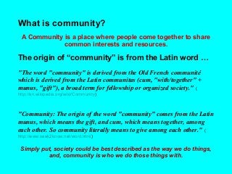
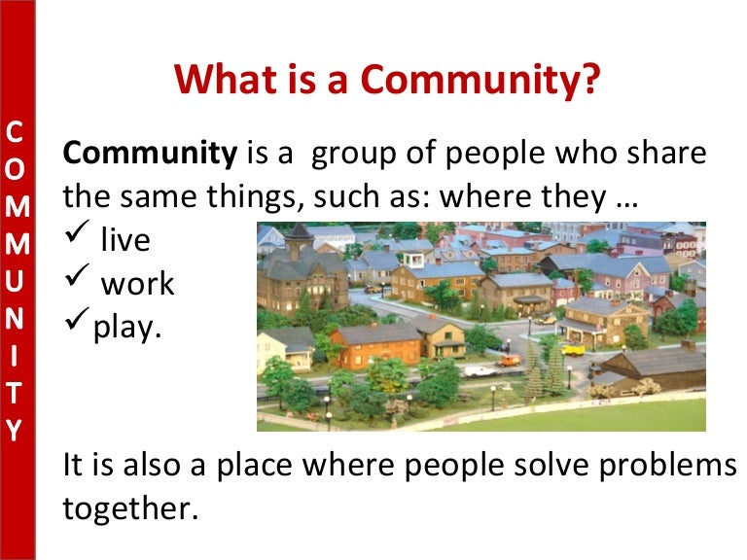

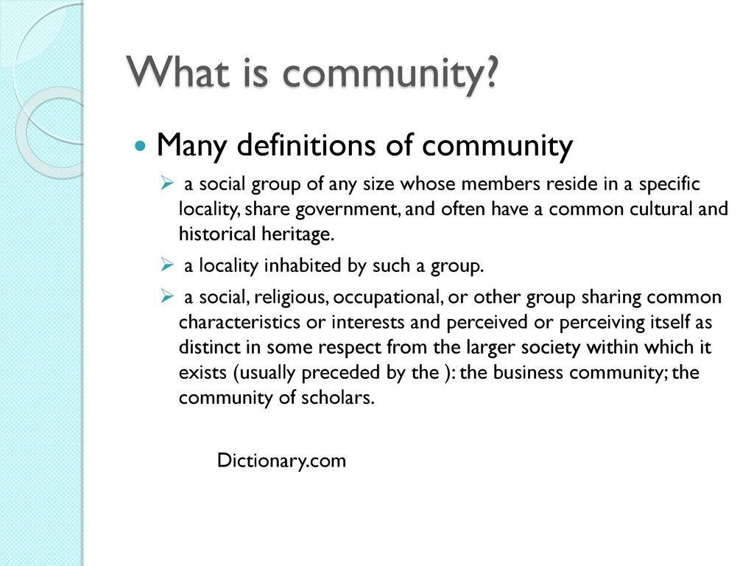
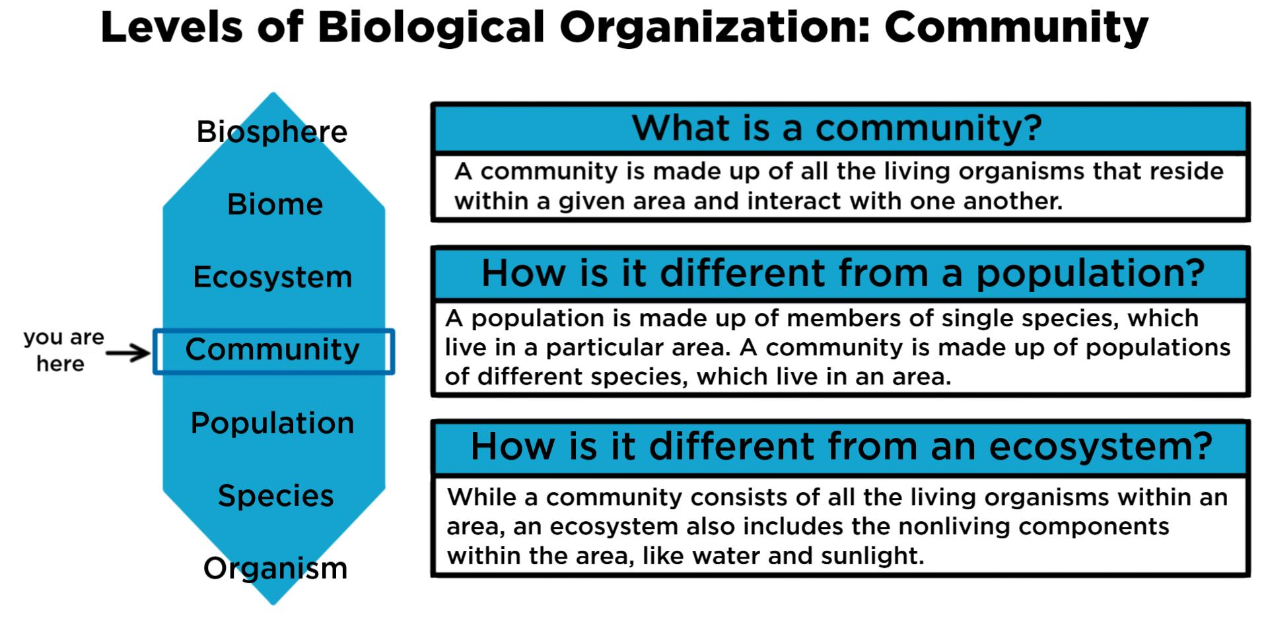
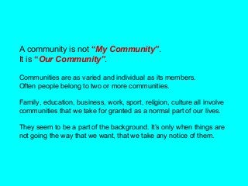
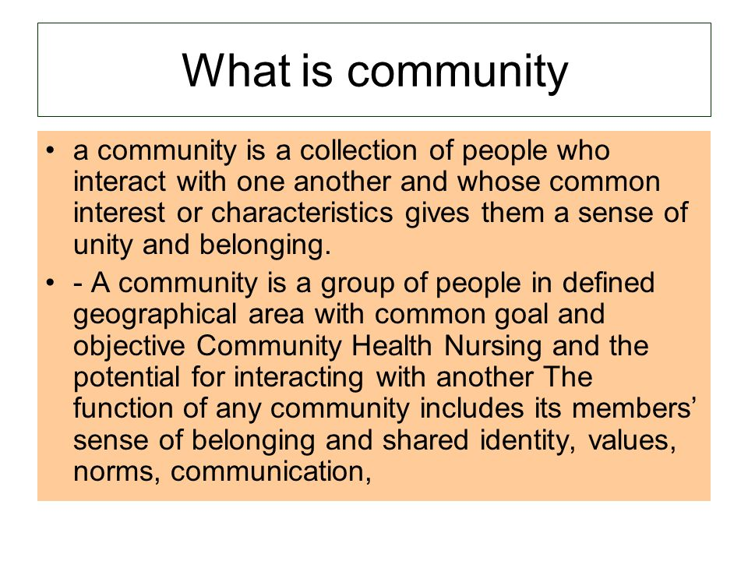
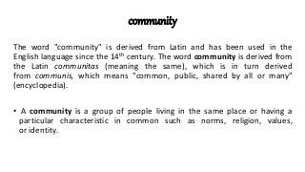
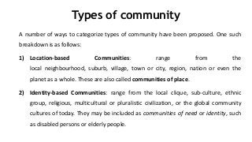
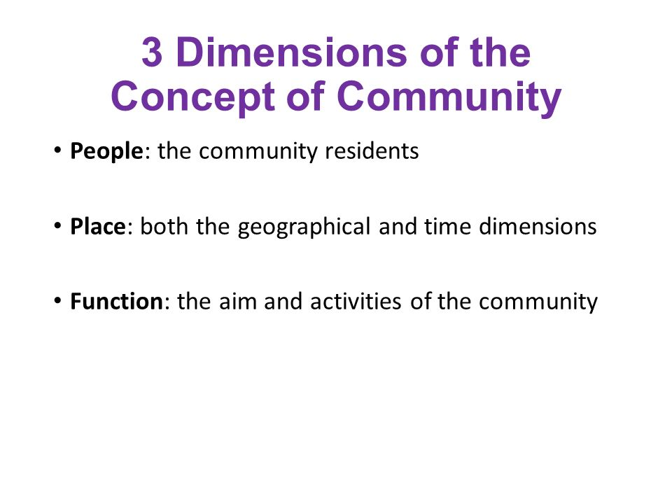
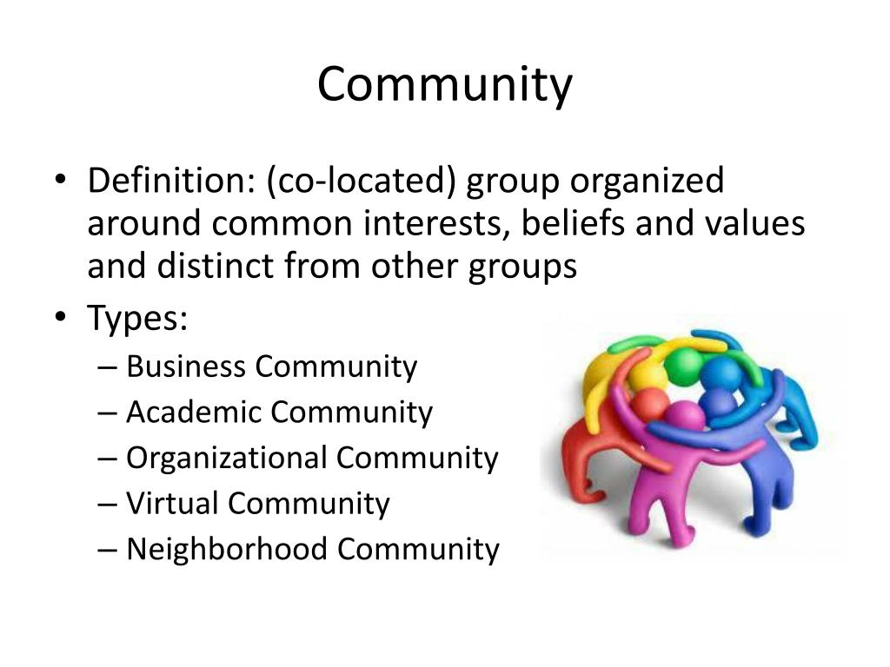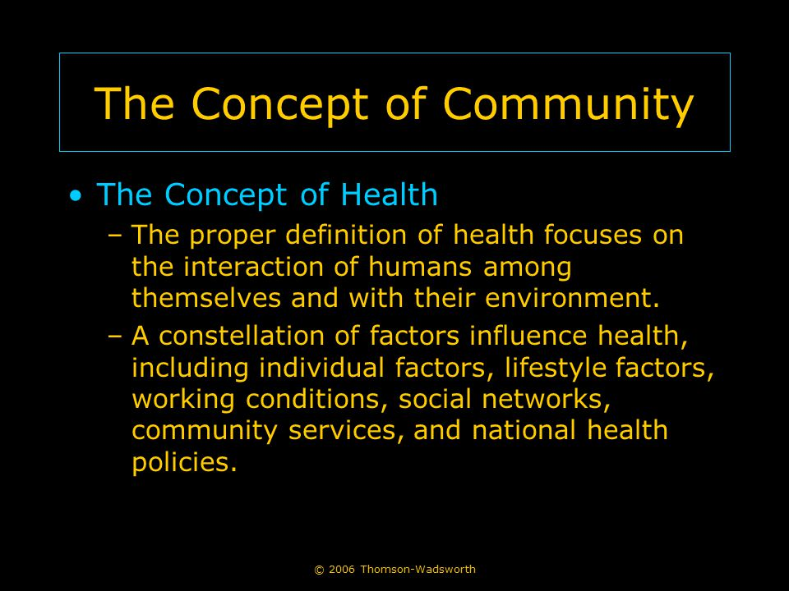

Components of community

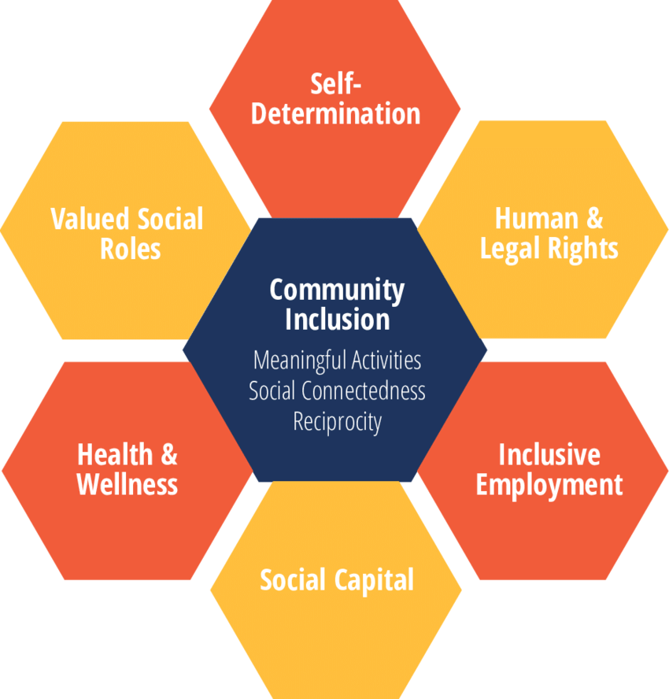

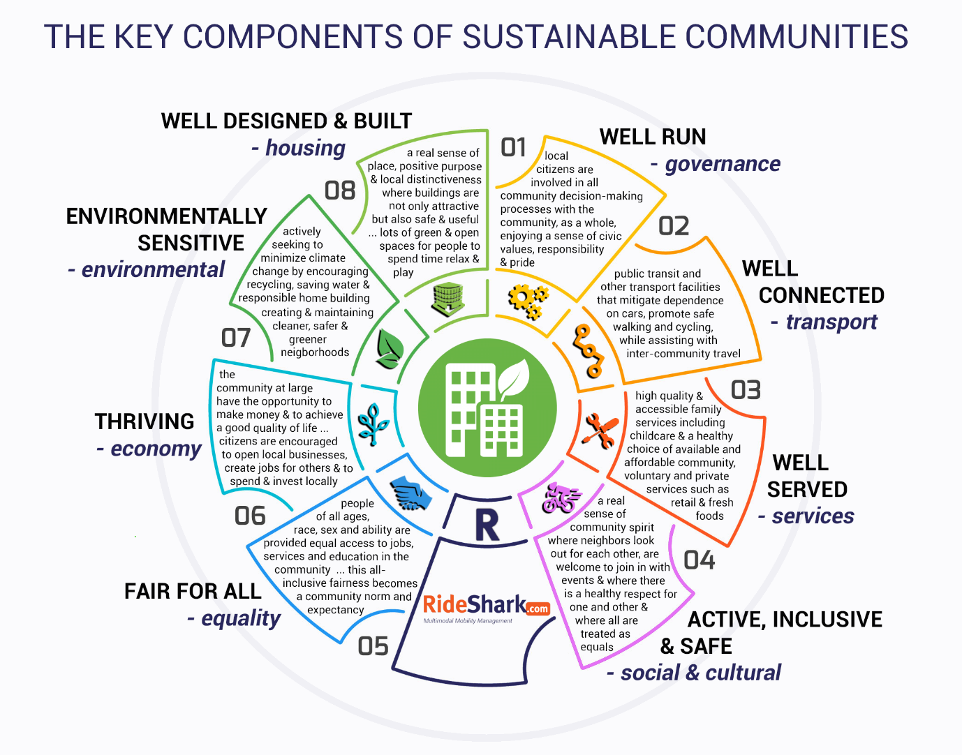
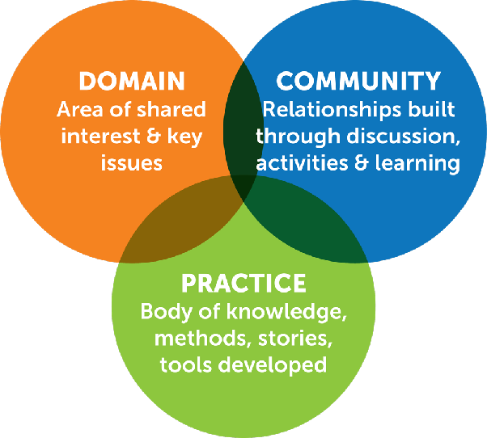
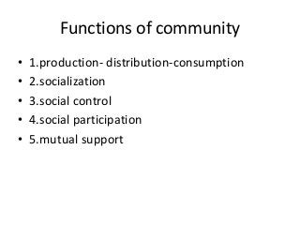
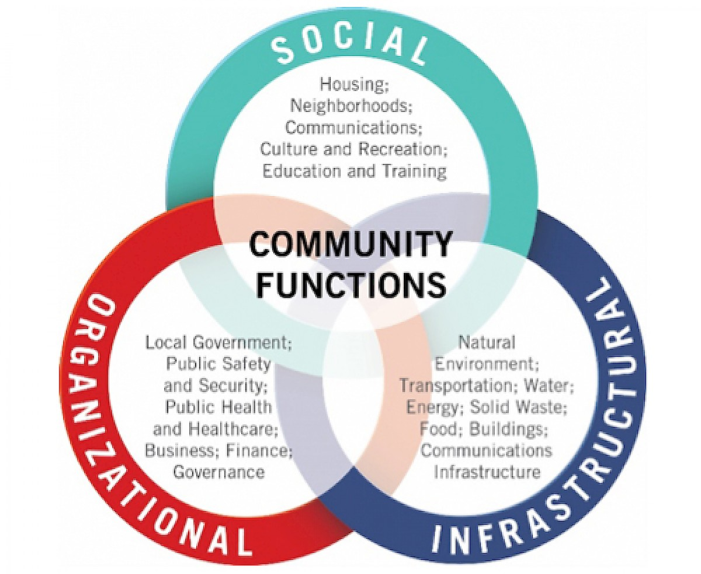
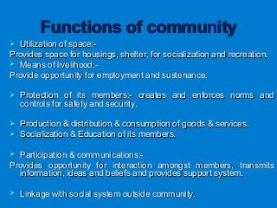

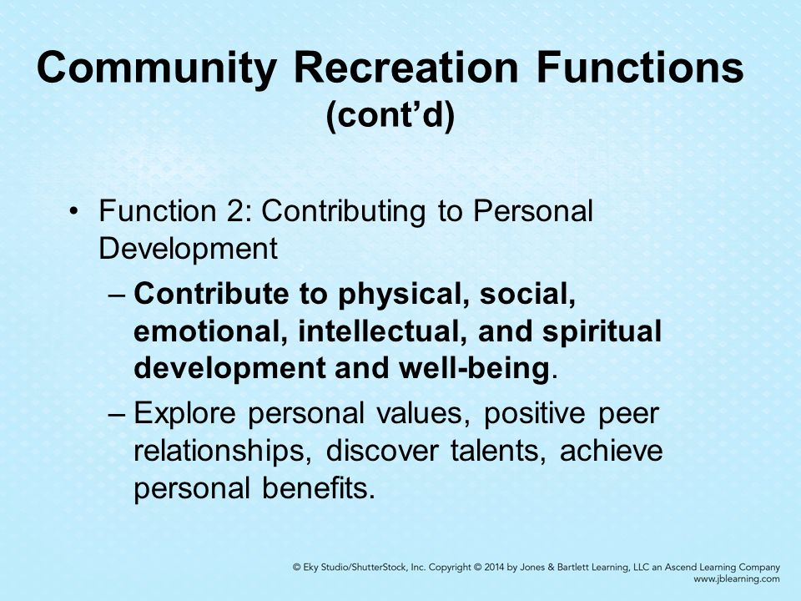
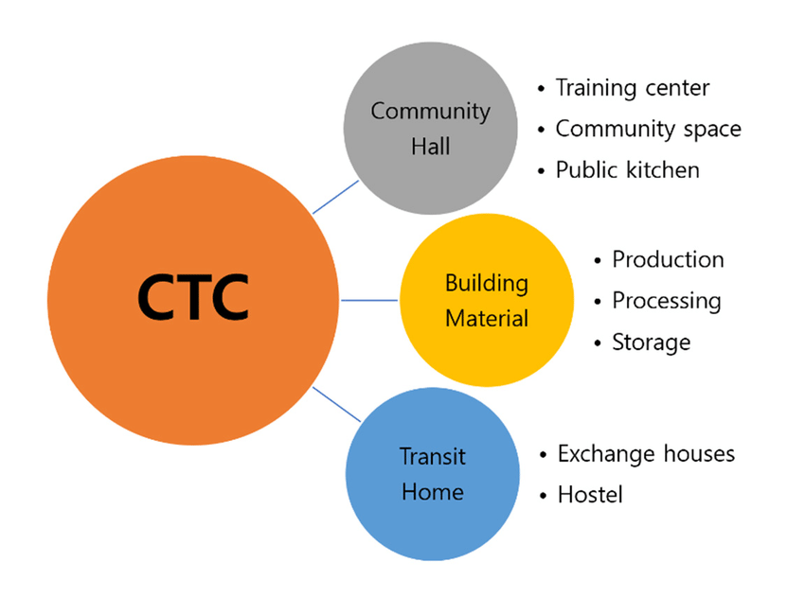
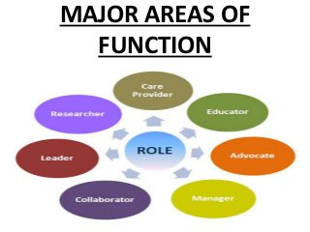
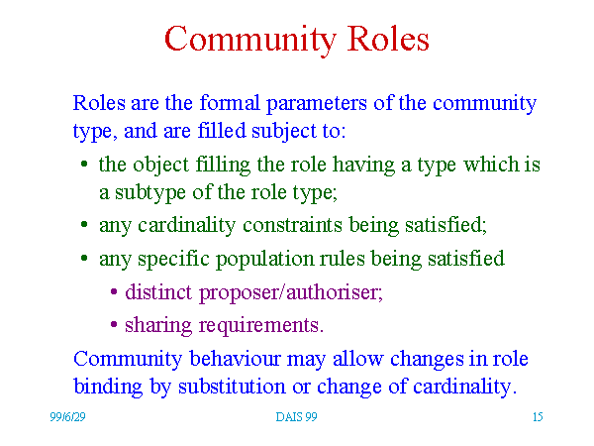
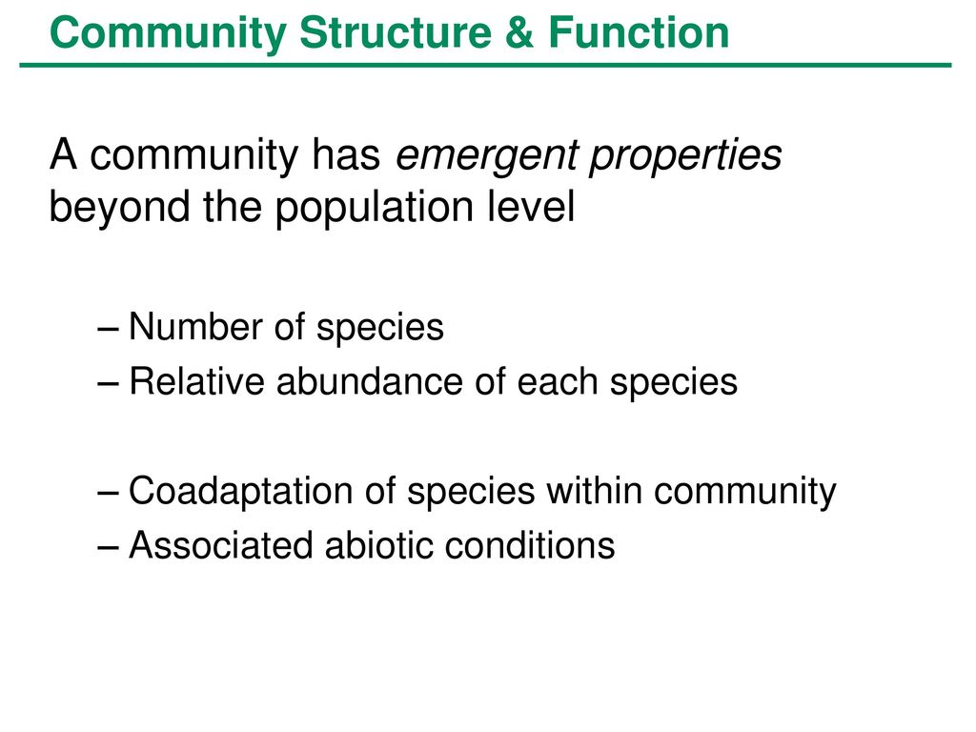
MAJOR FORMS OF COMMUNITY

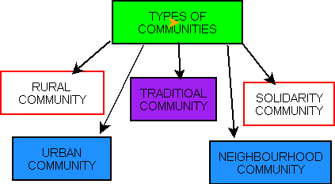
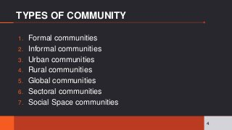
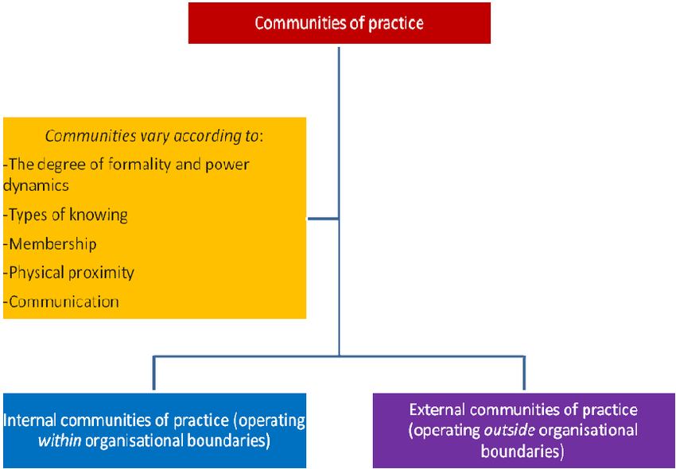

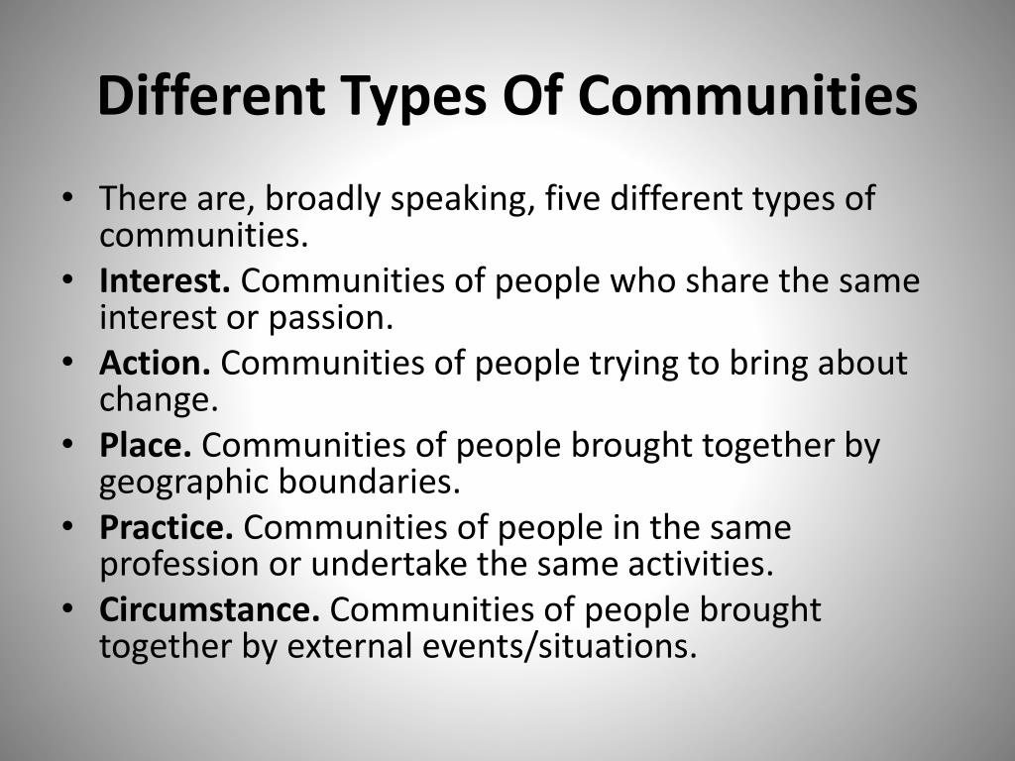
In general, a tribe is a group of people who live together and share a common language, culture, or history. Tribes often have a common ancestor and live in their own closed society. They also have similar rules of living or a specific purpose.
What are common characteristics of a tribe?
11 Distinctive Characteristics of the Tribes in India – Essay
- Definite Common Topography: ...
- Sense of Unity: ...
- Endogamous Group: ...
- Common Dialect: ...
- Ties of Blood-relationship: ...
- Protection Awareness: ...
- Distinct Political Organization: ...
- Common Culture:
- What are tribes in short?
- Definition: A tribe is a group of people who live and work together in a shared geographical area. A tribe has a common culture, dialect, and religion. They also have a strong sense of unity. The tribe is usually headed by a chief. A tribal society is a group of tribes organized around kinships.
What are different types of tribes?
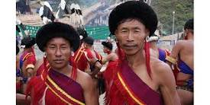
Still to get a brief idea about Indian tribes, here is a comprehensive list of 20 tribes, picked from different corners of India.
- Gonds Tribes. ...
- Bhils Tribes. ...
- Santhal Tribes. ...
- Great Andamanese Tribes. ...
- Khasi Tribes. ...
- Garo Tribes. ...
- Angami Tribes. ...
- Munda Tribes
- What is a tribal society?
- Definitions of tribal society. a society with the social organization of a tribe. types: hunting and gathering society, hunting and gathering tribe. group that supports itself by hunting and fishing and by gathering wild fruits and vegetables; usually nomadic. type of: society.
- Where did the word tribe come from?
- The term "tribe," which comes from the Latin tribus, was tied to classical and biblical images. The ancient Romans used tribus to denote segments of their own population, as well as the Celtic and Germanic societies with which many 19th- and early-20th-century Europeans and Americans identified.
- What's another word for tribal?
- In this page you can discover 13 synonyms, antonyms, idiomatic expressions, and related words for tribal, like: racial, common, kindred, pashtun, tribesman, nomadic, bedouin, indigenous, tribe, tribular and group.
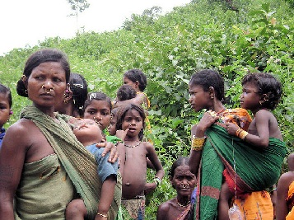
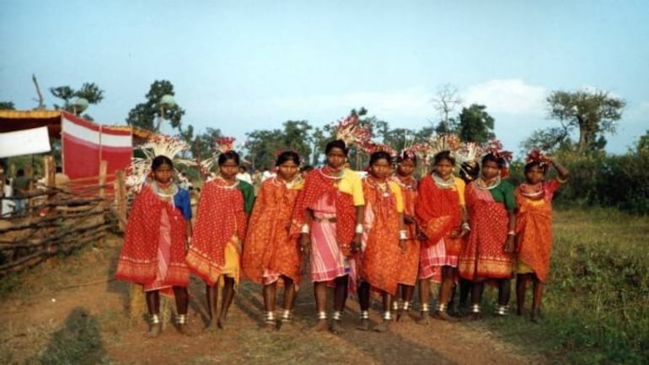
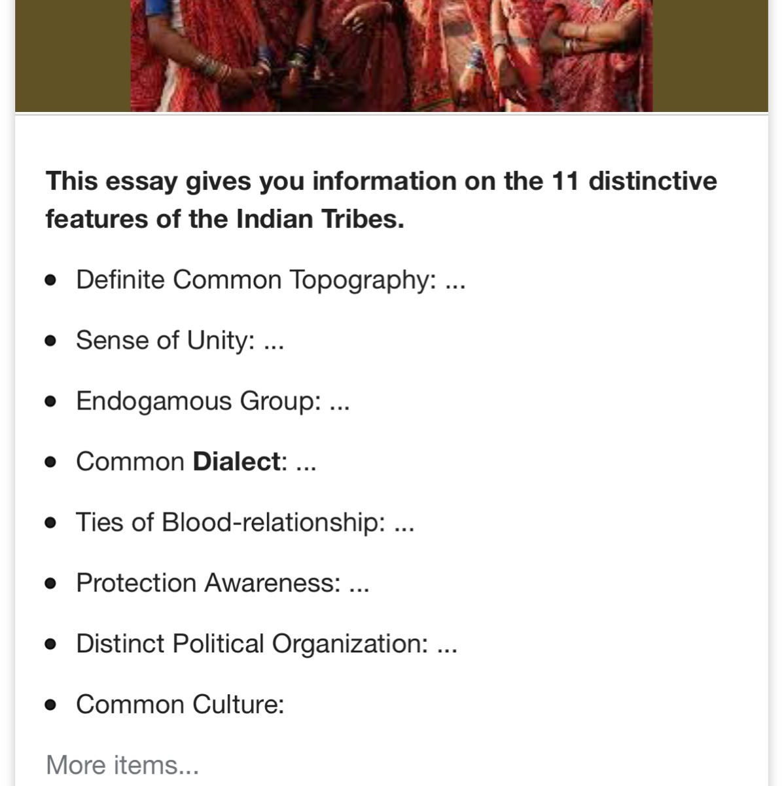
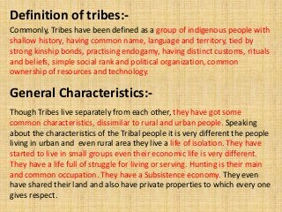

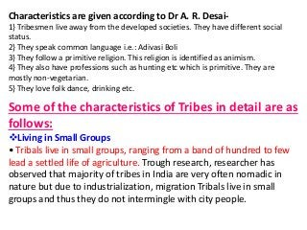
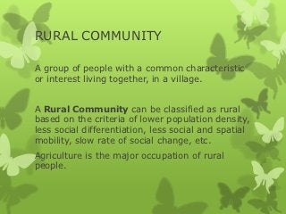

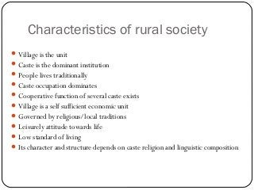
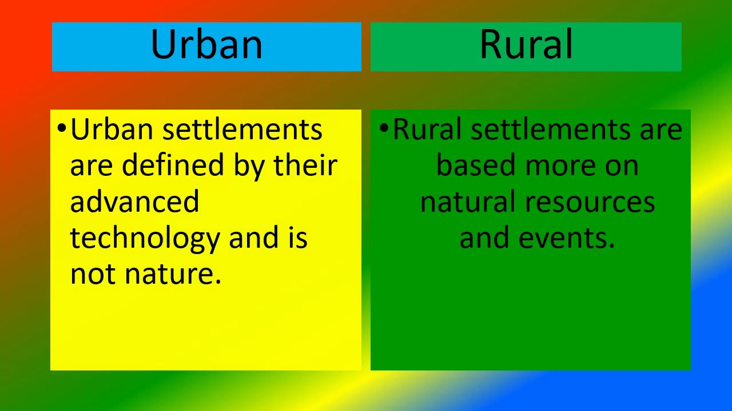

rural community means


In a rural area, there are fewer people, and their homes and businesses are located far away from one another. Agriculture is the primary industry in most rural areas. Most people live or work on farms or ranches. Hamlets, villages, towns, and other small settlements are in or surrounded by rural areas.
What is rural community and its characteristics?
The important features of a rural community are: Communities are smaller in size and sparsely populated (i.e the density of population is less). The population shows homogeneity of language, culture, customs etc. The main occupation is agriculture. People live in close contact with nature.

features of rural community
Rural Community: Top 10 Characteristics of the Rural Community– Explained!
- a. Size of the Community: ...
- b. Density of Population: ...
- c. Agriculture is the Main Occupation: ...
- d. Close Contact with Nature: ...
- e. Homogeneity of Population: ...
- f. Social Stratification: ...
- g. Social Interaction: ...
- h. Social Mobility:
another word for rural area
synonyms for rural area
- backcountry.
- outback.
- boondocks.
- frontier.
- hinterland.
- interior.
- isolation.
- sticks.
problems of rural community
The major problems that have been identified by literature review in many rural areas are poverty, illiteracy, unemployment, homelessness, crime, social evils, lower living standards, lack of facilities, services, and health.

advantages of rural life
The case for rural living
- Lower upfront costs for a more luxurious home. ...
- Reduced cost of living. ...
- Space to live and enhance wellbeing. ...
- A stronger sense of local community. ...
- A more relaxed pace of life. ...
- Better professional opportunities. ...
- Easier and cheaper to move around. ...
- Access to a large variety of amenities.
What are the advantages and disadvantages of rural areas?
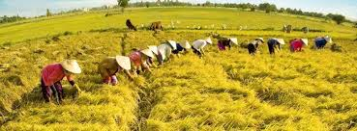
Advantages and Disadvantages in Rural
- Living space: spacious, comfortable, airy, many geenery.
- Habitat: no air pollution, quiet, less waste domestic and industrial waste.
- Psychology: Because the main job is agricultural labor should not be pressured on money, status social, title. (

Rural Community
There are many types of environments in which humans live. The majority of people in the world and in the United States live in urban settings, such as cities and suburban neighborhoods, because of the greater number of resources and opportunities afforded to people in cities. A smaller percentage, however, still live in rural communities around the world. What is a rural community? The rural living definition is one that changes depending on several different variables. Rural living can be defined by population density, or how many people live in a given area, or it can be defined by geographical isolation, or how the geography of a location separates people. Some sources define rural communities as communities with under 50,000 people living in a given location, usually by county. The United States Census Bureau defines rural as simply any population, housing, or territory that is not urban and defines "urban areas" as having a population of 50,000 or more, and "urban clusters" as having a population between 2,500 and 50,000.
Though most of the area of the United States is considered rural, only about 19% of America's population lives in rural communities. The term "rural" is also used to describe country living, where communities rely on natural resources more heavily than people in urban communities. Because rural communities are simply non-urban communities, there are several key characteristics used by people to describe rural areas. This lesson will outline those characteristics and discuss some commonalities between rural communities throughout the US and the world.


Characteristics of Rural Communities
There are many common characteristics of rural areas that both society and governing bodies look for. However, not all rural communities are one and the same, and areas that do not have these characteristics can still be considered rural. All communities have a degree of uniqueness, and communities are ever-changing as people grow, relocate, and change. The following sections outline some common characteristics of many rural communities, including size and density, finances and economy, common job practices, and demographic information.

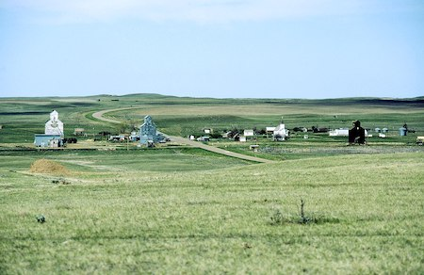
Small town in Montana

Size and Density of Rural Communities
Rural communities are thought of as being non-urban areas, which are defined as being under 2,500 people. Some rural communities are larger and have a more urban feel, whereas others are extremely small, some having a population as low as a few hundred people. Rural communities often have residential homes that are much farther apart than in urban or suburban areas. Homes are often interspersed among natural landscapes, with geographic features separating them, such as mountains, hills, rivers, and lakes.
The benefits of the additional space found in most rural communities are much more privacy, lower noise and light pollution, and more opportunities to be in nature and explore natural resources. The drawbacks of this can be limited opportunity for social interaction and limited meeting or gathering places, which can cause some members of the community to feel isolated and alone.

Finances of Rural Communities
There is often a single town center in a rural community with a main street on which a majority of local shops and businesses are positioned. These town centers are often very small; the saying "if you blink, you'll miss it" comes from driving through small rural towns. The cost of goods depends largely on the availability of resources, but on average tends to be lower than in urban settings. Urban households on average spend about 18% more than rural households. The flip side of this is that urban households tend to earn more on average than rural households. There are also higher poverty rates in rural communities as opposed to urban and suburban communities.

Work of Rural Communities
The economic value of rural areas is largely based on the natural resources available to people, and the monetization of those natural resources. This determines the type of work available in a community, and people living in rural communities are often specialists in their type of work. Rural economies largely rely on either agriculture, mining, manufacturing, recreation (tourism), or are dependent economically on the state or federal government. A large portion of rural communities is unspecialized, which usually means the area depends on a variety of economic categories.


Agricultural practices are common in rural areas.

The culture of rural communities is often defined by the type of work available. Rural communities can be described as farming communities, fishing communities, logging communities, or communities with a high amount of tourism for a certain part of the year. These types of work often dictate the way things are done in these communities. For example, communities that see a large amount of tourism in the summer see a huge influx in population during the season. The population then drops in the off-season, and shops close, opportunities for social interaction and engagement decrease, and sometimes even entire areas of the town go unused.
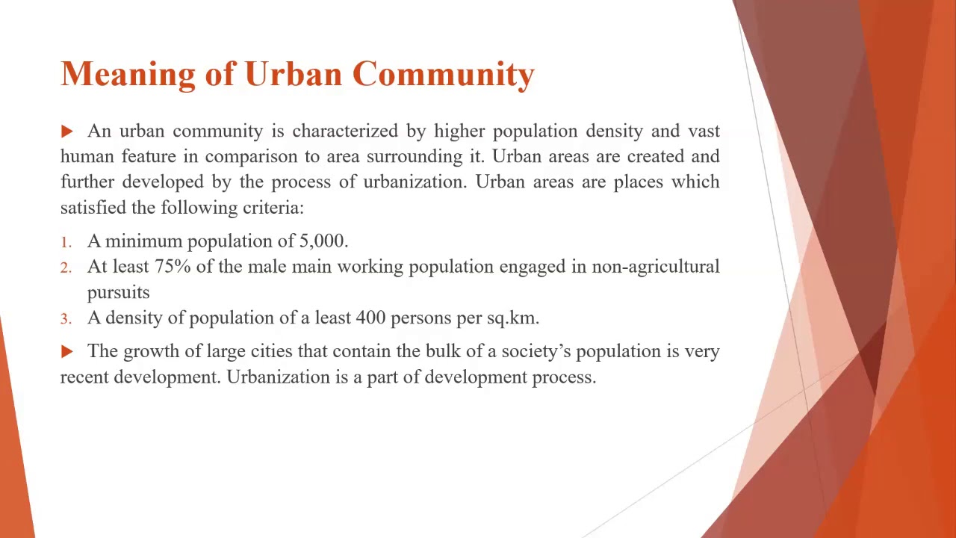

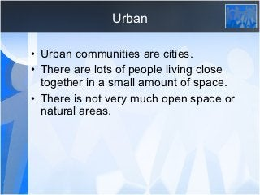
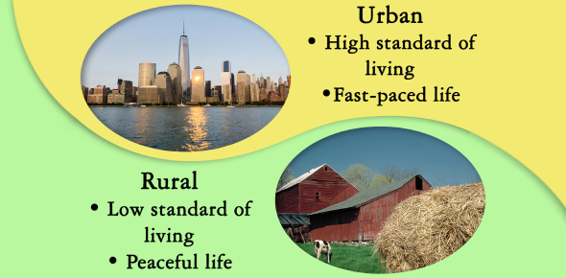
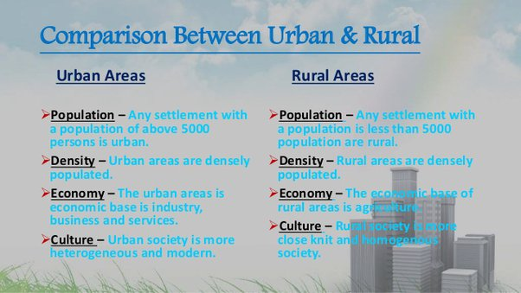
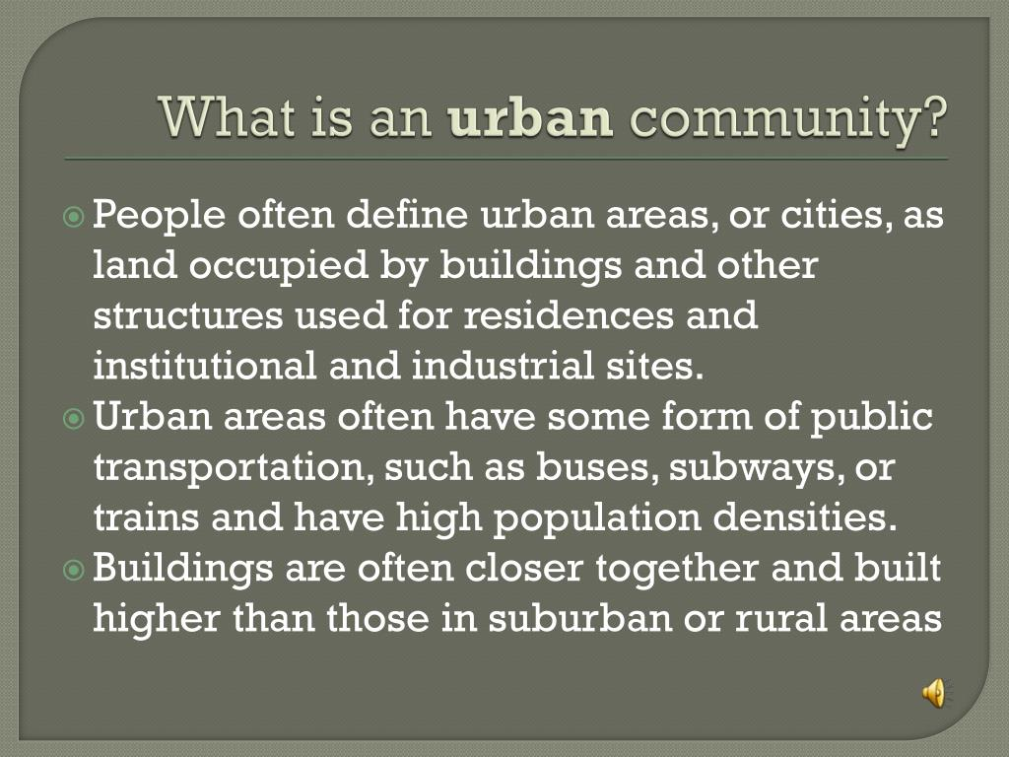
Some of the Important Characteristics of Urban Community are as follows:
A sociological analysis of urban community contains several salient features. They are as follows:
ADVERTISEMENTS:
1. Size:
As a rule, in the same country and at the same period, the size of an urban community is much larger than that of a rural community. In other words, urbanity and size of a community are positively correlated.

Image Courtesy : upload.wikimedia.org/wikipedia/commons/0/08/Ginza_area_at_Tower.jpg
2. Density of population:
ADVERTISEMENTS:
Density of population in urban areas is greater than in rural communities. Urbanity and density are positively correlated.
3. Family:
So far as urban community is concerned, greater importance is attached to the individual than to the family. Nuclear families are more popular in urban areas.
4. Marriage:
ADVERTISEMENTS:
In case of urban community there is a preponderance of love marriages and inter-caste marriages. One also comes across a greater number of divorces. Sons and daughters enjoy considerable freedom in choosing their life partners.
5. Occupation:
In the urban areas, the major occupations are industrial, administrative and professional in nature. Divisions of labour and occupational specialization are very much common in towns/cities/metropolises.
6. Class extremes:
ADVERTISEMENTS:
In the words of Bogardus, “Class extremes characterize the city.” A town and a city house the richest as well as the poorest of people. In a city, the slums of the poor exist alongside the palatial bungalows of the rich, amidst the apartments of the middle class members. The most civilized modes of behaviour as well as the worst racketeering are found in the cities.
7. Social heterogeneity:
If villages are the symbol of cultural homogeneity, the cities symbolize cultural heterogeneity. The cities are characterized by diverse peoples, races and cultures. There is great variety in regard to the food habits, dress habits, living conditions, religious beliefs, cultural outlook, customs and traditions of the urbanites.
8. Social distance:
ADVERTISEMENTS:
Social distance is the result of anonymity and heterogeneity. Most of one’s routine social contacts in a town or city are impersonal and segmentary in character. In the urban community social responses are incomplete and halfhearted. There is utter lack of personal involvement in the affairs of others.
9. System of interaction:
Georg Simmel held that the social structure of urban communities is based on interest groups. The circles of social contact are wider in the city than in the country. There is a wider area of interaction system per man and per aggregate. This makes city life more complex and varied. The city life is characterized by the predominance of secondary contacts, impersonal, casual and short-lived relations. Man, at any rate, the man in the street, virtually loses his identity being treated as a “number” having a certain “address”.
10. Mobility:
ADVERTISEMENTS:
The most important feature of urban community is its social mobility. In urban areas the social status of an individual is determined not by heredity or birth but by his merit, intelligence and perseverance. Urbanity and mobility are positively correlated.
11. Materialism:
In the urban community the social existence of man revolves round wealth and material possessions. The worth of an urbanite today is being judged not by what he is but by what he has. Status symbols in the form of financial assets, salaries, costly home appliances count a lot for the urbanites.
12. Individualism:
ADVERTISEMENTS:
The urbanites attach supreme importance to their own welfare and happiness. They hesitate to think or act for the good of others.
13. Rationality:
In urban community there is emphasis on rationality. People are inclined to reason and argue. Their relationship with others is governed, for the most part, by the consideration of gain or loss. Relationship takes place on a contractual basis. Once the contract is over, human relationship automatically comes to a close.
14. Anonymity:
As Bogardus observes, the “Urban groups have a reputation for namelessness.” By virtue of its size and population, the urban community cannot be a primary group. Here nobody knows anybody and nobody cares for anybody. The urbanites do not care for their neighbours and have nothing to do with their miseries or pleasures.
15. Norm and social role conflict:
ADVERTISEMENTS:
The urban community is characterized by norm and social role conflict. Factors such as the size, density and heterogeneity of the population, extreme occupational specialisation and the class structure prevalent in the urban context lead to such a state of affairs.
In the absence of uniform and fixed social norms, individuals or groups often seek divergent ends. This has a considerable share in causing social disorganization.
16. Rapid social and cultural change:
Rapid social and cultural change characterize urban life. The importance attached to traditional or sacred elements has been relegated to the background. The benefits of urban life have effected changes in respect of norms, ideologies and behaviour patterns.
17. Voluntary associations:
The urban community is characterized by impersonal, mechanical and formal social contacts occurring among the people. Naturally they have a strong desire for developing genuine social relationships to satisfy their hunger for emotional warmth and sense of security. They form associations, clubs, societies and other secondary groups.
ADVERTISEMENTS:
18. Formal social control:
Social control in urban community is essentially formal in nature. Individual’s behaviour is regulated by such agencies as police, jails, law courts etc.
19. Secularization of outlook:
In cities ritual and kinship obligations are diluted. Caste and community considerations yield to economic logic. This results in secularization of outlook.
20. Urban areas provide impulses for modernization in society as a whole.
The problems associated with urbanization are: High population density, inadequate infrastructure, lack of affordable housing, flooding, pollution, slum creation, crime, congestion and poverty. HIGH POPULATION DENSITY. This problem of high population density is caused due to the heavy rate of migration from rural areas .
What are the causes of urban problems?

Causes of Urban Sprawl
- Lower Land Rates. ...
- Improved Infrastructure. ...
- The Rise in Standard of Living. ...
- Lack of Urban Planning. ...
- Lack of Proper Laws that can Regulate Urban Planning. ...
- Lower House Tax Rates. ...
- The Rise in Population Growth. ...
- Consumer Preferences.
problems faced in cities
- Major issues and problems confronting US cities today include those involving fiscal difficulties, crowding, housing, traffic, pollution, public education, and crime. Several of these problems stem directly from the fact that cities involve large numbers of people living in a relatively small amount of space.
Unit-2
Introduction. Community Organisation is one of the primary methods of social work. It deals with intervention in the communities to solve the community problems. As a method of social work community organisation can solve the problems of many people in the community organization work in social work
Community organization in social work is a specialized field in which grassroots organizations hire individuals to develop programs, raise funding, or recruit or train leaders and other participants to work toward a specific community goal
mmunity through their collective involvement.
purpose of community organization
Community organization aims to organize, mobilize and educate people to build a sense of community. By doing so, the community gains power or influence over issues concerning their welfare.
community organizing important in social work

Community organizing can bring about social change for disadvantaged groups, improve community decision-making, reduce crime, improve safety and public health, spur local economies, and more. Risks can range from burnout and feelings of powerlessness to harassment and legal or corporal punishment.
types of community organization
Rothman has developed three models of community organizing which are locality devel
opment, social planning, and social action.
Characteristics of the Community Organization Model include:
- Understanding the context and root causes of health issues.
- Collaborative decision making and problem solving.
- Focusing efforts on specific issues.
- Actively engaging participation from various groups and organizations within the community.

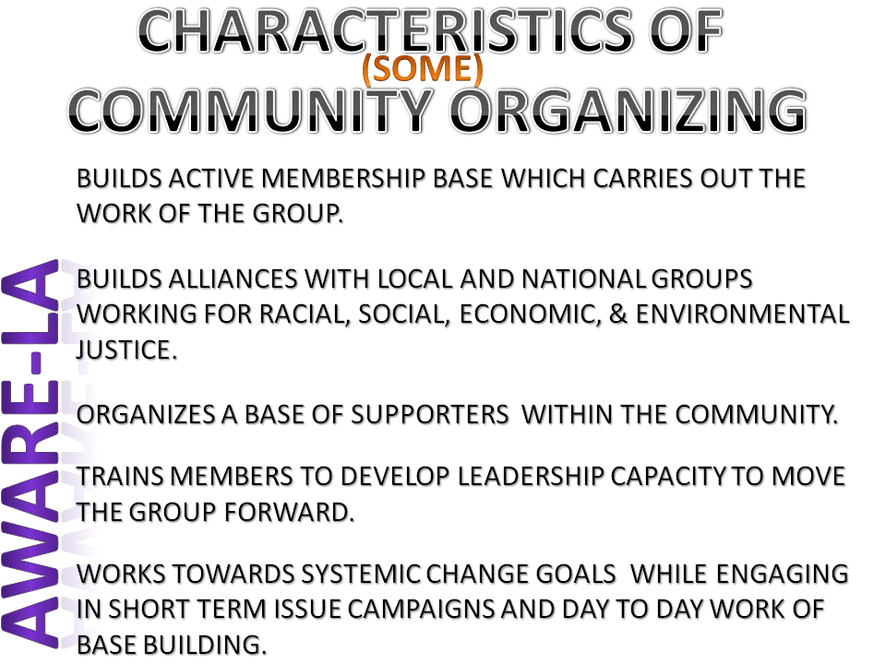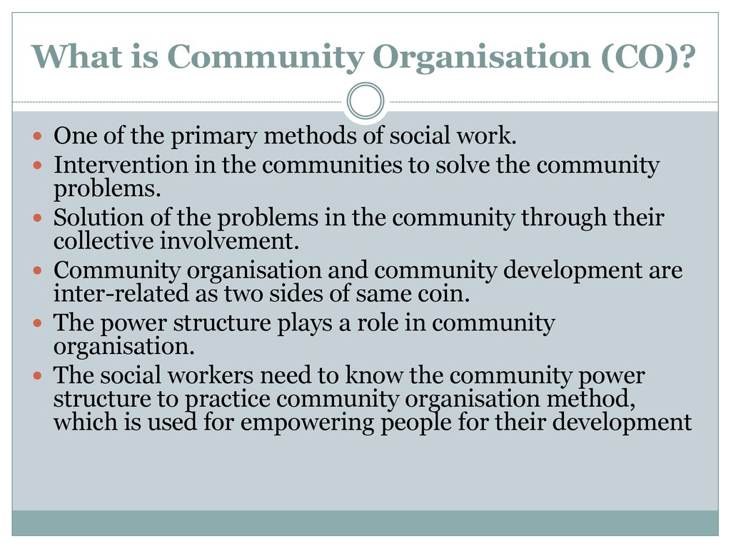
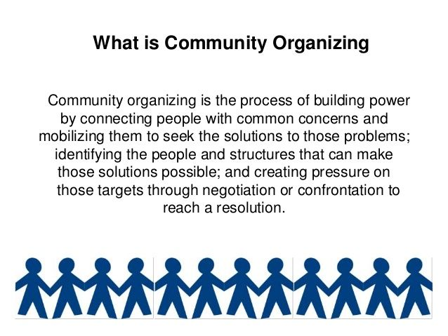
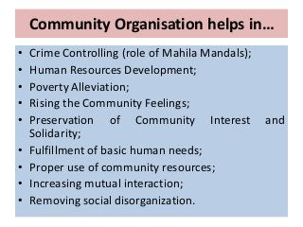

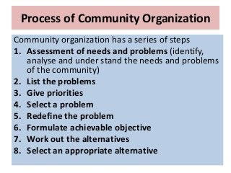
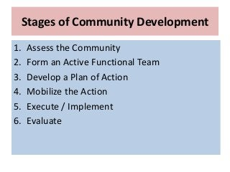

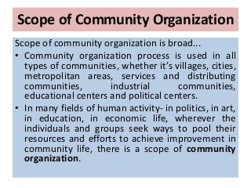

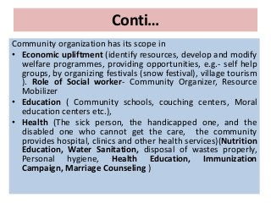
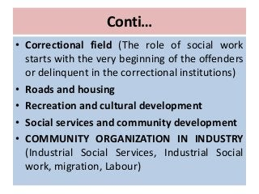
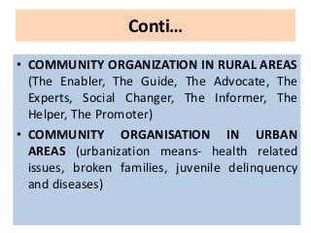
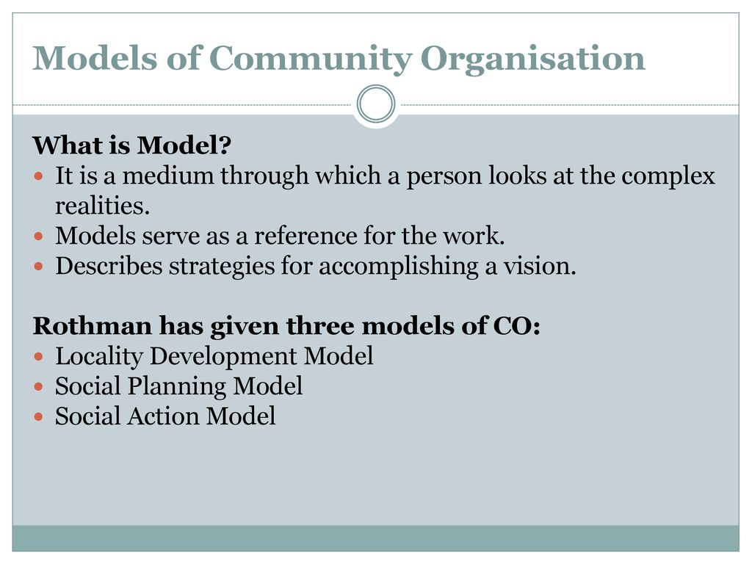

Models of community organization
byTeam MemberPosted atJuly 30, 2020
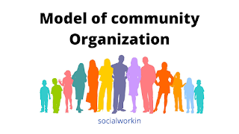
- To acquaint with the various models of community organization.
- To enable conceptual clarity on this model for best community organization practice.
Outcome
- Able to understand the various models of community development and organization.
- Able to demonstrate various models while working for a community organization.
Content
- Concept
- Introduction
- Models of the community organization
- Conclusion
Concept
There are three primary methods in social work that are working with individuals, groups, and communities. The sole purpose of the method is to bring about and progressive more effective adjustment between social welfare resources and welfare needs to overcome the problems and to enhance to have better social functioning. The term community organization become an important concept in the social work profession due to the publication of the
Introduction
Models are the conceptual designs of a particulars phenomenon to get the things done or we can say a model is nothing but a window through which a community worker looks at the complex nature of the community. Willing to work for the community must have the theoretical framework of the knowledge. The development of any community reflects on the development of its people. Most of the government and non-government organizations plan different development programs for improving the lives of the community people Therefore they need to understand different models of community organization. The knowledge and information will help to design strategies for ensuring the participation of people. let's understand different models of community organization.
Models of community organization.
According to Rothman (1947), there are three models of community organization.
- Locality development model
- Social Planning model
- Social action model
Locality Development
Locality development encompasses the concept of community change through the effective participation of a wide spectrum of people at the grass-root level for the determination of the goals and achieving for the same. Locality development model primarily emphasizes on the process of community building( UN Publication 1955) Locality development models reflect that the development of the community is possible when people make active participation in planning, implementing and evaluation process.
- Democratic Procedures
- Cooperation
- Self Help
- Local Leadership
- Educational objective
The above five essential elements are instrumental for the effective participation of the people in community organizations. The use of these elements will raise the capacity of the local people and can increase the degree of local people's participation.
Social Planning Model
Social planning is the process of planning social service programs for the improvement of the socio-economic condition of the people. This model primarily concerns with the social problem of the people. It encourages having a rational, well planned, and technical process for problem-solving with regard to social problems such as housing, water, and health. A deliberately planned and controlled change has the central place in this social planning model(
Social Action Model
The social action model is a theory of social work practice. The fundamental essence of the model is based on social justice, democracy, redistribution of power, and decision making. The model helps the community worker on how to take action through the empowerment practice. It is also understood as the strategies used by the group or community who feel they have inadequate power and resources to meet their needs. To ensure social justice, and equality the model try to work out for the review of various social policies and programs which continue to disempower the marginalized group and community.

Conclusion

The practice of these all models may require a set of skills and techniques of making effective practice in the community. The use of these various models can actually benefit the practitioners to be instrumental in bringing various issues of the marginalized groups/community to the mainstream of the society to raise the social standard of living of the people.

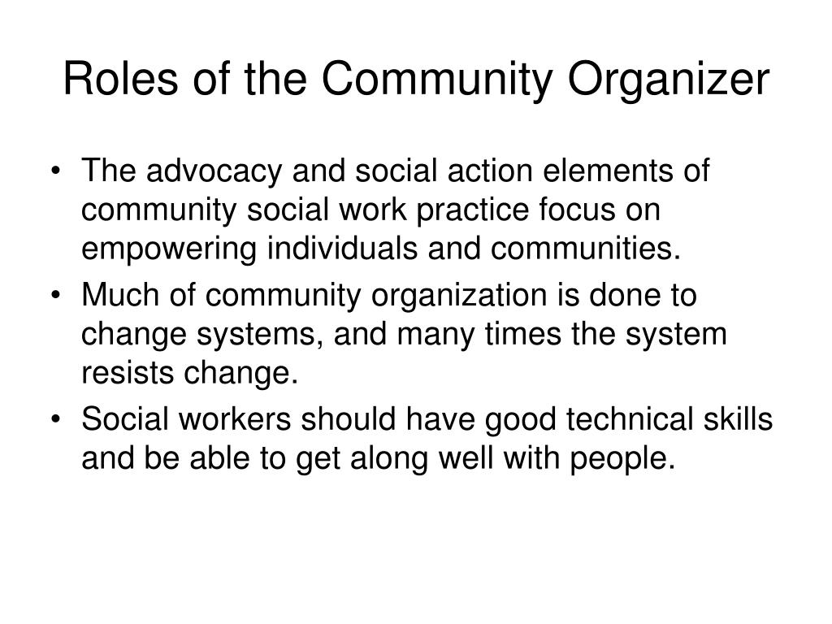
Unit-3
Social action is a method of professional social work aimed at solving social problems through redistribution of power and resources. Its objective is to achieve social justice and empowerment of the community. Social action mobilizes the general population to bring about structural changes in the social system.
important of social action
Through the commitment and skill of citizens, social action can empower communities, help people in need, and complement public services. Taking part in social action is also associated with higher levels of wellbeing, and can improve people's confidence and skills.
social action is considered as a secondary method of social work
Social Action, the master of the secondary method which aims to change social illness. Social action is meant to the mass betterment through propaganda and legislation. It plays a crucial role in the society to bring social changes through mass media. Also covers social, religious, political movements and reforms etc.
social action
Social action is people coming together to tackle an issue, support other people, or improve their local area. It involves people giving their time and other resources for the common good, in a range of forms – from volunteering to community-owned services, and peer networks to community organising.
4 types of social action
Max Weber's Social Action Theory divided the types of social action into the 4 categories mentioned above: traditional social action, affective social action, rational social action with values and instrumental social action.
What are the characteristics of social action?
Elements of Social Actions
- The actor. It is that individual who performs an act. ...
- The goal. ...
- Social situation. ...
- Normative orientation. ...
- Energy. ...
- The rational orientation to a system of discrete individual ends. ...
- The rational orientation to an absolute value. ...
- Traditionally oriented action: In such action.
principles of social action
Principles of social action are: a) principle of credibility building; b) principle of legitimization; c) principle of dramatization; d) principle of multiple strategies; e) principle of dual approach; and f) principle of manifold programmes.

scope of social action
The scope of social action is very vast and it is one of the most apt methods of social work practice even in today's context. The innovative approaches, participatory techniques, outreach, and holistic thinking are critically important in creating a better world, which is indeed the vision of social work profession.
social action example
Examples of social action can include raising awareness of environmental issues such as climate change, writing to your local MP about a change that is required in your community or visiting older people in care homes. These are just a few examples of an expansive list.
tools of social action
Social action can make people aware of your cause and your community.
...
- Organizing demonstrations, rallies and marches. The “classic” social actions, these often involve signs, speeches, entertainment, and/or elements of street theater.
- Picketing or organizing a strike. ...
- Organizing a boycott. ...
- Organizing a sit-in.
Who introduced social action in social work?
- 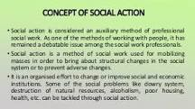

- Mary Richmond was the first social worker to use the word 'social action' in 1922. She defines social action as “mass betterment through propaganda and social legislation”
What is another term for social action?
What is another word for social action?
activism | action
involvement | logrolling
militancy | picketing
politicking | striking
direct action | effecting change

Social action is a method of professional social work aimed at solving social problems through redistribution of power and resources. Its objective is to achieve social justice and empowerment of the community. Social action mobilizes the general population to bring about structural changes in the social system.
importance of social action in social work
Social action gets people moving. It makes them feel strong, and makes them less likely to submit meekly to the rules and demands of those in power. It gives people responsibility for their own lives and actions, and brings out their leadership potential.

social action according to social work
Social action is an action within the framework of social work philosophy and practice that aims to achieve social change and progress by altering existing social structure and social relationship, modifying social policies, reforming social services and influencing social legislation.
scope of social action
The scope of social action is very vast and it is one of the most apt methods of social work practice even in today's context. The innovative approaches, participatory techniques, outreach, and holistic thinking are critically important in creating a better world, which is indeed the vision of social work profession.
process of social action
Social Action. In general sense the term 'process' can be understood as a series of systematic steps undertaken to accomplish some desired and specified goal/goals. In social action process refers to the generally accepted steps or stages involved while moving towards achieving the objectives of social action.
strategies of social action
Hornstein has classified these strategies or tactics of social action as: 1) Direct action: E.g. picketing, marches, fraternization, haunting, leafleting and renouncing honours. 2) Non-cooperation: E.g. strikes, boycott, tax-refusal. 3) Intervention: E.g. sit in, reversal strike, obstruction.
example of social action

Examples of social action can include raising awareness of environmental issues such as climate change, writing to your local MP about a change that is required in your community or visiting older people in care homes. These are just a few examples of an expansive list.
successful social action
A successful social action takes time, energy, money, passion, and can strain the resources of any good non-profit so if you are going to engage in advocacy – and we hope that you do – plan to be in it for the long haul and plan to invest the resources in the effort to be successful.
MARY RICHMOND •Richmond for the first time, in 1922, made use of the term social action in social work. • She has defined social action as “mass betterment through propaganda and social legislation”
Social action does have a definite set of goals of providing social justice to all. It employs certain strategies and tactics like negotiation, persuasion, competition, disruption, collaboration, bargain, strikes, boycotts to attain its objectives, which makes it different from other social work methods.
dual approach in social action
Principle of Dual Approach: Any activist has to build counter-systems or revive some unused system, which is thought to be beneficial to the mobilised public on a self-help basis without involving the opponent.

methods of social action
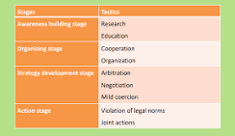

There are six methods of working with people in social work (casework, group work, community organisation, social action, social welfare administration and social work research).12-Apr-2018
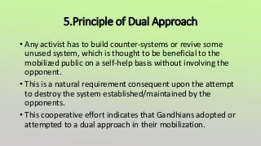


Unit -4
A social movement is a loosely organized effort by a large group of people to achieve a particular goal, typically a social or political one. This may be to carry out, resist or undo a social change. It is a type of group action and may involve individuals, organizations or both.

social movements cause
Deprivation, discontent, and frustration are frequently assumed to be sufficient causes for initiating or joining a social movement. The relationship is not a simple one, however. There is little evidence that the most deprived segments of a population are the most likely to participate in social movements.
Why are social movements important?
True social movements for good have the power to generate awareness that produces tangible results, helping the general population live longer, more productive, happier lives.
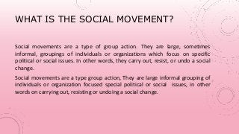
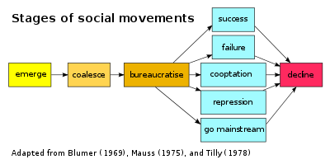
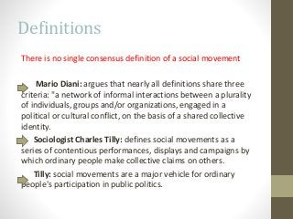
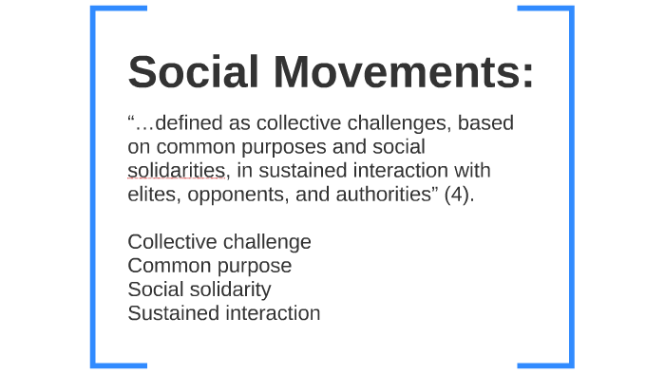
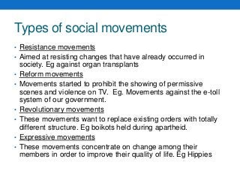
6 factors of a social movement
Structural-strain theory posits that social movements arise as a result of six factors: structural conduciveness, structural strain, growth and spread of a solution, precipating factors, lack of social control, and mobilization.
What is the meaning of social movements?
social movement, a loosely organized but sustained campaign in support of a social goal, typically either the implementation or the prevention of a change in society's structure or values. Although social movements differ in size, they are all essentially collective.
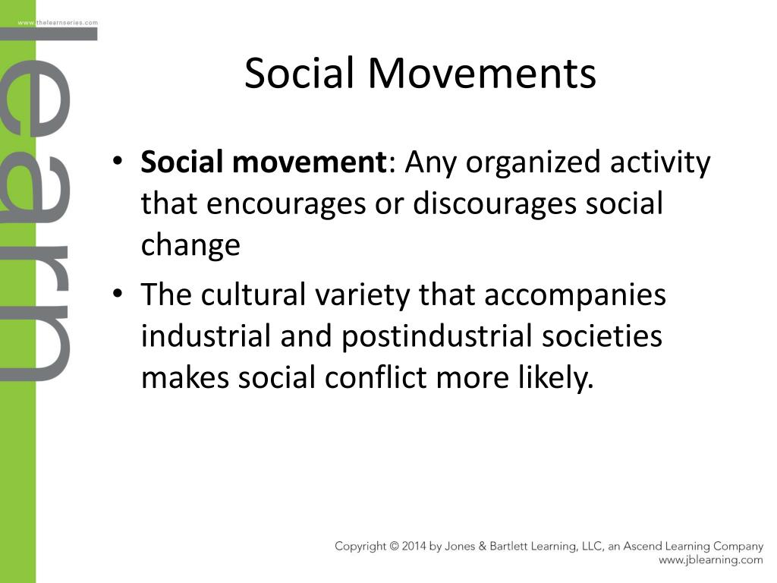
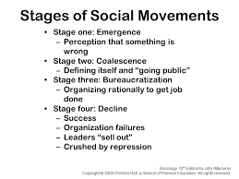

Social Movements: Meaning, Causes, Types, Revolution and Role
Social Movements: Meaning, Causes, Types, Revolution and Role!

The Meaning of Social Movements:
In the society a large number of changes have been brought about by efforts exerted by people individually and collectively. Such efforts have been called social movements. A social movement may, therefore, be defined as “a collectively acting with some continuity to promote or resist a change in the society or group of which it is a part”.
According to Anderson and Parker, social movement is “a form of dynamic pluralistic behaviour which progressively develops structure through time and aims at partial or complete modification of the social order.” Lundberg and others define social movement as, “a voluntary association of people engaged in concerted efforts to change attitudes, behaviour and social relationships in a larger society.”
Thus, social movement is the effort by an association to bring about a change in the society. A social movement may also be directed to resist a change. Some movements are directed to modify certain aspects of the existing social order whereas others may aim to change it completely. The former are called reform movements and the latter are known as revolutionary movements.
Social movements may be of numerous kinds, such as religious movements, reform movements, or revolutionary movements.

Social movements may be distinguished from institutions:
Firstly, Social institutions are relatively permanent and stable elements of a culture, whereas social movements have an uncertain life. Marriage is a permanent social institution but the life of family planning movement is not certain. Secondly, institutions hold institutional status. They are regarded as necessary and valuable aspects of the culture. A social movement lacks institutional status. Some people are indifferent or even hostile to it.
Social movements may also be distinguished from association. Firstly, an association is an organized group, while some social movements may be totally unorganized. Secondly, an association carries the customary behaviour of the society, while the social movement is concerned with some change in behaviour norms.
The following features of the social movement may be marked out:
(i) It is an effort by a group;
(ii) Its aim is to bring or resist a change in society;
(iii) It may be organized or unorganized;
(iv) It may be peaceful or violent;
(v) Its life is not certain. It may continue for a long period or it may die out soon.

Causes of Social Movements:
Social movements do not just happen. It is social unrest which gives rise to a social movement.
The social unrest may be caused by the following factors:

(i) Cultural Drifts:
The society is undergoing constant changes. The values and behaviour are changing in all civilized societies. In the course of cultural drift most of the people develop new ideas. To get these ideas operative in society they organise a movement. The development of a democratic society, the emancipation of women, the spread of mass education, the removal of untouchability, equality of opportunity for both the sexes, growth of secularism are the examples of cultural drift.

(ii) Social Disorganization:
A changing society is to some extent disorganized because changes in different parts of society do not take place simultaneously. One part changes more rapidly than the other producing thereby numerous lags. Industrialization has brought urbanization which has in its turn caused numerous social problems.
Social disorganization brings confusion and uncertainty because the old traditions no longer form a dependable guide to behaviour. The individuals become rootless. They feel isolated from the society. A feeling develops that the community leaders are indifferent to their needs. The individuals feel insecure, confused and frustrated. Confusion and frustration produce social movements.

(iii) Social Injustice:
When a group of people feel that injustice has been done to it they become frustrated and alienated. Such feeling of injustice provides fertile soil for social movements. The feeling of social injustice is not limited to the miserable poor. Any group, at any status level may come to feel itself the victim of social injustice. A wealthy class may feel a sense of injustice when faced with urban property ceiling Act or high taxes intended to benefit the poor. Social injustice is a subjective value judgment. A social system is unjust when it is so perceived by its members.
Thus, social movements arise wherever social conditions are favorable. It may be noted that in a stable, well integrated society there are few social movements. In such a society there are very few social tensions or alienated groups.
The people are contented. But in a changing and continuously disorganised society the people suffer from tensions. They are not fully contented. In such a society they perceive social injustice and become dissatisfied. It is the dissatisfied who build social movements. The modern society is more afflicted by social movements.
The people who are more susceptible to social movements are those who are:
(i) Mobile and have little chance to become integrated into the life of the community,
(ii) Not fully accepted and integrated into the group and are termed marginal,
(iii) Isolated from the community,
(iv) Threatened by economic insecurity and loss of social status,
(v) Free from family responsibilities or are estranged from their families,
(vi) Maladjusted.
Thus, the people who are homeless and misfits of society become the supporters of mass movements. It may also be noted that some people join the social movements for reasons unrelated to the movement’s objectives. Some may join it first to fill their leisure Ume, or they may be personally attracted to some of its members.
Or, they may join to get an office in the movement with the desire to achieve prestige or exercise power rather than to further the goals of the movement. It may again be emphasized that unless there is deep and widespread social discontent, social movements will not originate and develop.
The sequence pattern of social movement may be summarised as follows. First, there is unrest and discontent in some part of the population. A small group of individuals becomes conscious of the need for a change, voices its feelings and opinions, and sets out to influence the opinions and emotions of others and prepare them for a reform.
Then, thereafter, there is a period of growth in following. A preliminary organization is effected and the programme is restated in more popular and appealing terms. Then follows a more systematic effort to gain supporters. There is a formal campaign. Backed by the enlarged following and increased propaganda the leaders eventually exert pressure on those in authority.
The programme is either accepted or rejected, or partly accepted and partly rejected. If accepted, necessary institutional changes are made; if rejected the movement either collapses or reorganizes for a new trial of strength at a later date. Thus most completed movements pass through four stages of unrest, excitement, formalization and institutionalization.

Types of Social Movements:
It is not easy to give a classification of social movements because sometimes a movement is of a mixed nature or is of a different type at different stages of its career.
However, movements have been classified as follows:

(i) Migratory Movements:
Migratory movements take place when a large number of people leave one country and settle at some other place. The reason for mass migration may be discontent with present circumstances or the allurement of a bright future. Mere migration of people does not mean migratory movement.
There is a migratory social- movement only when there is a common focus of discontent, a shared purpose or hope for the future and a widely shared decision to move to a new location. The Zionist movement, the movement of Jews to Israel was a migratory social movement. Similarly, the movement of people from East Germany to West Germany can be called migratory social movement.

(ii) Expressive Movements:
When people are faced with a social system from which they cannot flee and which they feel powerless to change, the result is an expressive social movement. In an expressive social movement the individual comes to terms with an unpleasant external reality by modifying his reactions to that reality. He somehow makes life bearable. He tries to ignore the miserable present and fixes his gaze upon a glorious future. The Hippie movement is an expressive social movement.

(iii) Utopian Movement:
A Utopian movement is one which seeks to create an ideal social system or a perfect society which can be found only in man’s imagination and not in reality. There have been a number of Utopian socialist in the nineteenth century such as Robert Owen and Charles Fourier. Such movements are based on a conception of man as basically good, cooperative and altruistic. The Sarvodaya movement can be called a Utopian movement.

(iv) Reform Movements:
The reform movement is an attempt to modify some parts of the society without completely transforming it. Reform movements can operate only in a democratic society where people have freedom to criticize the existing institutions and may secure changes. The movements to abolish untouchability, dowry system, preserve wild life, control population growth are reform movements. The total revolution movement led by J. P. Narayan was a reform movement. The movement led by J. P. Narayan was a reform movement.

(v) Revolutionary Movements:
The revolutionary movement seeks to overthrow the existing social system and replace it with a greatly different one. The reform movement wants to correct some imperfections in the existing social system but a revolutionary movement wants to root out the system itself. Revolutionary movement’s flourish where reform is blocked so that revolution remains the people’s only alternative to their present misery. The communist movements in Soviet Russia and China were revolutionary movements.

(vi) Resistance Movements:
The resistance movement is an effort to block a proposed change or to uproot a change already achieved. The revolutionary movement arises because people are dissatisfied with the slow rate of social change whereas resistance movement arises because people consider social change too fast. The D. M. K. movement against Hindi can be termed resistance movement.

Role of Leadership:
Social movements in order to succeed must have effective organisation and strong leader. The members or supporters must be recruited in greater number, financial support must be procured and various tasks connected with the movement must be properly allocated. There must also be proper coordination among personnel assigned to more or less specific roles. In social movements the role of the leader is very important.
Many a movement fails due to lack of leadership. The leader is the spokesman of the group. He is the coordinator and the important participator in the decisions as to the goals and methods. He is an example to others. He enjoys great authority and power. He also enjoys great prestige. He excels others in personal qualities. The leader has great responsibilities. He is expected to fulfill them.
He is expected to keep his word, to stick by the members and to uphold the group norms and values. If he does not live up to the level expected, he suffers a loss of prestige and even of position in the group. He can be thrown out of leadership. If he betrays the confidence reposed in him by the supporters, he may even be killed. Thus, the leader plays a crucial role in a social movement. The success or failure of the movement depends largely on him.
The leadership functions are related to the
(i) goal achievement
(ii) to the strengthening of the social movement.
Functions under the first category are instrumental to achieving the goals of the group.
These functions are to:
(i) Make suggestions for action,
(ii) Evaluate the movement towards the goal,
(iii) Prevent activities irrelevant to the goal, and
(iv) Offer effective solutions for goal achievement.
Functions in the second category maintain and strengthen the movement. These functions are to
(i) Encourage the members,
(ii) Release tension that builds up,
(iii) Give everyone a chance to express himself, and
(iv) Stimulate coordinated action.
The leader has the basic responsibility for seeing that the social movement achieves its goals. The followers follow the leader because they recognise that he can lead them to the goal. The leader should select his technique with great forethought. It should be “reality-oriented.” The leader should know that in case of failure of the movement he may have to suffer rebuffs, loss of status and blame. He should, therefore, be very cautious in assuming the leadership, and having assumed should be careful in handling it successfully. A leader can channelise the mass enthusiasm into constructive social reforms or he can eventually destroy the social system.

an agrarian movement
13.2.1 Meaning. Agrarian movements include the movements of agrarian classes which are related to agriculture in terms of working on the land or in terms of both working on land and its ownership.

peasant movement
Peasant Movements are a part of social movements against British atrocities in the 18th and 19th centuries of the British Colonial Period. These movements had the sole purpose of restoring the earlier forms of rule and social relations.

father of peasant movement
Gogineni Ranga Nayukulu, also known as N. G. Ranga is regarded as the father of the Indian Peasant movement. He was an exponent of the peasant philosophy, Indian freedom fighter, classical liberal, parliamentarian and farmer leader. He is the founding president of Swatantra Party.
What are the major agrarian movements in India?
Now let us have a detailed discussion on some of the important peasant movements.
- Champaran Satyagraha (1917): ...
- Kheda Peasant Struggle: ...
- The Bardoli Movement in Gujarat: ...
- Moplah Rebellion in Malabar: ...
- Peasant Revolt in Telangana: ...
- Tebhaga Movement in Bengal:
Who is the father of peasant movement?
- Gogineni Ranga Nayukulu, also known as N. G. Ranga is regarded as the father of the Indian Peasant movement. He was an exponent of the peasant philosophy, Indian freedom fighter, classical liberal, parliamentarian and farmer leader. He is the founding president of Swatantra Party.

main objective of the peasant movement
- The objective of these movements were centered almost wholly on economic issues rather than ending the exploitation of the peasants. The peasants were brought into the broader struggle against colonialism beginning with Champaran, Kheda and later Bardoli movement.

the impact of peasant movement
- Unemployed people moved to villages and took to agriculture. This resulted in increased pressure on land. The cultivators often had to take loans to pay the rent, on failing to pay the rent, they were evicted from the land. Sometimes the overcrowded peasants took to crime to get out of unbearable conditions.

nature of peasant movement in India

- Peasants were the main force in agrarian movements, fighting directly for their own demands. The demands were centered almost wholly on economic issues. The movements were directed against the immediate enemies of the peasant—foreign planters and indigenous zamindars and moneylenders.

major problems that peasants are facing in India

- (i) Talukdars and landlords demanded from the peasants exorbitantly high rents and a variety of other taxes. (ii) Peasants had to do begar (labour without any payment) and work at landlords farms.

main objectives of agrarian movement
- The economic objectives of such reforms are to abolish inefficient production structures, exploit the efficiency of family farms, increase agricultural production, improve capital formation and increase demand for farm inputs and services that stimulate development in the non-agricultural sector.

- What does the agrarian reform mean?
- redistribution of the agricultural resources
- agrarian reform, redistribution of the agricultural resources of a country. Traditionally, agrarian, or land, reform is confined to the redistribution of land; in a broader sense it includes related changes in agricultural institutions, including credit, taxation, rents, and cooperatives.

3 agrarian reform
- The World Bank evaluates agrarian reform using five dimensions: (1) stocks and market liberalization, (2) land reform (including the development of land markets), (3) agro-processing and input supply channels, (4) urban finance, (5) market institutions.

importance of agrarian reform
- The agrarian reform contributed to relieve the unemployment pressure and to increase agricultural production and productivity, although it could not prevent a massive exodus of rural population from the mountains and the most marginal areas.

antyodaya movement

- ANTYODAYA ANNA YOJANA (AAY) AAY. AAY was a step in the direction of making TPDS aim at reducing hunger among the poorest segments of the BPL population.

Who started antyodaya?
Antyodaya Anna Yojana (AAY) is one of the biggest initiatives undertaken by the Government of India. It is a public distribution system scheme that was implemented in India in 2000.
Which Government started antyodaya?
the Government of Rajasthan
The Antyodaya programme was instituted for the upliftment of the poorest of the poor in the country. Launched first by the Government of Rajasthan in 1977, the programme was taken up by the Governments of Himachal Pradesh, Orissa, Uttar Pradesh, Bihar and Manipur in 1978.
What is the aim of Antyodaya Anna Yojana?
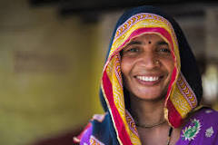

The main objective of the scheme is to ensure food security and to create hunger-freeee India. AAY scheme covers the poorest of the poor in India by supply of food and other important commodities for their daily needs on subsidized rates.

Who started the Sarvodaya Movement?
Gandhi's ideals have lasted well beyond the achievement of one of his chief projects, Indian independence His followers in India notably, Vinoba Bhave continued working to promote the kind of society that he envisioned, and their efforts have come to be known as the Sarvodaya Movement.

What do you mean by Sarvodaya Movement?
Sarvodaya means 'progress of all' or 'Universal uplift'. Gandhi started this Sarvodaya movement, and people consider it an addition to his efforts in his non-violence movement. The main objective of this event was to establish a new India based on non-violence and love.
When did the Sarvodaya Movement started?
�A Sarvodaya Economic Conference was held in December, 1949 which aimed at establishing a Sarvodaya society. The Sarvodaya movement may be viewed as an extension of the efforts of Mahatma Gandhi in the realisation of non-violent socialism

Why was Sarvodaya Movement started?
Note - The Sarvodaya movement was initiated by Mahatma Gandhi. It was aimed towards achieving progress in all sections of society. Dada Dharmadhikari, Jaya Prakash Narayan and Vinoba Bhave were all supporters and members of the Sarvodaya Movement and carried it forward.
What are the principles of Sarvodaya?
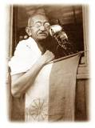
The Sarvodaya Movement is based on Truth, Non-violence and Self-denial. The Sarvodaya Movement makes a sincere and bold attempt to create the necessary atmosphere to bring together such individuals with an unwavering faith in the Welfare of All. The gain to the individual would be small.
Who prepared Sarvodaya plan?
Who said Sarvodaya?
WHO adopted Sarvodaya plan in India?
Detailed Solution
Plans | Formulated by | Year
The Sarvodaya Plan | Jayaprakash Narayan | January 1950
The Bombay Plan | Purshotamdas Thakurdas, J.R.D. Tata, G.D. Birla | 1944–45
The Gandhian Plan | Shriman Narayan Agarwal | 1944
The People's Plan. | M.N. Roy | 1945
Who gave sarvodaya plan in 1950?
leader Jaiprakash Narayan
Sarvodaya Plan: Following the publication of the NPC findings and the government's decision to pursue five-year plans, the famed socialist leader Jaiprakash Narayan devised a single blueprint for India's planned growth, the Sarvodaya Plan, which was published in January 1950.
Who started the Bhoodan movement?
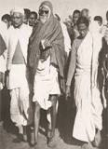
disciple Vinoba Bhave
Bhoodan Movement was started by Mahatma Gandhi's disciple Vinoba Bhave in April 1951. Born spontaneously at an evening meeting in an Andhra Pradesh village, the movement saw land owners gifting land to the landless.3 days ago
What are the aims of Bhoodan movement?
Ans. The Bhoodan Movement (Land Gift Movement) attempted to persuade wealthy landowners to voluntarily give a percentage of their land to landless people. It is also known as the Bloodless Revolution was a voluntary land reform movement in India.

Which act is known as bhoodan?
(ACT NO. 13 OF 1965) [10th May, 1965] AN ACT TO FACILITATE THE DONATION OF LANDS FOR BHOODAN YAGNA AND GRAMDAN, THE DISPOSAL OF SUCH LANDS AND MATTERS CONNECTED THEREWITH
What does the term Bhoodan means?
noun. (in India) a socioagricultural movement, started by Vinoba Bhave in 1951, in which village landowners are persuaded to give land to the landless
The Bhoodan movement (Land Gift movement), also known as the Bloodless Revolution, was a voluntary land reform movement in India.

What is the main purpose of Bhoodan Movement?
Ans. The Bhoodan Movement (Land Gift Movement) attempted to persuade wealthy landowners to voluntarily give a percentage of their land to landless people. It is also known as the Bloodless Revolution was a voluntary land reform movement in India.

What is the other name of Bhoodan Movement?
the Bloodless Revolution
The Bhoodan movement (Land Gift movement), also known as the Bloodless Revolution, was a voluntary land reform movement in India. It was initiated by Gandhian Vinoba Bhave in 1951 at Pochampally village, Pochampally.

What were Bhoodan Movement and Gramdan movement?
The Bhoodan and Gramdan movements led by Vinoba Bhave attempted to bring about a “non-violent revolution” in India's land reforms programme. These integrated movements were an attempted to implement land reforms by urging the landed classes to voluntarily surrender a part of their land to the landless
An environmental movement is a type of social movement that involves an array of individuals, groups and coalitions that perceive a common interest in environmental protection and act to bring about changes in environmental policies and practices.
What are the major environmental movements?

This legislation still exists today in the region.
- Chipko Movement. Year: 1973. ...
- Save Silent Valley Movement. Year: 1978. ...
- Jungle Bachao Andholan. Year: 1982. ...
- Appiko Movement. Year: 1983. ...
- Narmada Bachao Andholan (NBA) Year: 1985. ...
- Tehri Dam Conflict. Year: 1990's.
- What is the importance of environmental movement?
- The environmental movement has sought to protect the natural world through a number of initiatives, including reducing pollution, conserving natural resources, preventing endangered species from becoming extinct, and shielding natural areas from destruction or overdevelopment.
- Who started the environmental movement?
- June 1962: "Silent Spring"Rachel Carson's Silent Spring is published. Acclaimed as the catalyst of the modern environmental movement, Silent Spring condemns the overuse of pesticides.

What are the causes of environmental movement?
Major reasons of the emergence of environmental movements in India include:
- Control over natural resources.
- False developmental policies of the government.
- Socioeconomic reasons.
- Environmental degradation/ destruction.
- Spread of environmental awareness and media.
- Who is the most famous environmentalist?
- 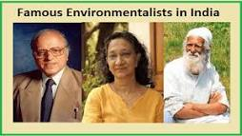
- 1. Sunderlal Bahuguna. He was born on January 9, 1927, near Tehri, Uttarakhand, British India.
- When did environmental movement start?
- 
- 1960s
- Scope of the movement
The modern Environmental movement, which began in the 1960s with concern about air and water pollution, became broader in scope to include all landscapes and human activities.

- Who is the main leader of Narmada Bachao Andolan?
- Narmada Bachao Andolan was also joined by several NGOs with local people, professionals, and activists as the founders with a non-violent approach. It was led by Medha Patkar.

- What is Narmada Bachao Andolan?
∙The Narmada Bachao Andolan (NBA) is an Indian social movement led by indigenous peoples (adivasis), farmers, environmentalists, and human rights activists who are protesting a number of huge dam projects along the Narmada River, which flows through Gujarat, Madhya Pradesh, and Which dam led to Narmada Bachao Andolan?
Narmada Bachao Andolan (NBA) forces end of World Bank funding of Sardar Sarovar dam, India, 1985-1993.
- Maharashtra.
- What were the outcome of Narmada Bachao Andolan?
- The outcome of Narmada Bachao Andolan
The World Bank has announced that it will establish an Independent Review of the Sardar Sarovar projects. The review was the first of its kind and included sweeping mandates and procedures for supervision

- Why Narmada Bachao Andolan was started?
- Narmada Bachao Andolan was started to help the people displaced by the Sardar Sarovar dam. Narmada Bachao Andolan also was known as NBA is a social movement formed by activist Medha Patkar.

- Who supported the Narmada Bachao Andolan?
- Baba Amte (1914-2008) was one of India's most respected social and moral leaders. Medha Patkar is an Indian activist and one of the initiators of The Save the Narmada Movement, Narmada Bachao Andolan (NBA).

- Chipko movement, also called Chipko andolan, nonviolent social and ecological movement by rural villagers, particularly women, in India in the 1970s, aimed at protecting trees and forests slated for government-backed logging.

- Location: Bhagirathi River Himalayas India Uttar ...
- Who started the Chipko movement?
- 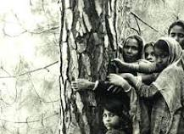
- It was then that environmentalist and Gandhian social activist Chandi Prasad Bhatt, founder of the cooperative organisation Dasholi Gram Swarajya Sangh, led the first Chipko movement near the village of Mandal in 1973.26-Mar-2018
Who were the 3 leaders of Chipko movement?
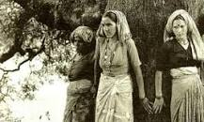

Sindhu Mary Jacob, Satyendra Tripathi: Chipko movement: Uttarakhand women's bid to save forest wealth.
Why was Chipko movement was started?

The Chipko Movement was triggered by a government decision to allot forest land to a sports goods company. Angered by the move, villagers formed circles around the trees to prevent them from being cut.26
What are the main aims of Chipko movement?
The main aim was to protect the trees by hugging them and not allowing cutting of these trees. This movement was also called Chipko Andolan. The Chipko movement quickly spread across communities and media, and forced the government, to whom the forest belongs, to rethink their priorities in the name of forest produce.
Which state started the Chipko movement?

Uttarakhand
The movement originated in the Himalayan region of Uttarakhand (then part of Uttar Pradesh) in 1973 and quickly spread throughout the Indian Himalayas. The Hindi word chipko means “to hug” or “to cling to” and reflects the demonstrators' primary tactic of embracing trees to impede loggers.
What does the word Chipko means?
hugging
(Chipko, a Hindi word meaning "hugging", is used to describe the movement because local village women literally "hugged" trees, interposing their bodies between the trees and the loggers to prevent their being cut down.)
Silent Valley Movement was a movement against the state to protect Silent valley, an evergreen tropical forest in the Palakkad district of Kerala, India.
What is the Silent Valley movement?
Silent Valley Movement was a movement against the state to protect Silent valley, an evergreen tropical forest in the Palakkad district of Kerala, India. It was started in 1973 to save the Silent Valley Reserve Forest from being flooded by a hydroelectric project.
Who was the leader of the Silent Valley movement?
Save Silent Valley was a social movement aimed at the protection of Silent Valley, an evergreen sub-tropical forest in the Palakkad district of Kerala, India. It was started in 1973 by an NGO led by Kerala Sasthra Sahithya Parishad (KSSP) to save the Silent Valley from being flooded by a hydroelectric project.
Who was the leader of the Silent Valley movement?
Save Silent Valley was a social movement aimed at the protection of Silent Valley, an evergreen sub-tropical forest in the Palakkad district of Kerala, India. It was started in 1973 by an NGO led by Kerala Sasthra Sahithya Parishad (KSSP) to save the Silent Valley from being flooded by a hydroelectric project.
Which state is known as Silent Valley?
Kerala, India
Silent Valley National Park
The Nilgiri Mountains as seen from Silent Valley National Park
Location in Kerala, India
Location | Kerala
Nearest city | Mannarkkad
Why Is Silent Valley famous?
Located in the Kundali Hills of the Western Ghats, the Silent Valley National Park holds a valuable reserve of rare plants and herbs. The park is rich in its wildlife, and elephants, lion-tailed macaques and tigers are the most common denizens of this park.
What is the old name of Silent Valley?

Sairandhri
In a booklet titled “Storm Over Silent Valley”, senior environmental journalist Darryl D'monte notes its widely accepted etymology. The valley was originally known as Sairandhri, another name for Draupadi, the wife of the Pandavas. And the river flowing through it is called Kunthipuzha, after their mother.
Who gave the name Silent Valley?
the British
What's in a name? In 1847, Robert Wright made the first investigations in the Silent Valley area. There are many legends as to how the valley got its name. One theory is that the British named it so, because of the absence of the Cicadas.
What is meant by Dalit movement?
Dalit movement is a struggle that tries to counter attack the socio – cultural hegemony of the upper castes. It is a movement of the masses that craves for justice through the speeches, literary works, dramas, songs, cultural organisations and all the other possible measurers.
Who started Dalit movement?
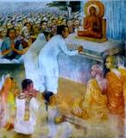
Ambedkar
The movement was launched in 1956 by Ambedkar when nearly half a million Dalits – formerly untouchables – joined him and converted to Navayana Buddhism. It rejected Hinduism, challenged the caste system in India and promoted the rights of the Dalit community.
What are the different types of Dalit movements?
The Dalit movement began as a protest movement, to bring socio-political transformation in the status of Dalits in India.
...
Other prominent movements in this category include:
- Adi Dravidas movement in Tamil Nadu.
- Shri Narayan Dharma Paripalan movement in Kerala.
- Nair Movement in 1861.
What are the causes of Dalit movement?
Top 6 Factors Responsible for the Rise of Dalit Movement in India
- Land Settlement: When the British arrived in India, most of the land belonged to the high-caste people who were either absentees or non-cultivating owners. ...
- Industry: ...
- Communication Facilities: ...
- Education: ...
- Press and Books: ...
- Legal System:
- Who is the father of dalit movement?
- Dr. B. R. Ambedkar
- B. R. Ambedkar, a Dalit himself, strongly advocated for abolishing the caste system and supported Dalit struggles. He is known as the Father of the Constitution.

What are the main problems of dalit movement?
- Dalit movements usually highlight issues of reservation and discrimination in an educational institution, and these issues affect a small proportion of the Dalit population. Rising income may have led many Dalits to challenge caste barriers, causing resentment among upper-caste groups, leading to a backlash.
Dalit movement is a struggle that tries to counter attack the socio – cultural hegemony of the upper castes. It is a movement of the masses that craves for justice through the speeches, literary works, dramas, songs, cultural organisations and all the other possible measurers.
When was Dalit movement started in India?
The movement was launched in 1956 by Ambedkar when nearly half a million Dalits – formerly untouchables – joined him and converted to Navayana Buddhism. It rejected Hinduism, challenged the caste system in India and promoted the rights of the Dalit community.

What are the features of dalit movement?
The Dalit-Bahujans are historically involved in the production and producing economy. The paper explores the features of the dalit movement likeliberty, equality, fraternity, secularism, democracy, egalitarianism, dignity of labor, social justice, Dalit historiography, Dalit agitation.

What are the impact of dalit movement?
The most important result of dalit movement has been the conslidation of dalit identity. The pressure created by the mobilisation of the dalits has led to amelioration of their social condition.

In other words, the Dalit movement of Karnataka is a dream child of Prof. B. K. He organized hundreds of Protests against the atrocities of forward castes indifference of government social inequality, caste system, naked procession of Dalit women, bribery and other hundreds of social ills
Where is Dalit movement?
Consequently, the Dalits began to call themselves Adi-Andhras in Andhra, Adi- Karnatakas in Karnataka, Adi-Dravidas in Tamil Nadu, Adi-Hindus in Uttar Pradesh and Adi-Dharmis in Punjab.
What are the features of dalit movement?
The Dalit-Bahujans are historically involved in the production and producing economy. The paper explores the features of the dalit movement likeliberty, equality, fraternity, secularism, democracy, egalitarianism, dignity of labor, social justice, Dalit historiography, Dalit agitation.
What is known as the women's movement?

The feminist movement (also known as the women's movement, or feminism) refers to a series of social movements and political campaigns for radical and liberal reforms on women's issues created by the inequality between men and women.
What was the main goal for the women's movement?
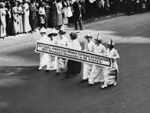
Their broad goals included equal access to education and employment, equality within marriage, and a married woman's right to her own property and wages, custody over her children and control over her own body.
What are the examples of women's movement?
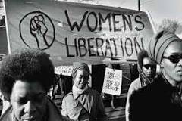
Contents
- Suffrage Movement.
- Women's Liberation Movement.
- Black Feminism.
- The Feminist Sex Wars.
- Riot Grrls.
26-Jan-2009

Who started the women's movement?

It commemorates three founders of America's women's suffrage movement: Elizabeth Cady Stanton, Susan B. Anthony, and Lucretia Mott.
What is women's movement in simple language?
women's movement. A movement to secure legal, economic, and social equality for women, also called the feminist movement. It has its roots in the nineteenth-century women's movement, which sought, among other things, to secure property rights and suffrage for women.
What are the basic women's rights?
These rights include the right to live free from violence, slavery, and discrimination; to be educated; to own property; to vote; and to earn a fair and equal wage. As the now-famous saying goes, “women's rights are human rights.” That is to say, women are entitled to all of these rights.
Why did the women's movement start?
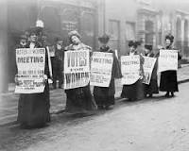
The movement for woman suffrage started in the early 19th century during the agitation against slavery. Women such as Lucretia Mott showed a keen interest in the antislavery movement and proved to be admirable public speakers.
What is women's movement in India?
Feminism in India is a set of movements aimed at defining, establishing, and defending equal political, economic, and social rights and opportunities for women in India. It is the pursuit of women's rights within the society of India.

The womens movement in Karnataka, in the beginning, laid more emphasis on womens ________.
A

Participation in the freedom struggle
B

Education
C

Participation in labour Work force
D

Health

Karnataka: Women-led march to Bengaluru, demanding liquor ban in state, to end with silent protest at Vidhana Soudha today
The 200-kilometre march, where protestors were demanding a liquor ban in Karnataka, was held under the banner of the Madya Nisheda Andolana, a women-led anti-alcohol movement. It started from Chitradurga on 19 January.
FP StaffJanuary 30, 2019 13:42:38 IST
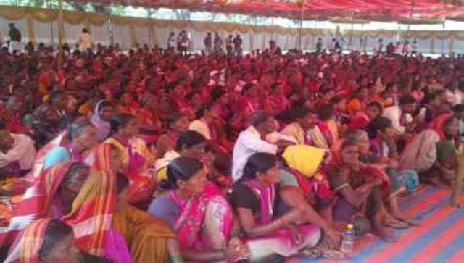
- More than 2,000 people, mostly women, will march towards Bengaluru's Vidhana Soudha and stage a silent protest, demanding a liquor ban in Karnataka.
- The 200-kilometre march under the banner of the Madya Nisheda Andolana (MNA), a women-led anti-alcohol movement, started from Chitradurga on 19 January.
- Renukamma, a 60-year-old woman and construction labourer from Raichur taking part in the march, died of injuries in an accident when the protestors reached Nelamangal
- The 200-kilometre march under the banner of the Madya Nisheda Andolana (MNA), a women-led anti-alcohol movement, started from Chitradurga on 19 January. On Sunday, they stayed at Kulavanahalli village near Nelamangala on the outskirts of Bengaluru, The Times of India reported.
- Renukamma, a 60-year-old woman and construction labourer from Raichur taking part in the march, died of injuries in an accident when the protestors reached Nelamangala, The News Minute reported. She was hit by a motorcycle while crossing the road, the news portal added.
- On their journey to the state capital, the protestors spread the message of the ill-effects of alcohol in the villages they passed through. According to The Times of India, the protestors made their way through Kyadigere, Hosuru, Nityananda Ashram, Javagondana Halli, Tavara Kere, Sira, Chikkanahalli, Dodda Alada Mara Cross, CB Temple, Darga Bellavi Cross, Tumakuru, Siddaganga mutt, Adichunchanagiri mutt and Kulavanahalli villages.
- However, The Hindu quoted some participants as saying that although the padayatra has nearly come to a close, no elected representative has addressed their concerns. They also claimed that Karnataka chief minister HD Kumaraswamy had called some participants but had not given any assurances.
- The women called for the march because alcohol addiction is resulting in violence against women in many villages and also causing poverty, The Hindu quoted protestors as saying. "It is difficult to make ends meet for the household when men spend a large chunk of the money on alcohol. As a result, children do not get adequate nutrition and are left malnourished," Sharada Gopal, a women’s rights activist, said.

Top 10 Women's Movements Over the Last 100 Years
- 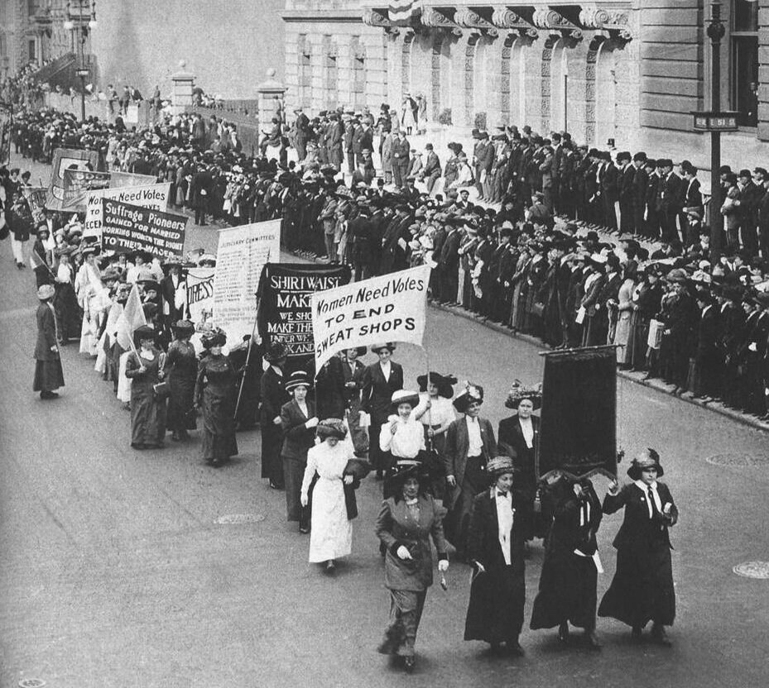
- Written by Katie Johnson, WIN Staff
- Women have experienced many movements and three (some debate four) waves of feminism throughout the last 100 years. These movements range from seeking out legal rights to personal freedom and equal opportunity. This past Sunday we celebrated International Women’s Day. It is a day defined as being “about unity, celebration, reflection, advocacy, and action for women.” The first National Women’s Day was observed across the United States in 1911.
- International Women’s Day was born out of the first wave of feminism, caught in the midst of the rise of radical ideologies and a period of booming expansion. Women everywhere were coming together for one cause: to gain equal legal rights. Although the first wave of feminism was well on its way by the first National Women’s Day, other monumental movements and significant events representing the interests of women have continued to occur throughout the last 100 years. As Gloria Steinem said, “The story of women’s struggle for equality belongs to no single feminist nor to any one organization but to the collective efforts of all who care about human rights.”
- 100 years ago women’s rights in the United States were severely limited. Women were bound to only a few jobs, and the right to vote wasn’t granted until late 1920. Only 50 years ago, the lives and opportunities of women were drastically different then the lives we have now still. In 1970, women could only dream of one day having a female Speaker of the House or Secretary of State. There were no women with a realistic shot at becoming President and no women heading Fortune 500 companies. The first woman to sit as an acting Supreme Court justice wouldn’t happen until 1981. But what were the movements that deciphered change? Here we outline the top ten women’s movements since 1920 that have helped create a more perfect union and establish better opportunities for all women.

- 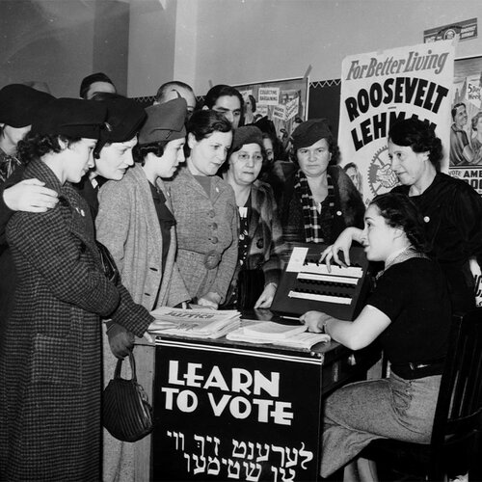

1920

Passage of the 19th Amendment
- On August 18, 1920, Congress ratified the 19th Amendment to the U.S. Constitution, declaring “the right to citizens of the United States to vote shall not be denied or abridged by the United States or any State on account of sex.” It was nicknamed the “Susan B. Anthony Amendment” in honor of her work on behalf of women’s suffrage. In theory, it granted the right to women of all races, but in practice it remained difficult for black women to vote, especially in the South until 1965.
- 

1942

Women Take Over
- During World War II, women had to take over many of men’s roles in order to maintain the economy. This time period was immortalized by Rosie the Riveter and the iconic poster with the catchphrase, “We can do it!” showing off her arm muscles. After World War II, women’s lives changed drastically. Although there was tremendous growth in the service sector, and women proved that they could do the same jobs as men with the same efficiency, women’s roles in society were restricted by cultural attitudes and legal precedents.
- 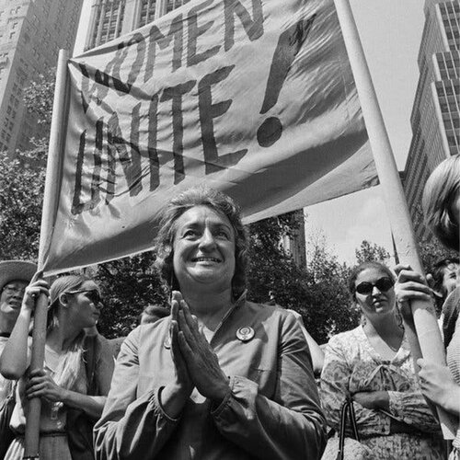

1963

Mystique Movement
- February 19, 1963, Betty Friedan’s The Feminine Mystique came out and sold over 3 million copies within 3 years. This phenomenon came to be associated with the second wave of feminism. Unlike the first wave which solely sought out legal rights for women, the second wave sought not only equal rights, but also equal opportunities and greater personal freedom for women. It’s goal was to change the way society thought about women. The Feminine Mystique railed against systemic sexism or “the problem that has no name.” It brought to light that women are taught that their place was in the home and if they were unhappy in this role, society deemed her broken and perverse.
- Friedman argued that the fault didn’t lie with women, but with a narrow-minded society that refused to let women tap into their creativity and intellect. It was not revolutionary in it’s thinking, but it was revolutionary in it’s reach. 3 million readers now had justification to be angry and were ready to rally for a unifying goal: social equality.
- This rally cry brought about systemic change both socially and politically for women over the next 15 years. These include: passage of Title VII of the Civil Rights Act which bars discrimination in employment on the basis of race and sex, the founding of the National Organization for Women (NOW) by a group of feminists including Betty Friedan, and signing Title IX into law which gave women the equal opportunity to education.
- 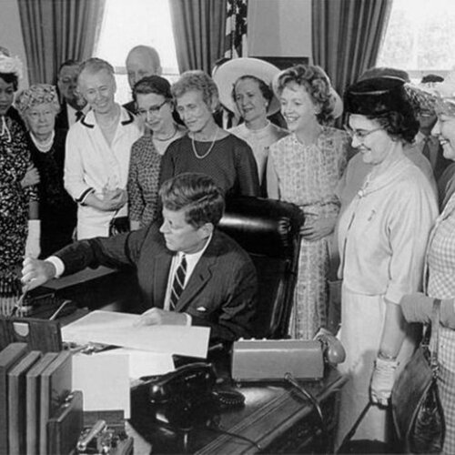

1963

Equal Pay Act
- On June 10, 1963, John F. Kennedy signed the Equal Pay Act into law. It was a landmark piece drafted by Ester Peterson, head of the Women’s Bureau of the Department of Labor. It prohibited employers from paying employees differently, on the basis of gender, for work that required “equal skill, effort, and responsibility.” This was the very first anti-discrimination law to address gender-based pay disparities. President Kennedy acknowledged the bill would not solve all the economic equality issues surrounding pay, but was an important first step to affirm “our determination that when women enter the labor force they will find equality in their pay envelopes.” Unfortunately as the pay gap shows, over fifty years later and we still haven’t gotten there.
- 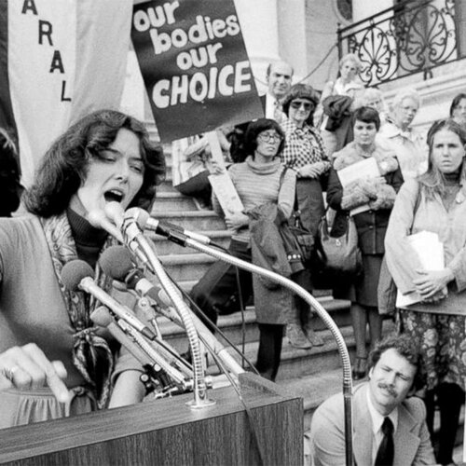

1973

A Woman’s Right to Choose
- On January 22, 1973, the monumental Supreme Court 7-2 Roe v. Wade decision, declared that the Constitution protects a woman’s right to an abortion. The right of a woman to terminate a pregnancy has always been controversial, primarily because of religious concerns regarding the potential personhood of embryos and fetuses. Prior to Roe v. Wade, abortion was illegal in America and many women were forced to choose between untenable pregnancies and potentially dying from dangerous procedures. The practice was so unsafe that approximately 17 percent of all deaths due to pregnancy were because of botched, illegal abortions. Now, it is estimated that less than 3 percent of women experience any serious complications due to abortion. In a later case surrounding abortion in 1992, the Supreme Court noted, “the ability for women to participate equally in the economic and social life of the Nation has been facilitated by their ability to control their reproductive lives.” Access to safe, legal abortions made it possible for many women to pursue employment, educational and personal opportunities that were often impossible and unreachable prior to Roe v. Wade.
- The Third wave of feminism embraced all kinds of ideas, languages and aesthetics that the 2nd wave rejected. There was no central goal like the first two waves, and there were disputes as to when the third wave began, whether it was 1991 or later. Overall, it can be defined as queer, sex-positive, trans-inclusive, body-positive, and most of all: digitally driven.
- 

1991

The Anita Hill Effect
- In October 1991, Americans were riveted by the hearing of Anita Hill, an African-American law professor who had accused Supreme Court nominee Clarence Thomas of sexual harassment. Her testimony would have lasting consequences that endure today. The all-white, all-male Senate Judiciary Committee questioned Hill, covering uncomfortable and unthinkable subjects. Her testimony had special significance as it was the first time someone had so publicly shared her account of workplace harassment and abuse. Women across the nation resonated with her experience.
- In 1992, following her testimony, a record number of female politicians were elected into office. Twenty-four women won election to the House of Representatives which more than doubled the total number of female representatives at the time. It’s important to note, the impressive gains of women in 1992 were not the product of any one event, but instead, the confluence of demographics, global politics, scandal, and the ripple effect of the women’s liberation movement.
- 

1998

Employers are held accountable
- June 26, 1998, the Supreme Court ruled on a pair of cases that would change the way U.S. law sees sexual harassment. The rulings for Faragher v. City of Boca Raton and Burlington Industries v. Ellerth, meant that employers would be held responsible for the acts of its supervisors and should be encouraged to prevent harassment. Jump-started by the media attention surrounding Anita Hill’s testimony, the number of workplace sexual harassment cases skyrocketed.
- Unfortunately, in the end, the intention of the ruling was less than clear. But in the Supreme Court’s words, the employer may not be liable if it can make the case that it “exercised reasonable care to prevent and correct promptly any sexually harassing behavior” and that “the plaintiff employee unreasonably failed to take advantage of any preventive or corrective opportunities provided by the employer or to avoid harm otherwise.” Despite the intention to help victims move ahead, the decisions also contributed to key reasons why workplace sexual harassment lawsuits are still hard to file today. The courts set a high bar for victims to prove that harassment conduct was sufficiently “severe and pervasive”.
- 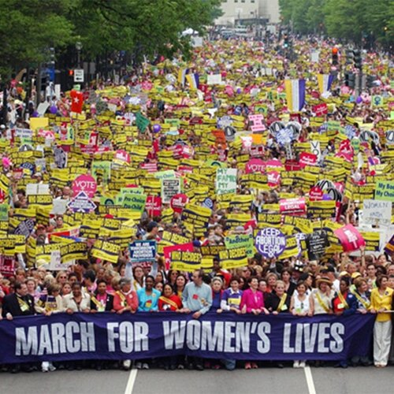

2004

March for Women’s Lives
- On April 25, 2004, 1.4 million participants took to the streets of Washington D.C. The demonstration was led by seven groups: National Organization for Women (NOW), American Civil Liberties Union, Black Women’s Health Imperative, Feminist Majority, NARAL Pro-Choice America, National Latina Institute for Reproductive Health, and Planned Parenthood Federation of America. The march was intended to address topics such as abortion rights, reproductive healthcare, women’s rights, and others.
- In 1992, NOW had organized the first March for Women’s Lives, with a turnout of 750,000 participants. The second March for Women’s Lives was organized with a broader coalition that included groups that focused on LGBT rights, immigrant women, indigenous women, and women of color. With a more inclusive movement, the turnout surpassed expectations and showed the power of a new, more comprehensive women’s movement.
- 

2014

HeForShe
- Kick-started September 20, 2014, at the Headquarters of the United Nations in New York, the HeForShe campaign was initiated by the UN in the hopes of achieving equality by encouraging both genders to partake as agents of change and take action against negative stereotypes and behaviors. Emma Watson promoted the campaign through a widely circulated speech that called to involve men and boys in promoting gender equality. It was a bold outcry and invitation for men and people of all genders to stand in solidarity with women, grounded in the idea that gender inequality affects us all socially, economically, and politically.
- UN Women made a call to mobilize the first 100,000 men in the campaign. The goal was reached within just three days.
- 

2017

Women’s March
- On January 21, 2017, in response to numerous factors: continued attempts by lawmakers to restrict access to abortions, persistent employment disparities, and contentious comments made by President Trump in a leaked video, among others, more than 200,000 people rallied in Washington D.C. to protest and advocate for women’s rights. Despite some ideological conflicts between event organizers over inclusion and diversity, the nationwide protest was a huge success with over 3 million participants across the nation, marking it one of the largest and most peaceful protests in U.S. History.
- That same year, the #MeToo Movement began as a response to sexual assault allegations against Hollywood producer Harvey Weinstein. Although the term was first coined in 2006 by Tarana Burke, it gained popularity when actress Alyssa Milano used the social media hashtag in 2017. The focus of #MeToo is to bring attention to sexual assault and harassment in the workplace and elsewhere.
- The third wave of feminism has brought on a number of movements much like the second wave. Other recent movements conceived and propagated online include: #YesAllWomen, Mattress Performance, #StandWithWendy, Slutwalks, and Time’s Up.
- Since women first got the right to vote in 1920, the country at large has changed vastly. 100 years ago, there were 0 women in Congress. In 1992, when women were first elected to Congress in mass numbers, there were a total of 33 women representing their states and communities. Today there are 127 women in the United States Congress. Although it’s only 23.7% of the seats, there is power in the numbers. Women continue to take on more leadership roles, run for office, and graduate with more advanced degrees than their counterparts. We continue to stand on the shoulders of giantesses who have paved the way for us, so that someday soon, hopefully, the timeline will end with gender parity.

Reference: -
Hardcastle ,David A, Community Practice ,theories,skills for social workers
Yadav CP Encyclopedia of social work and community organization

