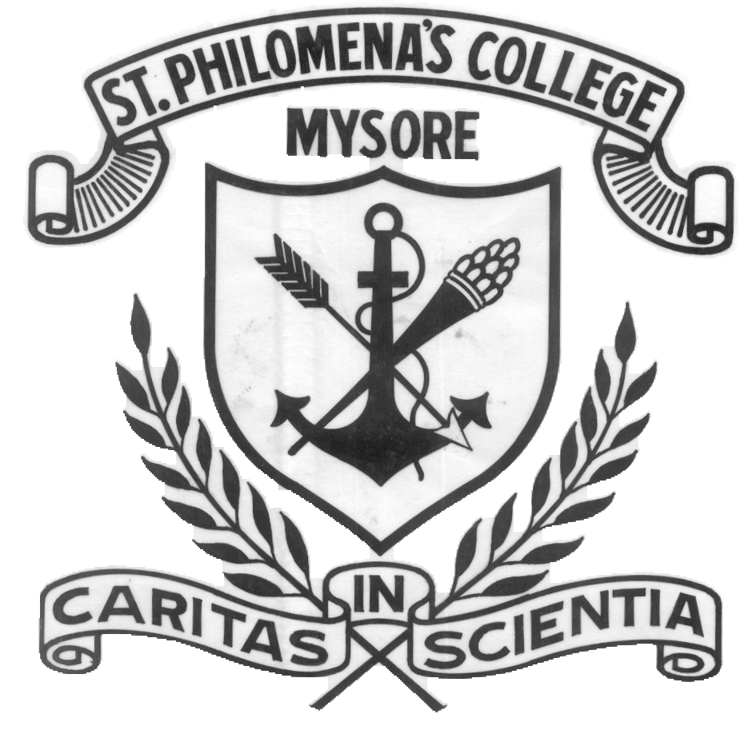

MYSOREDIOCESANEDUCATIONALSOCIETY
ST.PHILOMENA’S COLLEGE(AUTONOMOUS),MYSORE

Affiliated to University of Mysore

Report
Title: Understanding Cancer:Basics to bedside therapies
Preamble- The Department of Biochemistry had an invited lecture by Dr. Subbarao V Madhunapantula, Professor of cellular and molecular biology, Center of excellence in molecular biology and regenerative medicine laboratory, Department of Biochemistry,JSS medical college, JSSAHER, Mysore on 2nd May 2024 ,10.00- 11.30pm on the topic“Understanding Cancer:Basics to bedside therapies” for the Undergraduate and Post-graduation students of the department.
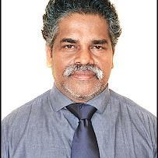
Resource Person
Organiser: PGDepartment of Biochemistry, St Philomena’s college(Autonomous), Mysore.
Venue:PG conference hall on 2nd May 2024 between 10.00 am to 11.30 pm

OBJECTIVES OF THE INVITED LECTURE:
Helps Students gain basic knowledge on the etiology, types, symptoms, existing treatments and scope on genes to be targeted in treatment of cancer.
To provide insights on various opportunities available in the areas of research in the field of Cancer.
Outcome of the program:
The invited lecture was attended by 70 students of UG & PG Biochemistry.
Cancer, with its complexities and challenges, demands not just scientific inquiry but also compassionate understanding. It touches lives in profound ways, reshaping narratives and igniting hope for breakthroughs that would redefine the landscape of healthcare.
Program began with the Welcome note addressing the Guest, Coordinator, HOD of the department and the audience, followed by introduction of the speaker.
Later, the guest addressed, motivated the audience and explained briefly the different causes, types of cancer & related preventive measures. He distinguished between apoptosis, necrosis, normal and cancerous cells leading to different types of cancers like: Carcinoma, Sarcoma, Leukemia, Lymphoma, Multiple myeloma, Melanoma and different types of tumours.
He added a note on the existing treatment followed by the existing and futuristic targets of different types of genes which can be used as hallmarks in treating cancer in a better way.
He explained regarding the vaccines available as a preventive measure in limiting few types of cancers and the initiatives taken by the government of India.
Speaker added limelight on the available areas of research in the field of Cancer which was useful for the students in picking them as their area of research in future.
Program was concluded with a brief vote of thanks to the audience and the Guest presenting him with a memento on behalf of the college.
This event marked a pivotal moment where we delved into the intricate realms of one of the most pressing challenges in modern medicine

