Sex determination in plants and animals
- In a vast majority of plants and animals, besides autosome, the cells of individual may contain one or more than one chromosome(s). These chromosomes are collectively referred to as allosomes. They differ from autosomes by their specialised functional role.

Autosomes are present in all cells of all organism but the existence of allosomes is not always universal. Allosomes are of different types. All types are not necessarily present in one organism.
An autosome is any chromosome that is not a sex chromosome. The members of an autosome pair in a diploid cell have the same morphology, unlike those in allosome pairs which may have different structures. The DNA in autosomes is collectively known as atDNA or auDNA. Autosomes bear genes for characters other than the sex while sex chromosomes. In man, out of a total of 23 pairs of chromosomes, there are 22 pairs of autosomes

Allosomes or Sex Chromosomes:
Chromosomes that are connected with the determination of sex, are called sex chromosomes. There are two types of sex chromosomes; X and Y. X chromosome is found in both males and females although one sex has only one while the other sex have two X-chromosomes.
Y-chromosome occurs only in one of the two sexes of a species, e.g., male fruit fly, human, male mice, some male plants and female birds, reptiles. Y-chromosome contains mostly heterochromatin and only few genes are located in it. On the other hand, X-chromosome is made of euchromatin and many genes are located on it.

Types of Sex Chromosomes:
The sex chromosomes are variously named as X and Y chromosomes (man and Drosophila), Z and W chromosomes (birds and moths), odd chromosomes, idiosomes, heterosomes or allosomes. The genes which determine the sex are being located on these chromosomes. The two members of this pair are often dissimilar in male and are represented as X and Y chromosomes or as Z and W chromosomes.

1. XX—XY Type:
In most insects including fruitfly Drosophila and mammals including human beings the females possess two homomorphic (= isomorphic) sex chromosomes, named XX. The males contain two het- eromorphic sex chromosomes, i.e., XY. The Y-chromosome is often shorter and heterochromatic (made of heterochromatin). It may be hooked (e.g., Drosophila). Despite differences in morphology, the XY chromosomes synapse during zygotene. It is because they have two parts, homologous and differential.
Homologous regions of the two help in pairing. They carry same genes which may have different alleles. Such genes present on both X and Y chromosomes are XY-linked genes. They are inherited like autosomal genes, e.g., xeroderma pigmentosum, epidermolysis bullosa. The differential region of Y-chromosome carries only Y-linked or holandric genes, e.g., testis determining factor (TDF).
It is perhaps the smallest gene occupying only 14 base pairs. Other holandric genes are of hypertrichosis (excessive hairiness) on pinna, porcupine skin, keratoderma dissipatum (thickened skin of hands and feet) and webbed toes. Holandric genes are directly inherited by a son from his father.
Genes present on the differential region of X-chromosome also find expression in males whether they are dominant or recessive, e.g., red-green colour blindness, haemophilia. It is because the males are hemizygous for these genes.
Human beings have 22 pairs of autosomes and one pair of sex chromosomes. All the ova formed by female are similar in their chromosome type (22 + X). Therefore, females are homogametic. The male gametes or sperms produced by human males are of two types, (22 + X) and (22 + Y). Human males are therefore, heterogametic (male digamety or male heterogamety).

2. XX—X0 Types:
In roundworms and some insects (true bugs, grasshoppers, cockroaches), the females have two sex chromosomes, XX, while the males have only one sex chromosome, X. There is no second sex chromosome. Therefore, the males are designated as X0. The females are homogametic because they produce only one type of eggs (A+X). The males are heterogametic with half the male gametes (gynosperms) carrying X-chromo- some (A+X) while the other half (androsperms) being devoid of it (A + 0). The sex ratio produced in the progeny is 1: 1 (Fig. ).
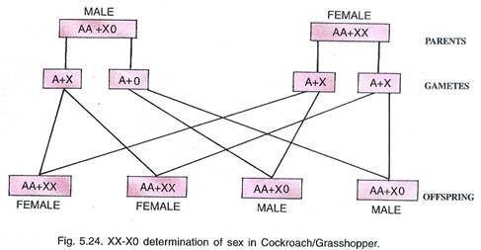

3. ZW—ZZ Type (= WZ—WW Type).
In birds and some reptiles both the sexes possess two sex chromosomes but unlike human beings the females contain heteromorphic sex chromosomes (AA + ZW) while the males have homomorphic sex chromosomes (AA + ZZ). Because of having heteromorphic sex chromosomes, the females are heterogametic (female heterogamety) and produce two types of eggs, (A + Z) and (A + W). The male gametes or sperms are of one type (A + Z). 1: 1 sex ratio is produced in the offspring (Fig).
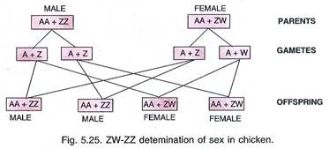

4. ZO — ZZ Type:
This type of sex determination occurs in some butterflies and moths. It is exactly opposite the condition found in cockroaches and grasshoppers. Here the females have odd sex chromosome (AA + Z) while the males have two homomorphic sex chromosomes (AA + ZZ). The females are heterogametic. They produce two types of eggs, male forming with one sex chromosome (A + Z) and female forming without the sex chromosome (A + 0). The males are homogametic, forming similar types of sperms (A + Z). The two sexes are obtained in the progeny in 50 : 50 ratio (Fig) as both the types of eggs are produced in equal ratio.




