ANTIBIOTIC SENSITIVITY TEST
An antibiotic sensitivity test is used to help find the best treatment for a bacterial infection. the top four tests for determining antimicrobial drug susceptibility. The tests are:
1. Dilution Susceptibility Tests 2. Disk Diffusion Tests 3. The Etest 4. Drug Concentration Measurement in Blood.

1. Dilution Susceptibility Tests:
Dilution susceptibility tests are based on determining minimum inhibitory concentration (MIC). In MIC, the antimicrobial activity is measured by determining the smallest amount of drug required to inhibit the growth of a test microbial pathogen and this smallest amount of drug does not allow the test microbial pathogen to grow after 16 to 20 hours of incubation. Two dilution susceptibility test techniques are commonly used.
These are:
(1) Broth dilution test and
(2) Agar dilution test.
1. Broth dilution technique:
In broth dilution technique, a series of culture tubes is prepared and inoculated with the clinical sample. Each tube contains medium with a different concentration of the antimicrobial drug.
After incubation, the culture tubes are checked for visible growth (turbidity) of the microbial pathogen. The tube containing the lowest concentration of the drug that completely inhibits the growth of the test microbial pathogen represents the minimum inhibitory concentration (MIC) of the given drug.
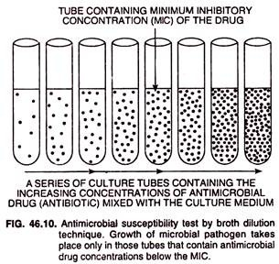
The MIC is not a constant for a given drug because it is affected by various factors such as:
(1) The nature of the test microbial pathogen,
(2) Size of the inoculum,
(3) Composition of the culture medium,
(4) The incubation time,
(5) pH, and
(6) Aeration.
However, when all conditions are rigorously standardized, different antimicrobial drugs can be compared to determine which is most effective against a given microbial pathogen.
Phenol coefficient technique is a standard method used to compare antimicrobial drugs. In this technique, a ratio of MIC of the test antimicrobial drug to the MIC of phenol is established using the same microbial pathogen, growth media, and growth conditions.
2. Agar dilution test:
The agar dilution test is very similar to the broth dilution test. Petri plates containing agar and various amounts of Antimicrobial drugs (antibiotics) are inoculated with test microbial pathogen and, after incubation, examined for growth.

2. Disk Diffusion Tests:
Two disk diffusion tests are used in clinical microbiology laboratory.
These are:
(i) Agar diffusion technique and
(ii) Kirby-Bauer method.
1. Agar diffusion technique:
Agar diffusion technique is routinely used to test for antimicrobial drug (antibiotic) susceptibility in microbial pathogens. In this technique , a Petri plate containing an agar medium overlayed with a culture of the test microbial pathogen is prepared. Known amounts of the antimicrobial drug are added to disks of filter paper.
These disks are then placed on to the agar surface and the Petri plate now is incubated for 24 to 48 hours. During incubation, the drug diffuses from the filter paper disk into the agar; more the distance from the filler paper disk, lower the concentration of the antimicrobial drug.
At some distance from the disk, the effective MIC is reached. Growth of microbial pathogen occurs further from this point, but growth is absent closer to the disk. A zone of inhibition is created with a diameter proportional to the amount of antimicrobial drug, added to the disk; the solubility of drug, the diffusion coefficient, and the overall effectiveness of the drug.
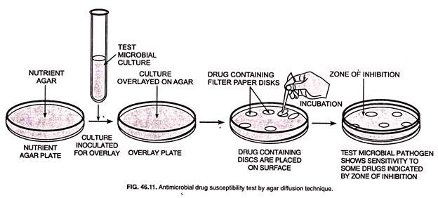
2. Kirby-Bauer Method:
Kirby-Bauer method was developed in the early 1960s by W. Kirby, A.W. Bauer, and their colleagues and is most often used to test antimicrobial drug susceptibility. In this method, agar media are inoculated by evenly spreading a defined density of a suspension of the microbial pathogen’s pure culture on the agar surface.
After the agar surface has dried for about 5 minutes, filter paper disks containing a defined quantity (μg/disk) of the antimicrobial drug are then placed on the inoculated agar surface with the help of either with sterilized forceps or with a multiple applicator .
The Petri plate is immediately placed in an incubator at 35°C. After 16 to 18 hours of incubation, the diameters of the zones of inhibition around each disk are measured.
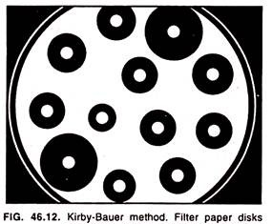
Inhibition zone diameters are then interpreted into the degree of microbial resistance .
A plot of MIC (on a logarithmic scale) versus zone inhibition diameter (arithmetic scale) is prepared for each antimicrobial drug . These plots are then used to find the zone diameters corresponding to the drug concentrations actually reached in the body of the host.
If the zone diameter for the lowest level readied in the body of the host is smaller than that observed with the test microbial pathogen, the latter should possess a MIC value low enough to be destroyed by the drug. A microbial pathogen possessing too high an MIC value (too small a zone diameter) is resistant to the drug at normal body concentrations.

3. The Etest:
The Etest is a non-diffusion based technique that employs a performed and redefined gradient of an antimicrobial drug immobilized on a plastic strip. Etest is particularly convenient for use with anaerobic microbial pathogens.
In it, a Petri plate containing proper agar amount is streaked in three different directions with the test microbial pathogen and special plastic Etest strips are placed on the agar surface so that they extend out radially from the centre
Each strip possesses a concentration gradient of an antimicrobial drug and is labeled with a scale of minimum inhibitory concentration (MIC) values. The lowest concentration in the Etest strip lies at the centre of the plate.
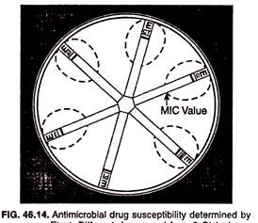
After overnight incubation or longer (24 to 48 hours), an elliptical zone of inhibition centred along the axis of the strip appears. The MIC value in μg/ml is read from the scales at the point it intersects the zone of inhibition.

4. Drug Concentration Measurement in Blood:
The drug used must reach a concentration more than minimum inhibitory concentration (MIC) of the pathogen at the infection site to become effective.
In cases of those diseases which become severe and life-threatening, it often becomes necessary to monitor the drug concentration in patient’s blood and other body fluids. This may be achieved with the help of microbiological, chemical, immunological, enzymatic, and chromatographic assays.

