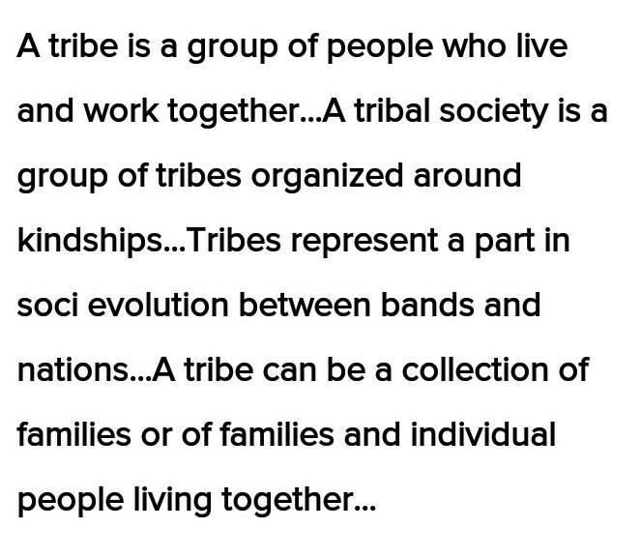
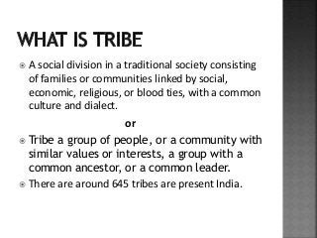
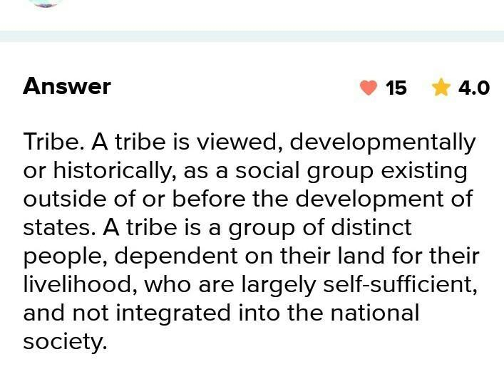
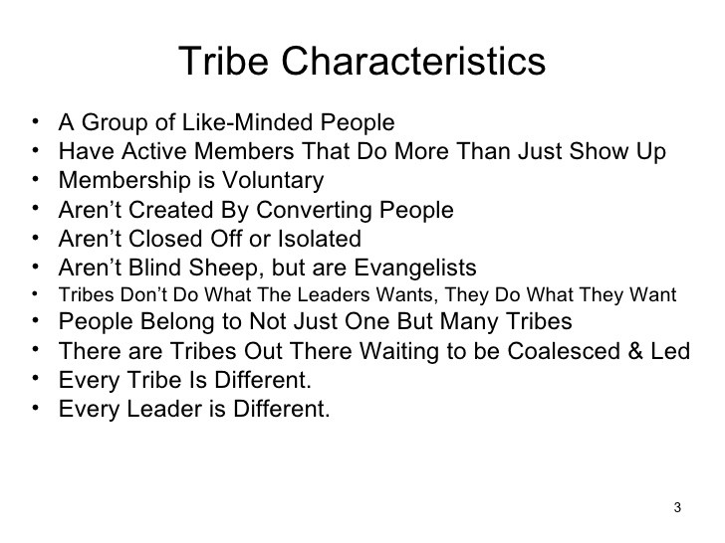
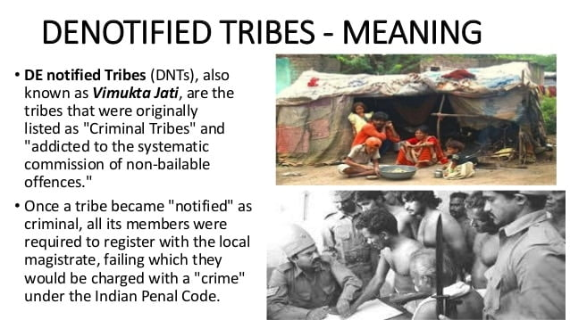

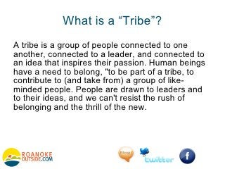
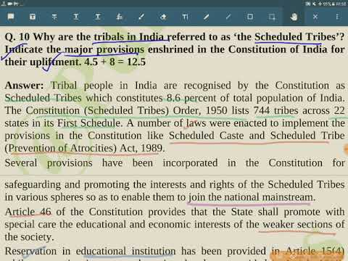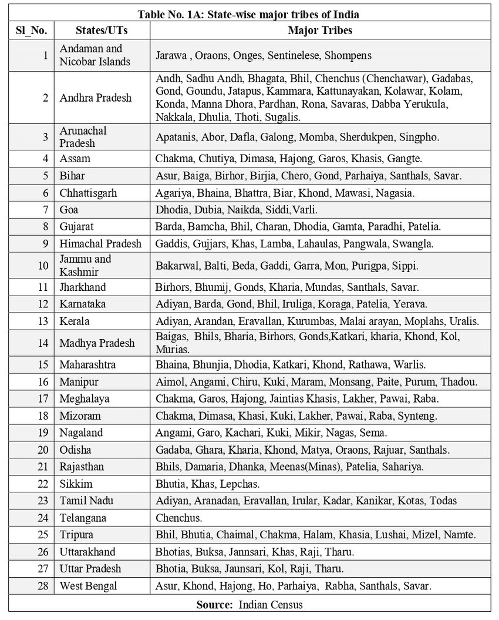
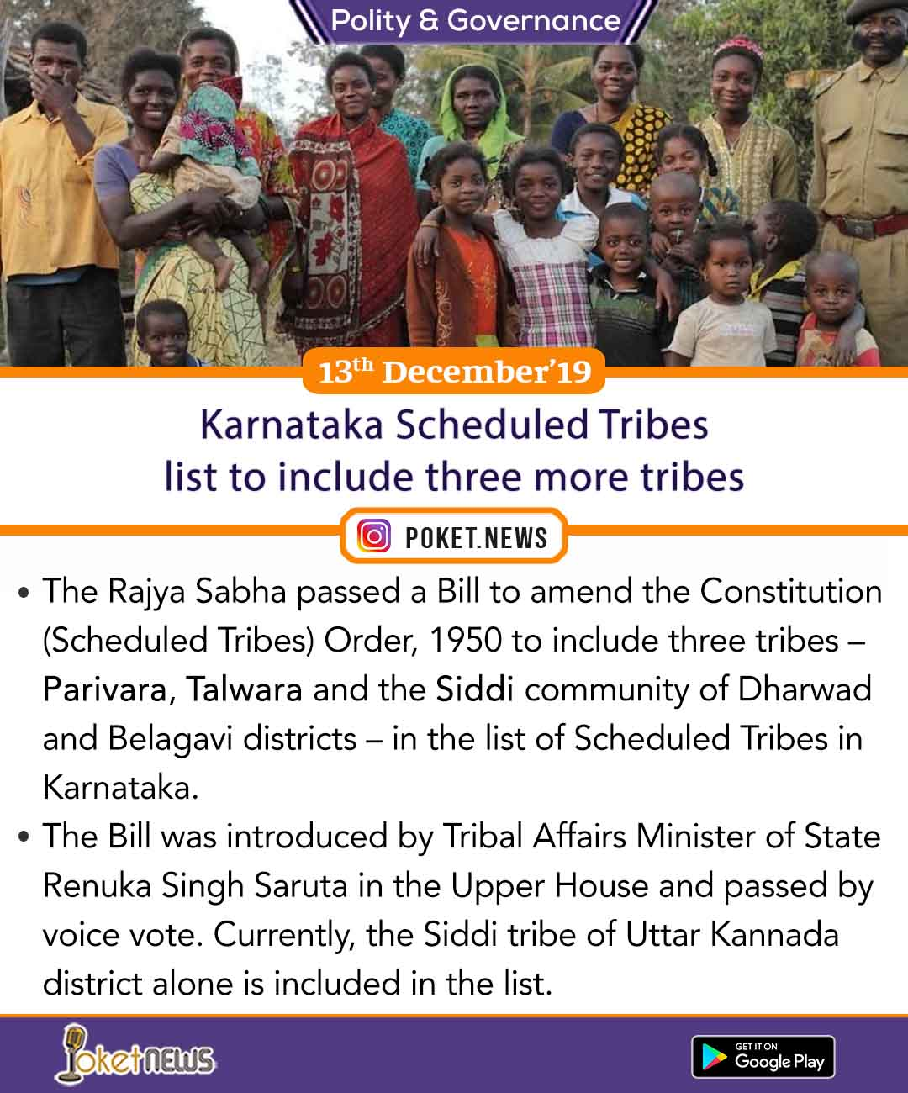
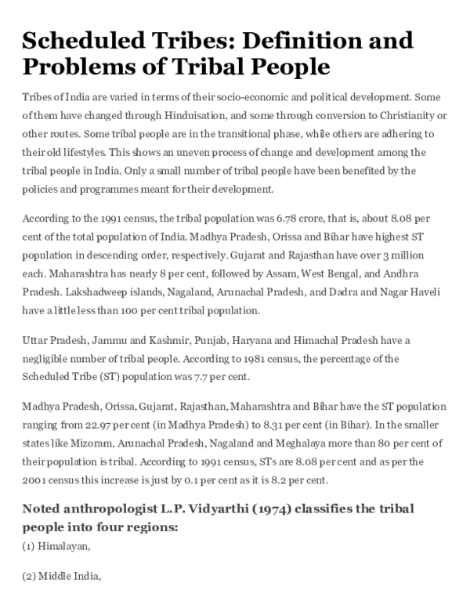
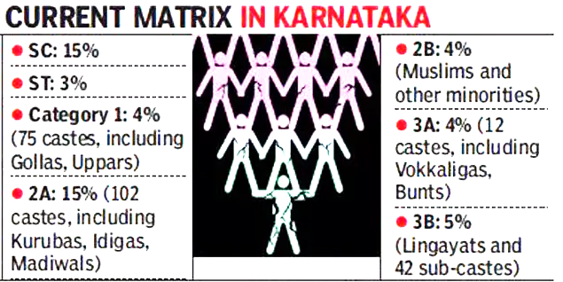
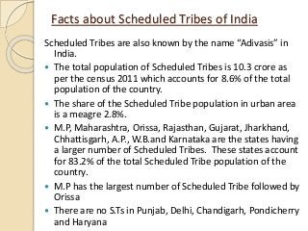
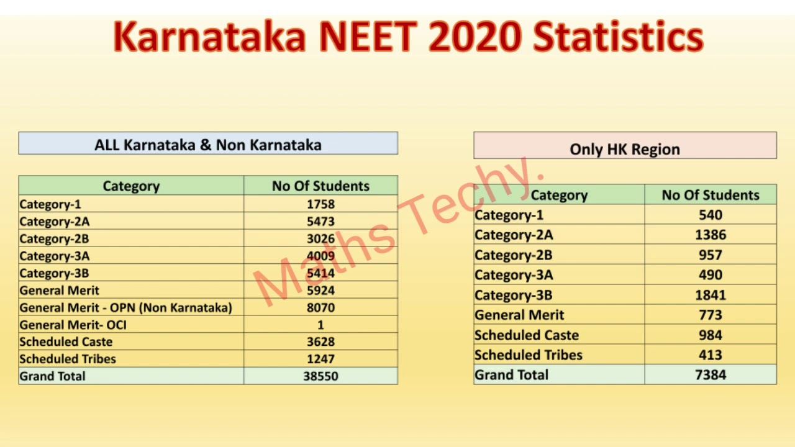
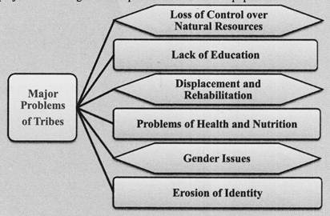

What are the main problems of Tribal communities?
- Poverty and exploitation.
- Economic and technological backwardness.
- Socio-cultural handicaps.
- Problems of assimilation with the non-tribal population.
- Illiteracy among tribals is a major hindrance to their development.
- Problems of tribal communities
- Issues of tribal development, integration and autonomy have confronted the Indian society right from the British rule in India. Complexity of Indian tribal population made the task of integration and autonomy even difficult. Ethnic tribal sub nationalism posed serious challenges and hampered the progress of the communities over the time. Autonomy is desired so that development policies are evolved to suit the tribal culture and lifestyle. On the other hand leaving the tribal in their own state will deepen the developmental divide between the mainstream and the tribals even deeper. Post independence the basic issue is that the integration is largely directed from above and not from below. Integration of tribes has neglected their own needs and desires. Integration has been on the terms of the mainstream society and it is also accused of benefitting the mainstream society only. The government monopoly over forests continued. The exploitation of forests accelerated as most of the mineral resources fall in forest and tribal areas. The policy of capital intensive industrialization adopted by the Indian government required mineral resources and power generation capacities that were concentrated in the tribal areas. Tribal lands were rapidly acquired for new mining and infrastructure projects. In the process tribals were displaced without any appropriate compensation or rehabilitation justified in the name of economic growth. These policies were often seen subjugating tribals and causing the degradation of the resources upon which they depended.
- Land Alienation:
The history of land alienation among the tribes began during British colonialism in India when the British interfered in the tribal region for the purpose of exploiting the tribal natural resources. Coupled with this tribal lands were occupied by moneylenders, zamindars and traders by advancing them loans etc. Opening of mines in the heart of tribal habitat and even a few factories provided wage labor as well as opportunities for factory employment.
- But this brought increasing destitution and displacement. After the British came to power, the Forest policy of the British Government was more inclined towards commercial considerations rather than human. Some forests were declared as reserved ones where only authorized contractors were allowed to cut the timber and the forest -dwellers were kept isolated deliberately within their habitat without any effort to ameliorate their economic and educational standards. The expansion of railway in India heavily devastated the forest resources in India.
- The Government started reserving teak, Sal and deodar forests for the manufacture of railway sleepers. Forest land and its resources provide the best means of livelihood for the tribal people and many tribes including the women engage in agriculture, food gathering and hunting they are heavily dependent on the products of the forest. Therefore when outsiders exploit the tribe's land and its resources the natural life cycle of tribal ecology and tribal life is greatly disturbed.
- Poverty and Indebtedness
Majority tribes live under poverty line. The tribes follow many simple occupations based on simple technology. Most of the occupation falls into the primary occupations such as hunting, gathering, and agriculture. The technology they use for these purposes belong to the most primitive kind. There is no profit and surplus making in such economy. Hence there per capita income is very meager much lesser than the Indian average. Most of them live under abject poverty and are in debt in the hands of local moneylenders and Zamindars. In order to repay the debt they often mortgage or sell their land to the moneylenders. Indebtedness is almost inevitable since heavy interest is to be paid to these moneylenders. Banking facilities in the tribal areas are as inadequate that the tribals have been forced to rely on moneylenders.
- Health and Nutrition
- In many parts of India tribal population suffers from chronic infections and diseases out of which water borne diseases are life threatening. They also suffer from deficiency diseases. The Himalayan tribes suffer from goiter due to lack of iodine. Leprosy and tuberculosis are also common among them. Infant mortality was found to be very high among some of the tribes. Malnutrition is common and has affected the general health of the tribal children as it lowers the ability to resist infection, leads to chronic illness and sometimes leads to brain impairment. The ecological imbalance like cutting of trees have increased the distances between villages and the forest areas thus forcing tribal women to walk longer distances in search of forest produce and firewood.
- Education
- Educationally the tribal population is at different levels of development but overall the formal education has made very little impact on tribal groups. Earlier Government had no direct programme for their education. But in the subsequent years the reservation policy has made some changes. There are many reasons for low level of education among the tribal people: Formal education is not considered necessary to discharge their social obligations. Superstitions and myths play an important role in rejecting education. Most tribes live in abject poverty. It is not easy for them to send their children to schools, as they are considered extra helping hands. The formal schools do not hold any special interest for the children. Most of the tribes are located in interior and remote areas where teachers would not like to go from outside.
- Cultural Problems
- Due to contact with other cultures, the tribal culture is undergoing a revolutionary change. Due to influence of Christian missionaries the problem of bilingualism has developed which led to indifference towards tribal language. The tribal people are imitating western culture in different aspects of their social life and leaving their own culture. It has led to degeneration of tribal life and tribal arts such as dance, music and different types of craft.
- Concept of Private Property
- The advent of the concept of private property in land has also adversely affected tribals whose community-based forms of collective ownership were placed at a disadvantage in the new system. Scheduled Tribes and Other Traditional Forest's Dwellers (Recognition of Forest Rights) Act 2006 popularly known as Forest Rights Act, 2006 tried to restore this status quo and ownership of the tribals but its implementation is not up to the mark.
- In Migration
- Many tribal concentration regions and states have also been experiencing the problem of heavy in migration of non-tribals in response to the pressures of development. The industrial areas of Jharkhand have suffered dilution of the tribal share of population. These processes continue to prevail and have become even more powerful since the 1990s when the country was opened up for liberalization. The huge agitations in Maharashtra against Jaitapur Nuclear Power Plant and Mining giant Vedanta in Niyamgiri in Orissa are the examples of reactionary movements against policy of alienation and exploitation of the tribals.
- Problem of separatism
- The divide and rule policy adopted by the British did a lot of damage to the tribal community of India. The British superimposed their own administrative patterns in the tribal areas and deprived the tribals of their traditional methods of interacting with the people. The Criminal Tribes Act which the British introduced gave an impression that the tribals were either criminals or anti socials. The tribal groups such as Kolis, Mundas, Khasis, and Santals who fought against the British were branded as dacoits and robbers. The British also promoted missionary activities especially in the Central and North Eastern hills. All these activities alienated tribals which continued even in the post independent India.

Various problems of tribal communities in India
- Resource exploitation:
  - The policy of liberalization and the new state perceptions of utilization of resources are diametrically opposed to the adivasi worldview of resource exploitation and this divide has only widened further with the intrusion of globalization’s market oriented philosophy of development.
  - The recent rapid technological advancement and unrivalled economic and political strength of world capitalism have created favourable conditions for the evasion and extraction of natural resources from the ecologically fragile territories of tribal people.
  - All available laws those relating to lands, forests, minor forest produce, water resources, etc. restrain people from using forests.
  - Primary resources such as fuel, fodder and minor forest produce which were available free to villagers are today either non-existent or have to be brought commercially.
  - For the Tribals, globalization is associated with rising prices, loss of job security and lack of health care.
- Displacement:
  - Since the emergence of liberalization, privatization and globalization (LPG), the areas inhabited by tribal population have been subject to various protests due to involuntary displacement.
  - Thus, forced evictions of tribals make way for mammoth capital-intensive development projects have become a distressing routine and ever-increasing phenomenon.
- Gaps in Rehabilitation:
  - There are gaps in the rehabilitation of the tribal community members displaced by development projects.
  - Only 21 lakh tribal community members have been rehabilitated so far of the estimated 85 lakh persons displaced due to development projects and natural calamities.
- Varied Problems across communities :
  - Health : For instance, recently Seven adults of the KhariaSavar community died within a span of just two weeks. Their lifespan is approximately 26 years less than the average Indian’s life expectancy.
    - Nearly 10% in West Godavari District are affected by Sickle Cell Anaemia.
  - Alienation : The problems in Red Corridor areas (especially Jharkhand, Odisha, Madhya Pradesh) is governance deficit and unfinished land reforms that has deprived the well being of tribes.
  - There is widespread infighting amongst tribes of North-East for natural resources and also of territorial supremacy.
- Vested interests:
  - In the name of upgradation of lifestyle of poor indigenous tribal people, the market forces have created wealth for their interests at the cost of livelihood and security of these tribes in the areas.
- Unemployment:
  - There is a heavy concentration of industrial and mining activities in the central belt. Despite intense industrial activity in the central Indian tribal belt, the tribal employment in modern enterprises is negligible.
  - Apart from the provisions of Apprenticeship Act, there is no stipulation for private or joint sector enterprises to recruit certain percentage of dispossessed tribal workforce.
  - They are forced onto the ever-expanding low paid, insecure, transient and destitute labour market.
  - About 40 per cent of the tribals of central India supplement their income by participating in this distorted and over exploitative capitalist sector.
- Affecting social life:
  - Many more are slowly crushed into oblivion in their homeland or in urban slums. Their economic and cultural survival is at stake.
  - The globalization behemoth has added new dimensions to the vulnerability of India’s downtrodden by exacerbating their social exclusion, and making large segments of tribal groups also vulnerable and excluded.
- Leading to subnational movements:
  - Inadequate social and economic infrastructure in areas that have insufficient resources for participation in mainstream development also has been at the root of various “sub-national movements” such as the Jharkhand, Uttarakhand and Bodoland.
- Tribal women:
  - Tribal forest economy is primarily a women’s economy, and it is women who are most directly affected by the corporate exploitation of their traditional lands.
  - In poverty stricken tribal areas large scale migration has revealed the increasing movement of young women towards urban centres in search of work.
  - Their living conditions are unhygienic, the salary is poor and tribal women are vulnerable to exploitation by unscrupulous agents.
  - There is a large number of anemic women amongst the tribes. There is a shortfall of 6,796 sub-centres, 1,267 primary health centres (PHCs) and 309 community health centres (CHCs) in the tribal areas at an all-India level as on March 31, 2015.
  - They have become the prime targets of sexual violation by managers, supervisors and even fellow male workers in the plantation industrial sectors.
- Informal jobs:
  - Construction sites, such as mines and quarries, and industrial complexes spelt doom for the local adivasi communities with the influx of immigrant labourers.
- Cultural Defacement:
  - Tribals are being forcefully integrated in to the society leading to them losing their unique cultural features and their habitat threatened.
- Isolated Tribes such as Sentinelese as still hostile to outsiders. The government must enforce “eyes on hands off ” policy in these cases.
  - The Jarawa community is facing acute population decline due to entry of outsiders into the area(The Andaman Trunk Road, among other projects, has cut into the heart of the Jarawa reserve).
- Denotified, semi-nomadic and nomadic tribes are yet to be included as Scheduled Tribes.
  - Their traditional occupations (snake charming, street acrobatics with animals) are now illegal and alternative livelihood options are not provided.
- Certain tribes have been characterised as Particularly Vulnerable Tribal Groups (PVTGs) (earlier known as Primitive Tribal Groups) on the basis of their greater ’vulnerability’ even among the tribal groups. There are 75 such tribes in India.
- Press Information Bureau
Government of India
Ministry of Tribal Affairs
24 JUN 2019 1:30PM by PIB Delhi
- New Schemes for Tribals
- The schemes of the Ministry of Tribal Affairs are demand driven and funding are made in various sectors including for employment-cum-income generation and covers activities such as establishment of Agro/Forest/Natural Resource based micro / village industries through training of tribal cooperatives, SHGs and individual entrepreneurs, promotion and skill development in traditional tribal culture areas like tribal jewellery, painting, dance forms, music and culinary art, Village tourism, Eco-tourism, etc.
- The scheme of Mechanism for Marketing of Minor Forest Produce (MFP) through Minimum Support Price (MSP) and Development of Value Chain for MFP covers various activities including procurement of MFPs when their market price falls below their notified MSP, setting up/expansion of storage facilities, expanding the knowledge base on MFP, training for sustainable collection, value addition, etc. The activities involving expanding knowledge base, training for sustainable collection, value addition, etc. are done through by the Ministry and the Central Government bears 100% of the expenditure incurred for these activities.
- While there is no proposal to introduce a separate scheme/policy on this matter, Ministry of Tribal Affairs desired to brand the activities being undertaken by it under the existing scheme of Mechanism for Marketing of Minor Forest Produce (MFP) through Minimum Support Price (MSP) and Development of Value Chain for MFP as “Van Dhan Vikas Karyakram”. Van Dhan Vikas Karyakram is a training and development of value chain components of the scheme of Mechanism for Marketing of Minor Forest Produce (MFP) through Minimum Support Price (MSP) and Development of Value Chain for MFP.
- Government is formulating Five Year Vision plan for overall development of the tribals for the next five years. Ministry of Tribal Affairs is implementing the following schemes / programmes for overall development/welfare of Scheduled Tribes:-

Sl. No. | Names of Schemes / Programmes
1 | Pre Matric Scholarship Scheme for ST students
2 | Post Matric Scholarship Scheme for ST students
3 | National Overseas Scholarship for ST students for studying abroad.
4 | National Fellowship and Scholarship for Higher Education of ST students  (a) Scholarship for Higher Education (earlier known as Top Class Education For ST Students).  (b) Fellowship (earlier known as Rajiv Gandhi National Fellowship Scheme for ST students).
5 | Grants-in-aid to Voluntary Organisations Working for welfare of STs
6 | Strengthening Education among ST Girls in Low Literacy Districts
7 | Development of Particularly Vulnerable Tribal Groups (PVTGs)
8 | Grants under Article 275 (1) of the Constitution of India
9 | Special Central Assistance(SCA) to Tribal Sub-Scheme(TSS)
10 | Grants-in-aid to Tribal Research Institutes
11 | Institutional Support for Development and Marketing of Tribal Products/Produce
12 | Support to National/State Scheduled Tribe Finance and Development Corporations
13 | Minor Forest Produce (MFP) through Minimum Support Price (MSP) and Mechanism of marketing of Development of Value Chain for MFP
14 | Research Information & Mass Education, Tribal Festival and Others

What are the main problems of Tribal communities?
The tribal communities face many challenges and problems. A few common ones are listed below:
- Poverty and exploitation.
- Economic and technological backwardness.
- Socio-cultural handicaps.
- Problems of assimilation with the non-tribal population.
- Illiteracy among tribals is a major hindrance to their development.
- The problem of health and nutrition is very common among tribals due to the lack of proper medical and sanitary facilities and poverty.
- Indebtedness due to lack of adequate sources of income.
- Tribals living in a village along with caste groups, sects and religious groups and maintaining their identity
- Tribals who have been degraded to the status of untouchables.

Six Main Problems Faced by the Indian Tribes
- Article shared by : <="" div="" style="margin: 0px; padding: 0px; border: 0px; outline: 0px; font-size: 16px; vertical-align: bottom; background: transparent; max-width: 100%;">
- ADVERTISEMENTS:
- In general, the problems of the Indian tribes can be discussed under the following heads:

1. Loss of Control over Natural Resources:
- Before the coming of the British, the tribals enjoyed unhindered rights of ownership and management over natural resources like land, forests, wildlife, water, soil, fish, etc. With the advent of industrialisation in India and the discovery of mineral and other resources in tribal inhabited areas, these pockets were thrown open to outsiders and state control replaced tribal control.
- Thus began the story of unending miseries for the tribals. With the impetus to the development process after independence, pressure on land and forests increased.
- ADVERTISEMENTS:
- This resulted in loss of ownership rights over land, owing to chronic indebtedness, unscrupulous landlords, moneylenders, contractors and officials. With the concepts of protected forests and national forests gaining currency, the tribals felt themselves uprooted from their cultural moorings and with no secure means of livelihood.

2. Lack of Education:
- According to the 1991 Census, nearly 70 per cent of the tribals are illiterates. Although it cannot be denied that education can act as the instrument for betterment of the tribals ensuring greater participation for them in the development process, still there are certain factors which inhibit the tribals from taking to education.
- These factors include tribal superstitions and prejudices, extreme poverty, nomadic lifestyle of certain tribes, lack of interest in alien subjects taught through an alien language and a lack of suitable teachers and other facilities in the tribal areas.

3. Displacement and Rehabilitation:
- After independence, the focus of the development process was on heavy industries and the core sector. As a result huge steel plants, power projects and large dams came up—most of them in the tribal inhabited areas. The mining activities were also accelerated in these areas. Acquisition of tribal land by the government for these projects led to large scale displacement of the tribal population. The tribal pockets of Chhotanagpur region, Orissa, West Bengal and Madhya Pradesh suffered the most.
- ADVERTISEMENTS:
- The cash compensation provided by the government was frittered away on wasteful expenditure. No settlements were provided for the displaced tribals within the industrial areas, who were forced to live in peripheries in slums or to migrate to adjoining states to work as unskilled workers in conditions of poverty. The migration of these tribals to the urban areas causes psychological problems for them as they are not able to adjust well to the urban lifestyle and values.

4. Problems of Health and Nutrition:
- Because of economic backwardness and insecure livelihood, the tribals face health problems, such as prevalence of disease, like malaria, cholera, tuberculosis, diarrhoea and jaundice, problems associated with malnutrition like iron deficiency and anaemia, high infant mortality rates, low levels of life expectancy, etc.

5. Gender Issues:
- The degradation of the natural environment, particularly through the destruction of forests and a rapidly shrinking resource base, has had its impact on the status of women. The opening of the tribal belts to mining, industries and commercialisation has exposed tribal men and women to the ruthless operations of the market economy, giving rise to consumerism and to commoditisation of women.

6. Erosion of Identity:
- Increasingly, the traditional institutions and laws of tribals are coming into conflict with modern institutions which create apprehensions among the tribals about preserving their identity. Extinction of tribal dialects and languages is another cause of concern as it indicates an erosion of tribal identity in certain areas.
How do you solve tribal problems?
- Assimilation is one of the ways of dealing with the tribal problems. ...
- According to this solution advocated by the social reformers and voluntary organizations, assisting and encouraging the tribals to assimilate them with the mainstream of national life, can alone permanently solve the tribal problems.
What are the causes of change in Indian tribal society?
Several factors as identified by Raha and Dubash Roy which have brought about changes in the tribal culture are: measures undertaken by the government, communication facilities, spread of education, process of urbanisation, occupational mobility, community development projects, frequent contacts with the neighbouring ...

Acculturation and Changes Occurring in Tribal Culture
Article shared by : <="" div="" style="margin: 0px; padding: 0px; border: 0px; outline: 0px; font-size: 16px; vertical-align: bottom; background: transparent; max-width: 100%;">
ADVERTISEMENTS:
Acculturation and Changes Occurring in Tribal Culture!
Cultural change is ‘change in knowledge, attitudes, ideas, behaviour, religious beliefs, and moral doctrines of individuals who compose the community or the society.’ Thus, cultural change is a multi-factorial process.
Several factors as identified by Raha and Dubash Roy which have brought about changes in the tribal culture are: measures undertaken by the government, communication facilities, spread of education, process of urbanisation, occupational mobility, community development projects, frequent contacts with the neighbouring Hindus in the urban areas, construction of dams in the tribal areas, impact of Christianity, facilities of bank credit, modern medicare, cooperative societies, modern legislation, cash and market economy, and reformist movements.
ADVERTISEMENTS:
The tribe-caste interaction and the process of acculturation is found among many tribes in different states. Its best example has been pointed out by Binay Kumar Patnaik’s study of Sabaras (tribe) in Ghorabar village in Orissa, who comprise 5 per cent of the total 235 households with 280 people.
The process of undergoing acculturation by this tribe is found in the following changes:
(1) The structural change in the tribe is found in discarding egalitarianism (with least of functional dependency) and accepting caste system and thereby introducing the system of stratification in the community.
(2) The community is hierarchically divided in four segments on the basis of ritual superiority which resembles Hindu Varna framework. There is functional distribution of occupations among the four divisions like the four varnas—hunting and fighting, worshipping, cultivation, and dancing and singing respectively. The difference is that while in the Varna system, worshipping occupies the highest ritual status, in this tribe it occupies second place in the hierarchy. Secondly, purity and pollution is absent in the Sabaras tribe as it is found in the caste system. Thus, Sabaras are accepted as a separate ‘caste’ and not as a tribe in the village.
ADVERTISEMENTS:
(3) Like the caste system among the Sabaras too, each sub-caste has its own panchayat which acts as a watch-dog of the community customs and taboos.
(4) Each sub-division of the Sabaras claims descent from three Sabaras who figure in Hindu mythologies—Mahabharata and Ramayana.
(5) The imprint of Hindu culture is prominent on the marriage customs of Sabaras, though inter-caste (inter-segment) marriage is absent. Polygamy is a taboo. Bride-price has been replaced by dowry.
Why the adopting of Hindu traits by the Sabaras is termed as a process of ‘acculturation’ and not ‘sanskritisation’ is because:
ADVERTISEMENTS:
(a) the benefit of acculturation is ‘economic gain’ and not achieving higher ritual status. By entering the Hindu-fold as a caste group, they have been assigned the occupation of wood-cutting and basket making permanently. After deforestation, they have become agricultural laborers; and
(b) the model adopted for mobility is not Brahmanic but Vaishya, which assures economic superiority to ritual superiority. Since the Sabaras are dependent on Telis for their occupations, they accepted them (Telis) as their reference group.
If we examine change in the culture of tribes in India, we find six main changes. These are as follows:
(1) The lifestyle of tribals, particularly those who live in or near the urban areas or in the midst of the numerically dominant non-tribal population, has changed due to imbibing of a large number of cultural traits of advanced Hindus. Many of their traditional traits have been replaced by alien traits.
ADVERTISEMENTS:
(2) The nature of change is such that the tribes are not losing their identity and also their traditional cultural heritage. They are not being ‘Hinduised’. However, tribals undergoing the process of Hinduisation have been pointed out by Bose (1953), Dutta Majumdar (1937), Deogaonkar (1990), Raha and Debash Ro, referring to the examples of tribes like Pati Rabhas (in Assam), Hos and Juangs (in Orissa), Santhals (in Bihar), Bhumij, Oraon, Munda, and Korkus (in Maharashtra), etc. Our contention is that adopting few cultural traits of Hindus is not undergoing the process of Hinduisation. The fact that these tribes still describe themselves as ‘tribes’ and not Hindus is important in our argument and contention of rejecting the process of Hinduisation.
(3) In some parts of India, the tribals have adopted some traits of Christianity also. Nagas, Mizo, Santhals, Oraon, Munda, Kharia, etc., are some tribes in North East and North West India on which we find marked imprint of Christianity. The evidence is provided by micro- level studies of tribals made by Dutta Majumdar (1956), Sahay (1976), Sachchidananda (1964) and Bose (1967).
(4) The changes among tribal people from Chotanagpur working as labourers in tea gardens of Assam and North Bengal are more visible in their material life than in their religious beliefs and practices. Those who work in industries have developed individualistic outlook due to the economic security provided to them which in turn has made them indifferent towards their traditional life.
(5) Agro-industrialisation in the tribal areas has affected the socio-cultural life of the tribals to the extent that changes in the family structure, marriage institution, authority structure, interpersonal relationship and weakening of clan panchayat’s authority have come to be observed (Kar, 1981). Trade unions also have much impact on the adibasi (tribal) labourers.
ADVERTISEMENTS:
Tribal labourers have organised themselves as a ‘class’ which has ultimately opened up a wider opportunity for taking part in active politics. The tribals who work in mines and collieries since long fail to retain link with their community because of which they are so compelled to adjust themselves with the rhythm of mining work, that they relinquish many traditional beliefs and social practices and adopt new attitudes and behaviour patterns.
Sachchidananda (1964) has referred to such changes among Munda and Oraon tribes of Bihar. R. Chandra (1989) has also referred to similar change in the socio-cultural life of Juangs and Irula tribes in Orissa who traditionally were accustomed to hunting, food-gathering and shifting cultivation but have now become settled cultivators and labourers on plantations. They have attained progressive outlook and have started using modern facilities of schools, banks, cooperative societies, Medicare, etc.
(6) Discarding traditional practices and adopting modern beliefs and values due to the impact of modern forces has not always proved functional for the tribals. Many tribes face the problem of maladjustment. Baiga tribe according to R. Joshi (1984) is one such tribe whose members earlier were fun-loving and contented, who spent evenings in dancing and drinking mahua, who owned land but had no demarcated ‘pattas’, whose women wore gold and silver ornaments without worry and fear but have now become very fearful and have come to be cheated by people with vested interests. Happiness has given place to suffering.
Thus, it is evident that tribals have changed a lot culturally, socially as well as economically due to exposure to various forces which having benefited them in many ways have also brought a number of evils in their communities. Many tribals have come to be deprived of their rights over land and forests and in many cases they are being fleeced by money lenders, big landowners, traders, businessmen and others.
ADVERTISEMENTS:
In spite of this, we cannot support ideas of scholars like Verrier Elwin who advocated keeping tribals in partial or full isolation and strongly advised that these people should be allowed to maintain their traditional and original tribal life as far as possible.
While we do not want tribal culture to be destroyed, at the same time, we do not want that tribes should remain ‘backward’ and not be benefited by industrial development, occupational mobility, education and benefits of welfare schemes. The isolated and segregated condition of the tribal world which results in their poverty, illiteracy, exploitation, etc., cannot be tolerated in this age. Their exposure to justice, enlightenment, help and cooperation is essential.

Tribal Areas and their Problems in India – UPSC
ByLotusAriseJuly 19, 2021
4 Comments
In this article, You will read Tribal Areas and their Problems in India – for UPSC (Cultural Setting – Geography Optional).

Tribal Areas (Tribal belt)
- India’s tribal belt refers to contiguous areas of settlement of Tribal people of India, that is, groups or tribes that remained genetically homogenous as opposed to other population groups that mixed widely within the Indian subcontinent.
- The tribal population in India, though a numerically small minority, represents an enormous diversity of groups.
- They vary among themselves in respect of language and linguistic traits, ecological settings in which they live, physical features, size of the population, the extent of acculturation, dominant modes of making a livelihood, level of development and social stratification.
- While tribes have a distinct culture and history, they also share commonalities with other marginalised sections of Indian society, such as the lack of adequate political representation, economic deprivation and cultural discrimination.
- However, tribal society must be appreciated and it must be recognised that non-tribal people have much to learn from the richness of tribal cultures and systems of knowledge.
- The category of ‘tribe’ entails a social and cultural dimension but the Scheduled Tribe category has politico-administrative implications.
- A majority of the Scheduled Tribe population is concentrated in the eastern, central and western belt covering the Nine States of Odisha, Madhya Pradesh, Chhattisgarh, Jharkhand, Maharashtra, Gujarat, Rajasthan, Andhra Pradesh and West Bengal.
- About 12 per cent inhabit the North-eastern region, about five per cent in the Southern region and about three per cent in the Northern States.
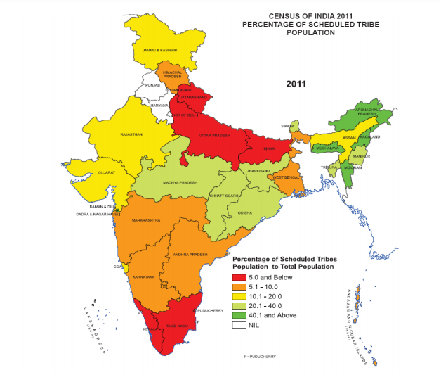
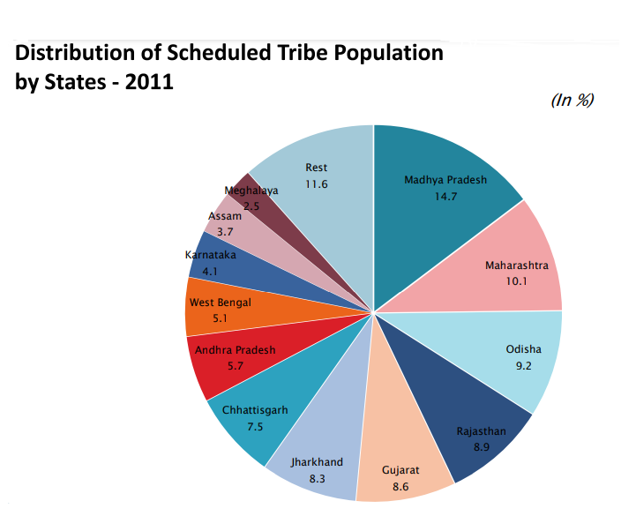
Distribution of Tribes
- The Scheduled Tribes are notified in 30 States/UTs and the number of individual ethnic groups, etc. notified as Scheduled Tribes is 705.
- The tribal population of the country, as per the 2011 census, is 10.43 crore, constituting 8.6% of the total population. 89.97% of them live in rural areas and 10.03% in urban areas. The decadal population growth of the tribal’s from Census 2001 to 2011 has been 23.66% against the 17.69% of the entire population.
- The sex ratio for the overall population is 940 females per 1000 males and that of Scheduled Tribes 990 females per thousand males.
- Broadly the STs inhabit two distinct geographical areas – Central India and the North- Eastern Area. More than half of the Scheduled Tribe population is concentrated in Central India, i.e., Madhya Pradesh (14.69%), Chhattisgarh (7.5%), Jharkhand (8.29%), Andhra Pradesh (5.7%), Maharashtra (10.08%), Orissa (9.2%), Gujarat (8.55%) and Rajasthan (8.86%).
- The other distinct area is the North East (Assam, Nagaland, Mizoram, Manipur, Meghalaya, Tripura, Sikkim, and Arunachal Pradesh).
- More than two-thirds of the ST population is concentrated only in the seven states of the country, viz. Madhya Pradesh, Maharashtra, Orissa, Gujarat, Rajasthan, Jharkhand, and Chhattisgarh.
- There is no ST population in 3 States (Delhi NCR, Punjab, and Haryana) and 2 UTs (Puducherry and Chandigarh), as no Scheduled Tribe is notified.
Scheduled Areas (Fifth Schedule)
- Scheduled Areas (under the Fifth Schedule of the Constitution) is “such areas as the President may by order declare to be Scheduled Areas”.
- At present, 10 States namely Andhra Pradesh, Chhattisgarh, Gujarat, Himachal Pradesh, Jharkhand, Madhya Pradesh, Maharashtra, Odisha, Rajasthan and Telangana have Fifth Schedule Areas.
Sixth Schedule
- It protects tribal populations and provides autonomy to the communities through the creation of autonomous development councils that can frame laws on land, public health, agriculture, and others.
- 6th Schedule applies to certain tribal areas of the States of Assam, Meghalaya, Tripura, and Mizoram.
- The Sixth Schedule provides for the creation of Autonomous District and Regional Councils and accords a host of legislative, executive, and judicial powers to these autonomous bodies.
- As of now, 10 autonomous councils exist in Assam, Meghalaya, Tripura and Mizoram.
- This special provision is provided under Article 244(2) and Article 275(1) of the Constitution.

Problems of tribal People
Tribes are generally backward, economically as well as educationally. The situation is not uniform in all parts of India. In the northeast, the situation has been disturbed for several years, whereas in the mainland (central India) problems related to poverty, unemployment, indebtedness, backwardness, and ignorance are acute.
The tribes of the northeast have a high level of politicization, literacy, and a high standard of living compared to their counterparts in other parts. The tribes were alienated from their own lands. The landlords and moneylenders of the plains gradually replaced the tribal landowners.
The survey done by B. K. Roy Burman (1972) shows that the tribals are the most backward because of their low literacy and primitive economy.
Since tribal people are at different social, political, economic, and ecological levels, their problems also differ in degree from each other. These differences can be seen in terms of hill tribes and plainsmen; between those who are engaged in forest-based economic pursuits and the ones who are employed as settled agriculturists; or between those who are Hinduised or converted to Christianity; and those who are adhering to an unadulterated tribal way of life.
Despite these distinctions, some common problems of the tribal people are:
- Poverty and exploitation.
- Economic and technological backwardness.
- Socio-cultural handicaps.
- Problems of assimilation with the non-tribal population.
S.M. Dube’s five-fold classification of the Indian tribes provides a clear picture of the problem of tribes in India. Dube (1982) mentions –
- aboriginals living in seclusion;
- tribal groups having an association with the neighboring non-tribal society and also maintaining their distinctiveness;
- tribals living in the village along with caste groups, sects, and religious groups and maintaining their identity;
- tribals who have been degraded to the status of untouchables;
- tribals who enjoy high social, economic, and political status.
Such a classification is based on the nature of cultural contacts of tribals with non-tribals.

Social Problems
High Incidence of Illiteracy (Lack of Education) & Gender Gap
- According to the 1991 Census, nearly 70 percent of the tribals are illiterates. Although it cannot be denied that education can act as the instrument for betterment of the tribals ensuring greater participation for them in the development process, still there are certain factors which inhibit the tribals from taking to education.
- These factors include tribal superstitions and prejudices, extreme poverty, nomadic lifestyle of certain tribes, lack of interest in alien subjects taught through an alien language and a lack of suitable teachers and other facilities in the tribal areas.
- The progress over the years on the literacy front may be seen from the following :
 | 1961 | 1971 | 1981 | 1991 | 2001 | 2011
Total literate population | 24 % | 29.4 % | 36.2 % | 52.2 % | 64.84% | 73.00 %
Scheduled Tribes (STs) population | 8.5 % | 11.3 % | 16.3 % | 29.6 % | 47.10% | 59.00%
Total female population | 12.9 % | 18.6 % | 29.8 % | 39.3 % | 53.67% | 64.60%
Total Scheduled Tribes (STs) female population | 3.2 % | 4.8 % | 8.0 % | 18.2 % | 34.76% | 49.40 %
Mortality rates
- The community also has registered the highest child mortality and infant mortality rates compared to other social groups.
Gender Issues
- The degradation of the natural environment, particularly through the destruction of forests and a rapidly shrinking resource base, has had an impact on the status of women. The opening of the tribal belts to mining, industries, and commercialization has exposed tribal men and women to the ruthless operations of the market economy, giving rise to consumerism and to the commoditization of women.
Problems of Assimilation with the Non-tribal Population
- The tribals have largely come under the impact of the dominant cultural streams of India. New divisions have been created among the tribals due to cultural change in their ranks. Stratification in tribal society in India has its roots in British policy, unevenness due to the impact of economic development, and varied cultural contact with the wider society. Modernization and industrialization has apparently reduced the gap between the tribals and the non-tribals, but it has also created new problems.
- The tribals, who have been uprooted from their lands, have not been absorbed in the new system. Hence, they are facing a new form of pauperization without a traditional support base.
Erosion of Identity
- Increasingly, the traditional institutions and laws of tribals are coming into conflict with modern institutions which create apprehensions among the tribals about preserving their identity. Extinction of tribal dialects and languages is another cause of concern as it indicates an erosion of tribal identity in certain areas.
Drug Addiction
- Consumption of alcohol is a part of social rituals among the tribal communities. At the national level, it is noted that about half of Scheduled tribe men (51%) consume some form of alcohol.
- The prevalence of alcohol consumption was found to be much lower among nonScheduled Tribe men (30%). Therefore, such a pattern of drinking alcohol among Scheduled Tribe men has a negative effect on their health. The estimated prevalence among Scheduled Tribes is found to be higher in the eastern states like Assam (70%), West Bengal (70%), Orissa (69%), and Jharkhand (67%). In a few exceptional cases like Sikkim, Manipur, West Bengal, Maharashtra, and Goa, a higher proportion of urban Scheduled Tribe men drink alcohol as compared to their rural counterparts.

Economic Problems
Loss of Control over Natural Resources
- Before the coming of the British, the tribals enjoyed unhindered rights of ownership and management over natural resources like land, forests, wildlife, water, soil, fish, etc. With the advent of industrialization in India and the discovery of minerals and other resources in tribal inhabited areas, these pockets were thrown open to outsiders, and state control replaced tribal control.
- Thus began the story of unending miseries for the tribals. With the impetus to the development process after independence, pressure on land and forests increased.
- This resulted in the loss of ownership rights over land, owing to chronic indebtedness, unscrupulous landlords, moneylenders, contractors, and officials. With the concepts of protected forests and national forests gaining currency, the tribals felt themselves uprooted from their cultural moorings and with no secure means of livelihood.
Poverty and Exploitation
- Poverty refers to the condition of not having the means to afford basic human needs such as clean water, nutrition, health care, clothing, and shelter. This is also referred to as absolute poverty. Relative poverty is the condition of having fewer resources or less income than others within a society or country or compared to worldwide averages.
- Generally, poverty is measured below Poverty Line (BPL) indices in rural areas. Below Poverty Line is an economic benchmark and poverty threshold used by the government of India to indicate economic disadvantage and to identify individuals and households in need of government assistance and aid. It is determined using various parameters which vary from state to state and within states.
- In the tenth five-year plan (2002-2007) survey, BPL for rural areas was based on the degree of deprivation in respect of 13 parameters, with scores from 0-4: landholding, type of house, clothing, food security, sanitation, consumer durables, literacy status, labour force, means of livelihood, the status of children, type of indebtedness, reasons for migrations, etc.
Land Alienation
Displacement and Rehabilitation
- After independence, the focus of the development process was on heavy industries and the core sector. As a result, huge steel plants, power projects, and large dams came up—most of them in the tribal inhabited areas. The mining activities were also accelerated in these areas. Acquisition of tribal land by the government for these projects led to large-scale displacement of the tribal population. The tribal pockets of the Chhotanagpur region, Orissa, West Bengal, and Madhya Pradesh suffered the most.
- The cash compensation provided by the government was frittered away on wasteful expenditure. No settlements were provided for the displaced tribals within the industrial areas, who were forced to live in peripheries in slums or to migrate to adjoining states to work as unskilled workers in conditions of poverty. The migration of these tribals to the urban areas causes psychological problems for them as they are not able to adjust well to the urban lifestyle and values.
Lack of Awareness about Government Schemes
- In the Indian context, scheduled tribes have the special provisions, constitutional rights for their social, economic and educational promotion. Recent tribal welfare schemes are:
  - a) Pre-metric and post-metric scholarship for scheduled tribes students,
  - b) Boy’s and Girl’s hostel for the tribal students in the tribal-dominated areas.
  - c) Rajiv Gandhi National Fellowship Scheme for tribal students in higher studies,
  - d) Establishment of Ashram school in tribal subplan area,
  - e) Vocational training in tribal areas,
  - f) Adivasi Mahila Sashaktikaran Yojana
  - g) Tribal forest Dwellers Empowerment Scheme,
  - h) National Scheduled Tribes Finance and Development Corporation (NSTFDC) self-employment scheme,
  - i) Eklavya Model Residential School for tribal students,
  - j) Sikshasshree for tribal day scholars,
  - k) Old age pension scheme for tribal people from BPL families with age of 60 years or above
  - l) Development of particularly primitive vulnerable tribal groups etc.
  - Besides, there are other general social and economic developmental schemes.
- In the field survey, it is found that most of the tribal people are very much poor, but they could not manage BPL ration card, job cards for 100 day works etc. Most of them hardly know the name of BPL ration card. As a consequence, they remain deprived from such benefits. Due to illiteracy and lack of awareness many families remain in dark about the assistance laid down for them by the Government. Government officers and supporting staff misbehave with them. More than 70% tribal households have no any banking facilities simply having no bank account.
Subsistence Economy
- Tribal economy is characterized as subsistence-oriented. The popular forms of subsistence economy are that of collecting, hunting, and fishing or a combination of hunting and collecting with shifting cultivation. Even the so-called plough using agricultural tribes do often, wherever scope is available, supplement their economy with hunting and collecting. A subsistence economy is characterized by simple technology, simple division of labour, small-scale units of production, and no investment of capital.
- The main problem of a subsistence economy is that if the system fails, and it can no longer meet the needs of those who exist within the economy, then it is difficult to obtain resources from elsewhere. A subsistence economy is wholly reliant on nature to provide for their needs, if a crop fails, or their resources be damaged in some way, then they do not have access to alternatives. A subsistence way of earning cannot afford a good livelihood as profit or earning is limited.
Unemployment
Health and Nutrition
- The public health and nutrition of the tribal people were not satisfactory during the colonial rule. It was in the year 1912 the Dooars labour act was passed but it was concerned with government inspection only in the matters of sanitation and public health. The enactment was promoted by the high incidence of sickness resulting in absenteeism and heavy death toll among the workers due to various diseases, particularly malaria and blackwater fever. Even after the independence, the laborers had not been provided modern facilities of treatment.
- In most of the diseases were concerned, they had to depend on the local process of treatment by Ojha or kabiraj, apart from this they had to depend on charlatan or quack, as because there was no qualified doctor, as a result, the patients had to expire for the wrong treatment.

Environmental Problems
Man-Animal conflicts
- Wild animals were very common to wander through the thick jungles. But after thinning of jungles, In recent years the man-animal conflict has gone up steeply owing to the increase in human population; land use transformations, developmental activities; species habitat degradation and fragmentation; growth of ecotourism and also increasing wildlife population as a result of conservation strategies.
- The human population and its growing demands for land and biological resources affected this landscape to great extent. Fragmentation of habitat has primarily occurred as a result of infrastructure development, widening of the road, conversion of the railway line to broad gauge including heavy traffic, river training works through large scale construction of embankments, deposition of dolomite in rivers in the foothills bordering Bhutan, and particle-containing dolomite in the flowing river coming from Bhutan hills.
- Tea plantations have taken a heavy toll on adjoining grasslands and also the industry has produced a huge amount of unplanned human settlements. A decrease in appreciation and an increase in a negative attitude towards wildlife has serious detrimental potential to impact the natural system of coexistence. All these factors led to an increased level of human-animal conflict.
Physical Constraints
- Traditionally, tribal people are interested to live in remote places of jungles and mountains.
- Transportation and way of communication are very hard in a civilized society.
- Climate is not healthy mainly during the rainy season in many tea garden areas.

Conclusion
The tribals (of Dooars) are carrying so many problems from the colonial period to the present era. Many discontents and grievances have grown up in the minds of neglected and depressed people. They have been feeling cries of losing their lands, ethnicity, cultural heritage, and freedom of identity for centuries.
Economic oppression, subjugation, and deprivation threaten the people every time. A considerable amount of tribal people step into the western provinces of the country to earn more money. Several times, the tribes are cheated by the middle man, civilized people. The tradition is going on and there is no positive sign of development. Different political leaders in different regimes use them as vote banks, even the tribal political leaders are there for their ethnic origin and identity, but not known among the tea garden workers. The tea garden workers expend their time in very pathetic conditions when the tea garden remains closed for several months to several years. No single article is sufficient to discuss their miserable conditions.
The tribes of India are divided into lineage's. While most of the tribes are divided into patrilineal lineages, Khasi and Garo of Meghalaya have matrilineal lineages. Like other people of India, the tribal population too recognises both types of kinship viz, consanguineous kinship.

Tribal Family in India: Origin, Functions and Classification
:
Family is the most basic among the social institution without which the society cannot thrive. The basis of every human society from the most primitive to the most modern is the family. It is existing in all cultures and among all the groups of peoples. In all human societies the smallest groups on the basis of ties of kinship are known as families.
Main Characteristics of Tribal Family:
(a) A Family has a limited size.
ADVERTISEMENTS:
(b) Members of a family have relationship of permanent nature, either affinal or consanguineous supported by emotional attachments.
(c) Husband and wife are permanent sexual partners.
(d) At least one member of the family has to be a bread earner for all the members.
(e) Members have a common habitation.
ADVERTISEMENTS:
(f) Members have a common nomenclature.
(g) Family is the cradle of education for the children.
(h) Family inculcates a sense of responsibility among its members.
Tribal societies are un-stratified and undifferentiated with a simple social organisation. The society is organized on the basis of kinship. Families are organised into clans, phratries, moieties and tribes.
ADVERTISEMENTS:
Origin:
Plato and Aristotle first wrote about family in a scientific manner. However, they embarked upon patriarchal family system only. Auguste Comte agree with the description of Plato and Aristotle. Lewis Morgan collected evidence relating to license on festive occasions, exchange of wives, lending of wives and the use of the same kinship terms, like father, for several individuals and basing on those evidences, he concluded that the family was not known among the simplest and the rudest people.
He further explained that fathers were not important in the primitive societies, due to free-sex relations and ignorance of the role of paternity. Morgan listed five different and successive forms of family, each form of family was associated with a corresponding and distinctive type of marriage.
They are as follows:
ADVERTISEMENTS:
1. The consanguine family which consisted of group, founded upon intermarriage.
2. The Punaluan family Founded upon the intermarriage of several sisters.
3. The syndyasmian or pairing family, founded upon marriage between single pairs, without giving the right of exclusive cohabitation to any person over another.
4. The patriarchal Family:— Founded upon the marriage of one man with several wives, each wife being separated from every other.
ADVERTISEMENTS:
5. The Monogamies family: — Arising out of marriage between single pairs with the right of exclusive cohabitation right with one another.
Westermarck’s scheme was characterized by the evolutionary attitude to the growth of institution. Briffault accepted the Morganian expiation of family and repudiated Westermarck’s views. He laid importance on supreme authority of mothers.
The Family can be viewed from two angles:
(i) From the point of view of universal and permanent institutions of mankind
ADVERTISEMENTS:
(ii) Considering it as a group or a deliberately formed association.
The former is concerned with the study of family as a functional unit and the latter is concerned with the character and composition of family, along with regional and temporal variations.
Functions:
As the most fundamental and basic social institution the family is a corporate group whose members live together and act together. In the process the family performs some activities as a functional unit. The functions of family may be discussed under two heads. Basic functions and traditional functions.
Basic Functions of Family:
(1) Biological functions:
These functions include the satisfaction of sexual desires, reproduction etc. and therefore considered important among all the functions of family.
(2) Psychological functions:
These functions include psychological satisfaction of all the members such as the protection and rearing of child, safety and security of wife etc.
(2) Traditional Functions:
ADVERTISEMENTS:
1. Economic Functions:
These functions include division of labour among the members of the tribe on the basis of capabilities, status, age, sex etc. and provide the unit for the economic pattern of the tribal. A member or some members of the family arrange for livelihood of the whole family. They also create and take care of the family property.
2. Social Functions:
Through these functions the family members establish the family status and maintain it. That apart, these functions also include socialization and education of children to prepare them as worthy members of the society. Through the process of socialization the members learn their culture. It begins with the birth of a child and ends with the death of a man. It is a continuous process. As regards the education of children, the tribal family performs the role of an agent and provides the child with the elementary instructions, such as language.
(c) Religious and cultural functions:
The tribal family also provides religious training relating’s to animism & Pantheism. It also provides learning about the tribal customs, traditions, taboos, dancing, singing, to the new generation.
ADVERTISEMENTS:
(d) Civic Functions:
Family is often described as the best school of civic virtue. An individual learns the fundamentals of society and culture in his family. These include the social norms and values and cultural prescriptions and proscriptions. Some educated tribal families also make the members politically conscious.
(e) Functions relating to health:
The tribal family looks after the health condition of its members. It also gives them the knowledge regarding tribal medicine, mostly based on herbs, roots, leave etc. However, the tribals have faith in magic, witchcraft, sorcery, etc. They believe that diseases are caused by the evil influence of bad spirits. Therefore, they mostly depend upon magic for cure of diseases.
(f) Organisational Function:
The tribal family happens to be the principal unit in the village organisation. Each family contributes money, labour and personnel for the participation in the village welfare.
ADVERTISEMENTS:
Classification of the Family:
Families have been classified on the basis of marriage, authority pattern, the nature of ancestry, etc.
The Classification is given below:
1. Based on one-self:
(a) Family of origin —It is the family in which one is born.
(b) Family of procreation — This is the family wherein the couples set up after marriage.
ADVERTISEMENTS:
2. According to the ways people marry:
(a) Monogamous family:
This is the family comprising of one husband and one wife. These are the most commonly occurring families.
(b) Polygynous family:
Where a man marries more than one wife, it is known as polygynous family. Polygynous marriages are prevalent over most of tribal India. Many consider it as a prestige and therefore among several tribal communities, a man with many wives is usually a rich and prosperous householder. In such societies, the relationship between the co-wives is usually friendly. The Gonds live in polygynous family. In Orissa, this type of family is found among all the tribes. The Nagas also have this type of family.
(c) Polyandrous Family:
ADVERTISEMENTS:
Where the woman marries more than one husband it is called polyandry.
It is of two types:
(i) Fraternal polyandry
(ii) Non-fraternal polyandry.
In Fraternal Polyandry a woman has more than one husband who are brothers. They all live together and share wives without any friction. The khasa of Jaunsar Bawar in the Himalayan region is the example of this type of family. In non-fraternal polyandry several men marry one woman and husbands are not related to each other.
(3) Based on Family Structure:
(a) Nuclear Family:
It is also known as the primary or elementary family. It consists of both the couple and their unmarried children. These families are found among the khasi, Juang, Santal and Bhuinya, etc.
(b) Joint Family:
It is the collection of closely related kins or any two or more nuclear families and is divided into two categories, Matrilocal joint family and patrilocal joint family. Such type of family are found among several tribes of India. But it is quite common among the Paraon and Santals.
(c) Extended Family:
When the nuclear family is extended by the addition of closely related kin, it is called the extended family. It consists of aunts, grandparents, grand children etc. This type of family may be described as a group based on kinship. These families are found among the Santal, Juang, Ho, etc.
(4) Based on Blood Relationship:
Considering from the view point of blood relationship tribal families may be classified into conjugal and consanguineous family types.
(a) Conjugal Family:
This type of family comprises of husband, wife, and their children along with their affinal kins.
(b) Consanguineous family:
If the nucleus of blood relatives is surrounded by a fringe of spouses, it is known as consanguineous family. In other words primary family together with blood relations constitute the consanguineous family. Marriage does not break up in this type of family and membership in the family tends to persist even after marriage. The Nayars of Malabar are an example of this type of family.
(5) According to the nature of Residence to which the Couple move after marriage:
(a) Patrilocal Residence:
When the couple after marriage moves to live with the husband’s family such residence is called the patrilocal residence. This type of family is quite common in the central India “Among the Oraon, Ho and Kharia tribes, for example, the residence is patrilocal”.
(b) Matrilocal Residence:
When the couple after marriage moves to live with the wife’s family such residence for the couple is called the matrilocal residence. An example is the khasi tribe. They live in the Khasi and Jayantia hills of Assam. At the time of marriage the Khasis are matrilocal but when the husband becomes self dependent he may set up an independent residence of his own.
(c) Neolocal Residence:
When the couple after marriage settle in an independent residence which is neither attached to the bride’s family of origin nor bride-groom’s family of origin it is called neo-local residence.
(d) Avunculocal Family:
This type of family is found among the Nayars of Kerala. In this Avunculocal type the married couple moves to the house of the maternal uncle and live with him soon after marriage.
(e) Matri-Patrilocal Family:
The chenchus of Andhra Pradesh live in this type of family. When immediately after marriage the bridegroom moves to the house of the bride and temporarily settles there till the birth of the first child and there after comes back to his family of Orientation, along with wife and child for permanent settlement, it is called the matri-patrilocal type of residence.
(f) Bilocal Family:
When, after marriage, the couple and their offspring’s put up with the parents of the male spouse or the female spouse, such a type of residence is known as Bilocal family.
(6) According to the Nature of ancestry and property Inheritance:
(a) Patrilineal Family:
When the reckoning of descent and inheritance of property takes place along the male line of descent, such a family is called patrilineal family. Oroans, Ho, and Kharia are the examples of patrilineal family.
(b) Matrilineal Family:
In this type of family the descent is traced along the female line and inheritance of property also takes place along the female line of descent. The Khasi tribe may be cited as an example in this regards.
(7) According to the inheritance of Name:
(a) Patronymic family:
When the off springs inherit the father’s name, they will said to have belonged to the patronymic family.
(b) Matronymic Family:
When the offspring’s inherit the mother’s name such a family is known as the matronymic family.
(8) According to the Source of Authority:
(a) Patriarchal family:
When the source of authority is the father it is called the patriarchal family. The father is the head of the patriarchal family. This type of family is widely prevalent among the Indian tribes. It is also called the patripotestal family.
(b) Matriarchal Family:
When the source of authority is the mother and when she or any other female member acts as the head of the family, it is called the matriarchal family. The Khasi and Garo of Assam and Meghalaya live in matriarchal families. This type of family is otherwise known as matripatestal family.
(c) Avunpostestal family:
When the source of authority is neither father nor mother but uncle it is called avaupostestal units.
The Khasi:
A common Khasi family is monogamous, primary or joint, matrilocal, matrilineal matronymic and matripotestal. They live in the Khasi and Jaintia Hill districts of Assam. Majumdar says that Khasi tribe can be cited as the best living example today of a society which is nearest to matriarchy.
What is the number of tribal communication in India?
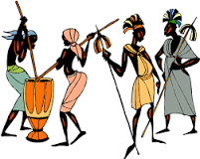
The Constitution of India has recognized tribal communities in India under 'Schedule 5' of the constitution. Hence the tribes recognized by the Constitution are known as ' Scheduled Tribes'. There are around 645 distinct tribes in India

What is the tribal language?
There are 21 tribal languages and 74 dialects which immensely contribute to the linguistic diversity of the state. Only six tribal languages — Santali, Ho, Soura, Munda and Kui — have a written script. Santali has already been included in the Eighth Schedule.

The main motive of a social worker is to lend a helping hand towards the less privileged section of the society, as per which, one of the main focus point is the tribal people. They need our help urgently to think in a broader aspect, for our country to prosper as a whole.
What is tribal social work?
In the late 20th century India, Tribal Social Work Practice was introduced to social work to integrate tribal values and beliefs to carry out developmental interventions among tribal. This looked forward to practice anti-oppressive social work while working with the indigenous communities in India.
What are the role of social worker in tribal development?
The main motive of a social worker is to lend a helping hand towards the less privileged section of the society, as per which, one of the main focus point is the tribal people. They need our help urgently to think in a broader aspect, for our country to prosper as a whole
What was the main function of the tribal society?
Understanding Tribal Societies
There was a unique bond of kinship among the members of each tribe. Their main source of livelihood was agriculture. However, hunter-gatherers or herders were also there. Some tribes were nomadic and kept on moving from one place to another.

The Social Worker Role and Impact on the Community
by FSU Online
July 27, 2020

Social workers have an immense impact on communities and the people that occupy them. However, the social worker role has shifted over the last few years and continues to evolve to match the rapid changes of the 21st century.
Social workers’ roles have grown to include crisis management as well as roles of empowerment and advocacy. Social workers can empower communities by encouraging individuals to take an active role in shaping social services, providing education programs and enabling economic independence long-term.
A notable example is the inspiring story of Nadine who was abandoned at the age of nine at a funeral in Lusaka, Zambia. Eleven years later Nadine is healthy and happy pursuing a social sciences degree at a university to educate and inspire kids who share a similar past.
Nadine's success was made possible by the social workers who started Empowerment Village in Zambia. This community was established to provide collective family, house, and education for abandoned children that operate under the creed, "All children need love, respect and security. It is their right."
Social workers’ efforts have the capacity to transform lives at the individual level while also creating a ripple effect at the community-level, to continue a wave of inspiration and motivation for generations.



What Do Social Workers Do?
Social workers assist people to cope with life's challenges by acting as an advocate to raise awareness for client needs and connecting them to solution-based programs and services.
CSW and LCSW provide individual, group, family and couples therapy. Their specialized training allows them to develop strategies to change behavior or cope with challenging situations. Social workers with clinical training may involve other healthcare disciplines to create treatment plans for their client.
Yet another social worker role is the role of macro social work, referring to the interaction between social workers and groups, community organizations and policymakers to develop or improve programs, services, policies and social conditions for communities.



Social Worker Responsibility
The social worker’s responsibility involves a combination of research, personal interaction, solution development and maintenance of programs and services for vulnerable populations.
According to The Bureau of Labor Statistics the typical social worker role includes the following duties and social worker responsibility:
- “Identify people and communities in need of help”
- “Assess clients’ needs, situations, strengths and support networks to determine their goals”
- “Help clients adjust to changes and challenges in their lives, such as illness, divorce or unemployment”
- “Research, refer and advocate for community resources, such as food stamps, childcare and health care to assist and improve a client’s well-being”
- “Respond to crisis situations such as child abuse and mental health emergencies”
- “Follow up with clients to ensure that their situations have improved”
- “Maintain case files and records”
- “Develop and evaluate programs and services to ensure that basic client needs are met
- “Provide psychotherapy services”



The Changing Social Worker Role
It’s undeniable that the social worker role is changing. The basic structure of the social worker role is evolving to better address the needs of communities by supporting self-development and using technology to enable educational programs.
Rory Tuell from The Guardian remarked on this evolving model when he said, “Our approach of tackling the many effects of poverty and marginalization and working with and alongside communities for their self-led development is the profession’s key contribution in solving social problems.
This approach needs to replace the old welfare model, where governments and international agencies provide last-minute assistance (if at all), rather than listening to and working with people and communities.”
The social worker responsibility has begun to include becoming more connected online, more specialized in their role and increasingly concerned with providing people educational programs and resources.



Types of Social Workers
The social worker role falls into a variety of categories. Some social workers occupy a more general role and others work with specific groups of individuals to provide support and coping strategies. The following are the primary types of social work practice.

Child and Family Social Worker Role
Child welfare social workers aim to strengthen family units and provide support to children and families. These social workers sometimes intervene to protect children from physical or emotional harm or neglect.
For example, a child may have experienced tremendous loss, experienced substance abuse or the effects of it, among other emotionally traumatic experiences.
In these cases, social workers are sometimes called upon to investigate allegations and may testify in court proceedings and cooperate with the courts regarding these allegations.
They may also be instructed to conduct follow up visits with children in the household or the foster care environment where they were placed to ensure the safety of the child in the cases where abuse was found.
Therapy and counseling often follow as the social worker aims to provide children with the best possible environment that offers love, respect and security.



School Social Worker Role
School social workers are an essential link between students, schools and the family. The social worker's responsibility at school involves providing leadership, mental health support, clarity around school discipline and other services.
More schools are operating online and school social workers can interact with students online to provide career counseling, school admission information and coping strategies on how to excel in online learning.
Health Care Social Worker Role
Health care social workers play a critical role in improving the physical and mental health of American citizens, especially vulnerable populations. They are often involved at a policy-level to solve biopsychosocial issues that contribute to poor health.
But it also should be noted that they are often at the personal-level providing case management for patients who need their services.



Mental Health and Substance Use Social Worker Role
Social workers that deal with mental health as addiction can fall under the broad category of clinical social work (CSW) and help with the assessment, diagnosis, treatment and prevention of mental health issues and other behavioral disorders.
The uncertainty caused by the global pandemic and consequential economic disparity in the U.S. has created an increasing need for mental health support and active coping mechanisms for American people and families.
Clinical social workers are trained to provide individuals with counseling and therapy to better manage their mental health and improve their quality of life.



Gerontology Social Worker Role
Social workers assist a growing number of seniors ages 65 plus that needs support in America. These social workers are essential as the aging Baby Boomers occupy a large fraction of the American population.
They administer care and services for the unique needs of this demographic and provide both health care and social services that enhance their wellbeing. Social workers that focus on the wellbeing of seniors also work with family caregivers and ensure their clients are being treated with respect and dignity.

Ethnicity and Race Social Worker Role
Social workers are committed to ending racism and eradicating discrimination and prejudice. Ethnicity and race social workers use action programs to address equity issues. These social workers are trained in addressing trauma and prioritize listening to the experiences and needs of communities.

LGBTQ Social Worker Role
Social workers that focus on the rights and wellbeing of the LGBT community support lesbian, gay, bisexual and transgender people of all races and ethnicities, all ages, all faiths and socioeconomic statuses through social justice and inclusion programs. On a macro level, social workers fight for laws, policies and programs that support and value the rights of LGBT individuals, families and communities.
SOCIO-ECONOMIC DEVELOPMENT OF SCHEDULED TRIBES
Programmes and important aspects related to Scheduled Tribes
1 Tribal Sub-Plan (TSP)
1.1 Since the beginning of the Planning process, efforts have been made to ensure that the
tribal people were included in the growth process. However, the strategy changed with each
Five Year Plan as new lessons were learnt from various developmental efforts. The first Five
Year Plan emphasized the provision of additional financial resources through a community
development approach to address the problems of tribal people rather than evolving a clear
cut tribal development strategy. Towards the end of the Plan (1954), 43 Special
Multipurpose Tribal Development Projects (MTDPs) were created. These MTDPs could not
fully serve the interest of the tribal people since the schemes were numerous and of a
general nature. This approach continued during the second Five Year Plan. In the third Plan,
a different strategy for tribal development was evolved by converting the Community
Development Blocks, where the concentration of tribal population was 66 % and above, into
Tribal Development Blocks (TDBs). By the end of the fourth Five Year Plan, the number of
Tribal Development Blocks in the country rose to 504. The strategy of development through
Tribal Development Blocks had its limitations as well, as it failed to address the cause of the
tribal population of the country living outside the Tribal Development Blocks, which
comprised more than 60% of the total tribal population. During the 5th Five Year Plan period,
the exercise of identification of tribal majority blocks was undertaken. These were later
constituted into 194 ITDAs/ITDPs in the country.
1.2 The present Tribal Sub Plan (TSP) strategy was initially developed by an Expert
Committee set up by the Ministry of Education and Social Welfare in 1972 under the
Chairmanship of Prof. S.C. Dube for the rapid socio-economic development of tribal people
and was adopted for the first time in the Fifth Five Year Plan. The TSP strategy, with some
modifications, continues till this day and the salient features with respect to TSP for States,
are given below:
i) The funds provided under the Tribal Sub Plan of the State have to be at least equal in
proportion to the ST population of each State or UT;
ii) Tribals and tribal areas of a State or UT are given benefits under the TSP, in addition to
what percolates from the overall Plan of a State/UT;
iii) The Sub-Plan should;
2
a) Identify the problems and need of tribal people and critical gaps in their
development.
b) Identity all available resources for TSP
c) Prepare a broad policy framework for development,
d) Prepare a detailed department wise plan
e) Define a suitable administrative strategy for its implementation.
f) Specify the mechanism for monitoring and evaluation.
(iv) The TSP strategy has been in operation in 22 States and 2 UTs. However, funds
meant for UTs are being provided for in the budget of Ministry of Home Affairs since
2003-04 and therefore, the Ministry of Tribal Affairs is not concerned in the administration
of TSP funds in the UTs.
(v) TSP concept is not applicable to the tribal majority States of Arunachal Pradesh,
Meghalaya, Mizoram and Nagaland and in the UTs of Lakshadweep and Dadra & Nagar
Haveli where tribals represent more than 60 % of the population, since the Annual Plan in
these States/UTs is itself a Tribal Plan. A statement showing State-wise total and
Scheduled Tribe population as per census 1991, 2001 and 2011 respectively is given at
ANNEXURE-I.
2 Funding of Tribal Development Programmes under TSP
2.1 Funds for tribal development under TSP are sourced from:
i) State Plans;
ii) The Special area programmes of Special Central Assistance (SCA) to Tribal Sub Plan
(TSP) and Grant under Article 275 (1) of the Constitution, as also the funds under the
other Schemes of the Ministry;
iii) Sectoral programmes of Central Ministries/ Departments; and
iv) Institutional Finance.
3 TSP Components of States and UTs
16.3.1 The Planning Commission had issued guidelines for the States and UTs to earmark
funds for TSP to be placed under a separate Budget Head Code 796 from total State/ UT
Plan outlay. As per guidelines issued by the Planning Commission, the Tribal Sub Plan
funds are to be non-divertible and non-lapsable. The guidelines also provide that the Tribal
Welfare Department will be nodal Departments for the formulation and implementation of the
Tribal Sub Plan in the States. Though the States are expected to provide under the TSP
funds which are at least equal to the percentage of the tribal population to the total
population in the State, and though the Ministry of Tribal Affairs and the Planning
Commission have repeatedly laid stress on earmarking of adequate resources, some of the
3
States while preparing the Annual Plan for even 2013-14 have continued to allocate fewer
than proportional resources to TSP.
4 TSP Components of Central Ministries/Departments
4.1 The TSP strategy is expected to be followed in the Central Ministries/Departments
also so that an adequate flow of funds in the Central Ministries/ Departments is ensured.
Ministries/ Departments had earlier been reporting difficulty in implementing TSP citing
indivisibility of projects, projects being applicable to all communities, including SCs/STs, etc.
The Ministry of Tribal Affairs taking this into account had approached Planning Commission
for devising a different strategy for Central Ministries on TSP. The Planning Commission
constituted a Task Force in June, 2010 under the chairmanship of Dr. Narendra Jadhav,
Member, Planning Commission. It recommended a classification of specific list of
Ministries/Departments according to their obligations regarding earmarking of Plan outlays
for TSP.
5 Special Central Assistance (SCA) to the Tribal Sub- Plan:
5.1 This is a major programme administered by the Ministry under which, grant is provided to
the State Governments based on annual allocation made by the Planning Commission. This
is treated as an additive to the State Plan, for areas where State Plan provisions are not
normally forthcoming to bring about economic development to tribals. The programme was
launched during 1974-75 and till the end of the IX Five Year Plan, the SCA to TSP was
meant for filling up critical gaps in the family-based income- generating activities of TSP.
From the Tenth Five Year Plan period, the objective and scope of SCA to TSP, was
expanded to cover employment-cum-income generation activities and infrastructure
incidental thereto. Beside family-based activities, other activities run by the Self-Help Groups
(SHGs)/ Community are also to be taken up. The ultimate objective of extending SCA to
TSP is to boost the demand based income-generation programmes and thus raise the
economic and social status of tribals. The guidelines for implementation by the States were
revised in May, 2003, and were further modified in January 2008. Recently in March 2014,
the Ministry of Tribal Affairs has issued operational guidelines for formulation,
implementation and monitoring of Tribal Sub-Plan and grants under Article 275(1) which has
brought out certain substantive changes in the thrust of these Special Area Programmes, as
also some procedural changes.
5.2 SCA is provided to 22 Tribal Sub-Plan States including the North Eastern States of
Assam, Manipur, Sikkim and Tripura and two Union Territories. Since 2003-04 funds meant
for UTs are being provided in the budget of Ministry of Home Affairs and therefore, Ministry
of Tribal Affairs is not concerned with the administration of funds in the UTs. Funds under
4
SCA to TSP are released for economic development in the following areas and for the
following population: -
(i) ITDP/ITDA areas (194 Nos.), which are generally contiguous areas of the size of at
least tehsil or block or more in which the ST population is 50% or more of the total
population;
(ii) MADA pockets (259 Nos.), which are identified pockets having 50% or more ST
population with a minimum population of 10,000;
(iii) Clusters (82 Nos.), which are identified pockets having 50% ST population with a
minimum population of 5,000,
(iv) Particularly Vulnerable Tribal Groups (PTGs), characterized by a low rate of growth
of population, pre-agricultural level of technology and extremely low level of literacy;
(v) Dispersed tribal population - those tribals who fall outside the categories at Sl No.(i)
to (iv) above.
5.3 The Ministry provides 100% grant-in-aid to State Governments from the SCA funds
made available to the Ministry for the purpose annually by the Planning Commission. Funds
to the level of Rs. 15.00 Lakhs per village under the program for Development of Forest
Villages were also provided as an extension of the Special Central Assistance to Tribal SubPlan (SCA to TSP). Government has decided that an additional funding upto Rs. 15.00 Lakh
each would be provided to all those forest villages which have availed the first phase funding
during the Xth Plan.
6 Grants under the First Proviso to article 275(1) of the Constitution:
6.1 The Ministry of Tribal Affairs provide grants to 22 Tribal Sub-Plan and 4 tribal majority
States under the First Proviso to article 275(1) of the Constitution to meet the cost of such
projects for tribal development as may be undertaken by the State Governments for the
promoting the welfare of the Scheduled Tribes in the State and for raising the level of
administration of the Scheduled Areas therein to that of the rest of the State. Since 1997-98,
it has been decided to utilize a part of the funds under Article 275(1) of the Constitution for
setting up 100 Model Residential Schools (named as Eklavya Vidyalaya) from class 6
th to
10th in States & UTs for tribal students. For this purpose, Rs.150.00 crores were earmarked
during the 9th Five Year Plan out of the funds available under Article 275(1) of the
Constitution. The objective of setting up of the Eklavya Vidyalayas is to provide quality
education to the tribal students. 164 Eklavya Vidyalayas were sanctioned to 22 States upto
31/03/2014 since the beginning and 120 Schools are reported to be functional
5
6.2 A fixed grant under the second proviso to Article 275(1) of the Constitution (NonPlan) is given to the Government of Assam in respect of the administration of tribal areas in
the hill districts of North Cachar and Karbi Anglong.
7 Centrally Sponsored Schemes:

7.1 The following Centrally Sponsored Schemes are presently being run by the Ministry
of Tribal Affairs for development of Scheduled Tribes.
(i) Post Matric Scholarship for STs /Book Bank
(ii) Upgradation of Merit of ST Students
(iii) Pre matric scholarship for ST students
(iv) Girls Hostels
(v) Boys Hostels
(vi) Establishment of Ashram Schools
(vii) Research and Training
(viii) Information and Mass Media
(ix) National Tribal Affairs Awards
(x) Centre of Excellence
(xi) Supporting Projects of All-India nature or Inter-State nature for Scheduled Tribes
(xii) Organisation of Tribal Festival
(xiii) Exchange of visits by Tribals
(xiv) Monitoring and Evaluation
(xv) Information Technology
(xvi) Lump-sum Provision for N.E.
8 Central Sector Schemes under which 100% Grant is given to States and UTs
8.1 The following Central Sector Schemes are presently being run by the Ministry of
Tribal Affairs for development of Scheduled Tribes:
(i) Grants-in-Aid to Voluntary Organisations
(ii) Special Incentives to NGOs performing exemplary tasks
(iii) Coaching & Allied Schemes
(iv) Vocational Training in Tribal Areas
(v) Strengthening of Education among ST Girls in Low Literacy Districts
(vi) Market Development of Tribal Products/ Produce (Tribal Cooperative Marketing
Development Federation of India Ltd. (TRIFED)
(vii) State Tribal Development Cooperative Corporation for Minor Forest Produce
(viii) Development of Particularly Vulnerable Tribal Groups (PVTGs)
(ix) National Scheduled Tribes Finance & Development Corporation
6
(x) Rajiv Gandhi National Fellowship for ST Students
(xi) Scheme of Institute of Excellence/ Top Class Institute
(xii) National Overseas Scholarship Scheme
(xiii) Mechanism for Marketing of Minor Forest Produce (MFP) through Minimum Support
Price (MSP) and Development of value Chain for MFP
(xiv) World Bank Project- Improving Development Programmes in the Tribal Areas
9 RECENT INITIATIVES OF MINISTRY OF TRIBAL AFFAIRS
9.1 The Ministry of Tribal Affairs committed to overall development of the people
belonging to Scheduled Tribes and to project the rights of such people and preserve and
promote tribal culture and heritage has recently taken up a number of new initiatives towards
their development.
1. Strengthening of Institutions:
9.2 The capacity of tribal people to harness the fruits of development and to access
various schemes for delivery of public goods and services has remained limited. The
Integrated Tribal Development Agencies were the Institutions assigned with the role to
facilitate such access. But over the years, several schemes- specific bodies at District level
became stronger whereas ITDAs/ ITDPs have become weak or non-existent in most of the
states. Similarly, Tribal Research Institutes have become weak in many states. This has
reduced knowledge support to persons in charge of tribal development. Urban areas have
seen increasing number of tribal people but there is no agency to look after their special
problems. During the year 2014-15, the Ministry has taken up strengthening of these
institutions on priority and also to create new ones so that they can deliver goods and
services more effectively. Under the existing schemes of SCA to Tribal Sub-Plan, Grants
under Article 275(1) of the Constitution and the scheme of ‘Grant-in-Aid to Tribal Research
Institutes’, the guidelines have been revised so that these institutions may be equipped with
proper infrastructure, manpower and flexibility.
9.3 In order to improve literacy amongst STs, Ministry of Tribal Affairs has taken following
initiatives during the last one year:
➢ Campaign for 100% physical enrolment
➢ Special focus on low literacy tribes and districts for all interventions
➢ Constructions of Residential Schools & Hostels and upgrade existing facilities
➢ Development of Primers in Tribal languages along with regional languages
➢ Academic sessions to be in sync with Tribal Festivals
➢ Schools Management committee to engage requisite teachers.
2. Umbrella scheme for Education of ST Children:
9.4 The following schemes for education have been merged into the umbrella scheme.
7
a) Establishing and strengthening of Ashram Schools.
b) Establishing and strengthening of Hostels.
c) Vocational training in tribal areas.
d) Post-Matric Scholarship.
e) Pre-Matric Scholarship.
9.5 The needs vary from State to State and this new scheme gives flexibility to opt for
expenditure. This year bulk of the grants have gone for scholarships.
3. Scheduling of Tribes and change of guidelines:
9.6 There are several communities which are not included in the list of Scheduled Tribes
and who claim the status of Scheduled Tribe on various grounds. The present process for
inclusion of community under Scheduled Tribe is non- transparent. Some of these claiming
communities were left out because of some historical mistakes like wrongly spelling them or
due to phonetic variations mainly because of writing of vernacular names in Roman script. A
task force constituted under the chairmanship of Secretary, Ministry of Tribal Affairs
examined these issues in detail and submitted their recommendations to the Ministry of
Tribal Affairs. All the recommendations of the Task Force have been accepted by the
Ministry. One of the key recommendations of the Task Force is that the valid names of
communities is that in Devnagri script so that the phonetic variation in English alphabet does
not lead to multiple rendering of the names.
4. Institutional mechanisms for promotion of Tribal Products and Marketing:
a) Scheme for Minor Forest Produce:
9.7 The price of MFP is very often determined by traders rather than by demand and
supply because of skewed information. The scheme is initially implemented in States having
areas under fifth Schedule of the Constitution for 12 MFPs namely (i) Tendu Leaves (ii)
Bamboo (iii) Mahua seed (iv) Sal Leaf (v) Sal Seed (vi) Lac (vii) Chironjee (viii) Wild Honey
(ix) Myrobalan (x) Tamarind (xi) Gums (Gum Karaya) and (xii) Karanj. The Ministry’s
agency, TRIFED has hosted ‘MFPNET’, a web-based portal through which current price of
MFPs can be known across important Mandis of different States.
b) Inauguration of Call Centre and Toll Free Number:
9.8 In order to provide real time information, daily prices of Minor Forest Produce in
various Mandis across the country can now be obtained through Toll Free Number 1800-
180-1551 which was inaugurated by the Hon’ble Minister for Tribal Affairs on 02.09.2014
c) E-Commerce Portal:
9.9 A portal for direct selling has been launched by TRIFED. In addition, TRIFED has
tied up with “snapdeal.com”.
8
5. Centers of Excellence
.9.10 The Ministry supports strengthening active research in Universities and reputed
institutions in order to involve them in a more focused, long term and policy-oriented work
relating to scheduling of Tribes. Currently three institutions are functioning with support from
the Ministry:
i) National Institute of Rural Development, Hyderabad in the field of Local Governance
and Rural Development.
ii) BAIF Development Research Foundation, Pune in the field of Rural Technologies for
Improvement in Livelihood and Quality of Life.
iii) Bhasha Research and Publication Centre, Vadodra in the field of Information,
Education and Communication.
9.11 The Ministry has recognized the Department of Odia, Vishva Bharati, Shanti NIketan
Centre of Excellence in the field of Tribal Language and Literature. Another proposal has
been approved by the Ministry to establish a National Research Centre in the Tribal
Research Institute, Bhubaneswar to promote research activities on subjects/ issues for
socio- economic development and culture of Scheduled Tribes.
6. Implementation of Forest Rights Act:
9.12 The Scheduled Tribes and Other Traditional Forest Dwellers (Recognition of Forest
Rights) Act, 2006 is a landmark legislation to recognize the pre-existing rights of tribals and
other traditional forest dwellers who are in occupation of forest land, but whose rights could
not be recorded. A copy of the Act is placed at ANNEXURE-II. The Act has come into force
w.e.f. 31/12/2007. In exercise of the powers conferred by sub-Sections (1) and (2) of Section
14 of the Act Government of India have also notified the Scheduled Tribes and Other
Traditional Forest Dwellers (Recognition of Forest Rights) Rules, 2007 and these Rules have
become effective from 01/01/2008. A copy of these Rules is placed at ANNEXURE-III. As
per information made available by the Ministry of Tribal Affairs, by the end of January, 2015,
i.e during more than seven years of implementation of the Act, more than 39.61 lakh claims
have been filed. Of these, 15.32 lakh Individual Rights and more than 29,800 Community
Forest Rights titles have been distributed covering a total area of 72.09 lakh acres of land.
So far 83.06 per cent of claim applications filed have been disposed of.
7. Vanbandhu Kalyan Yojana:
9.13 In order to achieve comprehensive development of tribals, Vanbandhu Kalyan Yojana
(VKY) is being implemented by the Ministry of Tribal Affairs which focuses on convergence
of different schemes of development. VKY also envisages a shift in working character and
rather than focusing merely on physical and financial achievements. For example, instead of
9
number of schools, it will see the number of students who have passed with distinction. The
proposed intervention is aimed at adopting a holistic approach commensurate to the Gujarat
Model for overall development of the tribal people with sustainability.
9.14 During 2014-15, budgetary support of Rs.3850 Crores has been made for various plan
schemes of the Ministry at RE stage. A Project Appraisal Committee, headed by Secretary,
Tribal Affairs, with representatives of State Governments, Financial Advisor Planning
Commission, etc. has been constituted to appraise and approve the proposals for allocation
under various schemes of the Ministry. This has helped in ensuring consultation with the
States, convergence of various schemes of the Ministry and other Centrally Sponsored
Schemes, transparency in the process of appraisal and fund releases and ensuring optimal
allocation of limited financial resources. The Committee has prioritized on education
especially that of girl child and low literacy tribes; health especially Sickle Cell Anemia,
Malaria, Malnutrition and Livelihood. Facilities of Toilets with running water and electricity in
residential schools has been emphasized. This process has helped in synchronizing national
priorities with State priorities.
8. Health and Nutrition Initiatives:
9.15 Initiatives taken by the Ministry of Tribal Affairs in relation to Health and Nutrition
aspect of Scheduled Tribes are:
a. Sickle Cell Anemia: To eradicate Sickle Cell Anemia, health check-up followed by
issue of Health cards of students of tribal department schools/ hostels to identify
sickle cell trait (HbAS) (SCT) cases has been undertaken. Parents are to be
made aware of the problems and its prevention methods. Health ministry has
been requested to include Sickle Cell test for all population groups in malariaprone areas.
b. Malaria: Composite fish culture for controlling mosquito population and also to
provide protein supplement to the people has been advocated and supported.
c. Traditional Corps and Food: Growing and consumption of minor millets, kitchen
garden for green leafy vegetable are encouraged in the project approvals to
address nutritional issues
d. Tribal Medicines and Practices: Documentation of Tribal Medicines and practices
through Tribal Research Institutes has been initiated. Efforts to mainstream tribal
medicines and validated practices for effective health service delivery for Tribal
people has been started.
9. National Tribal Festival: 2015
9.16 The Ministry of Tribal Affairs organized the National Tribal Festival ‘VANAJ’ in New
Delhi from 13th to 18th February, 2015. The festival provided glimpses of rich cultural heritage
10
of tribal communities across the country through unique forms of folk dances, songs and
other traditional practices and focused on developing a sense of appreciation of the cultural
diversity of the country. The highlights of the Festival included state specific tribal huts,
exhibition of books, art and crafts, tribal cuisine, award winning photographs and
demonstration of traditional skill in painting, craft and traditional medical practices. Screening
of documentary films and seminars on subject relevant to tribal issues were other attractions
of the six days event. The event would be organised from 2nd Friday to 3rd Wednesday of
February every year.
9.17 Details regarding each Scheme mentioned above and working of these Schemes and
other activities of the Ministry of Tribal Affairs are available on the website of the Ministry of
Tribal Affairs (http://www.tribal.nic.in )
10 SCHEDULED AREAS
10.1 The Scheduled Tribes live in contiguous areas unlike other communities. It is,
therefore, much simpler to have area approach for development activities and also
regulatory provisions to protect their interests. In order to protect the interests of Scheduled
Tribes with regard to land alienation and other social factors, provisions of “Fifth Schedule”
and “Sixth Schedule” have been enshrined in the Constitution.
10.2 The Fifth Schedule under Article 244(1) of Constitution defines “Scheduled Areas” as
such areas as the President may by Order declare to be Scheduled Areas after consultation
with the Governor of that State. This schedule contains provisions regarding the
administration and control of the Scheduled Areas and Scheduled Tribes. There are nine
States having Scheduled Areas, viz., Andhra Pradesh Chhattisgarh, Gujarat, Himachal
Pradesh, Jharkhand, Madhya Pradesh, Maharashtra, Orissa, and Rajasthan. The
Governors of these States have special responsibilities and powers. These States have
Tribes Advisory Councils (TACs). [In addition, Tamil Nadu and West Bengal, which do not
have any Scheduled Areas, also have statutory TACs]. List of orders in operation at present
in their original or amended form may be seen on the website of the Ministry of Tribal Affairs
i.e. (http://www.tribal.nic.in)
10.3 The Sixth Schedule under Article 244(2) of the Constitution relates to those areas in
the north-east which re-declared as “tribal areas” and provides for an District or Regional
Autonomous Councils for such areas. These councils have wide ranging legislative, judicial
and executive powers. The Schedule also contains provisions relating to the administration
of the areas declared as ‘tribal areas’. The Tribal Areas in relation to this Schedule are in
the States of Assam, (North Cochar Hills District and Karbi Anglong District) Meghalaya,
11
Mizoram and Tripura. There are Autonomous District Councils and Autonomous Regional
Councils in these areas, which have a long tradition of self-management systems. These
Autonomous Councils not only an administers various Departments and developmental
programmes but they also have powers to make large on a variety of subjects, e.g., land,
forest, shifting cultivation, village or town administration including village or town police and
public health and sanitation, inheritance of property, marriage and divorce and social
systems. These Councils are elected bodies and have powers of legislation, administration
of justice apart from executive developmental and financial responsibilities.
10.4 The advantages of Scheduled Areas are:
(a) The Governor of a State, which has Scheduled Areas, is empower to make
regulations in respect of the following:
(i) Prohibit or restrict transfer of land from tribals;
(ii) Regulate the business of money lending to the members of Scheduled Tribes
In making any such regulation, the Governor may repeal or amend any Act of
Parliament or of the Legislature of the State, which is applicable to the area in
question.
(b) The Governor may by public notification direct that any particular Act of Parliament
or of the Legislature of the State shall not apply to a Scheduled Area or any part
thereof in the State or shall apply to such area subject to such exceptions and
modifications as he may specify.
(c ) The Governor of a State having Scheduled Areas therein, shall annually, or
whenever so required by the President of India, make a report to the President
regarding the administration of the Scheduled Areas in that State and the executive
power of the Union shall extend to the giving of directions to the State as to the
administration of the said area.
(d) Tribes Advisory Council [TAC] shall be established in States having Scheduled
Areas. The TAC may also be established in any State having Scheduled Tribes but
not Scheduled Areas on the direction of the President of India. The TAC consists of
not more than twenty members of whom, as nearly as may be, three fourths are from
the representatives of Scheduled Tribes in the Legislative Assembly of the State.
The role of TAC is to advise the State Government on matters pertaining to the
welfare and advancement of the Scheduled Tribes in the State as may be referred to
it by the Governor.
(e) The Panchayats (Extension to Scheduled Areas)Act, 1996, vide which the provisions
of Panchayats, contained in Part IX of the Constitution, were extended to Scheduled
Areas, also contains special provisions for the benefit of Scheduled Tribes.
12
11 Panchayats (Extension to Scheduled Areas) ACT, 1996
11.1. The provisions of Part IX of the Constitution relating to Panchayats have been extended
to the Scheduled Areas in various States through the Panchayats (Extension to Scheduled
Areas) Act, 1996 (ANNEXURE-IV). Section (4) of this Act provides that notwithstanding
anything contained under Part IX of the Constitution, the Legislature of a State shall not make
any law under that Part which is inconsistent with any of the features mentioned in this
Section. Section (4) of the Act, inter alia, provides that:-
(i) (a) Every Gram Sabha shall approve of the plans, programmes and projects for social
and economic development before such plans, programmes and projects are taken
up for implementation by the Panchayat at the village level.
(b) Every Gram Sabha shall be responsible for the identification or selection of persons
as beneficiaries under the poverty alleviation and other programmes.
(i) Every Panchayat at the village level shall be required to obtain from the Gram
Sabha a certification of utilization of funds by that Panchayat for the plans,
programmes and projects.
(iii) The Gram Sabha or the Panchayats at the appropriate level shall be consulted
before making the acquisition of land in the Scheduled Areas for development
projects and before re-settling or rehabilitating persons affected by such projects in
the Scheduled Areas.
(iv) The recommendations of the Gram Sabha or the Panchayats at the appropriate
level shall be made mandatory prior to grant of prospecting license or mining lease
for minor minerals in the Scheduled Areas.
(v) The State Legislature shall endeavor to follow the pattern of the Sixth Schedule to
the Constitution while designing the administrative arrangements in the Panchayats
at district levels in the Scheduled Areas.
11.2 Some other powers of Gram Sabhas in the Scheduled Areas as provided in Section (4)
of the Act relate to (i) safeguarding and preserving the traditions and customs of the tribal
people, (ii) planning and management of miner water bodies in the Scheduled Areas. The
State Legislature is required to ensure that the Panchayats at appropriate level and the Gram
Sabha are endowed specifically with the power-
(i) to enforce prohibition or to regulate or restrict the sale and consumption of any
intoxicant,
(ii) to grant the ownership of minor forest produce,
(iii) to prevent the alienation of land in the Scheduled Areas and to take appropriate
action to restore any unlawfully alienated land to a Scheduled Tribe,
(iv) to manage village markets,
13
(v) to exercise control over money lending to Scheduled Tribes,
(vi) to exercise control over institutions and functionaries in social sectors and,
(vii) to exercise control over local plans and resources for such plans including tribal-sub
plans.
12 Scheduling and de-scheduling of Tribes:
12.1 Empowered by Clause (1) of Article 342, the President may, with respect to any State
or Union Territory, and where it is a State, after consultation with the governor thereof, notify
tribes or tribal communities or parts of these as Scheduled Tribes. This confers on the tribe
or part of it a Constitutional status for availing the rights and safeguards provided for the
Scheduled Tribes in the Constitution, in their respective State/UT.
12.2 Clause (2) of the Article empowers the Parliament to pass a law to include in or
exclude from the list of Scheduled Tribes, any tribe or tribal community or parts of these.
13 Criteria for specification of a community as a Scheduled Tribe:
13.1 The criteria followed for specification of a community as a Scheduled Tribe are:
(a) Indication of primitive traits,
(b) Distinctive culture,
(c) Geographical isolation,
(d) Shyness of contact with the community at large, and
(e) Backwardness.
13.2 This criteria is not spelt out in the Constitution but has become well established. It
takes into account the definitions in the 1931 Census, the reports of the first Backward
Classes Commission (Kalelkar) 1955, the Advisory Committee on Revision of SC/ST lists
(Lokur Committee) 1965 and the Joint Committee of Parliament on the Scheduled Castes
and Scheduled Tribes Order (Amendment) Bill, 1967 (Chanda Committee) 1969.
14 Procedure for inclusion in or exclusion from the list of Scheduled Tribes
14.1 In June, 1999, the Government approved modalities for deciding claims for inclusion in
or exclusion from the lists of Scheduled Tribes. According to these approved guidelines,
only those claims that have been agreed to by the concerned State Government, the
Registrar General of India and the National Commission for Scheduled Castes & Scheduled
Tribes will be taken up for consideration.
14.2 Whenever representations are received in the Ministry of Tribal Affairs for inclusion of
any community in the list of Scheduled Tribes of a State/UT, the Ministry forwards that
14
representation to the concerned State Government/U.T. Administration for recommendation
as required under Article 342 of the Constitution. If the concerned State Government
recommends the proposal, then the same is sent to the Registrar General of India (RGI).
The RGI, if satisfied with recommendation of the State Government, recommends the
proposal to the Central Government. Thereafter, the Ministry of Tribal Affairs refers the
proposal to the National Commission for Scheduled Castes and Scheduled Tribes for their
recommendation. If the National Commission for Scheduled Castes and Scheduled Tribes
also recommends the case, the matter is processed for the decision of the Cabinet after
consulting the concerned administrative Ministries. Thereafter the matter is put up before the
Parliament in the form of a Bill to amend the Presidential Order.
14.3 In case, there is disagreement between the views of the State Government and the
RGI, the views of the RGI are sent to the State Government for reviewing or further justifying
their recommendation. On receipt of the further clarification from the State Government/
Union Territory Administration, the proposal is again referred to the RGI for comments. In
such cases, where the RGI does not agree to the point of view of the State Government/ UT
Administration, Government of India may reject the said proposal.
14.4 Claims that neither the RGI nor the concerned State Government have supported are
rejected. Similarly, those cases where the State Government and the RGI favour inclusion
/exclusion, but not supported by the National Commission for Scheduled Castes and
Scheduled Tribes are also rejected.
15 Authorities Competent to Issue Scheduled Tribe certificates:
15.1 The candidates belonging to Scheduled Tribes may get Scheduled Tribe certificates, in
the prescribed form, from any one of the following authorities:
(i) District Magistrate/Additional District Magistrate/ Collector/ Deputy Commissioner/
Additional Deputy Commissioner/Deputy Collector/ Ist Class Stipendiary Magistrate/
City Magistrate/ Sub Divisional Magistrate/ Taluka Magistrate/Executive Magistrate/
Extra Assistant Commissioner. [not below the rank of Ist Class Stipendiary
Magistrate]
(ii) Chief Presidency Magistrate/Additional Chief Presidency Magistrate/ Presidency
Magistrate
(iii) Revenue Officers not below the rank of Tehsildar
(iv) Sub- Divisional Officer of the Area where the candidate and/ or his family normally
resides
(v) Administrator/ Secretary to the Administrator/ Development Officer [Lakshadweep
Islands]
15
16 Points to be observed while issuing/ verifying Scheduled Tribe certificates:
16.1 General:
16.1.1 Various points and issues are required to be considered before issuing a caste
certificate to an applicant. The nodal Ministry dealing with the policy issue relating to the
subject matter relating to inclusion into and exclusion from the list of SCs/STs has been with
the Ministry of Social Justice and Empowerment. These points and issues are given in detail
on the website of the Ministry of Social Justice and Empowerment
(http://www.socialjustice.nic.in ). However, some important issues are highlighted in this
Handbook for ready reference.
16.1.2 Where a person claims to belong to a Scheduled Tribes by birth it should be verified
that:-
(i) The person and his/her parents actually belong to the community claimed;
(ii) The community is included in the Presidential Order specifying the Scheduled Tribes
in relation to the concerned State;
(iii) The person belongs to that State and to the area within that State in respect of which
the community has been scheduled;
(iv) He/she may profess any religion;
(v) He/she or his/her parents/grandparents etc., should be permanent resident of the
State/UT on the date of notification of the Presidential Order applicable in his/her
case.
(vi) A person who is temporarily away from his permanent place of residence at the time
of the notification of the Presidential Order applicable in his case, say for example to
earn a living or seek education, etc. can also be regarded as a Scheduled Tribe, if his
tribe has been specified in that Order in relation to his State/Union Territory. But
he/she cannot be treated as such in relation to the place of his temporary residence
notwithstanding the fact that the name of his/her tribe has been scheduled in respect
of that State where he/she is temporarily settled, in any Presidential Order.
(vii) In the case of persons born after the date of notification of the relevant Presidential
Order, the place of residence for the purpose of acquiring Scheduled Tribe status, is
the place of permanent abode of their parents at the time of the notification of the
Presidential Order under which they claim to belong to such a tribe.
16.2 Scheduled Tribe claims on migration:
16.2.1 Where a person migrates from the portion of the State in respect of which his
community is scheduled to another part of the same State in respect of which community is
not scheduled, he will continue to be deemed to be a member of the Scheduled Tribe, in
relation to that State;
16
16.2.2 Where a person migrates from one State to another, he can claim to belong to a
Scheduled Tribe only in relation to the State to which he originally belonged and not in
respect of the State to which he has migrated.
16.3 Scheduled Tribe claims after marriage and status of their children:
16.3.1 The guiding principle is that no person who was not a Scheduled Tribe by
birth will be deemed to be a member of Scheduled Tribe merely because he or she has
married a person belonging to a Scheduled Tribe. Similarly a person who is a member of a
Scheduled Tribe would continue to be a member of that Scheduled Tribe, even after his or
her marriage with a person who does not belong to a Scheduled Tribes. However, status of
the children born out of such marriages would depend on the particular caste status of the
Unit-4

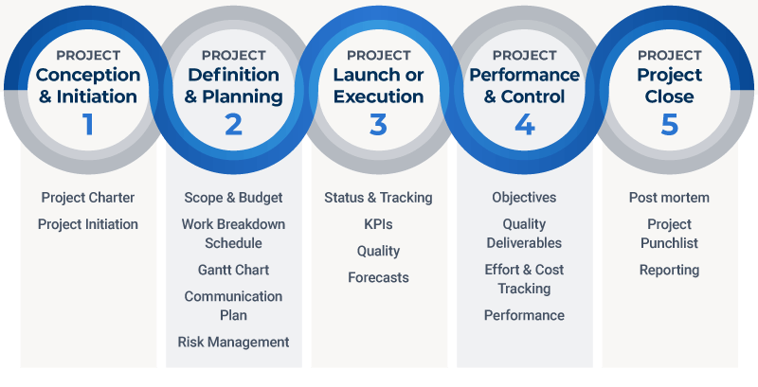
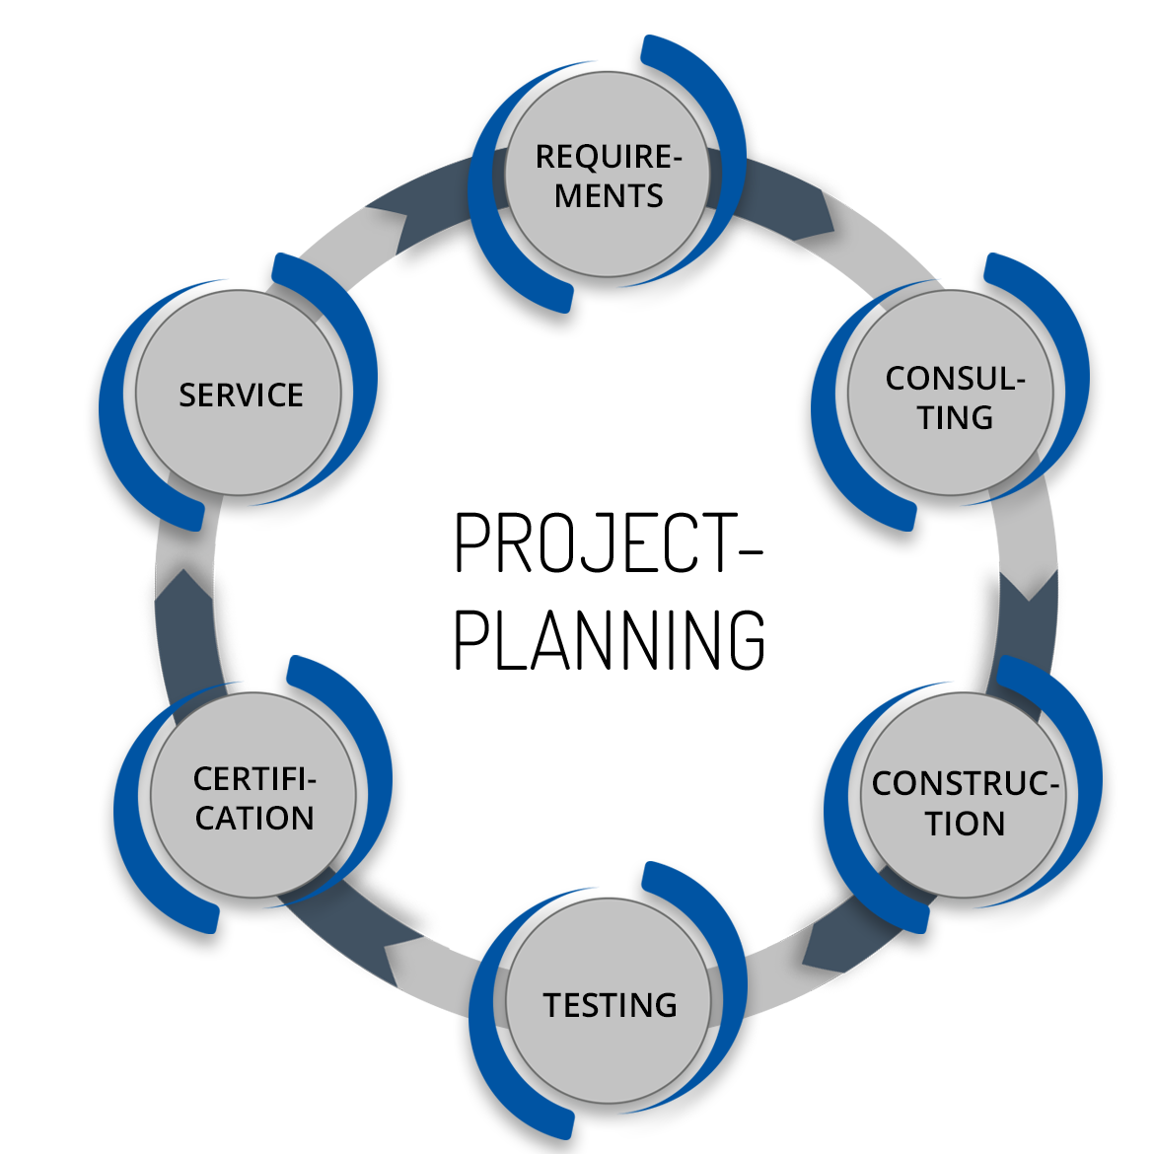
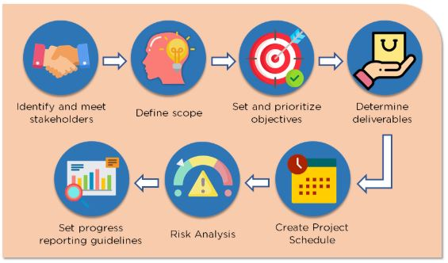
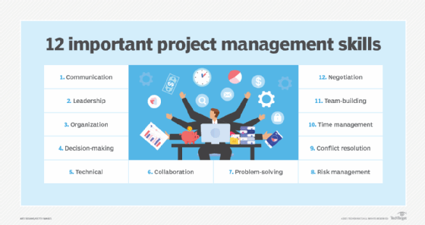
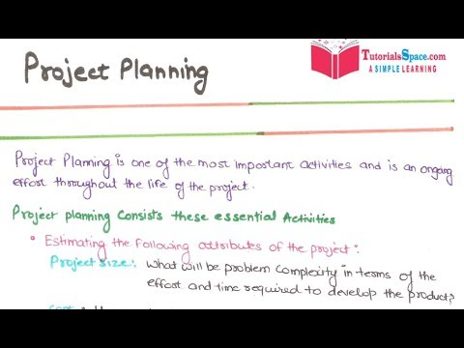
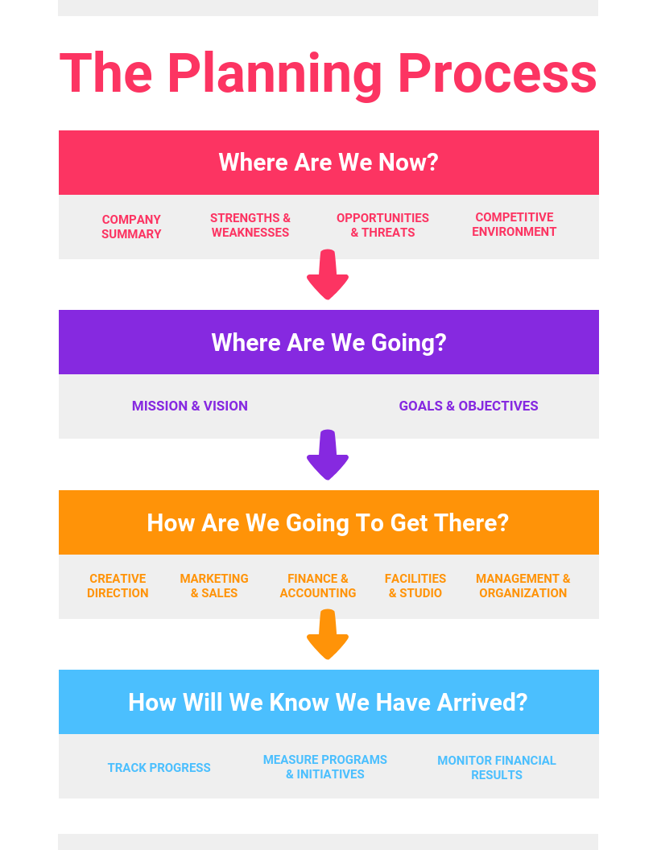
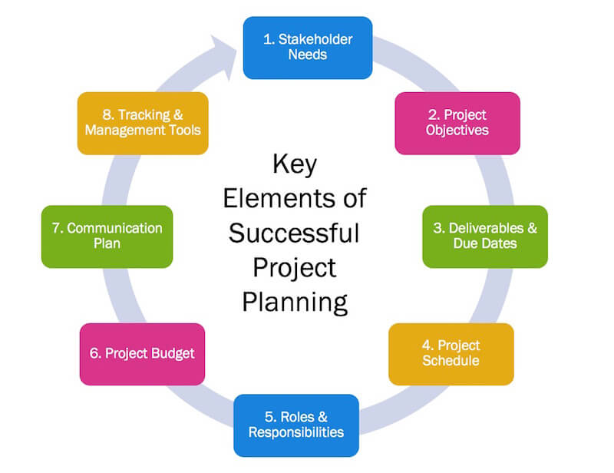


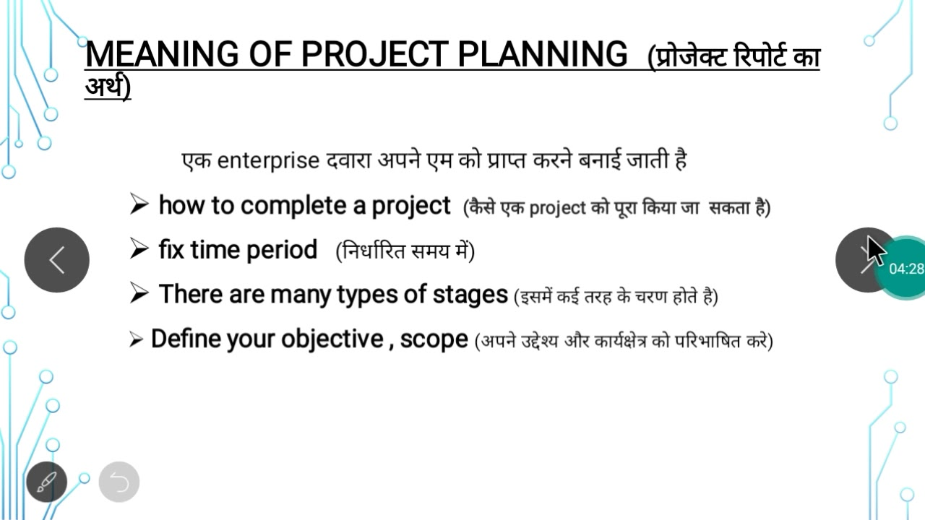
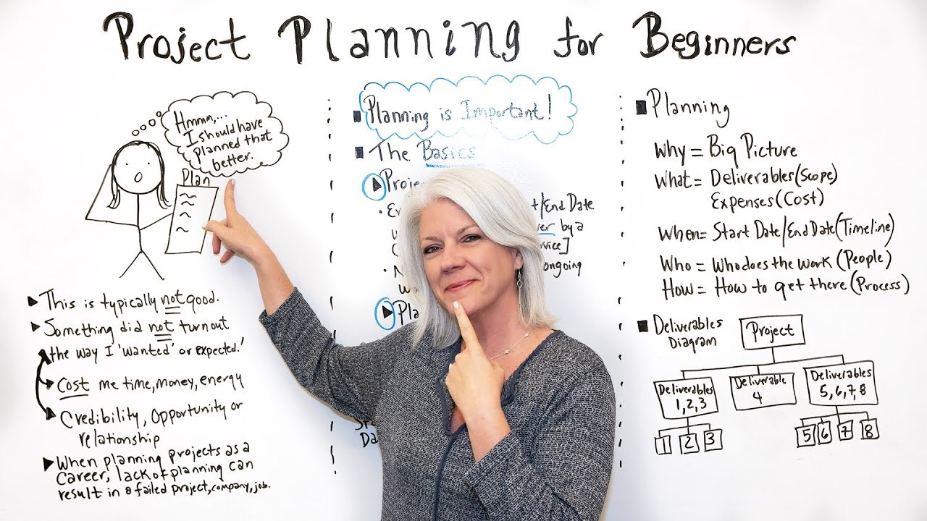
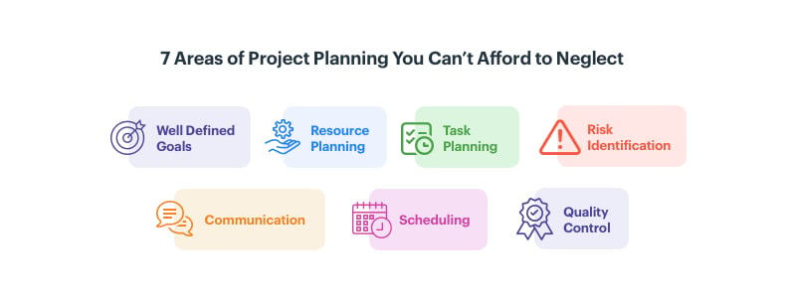




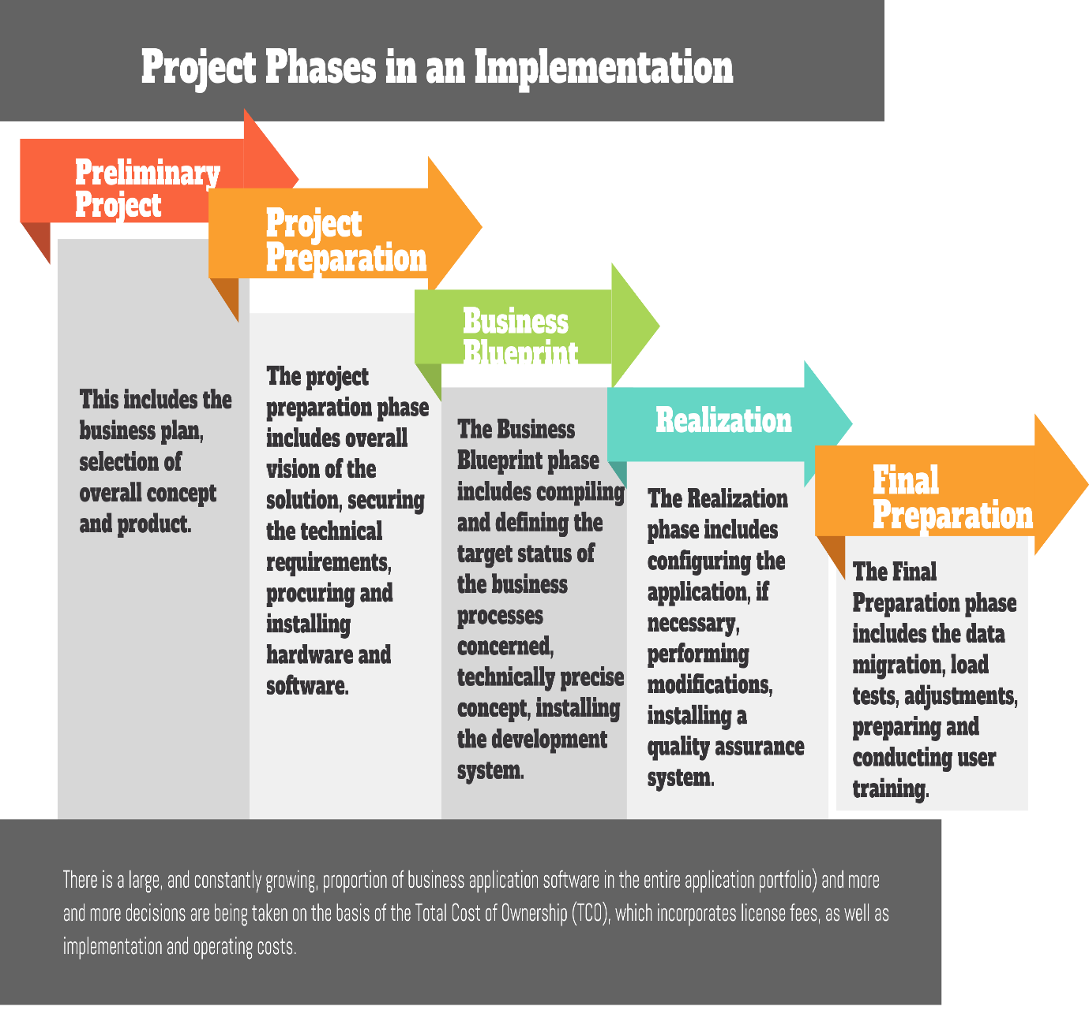
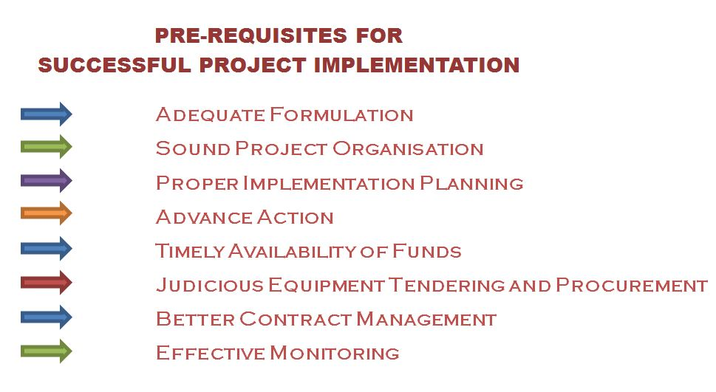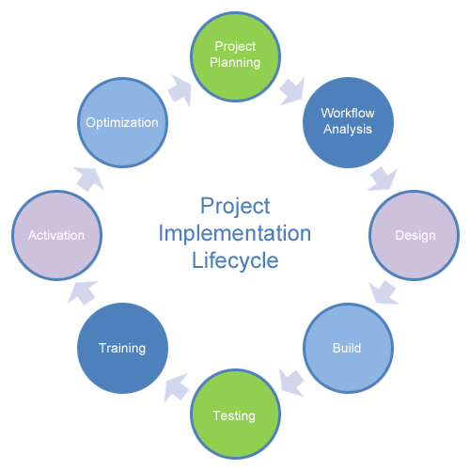
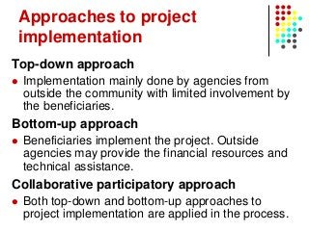

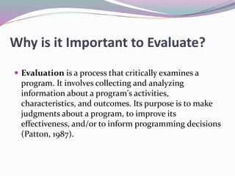
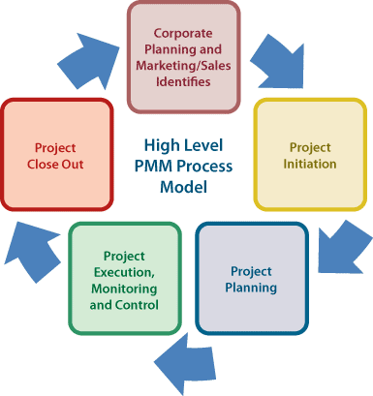

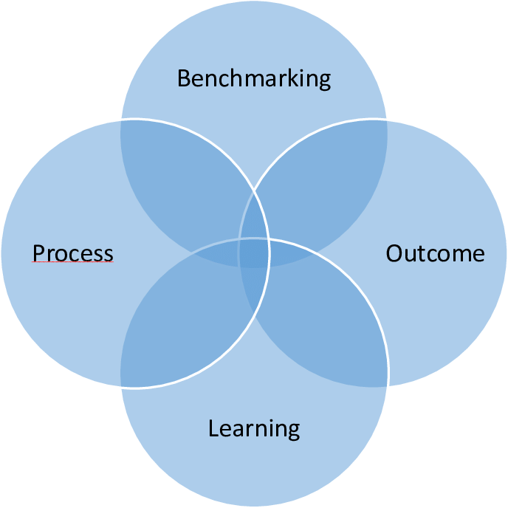
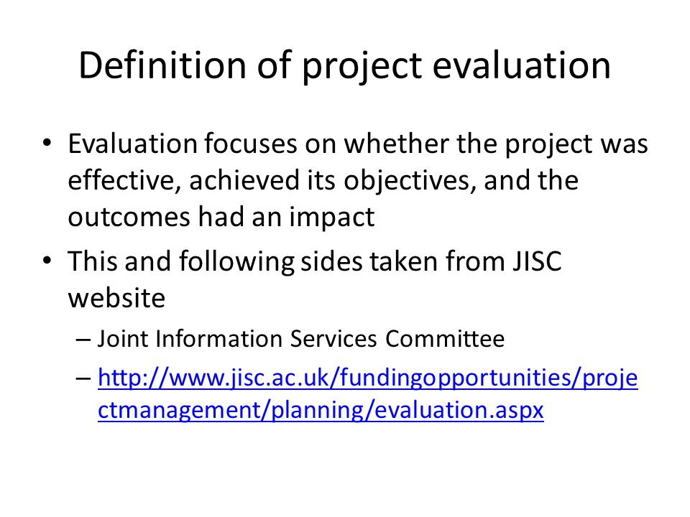
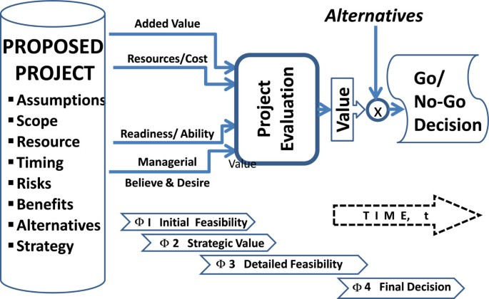
Unit-5
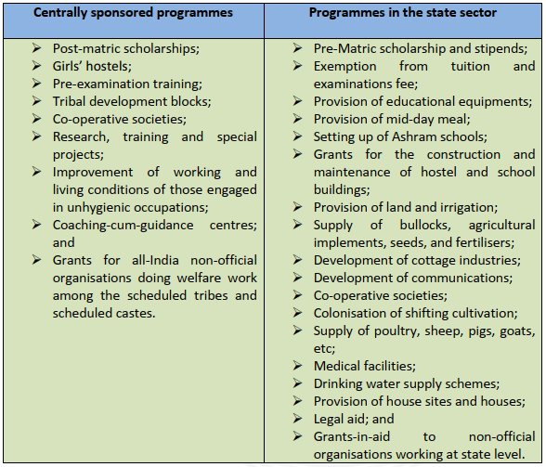
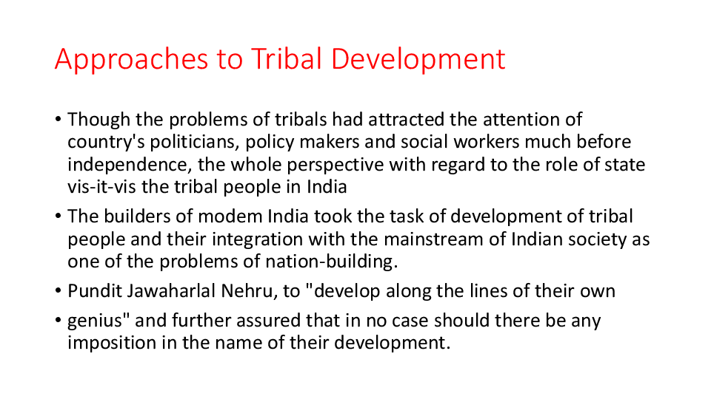
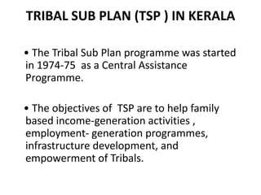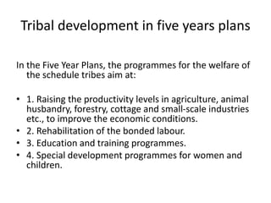
NGOs work in tribal areas
On International Day of the World's Indigenous Peoples, we look at five NGOs that have been working for tribal welfare across the country.
- Mrida Education and Welfare Society. ...
- Nilgiris Wynaad Tribal Welfare Society (NWTWS) ...
- Kalinga Institute of Social Sciences. ...
- Parivaar Education Society.
the schemes implemented by the Government for the development of tribals
The prominent schemes of NSTFDC are Term Loan, Adivasi Mahila Sashaktikaran Yojana – an exclusive scheme for Scheduled Tribe women, Adivasi Shiksha Rinn Yojana – Education Loan scheme, Micro Credit Scheme for Self Help Groups (SHGs) – comprising Scheduled Tribes as its members, Tribal Forest Dwellers Empowerment Scheme ...

- Schemes of Ministry of Tribal Affairs
Find schemes of Ministry of Tribal Affairs. Get information on schemes for students such as Post Matric Scholarship (PMS) for ST students, up gradation of Merit of ST students, Vocational Training Centres in tribal areas, establishment of ashram schools in tribal sub-plan areas, Rajiv Gandhi National Fellowship for ST students etc. Users can also find links for schemes on marketing of tribal produce, investment in TRIFED and development of Primitive Tribal Groups (PTGs) etc.

Related Links
- Scheme of Strengthening Education among Scheduled Tribe Girls in Low Literacy Districts

This Scheme of Strengthening Education among Scheduled Tribe (ST) Girls in Low Literacy Districts seeks to benefit Scheduled Tribe (ST) Girls. The scheme was introduced by the Ministry of Tribal Affairs. The objective of this scheme is to bridge the gap in literacy levels between the general female population and tribal women, through facilitating 100% enrolment of tribal girls in the identified Districts or Blocks and reducing drop-outs at...
- Central Sector Scholarship Scheme for Scheduled Tribe students

Central Sector Scholarship Scheme for Scheduled Tribe (ST) students was launched in the year 2007-08 and is dedicated to meritorious ST students. The Scheme is funded by the Central government. This scheme is applicable for meritorious ST students who are pursing studies at Degree and Post Graduate level. ST students can avail this scheme by contacting educational institutions and Ministry of Tribal Affairs.
- Vocational Training Centres in Tribal Areas

Find details of the Vocational Training Centres in Tribal Areas Scheme. The scheme is funded by the Central Government and provided by the Ministry of Tribal Affairs. Scheme related details such as eligibility, beneficiary, required documents, application procedure and forms are available. Contact details of the coordinating agency are also provided.
- Scheme of Marketing Development of Tribal Products or Produce
Get information about the Scheme of Marketing Development of Tribal Products or Produce provided by the Ministry of Tribal Affairs. Users can get details about the eligibility criteria, beneficiary type and benefits of the Scheme. Information on how to avail the Scheme is provided. Details of the applying authority and required documents are also available.
- Financial Assistance for support to Centres of Excellence

This Financial Assistance for support to Centres of Excellence scheme seeks to benefit Universities and Institutions working in the fields of tribal development and research. The scheme was introduced by the Ministry of Tribal Affairs. The objective of this scheme is to enhance and strengthen the institutional resource capabilities of various NGOs, Research Institutes and University Departments to conduct qualitative, action oriented and...
- Scheme for Release of Equity Support to the National and State Scheduled Tribes Finance and Development Corporations

Find details of the Scheme for Release of Equity Support to the National Scheduled Tribes Finance and Development Corporations (NSTFDCs) or State Scheduled Tribes Finance and Development Corporations (STFDCs). The scheme is funded by the Central Government and provided by the Ministry of Tribal Affairs. Scheme related details such as eligibility, beneficiary, required documents, application procedure and forms are available. Contact details...
- Grants to Tribal Research Institutes

Get information about the Grants to Tribal Research Institutes scheme, provided by Ministry of Tribal Affairs. Users can get details about the eligibility criteria, beneficiary type and benefits of the Scheme. Information on how to avail the Scheme is provided. Details of the applying authority and required documents are also available.
- Scheme to Upgrade Merit of Scheduled Tribe Students
Get information about Scheme to Upgrade Merit of Scheduled Tribe (ST) Students by Ministry of Tribal Affairs. The scheme is funded by the Central government. ST students studying in classes IX to XII are eligible for the scheme. Beneficiaries can contact Ministry of Tribal Affairs for more information about the Scheme.
- National Overseas Scholarships for Scheduled Tribe Students

This Central Scheme of National Overseas Scholarships for Scheduled Tribe (ST) Students seeks to benefit ST students. The scheme was introduced by the Ministry of Tribal Affairs. The objective of this scheme is to provide financial assistance to meritorious students for pursuing higher studies in foreign university in specified files of Master Level Courses, Ph.D and Post-Doctoral research programmes, in the field of Engineering, Technology...
- Rajiv Gandhi National Fellowship for Scheduled Tribe Students
Rajiv Gandhi National Fellowship for Scheduled Tribe (ST) Students scheme was launched in the year 2005-06 and is dedicated to Scheduled Tribe. The Scheme is funded by the Central government. This scheme is applicable for Scheduled Tribe students for pursuing higher studies such as M.Phil and Ph.D. ST Students can avail this scheme by contacting University Grant Commission (UGC) or Ministry of Tribal Affairs.
- Post Matric Scholarship for Scheduled Tribe Students
Get information about Post Matric Scholarship for Scheduled Tribe (ST) Students Scheme by Ministry of Tribal Affairs. The scheme is funded by the Central government. Scheduled Tribe Students pursuing professional, technical as well as non-professional and non-technical courses at various levels including correspondence courses are eligible for the scheme. Beneficiaries can contact Ministry of Tribal Affairs for more information about the...
- Centrally Sponsored Scheme of Hostels for Scheduled Tribe Girls and Boys
Get information about the Centrally Sponsored Scheme of Hostels for Scheduled Tribe (ST) Girls and Boys, provided by the Ministry of Tribal Affairs. Users can get details about the eligibility criteria, beneficiary type and benefits of the Scheme. Information on how to avail the Scheme is provided. Details of the applying authority and required documents are also available.
- Authorization Letter for voluntary organizations working for Old People

Access to the authorization letter for voluntary organizations working for old people by the Ministry of Tribal Affairs is given. This form is meant for voluntary organizations working in the field of integrated programme for older persons. Users can download the form and use it further.
- Application Form for New or On-going Proposals for financial assistance under the Scheme of Grant-in-Aid to Voluntary Organization for the Welfare of Scheduled Tribes

  - Share This
Get application form for new or on-going proposals for financial assistance under the scheme of grant-in-aid to voluntary organization for the welfare of Scheduled Tribes (STs) provided by the Ministry of Tribal Affairs. This form is meant for voluntary organisations working for welfare of STs. Users can download the form and use it further. Instructions on how to fill the form are also available.
- Proforma for Central Assistance under the Centrally Sponsored Scheme of Pre-Matric Scholarship for students belonging to Schedule Tribes studying in Classes IX & X

