FRENCH COOKING COMPETITION REPORT

The *French Cooking Competition* was held on [11TH MARCH 2024] at St.Philomena’s college to celebrate the richness of French gastronomy and to encourage students to explore French culture through cuisine.
Participants
The competition featured talented FRENCH students who prepared a variety of classic French dishes, showcasing both their cooking skills and their creativity.
Dishes Presented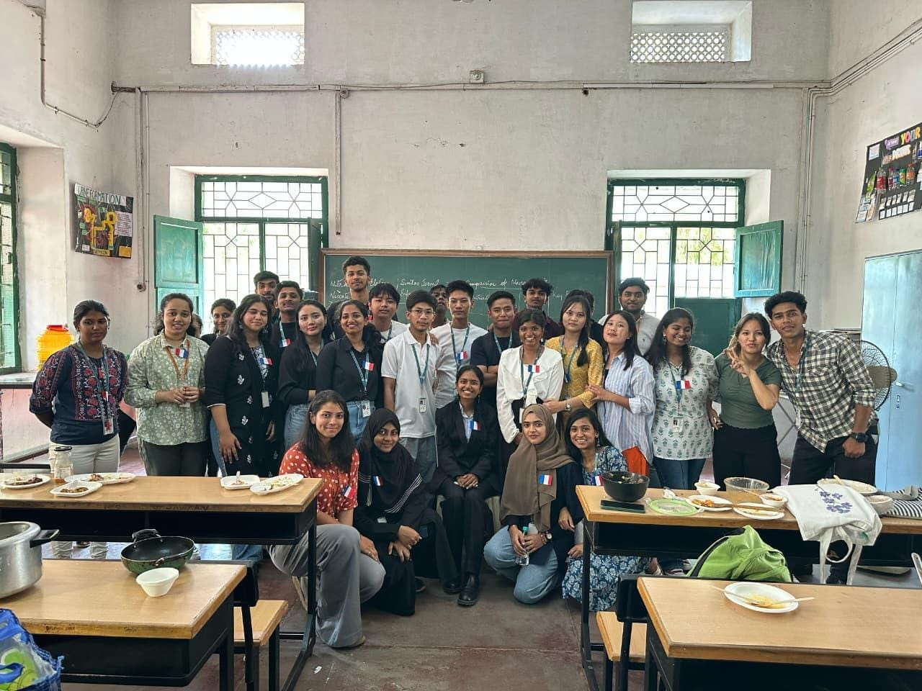
The menu for the event included:
1. *Crêpes* – Light and delicate pancakes served with both sweet and savoury fillings.
2. *Chicken Fricassée* – A creamy chicken stew cooked with herbs, vegetables, and white sauce.
3. *Mushroom Soup* – Smooth and flavourful soup made with fresh mushrooms and aromatic herbs.
4. *French Fried Chicken* – Crispy fried chicken with a French seasoning twist.
5. *Chicken Cordon Bleu* – Breaded chicken stuffed with ham and cheese, perfectly golden.
6. *Ratatouille* – A colourful Provencal vegetable medley slow-cooked with olive oil and herbs.
7. *Crème Brûlée* – A rich custard dessert topped with a caramelized sugar crust.
Judging Panel
The dishes were judged by a distinguished panel:
Mr. Ranjithe C. V. - DEPT. BBA TH
Dr. Seema Siddiq. – PG FSN
Dr. Kaneez Haleem. – PG FSN
Judges evaluated each dish based on presentation, taste, authenticity, and creativity.
Outcome & Feedback
The competition was a flavourful success. Students impressed the judges with their attention to detail, mastery of techniques, and passion for French culinary traditions. Many dishes were praised for their authentic flavours and elegant presentation.
The event also allowed students to practice teamwork, creativity, and time management, making it not just a competition but a valuable learning experience.
Conclusion:
The French Cooking Competition was a memorable celebration of culture, talent, and passion for food. The organizers extended their heartfelt thanks to all students, judges, and supporters, with the hope of making this an annual tradition.
French toast avec Fromage
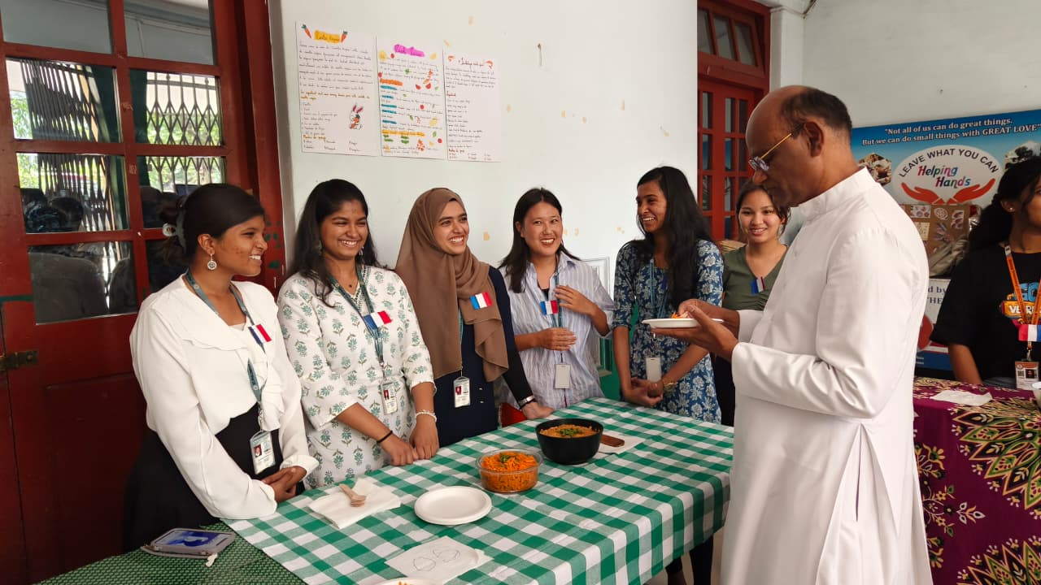
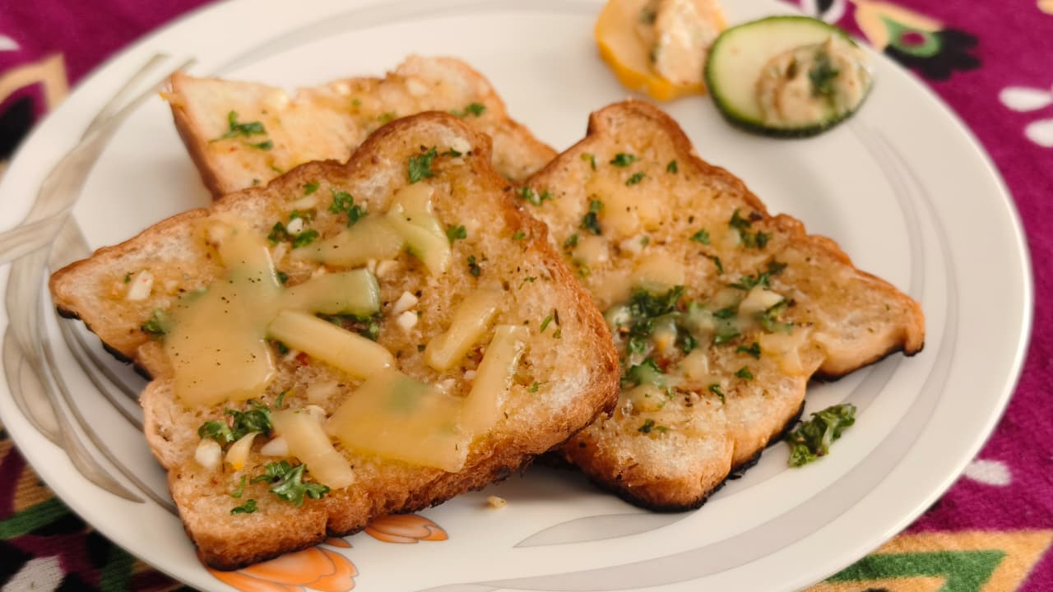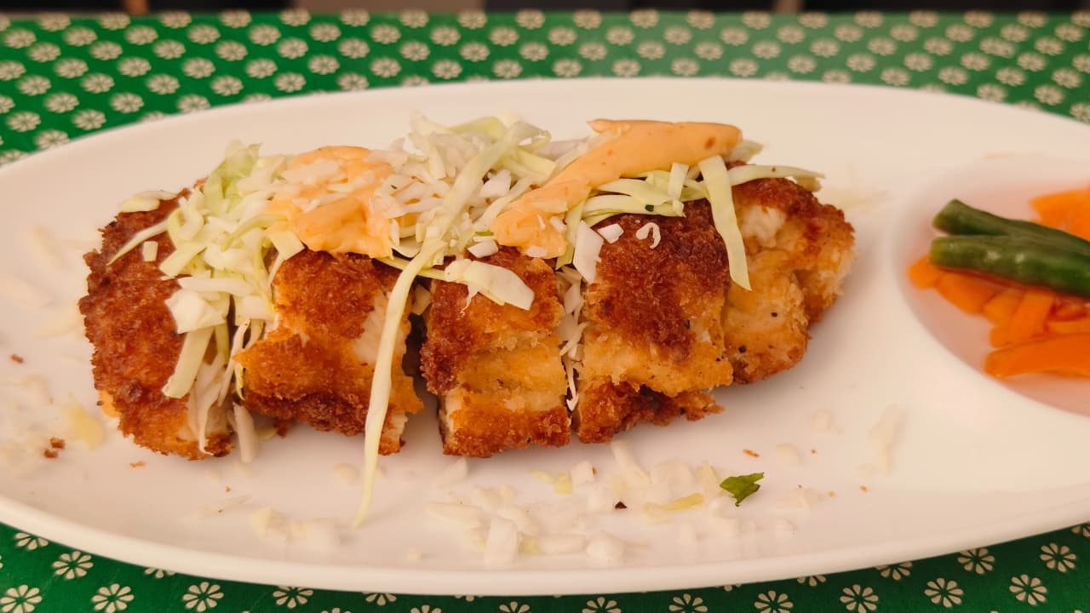
Chicken Cordon Bleu

