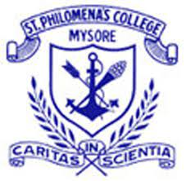
St. Philomena’s College (Autonomous), Mysore
3 days Induction Programme for the First Year First UndergraduateStudentsOrganized by the IQAC,29th June 2026– 1stJuly 2026, 09.30 AM to 12.30 PM
DEEKSHARAMBH - 2026
A Student Induction Programme

REPORT ON
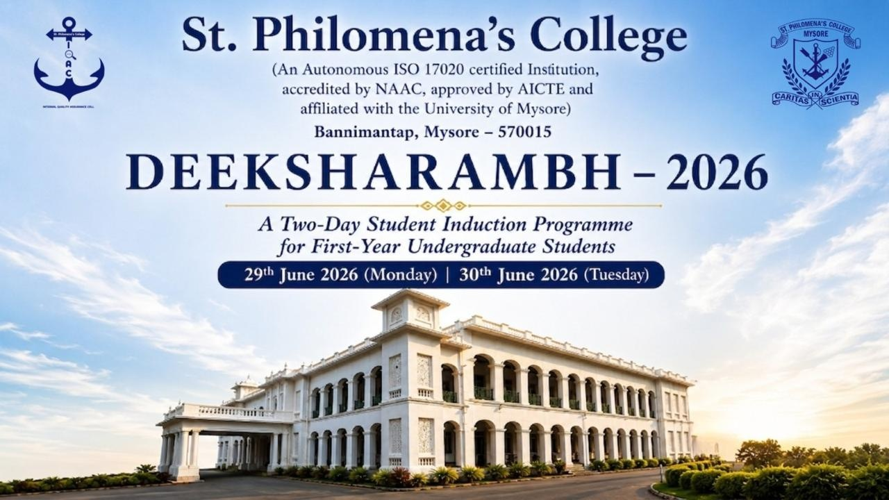

Event: “Deeksharambh" Orientation Program 2026

Place: College Indoor Stadium
DAY 1 – 29thJune 2026

Introduction
The Internal Quality Assurance Cell (IQAC) of St. Philomena's College (Autonomous), Mysuru, organized the first day of 'Deeksharambh–2026', a two-day Student Induction Programme for the newly admitted first-year undergraduate students on 29 June 2026. The programme was designed in accordance with the objectives of the State Education Policy (SEP) and UGC guidelines to provide students and their parents with a comprehensive understanding of the institution's academic environment, values, support systems, and opportunities for holistic development.
The induction programme brought together students, parents, faculty members, administrators, and invited dignitaries, creating a warm and welcoming atmosphere that reflected the institution's commitment to academic excellence, character formation, and value-based education.
Programme Proceedings
Registration and Welcome: 8:30 am
The programme commenced with the registration of newly admitted students and their parents at the entrance of the Indoor Stadium. Faculty members and volunteers welcomed the participants and guided them to the venue. The registration process ensured smooth attendance recording and distribution of necessary information.

Introduction and Opening Remarks: 9:30 am
The programme formally began with Dr. Deepa V., IQAC Co-Coordinator, serving as the Master of Ceremonies. She extended a warm welcome to the students, parents, dignitaries, and faculty members, describing the induction programme as the beginning of a meaningful academic journey. She emphasized that Deeksharambh was not merely an orientation programme but the foundation for students' intellectual, personal, and professional growth.

Philomena's Anthem: 9:35 am
The gathering stood in reverence as the Philomena's Anthem was rendered. The anthem reflected the spirit of unity, service, commitment, and institutional pride, creating an inspiring atmosphere for the commencement of the programme.

Prayer Service: 9:40 am
A solemn prayer service was led by Rev. Fr. Roshan S, Finance Officer, and Mr. Mathew C, Department of BSW, along with their team. The prayer invoked God's blessings upon the students, parents, faculty members, and the institution, seeking divine guidance, wisdom, strength, and success for the new academic year.

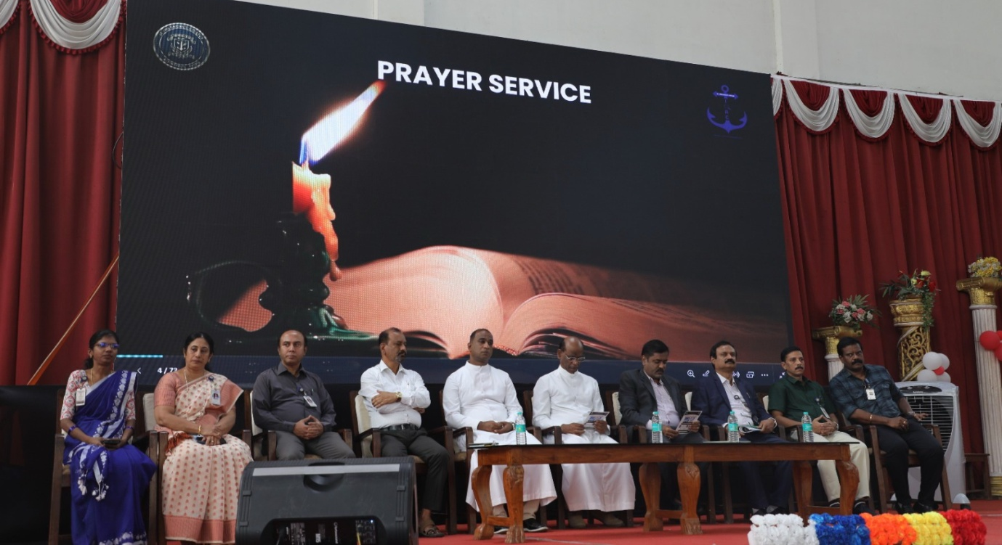
Inauguration by Lighting of the Lamp: 9:45 am
The programme was formally inaugurated with the ceremonial lighting of the lamp by:
- Rev. Dr. Lourdu Prasad Joseph, Rector
- Dr. Basavaraju R. Shreshta, Executive Director, GRAAM
The ceremonial lighting of the lamp symbolized the dispelling of ignorance through knowledge and marked the beginning of a new phase in the lives of the students.

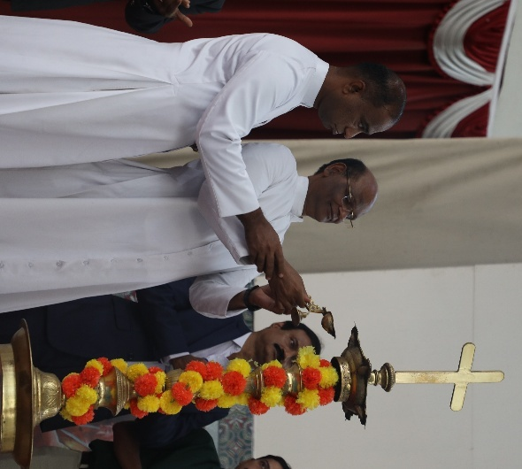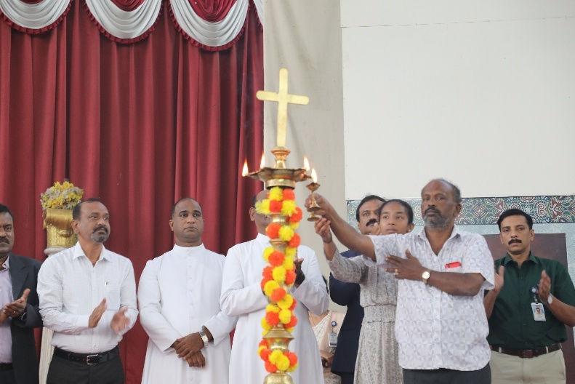

Welcome Address and Institutional Briefing: 9:50 am
Dr. Ravi J. D. Saldanha, Principal, welcomed the gathering and described St. Philomena's College as a "Temple of Learning" with an illustrious legacy of nearly eighty years.
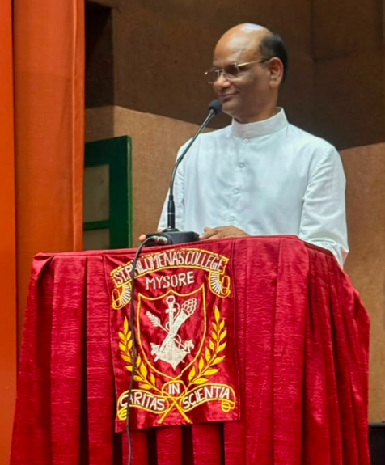
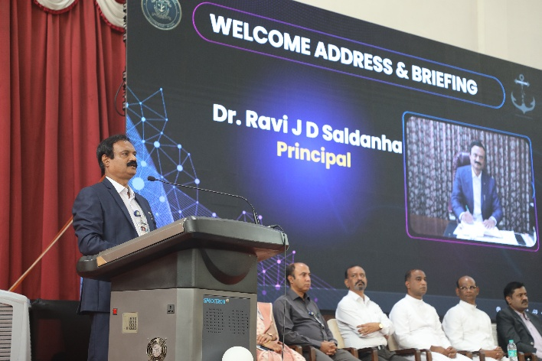
He introduced students and parents to the institution's vision, mission, academic excellence, discipline, and value-based education. He explained the academic regulations, UGC guidelines, attendance requirements, examination system, code of conduct, and opportunities available for students in academics, sports, cultural activities, research, extension programmes, NSS, NCC, clubs, and student forums.The Principal encouraged students to remain disciplined, responsible, and committed to continuous learning while making effective use of the resources and opportunities provided by the college.
Rector's Message: 10:10 am

Rev. Dr. Lourdu Prasad Joseph, Rector, addressed the gathering and expressed heartfelt gratitude to the parents for placing their trust in the institution.He assured the parents that the college remains committed to nurturing students through academic excellence, discipline, moral values, leadership, and personality development. He emphasized the importance of close collaboration between parents and teachers in shaping responsible citizens and urged students to uphold honesty, compassion, integrity, and social responsibility throughout their academic journey.
Introduction of the Chief Guest: 10:15 am
The profile of the Chief Guest, Dr. Basavaraju R. Shreshta, Executive Director, GRAAM (Grassroots Research and Advocacy Movement), Mysuru, was introduced by Ms. Kavitha R, Department of B. Com, highlighting his contributions towards community development, grassroots governance, research, leadership, and social transformation.
Felicitation of the Chief Guest: 10:20 am
The Chief Guest was felicitated by the dignitaries as a mark of respect and appreciation for his distinguished contribution to society and his acceptance of the invitation to address the students.
Vote of Thanks: 10:25 am
Mr. A. Thomas Gunaseelan, IQAC Coordinator, proposed the Vote of Thanks, expressing gratitude to the management, Rector, Principal, Chief Guest, dignitaries, faculty members, organizing committee, parents, and students for making the inaugural session successful.
Inaugural Address by the Chief Guest: 10:30 am
Delivering the inaugural address, Dr. Basavaraju R. Shreshta began with an inspiring story and encouraged students to make meaningful use of their three-year undergraduate journey.
He emphasized the importance of embracing diversity, adapting to challenges, developing leadership qualities, and cultivating the values of Aspiration, Inspiration, and Motivation (AIM). He advised students to build a strong academic foundation, learn from their parents and teachers, work collaboratively, develop civic consciousness, and contribute positively to society. His motivational address inspired students to pursue excellence with dedication, integrity, and social commitment.
Tea Break: 11:00 am
A short tea break was arranged for students, parents, dignitaries, and faculty members, providing an opportunity for informal interaction and networking.

College Documentary: 11:10 am
A documentary highlighting the 80-year journey of St. Philomena's College was screened.
The presentation showcased the institution's rich history, academic achievements, infrastructure, research initiatives, student accomplishments, placements, extension activities, sports achievements, cultural programmes, and community engagement, giving the newcomers a comprehensive overview of the institution.

Inspiring Journey: Alumni Testimonials: 11:25 am
Successful alumni shared their academic and professional journeys, motivating the students to utilize every opportunity available in the college. Their experiences inspired the newcomers to dream big, remain committed to learning, and strive for excellence.

ERP and Attendance Monitoring: 11:35 am
Mr. Roshan Roy D'Souza, Department of MCA, introduced students to the ERP system and demonstrated the digital attendance monitoring process. Students were informed about accessing attendance records, academic information, and institutional digital services through the ERP portal.

Examination and Evaluation System: 11:50 am
The session was a talk about the examination section by Dr. Reena Francis, head and dean of Commerce, Controller of examination, who gave us an insight about the examination pattern and the responsibility every student should have the examination pattern for C1 and C2 will be internal assessment, carried out at the department level, each carrying 10 marks. For the first batch of students the internal assessment will be of 20 marks, and the end-semester examination will be for 80 marks. Various activities like test assignments, quizzes, group discussions, and more will be decided by the teacher, with deadlines for submission or presentation in order to earn more marks. Additionally, the highest scorers of every class will receive ranks. The controller of examination also mentioned that there is a provision for repeating the C3 assessment, as C1 &amp; C2 cannot be repeated. There will be no score for the story, as the marks will be submitted to the examination section. Updates about the revaluation rules will be provided later. The speech concluded by dividing all the set time along with the location of the examination section. This comprehensive examination pattern aims to provide a fair and thorough assessment of students and knowledge and skills in the respective subjects.
UUCMS and ABC ID Orientation: 12:05 pm
Ms. Lydia Anjali A, UUCMS Coordinator, guided students through the UUCMS portal and Academic Bank of Credits (ABC ID) registration process. She explained the significance of digital academic records, credit accumulation, and online academic management under the higher education framework.
Academics and Curriculum Overview: 12:10 pm
Mr. Anand C, Dean of Academics, presented an overview of the curriculum structure under the semester system. He explained the Choice Based Credit System (CBCS), multidisciplinary learning, electives, skill enhancement courses, value-added programmes, and academic flexibility available to students.
Career Guidance and Placement Cell: 12:20 pm
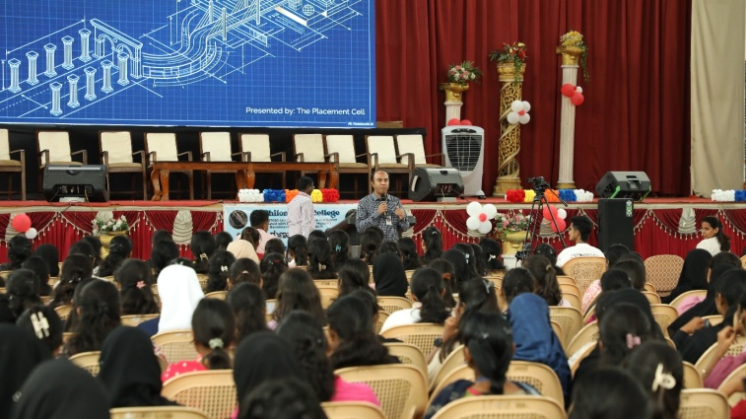
Mr. Ronald Prakash Cutinha, Vice Principal (Administration), introduced the Career Guidance and Placement Cell. He highlighted internship opportunities, industry collaborations, skill certification programmes, placement training, career counselling, and campus recruitment initiatives available to students from the first year onwards.

Special Presentation by SR Indian IAS Academy: 12:25 pm
Mr. Patel S. Ramesh Gowda, representing SR Indian IAS Academy, delivered a special presentation introducing students to Civil Services preparation. He motivated students to cultivate leadership qualities, develop a service-oriented mindset, and prepare for competitive examinations through systematic planning and disciplined learning.

Instructions and Open Forum: 12:32 pm
Academic heads addressed students and parents, providing important academic and administrative instructions. An interactive Open Forum allowed participants to seek clarifications regarding admissions, academics, examinations, attendance, student support services, scholarships, placements, and campus facilities.
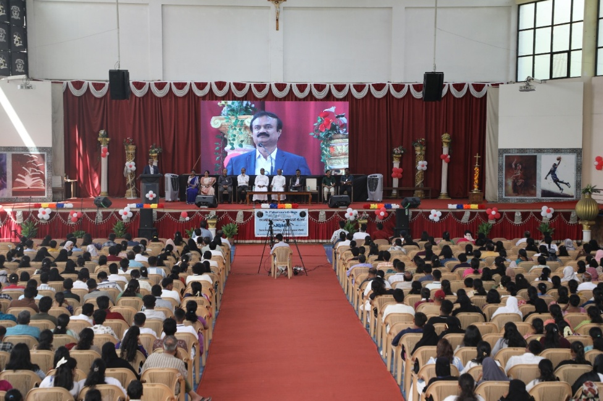
Closing Remarks: 12:45 pm
The Master of Ceremonies concluded the first day's programme by expressing gratitude to the management, dignitaries, faculty members, parents, and students. Participants were invited to attend the second day of Deeksharambh on 30 June 2026, after which the programme concluded with the National Anthem.
The National Anthem was played at 12:45 PM, concluding the day's formal programme.

Instructions and an AAD (Avoid Any Doubt) session were held at 12:32 PM, guiding students on queries and clarifications.

DAY 2 – 30th June- 2026
Introduction
The second day of Deeksharambh–2026, the two-day Student Induction Programme organized by the Internal Quality Assurance Cell (IQAC), was conducted on 30 June 2026 with the theme "Exploring Your Curriculum & Campus." The sessions were designed to equip newly admitted undergraduate students with essential life skills, emotional resilience, social responsibility, and awareness of contemporary issues beyond academics. The programme aimed to help students confidently transition into college life while fostering responsible citizenship and holistic development.

Programme Proceedings
Registration and Attendance: 9:30 am
The second day's programme commenced with the registration and attendance of first-year undergraduate students. Faculty members and volunteers welcomed the students and ensured smooth coordination of the programme.
Compering (MC): 9:45 am
The programme was compered by Ms. Priyanka Olivera, Department of BBA, who warmly welcomed the gathering and introduced the objectives of the second day's sessions. She briefed the students about the day's schedule and encouraged them to actively participate in the interactive programmes.

Welcome and Briefing: 9:55 am
Ms. Supritha R, Assistant Professor, Department of B. Com, welcomed the students and presented a brief overview of the day's activities. She emphasized that the induction programme was intended to prepare students not only for academic excellence but also for personal growth, leadership, and responsible citizenship.
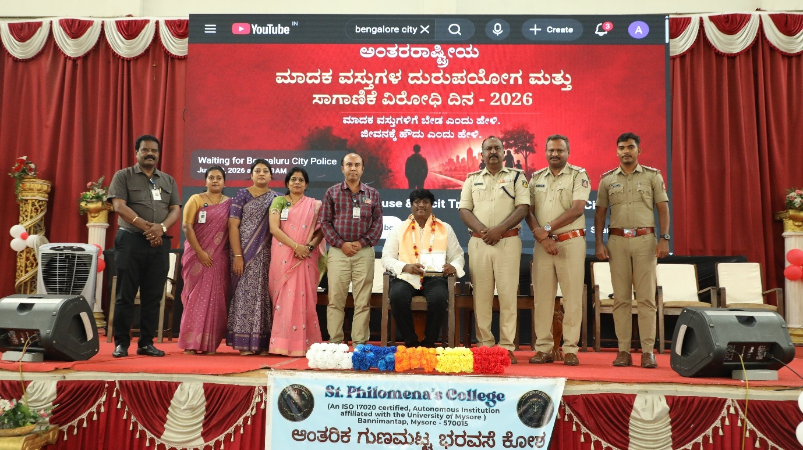
Motivational Session: Beyond Academics - Building Life Skills: 10:00 am
The highlight of the day was an inspiring motivational session by Dr. Niranjana Babu H.S, renowned psychologist, Associate Professor, Head of the Department of Commerce, PG Centre, Maharani's Commerce College, Mysuru.
Dr. Niranjana Babu delivered an engaging and interactive session focusing on personality development, emotional well-being, positive thinking, self-confidence, effective communication, stress management, and interpersonal relationships. He encouraged students to develop a positive attitude, believe in their abilities, and cultivate discipline, empathy, and resilience in their personal and academic lives.Through practical examples, motivational stories, humor, and interactive discussions, he highlighted that true success extends beyond academic achievement and depends on emotional intelligence, adaptability, ethical values, and continuous self-improvement. His lively interaction with students created an enthusiastic learning atmosphere, and the session received an overwhelming response from both students and faculty members.
Drug Abuse Prevention Awareness Program
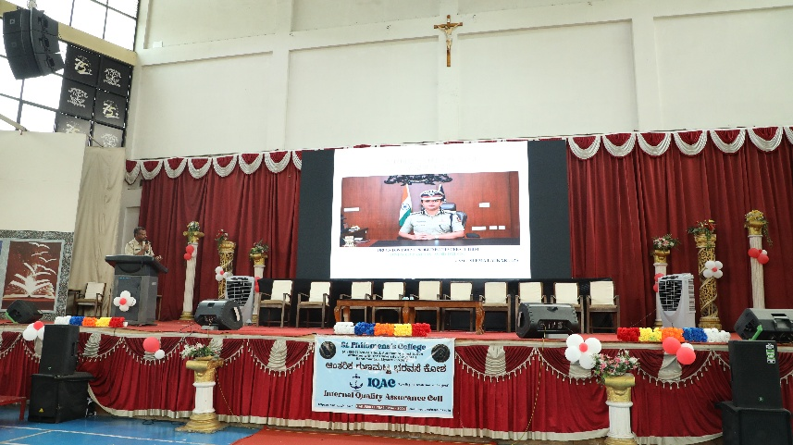
As part of the student induction program, a Drug Abuse Prevention Awareness Session was organized in collaboration with the Mysore City Police to sensitize students about the growing social menace of substance abuse.
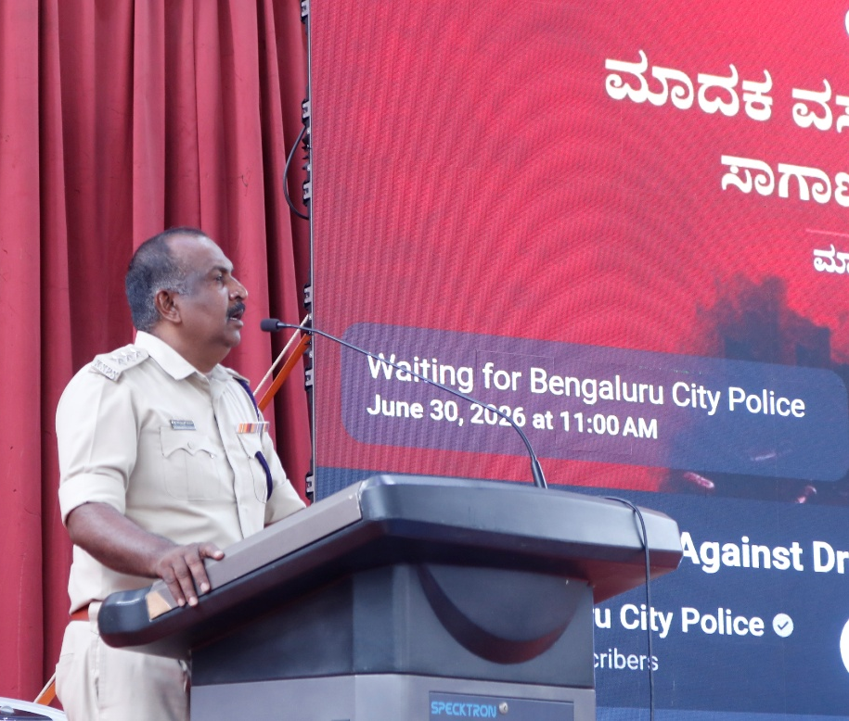
ACP Mathew Thomas addressed the students on the importance of making informed choices and maintaining a drug-free lifestyle. He explained the physical, psychological, social, and legal consequences of substance abuse and urged students to remain vigilant against peer pressure and negative influences. He encouraged them to become responsible citizens and actively contribute towards building a drug-free campus and society.
Inspector Raju elaborated on the legal implications of drug-related offences and educated students about the provisions of law, legal penalties, and the importance of respecting the law while safeguarding their future.
The awareness programme created a strong sense of social responsibility among students and emphasized the collective role of educational institutions, families, law enforcement agencies, and society in preventing substance abuse among youth.
The successful conduct of the awareness programme was supported by Mr. Ajay Anthony, Ms. Priyanka Olivera, Ms. Kavitha R., Ms. Mirium Priscilla, Mr. John Joseph, and Mr. Raviraj I. Vadigeri, who coordinated the event effectively.
Student Interaction
Throughout the programme, students actively participated in discussions, asked questions, and interacted with the resource persons. The sessions encouraged self-reflection, confidence building, and awareness about personal responsibility, healthy lifestyles, and informed decision-making.
The interactive format enabled students to express their thoughts freely while gaining valuable insights into managing academic pressures, emotional well-being, communication skills, and responsible social behaviour.
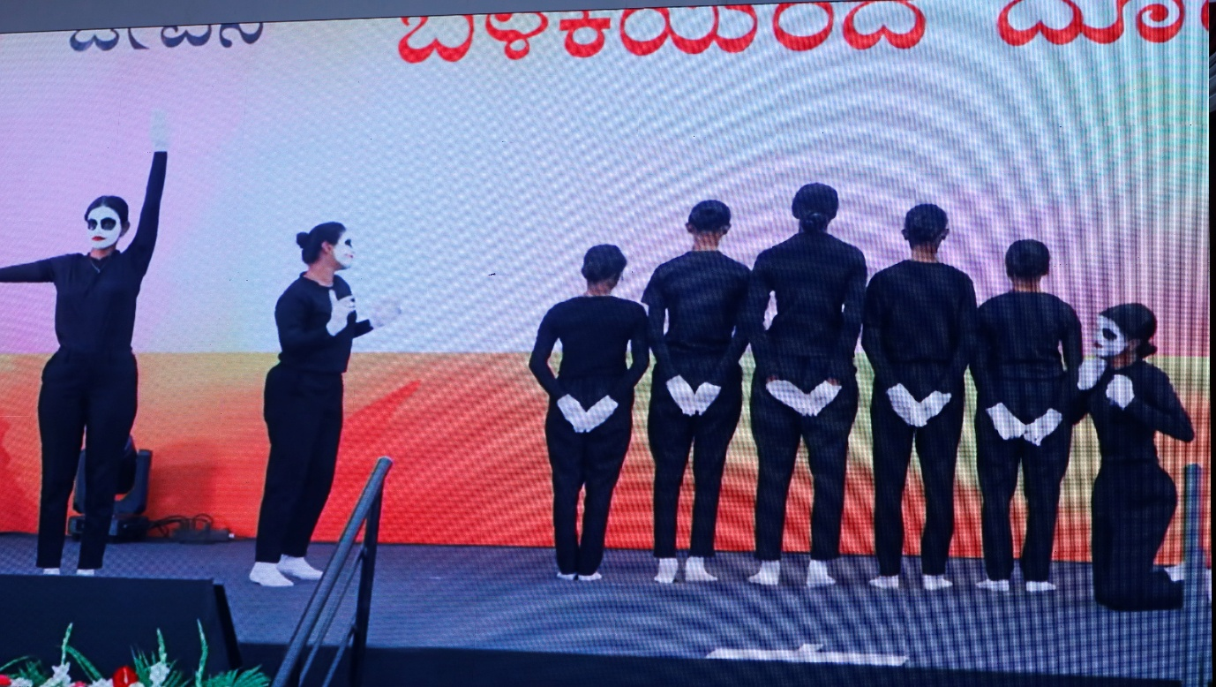
DAY 3 – 1st July- 2026
Introduction
The third and final day of Deeksharambh, 2026, the Student Induction Programme organized by the Internal Quality Assurance Cell (IQAC), was held on 01 July 2026 with the objective of familiarizing newly admitted undergraduate students with the various student support services, career opportunities, co-curricular activities, extension programmes, and campus facilities available at the institution. The sessions encouraged students to actively participate in academic, cultural, social, and leadership activities for their holistic development.

Programme Proceedings
Registration and Attendance: 9:30 am
The programme commenced with the registration and attendance of first-year undergraduate students. Faculty members welcomed the students and ensured the smooth conduct of the day's programme.

Compering (MC): 9:45 am
The programme was compered by Ms. Kavitha R., Department of B. Com, who welcomed the gathering and briefly recapped the previous two days of the induction programme. She introduced the day's sessions and encouraged students to make the most of the opportunities available throughout their college life.
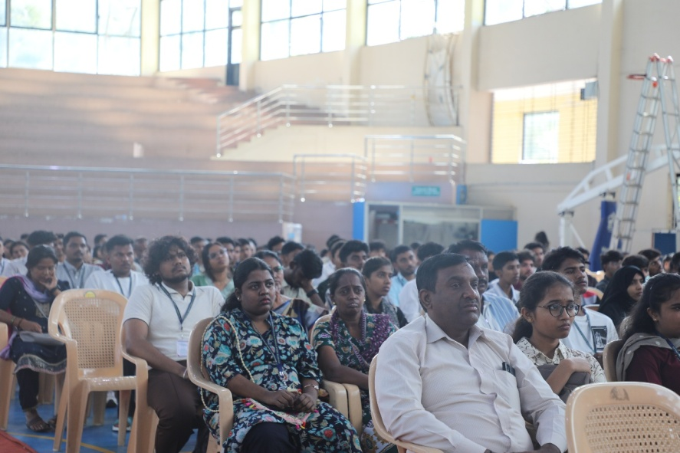

Career Guidance and Placement Cell: 10:00 am
Mr. Ronald Prakash Cutinha, Vice Principal (Administration) and Librarian, introduced the activities of the Career Guidance and Placement Cell. He explained the importance of internships, industry collaborations, skill development programmes, certification courses, placement training, and campus recruitment initiatives.
He motivated students to begin preparing for their careers from the first year itself by developing employability skills, communication abilities, leadership qualities, and professional ethics. The session also highlighted the services offered by the College Library, encouraging students to cultivate reading habits and utilize the library's extensive learning resources for academic excellence and lifelong learning.
A video presentation showcasing the activities and achievements of the library during the academic year 2025-2026 was screened, giving students an overview of the library facilities, digital resources, reading initiatives, and student engagement programmes.
Mentoring and Personal Growth System: 10:20 am
Dr. Florita Bernadette Alexander explained the institution's Mentoring and Personal Growth System, highlighting the mentor-mentee concept adopted by the college. She emphasised that every student would receive continuous academic guidance, personal counselling, and emotional support through regular interactions with faculty mentors, ensuring holistic development throughout their undergraduate programme.
Cultural Activities and Philo's Fest: 10:30 am
Dr. Deepa V. introduced the various cultural activities organized by the institution, including Philo's Fest, intercollegiate competitions, literary events, cultural festivals, and student talent platforms. She encouraged students to actively participate in cultural programmes to develop creativity, confidence, teamwork, leadership, and communication skills alongside academic learning.

Competitive Examinations Cell: 10:40 am
Dr. Poornima A.P., Coordinator, Competitive Examinations Cell, provided students with detailed information about coaching and guidance available for various competitive examinations, including UPSC, KAS, NET, GATE, Banking, SSC, and other government recruitment examinations.She encouraged students to develop a competitive spirit from the beginning of their academic journey and explained the support provided by the college through coaching classes, study materials, orientation programmes, and career guidance.
NSS, NCC, Youth Red Cross and Rovers & Rangers Showcase: 10:50 am

NSS Orientation – By Mr. Johnson Arulraj L, Dept. of English. NCC Introduction – By Sub Lt. Eliezer Vishwas (Naval Wing), Department of Physics, Associate NCC Officer and Lt. b. Francis Devasahayam, Associate NCC Officer, 16 KAR BN, NCC, from the Departments of criminology and Forensic Science respectively.
An awareness session on National Service Scheme (NSS) and National Cadet Corps (NCC) -Briefly Introduce NSS and NCC programs and explain its benefits and opportunities also Encourage student participation.The session successfully informed students about NSS and NCC, highlighting the benefits and opportunities available through these programsby Mr. Johnson Arulraj L, Mr. Francis Devasahayam B. (Artillery Battery)& By Sub Lt. Eliezer Vishwas (Naval Wing).
Dr. Sowmya and Mr. Mathew C, Rover Scout Leader, briefly discussed the importance and applications of Rangers and Rovers in various fields such as exploration. He Presented the Ranger and Rover units to the students and explained the key components and functionalities of each unit. Students were actively engaging and showing a keen interest in the operation of the Rangers and Rovers. Participants gained practical insights and felt more confident in handling the equipment.
Ms. Deepthi,Youth Red Cross (YRC) Coordinator, explained Studentsabout community service programmes, health awareness campaigns, blood donation drives, environmental initiatives, special camps, leadership training, social outreach activities, disaster management programmes, personality development camps, and opportunities for national-level participation.
The coordinators also highlighted the benefits of joining these units in developing discipline, leadership, patriotism, social responsibility, teamwork, and self-confidence.
As part of the session, a video presentation showcasing the major activities, achievements, camps, outreach programmes, and accomplishments of the NSS Unit during the academic year 2025- 2026 was screened. The presentation inspired students to actively participate in extension activities and community engagement initiatives.
Sports and Physical Education: 11:20 am
Ms. Peria Nayagamma S, Physical Education Director, introduced students to the sports facilities, fitness programmes, yoga activities, coaching opportunities, and various indoor and outdoor games available on campus.
She encouraged students to maintain physical fitness, participate in sports competitions, and represent the institution at university, state, and national levels, emphasizing that sports play an important role in discipline, teamwork, and overall personality development.

Vote of Thanks: 11:30 am
The Vote of Thanks was delivered by Mr. William Joseph, Department of English, who expressed sincere gratitude to the Management, Rector, Principal, IQAC, resource persons, faculty members, organizing committee, supporting staff, and students for their enthusiastic participation and cooperation throughout the three-day induction programme.

National Anthem: 11:35 am
The programme observed the National Anthem, reaffirming the spirit of patriotism, unity, and respect for the nation.
Instructions and Open Forum: 11:37 am
Academic Heads interacted with the students and clarified their queries regarding academics, campus facilities, examinations, student support services, and departmental activities. The interactive session enabled students to seek clarification and gain confidence before beginning their academic journey.
Campus Tour: 11:45 am
The induction programme concluded with a guided campus tour led by Mr. Arvind Kiscota and Dr. Sunil D'Souza. Students were taken around the campus and introduced to the academic blocks, classrooms, laboratories, library, examination section, administrative offices, indoor stadium, sports facilities, chapel, auditorium, student support centers, and other important infrastructure.
The campus visitsfamiliarized students with the institutional environment and helped them gain a better understanding of the facilities and resources available for their academic and personal development.
Overall Outcomes of Deeksharambh- 2026
- The programme provided a warm and meaningful welcome, helping students and parents understand the institution's vision, values, and academic culture.
- Students gained a clear understanding of the curriculum, academic regulations, examination system, UUCMS, ERP, and other institutional processes.
- Motivational and life-skill sessions inspired students to develop confidence, positive thinking, effective communication, and leadership qualities.
- Career guidance sessions created awareness about internships, placements, competitive examinations, higher education, and future career opportunities.
- Students were encouraged to actively participate in cultural activities, sports, research, clubs, and extension programmes for their overall development.
- Awareness programmes promoted social responsibility, ethical values, healthy living, and a commitment to building a drug-free campus.
- The campus tour and orientation to various student support services helped students become familiar with the college facilities and resources.
- Overall, the three-day induction programme enabled students to begin their academic journey with confidence, enthusiasm, and a strong sense of belonging to the institution.

Media coverage
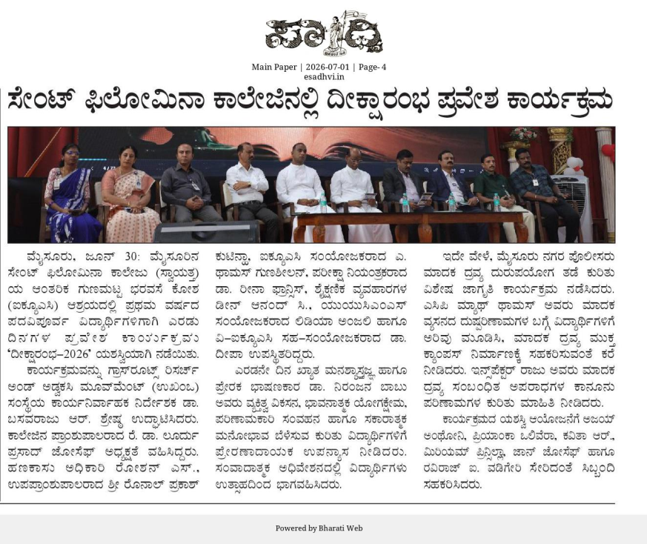https://publicalertnews.com/jillasuddi-mysuru-182/
Documentation In-charge:

Prepared by: Dr.Yamuna.B.Raj
Assistant Professor, Department of Journalism and Mass Communication
St. Philomena’s College (Autonomous), Mysuru
And
Dr.Florita Bernadetie Alexander
Assistant Professor, Department of Commerce
St. Philomena’s College (Autonomous), Mysuru

Date: 2nd July - 2026

