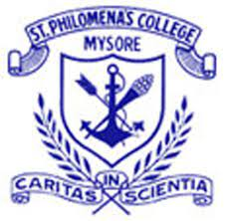
St. Philomena’s College
(Autonomous), Mysore-15

SIX - Day Faculty Development Programme
for the faculty members of UG & PG programmes
Organized by the IQAC

A REPORT ON
THE SIX-DAY FACULTY DEVELOPMENT PROGRAMME (FDP) ON

“Empowering Educators : Advanced Research Methodologies and Strategies for
High – Impact Publications”

DATE: ON 06th January 2025 – 11th January -2025
TIME - 02.00 PM to 04.30 PM

A REPORT ON THE SIX-DAY FACULTY DEVELOPMENT PROGRAMME (FDP) ON “Empowering Educators: Advanced Research Methodologies and Strategies for High – Impact Publications”

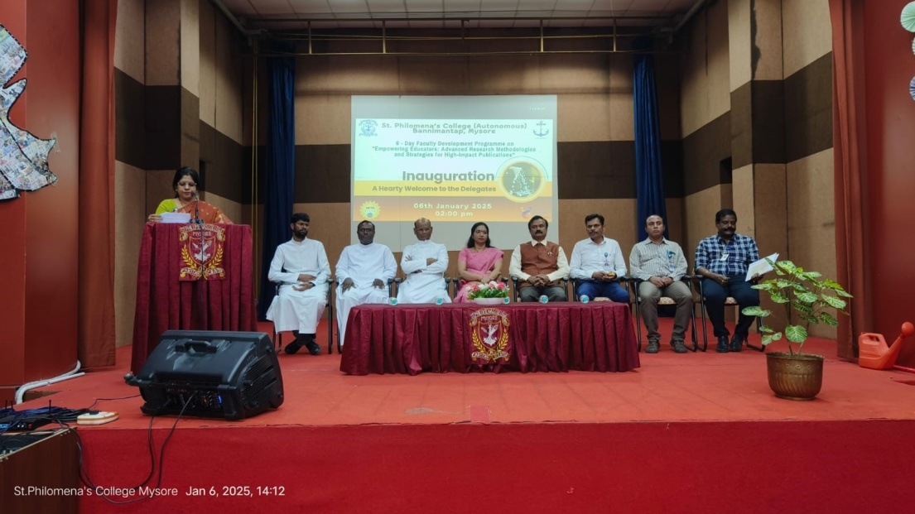
This report is submitted to present the details of the six - day FDP programme organized by the IQAC – Internal Quality Assurance Cell on 06th January to 11th January 2025, held in our college Auditorium.
The one week long FDP programme provided participants a comprehensive understanding of Research Methodology: Tools & Techniques and specially designed initiative aimed at equipping higher education teachers with the knowledge and skills required to excel in research and academic publishing. This programme was designed to be generic in nature for satisfying the needs of faculty pursuing their PhDs from academic institutions to provide them insights into cutting- edge research methodologies, data collection, design of experiments and statistical tools for analyzing data, strategies for crafting compelling manuscripts for top-tier journals also about the oral and written communication of research and dissemination the research outcome.
All the Research Scholars and academicians from different departments of the Undergraduate and Postgraduate programmes of St.Philomena’s College (Autonomous), Mysore attended the FDP programme.

- Improve Research skills.
- To acquaint the participants about various software packages and tools available for simulation and data analysis.
- To improve publication outcomes and empower educators.
- To encourage networking and collaboration among educators to promote interdisciplinary research.
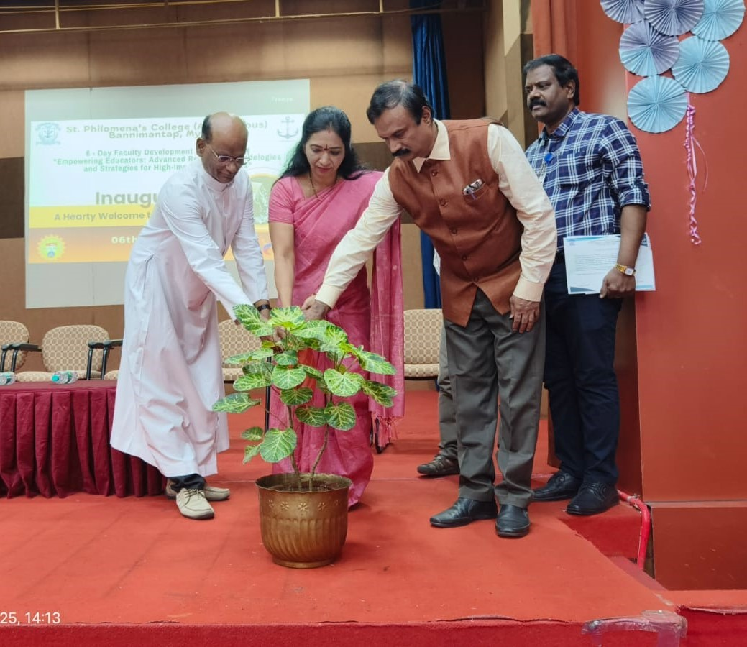
The Faculty Development Programme (FDP) commenced with an inaugural session organized by the Internal Quality Assurance Cell (IQAC), was conducted at the college auditorium. Dr. Deepa V, Co-coordinator, IQAC, Assistant Professor, Department of BBA, had played the role of Master of ceremony. The official inauguration was symbolized by watering of saplings – To Nurture the Growth of Faculty members by the Guest of Honor and the Speaker, Prof. Dr. Krishnaveni, Professor, Department of Studies in Physics, University Of Mysore, Rev. Dr. Lourdu Prasad Joseph, Rector, and Rev.Fr. Gnanapragasam, Administrator, Rev.Fr.David Sagayaraj S, Assistant to Rector, Dr.Ravi J D Saldanha. Principal, Mr. M. Nagaraj Urs, Vice Principal (Administration), Mr. Ronald Prakash Cutinha, Vice Principal (Administration), Mr. A. Thomas Gunaseelan, Coordinator, IQAC.

Mr. A. Thomas Gunaseelan, Coordinator, IQAC, delivered the welcome speech, setting the tone for the event.

The Rector - Rev. Dr. Lourdu Prasad Joseph delivered the inaugural address, welcoming participants to the FDP Programme. Emphasizing the importance of higher education, the Rector highlighted the need for innovative methodologies. The address also acknowledged the efforts of the Internal Quality Assurance Cell (IQAC) in organizing the event.

Dr. Sunil D'Soza, ICT Coordinator, Assistant Professor, Department of B’Com, introduced the speaker, paving the way for the FDP's academic sessions.

DAY 1 – 06.01.2025
SESSION: 1
RESOURCE PERSON: Prof. Dr. Krishnaveni, Professor, Department of Studies in Physics, and University of Mysore.
TOPIC: “Research Foundations and Literature Review”
Salient features: Introduction to Research Paradigms
*Identifying Gaps and framing Research questions
*tools for literature review (zotero, mendeley, etc).

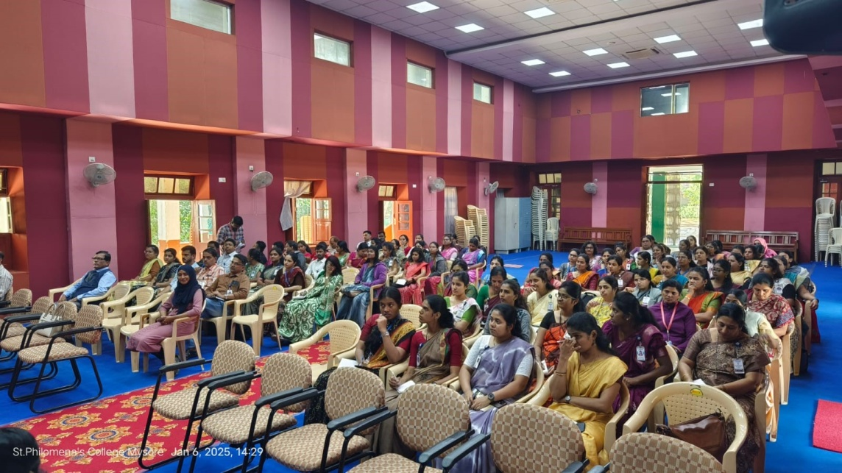

On day 1, Prof. Dr. Krishnaveni, delivered session on introduction to research basics of research, objectives of research, scientific approach of research, significance of research, scope of research, various steps in conducting a research, various phases of research funding, research methodology etc. Prof. Dr. Krishnaveni discussed about how one can use efficiently scientific language of writing. Also gave information about Classification and Research foundation. Prof. Dr. Krishnaveni emphasized on theoretical framework, problem statement and objectives of research and Tools like Zotero and Mendeley are introduced to help manage references and streamline the literature review process. These tools simplify organizing large volumes of academic papers and citations, which are crucial for impactful research.

DAY 2 – 07.01.2025
SESSION: 2
RESOURCE PERSON: DR. MOHAMMED MINHAJ, DEAN- ACADEMICS, SDMIMD, MYSORE.
TOPIC: “HARNESSING AI FOR ADVANCING RESEARCH PRACTICES”
Salient features: ACCELERATING LITERATURE REVIEW AND MANAGEMENT RESEARCH DATA
*AI IN ADDRESSING PLAGIARISM AND AI ENHANCEDANALYSIS AND VISUALIZATION
*REFERENCES AND CITATIONS- MANAGEMENT.
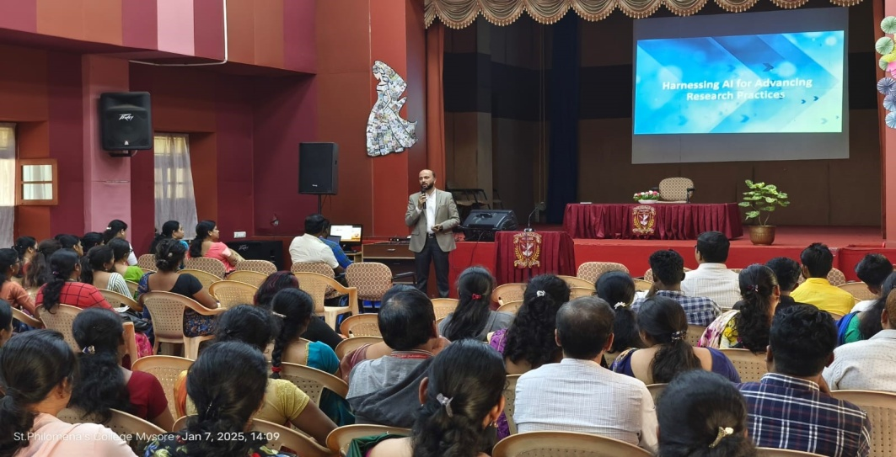
On day 2, DR. MOHAMMED MINHAJ, delivered session on the use of Artificial Intelligence (AI) in research is emphasized as a modern necessity. AI can: Automate literature reviews. DR. MOHAMMED MINHAJ discussed about how one can use efficiently Detect and prevent plagiarism, Assist in data analysis and visualization. Participants learn how to integrate AI tools effectively into their research processes, which not only saves time but also improves the quality and accuracy of their work.

DAY 3 – 08.01.2025
SESSION: 3
RESOURCE PERSON: DR. HARSHA, CHAIRMAN, DEPARTMENT OF ENVIRONMENTAL SCIENCE, DIRECTOR (R&D) AND SPECIAL OFFICER –PHD CELL, KSOU, MYSORE.
TOPIC: “FUTURE RESEARCH DIRECTIONS AND COLLABORATION”
Salient features: EXPLORING INTE4RDISCIPLINARY AND COLLABORATIVE RESERCH OPPORTUNITIES
*EMERGING TRENDS IN ACADEMIC RESEARCH
*BEST PRACTICES FOR SUSTAINING RESEARCH PRODUCTIVITY.
On day 3, DR. HARSHA, delivered session on This session prepares participants for future challenges and opportunities in academia:Emphasis is placed on interdisciplinary research, which fosters innovation by combining knowledge from different fields.
DR. HARSHA discussed about how one can use efficiently scientific Insights into emerging trends such as sustainability, technology-driven studies, and data-driven decision-making are shared. Strategies for building collaborations across institutions and disciplines are explored to enhance the reach and impact of research.

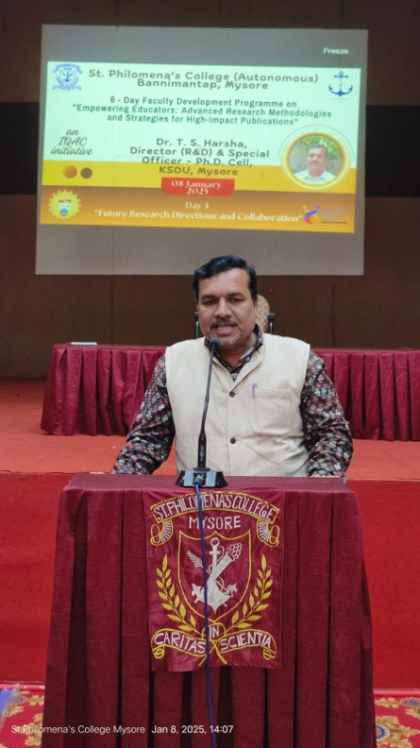
DAY 4 – 09.01.2025
SESSION: 4
RESOURCE PERSON: PROF. DR. G.S. PREMAKUMARA, PROFESSOR, DOS IN ECONOMICS, SIR MV PG CENTRE, UOM, TUBINAKERE, MANDYA.
TOPIC: “RESEARCH METHODOLOGY AND DESIGN”
Salient features: UNDERSTANDING THE ANATOMY OF A RESEARCH PAPER
*WRITING EFFECTIVE ABSTRACTS, INTRODUCTIONS AND DISCUSSION
*MANAGING REFERENCE AND AVOIDING PLAGIARISM.

On day 4, PROF. DR. G.S. PREMAKUMARA, delivered session on Structuring and Writing a Research Paper Writing a well-structured research paper is essential for publication in reputed journals. This session helps participants: Understand the anatomy of a paper (e.g., abstract, introduction, methodology, results, and discussion). PROF. DR. G.S. PREMAKUMARA emphasized on Develop skills for writing clear and compelling abstracts, cohesive discussions, and concise conclusions. Address common issues such as plagiarism and manage references using citation software

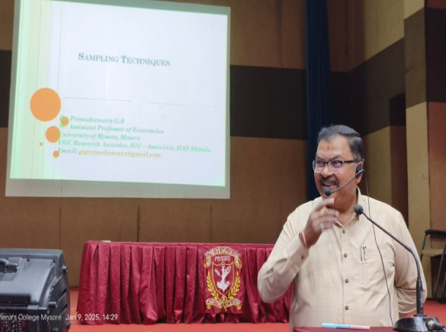

DAY 5 – 10.01.2025
SESSION:5
RESOURCE PERSON: DR.VASANTHA RAJU N, PRINCIPAL ( INCHARGE ) & LIBRARIAN, GFGC, TALAKADU, MYSORE.
TOPIC: “PUBLICATION ETHICS AND NEW SCHOLARLY PUBLISING MODELS”
Salient features: HOW TO CHOOSE THE RIGHT JOURNAL (SCOPUS, WEB OF SCIENCE, UGC CARE)
*NAVIGATING THE PEER REVIEW PROCESS
*STRATEGIES FOR ENHANCING ACCEPTANCE RATES.

On day 5, DR.VASANTHA RAJU N , delivered session on Publication Ethics and Scholarly Publishing Models. This session focuses on ethical research and selecting the right platforms for publication. Topics include: Guidelines for identifying credible journals indexed in Scopus, Web of Science, or UGC CARE.
DR.VASANTHA RAJU N emphasized on Understanding predatory journals and avoiding unethical publishing practices. Strategies for navigating the peer-review process and increasing acceptance rates.

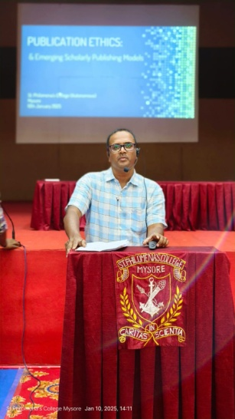

DAY 6 – 11.01.2025
SESSION: 6
RESOURCE PERSON: PROF. DR. LANCY D’SOUZA, PROFESSOR AND HEAD, DOS IN PSYCHOLOGY, MAHARAJA’S COLLEGE, MYSORE
TOPIC: “DATA COLLECTION AND ANALYSIS”
Salient features: SELECTING AND USING STAISTICAL TOOLS (SPSS, R, ETC)
*QUALITATIVE DATA ANALYSIS TECHNIQUES (THEMATIC ANALYSIS, NVIVO)
*DATA VISUALIZATION FOR RESEARCH PRESENTATION.
On day 6, PROF. DR. LANCY D’SOUZA, delivered session on Data Collection and Analysis. This session provides hands-on training in collecting, analyzing, and presenting data effectively. Statistical tools like SPSS and R are introduced to analyze quantitative data.
PROF. DR. LANCY D’SOUZA emphasized on Qualitative analysis methods, such as thematic analysis using NVivo, is taught. Participants also learn data visualization techniques to enhance the impact of research presentations.

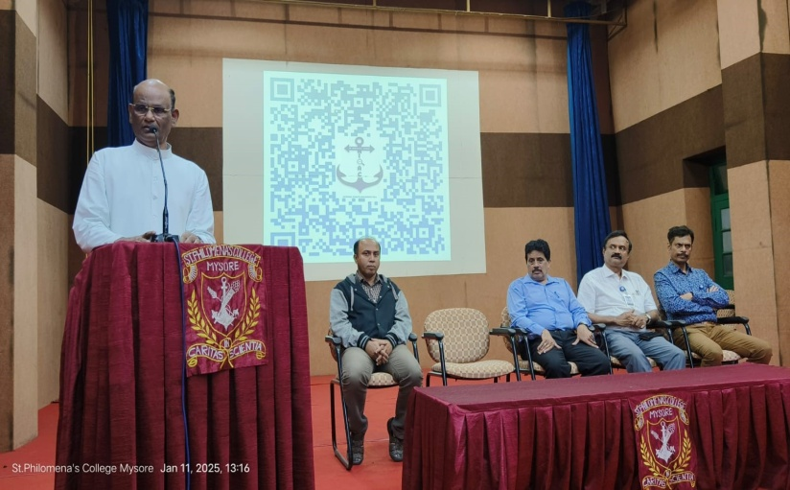

1. Improved research skills and competencies.
2. Enhanced understanding of research methodologies and innovations.
3. Effective integration of technology in research.
4. Contribution to the development of high- impact research.

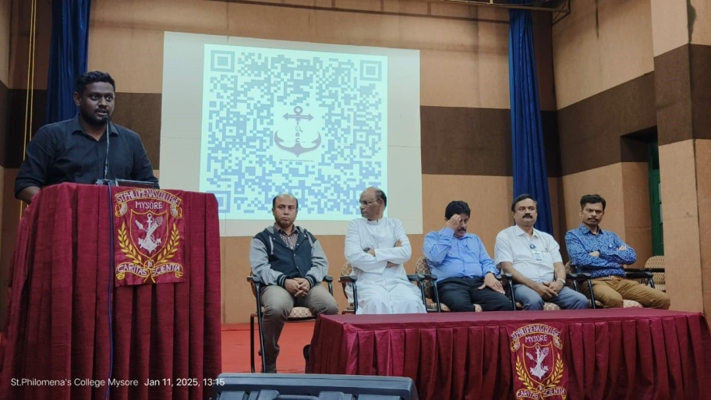
The FDP was concluded with valedictory function on 11th January, 2025. In the Valedictory session, Prof. Dr. Lancy D’Souza, Professor and Head, DOS in Psychology, Maharaja’s College, Mysore, Rev. Dr. Lourdu Prasad Joseph, Rector, and Rev.Fr. Gnanapragasam, Administrator, Rev.Fr.David Sagayaraj S, Assistant to Rector, Dr.Ravi J D Saldanha. Principal, Mr. M. Nagaraj Urs, Vice Principal (Administration), Mr. Ronald Prakash Cutinha, Vice Principal (Administration), Mr. A. Thomas Gunaseelan, Coordinator, IQAC, Dr. Deepa V, Co-coordinator, IQAC, Assistant Professor, Department of BBA, were present. Mr.William Joseph, Assistant Professor, Head, Department of English, had played the role of Master of ceremony. The welcome speech was given by Rev.Sr.Angeline Vimal, Assistant Professor, Department of English and The valedictory speech was given by Rev. Dr. Lourdu Prasad Joseph, Rector, congratulated the Coordinators and Organizing Committee for successfully conducting FDP, he also appreciated the FDP theme. The vote of thanks was given Dr. Deepa V, Co-coordinator, IQAC, Assistant Professor, Department of BBA; she highlighted the immense contribution of the Organizing Committee members and experts. Feedback by the participants and All the participants were distributed with the participant certificates on successful completion of SIX-DAY FACULTY DEVELOPMENT PROGRAMME (FDP) ON “Empowering Educators: Advanced Research Methodologies and Strategies for High – Impact Publications”.

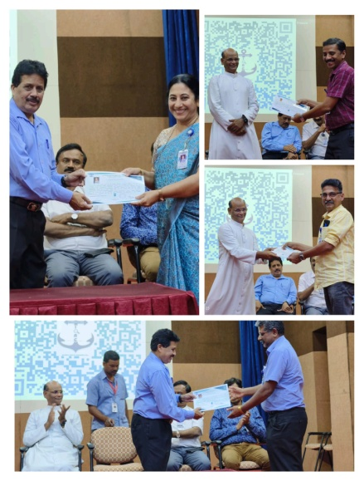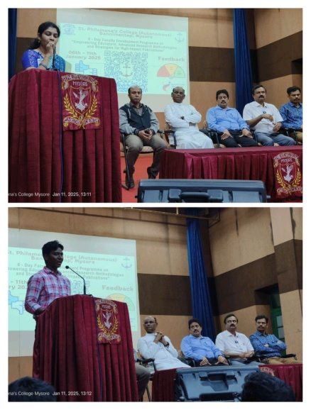

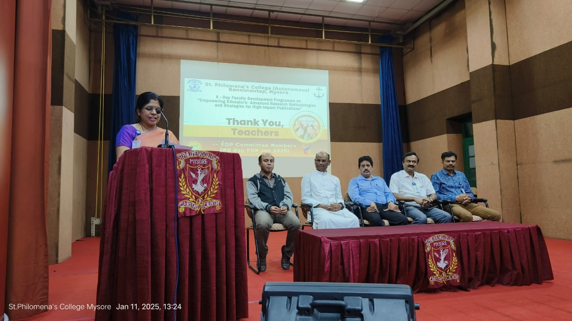

Drafted by, Dr.Yamuna.B.Raj, Asst.Prof, Department of Journalism and Mass Communication, St.Philomena’s College, (Autonomous,) Mysore.
Photography by, Mr.Swamynathan.A, Office Section, St.Philomena’s College, (Autonomous), Mysore.

