Report on Constitution Day Celebration
Date: November 26, 2024
Location: Indoor Stadium, St. Philomena’s College, Mysuru

Objectives
- To commemorate the adoption of the Indian Constitution and its significance in shaping India’s democracy.
- To educate students and staff about the principles of justice, liberty, equality, and fraternity enshrined in the Constitution.
- To inspire the college community to reflect on the Constitution’s relevance in their daily lives and reaffirm their commitment to its ideals.

Event Proceedings
St. Philomena’s College celebrated Constitution Day on November 26, 2024, with a program organized by the Equal Opportunity Cell in collaboration with students and faculty members. The event, held in the college’s indoor auditorium, commenced at 12:20 PM, with Miss Shirly, Assistant Professor, Department of MSW, hosting the session and welcoming the attendees.
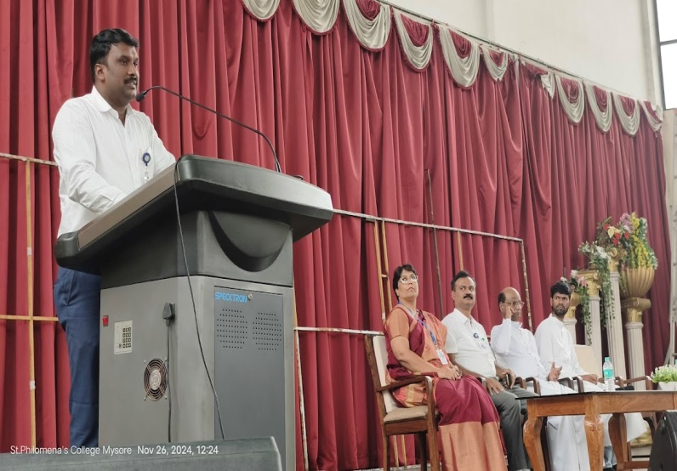
The program began with a keynote address by Dr. Nandeesha H.K., Coordinator of the Equal Opportunity Cell, who emphasized the evolution of the Indian Constitution, the contributions of its framers, and its critical role in fostering democracy and safeguarding fundamental rights.
Dr. Nandeesha H K also encouraged students to embrace the Constitution’s principles of justice, liberty, equality, and fraternity in their lives.

Constitution Pledge:
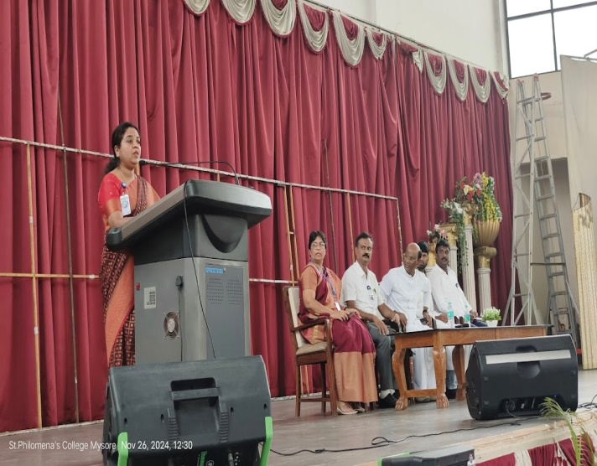
A significant part of the event was the administration of the “Constitution Day Pledge,” led by Dr. B. Shyla, Associate Professor of Chemistry. Students, faculty, and staff participated with enthusiasm, reaffirming their commitment to uphold the Constitution and its values in their daily lives. 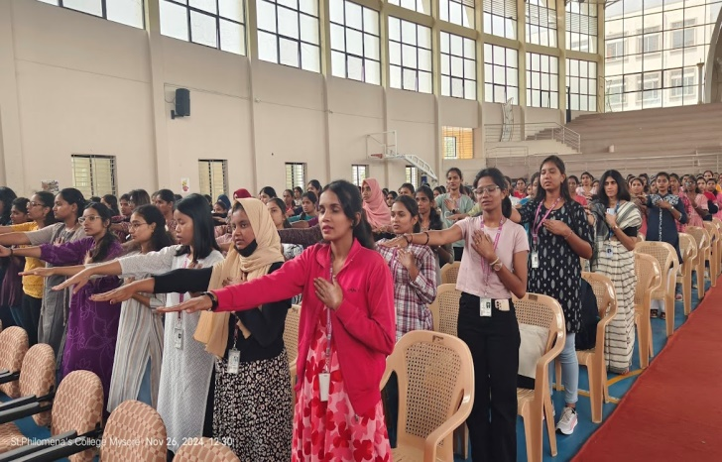
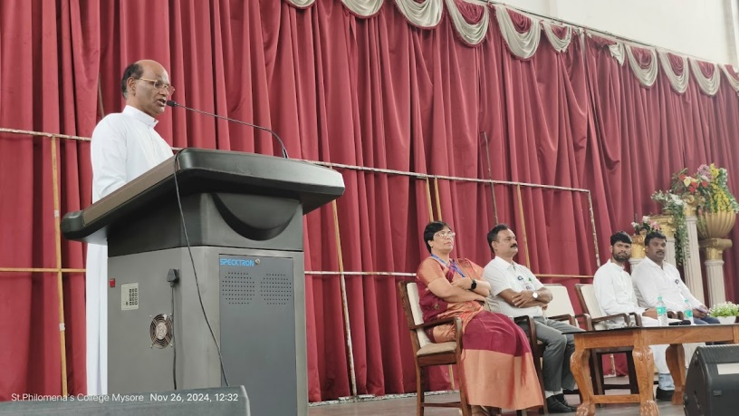
Rev. Fr. Lourdhu Prasad Joseph delivered a motivational speech, reflecting on the ideals enshrined in the Constitution. He urged the audience to actively incorporate values like justice, equality, and fraternity into their actions to contribute to a more inclusive and progressive society.
The program was further enriched by the presence of Dr. Ravi J.D. Saldanha, the Principal; Dr. Noor Mubashir C.A., PG Coordinator; and Rev. Fr. David Sagai Raj, Assistant to the Rector, who actively participated in the event and lent their support to the celebration. 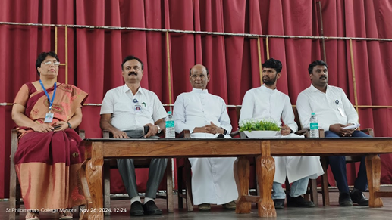
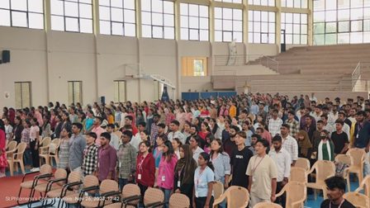
The program concluded with a vote of thanks delivered by Miss Shirly, Assistant Professor, Department of MSW, who expressed gratitude to the guest speakers, participants, and organizers for their contributions to the event’s success. The singing of the national anthem at 12:40 PM marked the formal end of the celebration.

Outcomes
- Enhanced awareness among students and faculty about the fundamental rights and duties outlined in the Constitution.
- Renewed commitment by the college community to uphold the principles of justice, liberty, and equality in their personal and professional lives.
- Reinforcement of the college’s dedication to promoting democratic values and inclusivity.

