Report on Environmental Sustainability Awareness Program at Government Higher Primary School, Bettadapura, Hunsur Taluk, Mysore District
Organized by PG Department of Commerce
28th November, 2024
On November 28th, 2024, First and Second year M.com students from St. Philomena’s College, (Autonomous) conducted an Environmental Sustainability Awareness Program at Government Higher Primary School, Bettadapura, Hunsur Taluk, Mysore District, aiming to educate and inspire young minds about the importance of sustainable living. Overall …. Students participated in this program.
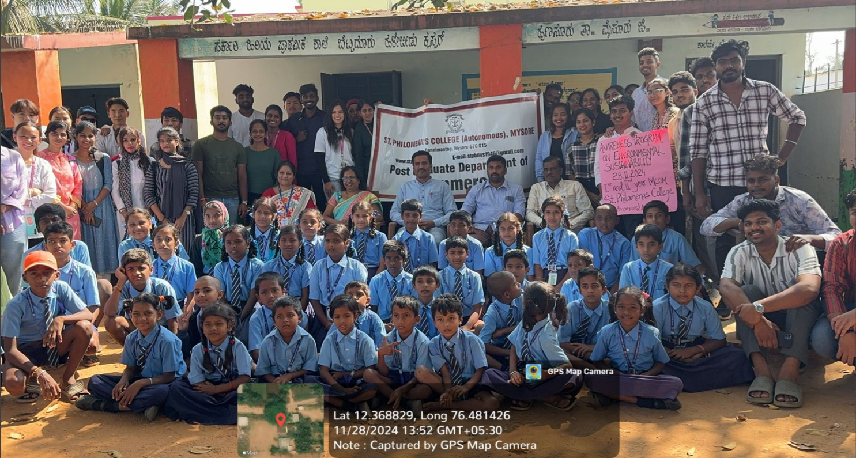

Objectives
The primary objectives of the program were:
- To Raise Awareness: Educate students about the critical issues related to environmental sustainability, such as climate change, pollution, and resource conservation.
- To Promote Sustainable Practices: Encouraging students to adopt eco-friendly habits in their daily lives, such as reducing waste, recycling, and conserving water and energy.
- To Foster a Sense of Responsibility: Instill a sense of responsibility among them towards the environment.
- To Empower Students: Provide knowledge and tools that empower students to contribute to environmental sustainability initiatives within their communities.
Program Details
The program included various interactive and engaging activities designed to capture the interest of the school students. Key activities included:
- Welcome and Icebreaker Session:
College students introduced themselves and conducted a fun icebreaker activity to build rapport with the school children.
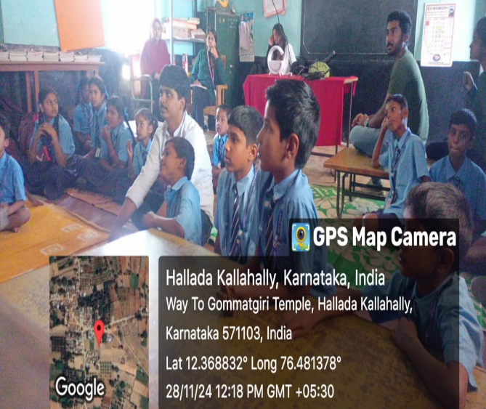
- Interactive Presentations: Topics covered included such as personal hygiene, environmental conservation etc.Presentations were supported by visual aids and real-life examples to make the session engaging.
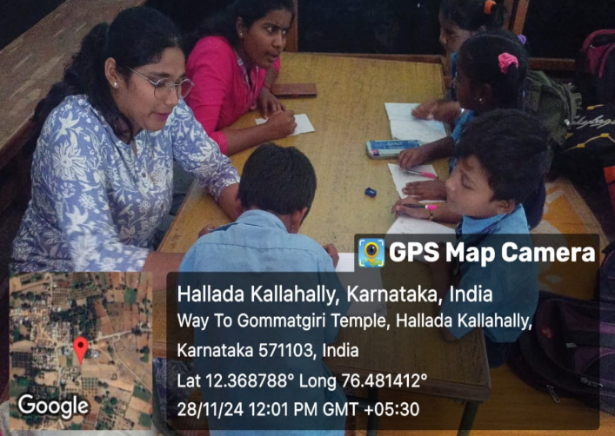

- Group Discussions:
Small group discussions allowed school children to express their thoughts and clarify their doubts on the topics.

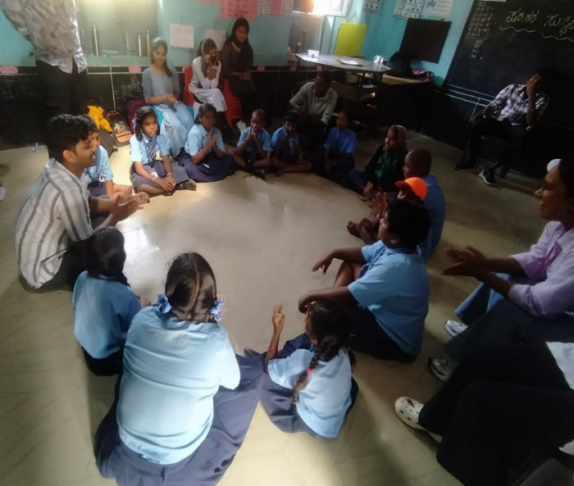
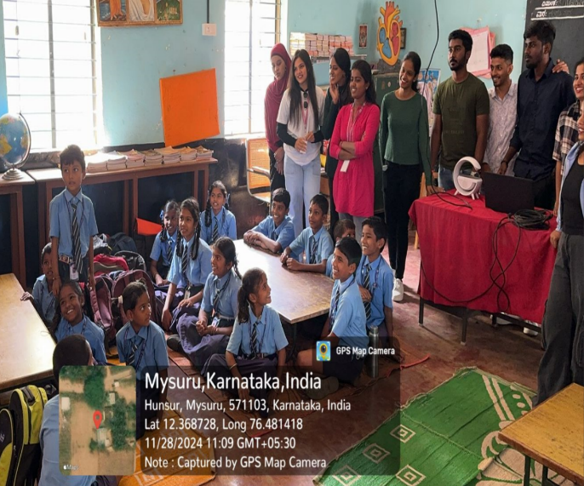
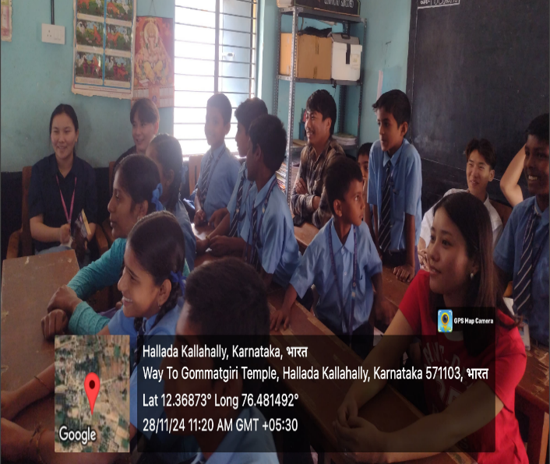
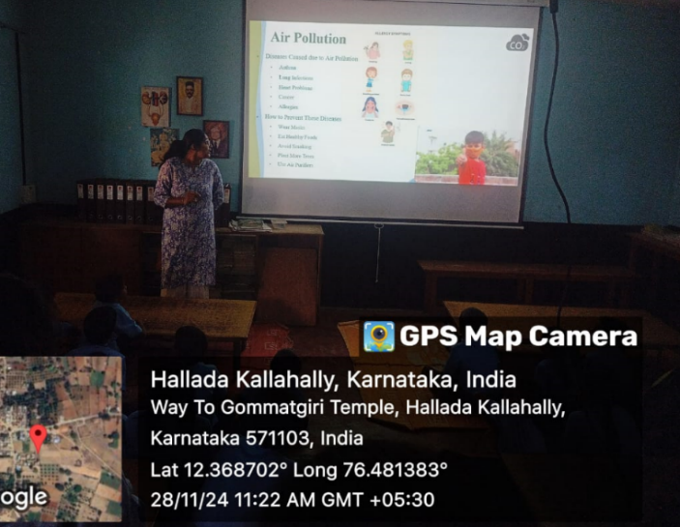
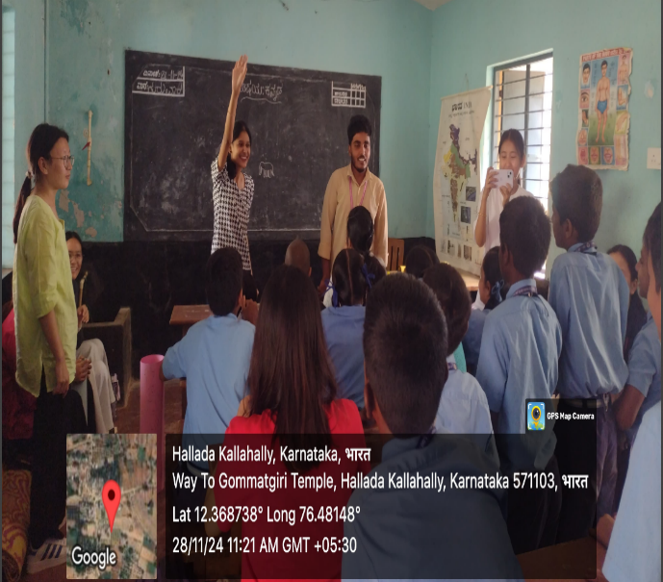

- Presentations: Informative presentations on topics such as "The Impact of Climate Change," "Reducing Plastic Waste," and "Importance of Biodiversity." These presentations were accompanied by visuals and short videos to make the content more accessible and engaging.

- Quiz Competition: An interactive quiz competition to test the students' knowledge on environmental topics and reinforce the information shared during the presentations.
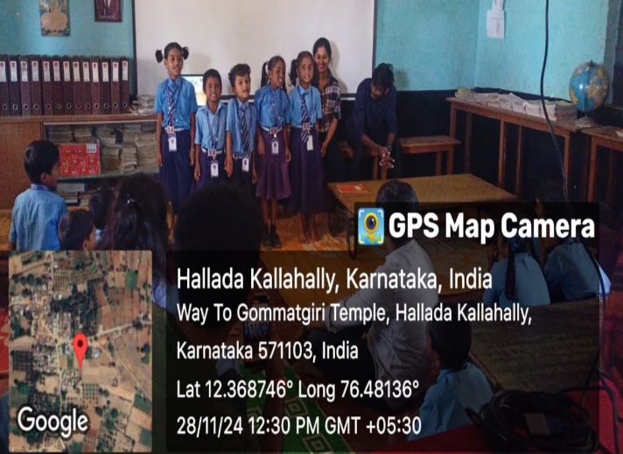

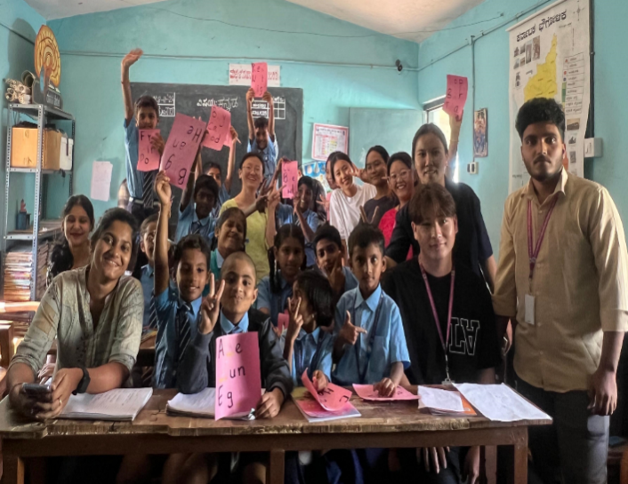
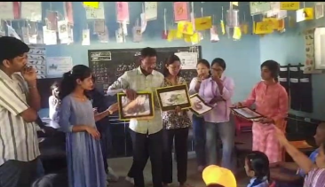

Outcomes:
The Environmental Sustainability Awareness Program achieved several positive outcomes:
- Increased Awareness: The students of Bettadapura Higher Primary Government School demonstrated a significant increase in their awareness of environmental issues. Many students could articulate the importance ofsustainability and the impact of human activities on the environment.
- Engagement and Enthusiasm: The interactive nature of the activities ensured high levels of student engagement and enthusiasm. The workshops and quiz competition were particularly well-received, with students actively participating and showing keen interest.
- Adoption of Eco-Friendly Practices: Following the program, the school administration reported a noticeable shift in student behavior towards more sustainable practices, such as reduced use of plastic and better waste management.
- Community Involvement: The program fostered a sense of community involvement among the students, with many expressing a desire to take part in local environmental initiatives and furthering the impact of the program beyond the school premises.
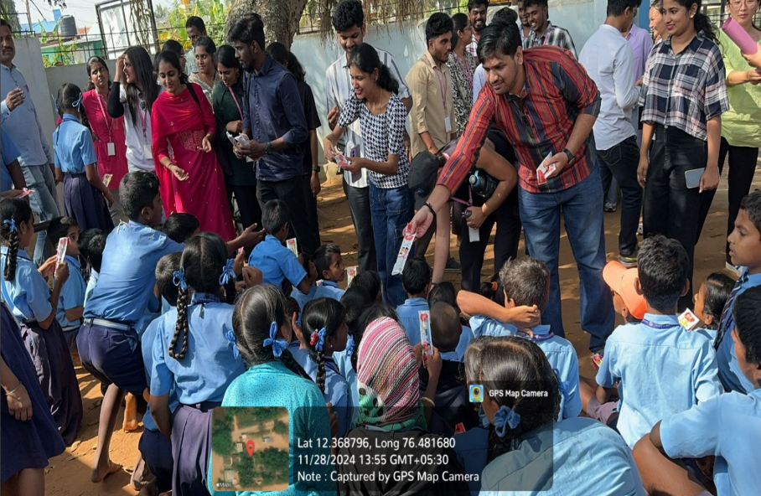
Conclusion
The Environmental Sustainability Awareness Program at Government Higher Primary School, Bettadapura, Hunsur Taluk, Mysore District was a resounding success, achieving its objectives of raising awareness, promoting sustainable practices, and fostering responsibility among young students. The collaboration between St. Philomena’s College, (Autonomous) Mysore and Government Higher Primary School, Bettadapura, Hunsur Taluk, Mysore District served as an excellent model for future programs, demonstrating the potential of educational initiatives to drive meaningful change in environmental sustainability at the grassroot level.

