Report on One-Day Workshop On
"UNLEASHING ENTREPRENEUR IN YOU"
Organized by PG Department of Commerce

Date: 21st November 2024
Venue: PG CONFERENCE HALL, IInd FLOOR
A one-day workshop, "Unleashing the Entrepreneur in You," was successfully organized by Department of Commerce on 21st November 2024. The workshop aimed to inspire and empower individuals by enhancing their entrepreneurial mindset and providing them with valuable insights into the challenges and opportunities in the entrepreneurial journey. 63 students participated in the workshop, 41 from M.Com, 5 from M.A. Economics, and 18 from M.Sc. Computer Science stream.
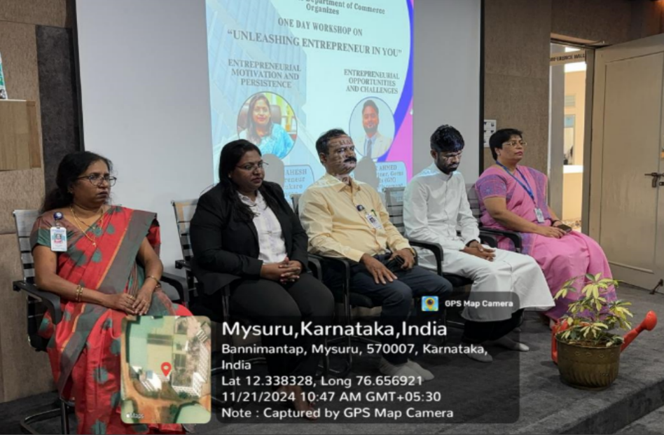
This workshop was structured into two interactive sessions led by esteemed speakers with expertise in entrepreneurship.
Objectives of the Workshop
- To ignite and nurture the entrepreneurial spirit among students.
- To equip students with strategies for staying motivated and persistent in their entrepreneurial endeavours.
- To provide practical knowledge in identifying entrepreneurial opportunities and overcoming challenges in the business world.
- To foster networking and idea-sharing among aspiring entrepreneurs.

SESSION DETAILS
Session 1: Entrepreneurial Motivation and Persistence

Speaker: Ms. Rachana Mahesh, Women Entrepreneur

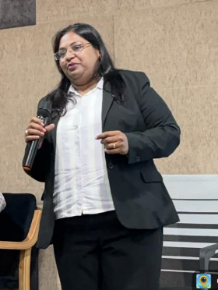
Ms. Rachana Mahesh delivered an inspiring session emphasizing the significance of motivation and persistence in entrepreneurship. She spoke about the fundamental difference between a career and a job, emphasizing that a career aligns with one's passion and long-term aspirations, whereas a job is typically centred on immediate financial needs. Ms. Rachana emphasized the importance of having clarity about one’s goal and encouraged students to explore the underlying aspects of their chosen business areas, such as understanding market dynamics, customer preferences, and operational intricacies.

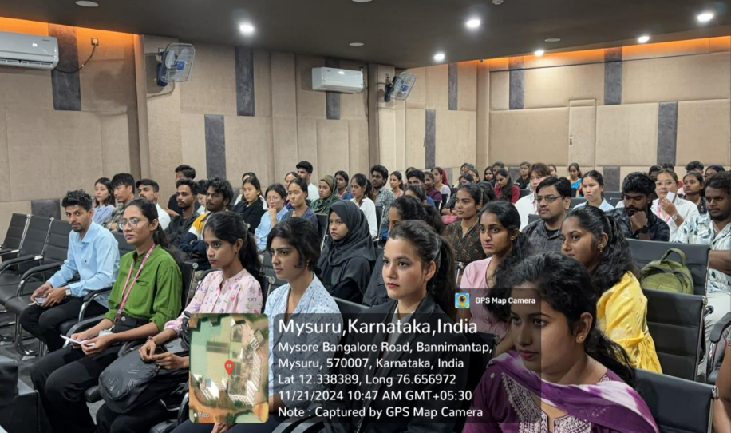
To make the session relatable, she shared incidents from her own entrepreneurial journey, illustrating the challenges she faced and the strategies she employed to overcome them. Her personal experiences resonated strongly with the students, inspiring them to persist despite obstacles.

The session concluded with an interactive Question and Answer segment, during which Ms. Rachana addressed questions from students, offering practical advice and motivating them to pursue their entrepreneurial aspirations with confidence.

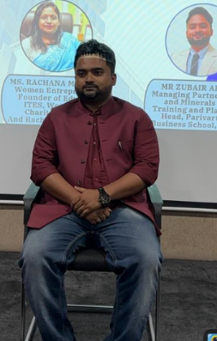
Session 2: Entrepreneurial Opportunities and Challenges

Speaker: Mr. Zubair Ahmed, Training and Placement Head,
Parivarthana Business School

Mr. Zubair Ahmed provided a thought-provoking session that shed light on recognizing and leveraging entrepreneurial opportunities while overcoming challenges. He began the session by explaining the fundamental difference between businessmen and entrepreneurs, emphasizing that businessmen often focus on managing existing resources to earn profits, while entrepreneurs create value by identifying opportunities and innovating solutions.

He accentuated that to be successful in business; one must either address a specific requirement or solve a pressing problem. Additionally, he introduced the concept of SWOC (Strengths, Weaknesses, Opportunities, and Challenges) analysis as a critical tool to evaluate feasibility and prepare strategically before starting any business venture.

To engage the participants further, Mr. Ahmed conducted group discussion. He divided the students into small groups and tasked them with brainstorming session for starting a business with zero investment.

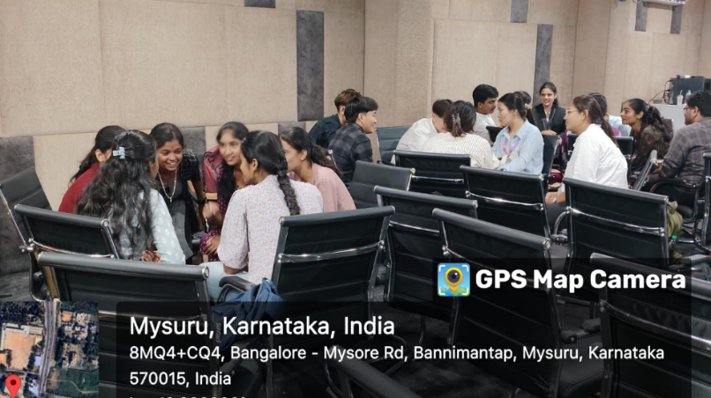
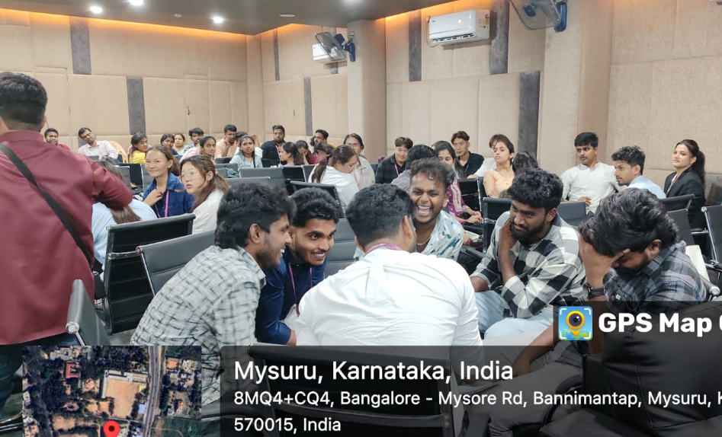

The interactive exercise encouraged participants to think creatively, analyse potential opportunities, and collaborate with their teammates. The activity not only fostered innovative thinking but also enhanced teamwork and problem-solving skills among the students.

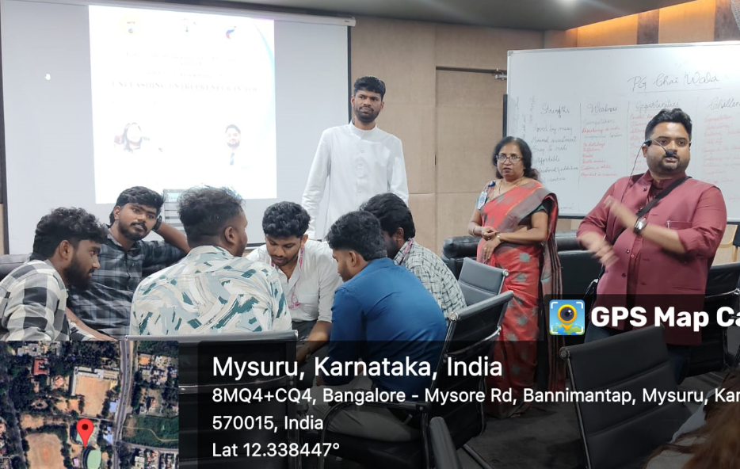

The session concluded with students presenting their ideas, receiving feedback, and feeling empowered to approach business challenges with a strategic and innovative mindset.

Expected Outcomes
By the end of the workshop, participants were expected to:
- Develop a stronger entrepreneurial mindset.
- Gain a deeper understanding of the motivational and psychological aspects of entrepreneurship.
- Identify actionable entrepreneurial opportunities in the areas of interest.
- Learn strategies to overcome common challenges faced by entrepreneurs.
- Build a professional network with like-minded individuals and industry experts.

Conclusion
The one-day workshop, "Unleashing the Entrepreneur in You," was an enriching experience that successfully fulfilled its objectives of inspiring and equipping students with the tools necessary to embark on their entrepreneurial journeys. With engaging sessions led by Ms. Rachana Mahesh and Mr. Zubair Ahmed, participants gained invaluable insights into motivation, persistence, opportunity identification, and practical business strategies.
The interactive nature of the workshop, including group activities and Question and Answer sessions, encouraged active participation, creative thinking, and collaboration among the attendees. The real-life examples, practical exercises, and actionable advice provided by the speakers left the participants motivated and prepared to take the first steps in their entrepreneurial endeavours.
The workshop concluded with positive feedback from students, who appreciated the relevance of the topics and the interactive format. It was not only a platform for learning but also an opportunity to network and share ideas, making it a memorable and impactful event for all involved.

