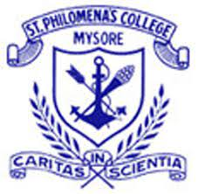
ST. PHILOMENA’S COLLEGE (Autonomous), MYSURU
Affiliated with the University of Mysore
Department of Journalism and Mass Communication &
B.Voc Media & Entertainment

Report on

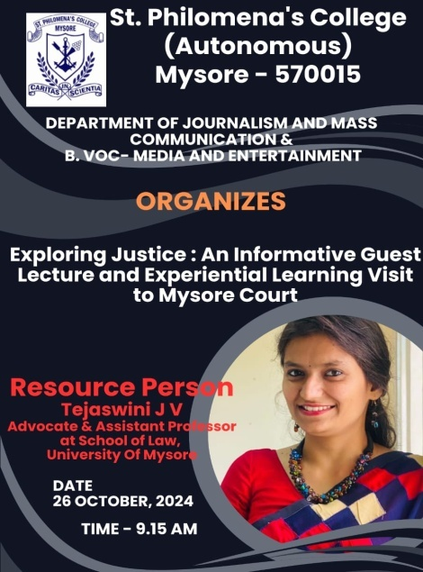
Event Title: Exploring Justice: An Informative Guest Lecture and Experiential Learning Visit to Mysore Court

Organized by:
Department of Journalism and Mass Communication &
B. Voc - Media and Entertainment,
St. Philomena's College (Autonomous), Mysore.

Date and Time: 26th October 2024, 9:15 AM

Venue: Mysore Court
Resource Person:
Ms. Tejaswini J V, Advocate & Assistant Professor at the School of Law, University of Mysore.

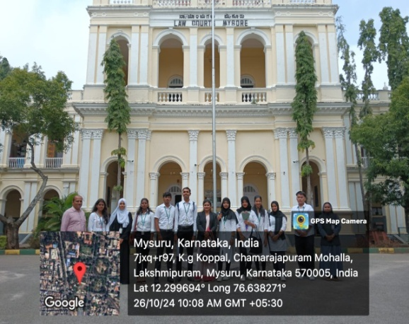
Introduction: The Department of Journalism and Mass Communication, in collaboration with the B. Voc - Media and Entertainment program of St. Philomena’s College, organized a guest lecturer and experiential learning visit titled "Exploring Justice." The event aimed to provide students with practical insights into the justice system and court proceedings, combining academic learning with firsthand experience.
Objective of the Event:
- The primary objective of the visit was to familiarize students with the judicial system in action, providing them an opportunity to understand the workings of the court.
- To observe live sessions, and interact with an expert from the legal field.
- To initiative was also intended to awareness about legal rights and responsibilities.
- To enhancing students understanding of the legal process as it relates to media and journalism.
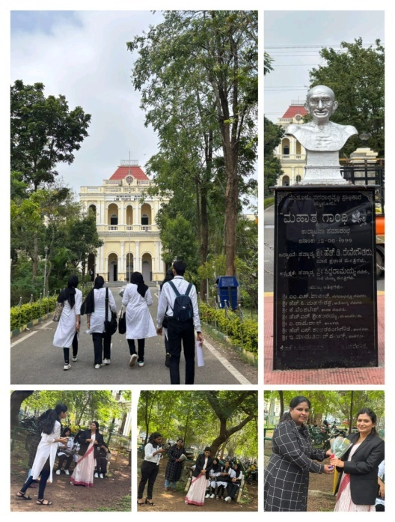
Interactive Lecture: Ms. Tejaswini discussed fundamental aspects of the justice system, ethics in journalism related to legal matters, and the importance of balanced and accurate legal reporting.

Observation of Court Proceedings: Students observed real cases and gained insight into the judicial process, legal terminologies, and the significance of evidence in decision-making.

Experiential Learning at Mysore Court:
Following the lecture, students were escorted to the Mysore Court where they had the opportunity to witness live court proceedings. This hands-on experience allowed them to observe the roles of judges, lawyers, and other court personnel, as well as to see how cases are presented and argued in real time. The visit provided an invaluable experience for students, bridging the gap between theoretical knowledge and practical application.
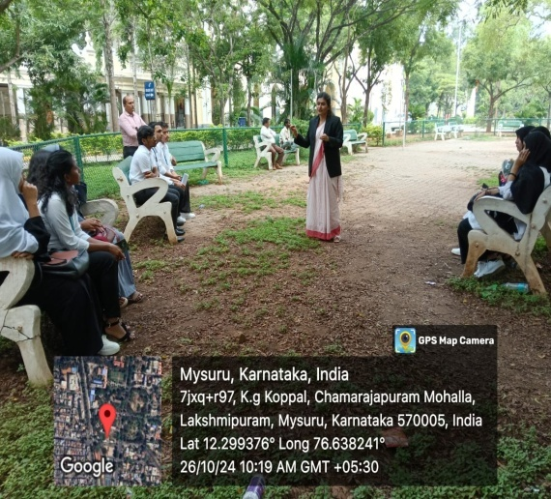

Q&A Session: The event concluded with a Q&A session where students engaged with Ms. Tejaswini, asking questions about the legal field and discussing various aspects of court reporting and justice.

Outcome of the Event:
The event was successful in enhancing students’ understanding of the justice system. By combining theoretical learning with practical observation, students were able to appreciate the intricacies involved in the field of law, particularly in relation to media and entertainment. This experience was instrumental in helping students understand their role as future journalists and media professionals in covering legal matters with accuracy and responsibility.

Conclusion:
The guest lecturer and experiential visit to Mysore Court provided a comprehensive learning experience that was both informative and engaging. The Department of Journalism and Mass Communication, along with the B. Voc - Media and Entertainment program, plans to organize similar events in the future to enrich students’ learning experiences and prepare them for responsible journalism.

Number of participants: 12
Drafted by, Dr.Yamuna.B.Raj, Asst. Prof, Department of Journalism and Mass Communication.

