St.Philomena’s College (Autonomous)
Bannimantap, mysore

Department of social work(UG)
[Extra CurricularActivity]

Introduction:
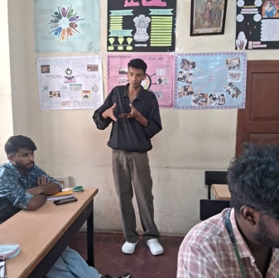
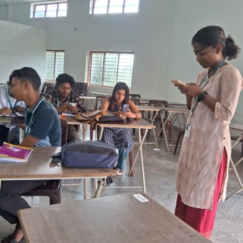
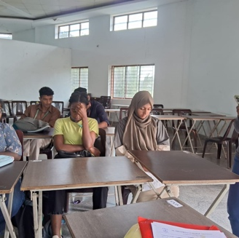
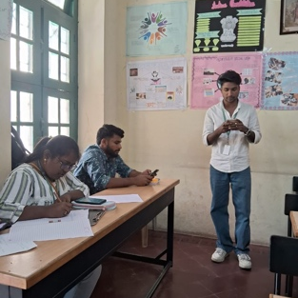
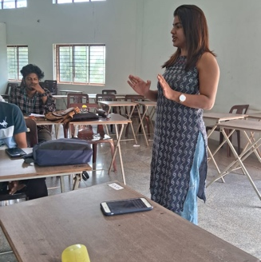
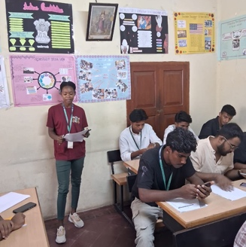
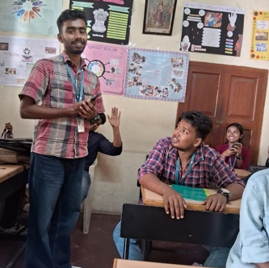
Students studying social work made PowerPoint presentations for their classes as part of their coursework. The lecturer gave each student instructions to make a PowerPoint presentation and present it to the class. All first-, second-, and third-year BSWs completed their job with more zeal.
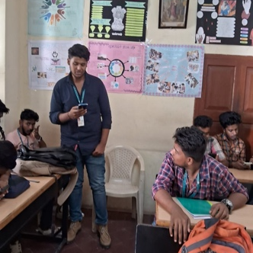

Outcome:

This type of ppt presentation brings Knowledge based Outcomes in students like Understand the topic/subject matter, Identify key concepts and ideas, Recognize relationships between concepts, Develop critical thinking skill, Enhance research skills

This also gives Skill based improvements in students like Effective communication, Public speaking and presentation skills, Organization and time management, Visual aids and multimedia usage, Confidence building.

Attitude vice the ppt presentation gives Increased interest in the subject, Appreciation for diverse perspectives, Open-mindedness to new ideas, Collaboration and teamwork, Enhanced creativity.
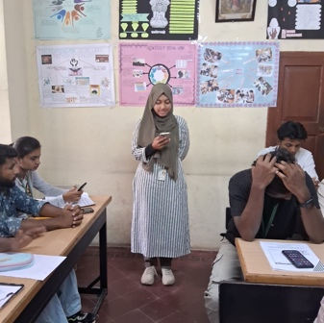
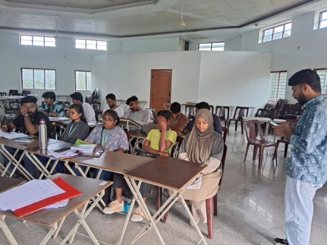
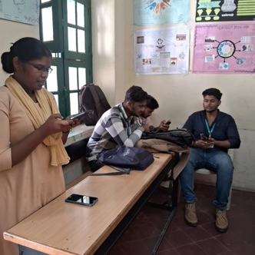
Ppt presentation also brings Behavioral Outcomes, Assessment Outcomes, Long-term Outcomes in students that includes Active participation in class discussions, Improved attendance and engagement,. Increased motivation to learn, Development of leadership skills, Effective feedback and self-assessment, Evaluate presentation content and structure, Assess communication and delivery skills, Review visual aids and multimedia usage, Evaluate teamwork and collaboration (if group project), Assess understanding of topic/subject matter, Enhanced career prospects,Improved academic performance, Increased confidence in public speaking, Development of lifelong learning skills,Effective communication in personal and professional settings

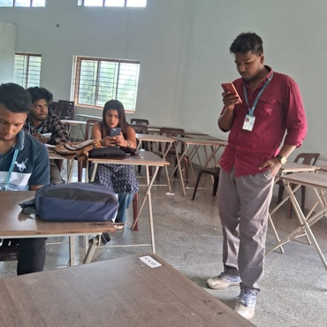
Students are very grateful to get such opportunities which academically, behaviourally, professionally, technically improves the students.


