Screen_Timer_Manual
- Downloading & Installation:-
Download the executable java Jar file from below link.
JavaProjects/PcTimer/Executable Jar at master · melvintauro/JavaProjects · GitHub
Install on any Operating system of your choice and double click to run the Java jar file.

- Navigation & Features.
- Hovering on the Icon in the system Tray will give quick access to Information required with out opening the information Table.
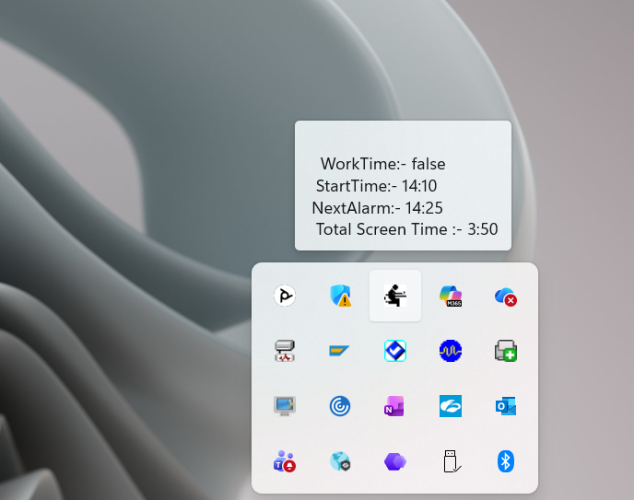
- Right Click will give access to the Menu.
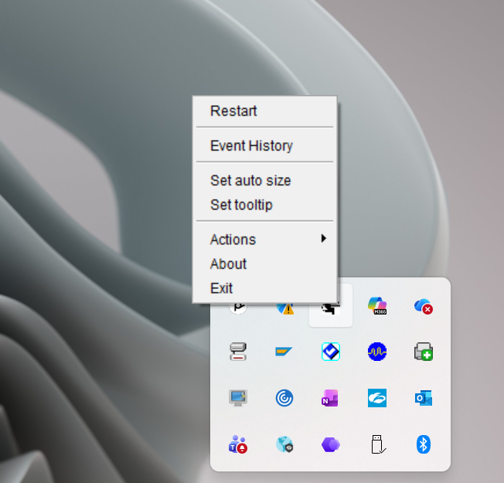
- Double Click on the Icon will open the shown window with various toolbar buttons.
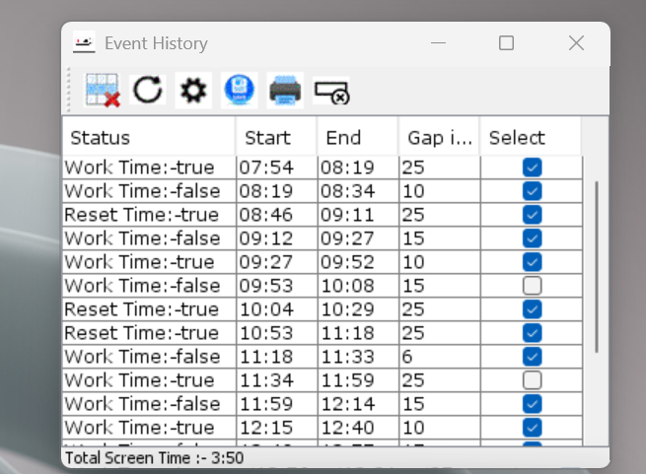
- Click on the Setting toolbar to open the blow window.
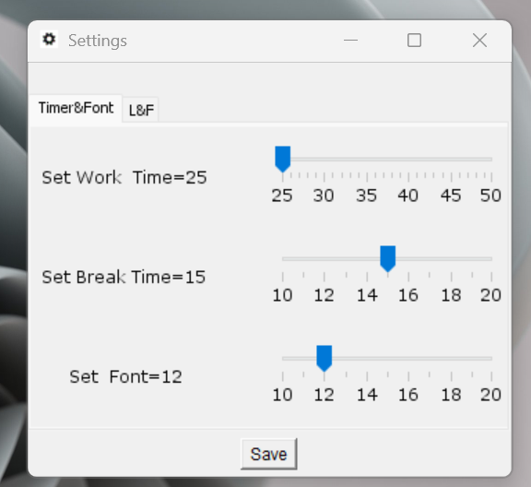
- Click on the Look and Feel Tab to access the below screen.
