UNIX
WORKSHOP
Freshmen Orientation 2007

Created by Mark Tan in July 2005
Updated in July 2007
version 1.4

1. Introduction
A. Audience
This session is conducted for individuals who will be using the UNIX operating system. It is assumed that the student has a general understanding of data processing concepts.

B. Session Objectives
Upon completion of the session, the student will be able to:
- Demonstrate an understanding of basic UNIX ideas.
- Log in and out of UNIX using an interactive terminal.
- Change the password and be aware of other responsibilities of owning an account.
- Demonstrate an understanding of where to get help.
- Use the appropriate UNIX commands to display/print files, copy/move files, change file access permissions, create/delete directories and change the current working directory.
- Use an editor to create files, input text, insert/replace text, copy/move text and exit/save changes.
- Use the mail utility to send/receive/delete messages.
- Demonstrate the use of bulletin board.
- Demonstrate how to create web pages.
2. Introduction to UNIX
2.1 What is UNIX?
UNIX is a multi-user, multi-tasking Operating System (OS) developed in 1960s with a simple straight-forward design making it easy for programmers to use. An OS is a software that is in charge of scheduling resources and processes of a system as well as managing and maintaining interactivity between the software and hardware of the system.

UNIX OS comprises of 4 parts: the Kernel, the shell, Commands and Utilities and Files and Directories.

2.1.1 The Kernel
The kernel is the core of the UNIX OS. Basically the kernel is a large program that is loaded into memory when the machine is turned on and it controls the allocation of hardware resources from this point onwards. The kernel recognizes what hardware resources are available such as processor(s), the on-board memory, the disk drives, network interfaces, etc, and it has the necessary driver interface programs to communicate to the devices that are connected to it.

2.1.2 The Shell
The shell is the utility that processes your requests. When you type in a command at your terminal, the shell interprets the command and runs the requested program. UNIX supports multiple users and multiple tasks, and different users can invoke the same utility programs, including the shell. The shell uses standard syntax for all commands. There are many different shell programs available, such as:
- Bourne shell aka sh, the original shell used in UNIX systems and in UNIX related environment.
- Bourne Again shell aka bash, the standard GNU shell, intuitive and flexible. Probably most advisable for beginning users while being at the same time powerful tool for the advanced and professional user.
- C shell aka csh, the syntax of this shell resembles that of the C programming language.
- Turbo C shell aka tcsh, a superset of the common C shell, enhancing user-friendliness and speed.
- Korn shell aka ksh.

SoC UNIX Server uses 2 types of shell, bash (default) and tcsh.

2.1.3 Commands and Utilities
Separate utilities can be easily combined to customize function and output. They are flexible, adaptable, portable, and modular. They use pipes and filters. There are over 200 standard commands plus numerous others provided through 3rd party software such as pine, bbs.

2.1.4 Files and Directories
The directory system supports a multilevel hierarchy. Files and directories have access protection. Files and directories are accessed through pathnames. Removable filesystems are also supported.

2.1.4.1 File Structure
All data in UNIX is organised into files. All files are organised into directories. These directories are organised into a tree-like structure called the filesystem. The following diagram describes the top level organization of the UNIX filesystem:
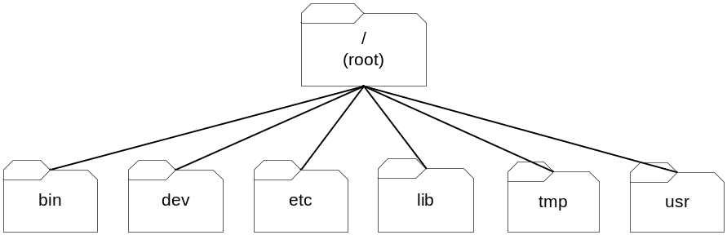
These directories, in turn, are also organised hierarchically.

For example:
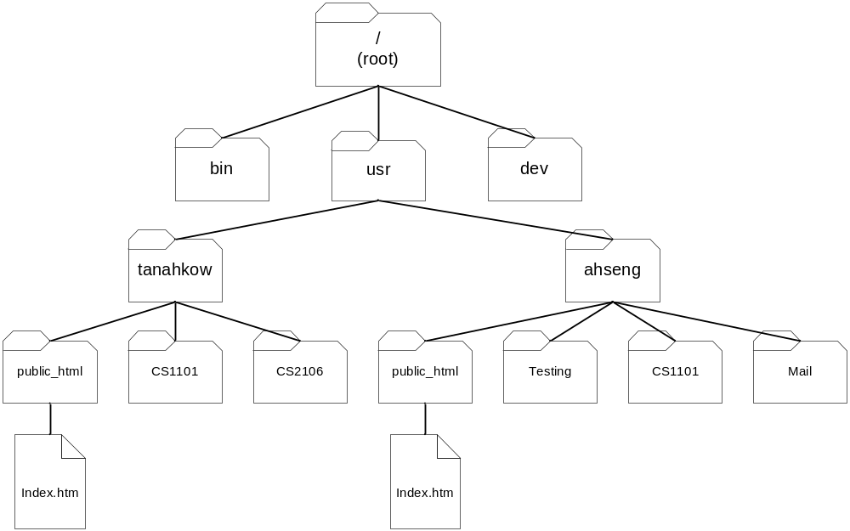
home

Every file has a name. A filename is composed of one to fourteen characters. Although you can use almost any character in a filename, you will avoid confusion if you choose characters from the following list.

- upper case letters [A-Z]
- lower case letters [a-z]
- numbers [0-9]
- underscore [_]
- period [.]
- comma [,]

The only exception is the root directory, which always uses the symbol /. No other directory or file can use this symbol.

Like children of one parent, no two files in the same directory can have the same name. Files in different directories, like children of different parents, can have the same name.

2.1.4.2 UNIX System Files
In order for you to have a basic understanding of the contents of some of the system directories, here is a partial list of those directories and what files they contain:

/bin This is one of the standard places where executable files are located.
They are available to all users.
/dev This is where the device files or device links are located.
/etc Supervisor directory commands, configuration files, disk configuration files, reboot files, valid user lists, groups, ethernet, hosts.
/lib This is where system libraries are located.
/tmp Where you find scratch processes, editors, compilers, and databases.
/mnt An auxiliary mountpoint directory, used for non-permanent filesystem mounts.
/lost+found orphans go here (look here after system crash)

This is not an exhaustive list of directories that contain system information but it is intended to remove some of the mystery behind these directories and the types of files they contain.
Hands-on 1 [Getting Started]
(Duration: 15 minutes)

In this hands-on, you will learn:
- How to login to and logout from Unix Server by SSH.
- Changing your password.
- Learn some informative commands.
- Understand Control characters.

1. Creating your UNIX account
The instructions are available at
https://www.comp.nus.edu.sg/cf/unix/socaccount.html

2. Connecting to UNIX Server by SSH
There are several UNIX servers in SoC as follows:
- sf3.comp.nus.edu.sg or sunfire.comp.nus.edu.sg
- sunfire-r.comp.nus.edu.sg (Connect from home through Singapore ISPs without activating VPN)
  - https://www.comp.nus.edu.sg/cf/unix/unixpass.html

Note: SoC Unix Quota for individual: 500MB.

1.1 Connect by SSH Client (refer to Figure 1)
- Click on “Quick Connect”.
- Type any server from above in the “Host name” textbox.
- Type in your user name in “User” textbox.
- Click on “Connect”.
- A prompt will ask for password. Enter your password and click “Ok”.
NOTE: UNIX password is CASE-SENSITIVE.

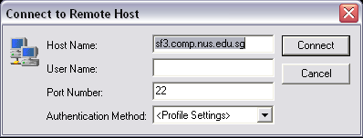
Figure 1. Quick Connect

- If you have successfully login to UNIX Server, you will see a screen similar to Figure 2.
NOTE: If the UNIX Server prompts you to change password, type N.
- To logout of the UNIX Server, type exit or click .

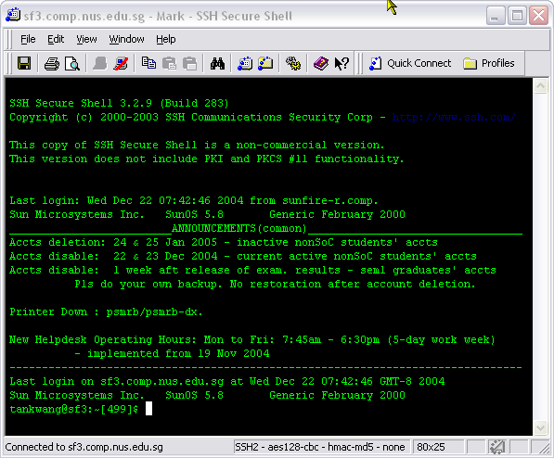
Figure 2. SunOS Connected by SSH.

3. Changing Password
It is recommended that you change your password regularly in order to keep your account secure and keep your vital lab works and personal data intact.

UNIX allows passwords with 8 characters and which have a combination of at least 2 of the following:
- Lowercase alphabets
- Uppercase alphabets
- Numbers
- Symbols

3.1 Changing Password (refer to Figure 3a-3c)
- Type the URL given below in your web browser (e.g. Internet Explorer, Firefox)
https://mysoc.nus.edu.sg/~myacct/
- You will see the following screen.
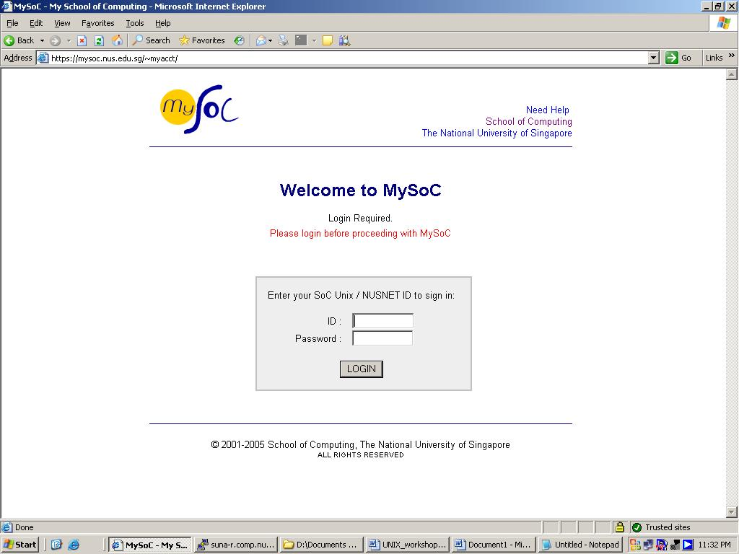
Figure 3a – MySoC myacct Login Screen

- Type in your SoC User/ NUSNET ID and password to login.
- Once you are login, you will see the screen shown in Figure 3b.

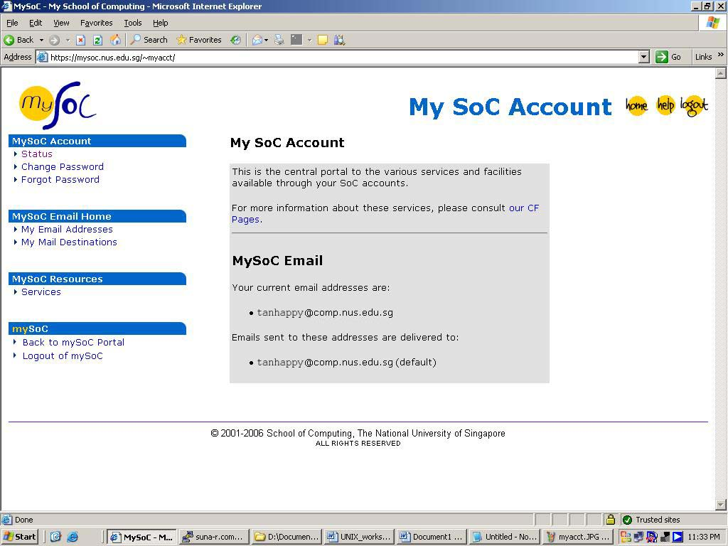
Figure 3b – My SoC Account

- Click on Change Password (Left-side, under MySoC Account)

- You will then see the screen given in Figure 3c.
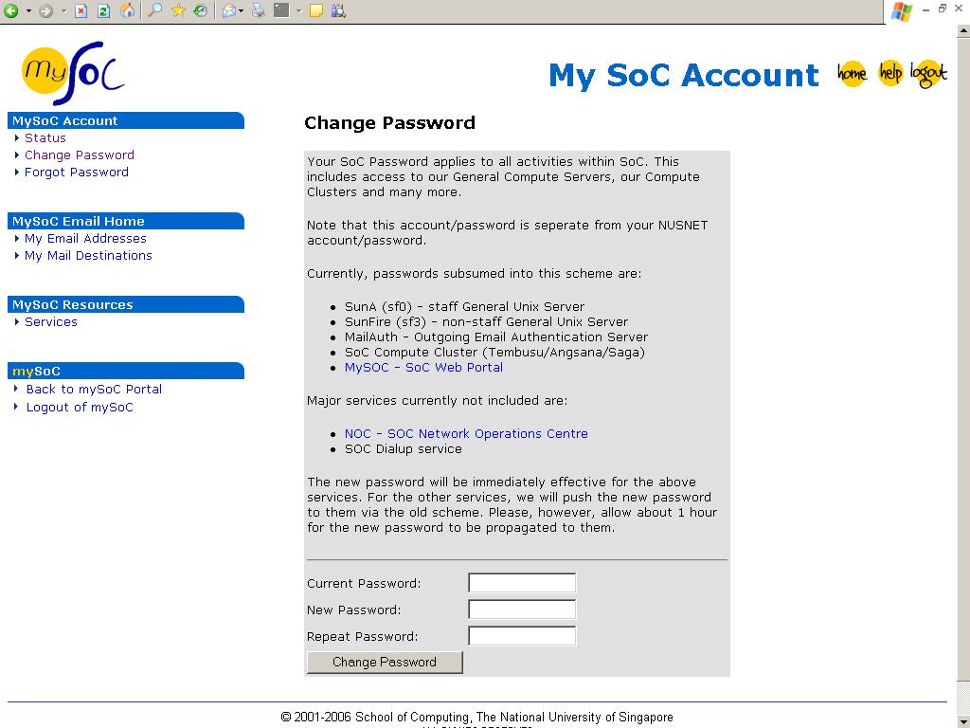
Figure 3c – Change Password screen

7. Enter your Current Password, and the New Password (and repeat it in the textbox above) to change your UNIX password.

4. Informative Commands
The following is a list of commands that provides information.
- whoami Prints the current username.
- date Prints the server date/time.
- cal Prints the calendar of current month.
- uptime Prints how long the server has been online.
- pusage Prints the user’s print quota available.
- pwd Prints the current working directory you are in.
- who A list of logged on users.
QUIZ: Which commands besides who provides comprehensive and customised information to find or check whether your friends are online?
QUIZ: How to clear the content of your screen?

5. Control Characters
This is a special set of signals send from the user to the kernel for specific actions. (If you are interested, you can learn from CS2106).

The following is commonly used control characters.
- Ctrl-C kills a process.
- Ctrl-\ quits a process.
Hands-on 2 [File/ Directory Manipulation]
(Duration: 30 minutes)

In this hands-on, you will learn:
- How to seek help in UNIX.
- Basic UNIX Commands and MS-DOS Equivalence.
- Viewing File content.

1. Accessing Help in UNIX
Do you have the following problems when working in UNIX shell?
- Forget the name of command to perform the required function.
- Forget the attribute of the command such as permission setting of the files instead of filenames alone.
- Forget how the commands work.
- etc…
The list goes on, so how to seek help in UNIX to solve all these problems?

1.1 Listing the commands available
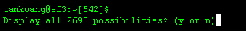
Figure 4. Display available commands.

If you are unsure of the command name at all, you can hit TAB and a screen similar to Figure 4 will be shown asking you to display all the commands or not.

If you know the first character of the command, you can type in the first character and hit TAB as shown in Figure 5. This will provide a specific search for the commands available.

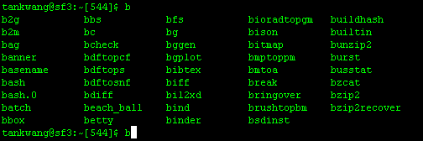
Figure 5. Display of available commands starting with “b”.

1.2 Simple description of the Command
Syntax: whatis <command>

1.3 Finding Documentation of the Command
Syntax: man [options …] <command>
This command is useful as it displays the usage, options, references or links needed and bugs fixed etc… to the users.

2. Basic UNIX Commands
The following is a list of special characters to increase efficiency.
- (.) dot current directory.
- (..) dot dot parent of current directory.
- (/) front slash root directory.
- (~) tilde home directory.

The following is a list of commands you may need for Task One below.
Directories and Files
- cd <dest> Change working directory
- ls [options…] <name> List the content of a directory
- mkdir <name> Create a new directory
- rmdir [options] directory… Delete directory(ies)
- cp [options] <src> <dest> Copy file(s)
- mv [options] <src> <dest> Move file(s)
- rm [options] file… Delete file(s)
- chmod [options] [mode] file Change access permission of a file/directory.

Display Content of file to screen
- cat [options] file… Concatenate and display file
- less [options] file… Display screen full of content of a file.
- head [-n #] file Display the first few lines of the file
- tail file Display the last part of the file

Task One (Work in pairs)
- Make sure you at your home directory. [use pwd to check]
- Change directory to /home/l/lujunche/workshop (or ~lujunche/workshop)
- Copy sample1 and sample2 to your home directory.
- Create a new directory called “workshop”.
- Create 3 directories called “folder1”, “folder2” and “folder3” respectively in “workshop”.
- Move sample1 to folder1 and sample2 to folder2.
- Use the display commands to view the sample1 and note the differences.
- Change directory to “workshop”.
- Delete the whole directory “folder2”.
NOTE: You need to clear the file in the directory in order to delete the directory.
- Use chmod to allow your partner to access the sample1.
Example: chmod go+r sample1
would allow students in the same group (specified as ‘g’ above) as you (stu07) as well as others (specified as ‘o’ above) to read (specified as ‘r’ above) your sample1 file.
- Try accessing your partner’s sample1 and copy it to folder3.
- Rename the sample1 to mytext.

The final product is shown in Figure 6 below.
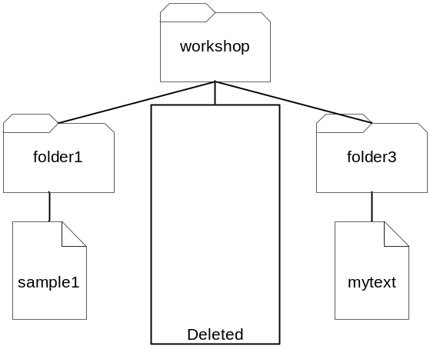
Figure 6. Task One Output

Hands-on 3 [Text editors]
(Duration: 15 minutes)

In this hands-on, you will learn:
- How to use pico, emacs and vim.

1. Using PICO
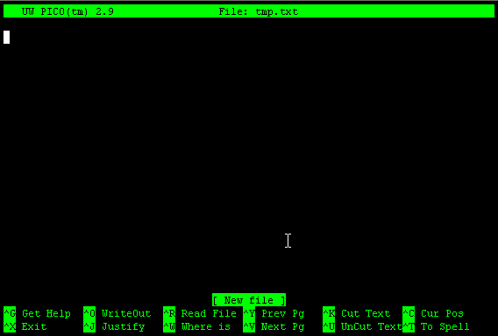
Figure 7. pico editor

pico is a simple text editor in UNIX. Its interface as shown in Figure 7. The bottom of the screen shows the shortcuts for efficient usage.
Syntax: pico filename

The following is a list of useful pico commands.
- CTRL-G Display appropriate help text
- CTRL-F or right-arrow Move Forward a character.
- CTRL-B or left-arrow Move Backward a character.
- CTRL-P or up arrow Move to the Previous line.
- CTRL-N or down-arrow Move to the Next line.
- CTRL-A Move to the beginning of the current line.
- CTRL-E Move to the end of the current line.
- CTRL-V Move forward a page of text (page down).
- CTRL-Y Move backward a page of text (page up).
- CTRL-W Search for text (where is), ignoring case.
- CTRL-D Delete the character at the cursor position.
- CTRL-K Delete the entire line at the cursor position.
NOTE: Consecutive deletes append lines to a buffer which subsequent undeletes will write at the current position.
- CTRL-U Undelete the last deleted line(s) at the current cursor position.
- CTRL-I Insert a <TAB> at the current cursor position.
- CTRL-J Format (justify) the current paragraph. Paragraphs are delimited by blank lines or indentation.
- CTRL-T Invoke the spelling check. Possible incorrect words are shown in context.
- CTRL-O Output the current buffer (file), saving it.
- CTRL-X Exit pico, saving buffer (file).

Task Two
- Change directory to ~/workshop/folder3.
- pico index.htm
- Do some textual input, explore the commands given above.
- The final content should be similar to Figure 8.
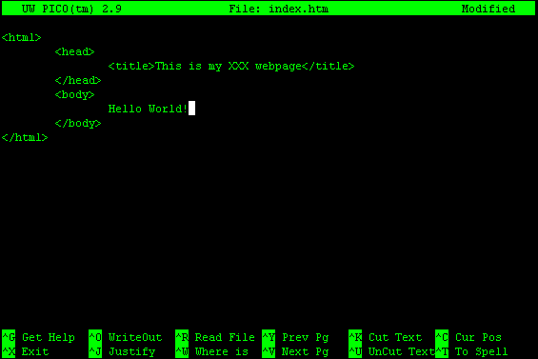
Figure 8. The final content of mytext
2. Using Emacs [optional]
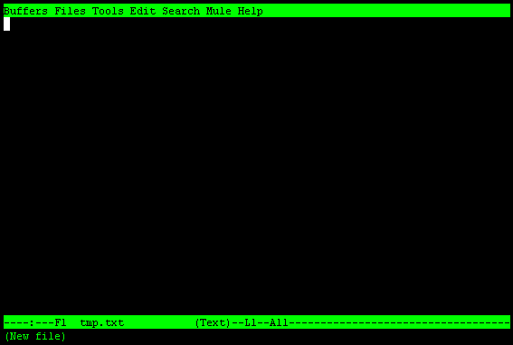
Figure 9. emacs editor

emacs is a freeware UNIX text editor available from the Free Software Foundation. With emacs you can create, view, and modify the contents of ordinary text files.
Syntax: emacs filename

The following is a list of basic emacs commands.
- CTRL-A Beginning of line
- CTRL-E End of line
- CTRL-V Page down
- Esc-V Page up
- CTRL-D Delete character at cursor
- CTRL-K CTRL-K Kill (and remember) entire line
- CTRL-K CTRL-K CTRL-Y Copy (remember) a line
- CTRL-Y Paste remembered line(s)
- CTRL-A DEL Join line to end of previous line
- CTRL-X U Undo
- CTRL-X CTRL-S Save file
- CTRL-X CTRL-C Exit

3. Using VIM [optional]
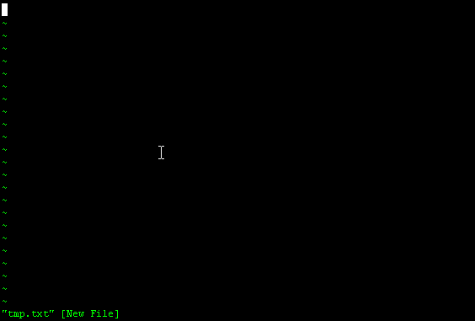
Figure 10. vim editor

vim is a very powerful editor in UNIX. It offers syntax highlighting for most of the programming languages such as Java, C, Perl etc… It includes complex and useful functionalities such as find and replace with regular expressions.
Syntax: vim filename

If you are keen, try vimtutor to teach you how to use vim.
Hands-on 4 [Mail & SoC Forum]
(Duration: 15 minutes)

In this hands-on, you will learn:
- How to use read and manage mails using pine.
- Setup Unix Mail using MS Outlook.
- How to read bulletin board using bbs.
- Setup Bulletin Board using MS Outlook.
- How to access SoC Forum at IVLE

1. Read and Manage mails
pine (Program for Internet News and Email) is a mail client in UNIX that allows you to receive and send mail via your UNIX account.

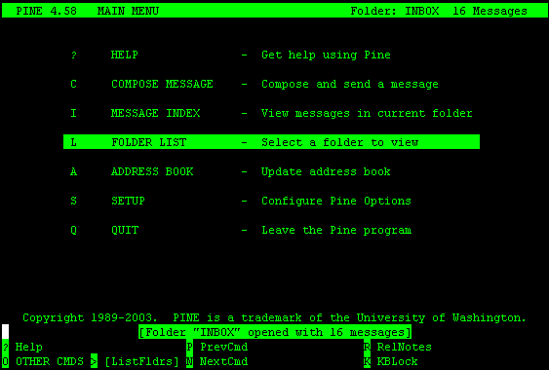
Figure 11. pine main menu

To execute pine, type pine in UNIX shell and you will see a screen similar to Figure 10. To access help, press (?) Question Mark.

1.1 Check Mail Messages
- Go to “Folder List” and then select Inbox.
- The messages marked with ‘N’ markers are new messages.
- Select the message by highlighting the message and ENTER to read the content of the message.
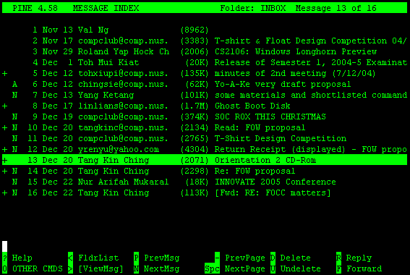
Figure 12. Pine Inbox Interface

1.2 Compose a message (refer to Figure 12)
- Go back to “Main Menu”, select “Compose Message”.
- You will have to provide the receiver’s address and subject.
- To add an attachment, press CTRL+J.
- To send the message, press CTRL+X.
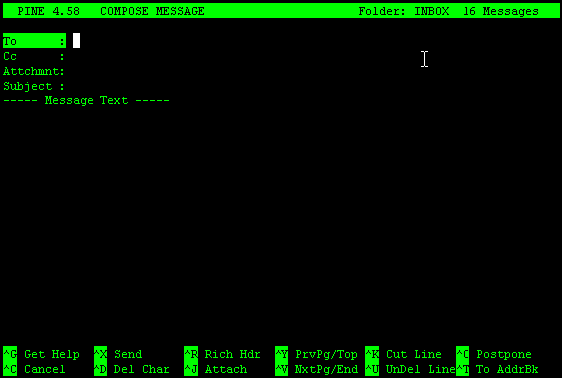
Figure 13. Pine Compose a Message Interface

Task Three
- Send a normal greeting email to your partner.
- Check to make sure that you have received your partner’s mail.
- Create a mail with attachment and send to your partner.
- Check that you have received your partner’s mail and attachment.

1.3 Setup Unix Mail using MS Outlook [Optional]
- Launch Outlook Express 5
Under Tools -> Accounts
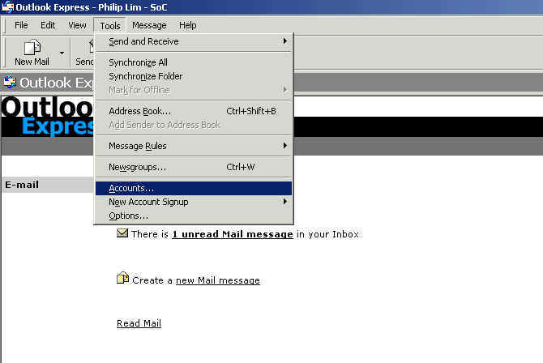
- In the Internet Accounts
Click on Add -> Mail
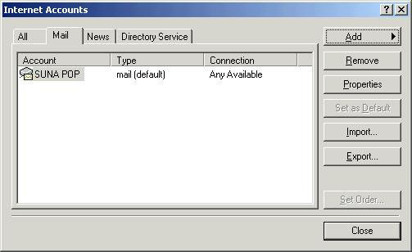
- When prompted type your name
Click Next
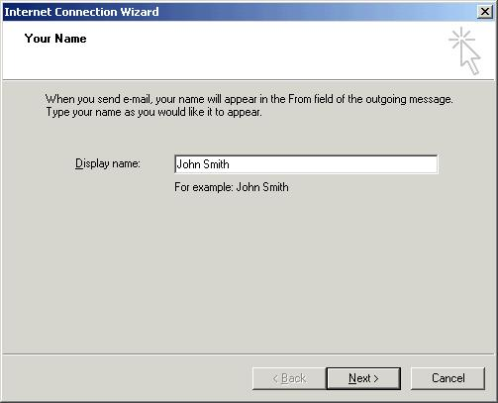
- Enter email address => your SoC email address (xxxxxxxx@comp.nus.edu.sg)
Click Next
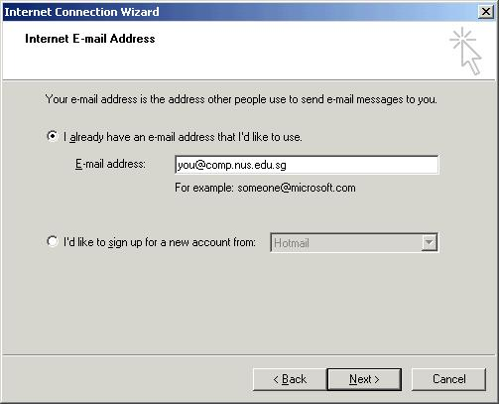
- Select IMAP
Enter incoming mail server:
For SoC staff only : stfimaphost.comp.nus.edu.sg
For SoC Research staff only: rstaffimaphost.comp.nus.edu.sg
For Non-SoC staff, students and others: stuimaphost.comp.nus.edu.sg
Enter outgoing mail server: mailauth.comp.nus.edu.sg
Click Next
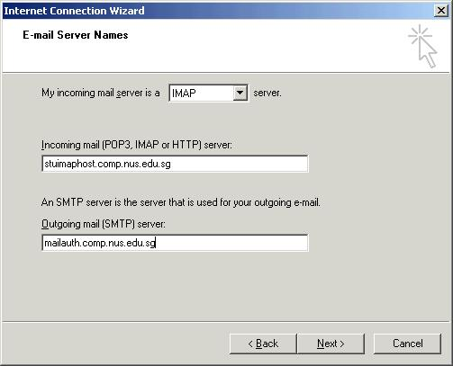
- Enter your unix account id:
Uncheck Remember password if you do not want your machine to remember your password.
Click Next
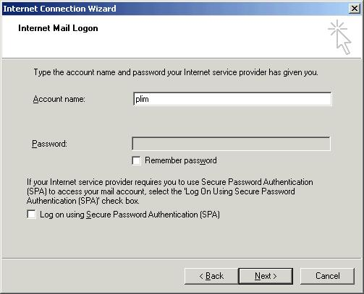
- Click Finish
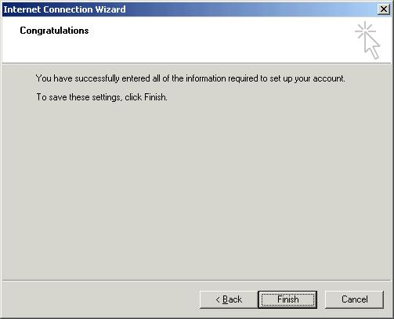
- After the above steps, now right click on stfimaphost.comp.nus.edu.sg (or whatever you just created and named)
Select Properties
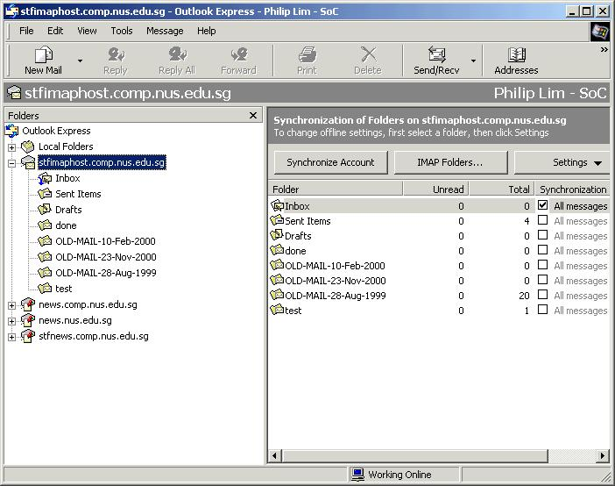
- Go to the Servers Tab.
Check My server requires authenication
Click on Settings...
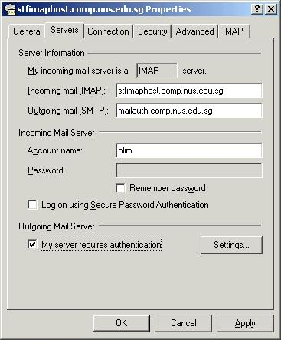
- Select Use same settings as my incoming mail server
Click OK
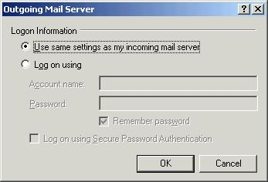
- Select the Advanced Tab.
Check This server require a secure connection (SSL) for both incoming and outgoing mail.
Click Apply, then click OK.
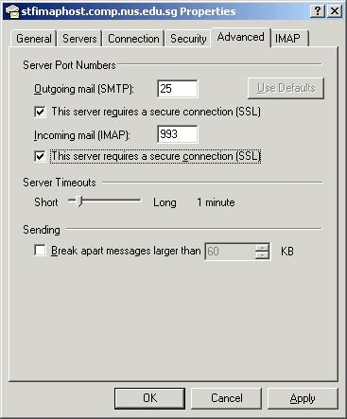
- That is it. DONE!
You can now read your mail using IMAP/SSL with Outlook Express 5.
[extracted from SoC Central Facility, https://www.comp.nus.edu.sg/cf/]

1.4 Using webmail [Optional]

You may also access emails via the webmail service at this URL:
https://mysoc.nus.edu.sg/~webmail
2. SoC Forum at IVLE
We also have an SoC Forum at the IVLE (Integrated Virtual Learning Environment).

The IVLE was set up by the university primarily to support teaching. Lecturers are able to mount their module contents and resources via IVLE. It supports facilities such as forums where students can participate in discussion, and workbins where notes and assignments are deposited by the lecturers and also where students submit their assignments to.

To access the SoC Foum, you need to get into IVLE:
http://ivle.nus.edu.sg

Click on the “Communities” tab and you should be able to see SoC Forum as one of the items in the list. Click on the “SoC Forum” and it will bring you there. (Note that the forum is currently unavailable as it is being migrated to the new IVLE 8.0. This might take some time.)

Hands-on 5 [Setup web pages]
(Duration: 15 minutes)

In this hands-on, you will learn:
- How to setup basic HTML pages.
- How to do a file transfer.

1. Setup HTML page
SoC provides each UNIX account user a web account which can be assigned through http://www.comp.nus.edu.sg/~yourusername. In order to allow people to view your web pages, some configurations and settings are required.

Task Four
- Create a directory public_html in your home directory.
- Copy the file index.htm in the folder3 directory your created earlier in Task Two to the directory ~/public_html.
- In home directory (you MUST be in your home directory before executing the following steps, if you are not sure, type “cd ~” without quotes), set the following permission settings.
  - chmod 711 ./
  - chmod 711 ./public_html
  - chmod 744 ./public_html/index.htm
- Check whether your webpage is working using the browser.

2. File transfer using SSH
You can transfer your files from your machine to UNIX Server and vice versa by using SSH Secure File Transfer Client. In order to open the SSH SFTP window, you need to click on the SSH Window. A window shown in Figure 15 will pop up.

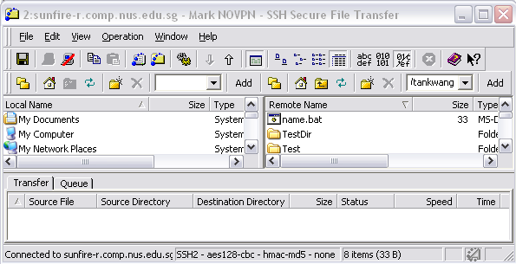
Figure 15. SSH SFTP Window
References

SoC Resources
For more information on Unix, please refer to this link.
- https://www.comp.nus.edu.sg/cf/
Dean’s Welcome Tea 2007:
- http://www.comp.nus.edu.sg/corpcomm/dwt2007/

General
- http://www.ee.surrey.ac.uk/Teaching/Unix/ [Recommended]
- http://www.ssc.upenn.edu/HELP/unix/Commands.Help
- http://www.sloppycode.net/nix/

Files & Directories
- http://www.itd.umich.edu/itcsdocs/s4148/
- http://www.isu.edu/departments/comcom/unix/workshop/fstour.html
- http://www.udel.edu/topics/os/unix/general/filemgmt.html

Editors
- http://www.itd.umich.edu/itdoc/r/r1172/ [vi]
- http://www.math.utah.edu/lab/unix/emacs-brief-tutorial.html [emacs]
- http://www.cs.indiana.edu/eip/tutorial.html [emacs]
- http://www.itd.umich.edu/itcsdocs/r1168/ [pico]

Mail Message
- http://www.washington.edu/pine/
- http://www.ksu.edu/InfoTech/e-mail/docs/pine/

