INF2001 - Introduction to Software Engineering

Labtorial Week 4 - Class & Sequence Diagram Assignment
Group Members: Melvyn (Student), Jorden (Student), Marcus (Faculty), Shahirah (Analyst), Alberto (Analyst), Hannah (Analyst)
Submitted by: Melvyn (own completed use cases - UC1, UC2 - highlighted in yellow)
Scenario: SIT is preparing to launch an Entrepreneurship Education Programme. A faculty committee plans to develop a web portal that allows students to subscribe to news about relevant activities (Hackathons, Workshops, Symposiums, Boot Camps, Innovation Challenges, etc.), so the committee can disseminate updates to subscribed students.

1. Object-Oriented Analysis

1.1 Solution Abstract
Students register for a portal account and log in through the SIT SSO Gateway. Once logged in, a student subscribes to one or more activity categories, and can manage or unsubscribe from these subscriptions. A student can also view the event listing. A faculty member creates an announcement for an activity, saves it as a draft, and submits it for approval. A second faculty member approves the announcement, after which the system publishes it and the Notification service sends event notifications to subscribed students through the Email Gateway. Faculty can also view a subscriber report summarising subscriptions by category.

1.2 Candidate Classes (noun extraction) and CRC cards
Nouns from the solution abstract and the Week 3 use cases were filtered to entity classes. The table lists each class with its responsibilities and collaborators (CRC card).
Class | Responsibilities | Collaborators
Student | Register, verify account, log in, manage subscriptions, view events, receive notifications | Account, Subscription, Notification
Faculty | Log in, create/submit/approve announcements, view subscriber reports | Account, Announcement, SubscriberReport
Account | Represent a portal account; authenticate via SSO, trigger verification email | Student, Faculty, SSOGateway, EmailGateway
Subscription | Track a student's subscribed categories; add/remove categories | Student, Category
Category | Represent an activity category (e.g. Hackathon, Boot Camp) | Subscription, Announcement
Announcement | Hold event details; move through draft/pending/published/rejected states | Faculty, Category, Notification
Notification | Deliver announcements to subscribed students; retry on failure | Student, Announcement, EmailGateway
SubscriberReport | Aggregate subscriber counts by category for planning | Subscription, Faculty
SSOGateway (external) | Authenticate users via SIT single sign-on; validate tokens | Account
EmailGateway (external) | Send verification links and event notifications by email | Account, Notification

2. UML Use Case Diagram
All 12 use cases with their actors, including the external SSO Gateway and Email Gateway. «include» marks mandatory sub-goals (e.g. logged-in actions include UC2 Log In; UC1/UC2/UC7 include the gateways). «extend» marks optional behaviour (e.g. UC9 Save as Draft and UC10 Submit for Approval extend UC8 Create Announcement).
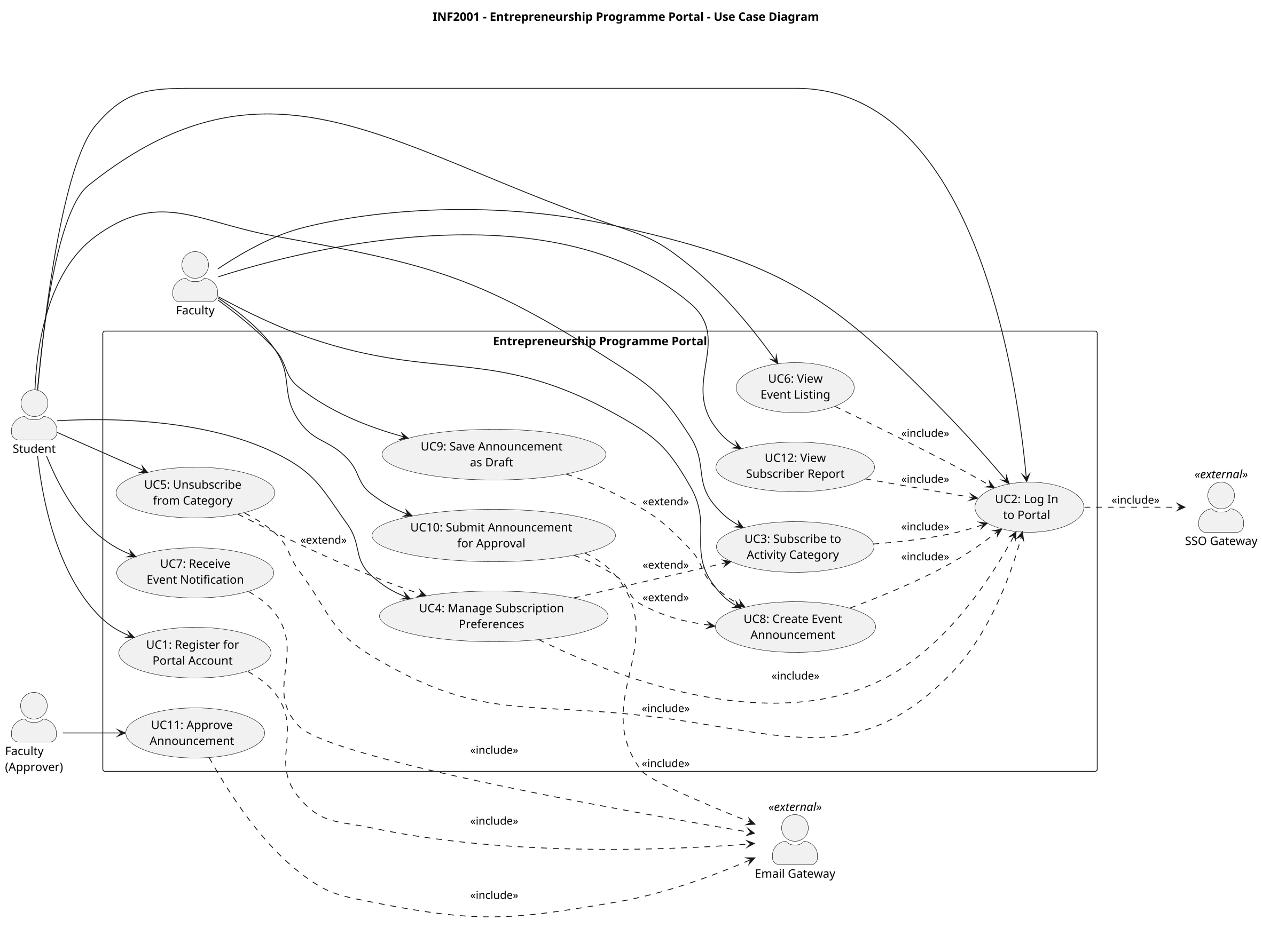

3. UML Class Diagram
All identified entities with attributes, operations, visibility markers (+ public, - private, # protected), associations with multiplicities, generalisation, and status enumerations. The external SSO Gateway and Email Gateway are modelled as «external» classes the portal depends on.
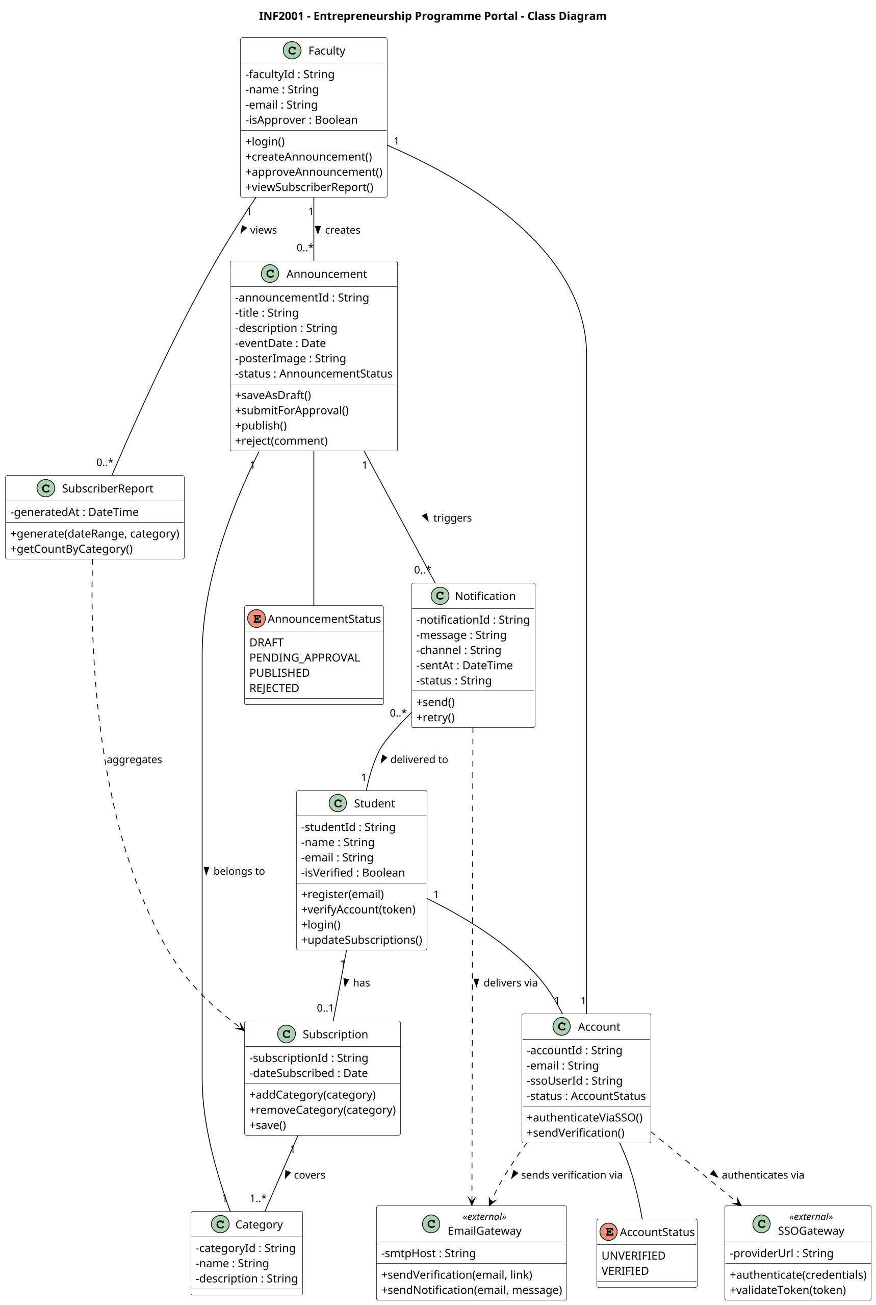

4. UML Sequence Diagrams
One sequence diagram per use case, showing participants, messages, return arrows, activation and alt/opt frames. UC1, UC2, UC7, UC10 and UC11 route through the external SSO Gateway and/or Email Gateway. Use cases highlighted in YELLOW (UC1 and UC2) were completed by Melvyn, the student submitting this document.

UC1: Register for Portal Account (by Melvyn)
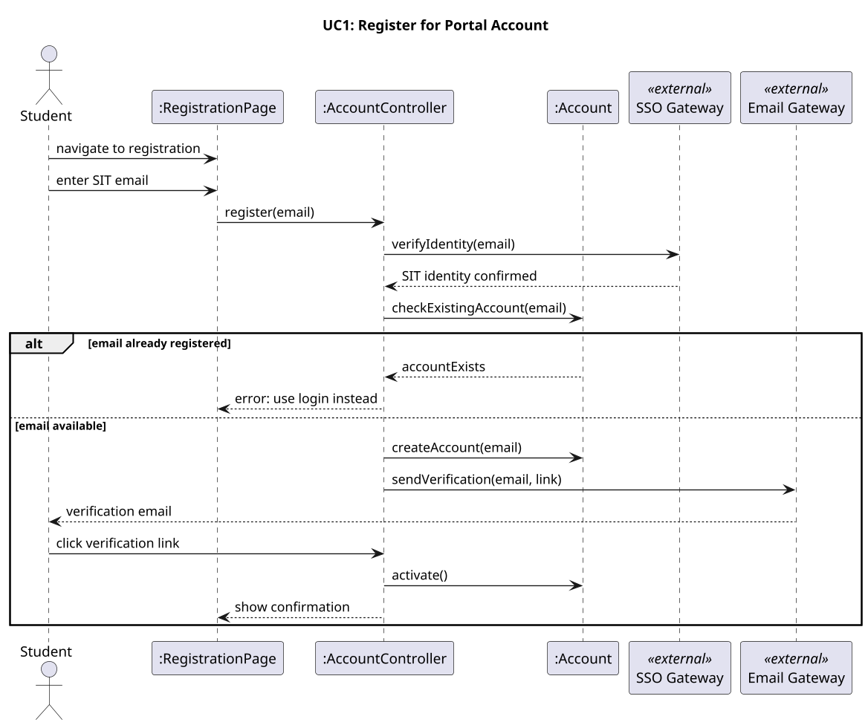

UC2: Log In to Portal (by Melvyn)
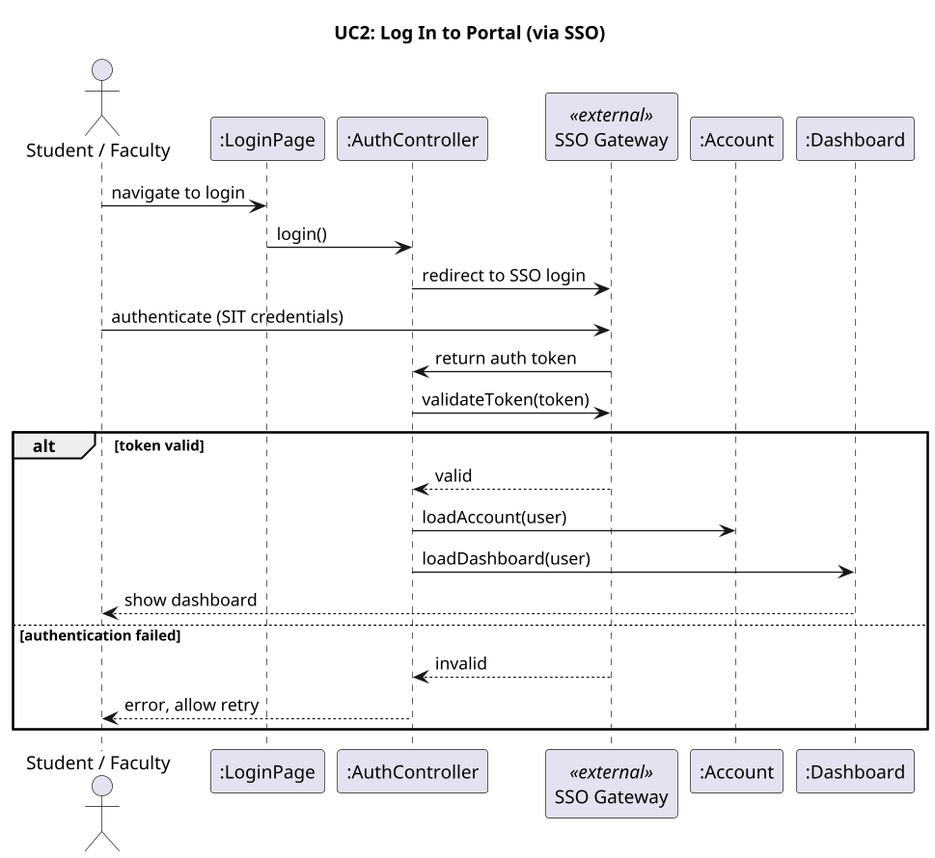

UC3: Subscribe to Activity Category (by Jorden)
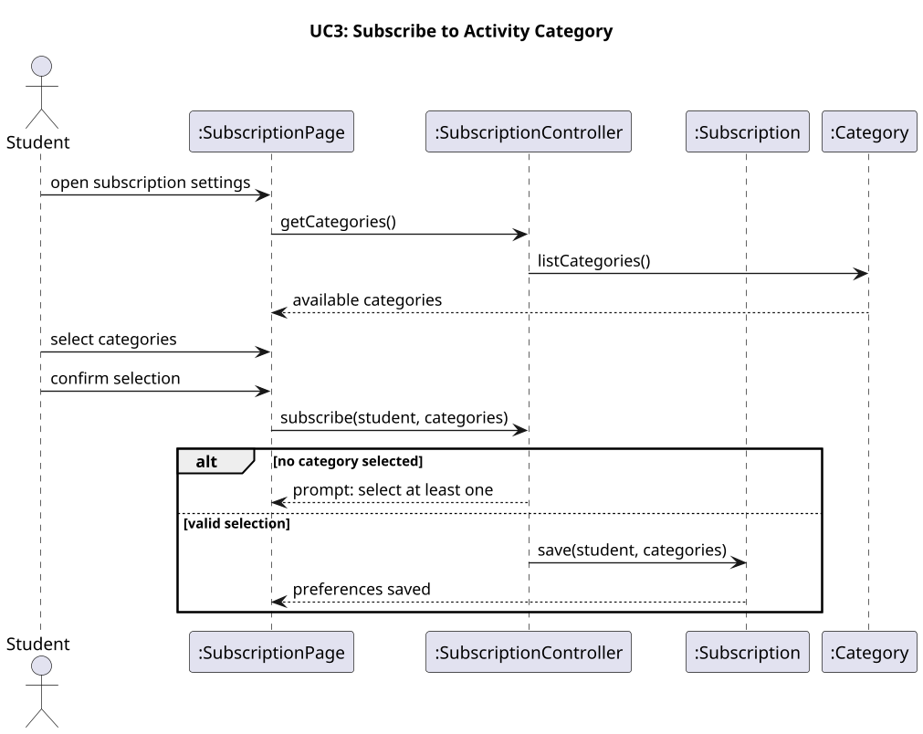

UC4: Manage Subscription Preferences (by Jorden)
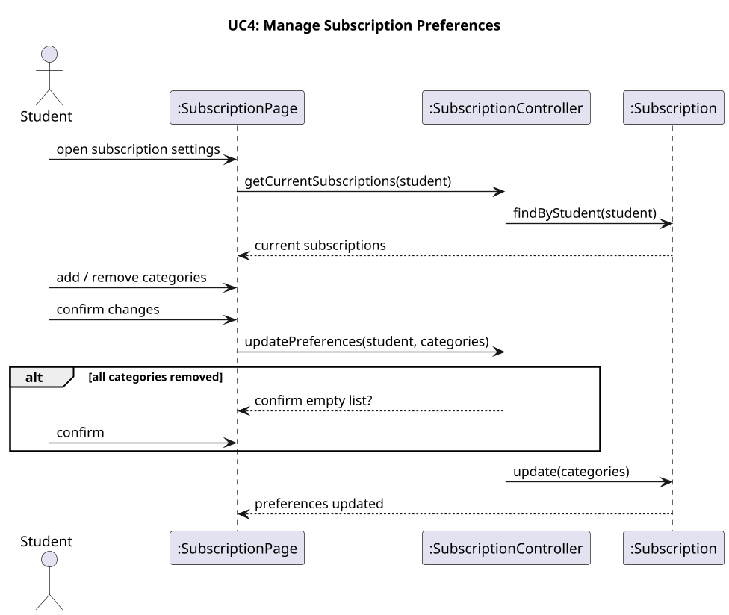

UC5: Unsubscribe from Category (by Shahirah)
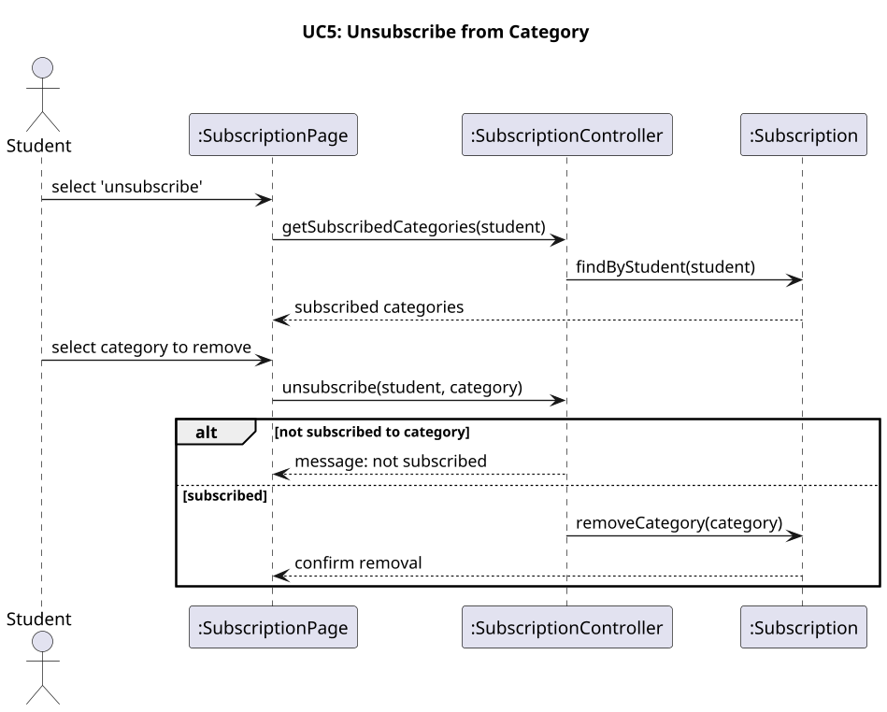

UC6: View Event Listing (by Shahirah)
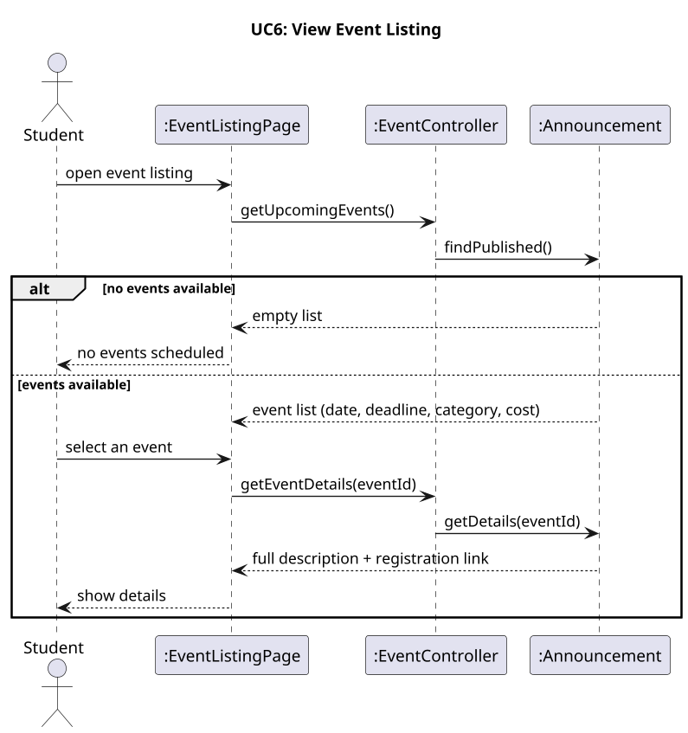

UC7: Receive Event Notification (by Alberto)
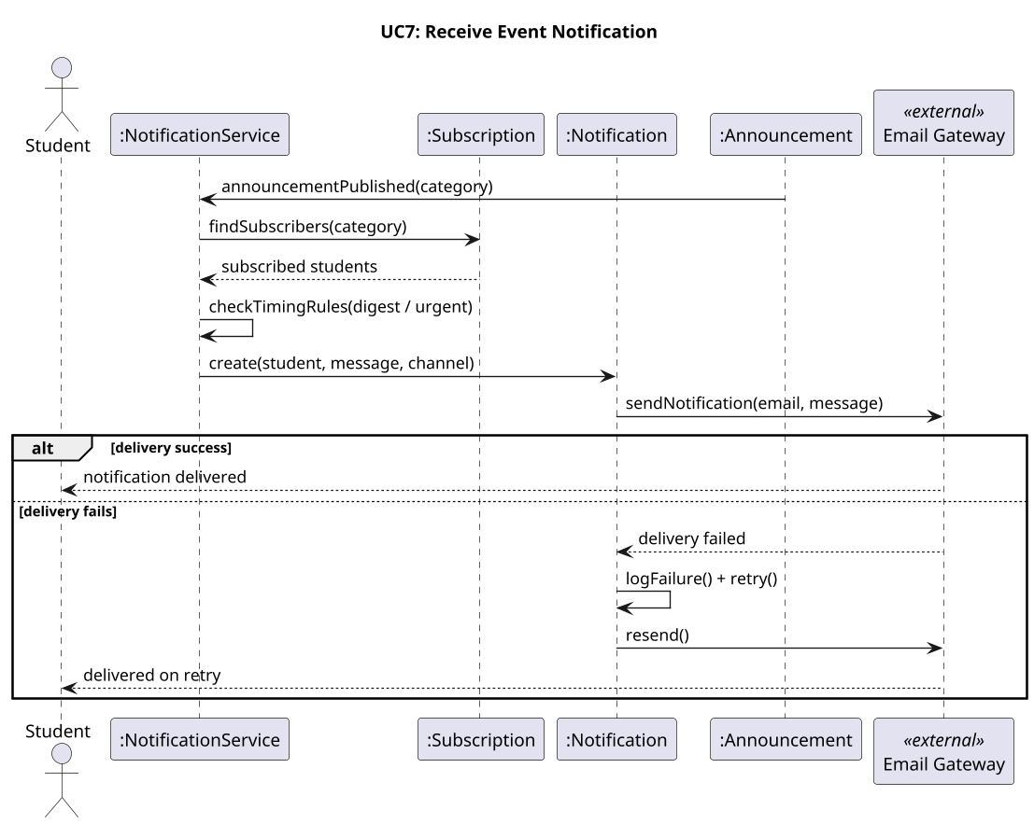

UC8: Create Event Announcement (by Alberto)
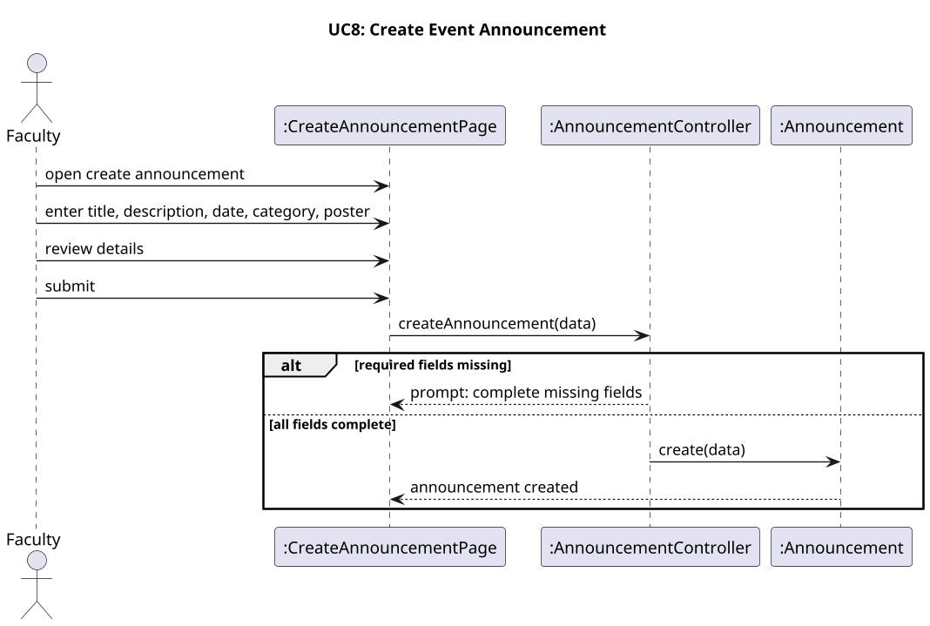

UC9: Save Announcement as Draft (by Marcus)
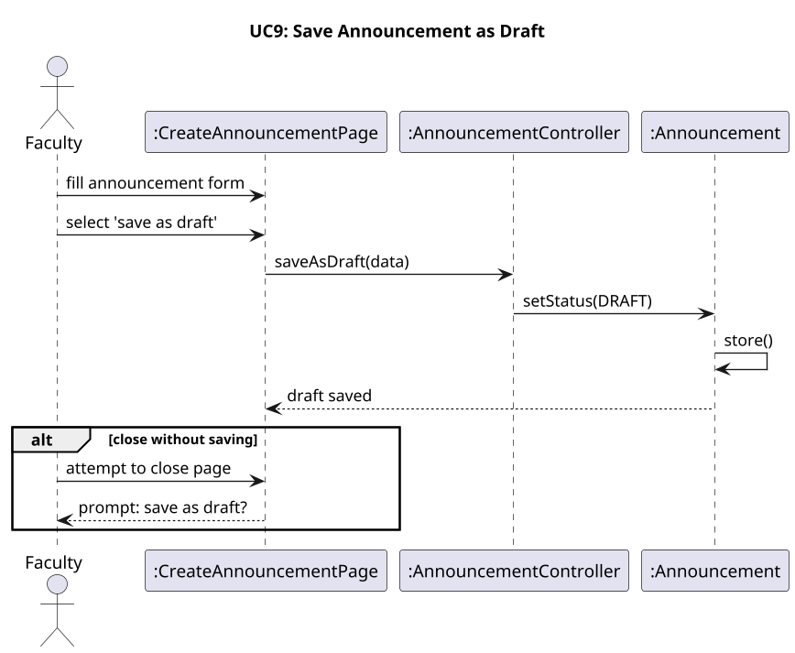

UC10: Submit Announcement for Approval (by Marcus)
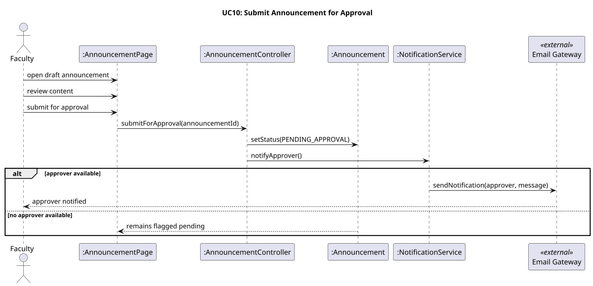

UC11: Approve Announcement (by Hannah)
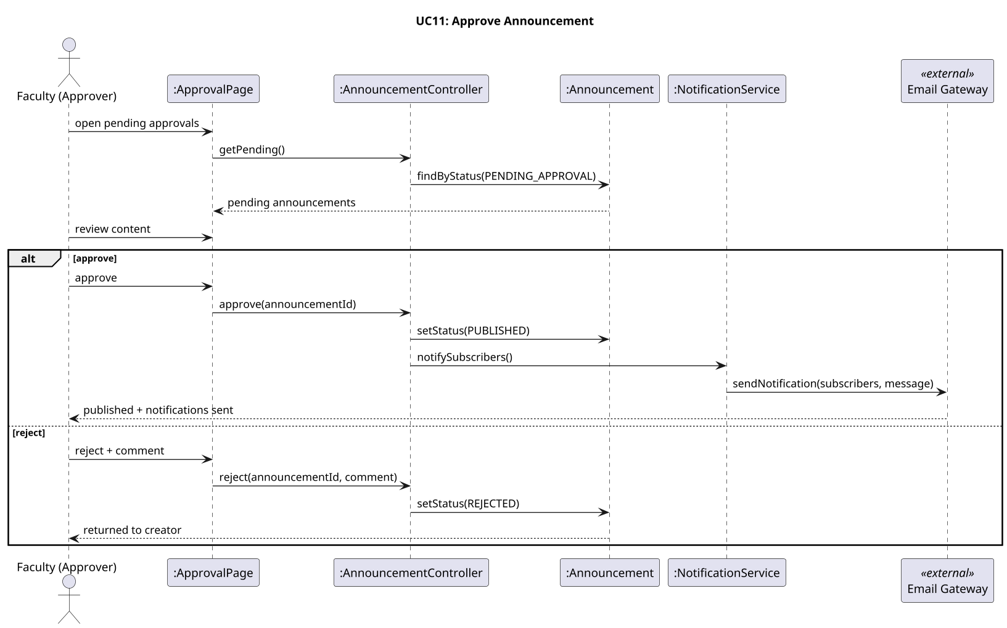

UC12: View Subscriber Report (by Hannah)
