Equipment / Item Description | Qty | Unit Price | Line Total | Business & Technical Purpose
PC Worth Shadow Phaser Workstation | 2 | ₱125,870.00 | ₱251,740.00 | High-performance desktop towers equipped with modern high-end processors, dedicated GPUs, and high-speed DDR5 memory. Essential for executing heavy computational tasks, rapid code compilation, database management, and local model training without system bottlenecks.
Nvision 22" IPS 120Hz Monitor (N2255GP-B) | 4 | ₱3,849.00 | ₱15,396.00 | Dual-monitor configuration (2 units per developer). Dual displays significantly increase development productivity by allowing side-by-side code editing, database monitoring, and documentation reviewing.
Logitech Meetup 4K Conference Camera | 1 | ₱69,412.00 | ₱69,412.00 | Enterprise-grade 4K Ultra-HD camera and full-duplex speakerphone. Dedicated for video conferencing, team syncs, stakeholder demonstrations, and hybrid meeting environments.
CyberPower UPS UT2200EG (2200VA / 1320W) | 1 | ₱6,549.00 | ₱6,549.00 | High-capacity Line-Interactive Uninterruptible Power Supply with Automatic Voltage Regulation (AVR). Protects workstations against sudden power outages, voltage spikes, and brownouts, preventing data corruption and hardware damage during critical tasks.
ANKER Soundcore Q20i Hybrid ANC Headphones | 2 | ₱2,695.00 | ₱5,390.00 | Active Noise Cancelling headsets for developer focus during complex tasks and clear audio during remote communication.
AULA F99 Mechanical Keyboard | 2 | ₱3,665.00 | ₱7,330.00 | Ergonomic, tactile input devices for daily development comfort and long-hour typing durability.
VXE Dragonfly R1 SE+ Wireless Mouse | 2 | ₱1,320.00 | ₱2,640.00 | Lightweight, precise optical mice for high-accuracy desktop navigation and workflow management.
TOTAL |  |  | ₱358, 457.00

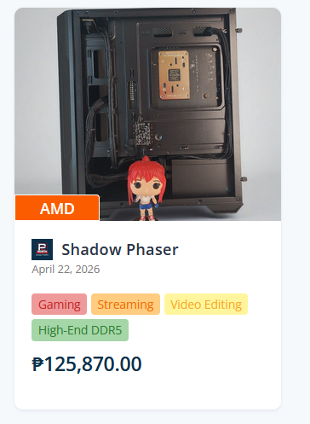
Pre-built Desktop Computer from PC Worth Shadow Phaser

AULA F99 Mechnical Keyboard (Side Carving-Greywoodshaft)
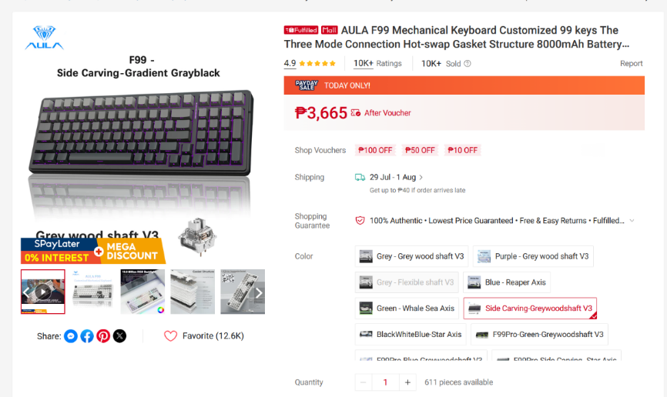

VXE Dragonfly R1 SE+ (500 mAh) Black
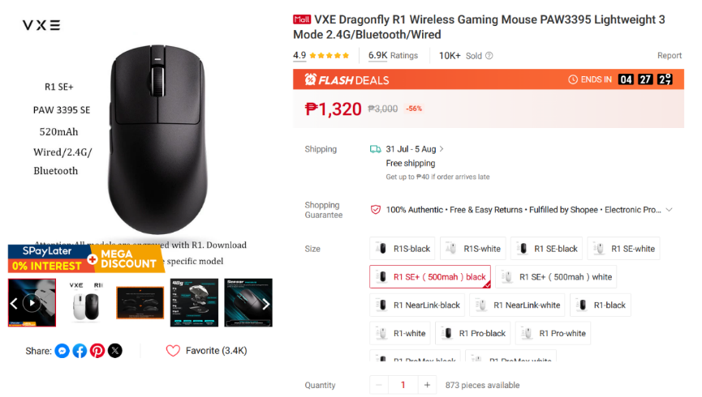

CyberPower UPS UT2200EG 2200VA/1320W
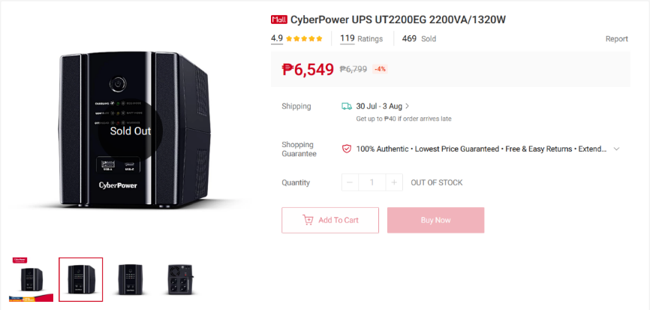

Nvision 22" IPS Monitor 120HZ FHD 100P Monitor N2255G
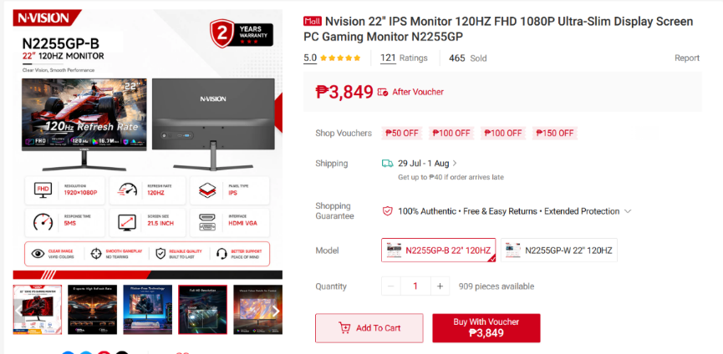

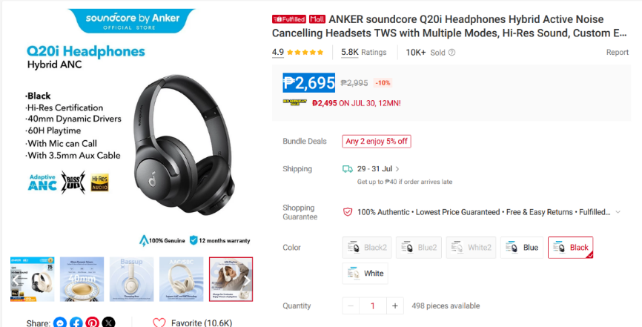
ANKER Soundcore Q20i Headphones

Logitech Meetup Video Conference Camera
