GeoMERIT: an open-source tool for reproducible target-specific selection of near-surface geophysical methods
Mahmoud M. Elwaheidi ^{1,*}
1 King Saud University, College of Science, Department of Geology and Geophysics, Riyadh 11451, Saudi Arabia.
* Corresponding author. Email: melwaheidi@ksu.edu.sa. ORCID: 0000-0003-4863-3184

Abstract
The selection of a geophysical method for a near-surface investigation strongly shapes the outcome of environmental, engineering, and hydrological surveys, yet it is usually made by tacit expert judgement that is difficult to document, justify, or reproduce. This paper presents GeoMERIT, an open-source, knowledge-based tool that makes this selection systematic and transparent for nine common near-surface methods. Using a weighted sum model, GeoMERIT scores each method against four criteria, physical-property contrast, data quality, cost, and time and effort, modulated by site-specific adjustment factors for target depth, ambient noise, and ground conductivity. Central to the tool is an explicit method-by-target physical-property-contrast matrix, derived from established geophysical references, that conditions every recommendation on the specific investigation target rather than on generic method resolution, so that the reasoning behind a recommendation is fully inspectable and reproducible. The tool is evaluated against documented field practice without recourse to human subjects. At three documented coastal-aquifer and landfill sites the top-ranked method matches the deployed method at two of three, with the deployed method within the top two at all three. In a reproducible benchmark of 22 documented field cases spanning groundwater, void, and archaeological targets, the deployed method is ranked first in 45.5% of cases and appears within the top-three shortlist in 81.8%; this agreement is stable to parameter encoding and to the choice of criterion weights, and a target-aware formulation outperforms a target-blind control, evidence that target-specific contrast carries genuine information. First-place agreement nonetheless concentrates in targets for which resistivity or radar methods are physically dominant, a limitation reported plainly and analysed. GeoMERIT is offered as a transparent, reproducible resource for training, survey planning, standardization, and quality assurance in near-surface geophysics.
Keywords: geophysical method selection; multi-criteria decision analysis; physical-property contrast; near-surface geophysics; open-source software; reproducible research.

1. Introduction
The selection of an appropriate geophysical method is a cornerstone of successful near-surface investigations in environmental, engineering, and hydrological applications (Reynolds, 2011). A wide array of techniques is available, each with distinct strengths, weaknesses, and operational requirements, and the choice among them is typically made through expert judgement (Everett, 2013). This reliance on subjective expertise creates recurring difficulties: method selection that is inconsistent across practitioners and institutions, survey designs that are suboptimal for less experienced or non-specialist users, and methodological choices that are difficult to document and justify for quality assurance and peer review.
This paper presents GeoMERIT (Geophysical Method Evaluation and Ranking by Investigation Target), an open-source software tool that makes this decision systematic, transparent, and reproducible. GeoMERIT applies a weighted sum model, a straightforward multi-criteria decision technique, to rank nine common near-surface methods (ERT, IP, SP, GPR, TEM, seismic refraction, magnetometry, gravity, and radiometric) for a stated investigation scenario. Each method is scored against four weighted criteria, physical-property contrast (40%), data quality (30%), cost (20%), and time and effort (10%), and the scores are refined by site-specific adjustment factors for target depth, ambient noise, and ground conductivity. The element that most strongly governs the behaviour of the tool is an explicit method-by-target physical-property-contrast matrix: the score a method receives for detecting the target is conditioned on what the target is, for example a saturated or saline aquifer, an air- or water-filled cavity, or a shallow archaeological feature, rather than on a generic, target-independent measure of resolution.
Because the contrast matrix and the method-capability parameters encode established geophysical knowledge, GeoMERIT is offered not as an independent predictor but as a transparent and auditable means of operationalizing that knowledge. Its outputs are evaluated in two complementary layers that involve no human subjects. First, in a retrospective field test, the rankings are compared with the methods actually deployed at three documented coastal-aquifer and landfill sites in Saudi Arabia, each with independent borehole and hydrochemical ground truth. Second, a reproducible benchmark of 22 documented field cases, extracted from the peer-reviewed literature and spanning groundwater, void, and archaeological targets, tests how consistently the tool reproduces the method chosen in real, published, successful surveys. A target-blind variant that replaces target-specific contrast with a generic resolution constant provides a diagnostic control, and a Monte Carlo analysis establishes that the reported agreement is stable to the way qualitative site parameters are encoded.
This work makes three contributions. First, and centrally, it delivers GeoMERIT, an openly licensed and archived software tool that operationalizes geophysical method selection and is usable for training, project planning, standardization, and quality assurance. Second, the tool is built on an explicit, literature-derived method-by-target physical-property-contrast matrix together with scientifically justified adjustment factors for depth, noise, and conductivity, all of which the user can inspect and modify, and the implementation is fully reproducible, with a single set of scripts regenerating every reported ranking, table, and figure from documented parameters. Third, the tool is benchmarked against documented field practice across 22 published cases and three retrospective field sites, with a target-blind diagnostic and a Monte Carlo robustness analysis, an evaluation that clarifies both where the tool agrees with established practice and, equally important, the specific conditions under which the present criteria diverge from it.

2. Background
Multi-criteria decision analysis (MCDA) provides a structured approach for evaluating multiple, conflicting criteria in decision-making (Malczewski, 1999). It has been applied widely in environmental management (Huang et al., 2011), resource allocation (Greene et al., 2011), and engineering design (Zardari et al., 2015), with extensive reviews spanning sustainable energy planning (Kumar et al., 2017; Pohekar and Ramachandran, 2004), coastal management (Zekic et al., 2025), water resources (Zhu et al., 2019), and the energy sector (Basilio et al., 2022; Loken, 2007). Within the geosciences, MCDA has supported landslide-susceptibility mapping (Feizizadeh et al., 2014), groundwater-potential zoning (Jha et al., 2007), and waste-disposal site selection (Sener et al., 2010). Its application to the fundamental problem of geophysical method selection, however, remains underexplored.
Few dedicated aids exist to support this decision in a standardized, documented way. Those that do tend to be narrow in scope, for example spreadsheet tools limited to a single class of investigation, and they rarely expose the physical reasoning behind a recommendation or allow that reasoning to be inspected and revised. GeoMERIT is designed to address this gap. It is intended not to replace expert knowledge but to encode it transparently, so that recommendations are consistent across practitioners, justifiable for quality assurance, and straightforward to inspect, modify, and extend. Framing method selection as an explicit weighted sum over documented physical-property contrasts also makes the tool falsifiable in a way that tacit judgement is not: its recommendations can be compared directly against what practitioners actually did in the field, which is the evaluation strategy adopted here.
Recent advances in machine learning have stimulated interest in data-driven decision-support systems for geoscientific applications. Most machine-learning models, however, require large and representative training datasets that are rarely available for geophysical survey design, and their internal decision processes are often difficult to interpret. Knowledge-based systems, by contrast, encode established physical principles explicitly, so that every recommendation can be inspected, modified, and traced directly to documented geophysical reasoning. For applications in which transparency, reproducibility, and scientific auditability are essential, such as survey planning and educational training, this interpretability is a substantial practical advantage over purely data-driven approaches. GeoMERIT therefore complements rather than competes with machine-learning methods, providing an explainable, physics-based framework whose assumptions remain fully accessible to the user.

3. The GeoMERIT framework

3.1. Scoring model, criteria, and weights
GeoMERIT implements a weighted sum model in which each geophysical method is scored against four criteria and the total score is the weighted sum of the individual criterion scores. A scenario is specified by the investigation target, the target depth, the prevailing site conditions of ground conductivity and ambient noise, the budget and schedule constraints, and the required resolution. For every method the tool computes a physical-property-contrast score conditioned on the target, a data-quality score, a cost score, and a time and effort score, modulates these by adjustment factors for depth, noise, and conductivity, and returns the full ranked list of methods with their numerical scores. The nine methods evaluated are electrical resistivity tomography (ERT, which subsumes DC resistivity and vertical electrical sounding, with which it shares its governing physics and measurement principle), induced polarization, self-potential, ground-penetrating radar (GPR), time-domain electromagnetics (TEM), seismic refraction, magnetometry, gravity including its microgravity variants, and radiometric surveying. The complete decision pathway is summarized in Figure 1, and the method-capability parameters used by the tool are listed in Table 1. The optimal depth range and the conductivity response of each method are drawn from standard near-surface references (Telford et al., 1990; Reynolds, 2011; Milsom and Eriksen, 2013; Butler, 2005), and the intrinsic resolution values are representative constants consistent with the comparative resolving power described in the same sources. The indicative cost and time per kilometre are representative order-of-magnitude values intended for relative comparison between methods rather than survey quotations, since actual costs and durations vary widely with country, contractor, terrain, and survey design; a user may replace them with local figures, and because the cost and time scores of Equations (4) and (5) are computed relative to the budget and schedule constraints, only the relative values of these parameters affect the ranking.
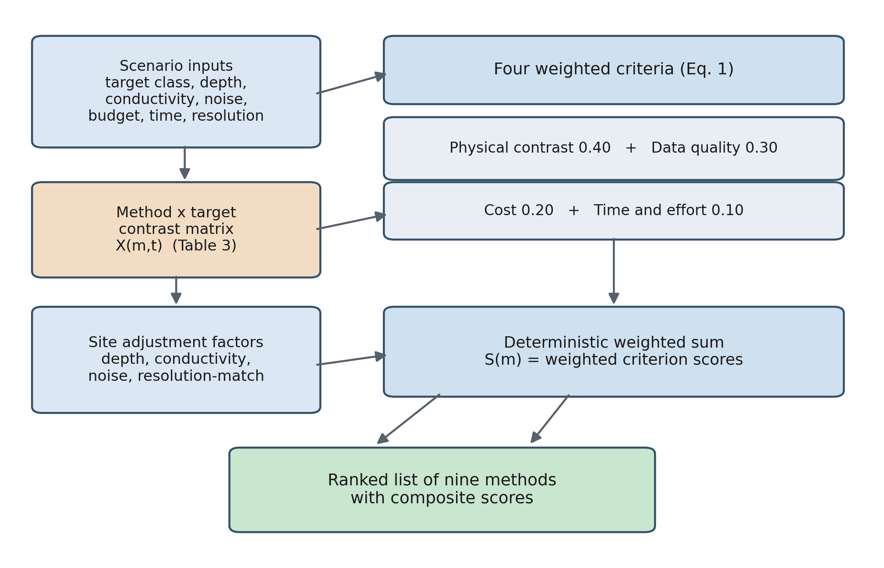
Figure 1. Decision pathway of GeoMERIT. Scenario inputs feed four weighted criteria; the method-by-target contrast matrix conditions the two physics-based criteria; site adjustment factors for depth, conductivity, noise, and resolution-match modify the criterion scores; and their weighted sum yields the ranked method recommendations.
Table 1. Method-capability parameters used by GeoMERIT. Depth range and conductivity response are from the cited near-surface references; resolution values are representative constants; cost and time per kilometre are representative order-of-magnitude values for relative comparison, not survey quotations. Conductivity response indicates whether ground conductivity attenuates the signal (attenuated), constitutes diagnostic target contrast (diagnostic), or is largely irrelevant (neutral).
Method | Depth range (m) | Resolution | Cost (USD/km) | Time (d/km) | Conductivity response
ERT | 1-100 | 0.80 | 3000 | 2.0 | Diagnostic
Induced polarization | 1-50 | 0.70 | 4000 | 2.5 | Diagnostic
Self-potential | 0.5-30 | 0.60 | 1500 | 1.0 | Diagnostic
GPR | 0.5-15 | 0.95 | 2500 | 1.5 | Attenuated (s=0.95)
TEM | 10-300 | 0.60 | 5000 | 3.0 | Diagnostic
Seismic refraction | 5-100 | 0.70 | 6000 | 4.0 | Neutral
Magnetometry | 0.5-50 | 0.65 | 2000 | 1.0 | Neutral
Gravity | 10-500 | 0.50 | 4500 | 3.5 | Neutral
Radiometric | 0-0.5 | 0.80 | 3500 | 1.5 | Neutral

The four criteria and their fixed weights, summarized in Table 2, reflect the relative importance commonly accorded to them in near-surface investigations (Milsom and Eriksen, 2013; Butler, 2005): physical-property contrast carries the largest weight because the physical basis for detecting the target is the primary determinant of whether a survey can succeed at all, data quality is weighted next, and cost and time and effort, while important operationally, are weighted below the two physics-based criteria. The weights are held constant across all scenarios, so that the scenario-dependence of a recommendation arises entirely from the target-specific contrast matrix and the site adjustment factors rather than from any adjustment of the weights, an arrangement chosen to keep the tool auditable and its behaviour reproducible. The objective justification of this weighting is examined in the results, and its stability is quantified there by a sensitivity analysis. The total score for method m is the weighted sum
S_m = 0.40 · P_m + 0.30 · Q_m + 0.20 · C_m + 0.10 · T_m (1)
in which the physical-property-contrast score P_m, the data-quality score Q_m, the cost score C_m, and the time and effort score T_m are each defined on a 0 to 100 scale by
P_m = 100 · X_{m,t} · f_depth · f_cond (2)
Q_m = 100 · X_{m,t} · f_noise · f_res (3)
C_m = max(0, 100 · (1 − c_m / B)) (4)
T_m = max(0, 100 · (1 − t_m / S)) (5)
where X_{m,t} is the physical-property-contrast value of method m for target class t, c_{m} and t_{m} are the indicative cost and time of the method, B and S are the budget and schedule constraints, and f_{depth}, f_{cond}, f_{noise}, and f_{res} are the site-specific adjustment factors. A defining feature of the model is that both physics-based criteria are anchored on the same target-conditioned contrast value: the physical-contrast score modulates it by the depth and conductivity factors that determine whether the target contrast is reachable and diagnostic at the site, and the data-quality score modulates it by the noise and resolution-match factors that determine the achievable signal-to-noise and spatial detail of the resulting image. This reflects the principle that the data quality achievable for a specific investigation is the signal-to-noise of that target physical-property contrast under site conditions, rather than the context-free resolution of the method. The cost and time scores compare each method indicative cost and duration with the budget and schedule constraints and are floored at zero, so that a method exceeding a constraint receives no credit on that criterion.
Table 2. Evaluation criteria and fixed weights.
Criterion | Weight | Description
Physical-property contrast | 0.40 | Ability to detect the specific target given the relevant physical-property contrast at the site (target-conditioned).
Data quality and resolution | 0.30 | Expected signal-to-noise and spatial detail of the image of the specific target under site conditions (target-conditioned).
Cost | 0.20 | Survey cost relative to the budget constraint.
Time and effort | 0.10 | Field acquisition and processing time relative to the schedule constraint.

3.2. Knowledge base: contrast matrix and adjustment factors
The physical-property-contrast value X_{m,t} quantifies, on a 0 to 1 scale, the physical basis for detecting a given target class with a given method, and it is the element that most strongly governs the behaviour of the tool. These values are derived from established physical-property relationships and method-applicability syntheses (Telford et al., 1990; Reynolds, 2011; Milsom and Eriksen, 2013; Everett, 2013; Butler, 2005; Loke, 1999; Binley and Kemna, 2005) and are reported in full in Table 3 and visualized in Figure 2. They are assigned from the published geophysical literature and are independent of any deployment outcome or agreement statistic, so that the field test and literature benchmark presented later evaluate the matrix against practice rather than reflecting it. The physical reasoning is direct. For groundwater and conductive contamination, detectability is governed primarily by the resistivity and conductivity contrast associated with saturation and dissolved solids, so the galvanic and electromagnetic methods, ERT, TEM, and induced polarization, receive the highest values, while GPR is strongly down-weighted because its signal is attenuated in conductive, saturated, or clay-rich ground. For void detection, the relevant contrasts are the density deficit and the resistivity or velocity discontinuity of a cavity, favouring microgravity, GPR in resistive host rock, ERT, and seismic methods. For archaeological prospection, the magnetic susceptibility and remanence of fired and ferrous features together with shallow structural contrasts dominate, favouring magnetometry, GPR, and ERT.
Table 3. Method-by-target physical-property-contrast values (X_{m,t}, 0 to 1), derived from published references and independent of any deployment outcome.
Method | Groundwater | Void | Archaeology | Primary physical basis
ERT | 0.95 | 0.80 | 0.75 | Bulk/pore-fluid resistivity contrast
TEM | 0.90 | 0.40 | 0.20 | Conductive-layer mapping; depth
Induced polarization | 0.75 | 0.35 | 0.45 | Clay/contamination chargeability
Seismic refraction | 0.70 | 0.70 | 0.25 | Velocity/water-table contrast
Self-potential | 0.55 | 0.25 | 0.30 | Fluid-flow / streaming potential
GPR | 0.30 | 0.90 | 0.92 | Dielectric contrast; high resolution
Gravity | 0.20 | 0.85 | 0.25 | Density deficit (voids)
Magnetometry | 0.15 | 0.30 | 0.90 | Magnetic susceptibility/remanence
Radiometric | 0.05 | 0.05 | 0.45 | Surface-material radioelement contrast

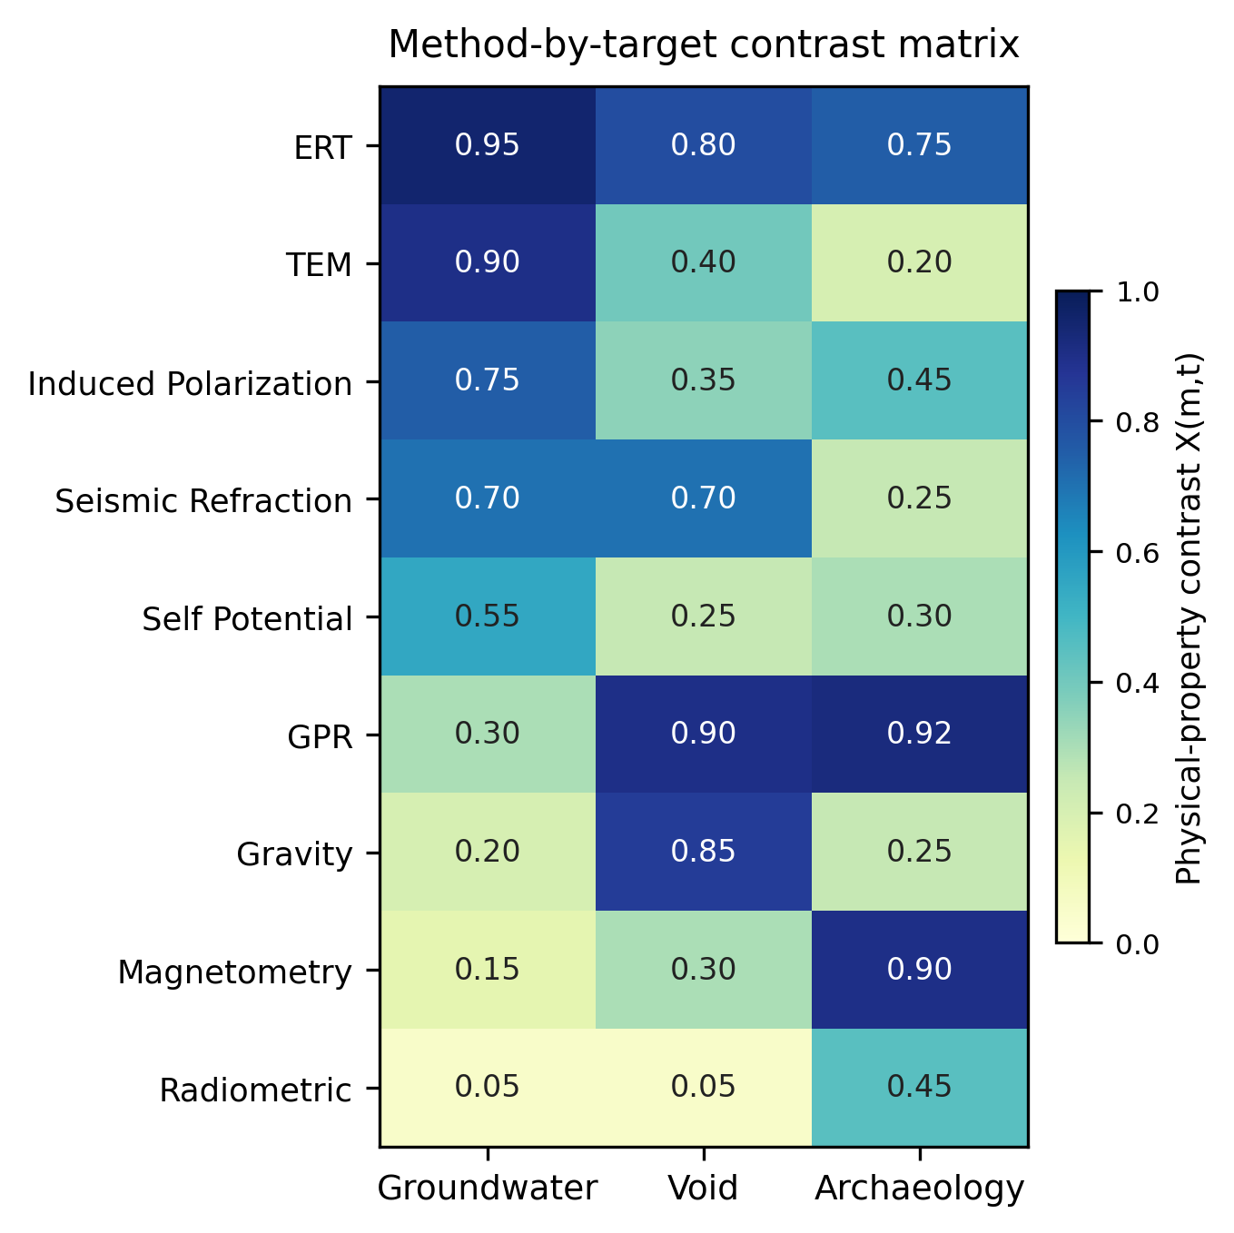
Figure 2. Heat map of the method-by-target physical-property-contrast matrix (X_{m,t}), corresponding to Table 3. Darker cells denote stronger physical suitability of a method for a target class.
Four adjustment factors modulate the criterion scores, each grounded in established geophysical behaviour, and two act on each of the two physics-based criteria. Acting on the physical-property-contrast score, the depth factor f_{depth} equals unity when a method operates within its optimal depth range and penalizes operation outside it, placing the larger penalty on the physically impossible case in which the target lies deeper than the maximum reach of the method, f_{depth} = max(0.20, 1 minus (d minus d_{max})/d_{max}), and only a mild fixed penalty of 0.85 on the over-capable case in which the target is shallower than the minimum depth of the method but the method usually remains serviceable. The conductivity factor f_{cond} distinguishes attenuation from diagnosis: for GPR, whose signal is attenuated in conductive ground, the score is reduced as f_{cond} = 1 minus s times (sigma/sigma_{max}), with sigma_{max} equal to 1000 mS/m, whereas for ERT, TEM, and induced polarization, where pore-fluid conductivity is itself the diagnostic target contrast, no penalty is applied, and for the conductivity-insensitive methods the factor is likewise unity, so that the electrical and electromagnetic methods best suited to conductive aquifers are not erroneously demoted. Acting on the data-quality score, the noise factor f_{noise} = 1 minus s times (N/100)² lowers the score according to the site noise level N in per cent and the noise sensitivity s of the method, the quadratic form reflecting the non-linear growth of noise impact, and the resolution-match factor f_{res} = min(1, r_{m}/r_{req}) down-weights, in proportion to the shortfall, any method whose intrinsic resolution falls below that required by the scenario. In this arrangement the intrinsic resolution of a method enters the score only through the resolution requirement of the scenario and does not set the base level of the data-quality criterion, which is anchored instead on the target-conditioned contrast.

3.3. Software implementation and use
GeoMERIT is written in Python and structured around a single decision class that exposes three inspectable knowledge structures, namely the table of method-capability parameters, the method-by-target physical-property-contrast matrix, and the four criterion weights. Scoring is deterministic: for a given scenario the class computes the four criterion scores, applies the depth, noise, conductivity, and resolution-match factors, and returns the candidate methods ranked by their weighted-sum score. Because no parameter is fitted to data, every recommendation is traceable to the published tables, and a user may edit any contrast value, weight, or capability parameter and observe the effect immediately. A run is defined by a compact set of named inputs, and a single call returns the full ordered list of methods with their composite scores, so that the user sees not only the top recommendation but the complete ranked list and the margins between methods. The investigation target is one of the three classes for which contrast values are defined: groundwater, which encompasses seawater intrusion and conductive contamination or leachate because their detectability is governed by the same pore-fluid resistivity contrast, void for air- or water-filled cavities, and archaeology for shallow structural, fired, or ferrous features. Site conditions, budget, and schedule may be supplied as explicit numerical values or through documented qualitative levels that the tool maps to numerical encodings, so that a user who knows only that a setting is, for example, conductive, rural, and moderately resourced can still obtain a ranking, while a user with quantitative information retains full control.
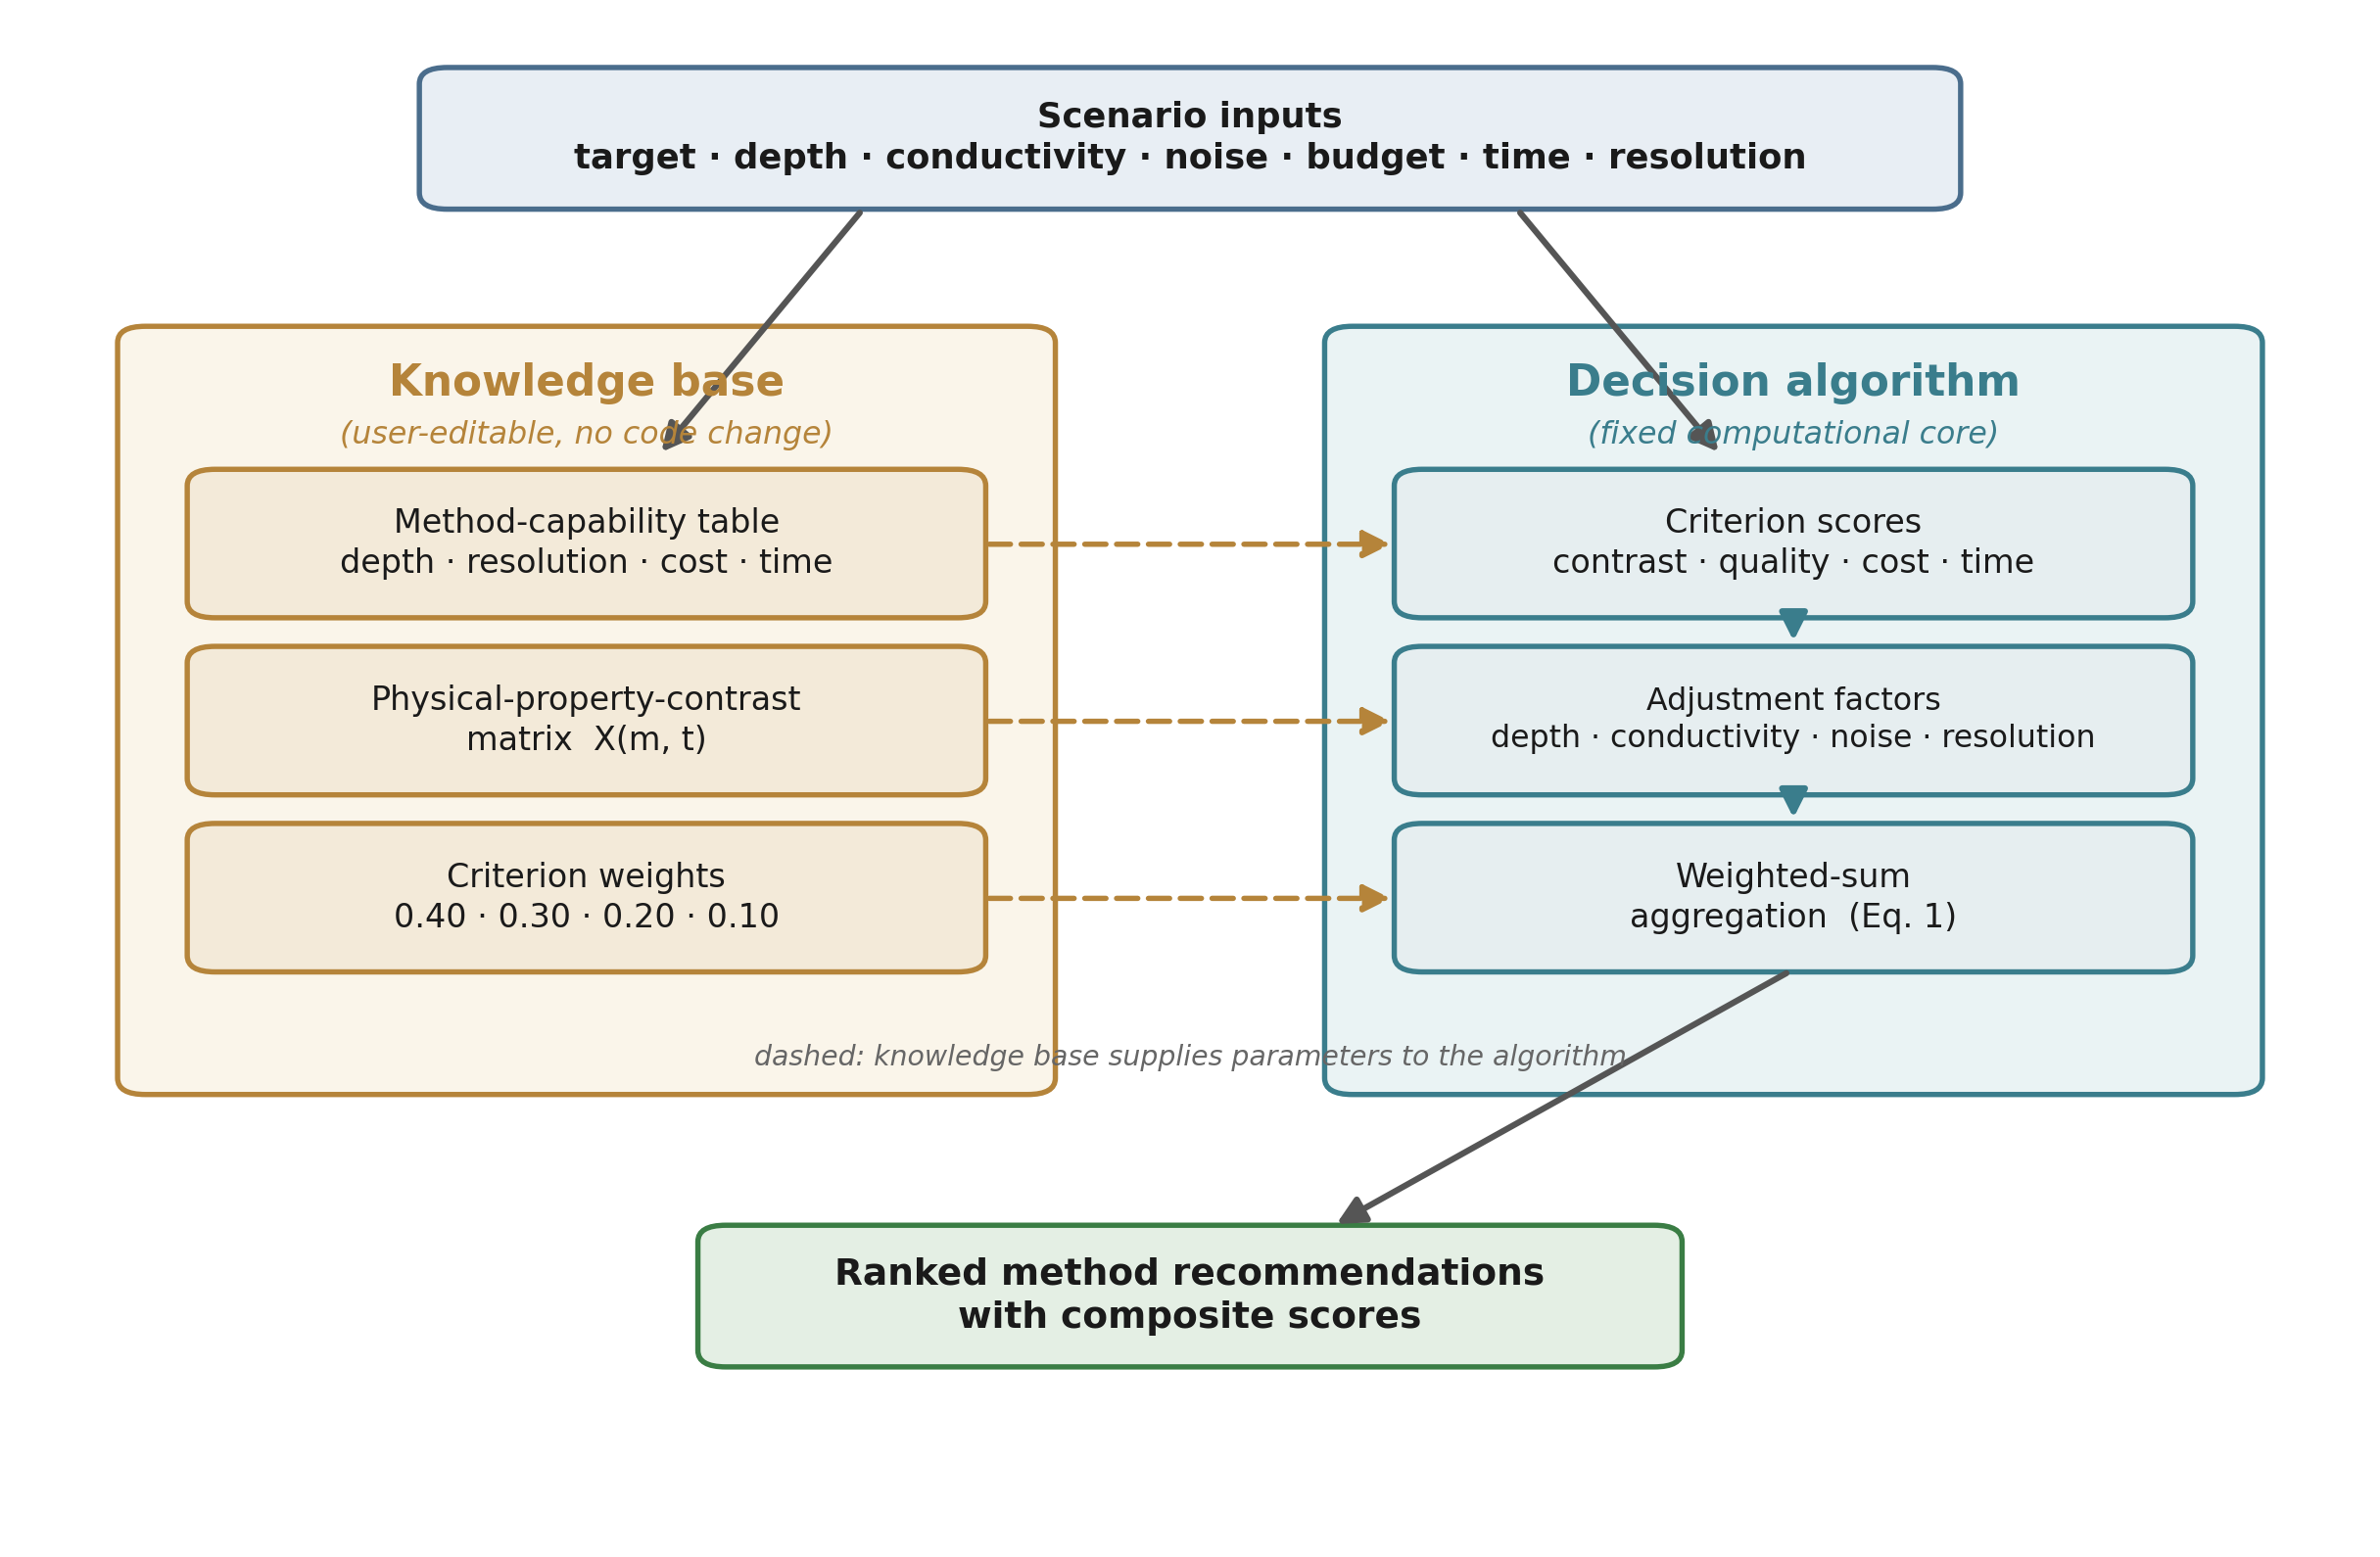
Figure 3. Software architecture of GeoMERIT. Scenario inputs are combined with the knowledge base (method-capability table, physical-property-contrast matrix, and criterion weights) to compute the four criterion scores; the depth, conductivity, noise, and resolution adjustment factors are then applied before the weighted-sum aggregation produces the ranked recommendations. The modular organization separates the user-editable knowledge base from the fixed decision algorithm, so that individual parameters, contrast values, or weighting schemes can be modified without altering the computational framework.
Figure 3 summarizes this organization. User-defined scenario parameters are first translated into numerical descriptors of the investigation target and site conditions. These inputs are combined with the method-capability database, the target-specific physical-property-contrast matrix, and the fixed evaluation weights to compute the four criterion scores. The adjustment factors for depth, conductivity, noise, and resolution are then applied before the weighted-sum aggregation produces the final ranked recommendations. Separating the knowledge base from the decision algorithm in this way allows individual parameters, contrast values, or weighting schemes to be modified without altering the computational framework itself, which is what keeps the knowledge base auditable and makes the tool straightforward to extend to new methods or target classes. Figure 4 shows the interface in use for a saline coastal groundwater scenario, in which ERT is ranked first and the electromagnetic and galvanic methods form the remainder of the ranked list, consistent with the physics of a conductive target.
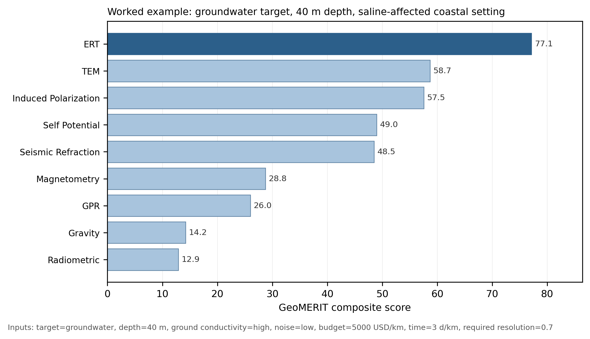
Figure 4. Example use of GeoMERIT. A scenario is specified as a set of named inputs (target class, target depth, ground conductivity, ambient noise, budget, time constraint, and required resolution), and a single call returns the nine candidate methods ranked by their weighted-sum score. For the saline coastal groundwater scenario shown, ERT is ranked first, with the electromagnetic and galvanic methods forming the remainder of the shortlist.
The implementation depends only on widely used scientific Python libraries, with NumPy for the numerical computation and pandas and Matplotlib supporting the accompanying benchmark scripts and figures, and it runs on Python 3.8 or later. A reproducibility script regenerates every ranking, table, and figure reported here from the documented scenario and site parameters, with any stochastic step executed under a fixed random seed, and a demonstration notebook illustrates typical use. The source code, the case-study and benchmark encodings, the machine-readable benchmark file, and the reproduction scripts are released under the MIT License and archived in a public repository with a citable identifier, making the tool and its knowledge base openly available, inspectable, and reusable.
Computational requirements are negligible, because all calculations consist of deterministic arithmetic operations on a small set of predefined parameters. On a single core of a standard x86-64 machine running Python 3.12, a complete ranking of the nine candidate methods for one scenario takes on the order of 0.01 ms, the full 22-case benchmark runs in well under one millisecond, and the Monte Carlo analyses reported here, which involve tens of thousands of individual rankings, complete in under a second. Computational cost is therefore insignificant relative to data preparation and interpretation, and the framework is equally suited to interactive, single-scenario decision support and to large-scale sensitivity or uncertainty analyses.

4. Demonstrations and benchmark
The behaviour of GeoMERIT is evaluated against documented field practice in two layers, neither of which involves human subjects. The first is a retrospective test against three documented field surveys in Saudi Arabia for which the deployed method and its independent ground truth are both known. The second is a reproducible benchmark of 22 documented field cases drawn from the peer-reviewed international literature and spanning all three target classes, in which the recommendation of the tool is compared with the method actually deployed in each published survey, and which is accompanied by a target-blind control, a Monte Carlo robustness analysis, a weight sensitivity analysis, an objective weighting comparison, an uncertainty propagation, and a classification of the cases in which the tool and practice disagree.

4.1. Retrospective field test
Three documented surveys provide a first, geographically focused test in which the deployed method and its borehole or hydrochemical ground truth are both known, so that the top-ranked method of the tool can be compared with the method actually used. The three sites are summarized in Table 4. The first, on the Jizan coastal plain, characterized seawater intrusion in a shallow alluvial aquifer with two-dimensional ERT, and nineteen wells confirmed the conductive saline zone. The second, in the Jazan coastal aquifer with a water table between 9 and 31 m, addressed the same target with central-loop time-domain electromagnetics. The third, in south-east Riyadh, assessed landfill impact on groundwater with vertical electrical soundings assembled into resistivity profiles, and the wells confirmed a slightly to moderately saline plume. Both survey objectives, seawater intrusion and landfill impact, are conductive-plume targets whose detectability is governed by the pore-fluid resistivity contrast that defines the groundwater class, and they are scored within that class, an encoding stated explicitly so that it is fully transparent.
Table 4. Field sites used for the retrospective test. VES denotes vertical electrical sounding, a DC resistivity technique within the ERT family.
Site | Location | Target | Deployed | Ground conductivity | Independent ground truth
1 | Jizan coastal plain | Seawater intrusion | ERT | Conductive | Saline aquifer; TDS to 7820 mg/L (19 wells)
2 | Jazan coastal aquifer | Seawater intrusion | TDEM | Conductive | Brackish aquifer; intrusion to about 3 km inland (6 wells)
3 | South-east Riyadh | Landfill impact | VES | Conductive | Slightly to moderately saline plume (about 12 wells)

Running GeoMERIT on the a-priori parameters of each site, taken only from information available before the survey, gives the rankings in Table 5 and Figure 5. The top-ranked method matches the deployed method at two of the three sites: ERT is ranked first at the Jizan site, matching the deployed ERT, and first at the south-east Riyadh site, consistent with the deployed vertical electrical sounding, which shares the physics of ERT. At the Jazan site the tool ranks ERT first with the deployed TEM in second place a short distance behind, so that although the top choice differs, the deployed method is placed within the top two at all three sites. This single difference is interpretable rather than incidental. At the shallow Jazan aquifer, where the water table lies within the depth range in which ERT operates in its most favourable regime, ERT receives the strongest combination of target contrast and resolution match. TEM was nonetheless deployed for reasons the criteria do not encode, namely that central-loop time-domain electromagnetics is a non-contact, rapidly deployed method well suited to covering a large coastal plain efficiently and to resolving conductive layers with high signal-to-noise. The difference therefore marks a concrete boundary of the model, that operational and logistical advantages are not represented among the four criteria, rather than a failure of the physical reasoning, since both ERT and TEM are physically appropriate for a conductive aquifer and the tool places both within the top two.
Table 5. GeoMERIT rankings at the three field sites (composite score of the top method; rank of the deployed method).
Site | Deployed method | GeoMERIT top-ranked (score) | Rank of deployed | Top-1 match
1 | ERT | ERT (77) | 1 | Yes
2 | TDEM | ERT (74); TEM second (62) | 2 | No (within top two)
3 | VES (ERT family) | ERT (65) | 1 | Yes

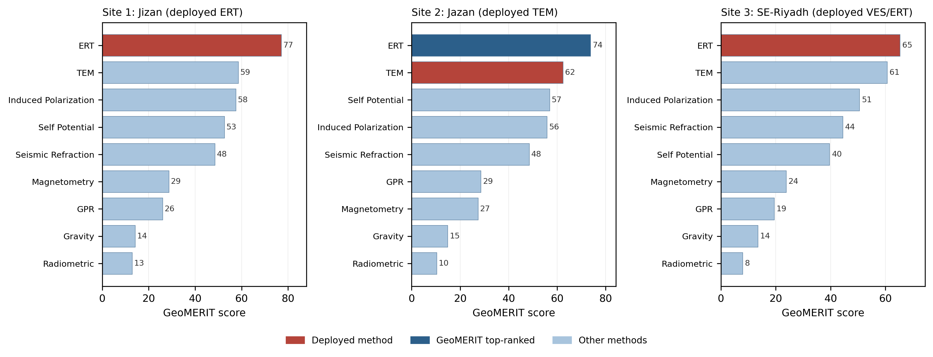
Figure 5. GeoMERIT scores for all nine methods at the three field sites, with the deployed method highlighted and the highest-ranked method at the top of each panel. The tool ranks the deployed method first at the Jizan and south-east Riyadh sites and ranks ERT above the deployed TEM at the Jazan site, where TEM is placed second.

4.2. Literature benchmark and its statistical characterization
The literature benchmark tests, at larger scale and without geographic restriction, how consistently GeoMERIT reproduces the method chosen in documented field surveys. Candidate cases were drawn from the peer-reviewed international literature published from 2015 onward, subject to explicit inclusion criteria: the source is a peer-reviewed, indexed publication; the survey objective falls within one of the three target classes; the paper reports sufficient a-priori site information, directly or through its geological and regional context, to encode target depth and the ground-conductivity setting; a single decisive method can be identified, even where complementary techniques were also used; independent ground truth in the form of boreholes, excavation, or a confirmed target is reported; and the digital object identifier resolves against the publisher record. Cases were selected to spread across all nine methods and all three target classes rather than defaulting to the most frequently published combinations, so that the benchmark exercises the full method set; selection by recency and indexation rather than by citation count was adopted deliberately so that recent surveys using current instrumentation are not excluded. The final benchmark comprises 22 cases, with nine groundwater, seven void, and six archaeological targets, and every one of the nine methods appears as the decisive method in at least one case. For each case the a-priori site parameters were encoded following the same procedure used for the retrospective field test, drawing depth and conductivity from the reported values where stated and from the geological context of the paper where only qualitative information is given, with every qualitative-to-numerical encoding recorded and flagged in the machine-readable benchmark file. GeoMERIT was then run on those parameters, blind to the deployed method, and its top-one and top-three recommendations were recorded. The benchmark is distributed as a comma-separated file together with a script that regenerates the agreement statistics and figures, so that it is auditable and can be re-run or extended.
Across the 22 cases, GeoMERIT ranks the deployed method first in 10 cases, a top-one agreement of 45.5% with a percentile bootstrap 95% confidence interval of 27.3% to 63.6%, and places it within the top three in 18 cases, a top-three agreement of 81.8% with a confidence interval of 63.6% to 95.5%. Measured against the agreement expected from random method choice, these correspond to a Cohen kappa of 0.39 at first place and 0.73 within the top three, the latter indicating substantial agreement beyond chance. The confidence intervals are wide, as is expected for a sample of this size, and are reported so that the precision of the estimates is not overstated. The agreement is not uniform across targets or methods, and the pattern is as informative as the aggregate. By target class, top-one agreement is 56% for groundwater, 43% for void, and 33% for archaeology, while top-three agreement is high and comparatively even at 78%, 86%, and 83% respectively (Figure 6, Table 6). By deployed method the distribution is more uneven: the tool reproduces the deployed method at first place in five of six ERT cases and all four GPR cases, and in one of two TEM cases, but it does not rank any of the remaining methods first, including cases where gravity, magnetometry, seismic refraction, self-potential, induced polarization, or radiometric methods were the deployed and field-validated choice. At the top-three level most of these methods are reproduced, with all gravity, magnetometry, induced polarization, and TEM cases placing the deployed method within the shortlist, while two methods, seismic refraction and radiometric, are not reproduced even within the top three in the cases sampled here.
Table 6. Benchmark agreement with the deployed method, overall and by target class and by deployed method. Counts are cases in which the deployed method is ranked first (top-1) or within the top three (top-3).
Grouping | n | Top-1 | Top-1 % | Top-3 | Top-3 %
Overall | 22 | 10 | 45.5 | 18 | 81.8
Groundwater | 9 | 5 | 56 | 7 | 78
Void | 7 | 3 | 43 | 6 | 86
Archaeology | 6 | 2 | 33 | 5 | 83
ERT (deployed) | 6 | 5 | 83 | 6 | 100
GPR (deployed) | 4 | 4 | 100 | 4 | 100
TEM (deployed) | 2 | 1 | 50 | 2 | 100
Gravity (deployed) | 3 | 0 | 0 | 3 | 100
Magnetometry (deployed) | 2 | 0 | 0 | 2 | 100
Induced polarization (deployed) | 1 | 0 | 0 | 1 | 100
Self-potential (deployed) | 1 | 0 | 0 | 0 | 0
Seismic refraction (deployed) | 2 | 0 | 0 | 0 | 0
Radiometric (deployed) | 1 | 0 | 0 | 0 | 0

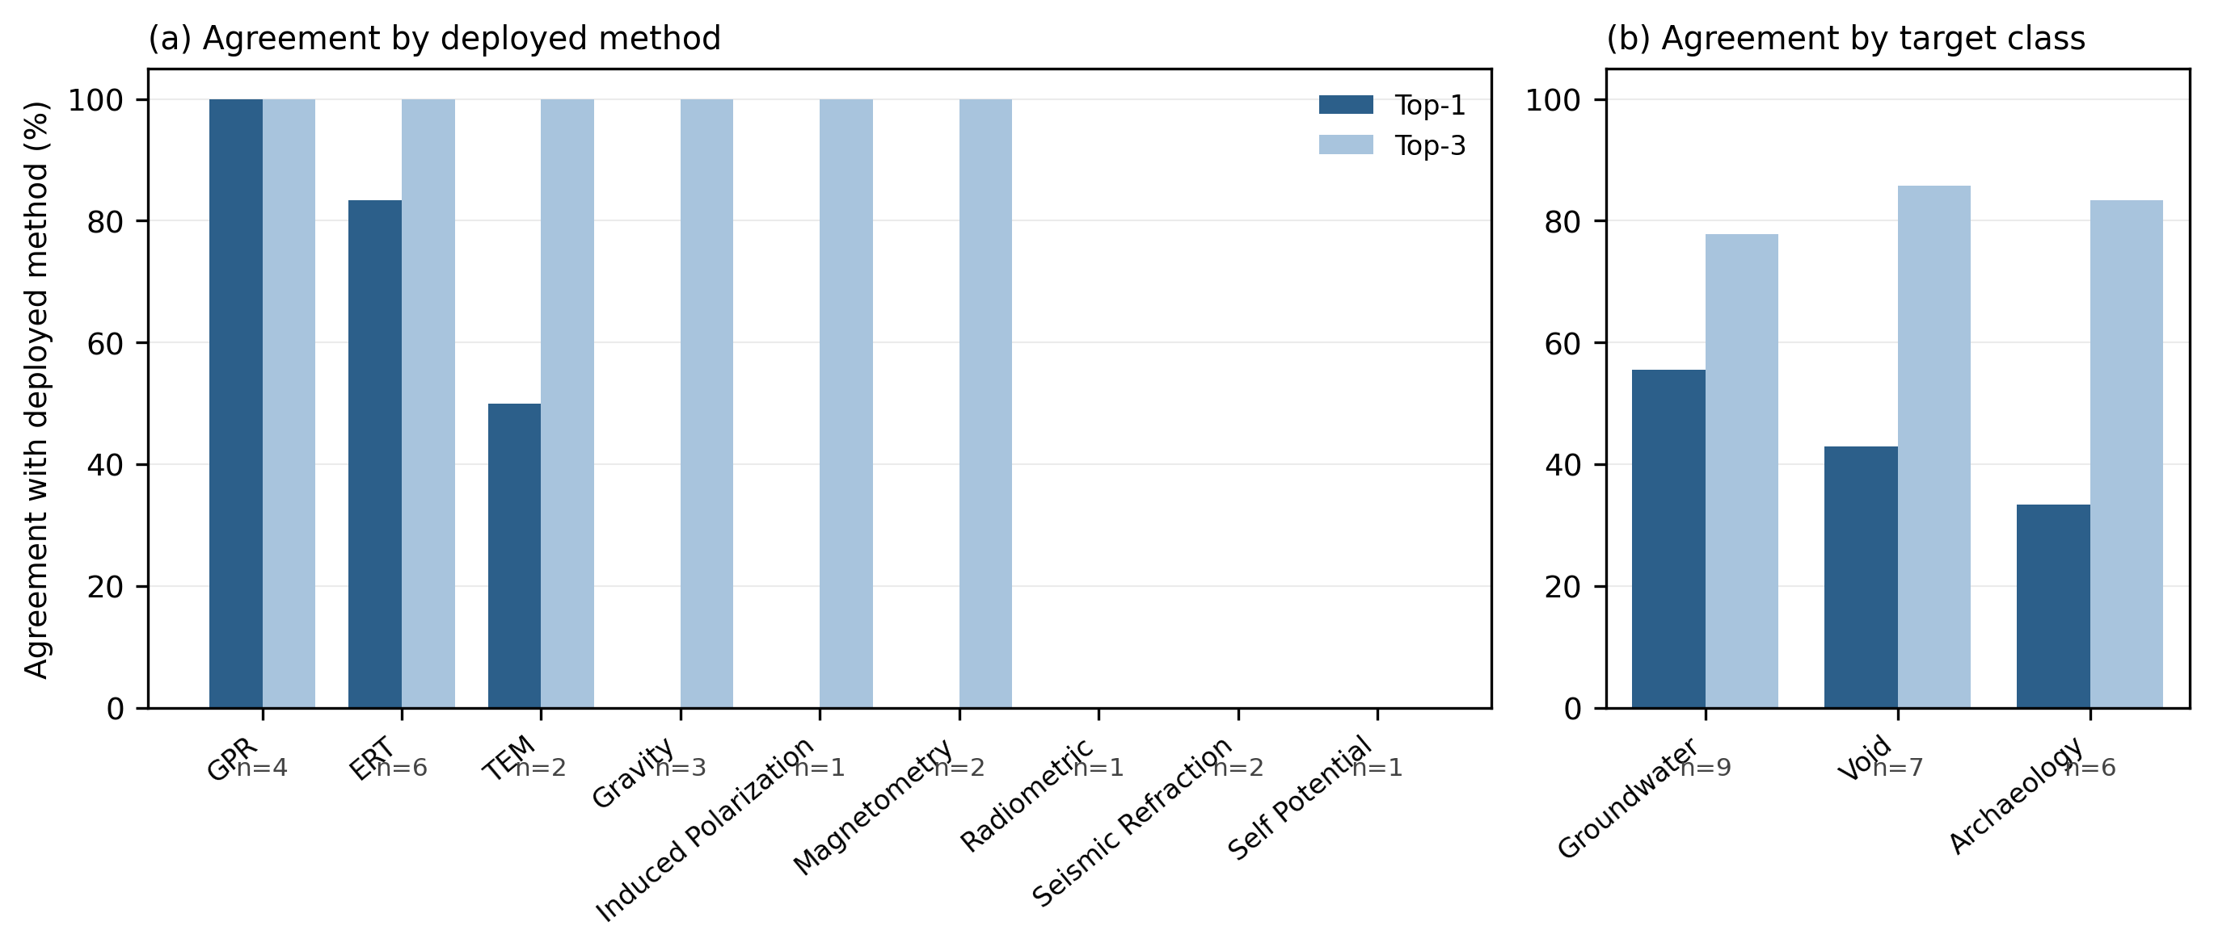
Figure 6. Benchmark agreement with the deployed method. Panel (a): top-one and top-three agreement by deployed method; the absence of a top-one bar for gravity, induced polarization, magnetometry, radiometric, seismic refraction, and self-potential denotes a true zero, that is, the tool did not rank these methods first in any sampled case. Panel (b): agreement by target class. Sample sizes are annotated beneath each group.
Two controls establish that this agreement reflects the target-specific knowledge base rather than an artefact of the aggregation or the encoding. The first isolates the contribution of the contrast matrix. In a target-blind formulation the physical-contrast criterion is reduced to the generic resolution constant of each method, removing the target conditioning, and the benchmark is recomputed unchanged in every other respect; this reproduces the deployed method first in only 7 of 22 cases, a top-one agreement of 31.8%, and within the top three in 14 of 22, a top-three agreement of 63.6%, against 45.5% and 81.8% for the target-aware tool. The target-aware model therefore agrees with documented practice substantially more often at both thresholds, direct evidence that the contrast matrix carries genuine target-specific information beyond generic resolution. The second control addresses the encoding. Because a proportion of the benchmark parameters were encoded from qualitative descriptions, a single numerical choice could in principle determine whether a case agrees; a Monte Carlo analysis therefore perturbs the target depth, ground conductivity, noise level, budget, and schedule within plausible bands around their encoded values and re-runs the ranking 2000 times per case under a fixed random seed. The aggregate agreement is essentially unchanged, with a mean per-case top-one match probability of 0.44 and a mean top-three probability of 0.83. Classifying each case by the stability of its outcome, nine are stable matches in which the deployed method is ranked first across essentially the whole perturbation range, twelve are stable mismatches in which it is not, and only one case is sensitive to the encoding (Figure 7). The disagreements identified in the benchmark are therefore structural properties of the criteria and contrast values rather than artefacts of how qualitative parameters were encoded.
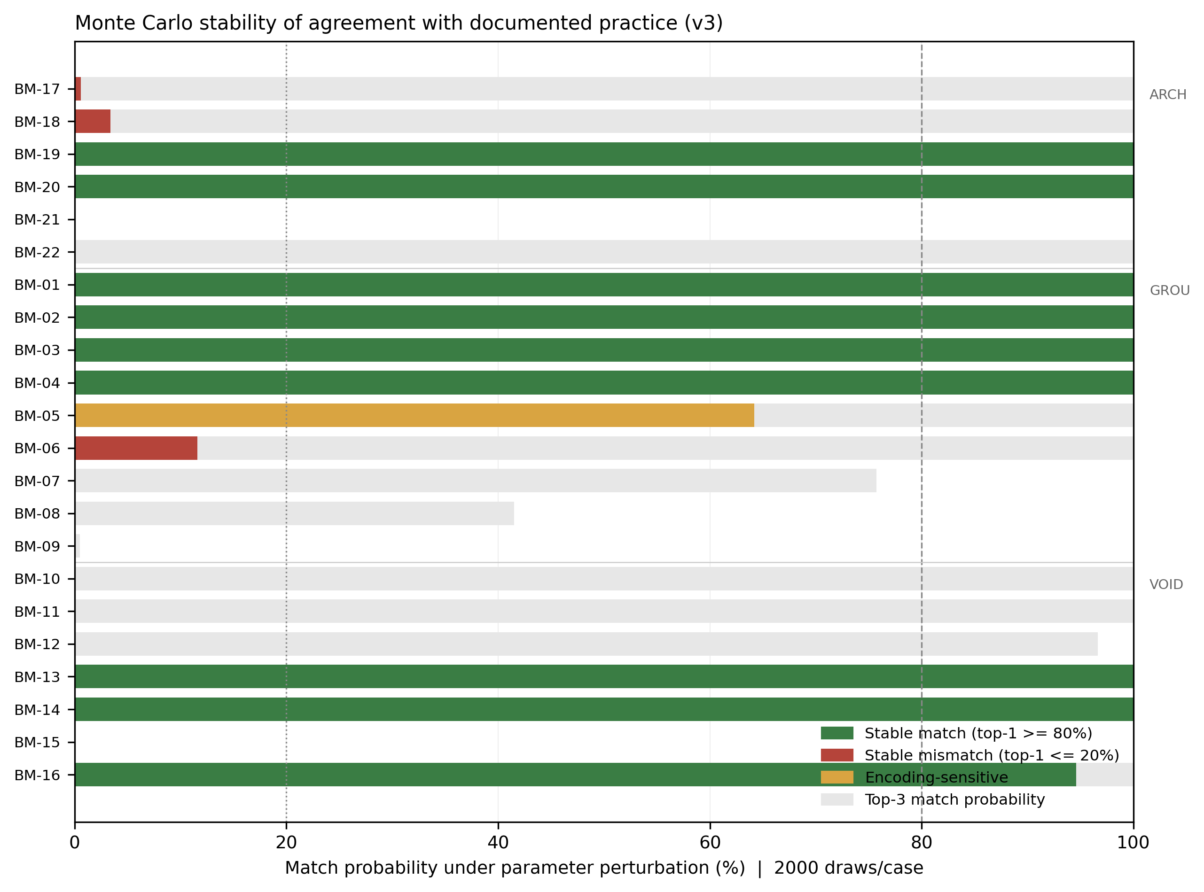
Figure 7. Monte Carlo stability of benchmark agreement (2000 perturbed draws per case, fixed seed). Foreground bars show the top-one match probability under parameter perturbation, coloured by stability class (green, stable match; red, stable mismatch; amber, encoding-sensitive); light background bars show the top-three match probability. Dashed and dotted lines mark the 80% and 20% thresholds used to classify stability. Cases are grouped by target class.

4.3. Weighting: sensitivity and objective comparison
Two analyses address whether the recommendations depend on the specific choice of criterion weights and whether that choice is defensible. The first is a global sensitivity analysis of the four weights, conducted over the 22 benchmark cases. Perturbing each weight in turn by up to thirty per cent, with the remaining three renormalized to preserve their proportions, changes the top-one agreement by at most nine percentage points and the top-three agreement hardly at all, and no single weight acts as a fragile hinge; increasing the data-quality or cost weight slightly improves agreement. Sampling weight vectors uniformly from the space of all admissible weightings that respect the intended priority order, in which physical contrast is weighted at least as heavily as data quality, then cost, then time and effort, the top-one agreement remains between 46% and 55% and the top-three agreement between 77% and 82% across five thousand draws, and the fixed weights sit near the lower end of the top-one range, so the reported result is representative of, and if anything conservative within, this family of weightings rather than a favourable selection from it (Figure 8). Sampling without the order constraint, over all possible weightings including physically unreasonable ones such as those dominated by time and effort, produces a much wider spread, as expected: the recommendations are robust across the weightings a geophysicist would actually consider, but not across arbitrary weightings, and no sensible scheme would be.
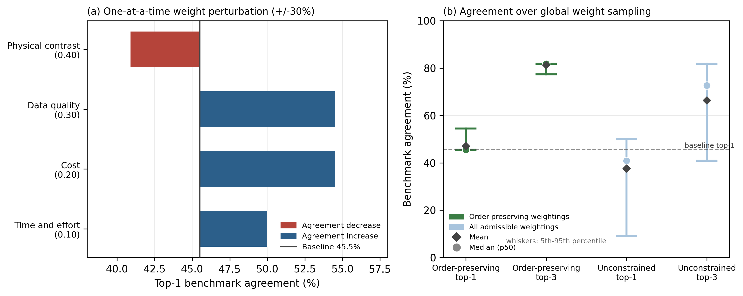
Figure 8. Weight sensitivity of benchmark agreement. Panel (a): one-at-a-time perturbation of each weight by up to thirty per cent, showing the range of top-one agreement about the baseline. Panel (b): distribution of top-one and top-three agreement over global weight sampling, for weightings that respect the intended priority order (green) and for all admissible weightings (light blue); whiskers span the 5th to 95th percentiles.
The second analysis asks whether the weights could instead be set objectively from the data. Shannon entropy weighting, a standard objective scheme, assigns to each criterion a weight proportional to its dispersion across the alternatives, on the reasoning that a criterion which separates the options more strongly carries more discriminating information. Applied to the decision matrix of criterion scores across the benchmark, entropy weighting assigns the largest weights to time and effort and to cost, at approximately 0.34 and 0.30, and the smallest to physical contrast and data quality, at approximately 0.19 and 0.16, inverting the intended priority order, and the benchmark agreement under these weights falls to 36% at first place and 55% within the top three. This is a useful negative result. It arises because cost and time vary widely across methods for reasons unrelated to whether a method is physically suited to the target, so a purely statistical criterion mistakes their dispersion for importance, whereas physical contrast, often high for several methods at once within a target class, appears less dispersed even though it is the geophysically decisive criterion. The divergence and the associated loss of agreement demonstrate that the weights of a physics-driven decision aid must encode domain knowledge rather than data dispersion, which is the basis on which the fixed, priority-ordered weights are adopted; the sensitivity analysis then shows the recommendations are stable throughout the family of weightings that respect that priority.

4.4. Probabilistic recommendations and analysis of disagreements
The deterministic ranking can be accompanied by a probabilistic recommendation that propagates input uncertainty. Perturbing the site parameters of the three field sites and of the worked example within the same plausible bands and re-ranking five thousand times gives, for each scenario, the probability that each method occupies first place together with the distribution of its composite score. For all three groundwater field sites the top recommendation is completely stable, ERT occupying first place in every draw, so the recommendation is insensitive to the stated uncertainty in depth, conductivity, noise, budget, and schedule; at the Jazan site the same analysis shows that the tool prefers ERT to the deployed TEM with certainty and that TEM occupies second place, so the disagreement there is a firm structural preference rather than a marginal or noisy one (Figure 9). Reporting the rank-one probability and the score bands in this way turns the ranking into a probabilistic recommendation without altering the underlying scoring.
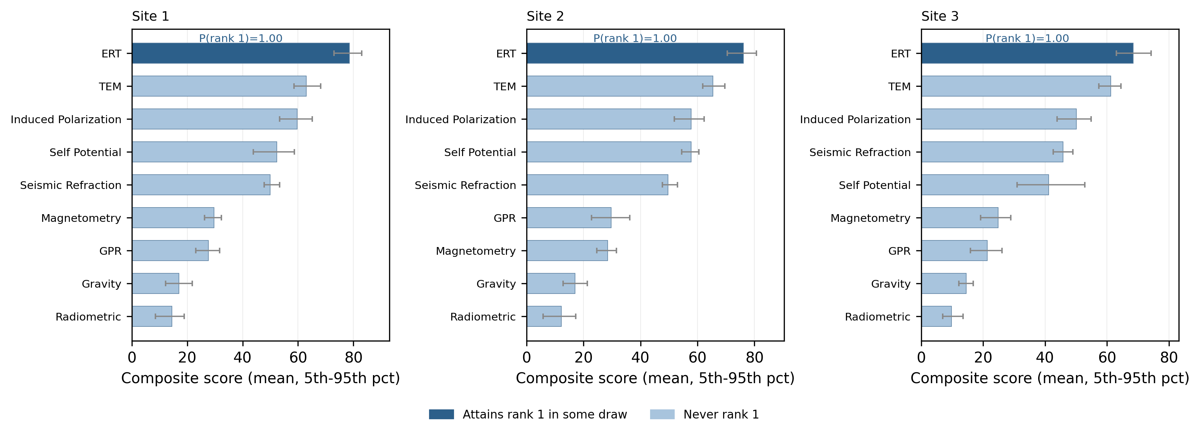
Figure 9. Probabilistic recommendation for the three field sites under input-parameter uncertainty (5000 draws per site). Bars show the mean composite score with 5th to 95th percentile intervals; methods that attain first place in at least one draw are shown in the darker shade. The rank-one probability of the top method is annotated beneath each panel.
The twelve stable disagreements identified in the benchmark are more informative when classified by cause than when counted, and they fall into three categories, shown in Figure 10 and summarized in Table 7. In three cases the disagreement is operational: the deployed method is physically appropriate and is ranked second by the tool, but was chosen over the top-ranked method for logistical reasons the criteria do not encode, as at the Jazan field site and in two archaeological surveys where magnetometry was preferred to GPR for rapid area coverage. In six cases the cause is the contrast and resolution structure, in which the tool ranks a high-resolution electrical or radar method above the deployed method, yet the deployed method is still retained within the top-three shortlist; these are the cases underlying the concentration of first-place agreement on ERT and GPR. In the remaining three cases the disagreement reflects the scope of the current criteria: the deployed method has a diagnostic basis that is only weakly represented, such as the velocity contrast exploited by seismic refraction or the near-surface radioelement contrast exploited by gamma-ray radiometric surveying, and in these cases the method is under-ranked to the point of falling outside the top three. This classification localizes where the tool departs from practice and, in doing so, points to the specific parts of the knowledge base whose refinement would most improve it.
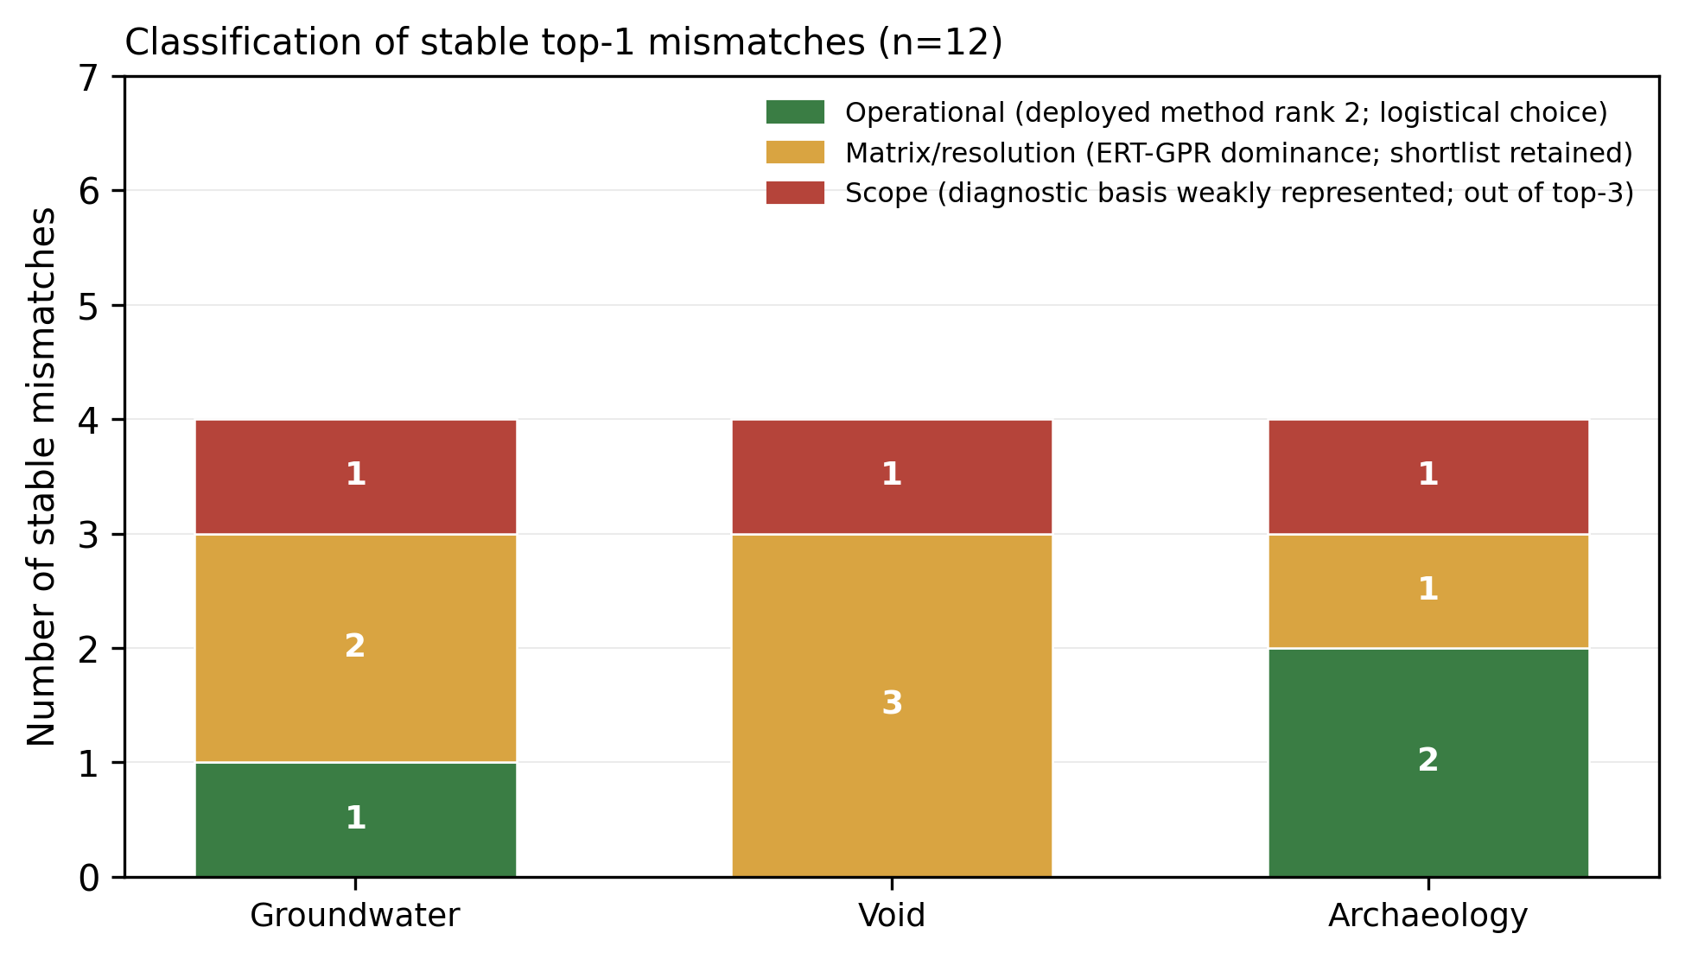
Figure 10. Classification of the twelve stable top-one disagreements by cause and target class: operational (deployed method ranked second, chosen for logistical reasons), matrix and resolution (electrical or radar method ranked above the deployed method, shortlist retained), and scope (diagnostic basis weakly represented, deployed method outside the top three).
Table 7. The twelve stable disagreements classified by cause, with the rank assigned to the deployed method and its Monte Carlo top-three retention probability.
Case | Target | Deployed | Top-ranked | Rank of deployed | Category
BM-06 | Groundwater | TEM | ERT | 2 | Operational
BM-17 | Archaeology | Magnetometry | GPR | 2 | Operational
BM-18 | Archaeology | Magnetometry | GPR | 2 | Operational
BM-07 | Groundwater | Induced polarization | ERT | 3 | Matrix/resolution
BM-08 | Groundwater | Self-potential | ERT | 4 | Matrix/resolution
BM-10 | Void | Gravity | GPR | 3 | Matrix/resolution
BM-11 | Void | Gravity | ERT | 3 | Matrix/resolution
BM-12 | Void | Gravity | GPR | 3 | Matrix/resolution
BM-22 | Archaeology | ERT | GPR | 3 | Matrix/resolution
BM-09 | Groundwater | Seismic refraction | ERT | 4 | Scope
BM-15 | Void | Seismic refraction | GPR | 4 | Scope
BM-21 | Archaeology | Radiometric | Magnetometry | 6 | Scope

5. Discussion
The two evaluation layers give a consistent and specific picture of what GeoMERIT does well and where it does not. On the top-three shortlist, the tool agrees with documented field practice in the large majority of cases, 18 of 22 in the literature benchmark and all three retrospective field sites, and this agreement is stable to parameter encoding and substantially stronger than the target-blind control. For the practical purpose the tool is intended to serve, presenting a practitioner or a trainee with a short list of physically appropriate methods for a stated target, the evidence supports the tool as consistent with established practice. The advantage of the target-aware formulation over the target-blind control, at both the top-one and top-three thresholds, confirms that the contribution of the contrast matrix is real and not an artefact of method resolution.
At the same time, the benchmark reveals a clear structural limitation at the level of the single top recommendation, which the analysis reports rather than conceals. Agreement at first place concentrates in targets for which ERT or GPR is physically dominant: the tool ranks the deployed method first in almost all ERT and GPR cases but does not rank any of gravity, magnetometry, seismic refraction, self-potential, induced polarization, or radiometric first in the sampled cases, even where these were the deployed and independently validated choice. The Monte Carlo analysis shows this is not an encoding artefact. Its origin lies in the joint effect of the contrast-matrix values and the resolution-match term: ERT and GPR combine high target contrast in their favoured classes with high intrinsic resolution, so that once the resolution-match factor and the cost term are included they tend to win first place even against a method whose target contrast is nominally high, such as gravity for a void. In practical terms the present tool behaves, at the level of the single best recommendation, more like a reliable identifier of the dominant electrical or radar method than like a nine-way selector, and it should be described and used as such. The top-three shortlist, where most methods are reproduced, is the level at which the tool earns its agreement with practice, and it is the output on which users should rely.
This limitation interacts with a deliberate design choice that must be stated plainly. Both the physical-contrast criterion and the data-quality criterion are anchored on the same target-conditioned contrast value, so that the contrast matrix influences seventy per cent of the composite score. This is justified physically, since the data quality achievable for a specific investigation is the signal-to-noise of that target physical-property contrast rather than the context-free resolution of the method, and the target-aware formulation agrees with practice more often than the target-blind control that sets data quality by generic resolution. The cost of the choice is a concentration of the score on one carefully assigned table, which raises the importance of the individual contrast values and means that any error or coarseness in the matrix propagates strongly into the ranking. The matrix values are therefore the primary locus of both the strengths and the weaknesses documented here, and refining them, in particular re-examining the relative contrast of gravity, seismic refraction, and the other under-ranked methods against ERT and GPR, is the most direct route to improving first-place agreement. The weighting is, by contrast, not the critical determinant: the sensitivity analysis shows the recommendations are stable across the family of weightings that respect the intended priority order, and the entropy comparison shows that a purely statistical weighting performs worse precisely because it discards the domain knowledge the fixed weights encode.
Two limitations of the benchmark itself bound the strength of these conclusions and deserve explicit statement. The first is selection bias. Published field surveys overwhelmingly report methods that succeeded; a survey that chose a physically poor method and failed is unlikely to be written up or, if written, to pass review. The benchmark can therefore test agreement with successful, documented deployments, but it cannot sample the full space of decisions that practitioners face, including poor ones, and the agreement it measures reflects consistency with established, successful practice rather than an independently verified capacity to predict the best method in an arbitrary setting. The second is that the parameter encodings are drawn from the source publications by a single reader, so that although every encoding is documented and flagged in the released benchmark file, and the Monte Carlo analysis shows the results are not sensitive to reasonable variation in those encodings, the possibility of systematic encoding choices cannot be excluded by the design alone. These considerations, together with the concentration of the score on the contrast matrix, are the reasons the tool is presented as a transparent operationalization of established knowledge, consistent with documented practice on the top-three shortlist, and not as an independently validated predictor. The wide confidence intervals on the agreement rates, a direct consequence of the sample size, reinforce this cautious reading.
Relative to other multi-criteria approaches, the design of GeoMERIT trades sophistication for transparency. Methods such as the analytic hierarchy process derive weights from structured pairwise comparison, and outranking methods such as ELECTRE and PROMETHEE model preference and indifference thresholds explicitly (Saaty, 2013; Greco et al., 2016). GeoMERIT adopts the simplest defensible aggregation, a weighted sum with fixed, documented weights, so that every element of a recommendation is inspectable and reproducible and the tool can be audited against field practice. The evaluation here indicates that the more consequential determinant of agreement is not the aggregation rule but the quality and granularity of the underlying physical-property-contrast values, and the target-blind control supports this reading by showing that removing the target conditioning, while leaving the aggregation unchanged, is what degrades agreement. Positioned in these terms, the contribution of the work is not a new decision algorithm but a transparent, reproducible, and auditable knowledge-based system for geophysical survey design, together with a reusable method for evaluating such systems against documented field practice.
More broadly, GeoMERIT illustrates how domain knowledge can be formalized into a transparent computational tool without sacrificing interpretability. As reproducible computational research becomes an increasingly important expectation in the geosciences, frameworks that expose rather than obscure their underlying assumptions offer a valuable complement to increasingly complex data-driven approaches. The methodology presented here is not specific to method selection: the same pattern, an explicit and editable knowledge base separated from a simple, auditable aggregation and evaluated against documented practice, could serve as a general template for explainable decision-support systems in other areas of environmental and engineering geoscience.

6. Future work
Several developments follow directly from the evaluation. The most important is a principled refinement of the physical-property-contrast matrix to address the concentration of first-place recommendations on ERT and GPR, re-examining the relative contrast values of the under-ranked methods, in particular gravity, seismic refraction, and the electromagnetic and self-potential techniques, against the dominant electrical and radar methods, and doing so from physical first principles rather than by tuning the values to raise agreement statistics. Associating each contrast value with an uncertainty range or a literature-supported interval, and propagating that matrix uncertainty into the ranking alongside the input uncertainty already treated here, would further reduce concerns about the subjectivity of the manually assigned values. The concentration of first-place agreement on the highest-resolution methods also invites structural refinements to the scoring, such as nonlinear or diminishing-returns utility functions and target-specific normalization, which could be evaluated against the same benchmark. Expanding the set of target classes beyond the current three, for example to distinguish contamination and leachate from natural groundwater and to add engineering, geotechnical, fault- and fracture-mapping, and mineral or geothermal targets, would broaden applicability but requires new contrast values with the same literature grounding. Incorporating operational factors such as site access, deployment speed, and the non-contact nature of a method, which the failure analysis shows can govern real decisions, would address a documented boundary of the current criteria without compromising the transparency of the scheme. Adaptive or user-adjustable weighting is a natural extension provided the weights remain inspectable, and comparison with additional multi-criteria aggregations such as outranking or compromise-ranking methods over the same knowledge base would further separate the contribution of the aggregation from that of the contrast matrix. Finally, enlarging the benchmark and having cases encoded by parties independent of the tool author would strengthen the evidential value of future evaluations.

7. Conclusions
GeoMERIT is an open-source tool that makes geophysical method selection systematic, transparent, and reproducible for nine common near-surface methods across groundwater, void, and archaeological targets. Its recommendations rest on an explicit, literature-derived method-by-target physical-property-contrast matrix and documented adjustment factors, and its implementation regenerates every reported result from documented parameters. Benchmarked against documented field practice, the tool places the deployed method within its top-three shortlist in the large majority of cases, 18 of 22 published cases and all three retrospective field sites, with agreement that is stable to parameter encoding and substantially stronger than a target-blind control, evidence that target-specific contrast carries genuine information. The same benchmark shows plainly that first-place agreement concentrates in ERT-dominant and GPR-dominant targets and that several methods are systematically under-ranked at the single best recommendation, a structural consequence of the contrast and resolution structure rather than of parameter encoding. GeoMERIT should therefore be understood and used as a transparent operationalization of established knowledge whose reliable output is a physically appropriate shortlist, valuable for training, planning, standardization, and quality assurance, and refining the physical-property-contrast values is identified as the most direct route to strengthening its single best recommendation.

CRediT authorship contribution statement
Mahmoud M. Elwaheidi: Conceptualization, Methodology, Software, Formal analysis, Investigation, Data curation, Visualization, Writing - original draft, Writing - review and editing.

Declaration of competing interest
The author declares that he has no known competing financial interests or personal relationships that could have appeared to influence the work reported in this paper.

Declaration of generative AI and AI-assisted technologies in the manuscript preparation process
During the preparation of this work the author used a generative AI assistant (large language model) to support literature-synthesis organization, code documentation, and language editing. After using this tool, the author reviewed and edited the content as needed and takes full responsibility for the content of the publication.

Data availability
GeoMERIT is open-source under the MIT License. The source code, the case-study encodings, the machine-readable literature-benchmark file (benchmark_cases.csv), and the scripts that reproduce all reported results, tables, and figures are available on GitHub (https://github.com/melwaheidi/GeoMERIT) and archived at Zenodo (https://doi.org/10.5281/zenodo.20932723). The benchmark records, for each case, the extracted a-priori parameters and their source citation; third-party datasets and source texts are not redistributed and are cited to their original publications.

Funding
This research was supported by the Ongoing Research Funding Program (ORF-2026-1771), King Saud University, Riyadh, Saudi Arabia.

References
Alharbi, S.S., Qaysi, S.I., Elwaheidi, M.M., 2023. Hydrogeophysical characterization of the southern Red Sea coastal aquifer, Saudi Arabia, using time-domain electromagnetic method. Hum. Ecol. Risk Assess. 29, 449-462.
Amanatidou, E., Vargemezis, G., Tsourlos, P., 2022. Combined application of seismic and electrical geophysical methods for karst cavities detection: a case study at the campus of the new University of Western Macedonia, Kozani, Greece. J. Appl. Geophys. 196, 104499. https://doi.org/10.1016/j.jappgeo.2021.104499.
Pereiro, T.d., Fonte, J., García Sánchez, J., Ribeiro, F., Ferrer Sierra, S., 2025. An Integrated GPR and Magnetometry Survey of the Roman Fort of Aquis Querquennis (Northwest Iberia). Remote Sens. 17(10), 1785. https://doi.org/10.3390/rs17101785.
Arisona, A., Ishola, K.S., Muliddin, M., Hamimu, L., Hasria, H., 2023. The potential of microgravity technique in subsurface cavities detection at Chan Sow Lin Site in Kuala Lumpur, Malaysia: a case study. Model. Earth Syst. Environ. 9, 771-782. https://doi.org/10.1007/s40808-022-01519-y.
Badhrais, O.M.O., 2025. Integrated Use of DC Resistivity and Hydrochemical Methods for the Assessment of MSW Landfill Effect on Groundwater Quality, South-East Riyadh, Saudi Arabia. Unpublished MSc Thesis, King Saud University, Riyadh, Saudi Arabia.
Basílio, M.P., Pereira, V., Costa, H.G., Santos, M., Ghosh, A., 2022. A systematic review of the applications of multi-criteria decision aid methods (1977-2022). Electronics 11(11), 1720. https://doi.org/10.3390/electronics11111720.
Belton, V., Stewart, T., 2012. Multiple Criteria Decision Analysis: An Integrated Approach. Springer.
Binley, A., Kemna, A., 2005. DC resistivity and induced polarization methods. In: Rubin, Y., Hubbard, S.S. (Eds.), Hydrogeophysics, pp. 129-156. Springer. https://doi.org/10.1007/1-4020-3102-5_5.
Butler, D.K., 2005. Near-Surface Geophysics. Society of Exploration Geophysicists.
Najib, S., Fadili, A., Boualla, O., Mehdi, K., Bouzerda, M., Makan, A., Zourarah, B., Ilmen, S., 2025. Assessment of Geohydraulic Parameters in Coastal Aquifers Using Electrical Resistivity Tomography: A Case Study from the Chaouia Region, Western Morocco. Earth 6(4), 149. https://doi.org/10.3390/earth6040149.
Cinelli, M., Kadziński, M., Gonzalez, M., Słowiński, R., 2020. How to support the application of multiple criteria decision analysis? Let us start with a comprehensive taxonomy. Omega 96, 102261. https://doi.org/10.1016/j.omega.2020.102261.
Donoho, D.L., 2010. An invitation to reproducible computational research. Biostatistics 11(3), 385-388. https://doi.org/10.1093/biostatistics/kxq028.
El Emam, A., Lethy, A., Radwan, A.M., Awad, A., 2021. Archaeological investigation and hazard assessment using magnetic, ground-penetrating radar, and GPS tools at Dahshour area, Giza, Egypt. Front. Earth Sci. 9, 674953. https://doi.org/10.3389/feart.2021.674953.
Everett, M.E., 2013. Near-Surface Applied Geophysics. Cambridge University Press.
Feizizadeh, B., Roodposhti, M.S., Jankowski, P., Blaschke, T., 2014. A GIS-based extended fuzzy multi-criteria evaluation for landslide susceptibility mapping. Comput. Geosci. 73, 208-221. https://doi.org/10.1016/j.cageo.2014.08.001.
Greco, S., Figueira, J., Ehrgott, M., 2016. Multiple Criteria Decision Analysis, Vol. 37. Springer, New York.
Greene, R., Devillers, R., Luther, J.E., Eddy, B.G., 2011. GIS-based multiple-criteria decision analysis. Geogr. Compass 5(6), 412-432. https://doi.org/10.1111/j.1749-8198.2011.00431.x.
Grindsted landfill leachate study: Maurya, P.K., Ronde, V.K., Fiandaca, G., Balbarini, N., Auken, E., Bjerg, P.L., Christiansen, A.V., 2017. Detailed landfill leachate plume mapping using 2D and 3D electrical resistivity tomography, with correlation to ionic strength, Grindsted, Denmark. J. Appl. Geophys. 138, 1-8. https://doi.org/10.1016/j.jappgeo.2017.01.019.
Hinze, W.J., Von Frese, R.R., Saad, A.H., 2013. Gravity and Magnetic Exploration: Principles, Practices, and Applications. Cambridge University Press.
Huang, I.B., Keisler, J., Linkov, I., 2011. Multi-criteria decision analysis in environmental sciences: ten years of applications and trends. Sci. Total Environ. 409(19), 3578-3594. https://doi.org/10.1016/j.scitotenv.2011.06.022.
Hwang, C.L., Yoon, K., 1981. Multiple Attribute Decision Making: Methods and Applications--A State-of-the-Art Survey. Springer, Berlin, Heidelberg.
Ince, D.C., Hatton, L., Graham-Cumming, J., 2012. The case for open computer programs. Nature 482(7386), 485-488. https://doi.org/10.1038/nature10836.
Jacob, T., Pannet, P., Beaubois, F., Baltassat, J.M., Hannion, Y., 2020. Cavity detection using microgravity in a highly urbanized setting: a case study from Reims, France. J. Appl. Geophys. 179, 104113. https://doi.org/10.1016/j.jappgeo.2020.104113.
Jha, M.K., Chowdhury, A., Chowdary, V.M., Peiffer, S., 2007. Groundwater management and development by integrated remote sensing and geographic information systems. Water Resour. Manag. 21(2), 427-467. https://doi.org/10.1007/s11269-006-9024-4.
Kayın, S., Aydın, N.G., Apaydın, O., İşseven, T., 2025. Integrated Geophysical Survey (GPR, ERT and Magnetometry) at the Kalehisar Archaeological Site in Central Anatolia. Archaeol. Prospect. 32(4), 927-947. https://doi.org/10.1002/arp.70000.
Kumar, A., Sah, B., Singh, A.R., Deng, Y., He, X., Kumar, P., Bansal, R.C., 2017. A review of multi-criteria decision making (MCDM) towards sustainable renewable energy development. Renew. Sustain. Energy Rev. 69, 596-609. https://doi.org/10.1016/j.rser.2016.11.191.
Loke, M.H., 1999. Electrical Imaging Surveys for Environmental and Engineering Studies: A Practical Guide. Geotomo Software, Penang.
Løken, E., 2007. Use of multicriteria decision analysis methods for energy planning problems. Renew. Sustain. Energy Rev. 11(7), 1584-1595. https://doi.org/10.1016/j.rser.2005.11.005.
Maeshi, T.S., Elwaheidi, M.M., Zaidi, F.K., Qaysi, S.I., under review. Integrated assessment of seawater intrusion in arid coastal aquifers using electrical resistivity tomography. Journal of King Saud University - Science (manuscript JKSUS_729_2026).
Mahmoud, H.H., Kotb, A.D.M., Tawfik, M.Z., 2021. Application of time domain electromagnetic survey to detect fractured limestone aquifer in desert fringes, West Assiut, Egypt. NRIAG J. Astron. Geophys. 10(1), 235-243. https://doi.org/10.1080/20909977.2021.1913393.
Malczewski, J., 1999. GIS and Multicriteria Decision Analysis. John Wiley & Sons, New York.
Martínez-Moreno, F.J., Monteiro-Santos, F.A., Madeira, J., Bernardo, I., Soares, A., Esteves, M., Adão, F., 2016. Water prospection in volcanic islands by Time Domain Electromagnetic (TDEM) surveying: the case study of the islands of Fogo and Santo Antão in Cape Verde. J. Appl. Geophys. 134, 226-234. https://doi.org/10.1016/j.jappgeo.2016.09.020.
Milsom, J., Eriksen, A., 2013. Field Geophysics, 3rd ed. John Wiley & Sons, Chichester.
Porzucek, S., Loj, M., 2021. Microgravity Survey to Detect Voids and Loosening Zones in the Vicinity of the Mine Shaft. Energies 14(11), 3021. https://doi.org/10.3390/en14113021.
Munda, G., 2004. Social multi-criteria evaluation: methodological foundations and operational consequences. Eur. J. Oper. Res. 158(3), 662-677. https://doi.org/10.1016/S0377-2217(03)00369-2.
Niculescu, B.M., Andrei, G., 2021. Application of electrical resistivity tomography for imaging seawater intrusion in a coastal aquifer, Vama Veche, Romanian Black Sea coast. Acta Geophys. 69, 613-630. https://doi.org/10.1007/s11600-020-00529-7.
Peng, R.D., 2011. Reproducible research in computational science. Science 334(6060), 1226-1227. https://doi.org/10.1126/science.1213847.
Pohekar, S.D., Ramachandran, M., 2004. Application of multi-criteria decision making to sustainable energy planning--a review. Renew. Sustain. Energy Rev. 8(4), 365-381. https://doi.org/10.1016/j.rser.2003.12.007.
Reynolds, J.M., 2011. An Introduction to Applied and Environmental Geophysics, 2nd ed. John Wiley & Sons, Chichester.
Robinson, V., Black, S., Fry, R., Beddow, H., Clark, R., Fulford, M., 2024. Radiating encouragement: further investigation into the application of gamma ray spectroscopy for archaeological prospection at the Roman town of Silchester. Archaeol. Prospect. 31(3), 249-266. https://doi.org/10.1002/arp.1950.
Ruangpan, L., Vojinovic, Z., Plavšić, J., Doong, D.J., Bahlmann, T., Alves, A., Franca, M.J., 2021. Incorporating stakeholders\' preferences into a multi-criteria framework for planning large-scale nature-based solutions. Ambio 50(8), 1514-1531. https://doi.org/10.1007/s13280-020-01419-4.
Saaty, T.L., 2013. Analytic hierarchy process. In: Gass, S.I., Fu, M.C. (Eds.), Encyclopedia of Operations Research and Management Science, pp. 52-64. Springer, Boston.
Ebraheem, M.O., Ibrahim, H.A., 2019. Detection of karst features using ground-penetrating radar: a case study from the western limestone plateau, Assiut, Egypt. Environ. Earth Sci. 78, 563. https://doi.org/10.1007/s12665-019-8572-x.
Meng, J., Zhang, J., Mao, D., Han, C., Guo, L., Li, S., Chao, C., 2022. Organic Contamination Distribution Constrained with Induced Polarization at a Waste Disposal Site. Water 14(22), 3630. https://doi.org/10.3390/w14223630.
Singh, K.K.K., Ghosh, C.N., 2021. Detection of subsurface cavity due to old mine workings using electrical resistivity tomography: a case study. J. Earth Syst. Sci. 130, 234. https://doi.org/10.1007/s12040-021-01781-1.
Soueid Ahmed, A., Revil, A., Steck, B., Vergniault, C., Jardani, A., Vinceslas, G., 2019. Self-potential signals associated with localized leaks in embankment dams and dikes. Eng. Geol. 253, 229-239. https://doi.org/10.1016/j.enggeo.2019.02.016.
Sunkpal, D.T., Ankamah, A.T., Tuoyang, M.K., Ankah, M.L.Y., 2022. Geophysical investigation of groundwater potential zones and modeling of subsurface materials using seismic refraction surveys. Model. Earth Syst. Environ. 8, 4389-4400. https://doi.org/10.1007/s40808-022-01405-7.
Khalil, A., Mansour, K., El Kotb, A., Zahra, H., Abdallatif, T.F., Salem, M., Shaheen, M., 2023. Archaeogeophysical investigation using magnetic and GPR surveys at Tal-Baltus, Menofia Governorate, Egypt. Geosci. J. 27, 599-611. https://doi.org/10.1007/s12303-023-0015-8.
Telford, W.M., Geldart, L.P., Sheriff, R.E., 1990. Applied Geophysics, 2nd ed. Cambridge University Press, Cambridge.
Torrese, P., Zucca, F., Martini, S., Benazzi, S., Drohobytsky, D., Gravel-Miguel, C., Hodgkins, J., Meyer, D., Miller, C., Peresani, M., Orr, C., Riel-Salvatore, J., Strait, D.S., Negrino, F., 2022. Ground truth validated 3D electrical resistivity imaging of the archaeological deposits at Arma Veirana cave (northern Italy). J. Quat. Sci. 37(6), 1112-1132. https://doi.org/10.1002/jqs.3406.
Triantaphyllou, E., 2000. Multi-Criteria Decision-Making Methods: A Comparative Study. Springer, Boston.
Tarallo, D., Alberico, I., Cavuoto, G., Pelosi, N., Punzo, M., Di Fiore, V., 2023. Geophysical assessment of seawater intrusion: the Volturno coastal plain case study. Appl. Water Sci. 13, 234. https://doi.org/10.1007/s13201-023-02033-x.
Zhou, J., Feng, W., Guan, P., Liu, J., Zhang, H., Wang, Z., 2025. Comprehensive Detection of Groundwater-Affected Ancient Underground Voids During Old Town Renewal: A Case Study from Wuhan, China. Water 17(23), 3356. https://doi.org/10.3390/w17233356.
Zardari, N.H., Ahmed, K., Shirazi, S.M., Yusop, Z.B., 2015. Weighting Methods and Their Effects on Multi-Criteria Decision Making Model Outcomes in Water Resources Management. Springer, Dordrecht. https://doi.org/10.1007/978-3-319-12586-2.
Zekić, A., Gundić, A., Grbić, L., Vukić, M., 2025. The application of multi-criteria analysis to coastal zone management decision-making. Sustainability 17(13), 6194. https://doi.org/10.3390/su17136194.
Zhu, F., Zhong, P.A., Cao, Q., Chen, J., Sun, Y., Fu, J., 2019. A stochastic multi-criteria decision-making framework for robust water resources management under uncertainty. J. Hydrol. 576, 287-298. https://doi.org/10.1016/j.jhydrol.2019.06.049.
Şener, Ş., Şener, E., Nas, B., Karagüzel, R., 2010. Combining AHP with GIS for landfill site selection: a case study in the Lake Beyşehir catchment area (Konya, Turkey). Waste Manag. 30(11), 2037-2046. https://doi.org/10.1016/j.wasman.2010.05.024.

