Bug Tracking Project
Problem Statement #25: Municipal Solid Waste Route Optimizer
Name: Merull Shah
SRN: PES1UG24CS270
Problem Statement: BPS#25
Jira Link: https://merullshah25.atlassian.net/jira/software/projects/BUG/

1. Bug Tracker Project Creation
A Jira Bug Tracking project was created to log defects found while testing the Municipal Solid Waste Route Optimizer against its Lab 1 acceptance criteria. Each defect references the requirement whose acceptance criterion it violates.
Field | Value
Project name | BugTracker_BPS#25
Project key | BTBPS25
Template | Bug tracking (Jira Software)
Work item type | Bug
Workflow | Open → In Progress → Resolved → Closed
Defects logged | 9

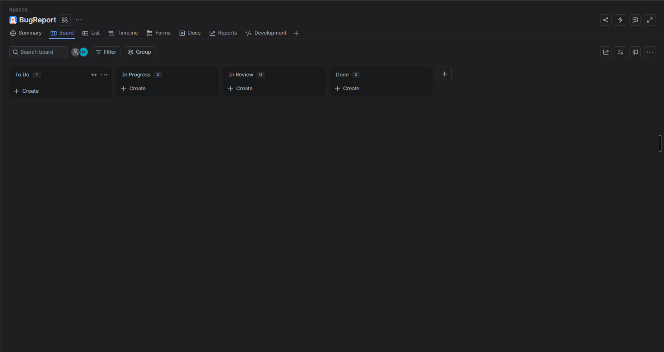
Figure 1: Bug Tracking project created in Jira

2. Defect Summary
The table below lists every defect raised, its severity and priority, and the requirement whose acceptance criterion it breaches. Severity describes the impact on the system; priority describes the urgency of the fix.
Bug ID | Summary | Severity | Priority | Violates
BUG-01 | Bins at exactly 80% fill are excluded from the generated route | Major | High | FR-001
BUG-02 | Manually tagged bin is dropped when the route is regenerated | Major | High | FR-002
BUG-03 | Collected bin still appears on the driver manifest after confirmation | Major | High | FR-003
BUG-04 | Complaint accepted without a valid bin reference when submitted offline | Major | Medium | FR-004
BUG-05 | Breakdown alert not raised when the truck loses GPS before reporting | Critical | Highest | FR-005
BUG-06 | Route recalculation exceeds the 45-second target at full scale | Critical | Highest | NFR-001
BUG-07 | Telematics payload written to the application log in plaintext | Critical | Highest | NFR-002
BUG-08 | Stale bin readings older than 24 hours are not rejected | Minor | Medium | FR-001
BUG-09 | 'No collection required' message not shown for an empty zone | Minor | Low | FR-002

- Critical (3): BUG-05, BUG-06, BUG-07 — service continuity, performance and security failures.
- Major (4): BUG-01 to BUG-04 — core collection workflow defects with visible user impact.
- Minor (2): BUG-08, BUG-09 — data-freshness and messaging defects with workarounds.
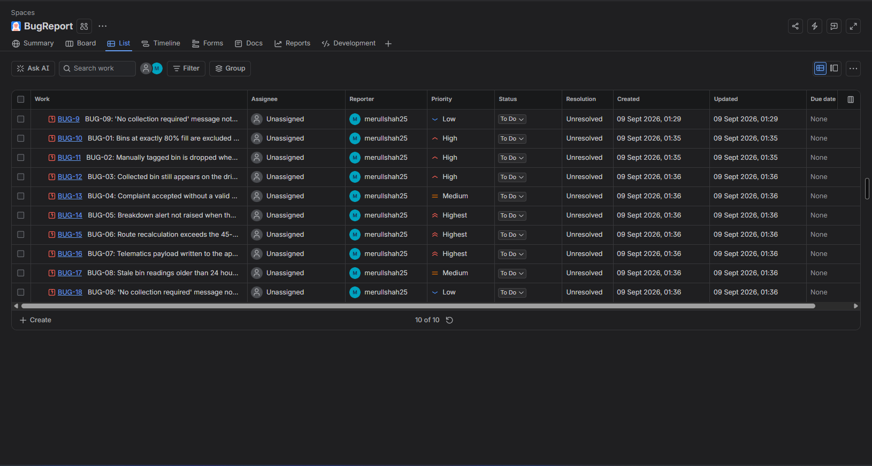
Figure 2: All defects reported, shown in the Bug Tracker list view
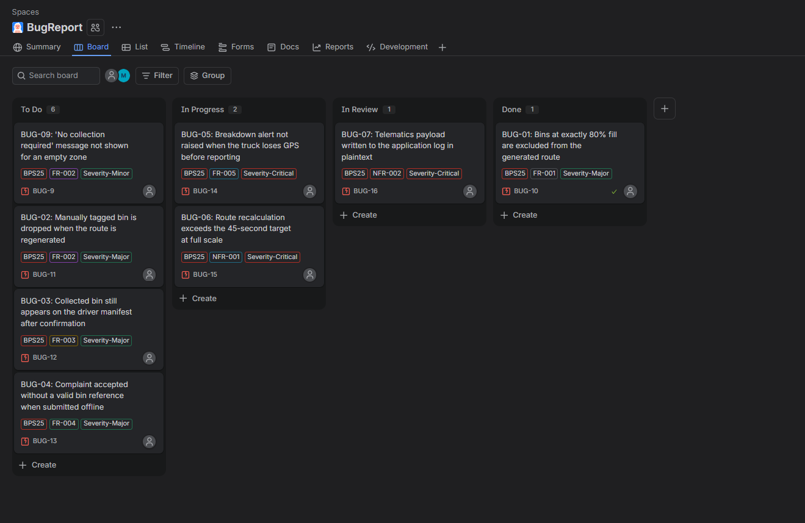
Figure 3: Bug board with defects distributed across workflow columns

3. Defect Details
Each defect below is recorded in Jira with the same fields: steps to reproduce, expected result and actual result, plus the requirement it traces to.

BUG-01 — Bins at exactly 80% fill are excluded from the generated route
Field | Detail
Severity / Priority | Major / High
Violates requirement | FR-001
Steps to reproduce | Set a bin's fill level to exactly 80%. Generate a route for that zone.
Expected result | Bin is included — the requirement states at or above the 80% threshold.
Actual result | Bin is excluded; the filter uses a strict greater-than comparison.
Status | Open

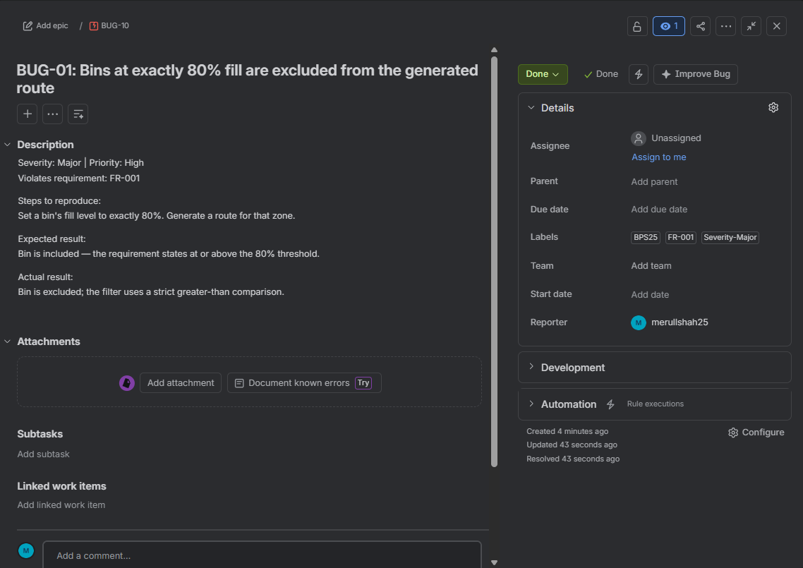
Figure 4: Jira detail view for BUG-01

BUG-02 — Manually tagged bin is dropped when the route is regenerated
Field | Detail
Severity / Priority | Major / High
Violates requirement | FR-002
Steps to reproduce | Tag a bin below 80% for pickup. Generate a route, then regenerate it without publishing.
Expected result | The tagged bin remains on the manifest across regenerations.
Actual result | The tag is cleared on regeneration and the bin disappears from the manifest.
Status | Open

BUG-03 — Collected bin still appears on the driver manifest after confirmation
Field | Detail
Severity / Priority | Major / High
Violates requirement | FR-003
Steps to reproduce | As a driver, mark an assigned bin collected. Observe the manifest for 10 seconds.
Expected result | Bin status resets to 0% and it leaves the route list within 5 seconds.
Actual result | Status resets in the backend but the manifest only refreshes on manual pull-to-refresh.
Status | Open

BUG-04 — Complaint accepted without a valid bin reference when submitted offline
Field | Detail
Severity / Priority | Major / Medium
Violates requirement | FR-004
Steps to reproduce | Put the citizen app in airplane mode. Submit a complaint with the bin field blank. Reconnect.
Expected result | Submission is rejected; a bin reference and timestamp are mandatory.
Actual result | The queued complaint syncs and is logged with a null bin reference.
Status | Open

BUG-05 — Breakdown alert not raised when the truck loses GPS before reporting
Field | Detail
Severity / Priority | Critical / Highest
Violates requirement | FR-005
Steps to reproduce | Simulate a telematics breakdown event from a truck with no current GPS fix.
Expected result | Supervisor is alerted within 30 seconds and the route is recalculated.
Actual result | The event is discarded during validation; no alert fires and the bins stay unassigned.
Status | Open
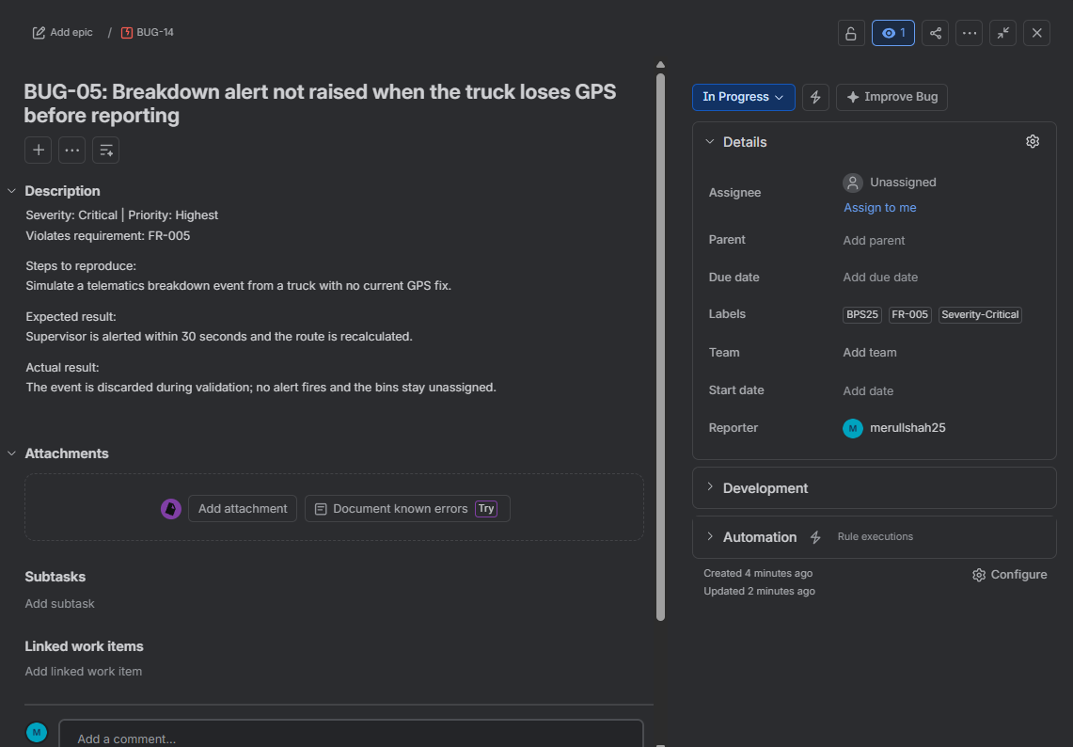
Figure 5: Jira detail view for BUG-05

BUG-06 — Route recalculation exceeds the 45-second target at full scale
Field | Detail
Severity / Priority | Critical / Highest
Violates requirement | NFR-001
Steps to reproduce | Run the benchmark harness with 50 trucks and 10,000 bins under simulated peak load.
Expected result | Recalculation completes in under 45 seconds.
Actual result | Recalculation takes appreciably longer than the target; record the measured figure here.
Status | Open

BUG-07 — Telematics payload written to the application log in plaintext
Field | Detail
Severity / Priority | Critical / Highest
Violates requirement | NFR-002
Steps to reproduce | Enable debug logging and trigger a telematics position update. Inspect the application log.
Expected result | No location or telematics data appears unencrypted in any store.
Actual result | Raw coordinates are written to the log file, bypassing the encryption-at-rest control.
Status | Open

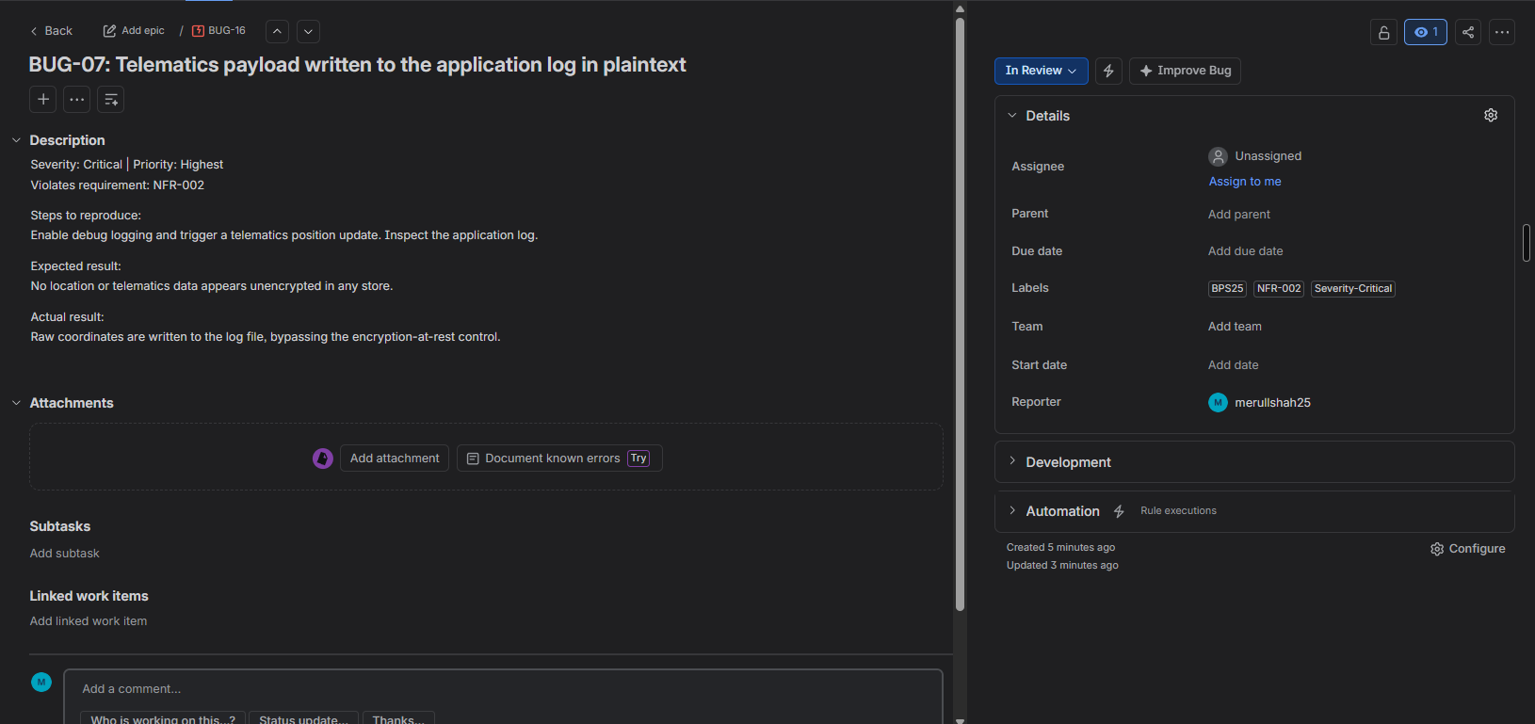
Figure 6: Jira detail view for BUG-07

BUG-08 — Stale bin readings older than 24 hours are not rejected
Field | Detail
Severity / Priority | Minor / Medium
Violates requirement | FR-001
Steps to reproduce | Set a bin's last reading timestamp to 30 hours ago with a 95% fill value. Generate a route.
Expected result | The stale reading is rejected as it breaches the use-case precondition.
Actual result | The bin is routed on the stale value, sending a truck to an already-empty bin.
Status | Open

BUG-09 — 'No collection required' message not shown for an empty zone
Field | Detail
Severity / Priority | Minor / Low
Violates requirement | FR-002
Steps to reproduce | Select a zone where no bin is above 80% and none is tagged. Click Generate Route.
Expected result | A 'No collection required' message is displayed (alternate flow 3a).
Actual result | An empty route manifest is generated and published instead.
Status | Open

4. Defect Distribution
Grouping the defects by the requirement they violate shows where testing found the most fragility. The two nonfunctional requirements each produced a Critical defect, which is characteristic of quality attributes that are easy to state and hard to verify without dedicated tooling.
Req ID | Defects | Highest severity | Defect IDs
FR-001 | 2 | Major | BUG-01, BUG-08
FR-002 | 2 | Major | BUG-02, BUG-09
FR-003 | 1 | Major | BUG-03
FR-004 | 1 | Major | BUG-04
FR-005 | 1 | Critical | BUG-05
NFR-001 | 1 | Critical | BUG-06
NFR-002 | 1 | Critical | BUG-07

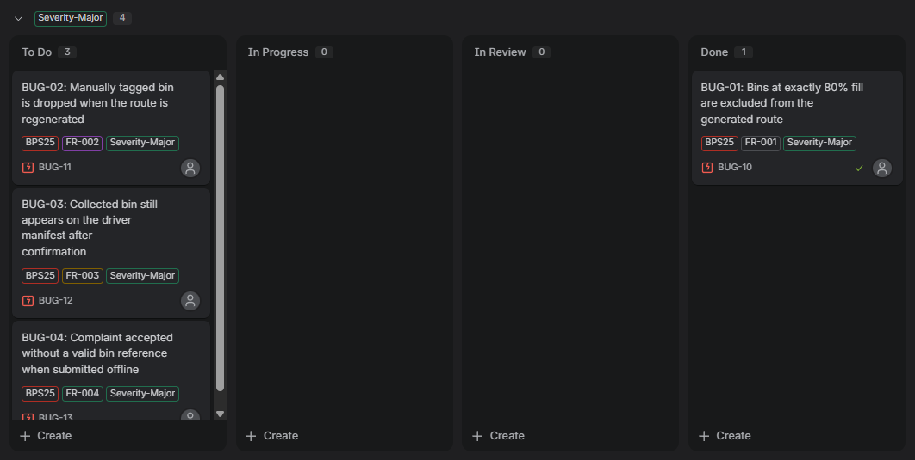
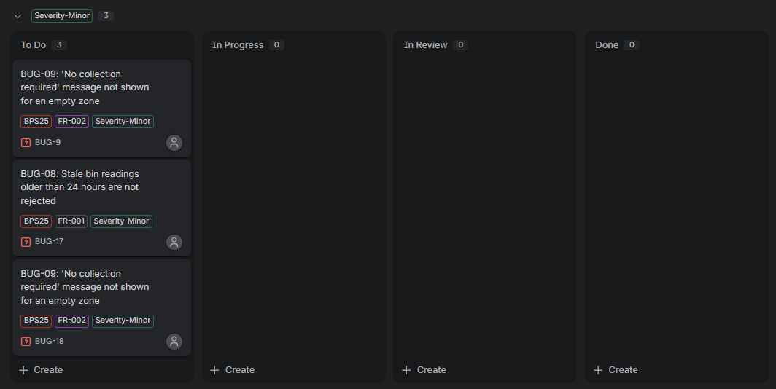
Figure 7: Defects grouped by priority or severity

