Kanban Project
Problem Statement #25: Municipal Solid Waste Route Optimizer
Name: Merull Shah
SRN: PES1UG24CS270
Problem Statement: BPS#25
Jira Link: https://merullshah25.atlassian.net/jira/software/projects/KAN/boards/34

1. Kanban Project Creation
A Jira Software project was created using the Kanban template for Problem Statement #25, the Municipal Solid Waste Route Optimizer. The project visualises the full requirement set on a single board and advances work items across columns without fixed timeboxes.
Field | Value
Project name | Kanban_BPS#25
Project key | KBPS25
Template | Kanban (Jira Software)
Project type | Company-managed
Problem statement | #25 — Municipal Solid Waste Route Optimizer
Work item hierarchy | Epic → Story → Task → Sub-task

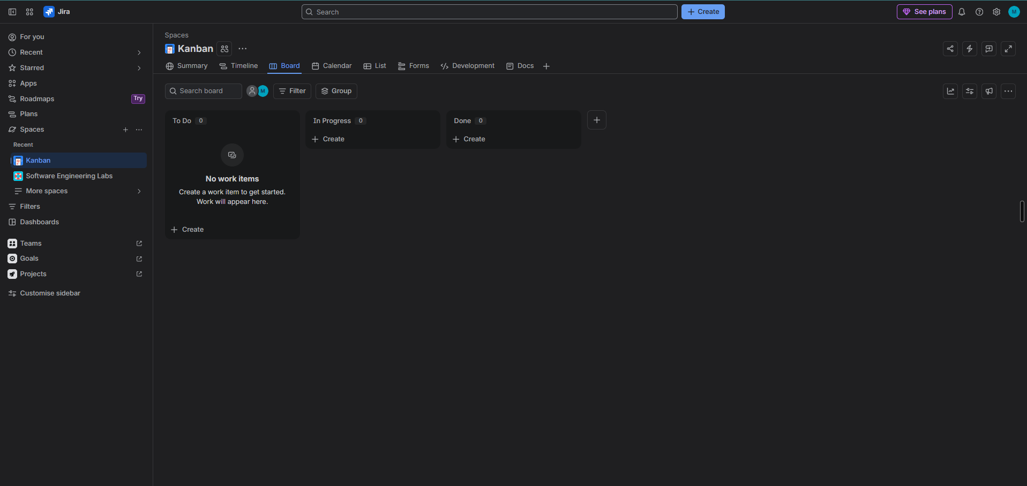
Figure 1: Kanban project created, showing the project name and auto-generated key updated to KBPS25

2. Board Creation with the Requirement Set
All seven Lab 1 requirements — five functional and two nonfunctional — were added to the Kanban board as work items. The table below is the requirement set carried forward from Lab 1.
Req ID | Type | Description | Priority
FR-001 | Functional | Generate optimized daily routes including only bins over the 80% fill threshold. | High
FR-002 | Functional | Allow a Supervisor to manually tag a sub-threshold bin for the next route. | Medium
FR-003 | Functional | Allow a Truck Driver to mark an assigned bin collected, resetting fill to 0%. | High
FR-004 | Functional | Allow a Citizen to submit a missed-pickup complaint against a bin and date. | Medium
FR-005 | Functional | Notify the Supervisor on truck breakdown and recalculate the affected route. | High
NFR-001 | Nonfunctional | Route recalculation for 50 trucks across 10,000 bins in under 45 seconds. | High
NFR-002 | Nonfunctional | Encrypt bin location and telematics data in transit and at rest (AES-256 / TLS 1.3). | High

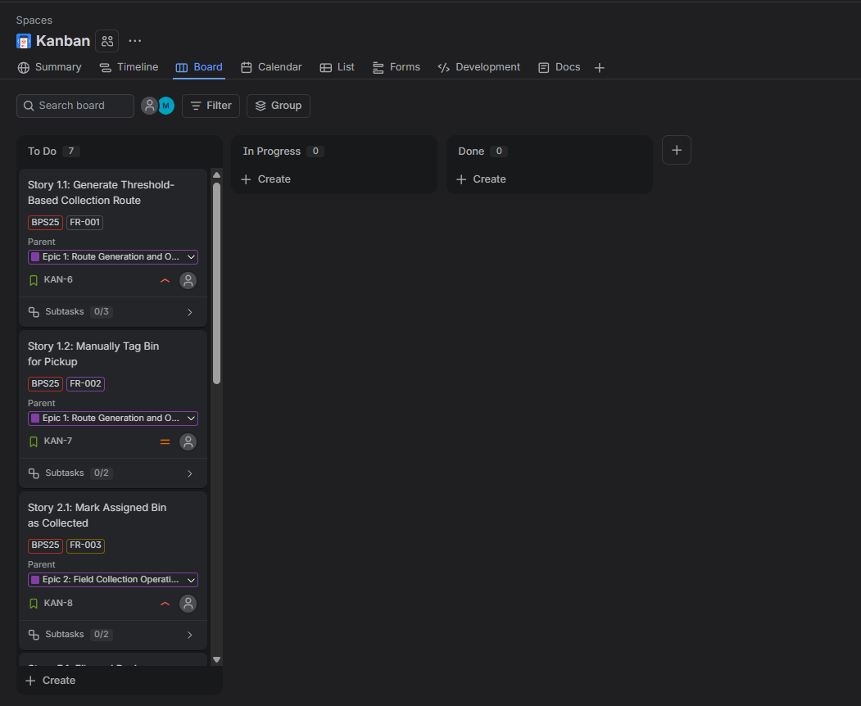
Figure 2: Kanban board populated with the 5 functional and 2 nonfunctional requirements

3. Epics (Scenarios)
The seven requirements were grouped into five Epics representing the major functional scenarios of the system. Each Epic was then assigned to its board work items so that every item on the board rolls up to a scenario.
Epic (Scenario) | Requirements | Use cases covered
Epic 1: Route Generation and Optimization | FR-001, FR-002 | UC-01 Generate Optimized Route, UC-02 Verify Bin Location, UC-03 Manually Tag Bin
Epic 2: Field Collection Operations | FR-003 | UC-04 View Assigned Route, UC-05 Mark Bin Collected
Epic 3: Citizen Engagement and Complaint Handling | FR-004 | UC-07 File Missed-Pickup Complaint, UC-08 Review Complaints
Epic 4: Fleet Disruption and Service Continuity | FR-005 | UC-06 Reassign Route on Breakdown
Epic 5: Platform Performance and Security | NFR-001, NFR-002 | Cross-cutting quality attributes (no discrete use case)

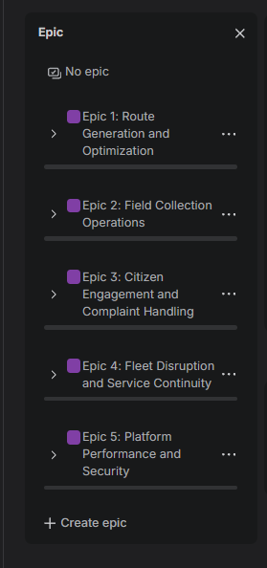
Figure 3: Epics created and assigned to board work items

4. User Stories for the Seven Requirements
One User Story was written per requirement using the standard Agile convention — As a [role], I want [goal], So that [benefit]. Each story is linked to its parent Epic and carries the requirement ID it satisfies.
User Story | As a | Traces to | Priority | Epic
Story 1.1: Generate Threshold-Based Collection Route | Sanitation Supervisor | FR-001 | High | Epic 1
Story 1.2: Manually Tag Bin for Pickup | Sanitation Supervisor | FR-002 | Medium | Epic 1
Story 2.1: Mark Assigned Bin as Collected | Truck Driver | FR-003 | High | Epic 2
Story 3.1: File and Review Missed-Pickup Complaint | Citizen | FR-004 | Medium | Epic 3
Story 4.1: Reassign Route on Truck Breakdown | Sanitation Supervisor | FR-005 | High | Epic 4
Story 5.1: Meet Route Recalculation Performance Target | Sanitation Supervisor | NFR-001 | High | Epic 5
Story 5.2: Encrypt Bin Location and Telematics Data | Municipal IT Administrator | NFR-002 | High | Epic 5

Full story text for each item is recorded in the work item description in Jira, in the form:
- Story 1.1: Generate Threshold-Based Collection Route — As a Sanitation Supervisor, I want the system to generate an optimized daily route containing only bins over 80% fill, So that I prevent overflow while minimising unnecessary stops.
- Story 1.2: Manually Tag Bin for Pickup — As a Sanitation Supervisor, I want to manually tag a bin below the 80% threshold for the next route, So that I can handle complaints and scheduled special collections.

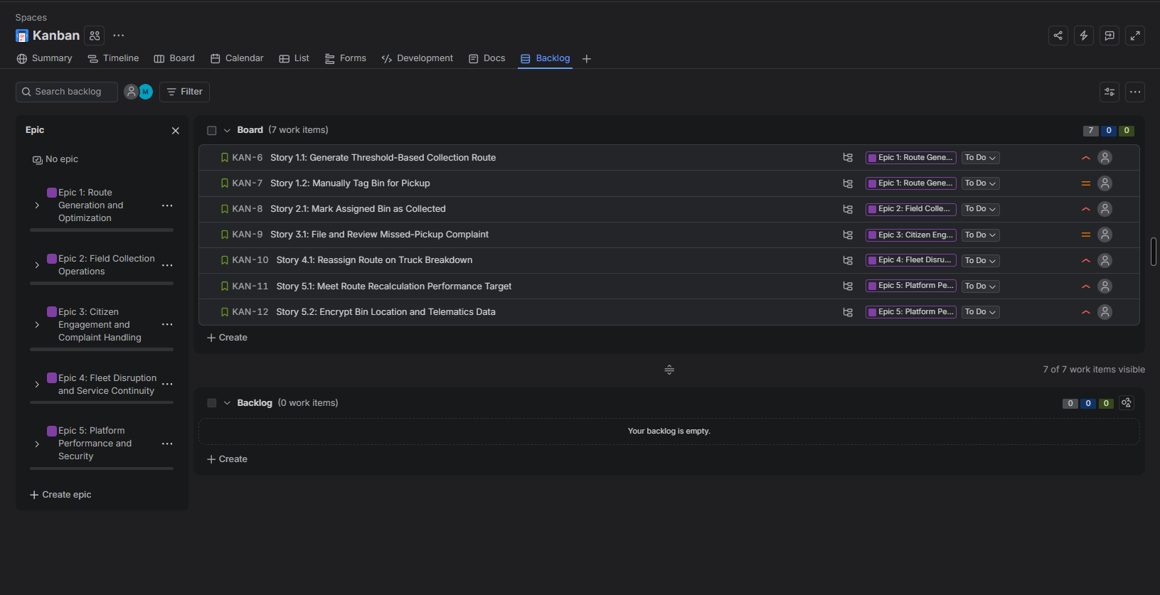
Figure 4: All seven User Stories created on the board, grouped under their Epics

5. Tasks and Sub-tasks
Each story covering a functional or nonfunctional requirement was broken down into technical sub-tasks so that progress can be tracked at a finer grain as cards move across the Kanban columns.
Parent Story | Task / Sub-task
Story 1.1 (FR-001) | Integrate Smart Bin Network fill-level feed
Story 1.1 (FR-001) | Implement 80% threshold filter and GPS verification
Story 1.1 (FR-001) | Build route sequencing optimizer and supervisor review screen
Story 1.2 (FR-002) | Add bin tagging control to supervisor dashboard
Story 1.2 (FR-002) | Honour tagged bins in route generation and empty-zone flow
Story 2.1 (FR-003) | Build driver mobile manifest view
Story 2.1 (FR-003) | Implement collection confirmation and fill-level reset
Story 3.1 (FR-004) | Build citizen complaint submission form
Story 3.1 (FR-004) | Build supervisor complaint review queue
Story 4.1 (FR-005) | Ingest breakdown events and alert supervisor
Story 4.1 (FR-005) | Redistribute stranded bins across active fleet
Story 5.1 (NFR-001) | Build peak-load benchmarking harness
Story 5.1 (NFR-001) | Profile and tune optimizer to sub-45-second target
Story 5.2 (NFR-002) | Enforce TLS 1.3 on all location and telematics endpoints
Story 5.2 (NFR-002) | Apply AES-256 encryption at rest and run security audit

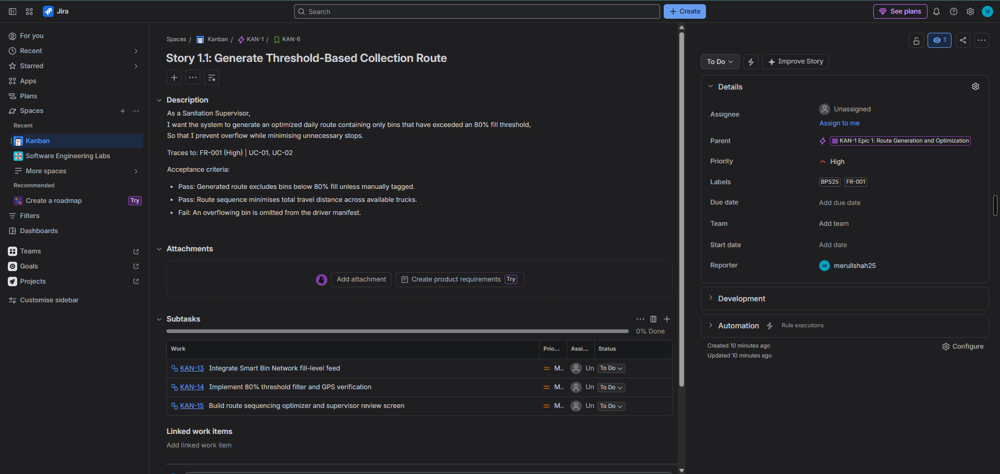
Figure 5: Tasks and sub-tasks added beneath the stories for all FRs and NFRs

6. Backlog with Epic Assignment
The backlog was built from the full work item set, with every backlog entry assigned to one of the five Epics. No item is left unassigned, so the Epic panel filter accounts for the entire backlog.
Backlog item | Epic | Req ID | Priority
Story 1.1: Generate Threshold-Based Collection Route | Epic 1 | FR-001 | High
Story 1.2: Manually Tag Bin for Pickup | Epic 1 | FR-002 | Medium
Story 2.1: Mark Assigned Bin as Collected | Epic 2 | FR-003 | High
Story 3.1: File and Review Missed-Pickup Complaint | Epic 3 | FR-004 | Medium
Story 4.1: Reassign Route on Truck Breakdown | Epic 4 | FR-005 | High
Story 5.1: Meet Route Recalculation Performance Target | Epic 5 | NFR-001 | High
Story 5.2: Encrypt Bin Location and Telematics Data | Epic 5 | NFR-002 | High

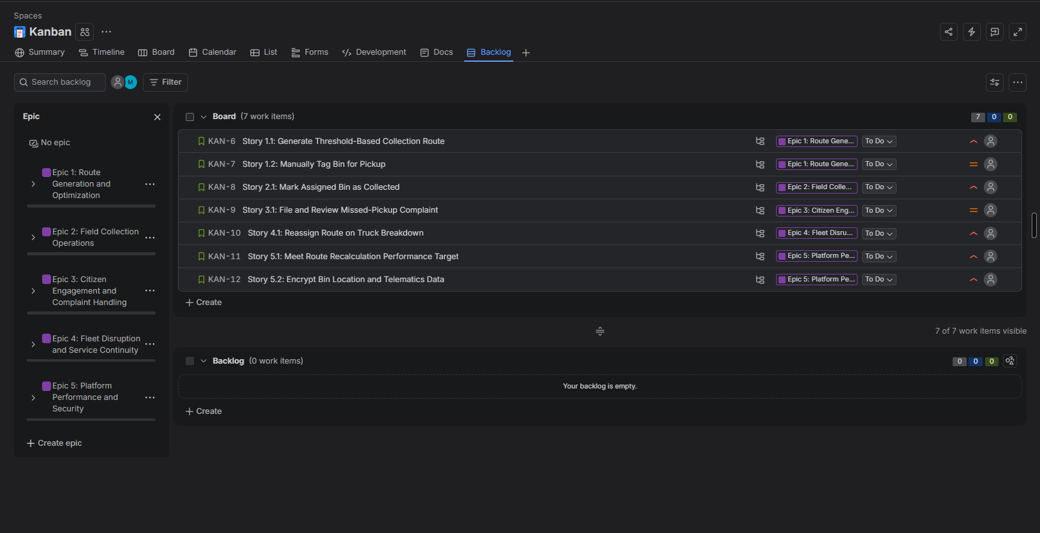
Figure 6: Backlog list with an Epic assigned to every entry
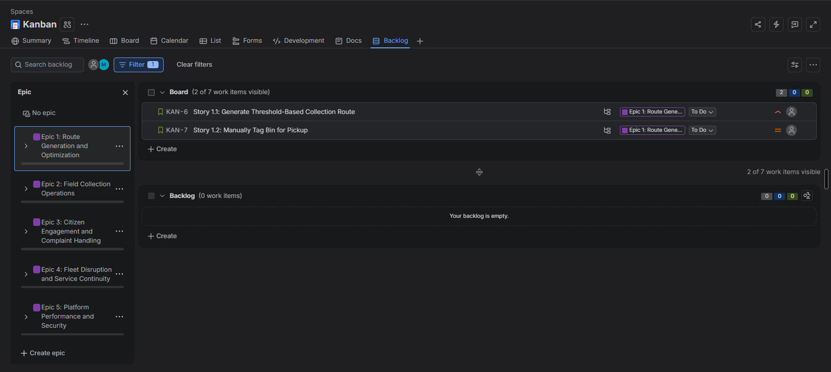
Figure 7: Backlog filtered by a single Epic, showing only that Epic's items

7. Kanban Flow
Work items were advanced across the Kanban columns in priority order. Unlike Scrum, the Kanban board has no sprint boundary — items are pulled into In Progress as capacity allows, which is why the board is captured at more than one point in time.
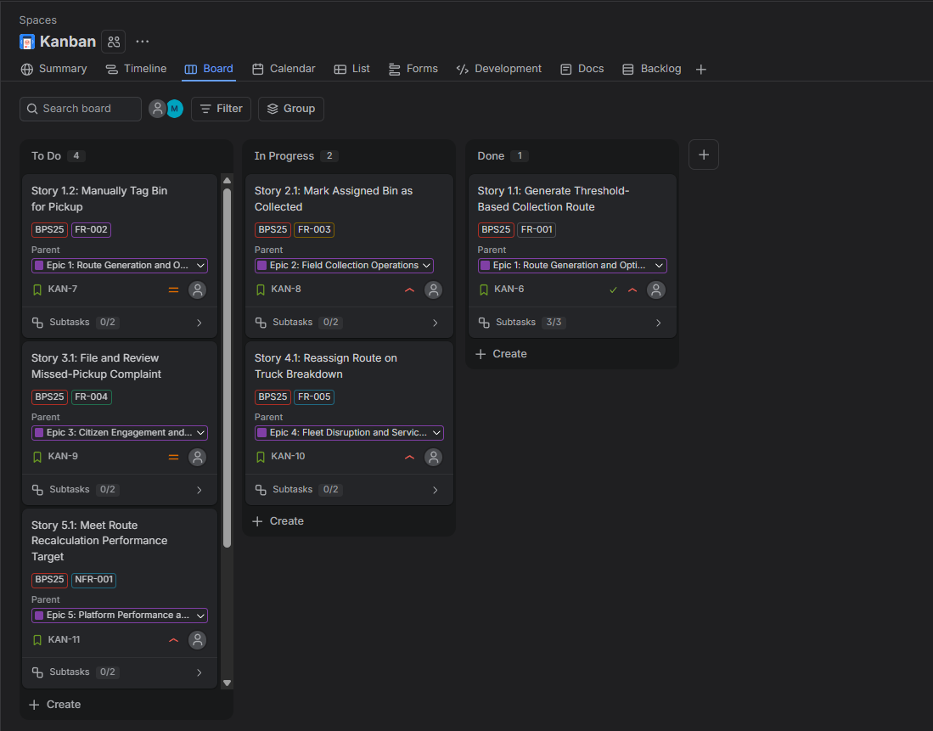
Figure 8: Kanban board with items distributed across To Do, In Progress and Done
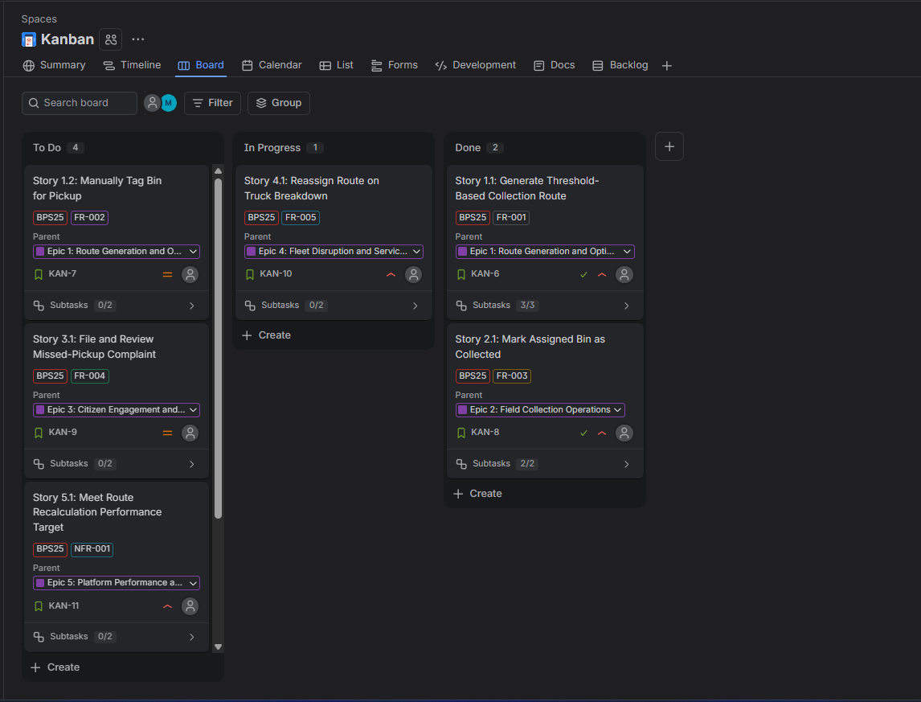
Figure 9: Kanban board after advancing the high-priority items to Done

