Scrum Project Agile Backlog Creation & Sprint Simulation in Jira
Problem Statement #25: Municipal Solid Waste Route Optimizer
Name: Merull Shah
SRN: PES1UG24CS270
Problem Statement: BPS#25
Jira Link: https://merullshah25.atlassian.net/jira/software/projects/SCRUM/boards/1

1. Scrum Project Creation
A Jira Software project was created using the Scrum template for Problem Statement #25. The same seven Lab 1 requirements used in the Kanban project were converted into Epics, User Stories, Tasks and Sub-tasks, then estimated, prioritised and delivered across two simulated sprints.
Field | Value
Project name | Software Engineering Labs
Project key | SCRUM
Template | Scrum (Jira Software)
Board | SCRUM board (board ID 1)
Work item hierarchy | Epic → Story → Sub-task
Labels | BPS25, plus the requirement ID (FR-001 … NFR-002) on every item
Sprint length | 1 week

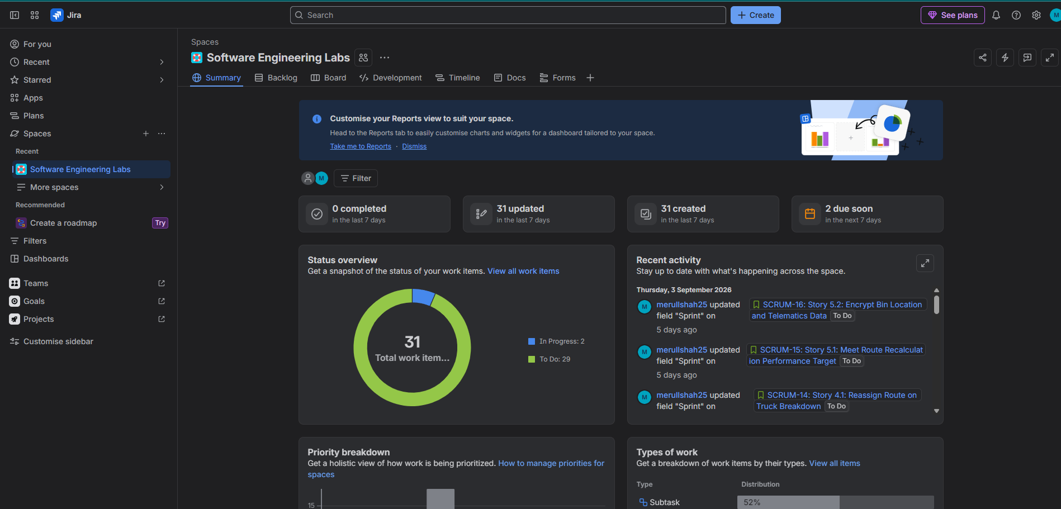
Figure 1: Scrum board created for the project

2. Requirements Carried Forward from Lab 1
Req ID | Type | Description | Priority
FR-001 | Functional | Generate optimized daily routes including only bins over the 80% fill threshold. | High
FR-002 | Functional | Allow a Supervisor to manually tag a sub-threshold bin for the next route. | Medium
FR-003 | Functional | Allow a Truck Driver to mark an assigned bin collected, resetting fill to 0%. | High
FR-004 | Functional | Allow a Citizen to submit a missed-pickup complaint against a bin and date. | Medium
FR-005 | Functional | Notify the Supervisor on truck breakdown and recalculate the affected route. | High
NFR-001 | Nonfunctional | Route recalculation for 50 trucks across 10,000 bins in under 45 seconds. | High
NFR-002 | Nonfunctional | Encrypt bin location and telematics data in transit and at rest (AES-256 / TLS 1.3). | High

3. Epics
The seven requirements were grouped into five major functional themes. Each Epic description names the requirements and use cases it covers together with its primary and supporting actors.
Key | Epic | Requirements | Use cases covered
SCRUM-5 | Epic 1: Route Generation and Optimization | FR-001, FR-002 | UC-01 Generate Optimized Route, UC-02 Verify Bin Location, UC-03 Manually Tag Bin
SCRUM-6 | Epic 2: Field Collection Operations | FR-003 | UC-04 View Assigned Route, UC-05 Mark Bin Collected
SCRUM-7 | Epic 3: Citizen Engagement and Complaint Handling | FR-004 | UC-07 File Missed-Pickup Complaint, UC-08 Review Complaints
SCRUM-8 | Epic 4: Fleet Disruption and Service Continuity | FR-005 | UC-06 Reassign Route on Breakdown
SCRUM-9 | Epic 5: Platform Performance and Security | NFR-001, NFR-002 | Cross-cutting quality attributes (no discrete use case)

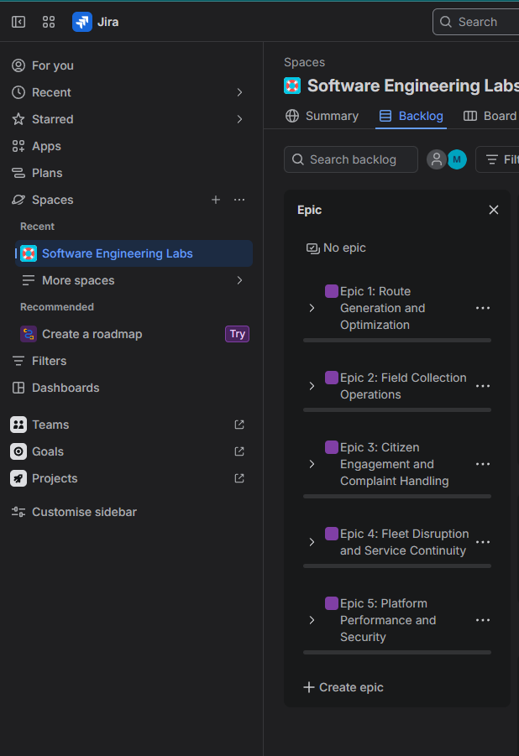
Figure 2: All five Epics in the backlog Epic panel

4. User Stories
One User Story was written for each requirement in the As a / I want / So that form. Every story records its acceptance criteria and traces to a requirement and its use cases.
Key | User Story | Traces to | Priority | Points | Sprint
SCRUM-10 | Story 1.1: Generate Threshold-Based Collection Route | FR-001 | High | 8 | Sprint 1
SCRUM-11 | Story 1.2: Manually Tag Bin for Pickup | FR-002 | Medium | 3 | Sprint 1
SCRUM-12 | Story 2.1: Mark Assigned Bin as Collected | FR-003 | High | 5 | Sprint 1
SCRUM-13 | Story 3.1: File and Review Missed-Pickup Complaint | FR-004 | Medium | 3 | Sprint 1
SCRUM-14 | Story 4.1: Reassign Route on Truck Breakdown | FR-005 | High | 13 | Sprint 2
SCRUM-15 | Story 5.1: Meet Route Recalculation Performance Target | NFR-001 | High | 13 | Sprint 2
SCRUM-16 | Story 5.2: Encrypt Bin Location and Telematics Data | NFR-002 | High | 8 | Sprint 2

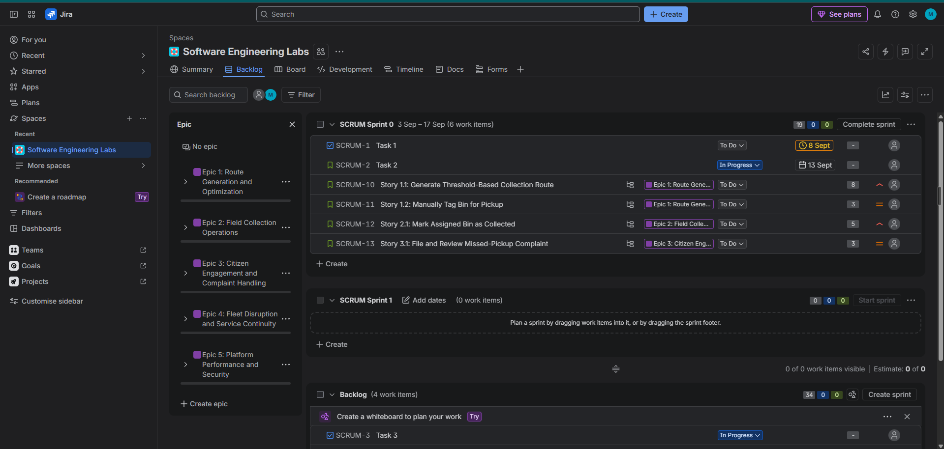
Figure 3: Backlog populated with all Epics and User Stories
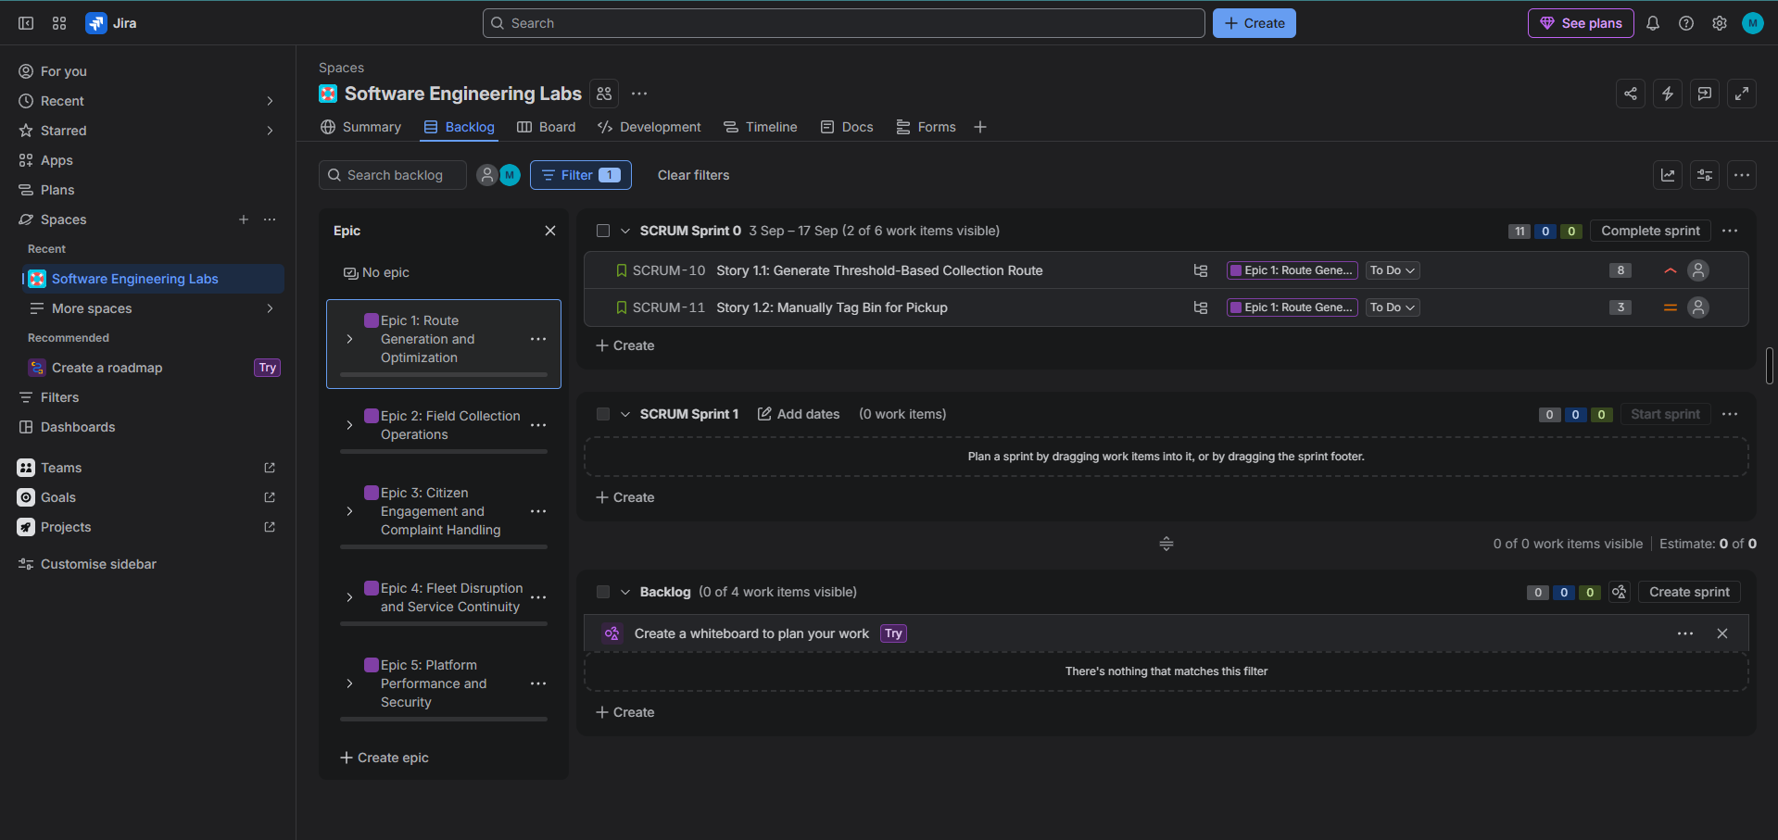
Figure 4: User Stories filtered under a single Epic

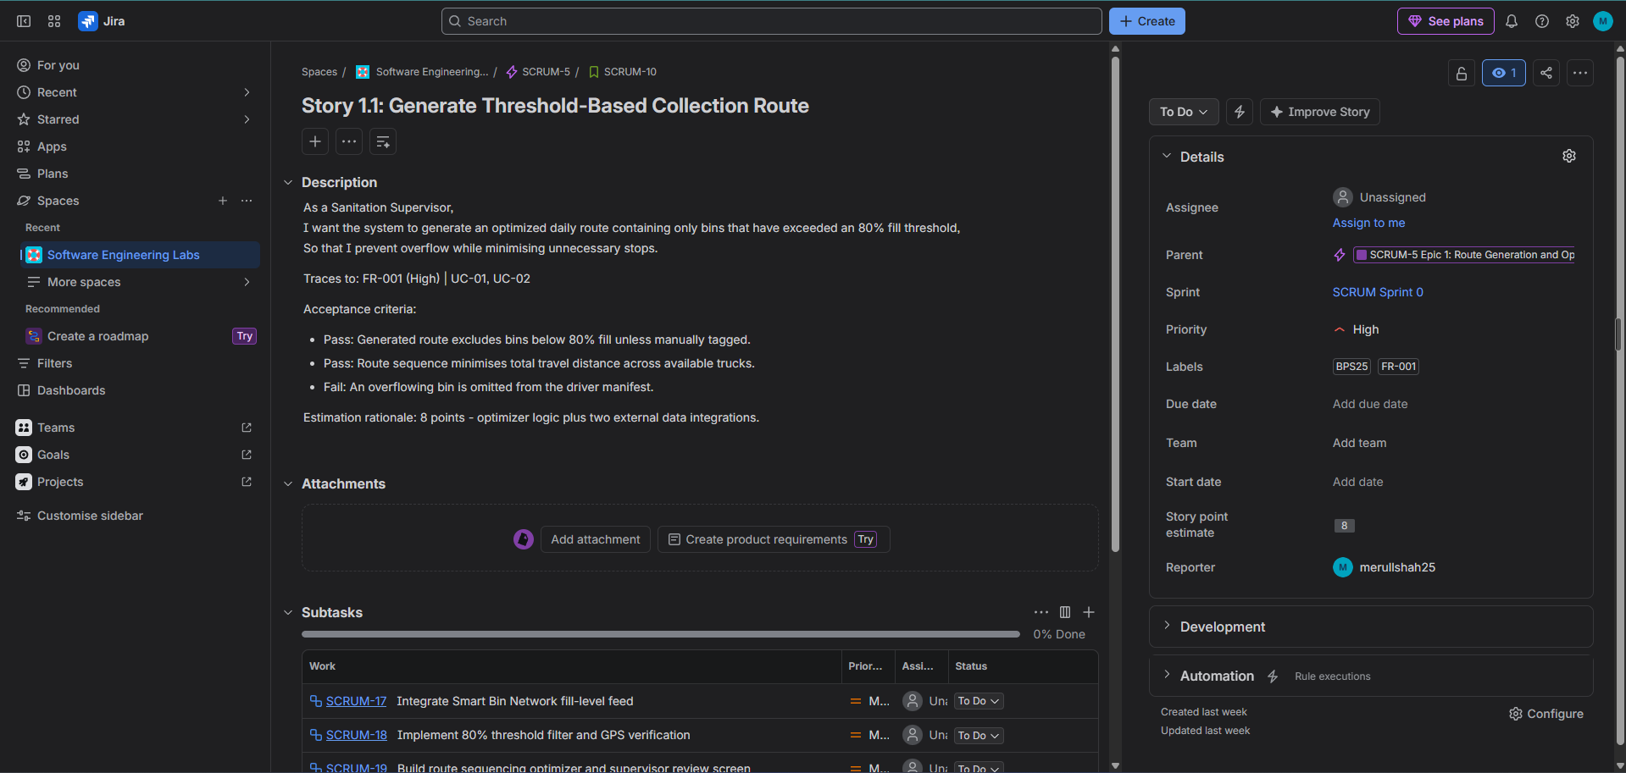
Figure 5: Detail view of one User Story showing the As a / I want / So that description and acceptance criteria

5. Tasks and Sub-tasks
Fifteen sub-tasks were created across the seven stories so work could be tracked at a finer grain on the sprint board.
Parent Story | Key | Sub-task
Story 1.1 (FR-001) | SCRUM-17 | Integrate Smart Bin Network fill-level feed
Story 1.1 (FR-001) | SCRUM-18 | Implement 80% threshold filter and GPS verification
Story 1.1 (FR-001) | SCRUM-19 | Build route sequencing optimizer and supervisor review screen
Story 1.2 (FR-002) | SCRUM-20 | Add bin tagging control to supervisor dashboard
Story 1.2 (FR-002) | SCRUM-21 | Honour tagged bins in route generation and empty-zone flow
Story 2.1 (FR-003) | SCRUM-22 | Build driver mobile manifest view
Story 2.1 (FR-003) | SCRUM-23 | Implement collection confirmation and fill-level reset
Story 3.1 (FR-004) | SCRUM-24 | Build citizen complaint submission form
Story 3.1 (FR-004) | SCRUM-25 | Build supervisor complaint review queue
Story 4.1 (FR-005) | SCRUM-26 | Ingest breakdown events and alert supervisor
Story 4.1 (FR-005) | SCRUM-27 | Redistribute stranded bins across active fleet
Story 5.1 (NFR-001) | SCRUM-28 | Build peak-load benchmarking harness
Story 5.1 (NFR-001) | SCRUM-29 | Profile and tune optimizer to sub-45-second target
Story 5.2 (NFR-002) | SCRUM-30 | Enforce TLS 1.3 on all location and telematics endpoints
Story 5.2 (NFR-002) | SCRUM-31 | Apply AES-256 encryption at rest and run security audit

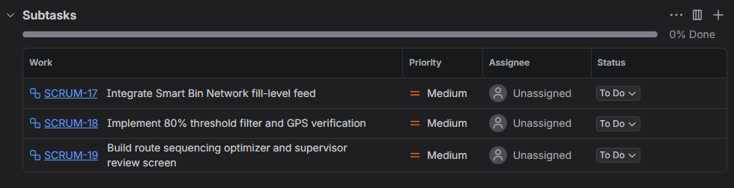
Figure 6: Sub-tasks listed under their parent User Story

6. Backlog Prioritisation
Priorities were carried across from the Lab 1 requirements table and reflect user impact. High-priority items are those where failure causes a missed or overflowing collection; Medium-priority items support edge cases and the citizen feedback loop.
- High — FR-001, FR-003, FR-005, NFR-001, NFR-002 (5 items): core collection service and platform quality attributes.
- Medium — FR-002, FR-004 (2 items): supervisor override and citizen complaint handling.
- The backlog is ordered so High-priority stories sit above Medium-priority ones.

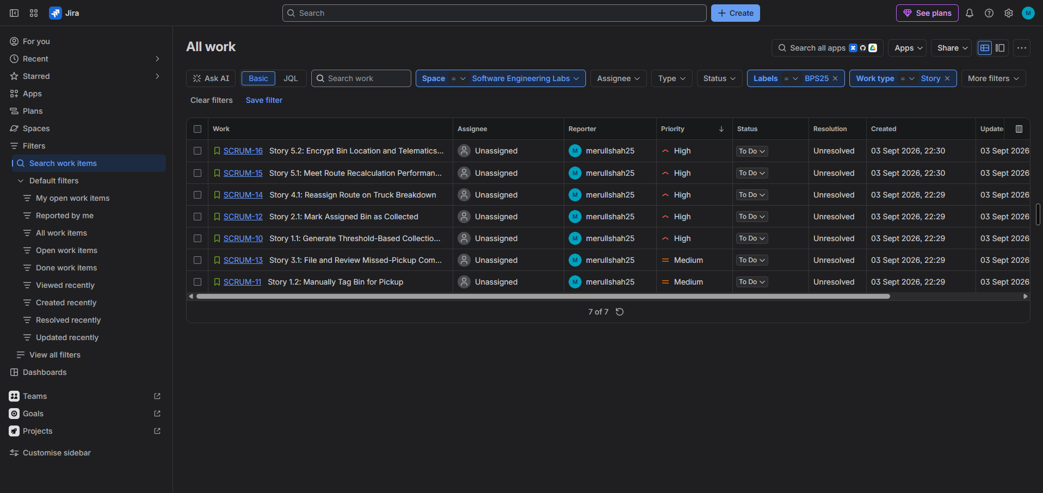
Figure 7: Backlog ordered by priority with priority icons visible on each row

7. Story Point Estimation (Planning Poker)
Story points were assigned on the Fibonacci scale (1, 2, 3, 5, 8, 13, …) using Planning Poker. Points express complexity, volume of work and uncertainty rather than hours — which is why the two research-heavy items attract 13 points despite touching less UI than some smaller stories. The non-linear scale reflects the fact that confidence drops sharply as items grow.
Key | Story | Points | Estimation rationale
SCRUM-10 | Generate Threshold-Based Route | 8 | Optimizer logic plus two external data integrations
SCRUM-11 | Manually Tag Bin for Pickup | 3 | A UI control plus an override branch in the existing filter
SCRUM-12 | Mark Assigned Bin as Collected | 5 | Mobile view plus a state update with a 5-second latency target
SCRUM-13 | File and Review Complaint | 3 | A validated form, a ticket record, and a review list
SCRUM-14 | Reassign Route on Breakdown | 13 | Event ingestion, alerting, and mid-day re-optimization
SCRUM-15 | Recalculation Performance Target | 13 | Load harness, profiling and tuning with an uncertain outcome
SCRUM-16 | Encrypt Location and Telematics Data | 8 | Transport and storage hardening plus audit evidence

Total backlog: 53 points. Sprint 1 committed 19 points (SCRUM-10 to SCRUM-13); Sprint 2 committed 34 points (SCRUM-14 to SCRUM-16).

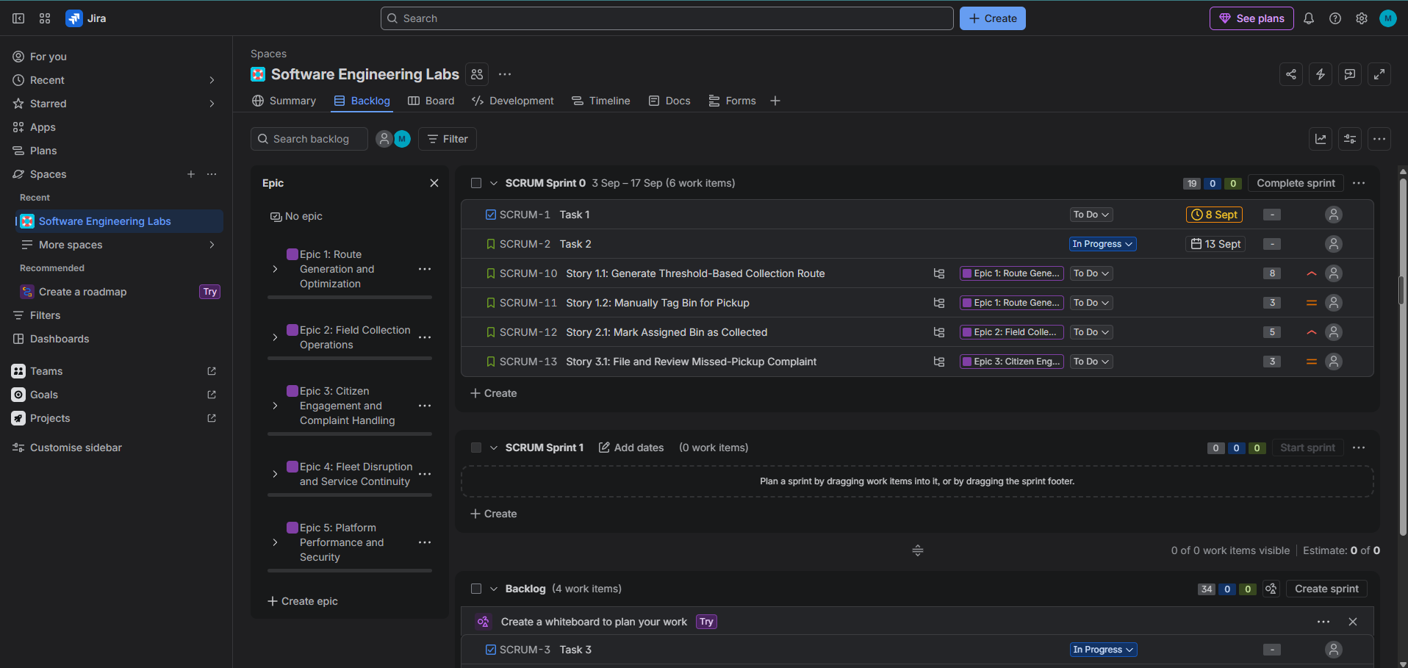
Figure 8: Story point estimates against each backlog item

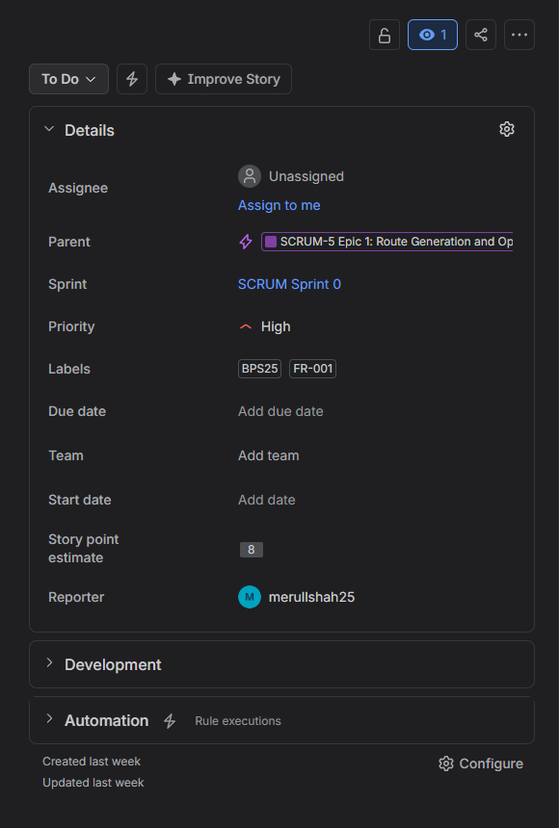
Figure 9: Story points field in a single work item detail panel

8. Sprint 1 Simulation
Sprint 1 was planned with the four highest-priority stories, totalling 19 story points over a one-week timebox. Work items were then progressed from To Do to In Progress to Done.
Sprint 1 scope: SCRUM-10 (8), SCRUM-11 (3), SCRUM-12 (5), SCRUM-13 (3) — 19 points.
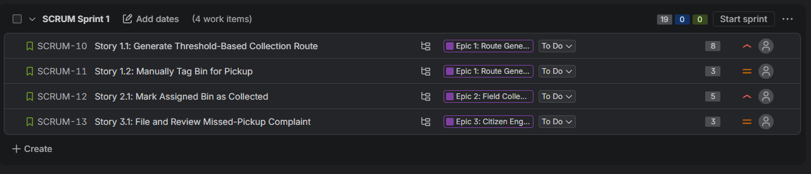
Figure 10: Sprint 1 planned in the backlog, showing committed items and total estimate
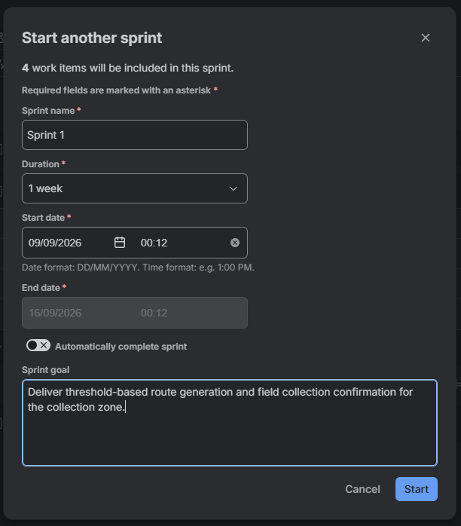
Figure 11: Sprint 1 start dialog with the one-week duration and sprint goal
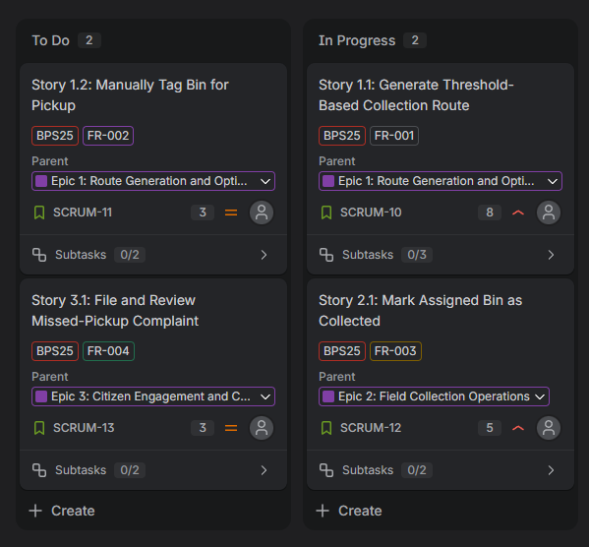
Figure 12: Active sprint board mid-sprint, items spread across To Do, In Progress and Done
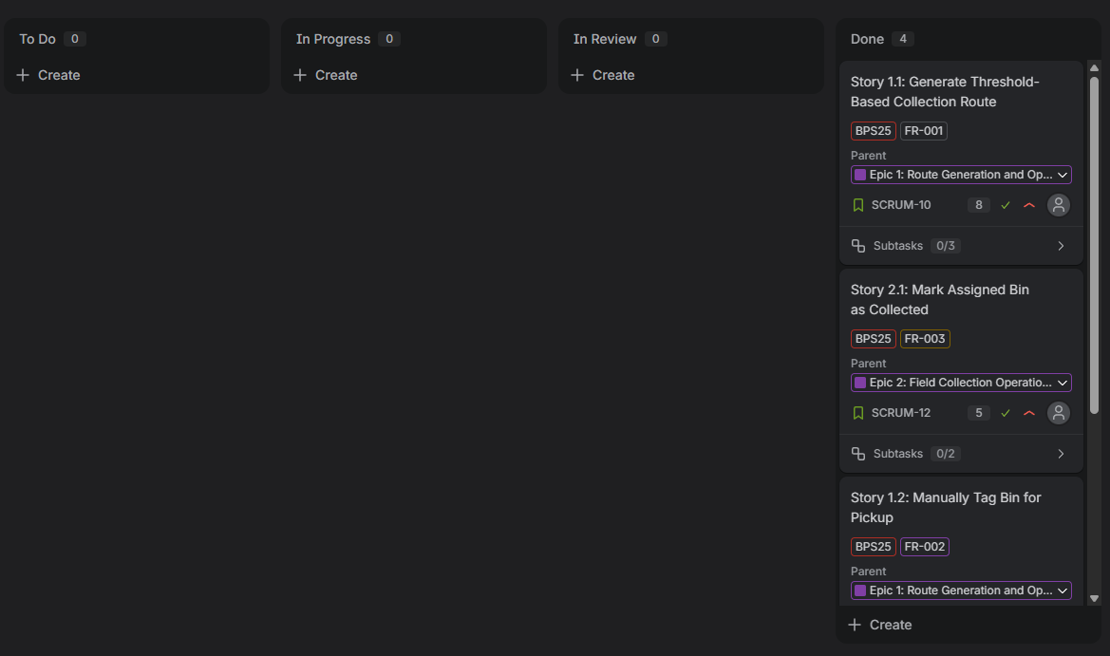
Figure 13: Active sprint board at completion, all items in Done

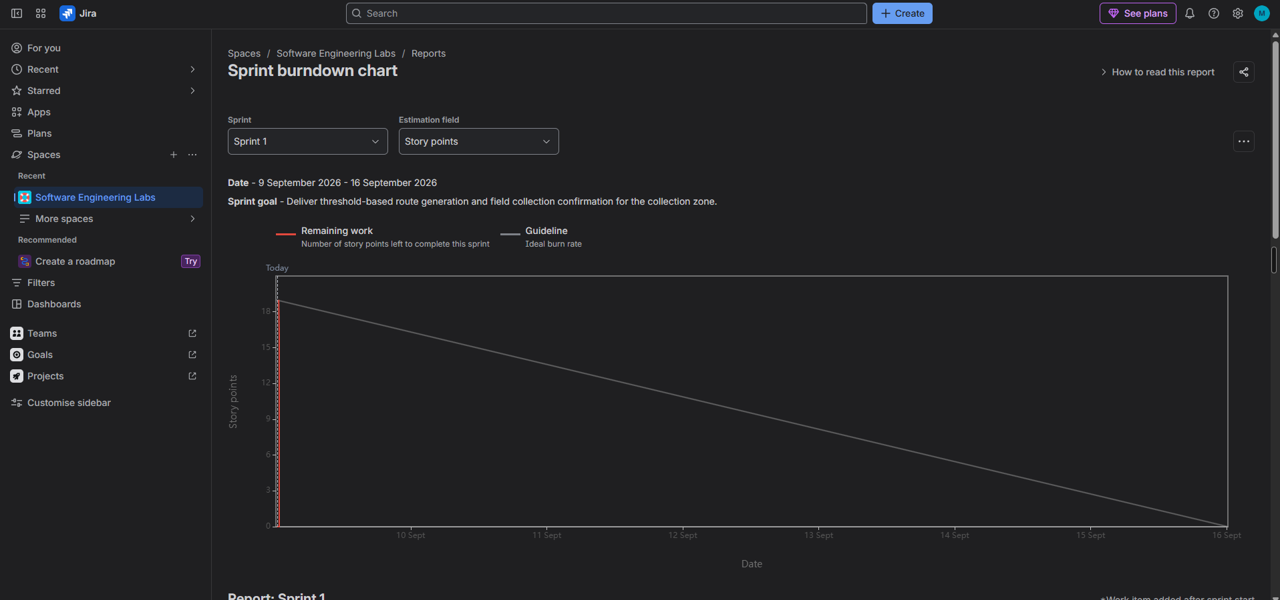
Figure 14: Sprint 1 burndown chart

Sprint 1 burndown observations
Describe the shape of the red remaining-work line against the grey guideline: where it stayed flat, where it dropped, and whether it finished above or below the guideline.
Answer: The red remaining-work line held at 19 points only briefly before dropping vertically to zero on 9 September, the opening day of the sprint. The grey guideline ran diagonally across the full week to 16 September, so the actual line sat far below it for the whole remaining period. The sprint finished ahead of the guideline in the most extreme way possible: all 19 points closed on day one, leaving six days of the timebox unused. The chart therefore records a single completion event rather than a genuine burn-down, which reflects the simulated nature of the exercise — the work was marked complete in one sitting rather than progressed across the sprint.

9. Sprint 2 Simulation
Sprint 2 carried the three remaining stories — the two 13-point items and one 8-point item — totalling 34 story points. This gives a deliberate contrast with Sprint 1: fewer items, but a heavier and more uncertain load.
Sprint 2 scope: SCRUM-14 (13), SCRUM-15 (13), SCRUM-16 (8) — 34 points.

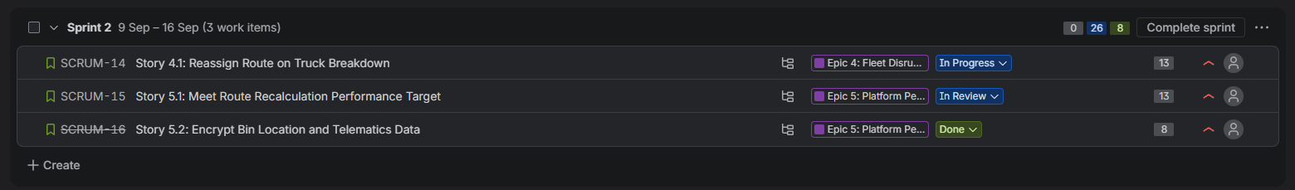
Figure 15: Sprint 2 planned in the backlog with its committed items
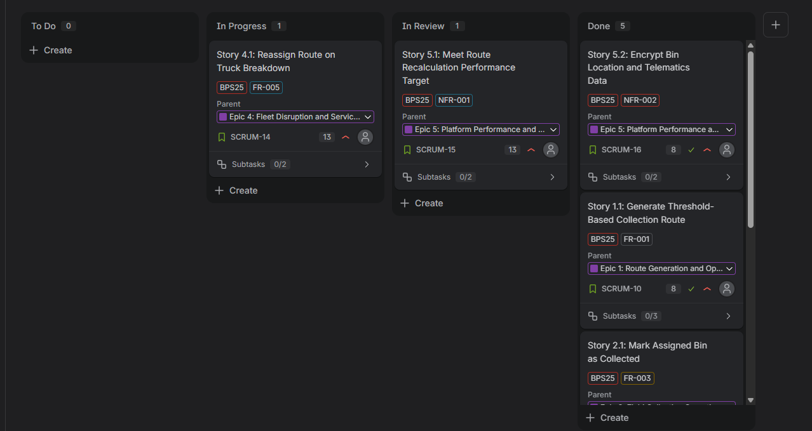
Figure 16: Sprint 2 active board with items in progress
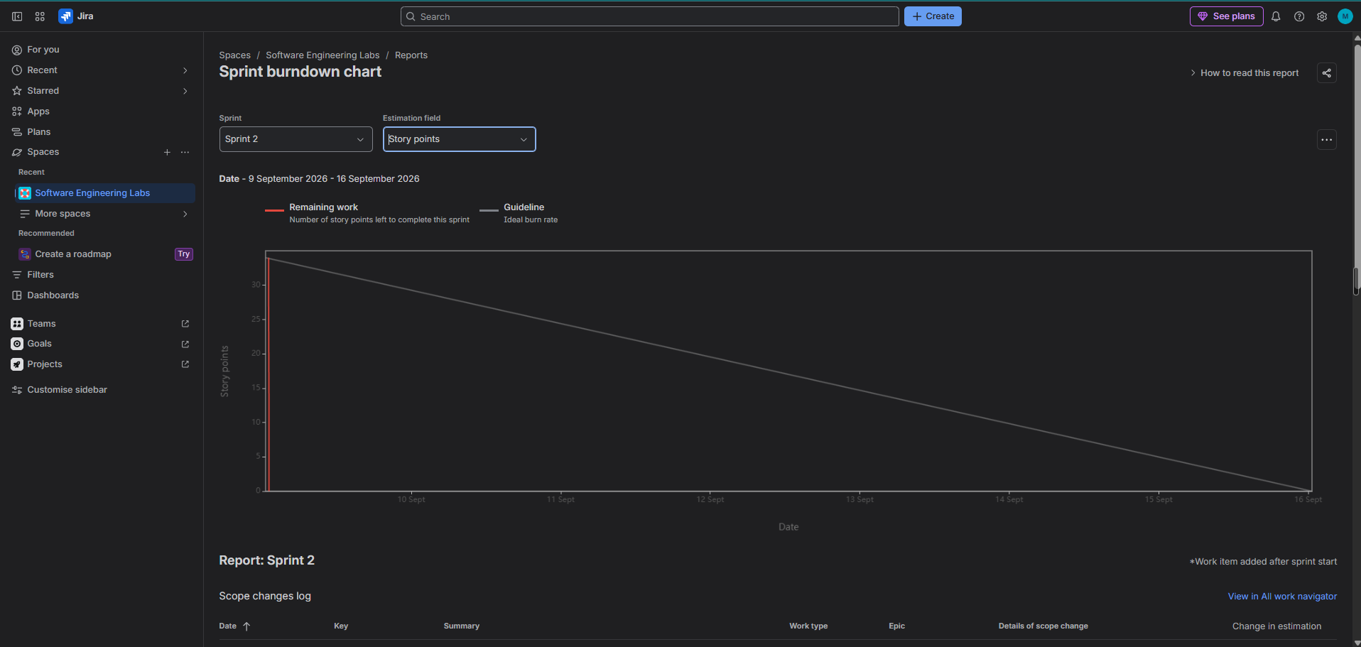
Figure 17: Sprint 2 burndown chart

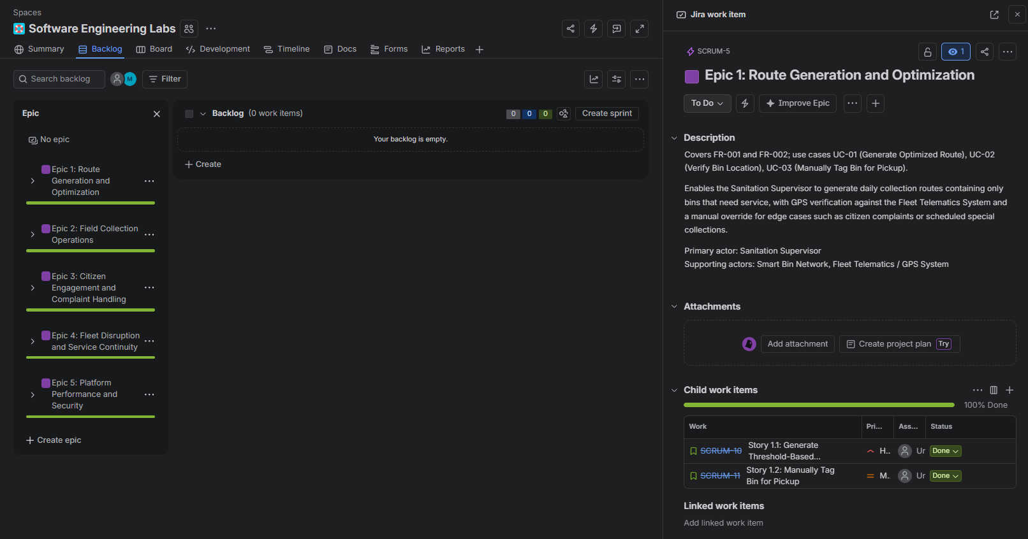
Figure 18: Epic progress bars after both sprints, showing completion and total points per

10. Reflection Questions

10.1 Did your estimations reflect the actual effort?
Compare the points assigned against how the work actually moved. Consider whether the 13-point items (SCRUM-14, SCRUM-15) really were roughly four times the effort of the 3-point items, and whether any story should be re-estimated or split.
Answer: The estimates were never really tested by this simulation. Because no implementation work was carried out, every story moved from To Do to Done in a single sitting, so the 8/3/5/3 spread in Sprint 1 and the 13/13/8 spread in Sprint 2 never had to survive contact with real effort. What the exercise did expose is the relative reasoning behind the numbers rather than their accuracy. FR-005 and NFR-001 were both given 13 points because their difficulty lies in uncertainty rather than volume — a mid-day re-optimisation across a live fleet, and a performance target that may not be reachable without algorithmic change. On reflection both are too large for a single sprint item and should be split: NFR-001 divides naturally into building the benchmark harness and meeting the 45-second target, which are separable because the first is bounded work and the second is open-ended. Story 1.1 at 8 points is the estimate I would defend as it stands, since its three sub-tasks map cleanly onto roughly three days of work.

10.2 Was your backlog well-prioritised?
Consider whether the High/Medium split from the Lab 1 requirements table produced a sensible delivery order, and whether any dependency was violated — for example, FR-002 (manual tagging) extends FR-001 (route generation), so scheduling the two in the same sprint matters.
Answer: The High/Medium split carried over from the Lab 1 requirements table produced a workable delivery order, and no dependency was violated. The case that mattered was FR-002, which extends FR-001 in the use-case model: manual bin tagging has no meaning until threshold-based route generation exists, and alternate flow 3a depends on both. Both were scheduled in Sprint 1 under Epic 1, so the dependency was respected. The weaker aspect is that Sprint 2 collected the entire high-risk tail — two 13-point stories and an 8 — into one 34-point sprint, nearly double Sprint 1's 19. Ordering strictly by requirement priority pushed all the uncertain work to the end, which is the opposite of what risk-driven prioritisation would suggest. A better split would have moved FR-005 into Sprint 1 and NFR-002 into Sprint 2, balancing the sprints at roughly 27 points each and surfacing the hardest problem earlier.

10.3 How did your simulated sprint align with your plan?
Note whether all committed items reached Done, whether anything was carried over, and how the 19-point and 34-point sprints compared in practice.
Answer: All committed items reached Done in both sprints and nothing was carried over: Sprint 1 closed four stories totalling 19 points, Sprint 2 closed three totalling 34, and all 15 sub-tasks were completed. In that narrow sense both sprints hit their plan exactly. The alignment is misleading, however, because a one-week timebox was compressed into roughly an hour in each case. One genuine deviation did emerge. Neither sprint could initially be completed, because the parent stories had been moved to Done while their sub-tasks remained in To Do, and Jira blocked completion until all 15 sub-tasks were closed. That is a real Agile lesson rather than a tooling quirk: a story is not done while its child work is still open, and the definition of done has to hold at every level of the hierarchy. A second, smaller deviation is that the board carries four columns — To Do, In Progress, In Review, Done — rather than the three assumed during planning, so the workflow actually exercised was a step longer than the plan described.

10.4 What insights did the burndown chart give about your team's capacity?
Relate the burndown shape to velocity: a sharp late drop suggests work was not broken down finely enough; a line consistently below the guideline suggests under-commitment. State what you would commit to in a hypothetical Sprint 3 based on the two observed velocities.
Answer: The burndown charts give very little insight into capacity, and saying so is the honest reading. Both sprints show a line that stays flat and then drops vertically; Sprint 2 has one small step at 26 points where NFR-002 was closed slightly ahead of the other two, but the shape is otherwise identical. The handout notes that a sharp drop suggests work was not estimated accurately or broken down properly. Here the cause is more basic than that: progress was not tracked incrementally at all, so the chart records the moment work was marked done rather than the moment it was done. With two data points of 19 and 34 points apparently delivered within an hour each, no meaningful velocity can be derived. If a Sprint 3 were planned honestly, the only defensible basis would be to disregard these figures and commit to a small amount — perhaps 8 to 13 points — then measure actual throughput before scaling up. The methodological conclusion is that a burndown is only as informative as the discipline of updating item status daily.

