Output:

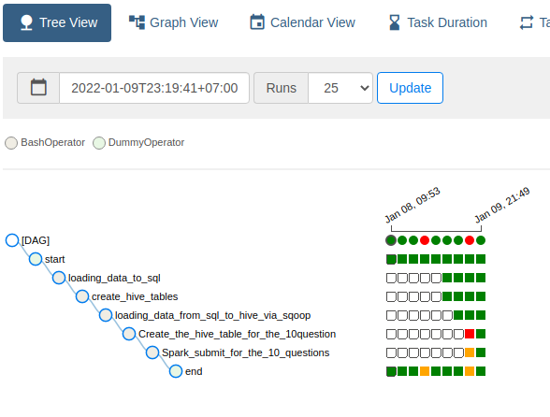

Single Dag

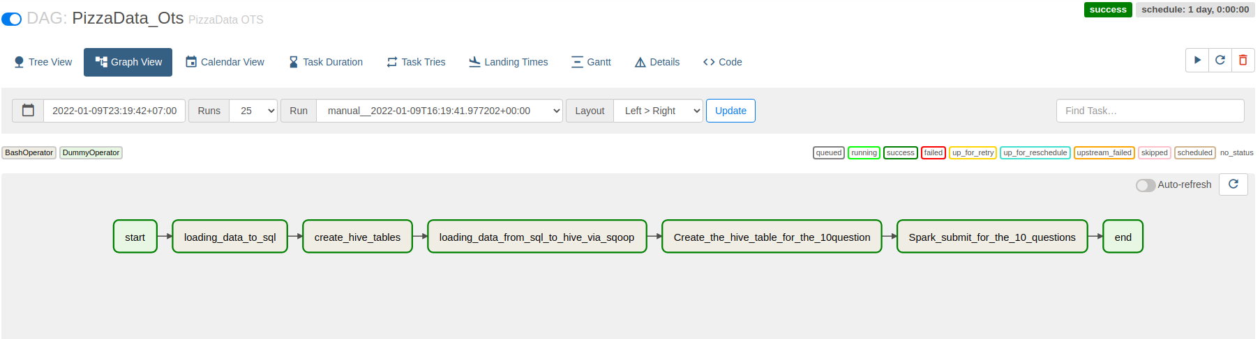

1st Question

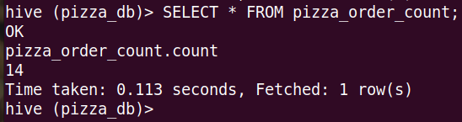

2nd Question

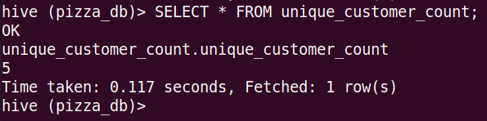

3rd Question

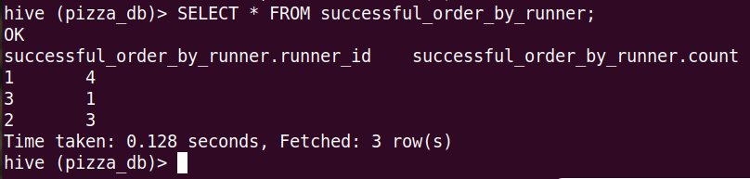

4th Question

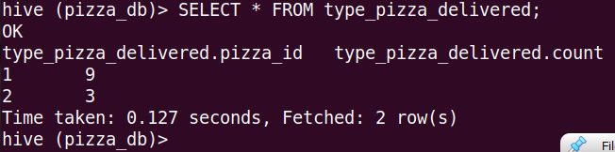

5th Question

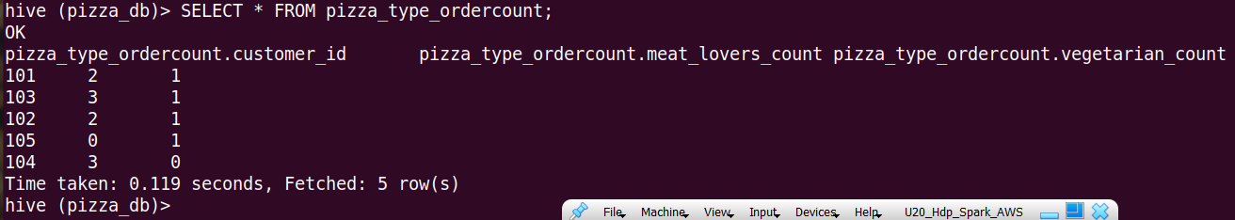

6th Question

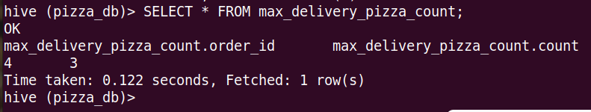

7th Question

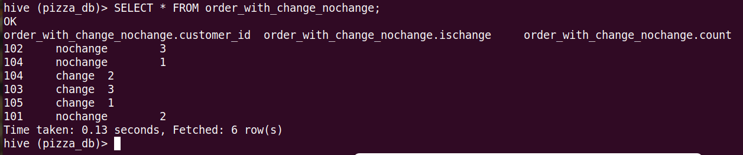

8th Question



9th Question

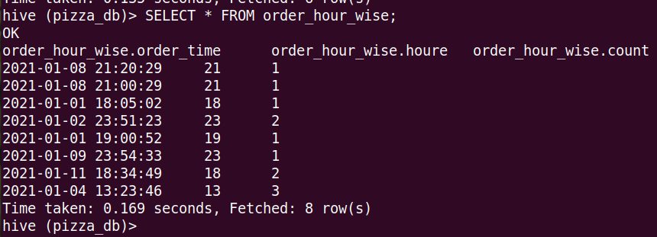

10th Question

