**SCD1 Achived in the hive**

Customer id 73

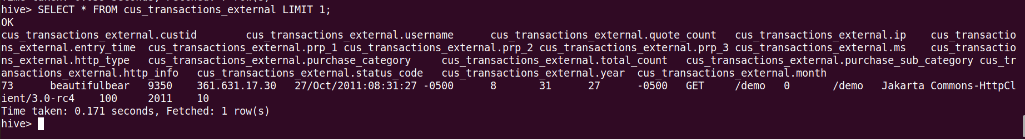

Only one record I updated

Updated CustomerID 73

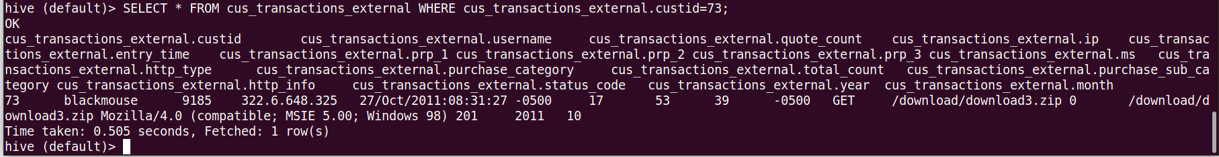

Verifying the before hadfs and after hdfs in the SQL table

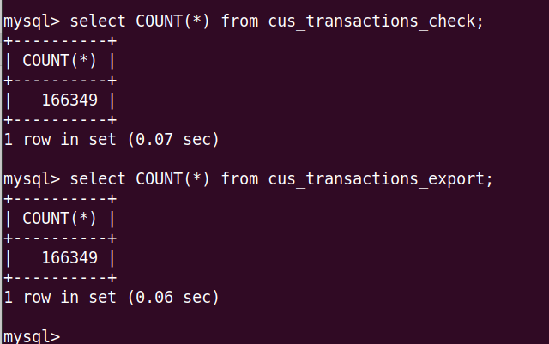

Total counts are same

Validating the rows in the external table HIVE as there was only one row which got updated

