**2. Listing News**

**[GranX Gest Listed on XT.com Exchange]**

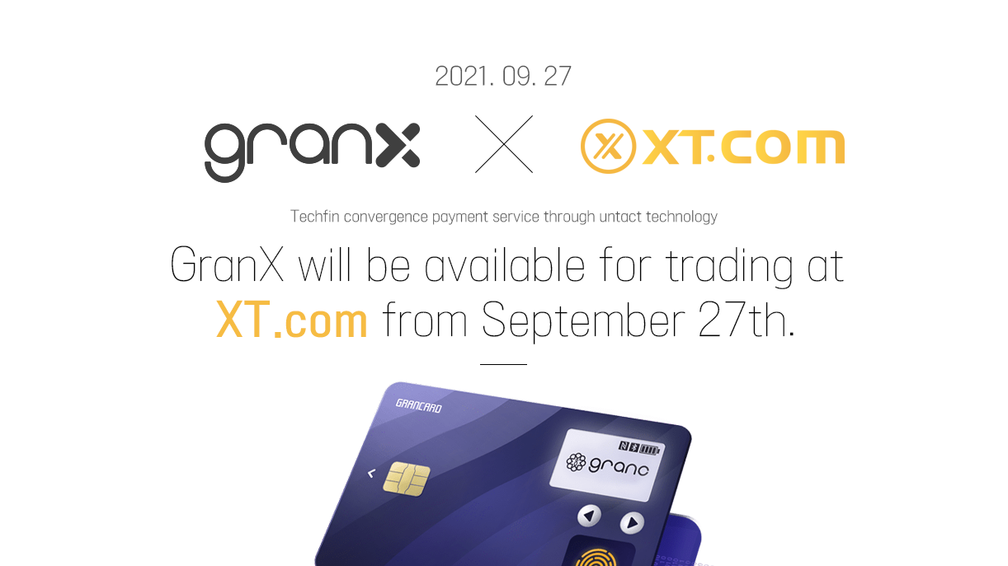

GranX Chain(<http://www.granc-chain.com>), a biometric data-based authentication and payment company, announced on the 27th that its token GranX Token will be listed on the virtual asset exchange XT.com(<https://www.xt.com/>).

XT.com, headquartered in Hong Kong, is a global virtual asset exchange with a 24-hour trading volume of about 630 billion won, with more than 7 million users and operating offices in Korea, Japan, Singapore, and Spain. It also supports margin trading and OTC transactions.

GranX Chain is an authentication platform that applies biometric technology and provides decentralized identity verification (DID) services. User’s biometric information generated and stored in the GranX card is encrypted and stored in the blockchain; when necessary, the information stored in the GranX card is authenticated through comparison with information stored in the blockchain.

“We will try our best to protect users’ valuable information and financial assets from security risks by operating biometric IDs and other personal and financial information and assets separately from the network,” an official from the GranX Chain said.